Supplementary Information for
Engineering Quantum Dot Surfaces to Preserve Protein-DNA Interactions for Single-Molecule Visualization

Youngseo Kim^{1†}, Hyerim Kim^{2†}, Munryul Choi³, Hyun Suk Kim⁴, Soyeong An¹, Orlando D. Schärer^{1, 4, 5}, Jongnam Park^{2, 3, 6*}, and Ja Yil Lee^{1, 4*}
¹ Department of Biological Sciences, Ulsan National Institute of Science and Technology, Ulsan 44919, Republic of Korea
² Department of Energy and Chemical Engineering, Ulsan National Institute of Science and Technology, Ulsan 44919, Republic of Korea
³ Uniqdot, Inc., Ulsan 44919, Republic of Korea
⁴ Institute of Basic Science Center for Genomic Integrity, Ulsan, 44919, Republic of Korea
⁵ Department of Pharmacology and Chemical Biology & Hillman Cancer Center, University of Pittsburgh Medical School, Pittsburgh, PA 15213, United States.
⁶ Department of Biological Medical Engineering, Ulsan National Institute of Science and Technology, Ulsan 44919, Republic of Korea

* Corresponding author: Ja Yil Lee and Jongnam Park

† Youngseo Kim and Hyerim Kim have contributed equally to this work
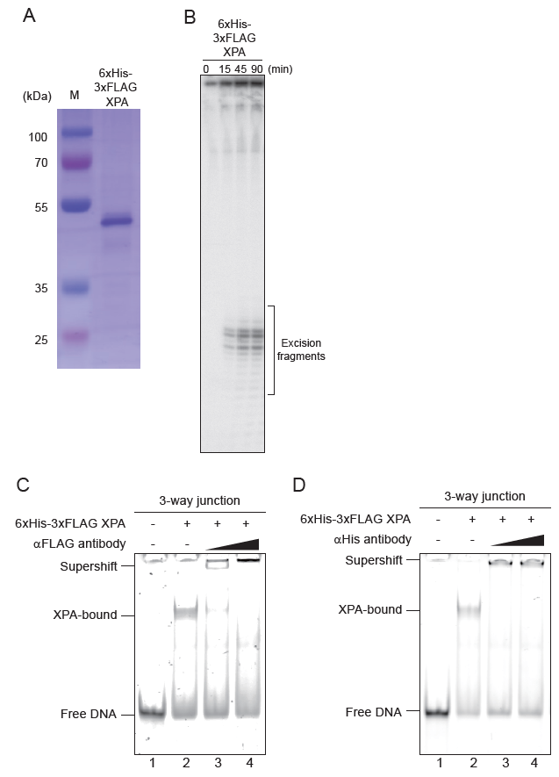
Figure S1. XPA purification and activity test. (A) 10% SDS PAGE gel image for human 6xHis-3xFLAG-XPA. (B) In vitro NER assay with 6xHis-3xFLAG-XPA. (C) Electrophoretic mobility shift assay (EMSA) for supershift with anti-FLAG antibody (αFLAG). In the presence of αFLAG, the XPA-DNA complex band disappears, and all bands remain in the well because of the binding of αFLAG to XPA. (D) EMSA for supershift with anti-His antibody (αHis). In the presence of αHis, the XPA-DNA complex band disappears, and all bands remain in the well because of the binding of αHis to XPA.
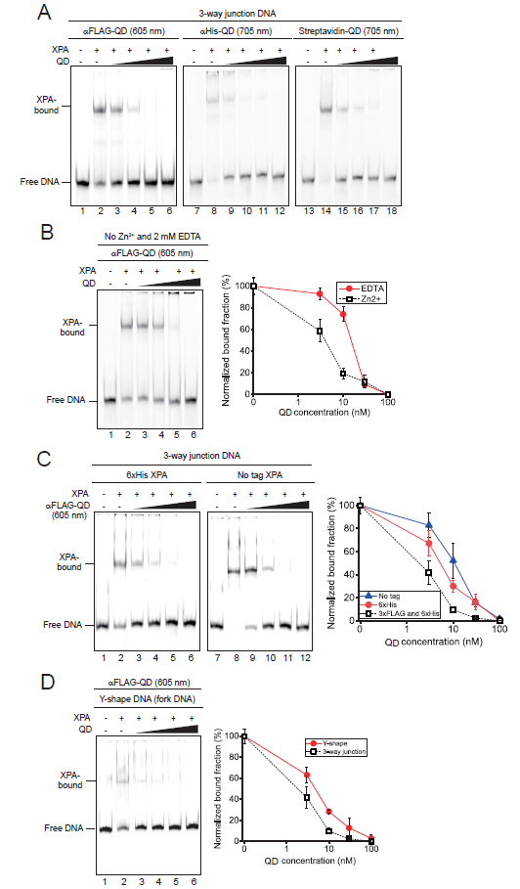
Figure S2. XPA dissociation by commercial QDs under various conditions. (A) XPA dissociation from 3-way junction DNA according to different types of proteins that are conjugated to QDs. Different concentrations of QDs (0, 3, 10, 30, and 100 nM) are tested. Quantified data are displayed in Figure 1F. (B) Zn2+ ion effect on the XPA dissociation from 3-way junction DNA by αFLAG-QD (605 nm) at different concentrations (0, 3, 10, 30, and 100 nM). EMSA gel image (left) and quantified data (right). Error bars are obtained from standard errors in triplicate. (C) Epitope tag effect on the XPA dissociation from 3-way junction DNA by αFLAG-QD (605 nm) at different concentrations (0, 3, 10, 30, and 100 nM). EMSA gel image (left) and quantified data (right). Error bars are obtained from standard errors in triplicate. (D) DNA substrate effect on the XPA dissociation by αFLAG-QD (605 nm) at different concentrations (0, 3, 10, 30, and 100 nM). Y-shape DNA (fork) is tested instead of 3-way junction DNA. EMSA gel image (left) and quantified data (right). Error bars are obtained from standard errors in triplicate.

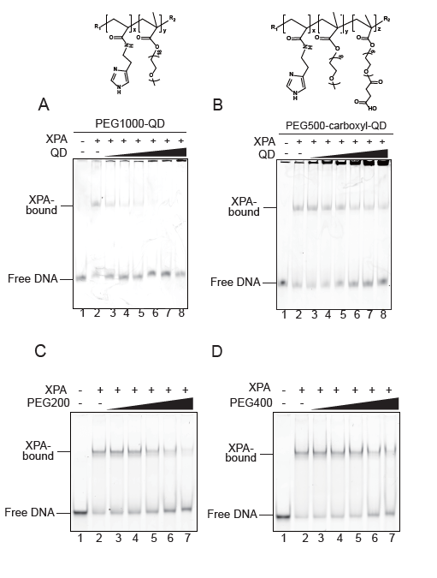
Figure S3. PEG effect on the XPA dissociation from DNA. (A) PEG1000-coated QDs titrated to XPA-DNA complex (3-way junction). Chemical structures of coated polymers are displayed above the EMSA gel data. Quantified data are displayed in Figure 2C. (B) Titration of synthesized QDs coated with 500 Da PEG (PEG500) modified with carboxyl-groups at different concentrations (0, 0.3, 1, 3, 10, 30, and 100 nM) to XPA-DNA complex (3-way junction). Chemical structures of coated polymers are displayed above the EMSA gel data. (C) EMSA for titration of PEG200 at different concentrations (0, 2.5, 5, 10, 20, and 30%) to XPA-DNA complex (3-way junction). (D) EMSA for titration of PEG400 at different concentrations (0, 2.5, 5, 10, 20, and 30%) to XPA-DNA complex (3-way junction).

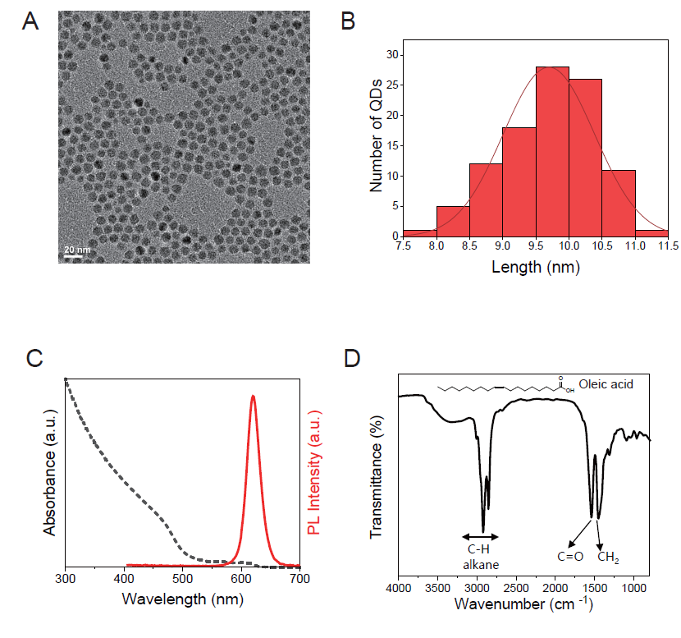
Figure S4. CdZnSeS/ZnS QDs. (A) TEM image of the synthesized CdZnSeS/ZnS QDs, showing uniform morphology. (B) Size distribution histogram obtained from TEM analysis. (C) UV–vis absorption and photoluminescence (PL) spectra of the CdZnSeS/ZnS QDs. (D) FT-IR spectrum of oleic-acid–capped CdZnSeS/ZnS QDs.

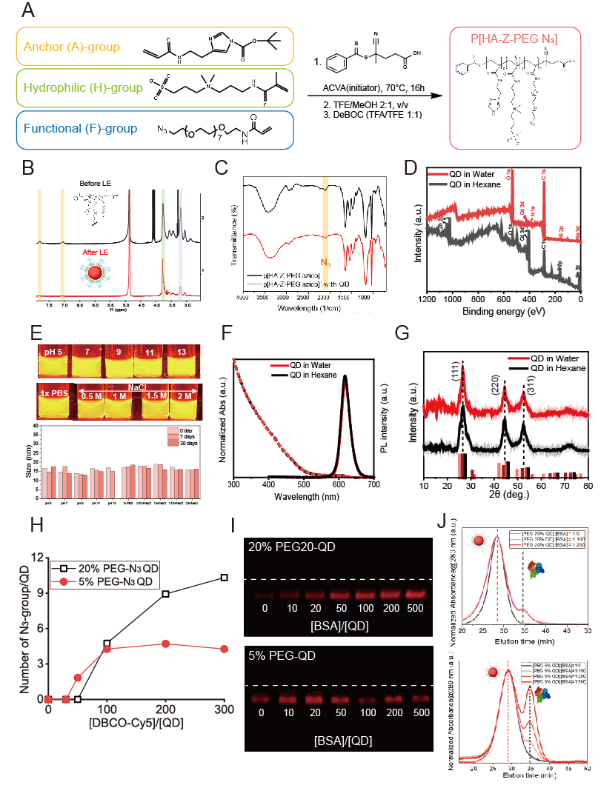
Figure S5. Surface engineering of QDs and the stability test. (A) Reaction mechanism for polymer synthesis via RAFT polymerization. (B) ¹H NMR spectra of the polymer ligand (p[HA-Z-PEG N3]) and CdSe QDs after ligand exchange. ¹H NMR spectrum of purified QDs after ligand exchange shows a notable decrease in the imidazole-related proton signals (δ ≈ 6.81–7.08 and 7.64–7.94 ppm) originating from the A-group of the polymer, indicating strong coordination of the anchor units to the QD surface. In contrast, signals corresponding to the zwitterionic H-group (δ ≈ 3.01–3.15 ppm) and PEG-based F-group (δ ≈ 3.54–3.73 ppm) remain clearly observable. (C) Fourier transform infrared spectroscopy (FT-IR) data of the polymer ligand (p[HA-Z-PEG N3]) and CdSe QDs after ligand exchange. (D) X-ray Photoelectron Spectroscopy (XPS) survey spectra of QDs before and after surface modification with polymer. (E) Colloidal stability test image and dynamic light scattering (DLS) data of QDs after ligand exchange at various salt concentrations and pH conditions. (F) UV–vis absorption, photoluminescence (PL) spectra of QDs before and after aqueous ligand exchange. (G) X-ray diffraction (XRD) patterns of QDs before and after aqueous ligand exchange. (H) Number of azide-group per QD estimated from the absorbance of Cy5-DBCO that is conjugated to the QD surface. (I) Agarose gel electrophoresis of (top) 20% PEG- and (bottom) 5% PEG-QDs with the increase of molar ratio of BSA and QD. (J) UV chromatogram at 280 nm of FPLC for (top) 20% PEG-QD and (bottom) 5% PEG-QD, which are incubated with BSA at different molar ratios (1:0, 1:100, and 1:200).

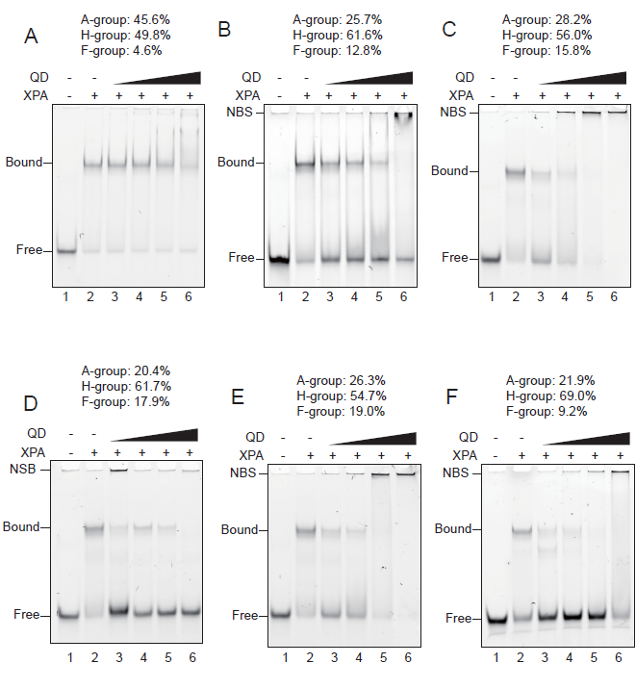
Figure S6. XPA dissociation test depending on the polymer composition on the QD surface. QDs are titrated at different concentrations (10, 30, and 100 nM) to the XPA-DNA complex (3-way junction). (A) A: H: F is 45.6%: 49.8%: 4.6%. (B) A: H: F is 25.7%: 61.6%: 12.8%. (C) A: H: F is 28.2%: 56.0%: 15.8%. (D) A: H: F is 20.4%: 61.7%: 17.9%. (E) A: H: F is 26.3%: 54.7%: 19.0%. (F) A: H: F is 21.9%: 69.0%: 9.2%. NBS indicates nonspecific binding of DNA or DNA-protein complex with QDs.

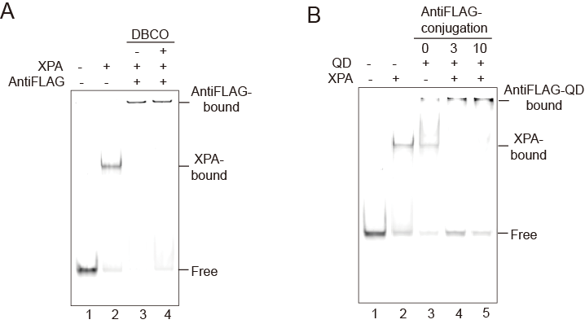
Figure S7. EMSA for the effect of (A) DBCO-modified antibody (antiFLAG) and (B) antiFLAG-conjugated QDs. 0, 3, and 10 indicates the molar ratio of antiFLAG to QD in conjugation.

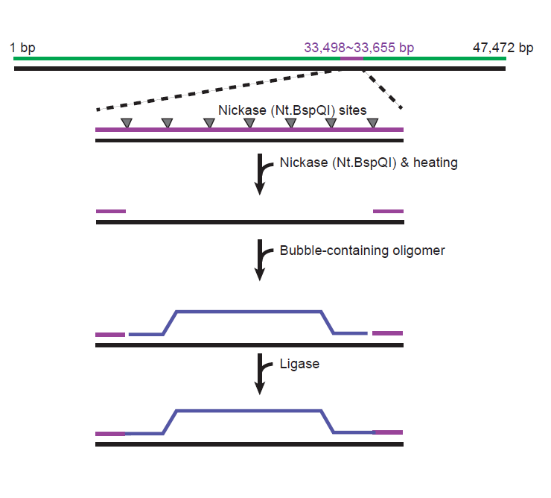
Figure S8. Schematic of bubble-insertion into lambda DNA. Engineered λ-DNA (λ-I3) containing 7 nickase sites between 33,498 bp and 33,655 bp is treated with nickase (Nt.BspQI). Heat denaturation induces a long gap, on which a bubble construct is hybridized and ligated.

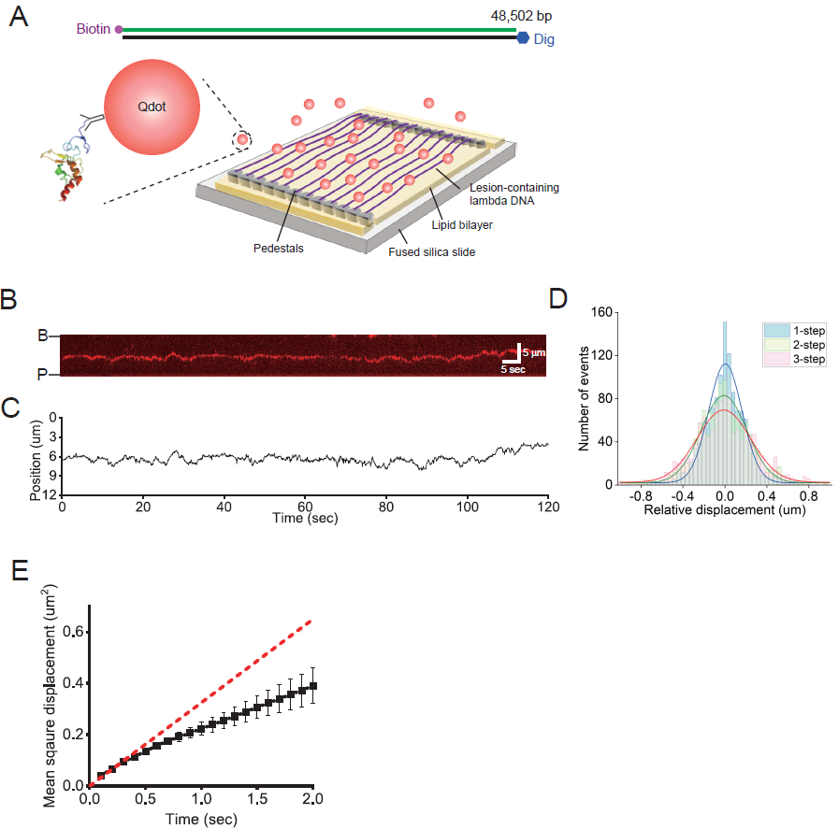
Figure S9. Analysis of diffusive motion of XPA using double-tethered DNA curtains. (A) (Top) Lambda DNA (λ-DNA) construct for double-tethered DNA curtains. One end of λ-DNA is labeled with biotin, while the other end is modified with digoxigenin. (Bottom) Schematic of double-tethered DNA curtain assay. The biotinylated end is stalled at the nano-barrier while the other end is tethered to the pedestal that is coated with anti-digoxigenin. XPA is labeled with αFLAG-QD (705 nm), which is newly synthesized to prevent the XPA dissociation from DNA. XPA structure is adopted from Protein Data Bank (PDB ID: 1XPA). (B) Representative kymograph displaying XPA movement along single undamaged λ-DNA. (C) Time trace that is obtained from single-molecule particle tracking for the molecule in Figure S9B. (D) Relative displacement from Figure S9C. (E) Mean square displacement (MSD) as a function of time. Diffusion coefficient is estimated from the linear fitting (red dashed line) of the first three data points in the MSD.

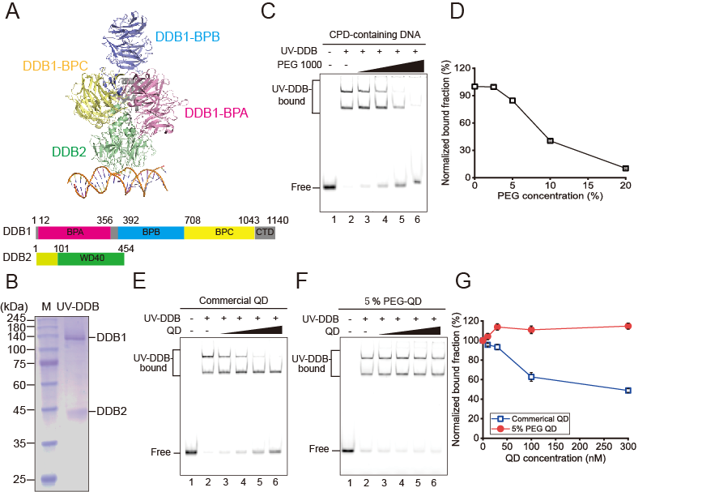
Figure S10. (A) (Top) UV-DDB structure (PDB: 4E54) and (bottom) domains. (B) SDS PAGE for UV-DDB purification. (C) PEG 1000 titration (0, 2.5%, 5%, 10%, 20%, and 30%) for UV-DDB binding to CPD-containing DNA. (D) Quantification of Figure S10C. (E) Commercial QD (Q21301MP, Thermo Fisher Scientific) and (F) 5% PEG QD titration (0, 10, 30, 100, and 300 nM) for UV-DDB binding to CPD-containing DNA. (G) Quantification of Figure S10E and S10F. Error bars are obtained from standard errors in triplicate.

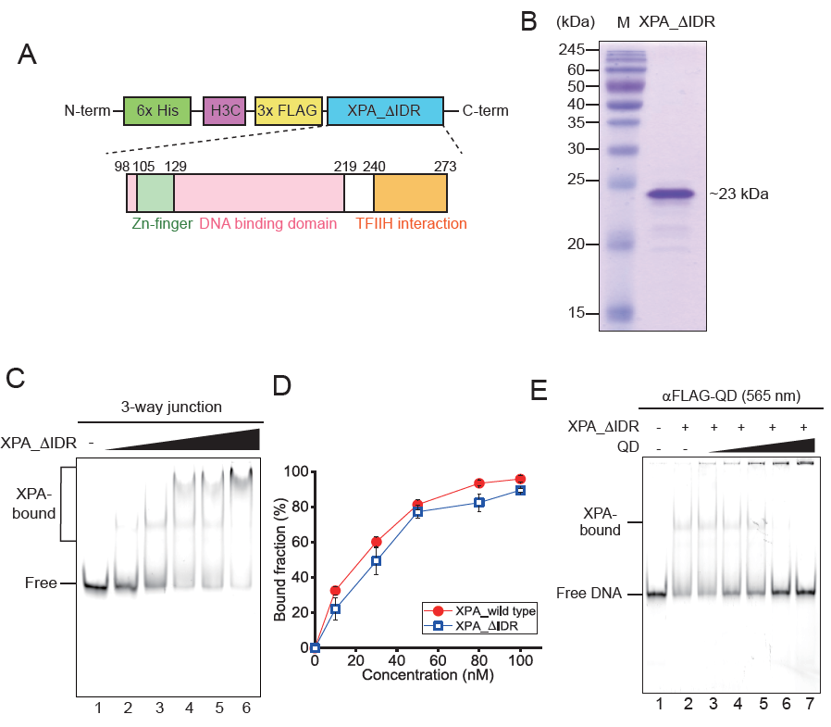
Figure S11. Dissociation of a deletion mutant that does not have intrinsically disordered region (IDR). (A) Domain structure of a deletion mutant (XPA_ΔIDR) where the amino-terminal IDR (1~97 amino acids) is removed. (B) SDS PAGE for the purification of XPA_ΔIDR (~23 kDa). (C) EMSA for the titration of XPA_ΔIDR to 3-way junction DNA substrates. 5 nM DNA is incubated with different concentrations of XPA_ΔIDR (0, 10, 30, 50, 80, and 100 nM). (D) Quantification of the EMSA in Figure S11C. Errors are obtained from standard errors in triplicate. Wild type data are adopted from Figure 1D. (E) EMSA showing QD-mediated dissociation of XPA_ΔIDR from three-way junction DNA. 30 nM XPA_ΔIDR is incubated with 5 nM 3-way junction DNA, and then different concentrations of αFLAG-QDs (565 nm) (0, 3, 10, 30, 100, and 300 nM) are added.

Table S1. Sequence information of primers and oligomers used in experiments.
Name | Sequence | Manufacture
YFA | ACCATGATTACGAATGGTTCGGAATCCTGACGAAC | Bioneer
YFB | ATGCCTGCACGAATTAAGCCATTCGTAATCATGGT | Bioneer
FAM_YFC | [FAM]GTTCGTCAGGATTCCAATTCGTGCAGGCAT | Bioneer
CY5_Dup | [Cy5]TCAACGTGGGCAAAGATGTCCTAGCAAGTCACGATATGGT | Bioneer
Dup-comp | ACCATATCGTGACTTGCTAGGACATCTTTGCCCACGTTGA | Bioneer
Cy5-Yshape | [Cy5]CTATGGCGAGGCGATTATCTTCCCTTTGCTGTGGGTCTTCCGTTCGTC | Bioneer
Yhape-comp | TTTTTTTTTTTTTTTTTTTTTTTTTTTTTTTTAATCGCCTCGCCATAG | Bioneer
Biotin-cos-R | [Phosphate]AGGTCGCCGCCC[biotin] | Bioneer
Multi-Dig-cos-L | [Phosphate]GGGCGGCGACC[digoxigenin-dT][digoxigenin] | Bionics
λ-I3-bubble | [Phosphate]TGCATGCGGCCGCTCTTCCCATGGTGCGATTTTGTGGTTCCCATACCGTATAACCATTTGGCTGTCCAAGCTCCGGGTGTTTGTTTTCCGCTCTTCCCATGGTGCGATCGCTCTTCG | Bioneer
CPD_temp | 5’-Phos-TGC ATG CGG CCG CTC TTC CC[CPD]GG TGC GAT CGC TCT TCG -3’ | Gene Link
CPD_comp_FAM | 5’-FAM-CGA AGA GCG ATC GCA CCA TGG GAA GAG CGG CCG CAT GCA-3’ | Bioneer

Table S2. Polymers coated on the QD surface and their relative composition.
Name | A group | H group | F group | Bound/Dissociation
RP1 | 38.50% | 56.47% | 5.18% | Bound
RP2 | 29.67% | 65.86% | 4.47% | Bound
RP3 | 29.60% | 65.90% | 4.50% | Bound
RP4 | 45.60% | 49.80% | 4.60% | Bound
RP5 | 39.80% | 55.00% | 5.20% | Bound
RP6 | 26.80% | 68.80% | 4.40% | Bound
RP7 | 35.00% | 60.50% | 4.60% | Bound
RP8 | 30.30% | 63.60% | 6.10% | Bound
RP9 | 30.60% | 62.60% | 6.80% | Bound
RP10 | 38.00% | 56.80% | 5.30% | Bound
RP11 | 31.60% | 62.40% | 6.00% | Bound
RP12 | 26.10% | 68.80% | 5.10% | Bound
RP13 | 30.90% | 46.75% | 22.35% | Dissociation
RP14 | 23.80% | 65.00% | 11.20% | Dissociation
RP15 | 8.90% | 68.00% | 23.00% | Dissociation
RP16 | 22.50% | 59.30% | 18.20% | Dissociation
RP17 | 25.70% | 61.60% | 12.80% | Dissociation
RP18 | 24.70% | 64.70% | 10.60% | Dissociation
RP19 | 28.20% | 56.00% | 15.80% | Dissociation
RP20 | 20.40% | 61.70% | 17.90% | Dissociation
RP21 | 26.30% | 54.70% | 19.00% | Dissociation
RP22 | 21.90% | 69.00% | 9.20% | Dissociation
RP23 | 22.00% | 62.30% | 15.80% | Dissociation

