Supporting Information

2D MoS₂-Conformal 3D-Printed Platform for Dual Phototherapy and Bone Regeneration

Jong Hwa Seo^{1,†}, In ho Choi^{2,3,4†}, Hyun Lee⁵, Seojoon Bang¹, Hyeong Seok Kang¹, Chan Ho Moon¹, Ju Yeong Gwon⁶, Nayoung Lee¹, Geonwoo Kim¹, Youn Ha Cho^{2,3,4}, Se Jin Choi^{2,3,4}, Hyo Jin Joo^{2,3,4}, Ji Hye Kim^{2,3,4}, Eun Saem Song^{2,3,4}, Jihoon Kim^{7,8}, Dongjun Kim^{7,8}, Sungsu Kang⁹, Dong Yun Lee⁶, Donghyun Lim⁶, Kisuk Yang¹⁰, Gi Doo Cha¹¹, Soo-Hong Lee¹², Jungwon Park^{7,8}, Min-Ho Kang^{2,3,4*}, Hyun-Do Jung^{1*}

J. H. Seo, S. Bang, H. S. Kang, C. H. Moon, N. L, G. K, H.-D. Jung
¹Division of Materials Science and Engineering, Hanyang University, Seoul 04763, Republic of Korea
E-mail: hdjung@hanyang.ac.kr, Hyun-Do Jung

I. H. Choi, Y. H. Cho, S. J. Choi, H. J. Joo, J. H. Kim, E. S. Song, M.-H. Kang
²Department of Biotechnology, The Catholic University of Korea, Bucheon 14662, Republic of Korea
³Department of Biomedical-Chemical Engineering, The Catholic University of Korea, Bucheon 14662, Gyeonggi-do, Republic of Korea
⁴Research Institute for Controlled Biomaterials of Regulated Cell Death, The Catholic University of Korea, Bucheon 14662, Republic of Korea
E-mail: mhkang@catholic.ac.kr, Min-Ho Kang

H. Lee
⁵Research Institute of Intelligent Manufacturing & Materials Technology, Korea Institute of Industrial Technology, 156, Gaetbeol-ro, Yeonsu-gu, Incheon 21999, Republic of Korea

J. Y. Gwon, D. Y. Lee, D. H. Lim
⁶Department of Bioengineering, Hanyang University, Seoul 04763, Republic of Korea

J. H. Kim, D. J. Kim, J.W. Park
⁷Department of Chemical and Biological Engineering, Institute of Chemical Processes, Seoul National University, Seoul 08826, Republic of Korea
⁸Center for Nanoparticle Research, Institute for Basic Science (IBS), Seoul 08826, Republic of Korea

S. S. Kang
⁹ Department of Chemistry, University of Chicago, Chicago, Illinois 60637, United State

K. S. Yang
¹⁰Division of Bioengineering, College of Life Sciences and Bioengineering, Incheon National University, Incheon 22012, Republic of Korea

G. D. Cha
¹¹Department of Systems Biotechnology, Chung-Ang University, Anseong-si, Gyeonggi-do, 17546, Republic of Korea

S.-H. Lee
¹²Department of Biomedical Engineering, Dongguk University, Seoul 04620, Republic of Korea

†These authors contributed equally to this work.
*These authors are co-corresponding authors.
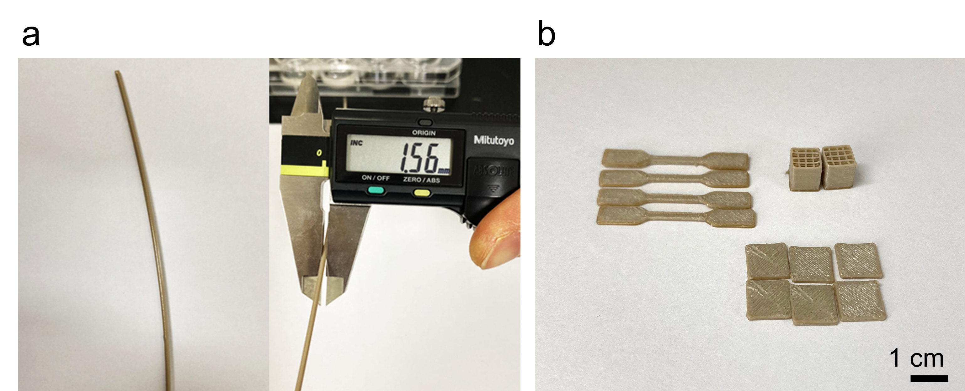
Fig. S1. Fabrication and structural versatility of PEEK filament and PEEK constructs. Optical images of (a) fabricated PEEK filament and (b) architecturally diverse PEEK constructs fabricated via FDM-based 3D printing.

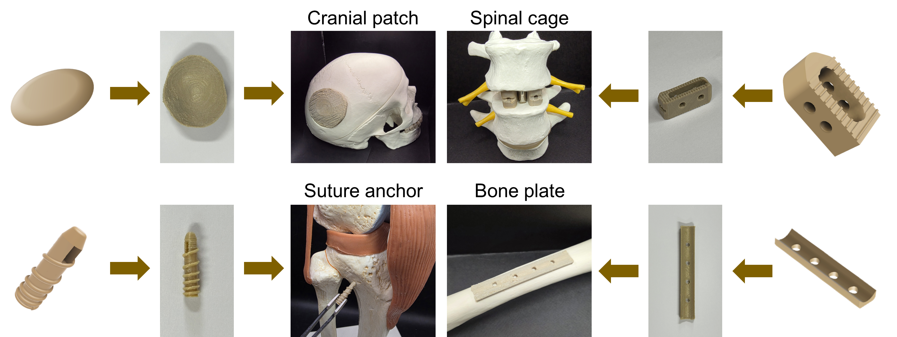
Fig. S2. Design versatility and anatomical applicability of PEEK implants. Representative CAD designs, corresponding fabricated PEEK constructs, and simulated implantation into anatomical bone models, including cranial patch, suture anchor, spinal cage, suture anchor, and bone plate.

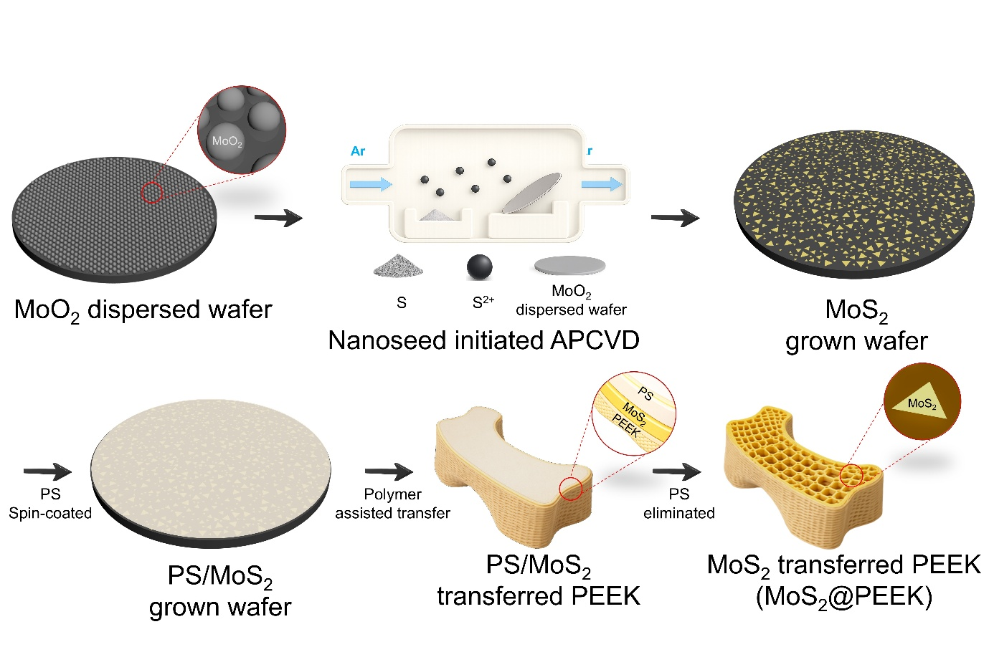
Fig. S3. Schematic illustration of MoS₂ synthesis and MoS₂@PEEK fabrication via polymer-assisted transfer. MoO₂ solution was dispersed on a wafer and MoS₂ was grown on the wafer by nanoseed-initiated APCVD using the MoO₂ dispersed wafer and sulfur powder. Polystyrene was spin-coated onto the MoS₂ grown wafer and MoS₂ was transferred onto PEEK surface via polymer-assistant transfer process.
.

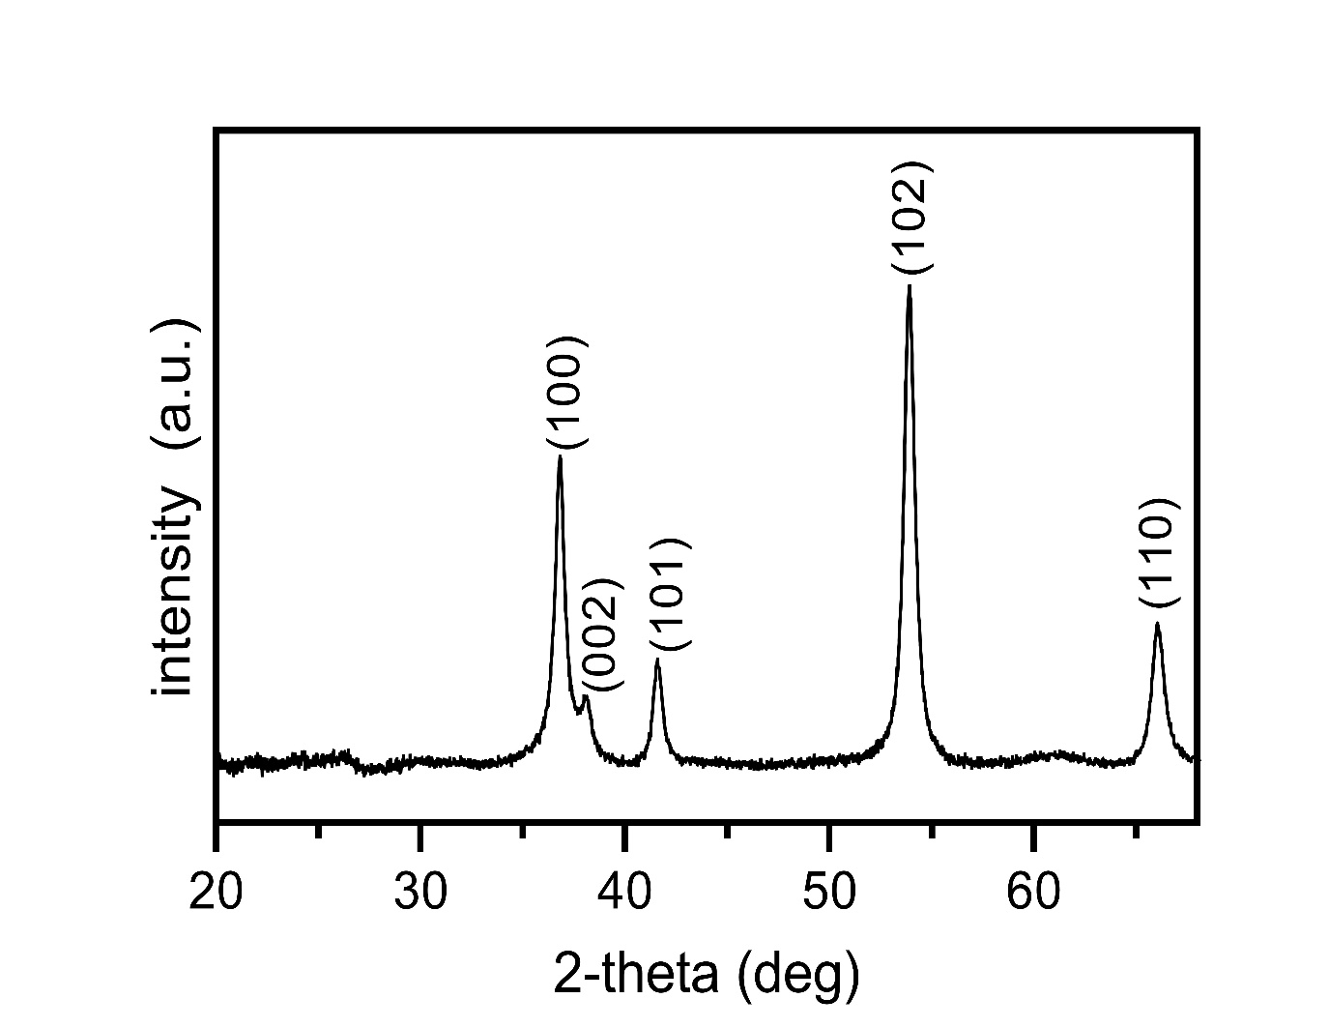

Fig. S4. X-ray diffraction spectrum of MoO₂ nanoparticles precursor for MoS₂ synthesis.

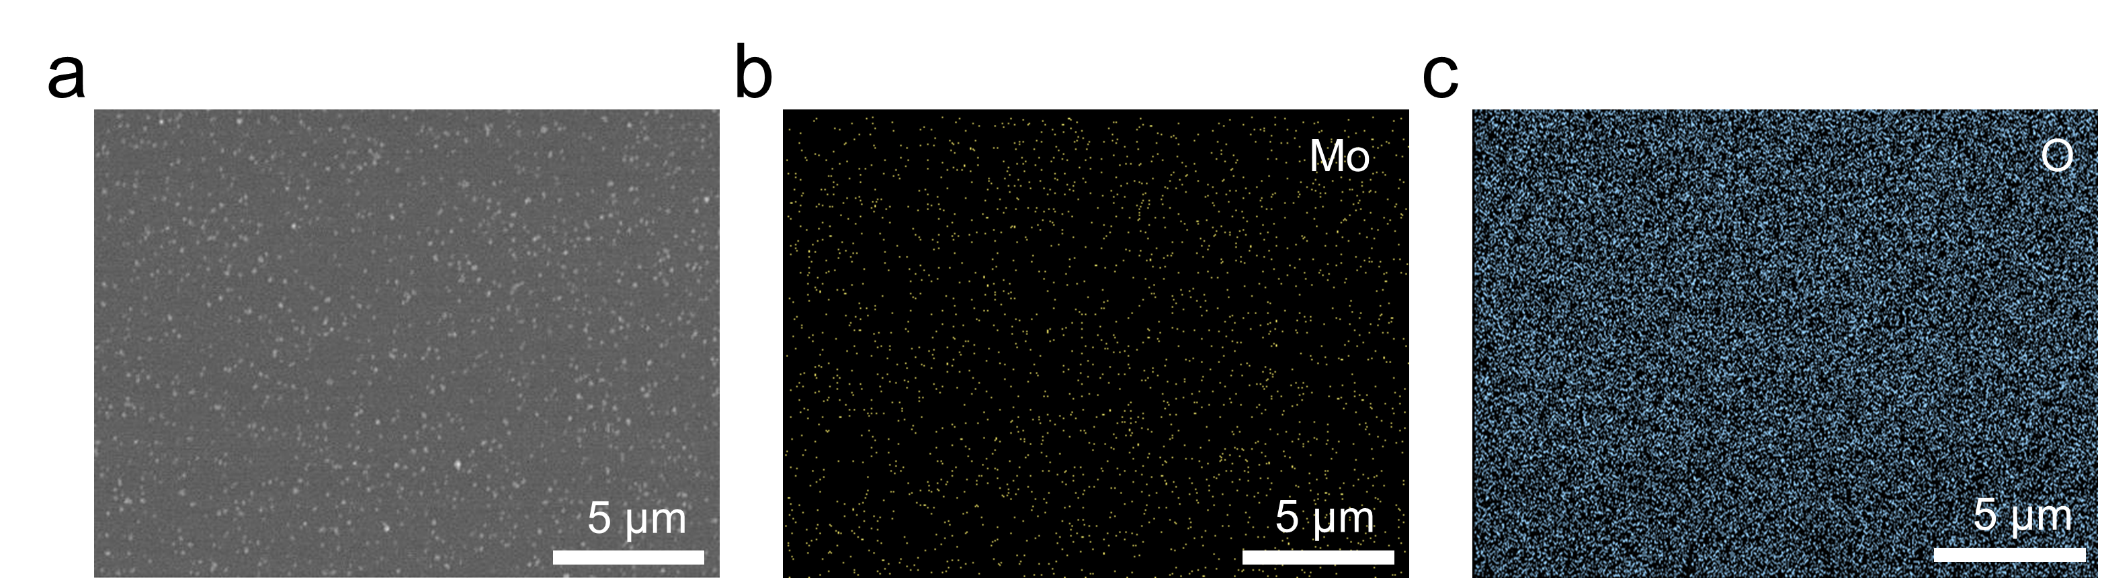
Fig. S5. Surface SEM and EDX analysis of MoO₂ dispersed wafer. (a) SEM image and EDX elemental maps of (b) Mo and (c) O on the surface of MoO₂ dispersed wafer.

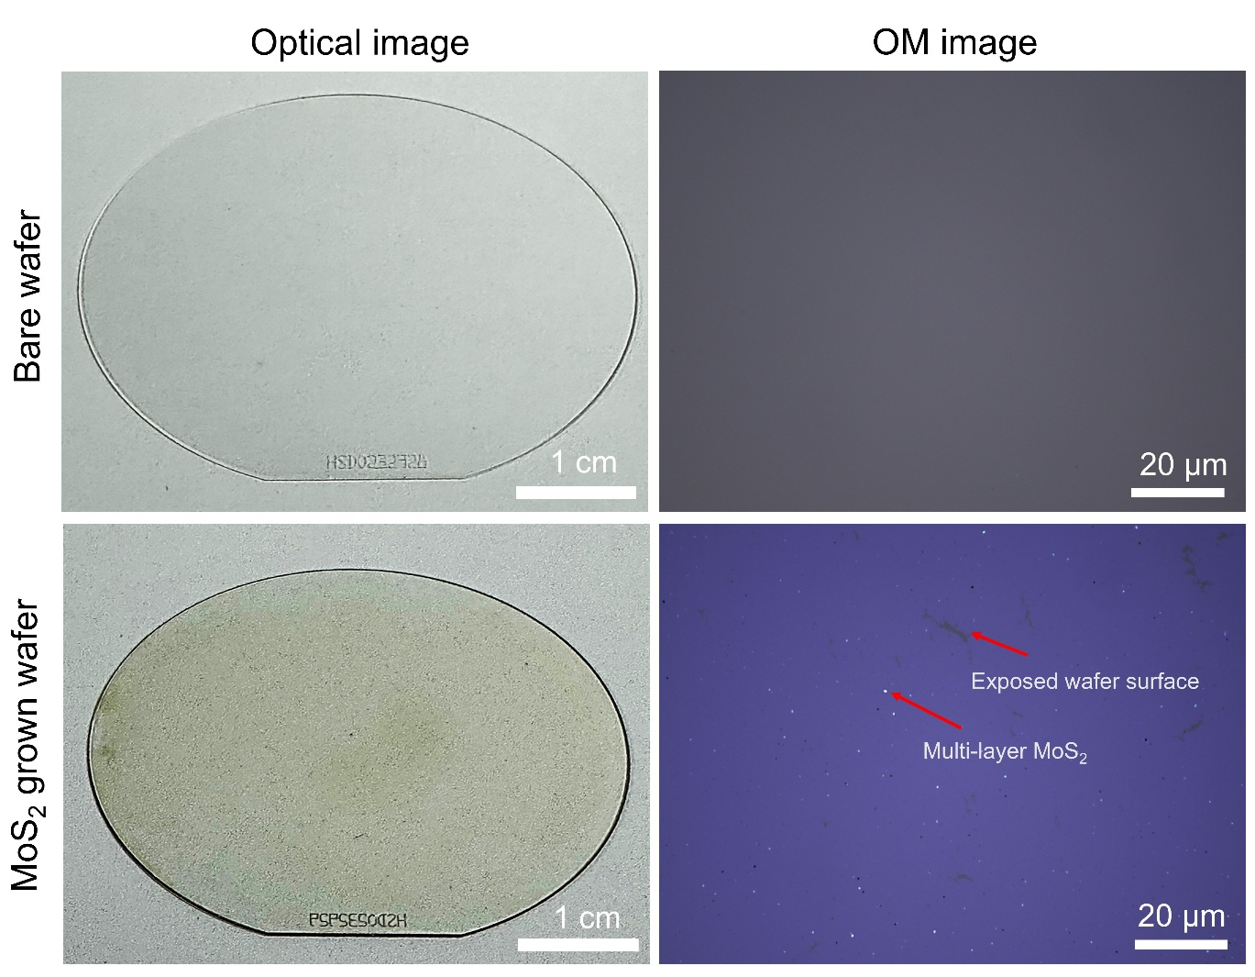

Fig. S6. Optical images and optical microscopy images of bare wafer and 2D MoS₂ grown wafer.

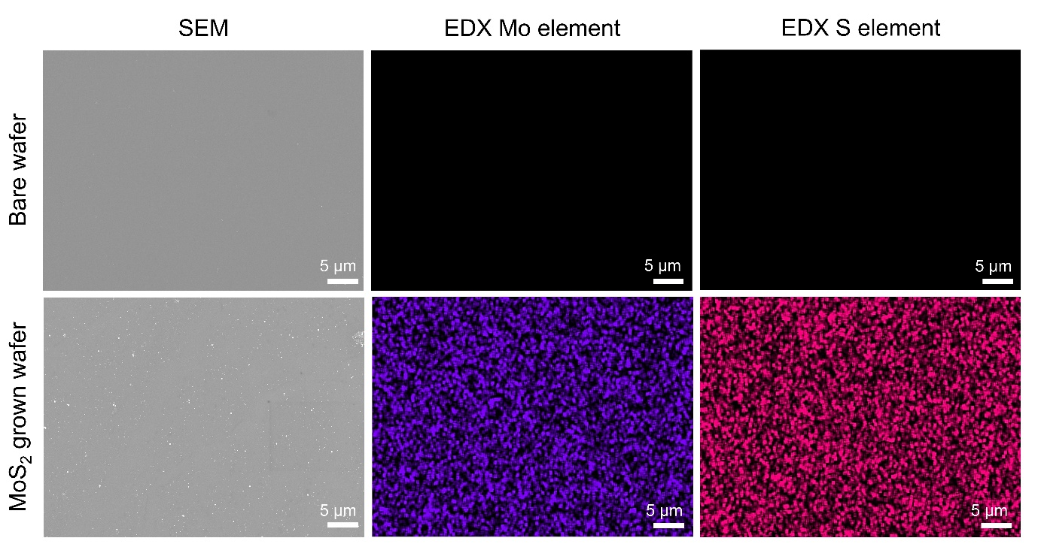
Fig. S7. SEM and EDX elemental mapping images of the bare wafer and the 2D MoS₂ grown wafer.

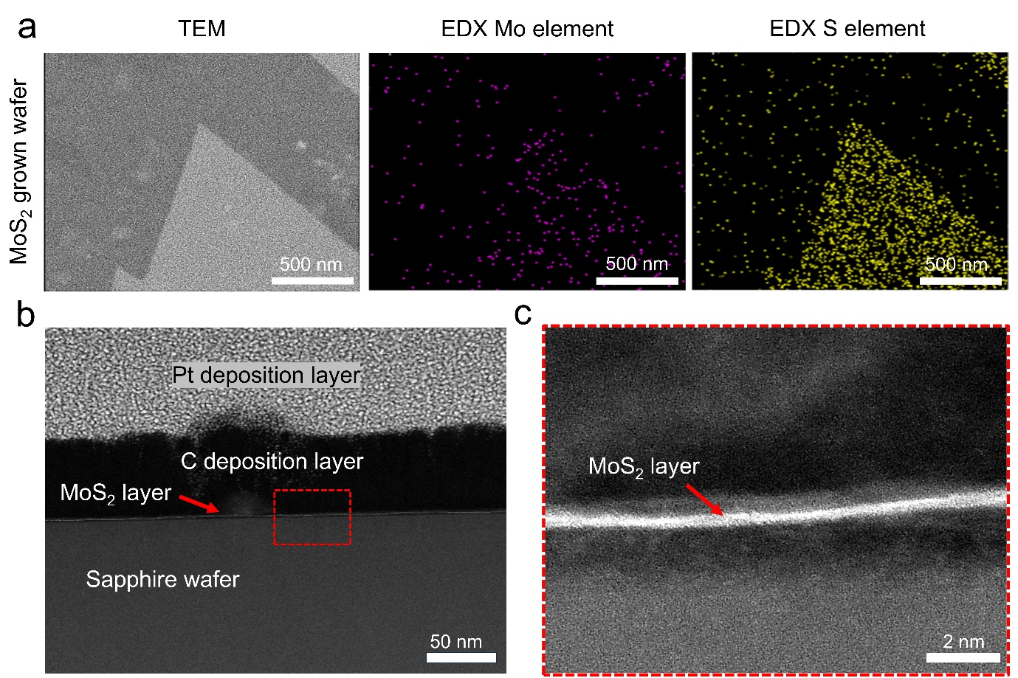
Fig. S8. TEM and EDX analysis of 2D MoS₂ grown wafer. (a) Surface TEM and EDX images of the 2D MoS₂ grown wafer. (b) Low and (c) high magnification of cross-sectional TEM image of 2D MoS₂ grown wafer.

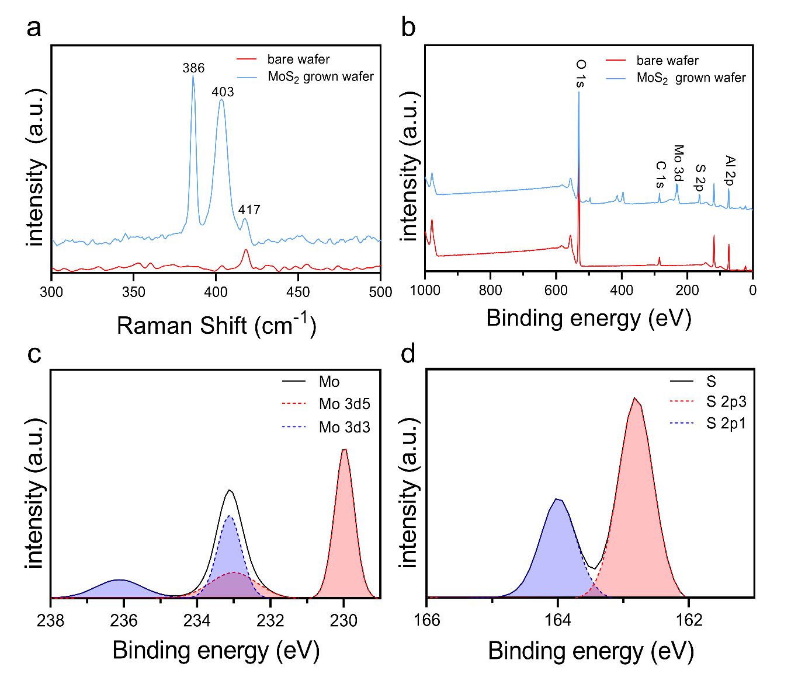

Fig. S9. Surface chemical analysis of 2D MoS₂ grown wafer. (a) Raman spectra of bare wafer and 2D MoS₂ grown wafer. (b) Full XPS spectra of bare wafer and the MoS₂ grown wafer. Deconvoluted high-resolution XPS spectra of (c) Mo 3d and (d) S 2p for the 2D MoS₂ grown wafer.

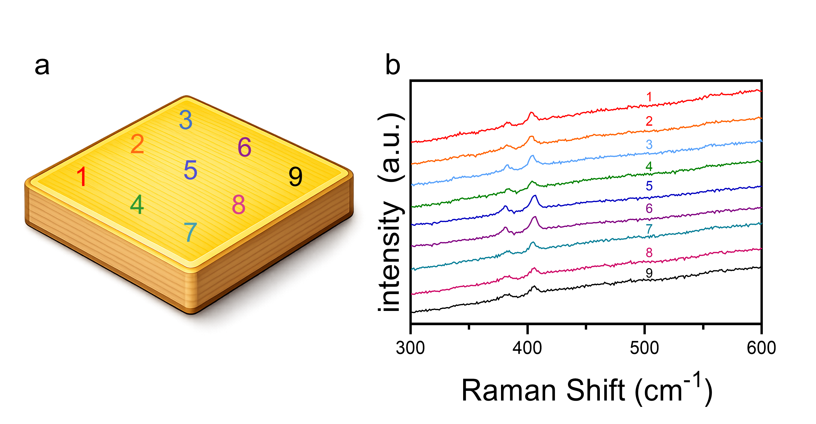
Fig. S10. Region-resolved Raman spectra of MoS₂@PEEK. (a) Positions of Raman analysis on MoS₂@PEEK. (b) Raman spectra of the MoS₂@PEEK from position 1 to 9.

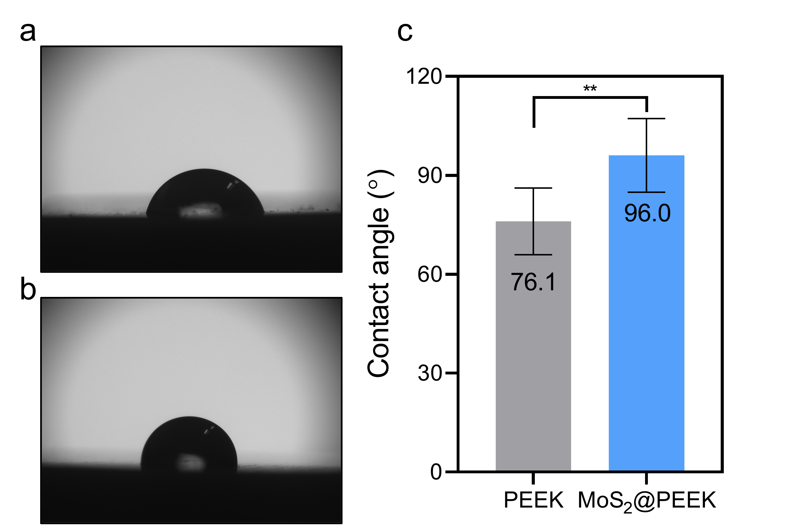
Fig. S11. Water contact angle (WCA) comparison between PEEK and MoS₂@PEEK. Representative images of water droplets on the surfaces of (a) PEEK and (b) MoS₂@PEEK. (c) The average contact angles of the PEEK and the MoS₂@PEEK (n = 3). Data are shown as mean ± standard deviation (SD). Normality was assessed using the Shapiro-Wilk test. Statistical significance between two groups was determined using an unpaired Student’s T-test, with significance at *p<0.05, **p<0.01, ***p<0.005, and ****p<0.001.

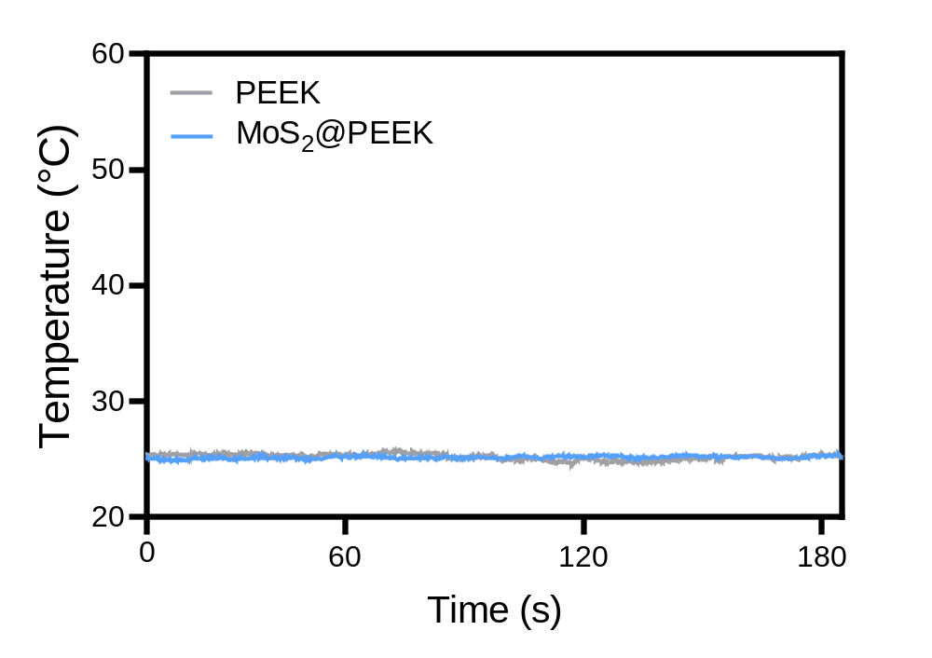
Fig. S12. Temperature elevation profiles under photoirradiation with a wavelength of 650 nm.

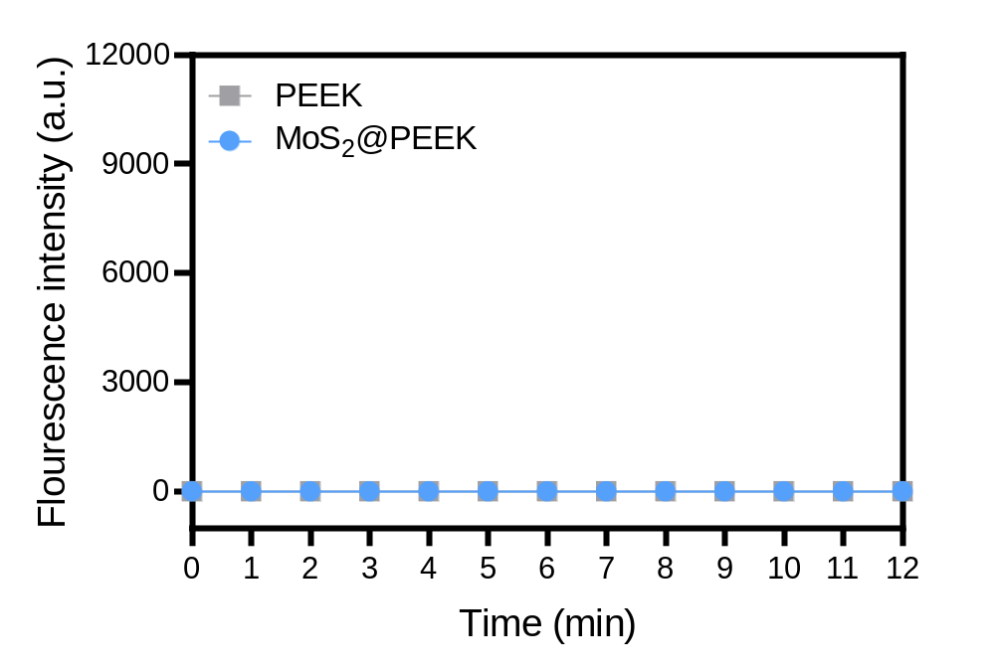
Fig. S13. Time-dependent singlet oxygen generation evaluated by SOSG fluorescence intensity under 808 nm NIR irradiation.

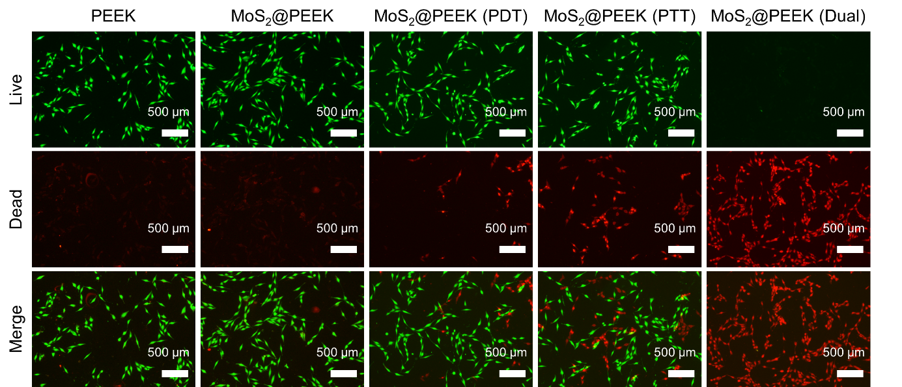
Fig. S14. Live and dead staining fluorescence images of cancer cells after 1 day of culture on different 3D-printed scaffolds.

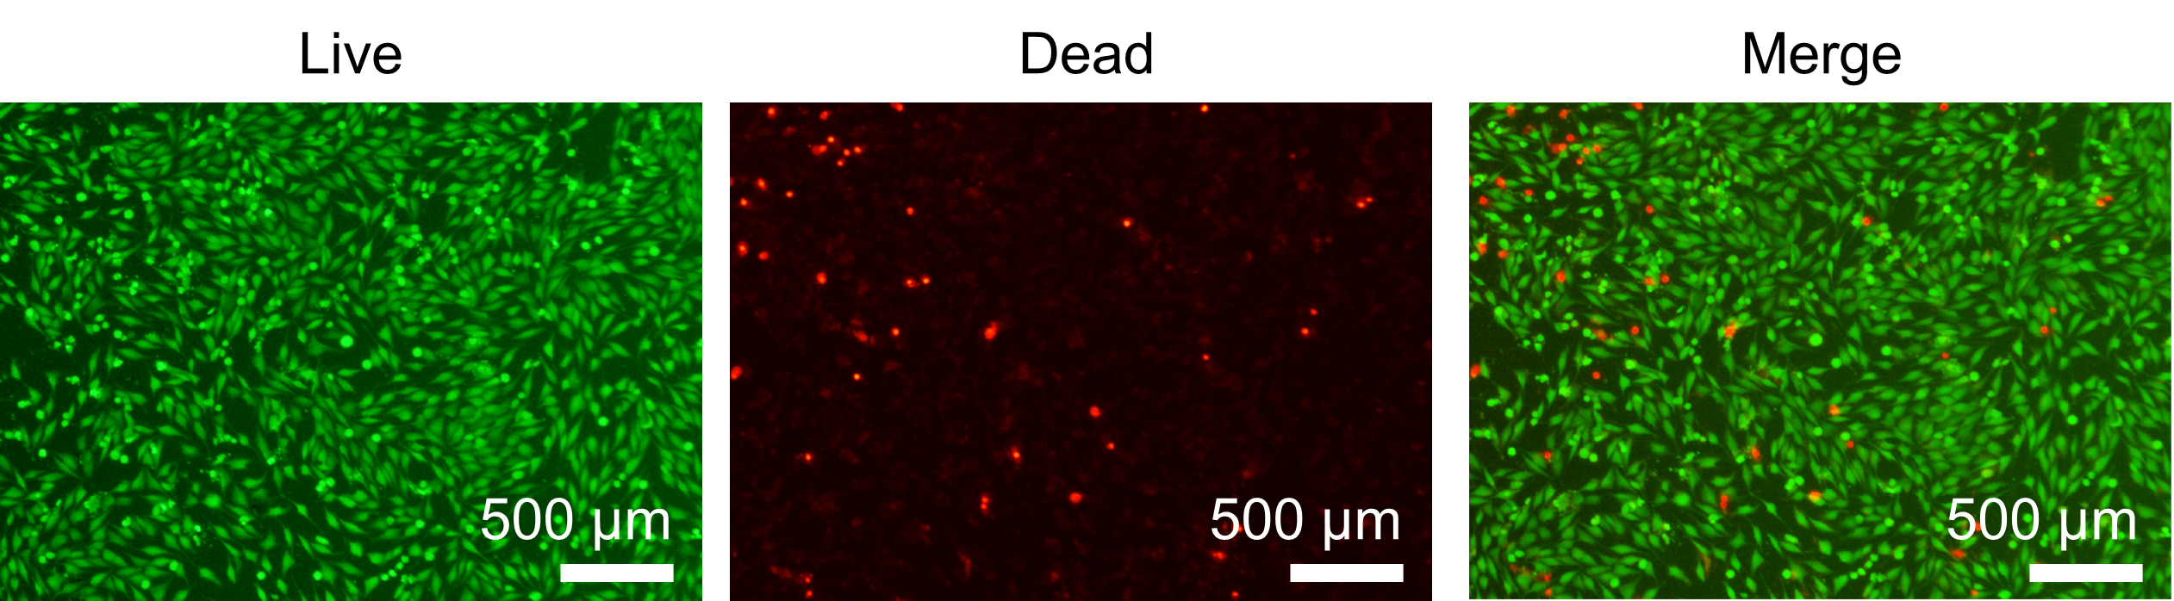
Fig. S15. Live and dead staining fluorescence images of cancer cells after 3 days of culture on PEEK scaffold.

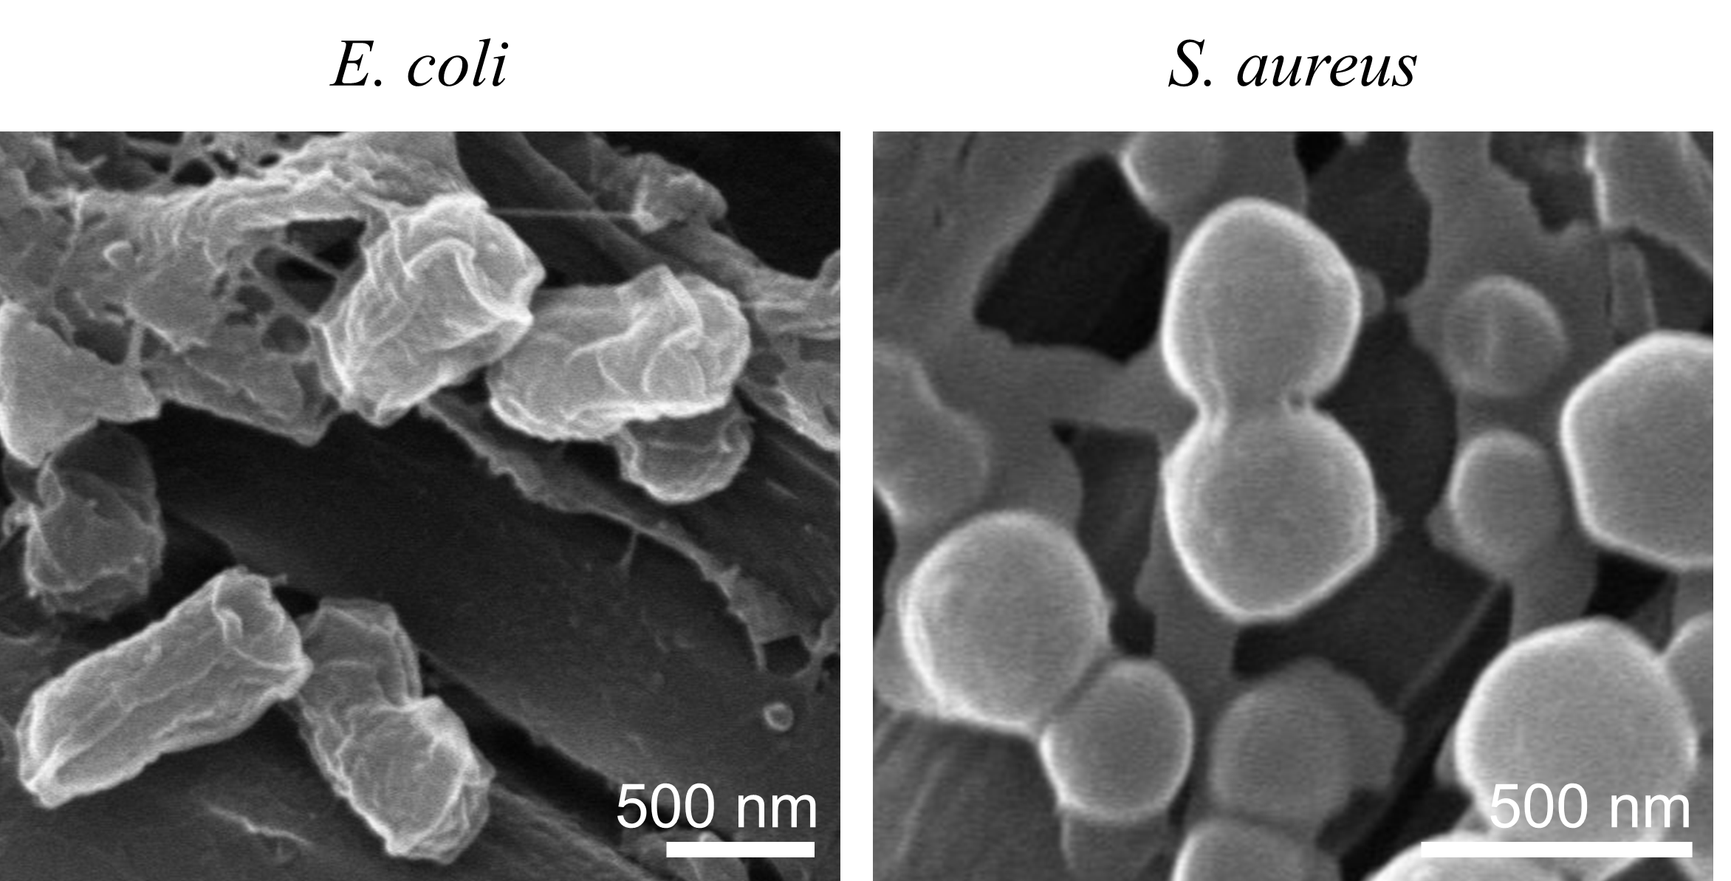
Fig. S16. SEM observation of E. coli and S. aureus attached to PEEK scaffold.

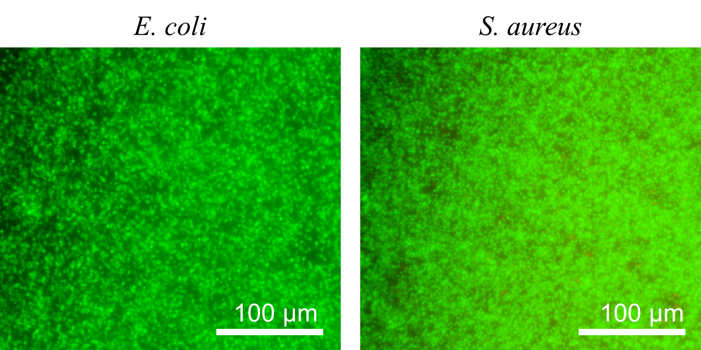
Fig. S17. Live and dead staining fluorescence images of E. coli and S. aureus attached to PEEK scaffold.

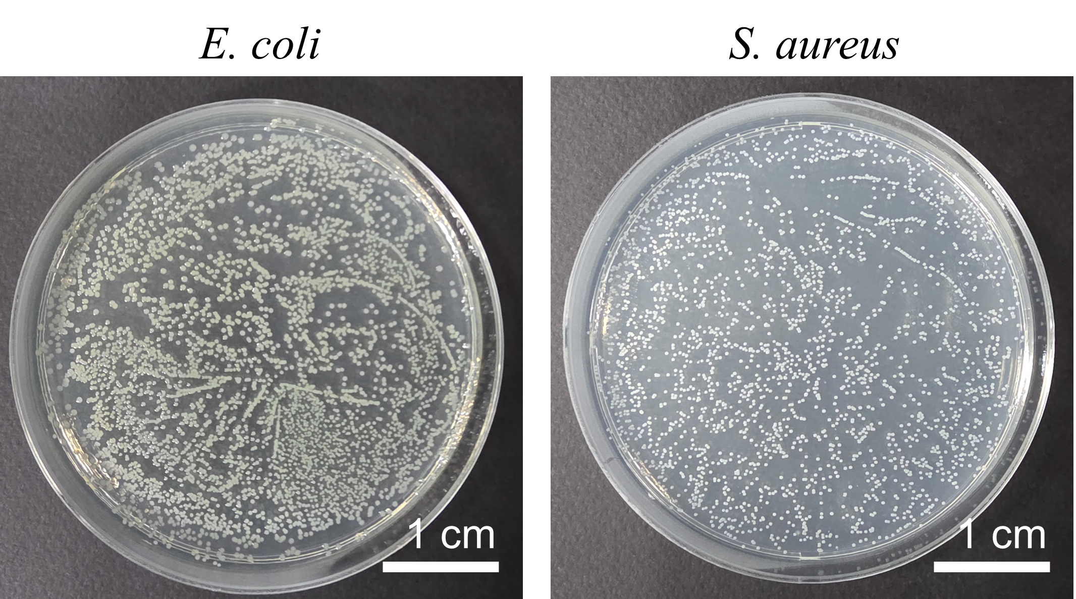
Fig. S18. Representative colony images of E. coli and S. aureus on PEEK scaffold.

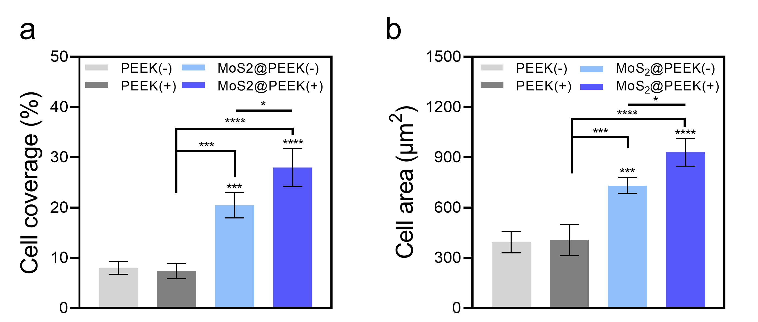
Fig. S19. In vitro assessment of pre-osteoblast attachment. (a) Quantitative analysis of cell adhesion coverage based on fluorescence imaging (n = 3). (b) Quantification of cell spreading area determined from SEM micrographs (n = 3). Data are shown as mean ± standard deviation (SD). Normality was tested using the Shapiro-Wilk method, and one-way ANOVA followed by Tukey’s HSD post hoc analysis was applied. For non-normally distributed data, statistical analysis was performed using the Kruskal-Wallis H test followed by pairwise comparisons with the Mann-Whitney U test, with significance at *p<0.05, **p<0.01, ***p<0.005, and ****p<0.001.

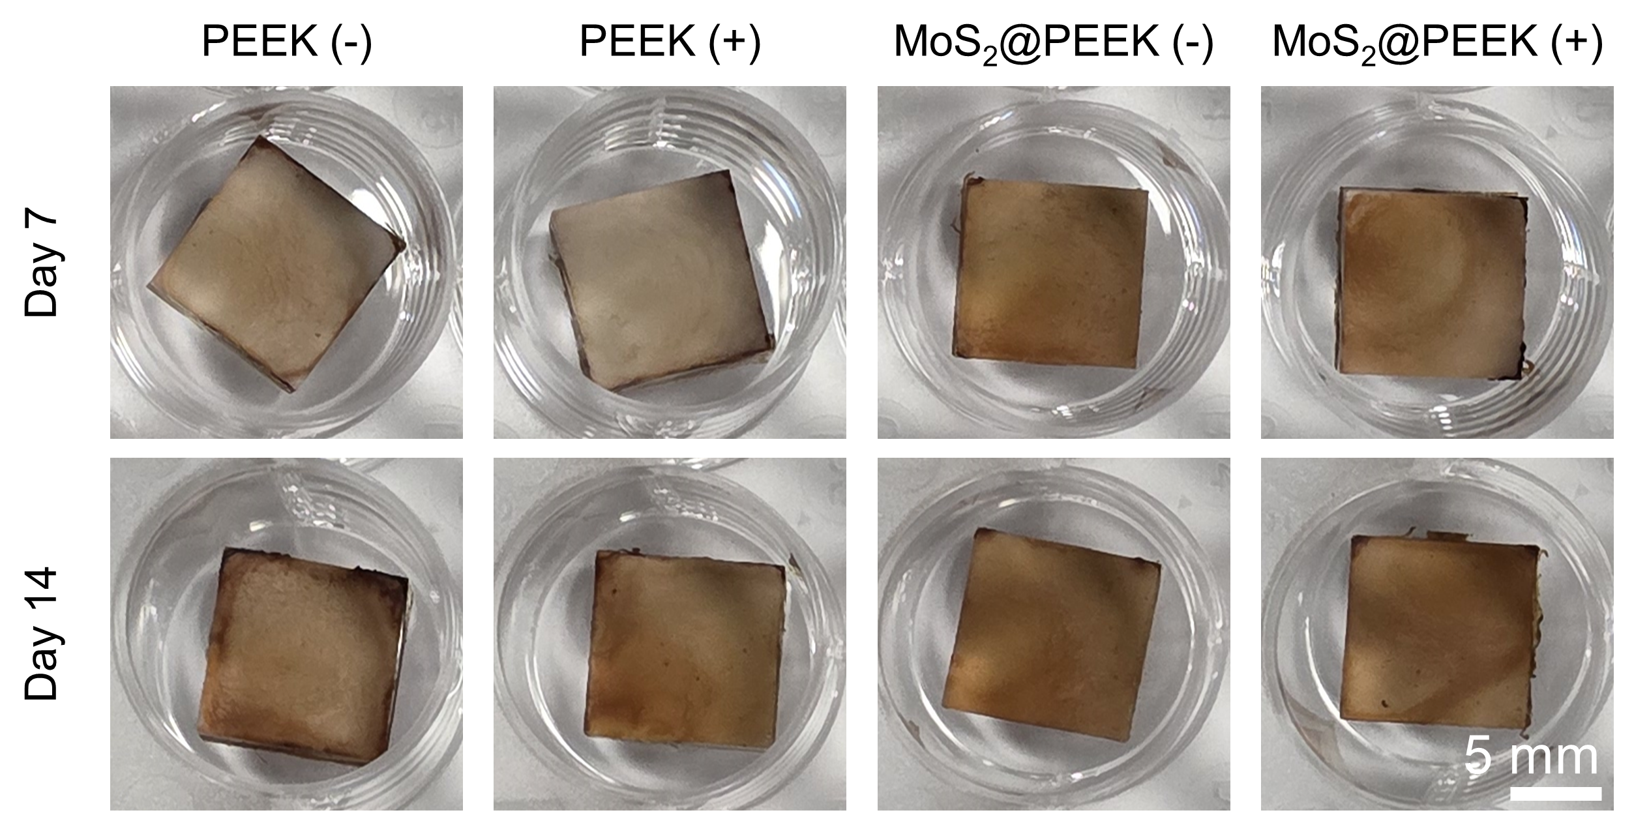
Fig. S20. Representative optical images of ARS staining of PEEK and MoS₂@PEEK scaffolds under NIR-induced hyperthermia after 7 and 14 days of culture.

