Additional information:

Amplification-Free Colorimetric Detection of Exosomal miRNA Using a CRISPR/Cas13a-Activated HRP/Au/MoS₂ Nanobiohybrid Catalyst

Myeong-Jun Lee^{1,‡}, Minkyu Shin ^{2,‡}, Joungpyo Lim¹, Ha Rim Ahn³, Dain Jung¹,
Shan Liu⁴, Chenzhong Li⁵, Jin-Ha Choi^{6,*}, and Jeong-Woo Choi^{1,*}

¹Department of Chemical & Biomolecular Engineering, Sogang University, 35, Baekbeom-ro, Mapo-gu, Seoul, 04107, Republic of Korea
²Department of Chemical Engineering, Research Center of Chemical Technology, Hankyong National University, Gyeonggi–do, 17579, Republic of Korea
³Department of Surgery, Jeonbuk National University Medical School, Jeonju-si 54907, Republic of Korea
⁴Sichuan Provincial Key Laboratory for Human Disease Gene Study, Department of Medical Genetics, Sichuan Academy of Medical Sciences & Sichuan Provincial, People’s Hospital, University of Electronic Science and Technology of China, Chengdu, 610072, China
⁵Biomedical Engineering, School of Medicine, The Chinese University of Hong Kong, Shenzhen, 518172, China
⁶School of Chemical Engineering, Jeonbuk National University, 567, Baekje-daero, Deokjin-gu, Jeonju-si, Jeollabuk-do, 54896, Republic of Korea

‡These authors contributed equally to this work
*Corresponding authors: Jeong-Woo Choi (jwchoi@sogang.ac.kr) and Jin-Ha Choi (jhchoi@jbnu.ac.kr)

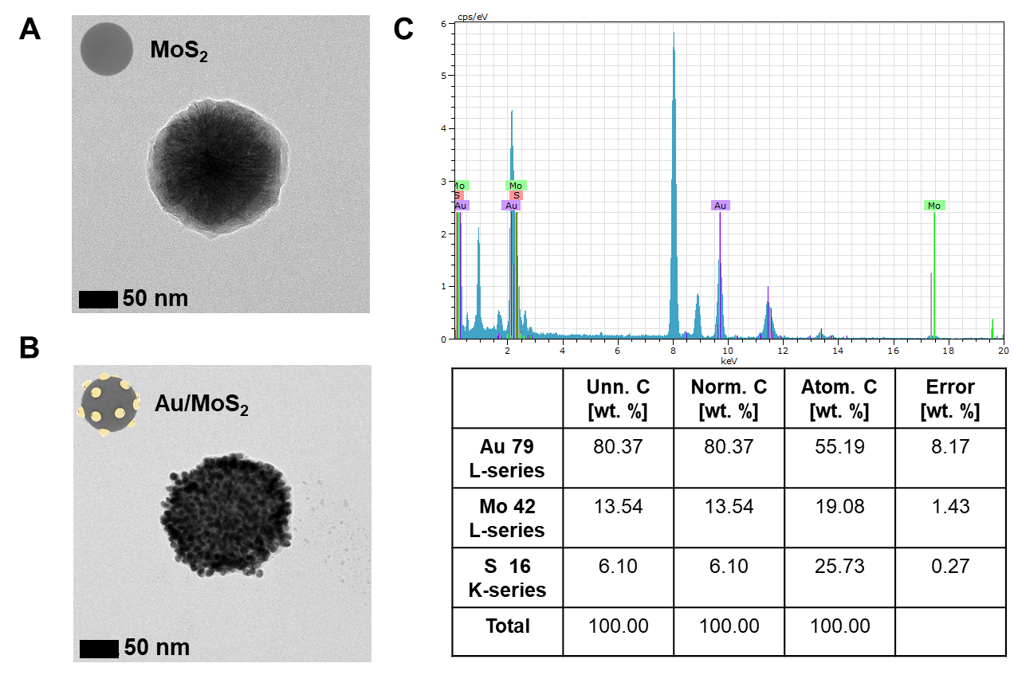
Fig. S1. TEM images of (A) MoS₂ NP, (B) Au/MoS₂ NP, and (C) EDS analysis of Au/MoS₂ NP.

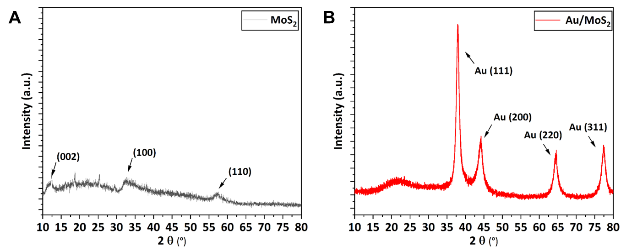
Fig. S2. XRD analysis of (A) MoS₂ NP and (B) Au/MoS₂ NP.

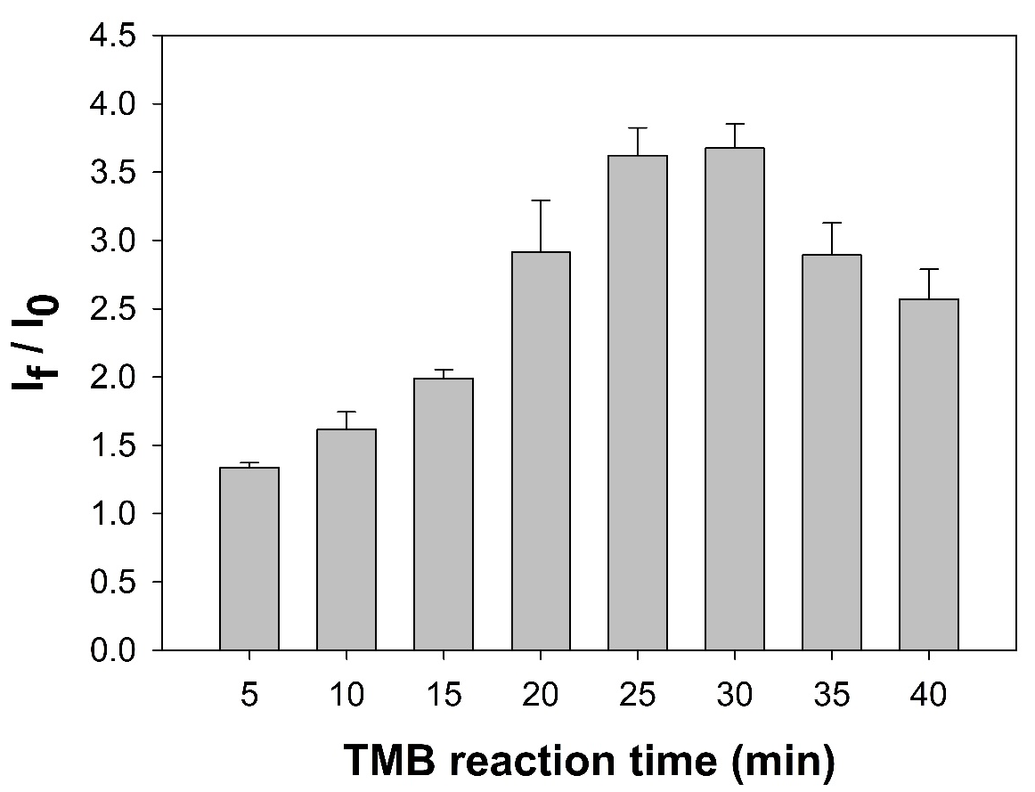
Fig. S3. Optimization of TMB reaction time for the MNB-ssRNA-HRP/Au/MoS₂ system integrated with CRISPR/Cas13a. Prolonged reaction beyond 30 min resulted in an increase in the background signal (I₀), leading to a decrease in the signal-to-background ratio (I_{f}/I₀). Experiments were performed at a miR-155 concentration of 10 pM (n = 3).

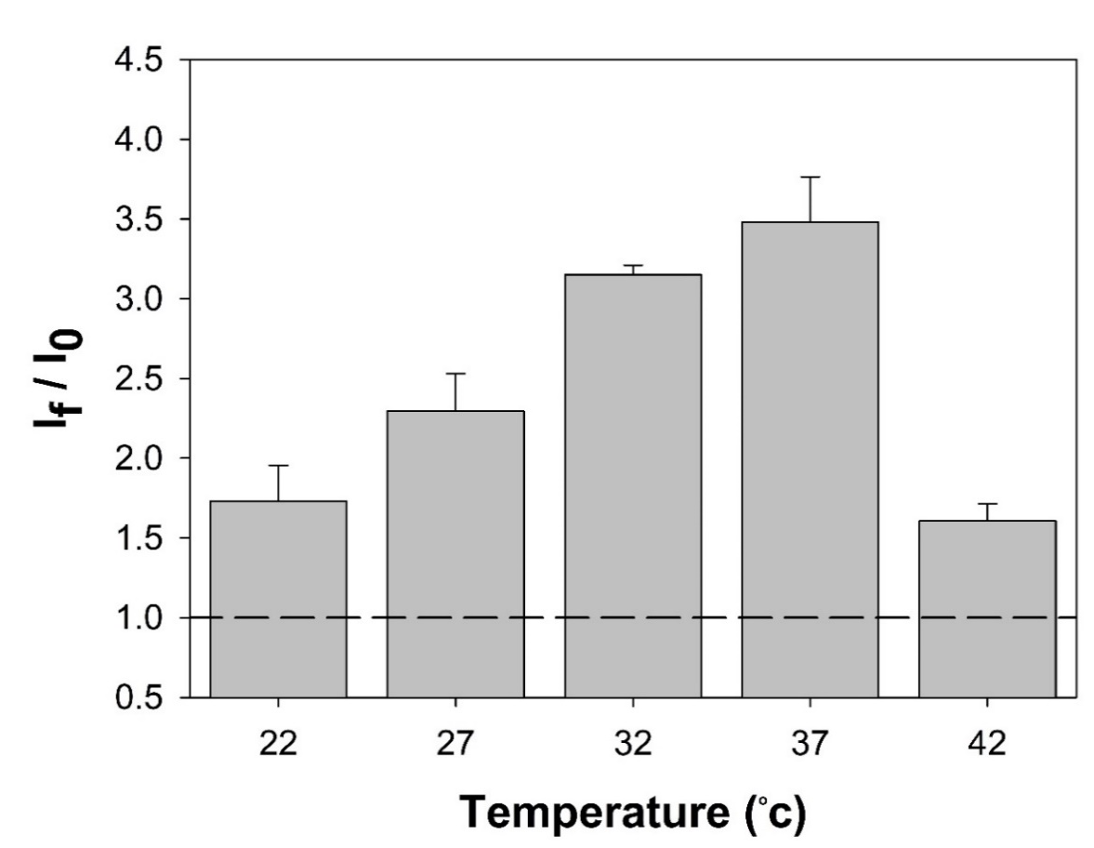
Fig. S4. Optimization of CRISPR/Cas13a trans-cleavage activity in the MNB-ssRNA-HRP/Au/MoS₂ system. Colorimetric responses were measured under different temperature conditions to evaluate the effect on Cas13a trans-cleavage activity. Experiments were performed at a miR-155 concentration of 10 pM (n = 3).
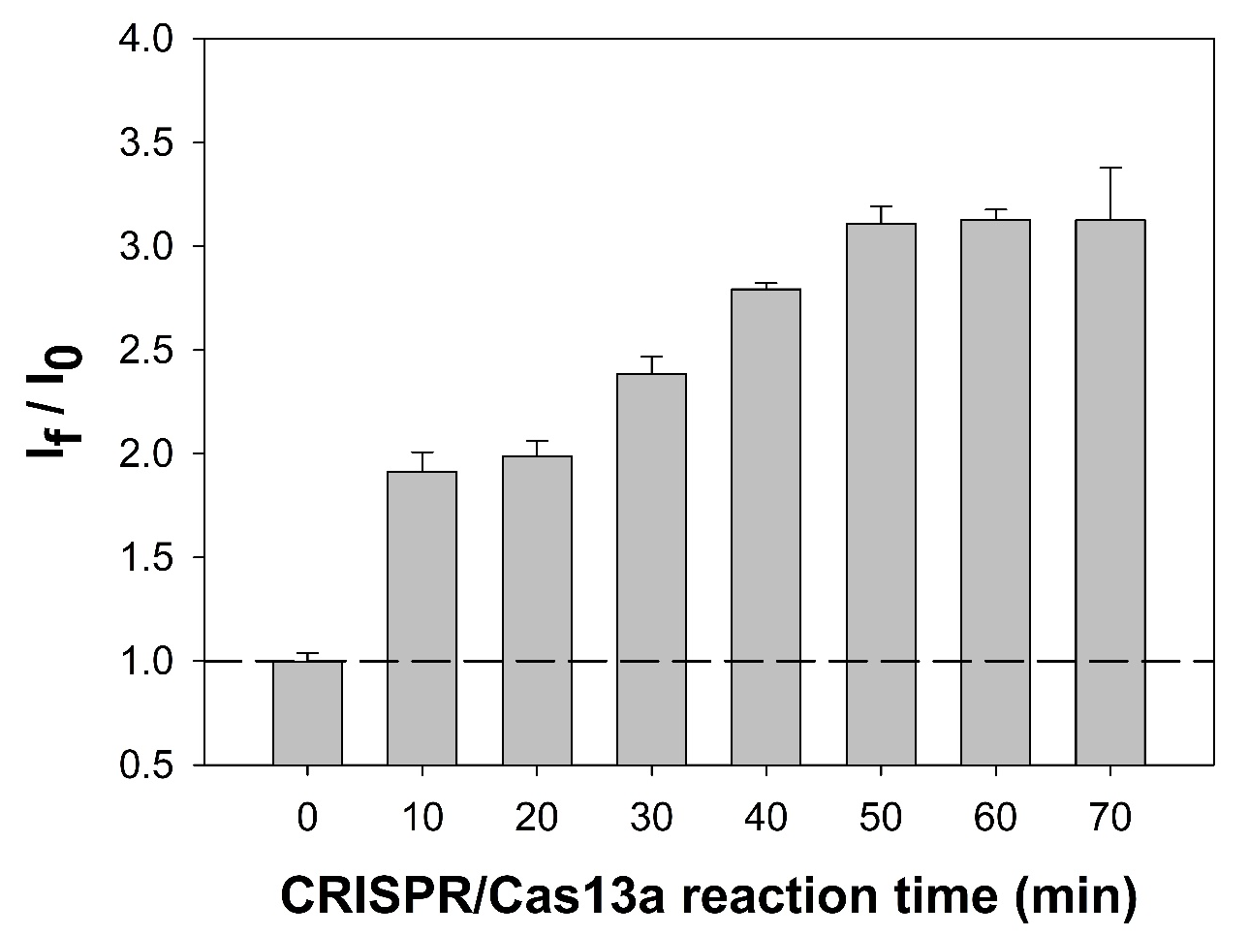
Fig. S5. Optimization of CRISPR/Cas13a trans-cleavage activity in the MNB-ssRNA-HRP/Au/MoS₂ system. Colorimetric responses were measured at different reaction times to evaluate their effect on Cas13a trans-cleavage activity. Experiments were performed at a miR-155 concentration of 1 pM (n = 3).

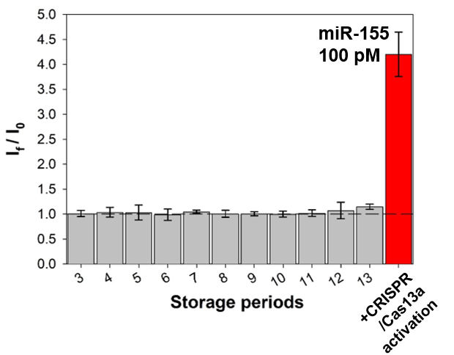
Fig. S6. Storage stability of the assembled MNB–ssRNA–HRP/Au/MoS₂ sensing complex at 4 °C. The colorimetric signal in the supernatant was monitored during storage for up to 13 days after magnetic separation. Only background-level signals were observed throughout the storage period, indicating negligible spontaneous release of HRP/Au/MoS₂. After 13 days, the stored complex was challenged with 100 pM miR-155 in the CRISPR/Cas13a assay, resulting in a strong colorimetric response and confirming retention of target-responsive sensing activity. (Base line = I_{f}/I₀ on Day 0)
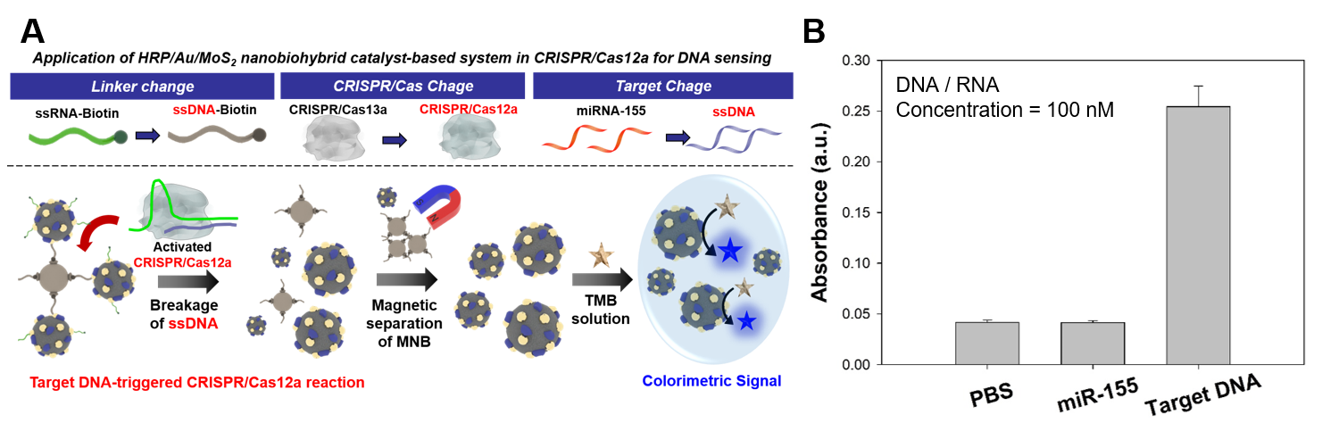
Fig. S7. Proof-of-concept extension of the HRP/Au/MoS₂-based colorimetric sensing platform to DNA detection using CRISPR/Cas12a. (A) Schematic illustration of the Cas12a-based sensing system, in which target DNA activates CRISPR/Cas12a and induces collateral cleavage of the ssDNA linker, resulting in the release of HRP/Au/MoS₂ for colorimetric signal generation. (B) Colorimetric responses obtained with PBS, non-target miR-155, and target DNA at a nucleic acid concentration of 100 nM. Data are presented as the mean ± SD from three independent experiments (n = 3).

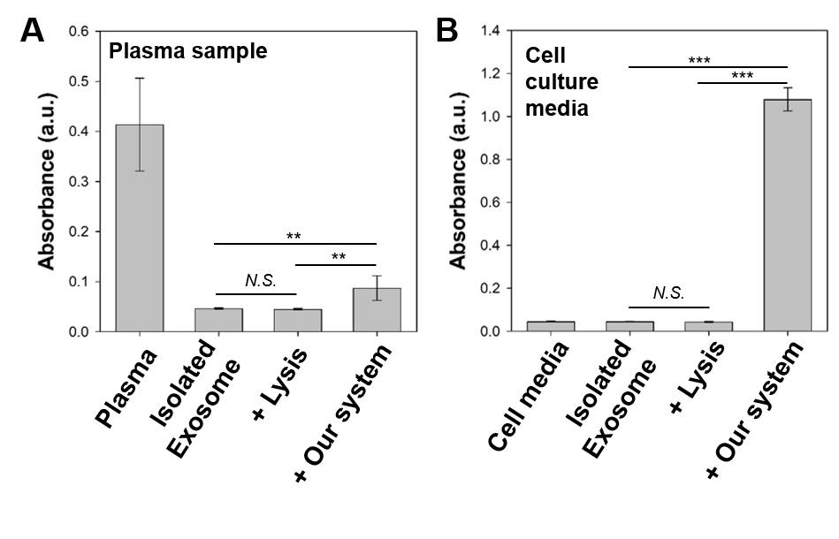
Fig. S8. Evaluation of matrix-derived peroxidase-like background and confirmation of CRISPR/Cas13a-dependent colorimetric signal generation in biological samples. (A) TMB/H₂O₂ colorimetric responses obtained from plasma, isolated exosomes, lysed exosomes, and lysed exosomes analyzed using the complete CRISPR/Cas13a-based sensing platform. Plasma exhibited intrinsic peroxidase-like activity, whereas this background signal was markedly reduced after exosome isolation and remained negligible after exosome lysis. A significant colorimetric response was observed only when the lysed exosome sample was analyzed using the complete sensing platform. (B) Corresponding analysis using cell culture medium, which showed negligible intrinsic peroxidase-like activity before and after exosome isolation and lysis, while a significant signal was generated after analysis with the complete CRISPR/Cas13a-based sensing platform. Data are presented as the mean ± standard deviation (SD) from three independent experiments (n = 3). Statistical significance was determined using one-way ANOVA followed by Tukey’s multiple-comparison test (**P < 0.01, ***P < 0.001; N.S., not significant).

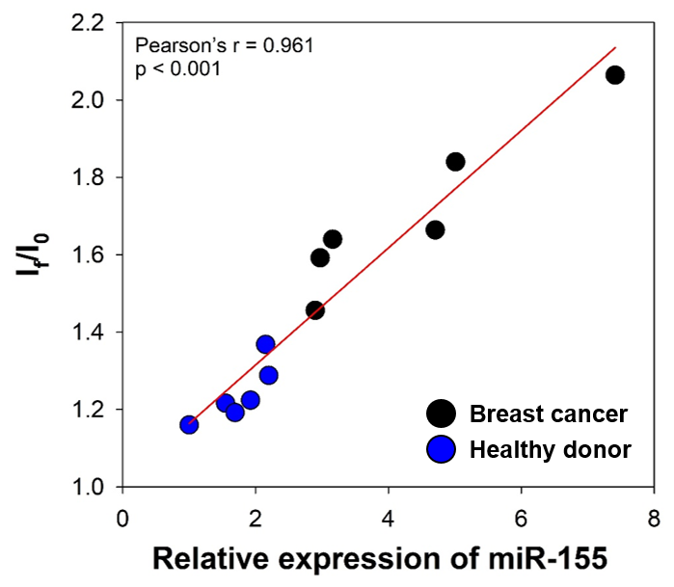
Fig. S9. Correlation between RT-qPCR measurements and colorimetric signals for Exo-miR-155 detection in clinical samples (n = 12). Pearson correlation analysis showed a strong positive correlation between the two methods (r = 0.961, p < 0.001).

Table S1. Nucleic acid sequences used in this study
Name | Sequence (5’ to 3’)
CRISPR/Cas13a system
crRNA | GAUUUAGACUACCCCAAAAACGAAGGGGACUAAAACAACCCC  UAUCACGAUUAGCAUUAA
Target miRNA (miR-155) | UUAAUGCUAAUCGUGAUAGGGGUU
Mis-match | UUAAUGCUAAUCCUGAUAGGGGUU
ssRNA | [Thiol]-AAUGGCAAAUGGCA-[Biotin]
RT-qPCR primers
RT-primer | GCGAGCACAGAATTAATACGACTCACTATAGGTTTTTTTTTTTTT
Forward | CGTTAATGCTAATCGTGATAGGGGT
Reverse | GCGAGCACAGAATTAATACGAC

Table S2. Kinetic parameters of HRP/Au/MoS₂ and HRP. K_{m} is the Michaelis constant, V_{max} is the maximal reaction velocity.
Catalyst | K_{m} (mM) |  | V_{max} (10⁻⁸ M s⁻¹) |  | Reference
Catalyst | TMB | H₂O₂ | TMB | H₂O₂ | Reference
HRP | 0.619 | 2.91 | 0.915 | 0.190 | (Guo et al., 2018)
HRP/Au/MoS₂ | 0.880 | 4.81 | 13.5 | 20.3 | This work

Table S3. Intra-assay and inter-assay precision of the CRISPR/Cas13a-based colorimetric sensing platform at representative miR-155 concentrations.
 |  | Intra-assay |  |  |  |  | Inter-assay
Spike sample |  | Conc. | Mean | SD | CV (%) |  | Conc. | Mean | SD | CV (%)
100  fM | 1 | 81.37 | 91.91 fM | 12.42 | 13.51 | Batch1 | 89.63 | 110.68 | 24.06 | 21.74
100  fM | 2 | 105.6 | 91.91 fM | 12.42 | 13.51 | Batch2 | 136.9 | 110.68 | 24.06 | 21.74
100  fM | 3 | 88.75 | 91.91 fM | 12.42 | 13.51 | Batch3 | 105.5 | 110.68 | 24.06 | 21.74
10  pM | 1 | 14.78 | 12.92 pM | 2.236 | 17.31 | Batch1 | 13.24 | 10.58 | 2.593 | 24.5
10  pM | 2 | 13.55 | 12.92 pM | 2.236 | 17.31 | Batch2 | 8.06 | 10.58 | 2.593 | 24.5
10  pM | 3 | 10.44 | 12.92 pM | 2.236 | 17.31 | Batch3 | 10.45 | 10.58 | 2.593 | 24.5

Table S4. Nucleic acid sequences used for the proof-of-concept CRISPR/Cas12a-based DNA detection assay. The BRCA1-derived ssDNA sequence was used as the model target, and the ssDNA linker was modified with a thiol group at the 5′ end and biotin at the 3′ end for nanoparticle conjugation and magnetic-bead assembly.
Name | Sequence (5’ to 3’)
CRISPR/Cas12a system
crRNA | UAA UUU CUA CUC UUG UAG AUG AUU UUC UUC CUU UUG UUC A
Target ssDNA (BRCA1) | TTA TGA ACA AAA GGA AGA AAA TCA
Linker ssDNA | Thiol-AAA AAA AAA ATA GCT TAT CAG AAA AAA AAA-Biotin

Table S5. The pathological information of plasma sample.
Sample | Age | Sex | Cancer | TNM stage | HER-2
P1 | 60 | Female | Breast cancer | T1bN0 | NEG
P2 | 48 | Female | Breast cancer | T1cN0 | NEG
P3 | 53 | Female | Breast cancer | T1cN0 | NEG
P4 | 77 | Female | Breast cancer | T1cN0 | NEG
P5 | 52 | Female | Breast cancer | T2N1a | NEG
P6 | 51 | Female | Breast cancer | T2N2a | NEG
N1 | 37 | Female | Healthy donor
N2 | 58 | Female | Healthy donor
N3 | 49 | Female | Healthy donor
N4 | 38 | Female | Healthy donor
N5 | 36 | Female | Healthy donor
N6 | 45 | Female | Healthy donor

[Reference]
Guo, J. J.; Wang, Y.; Zhao, M. 3D flower-like ferrous(II) phosphate nanostructures as peroxidase mimetics for sensitive colorimetric detection of hydrogen peroxide and glucose at nanomolar level. Talanta 182, 230-240 (2018). https://doi.org/10.1016/j.talanta.2018.01.080

