Supplementary Information
Tube-in-Tube Hollow RuCrMn Oxide Nanofibers for Noble-Metal-Efficient Oxygen Evolution via Cr/Mn-Regulated Ru Active Sites
Subin Lee,^{1,+} Joohee Lee,^{1,2,+} Saleem Sidra,^{3,+} Sieon Jung,^{4,+} Myong Yong Choi,^{4,*} Do Hwan Kim,^{3,}* Myung Hwa Kim,^{1,2,}* Youngmi Lee^{1,}*
¹Department of Chemistry & Nanoscience, Ewha Womans University, Seoul 03760, Republic of Korea
²Institute for Multiscale Matter and Systems (IMMS), Ewha Womans University, Seoul 03760, Republic of Korea.
³Division of Science Education and Institute of Fusion Science, Graduate School of the Department of Energy Storage/Conversion Engineering (BK21 FOUR), Jeonbuk National University, Jeonju, Jeonbuk 54896, Republic of Korea.
⁴Core-Facility Center for Photochemistry & Nanomaterials, Department of Chemistry (BK21 FOUR), Research Institute of Advanced Chemistry, Gyeongsang National University, Jinju 52828, Republic of Korea.

⁺Authors contributed equally to this work.
*Correspondence: dhk201@jbnu.ac.kr (D.H.K); myungkim@ewha.ac.kr (M.H.K.); mychoi@gnu.ac.kr (M.Y.C); youngmilee@ewha.ac.kr (Y.L)

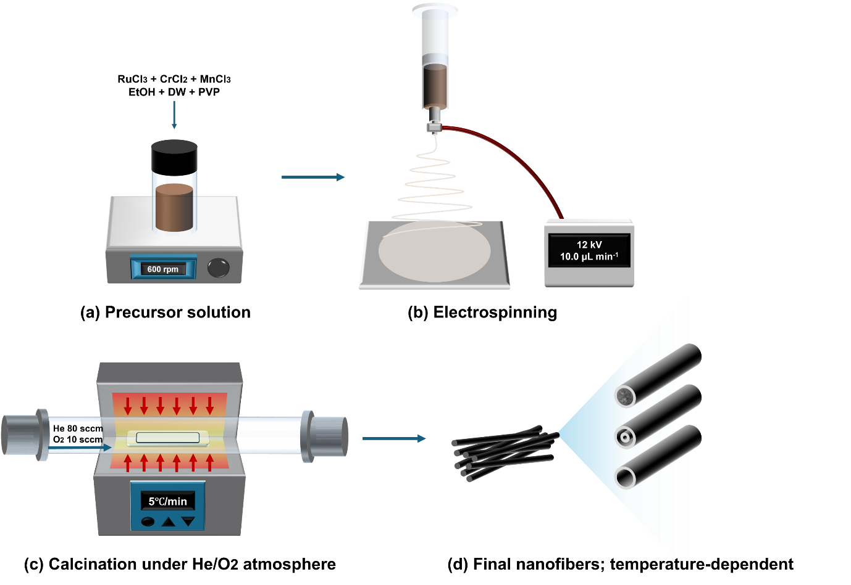
Fig. S1. The schematic representation of the formation of the temperature regulated (RuCrMn)O₂ nanofibers.

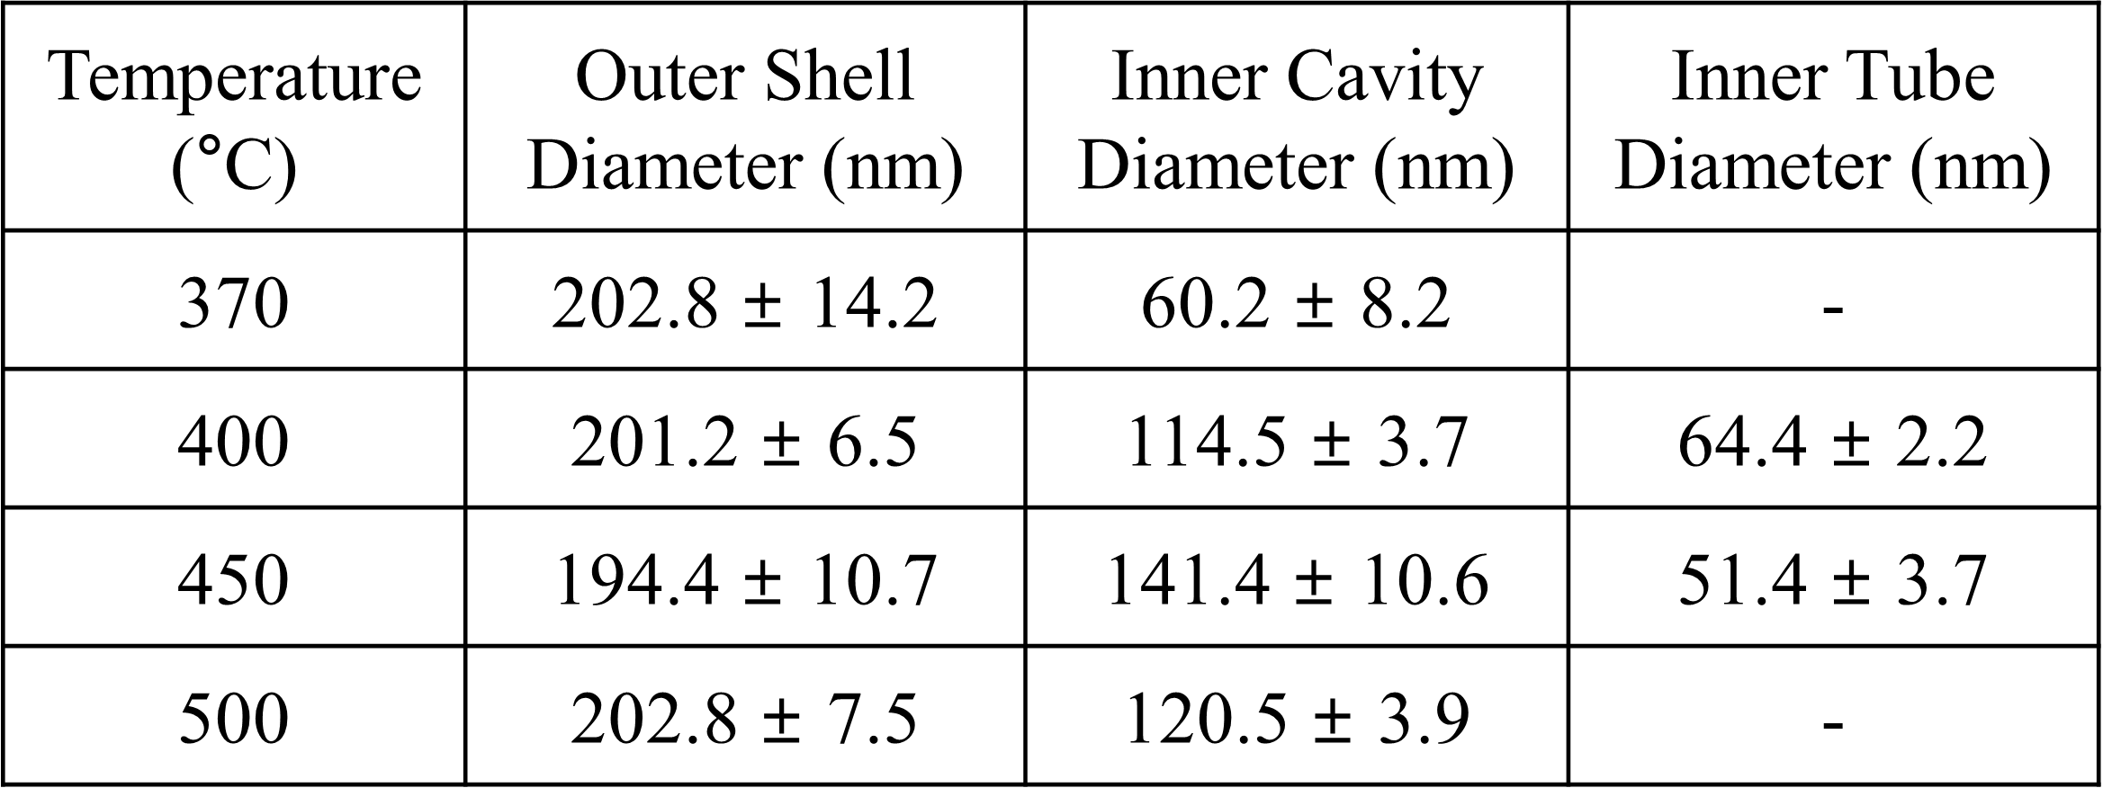
Table S1. The inner and outer diameters of the nanofibers calcined at various temperatures measured from the FE-SEM images.

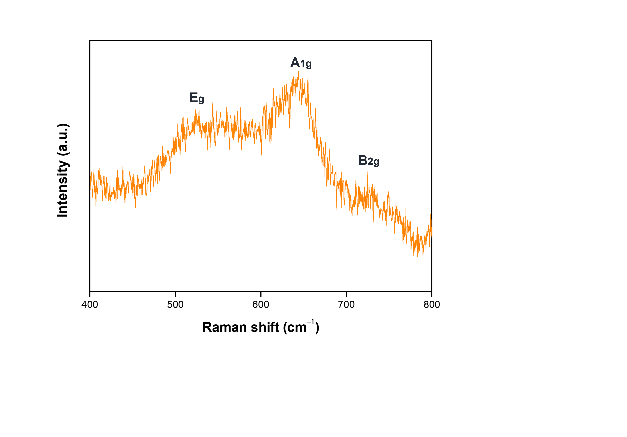
Fig. S2. Raman spectrum of (RuCrMn)O₂ nanofibers calcined at 400 ℃.

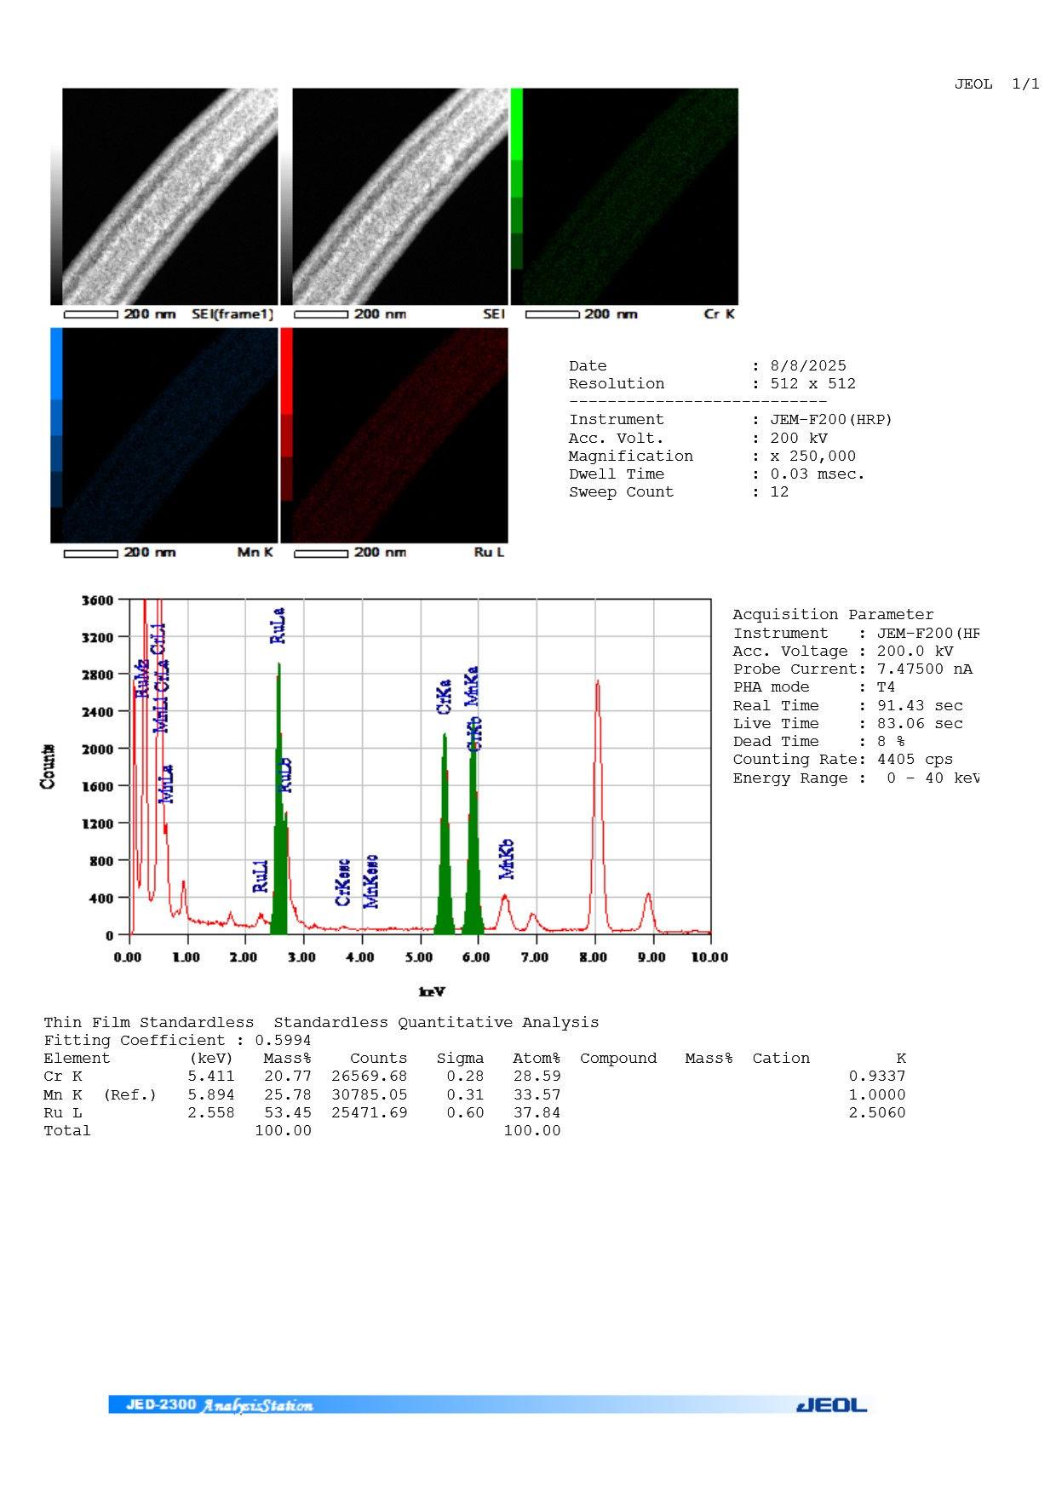
Fig. S3. EDS spectrum of TEM-EDS mapping of the (RuCrMn)O₂ nanofibers calcined at 400 °C.

Table S2. Quantitative analysis results of SEM-EDS mapping (n = 20) of the (RuCrMn)O₂ nanofibers calcined at 400 °C.

Element | Wt% | Wt% Sigma | Atomic% | Atomic% Sigma
Cr | 24.177 | 0.2905 | 31.5145 | 0.9763
Mn | 31.316 | 0.3365 | 38.6185 | 1.7746
Ru | 44.507 | 0.3690 | 29.8690 | 1.7490
Total | 100.00 |  | 100.00

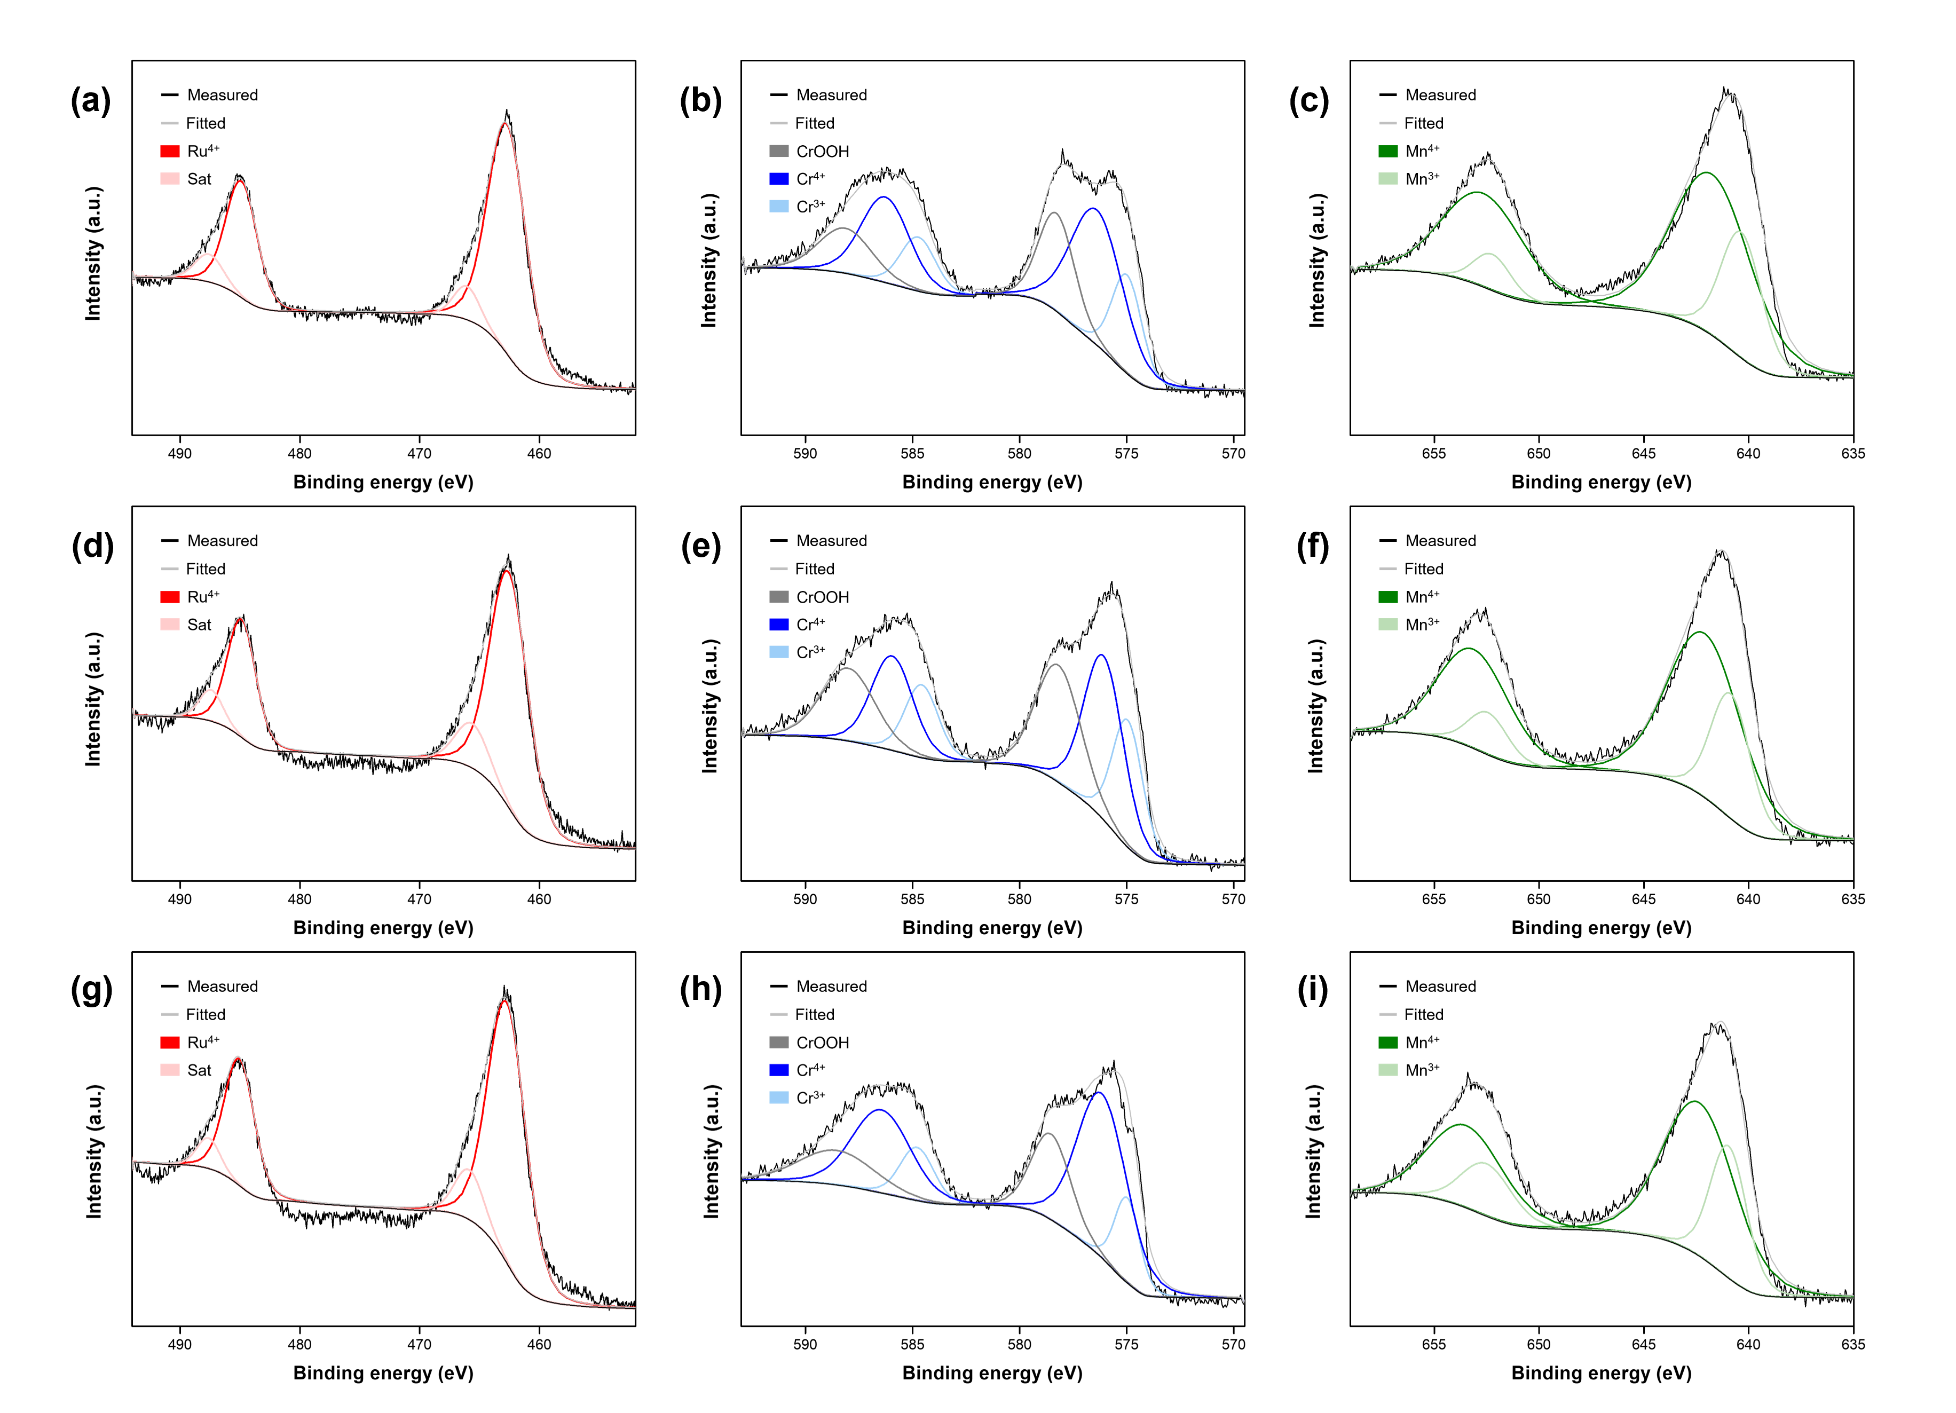
Fig. S3. High resolution XPS spectra of (RuCrMn)O₂-T for Ru 3p, Cr 2p, and Mn 2p regions. (a)~(c): 370 °C, (d)~(f): 450 °C, and (g)~(i): 500 °C, respectively.

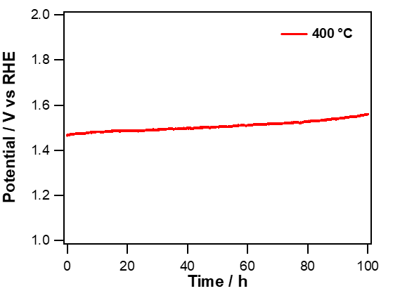
Fig. S4. Stability of (RuCrMn)O₂-400 loaded on a carbon paper at a constant current density of 10 mA cm⁻² in 1 M KOH aqueous solution.

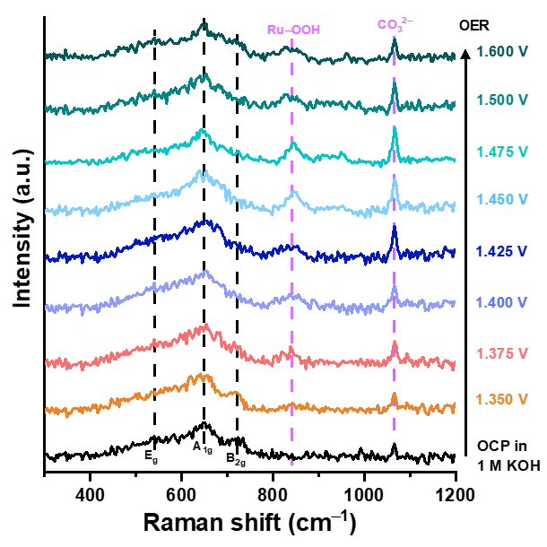
Fig. S5. Operando Raman spectra recorded during OER in 1.0 M KOH at different potential range from 1.35 V to 1.60 V vs. RHE.

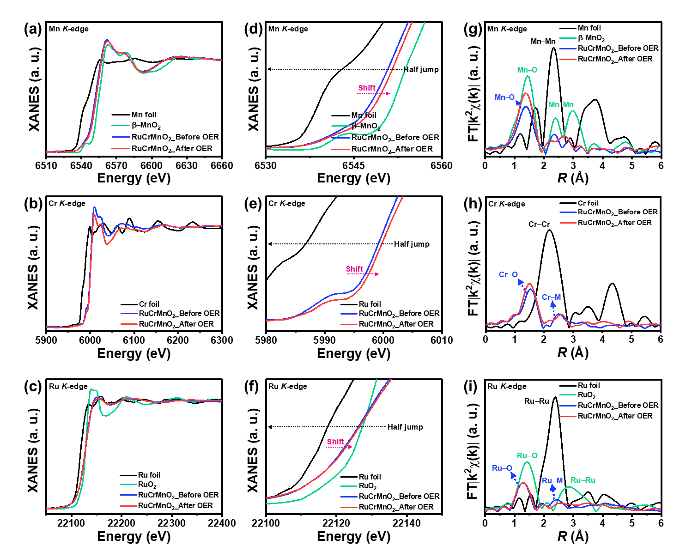
Fig. S6. (a-f) Mn, Cr, and Ru K-edge XANES spectra of (RuCrMn)O₂-400 before and after OER samples were compared with those of appropriate reference materials: Mn foil and β-MnO₂ for the Mn K-edge, Cr foil for the Cr K-edge, and Ru foil and RuO₂ for the Ru K-edge, and corresponding half-edge energy profiles, and (g) k²-weighted EXAFS oscillation functions (χ(k)) at the Mn, Cr, and Ru K-edge and the corresponding FT-EXAFS spectra in radial distance (R-space) for Mn, Cr, and Ru in (RuCrMn)O₂-400 before and after OER samples.

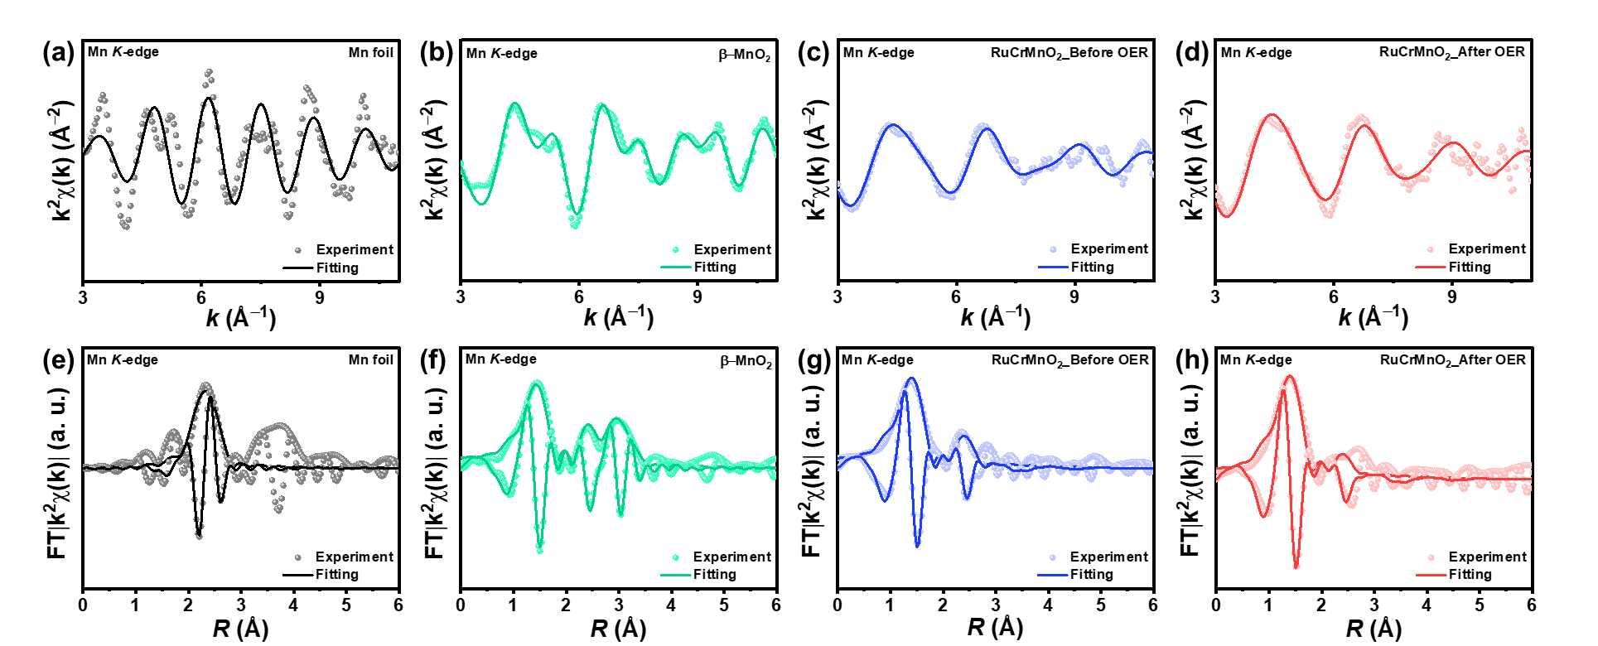
Fig. S7. (a-d) Mn K-edge EXAFS χ(k) spectra in k-space with k² weighting, and (e-h) Fourier-transformed Mn K-edge EXAFS spectra in R-space obtained from k²-weighted χ(k). Solid dots denote the experimental data, and solid lines represent the fitted curves obtained from structural modeling.

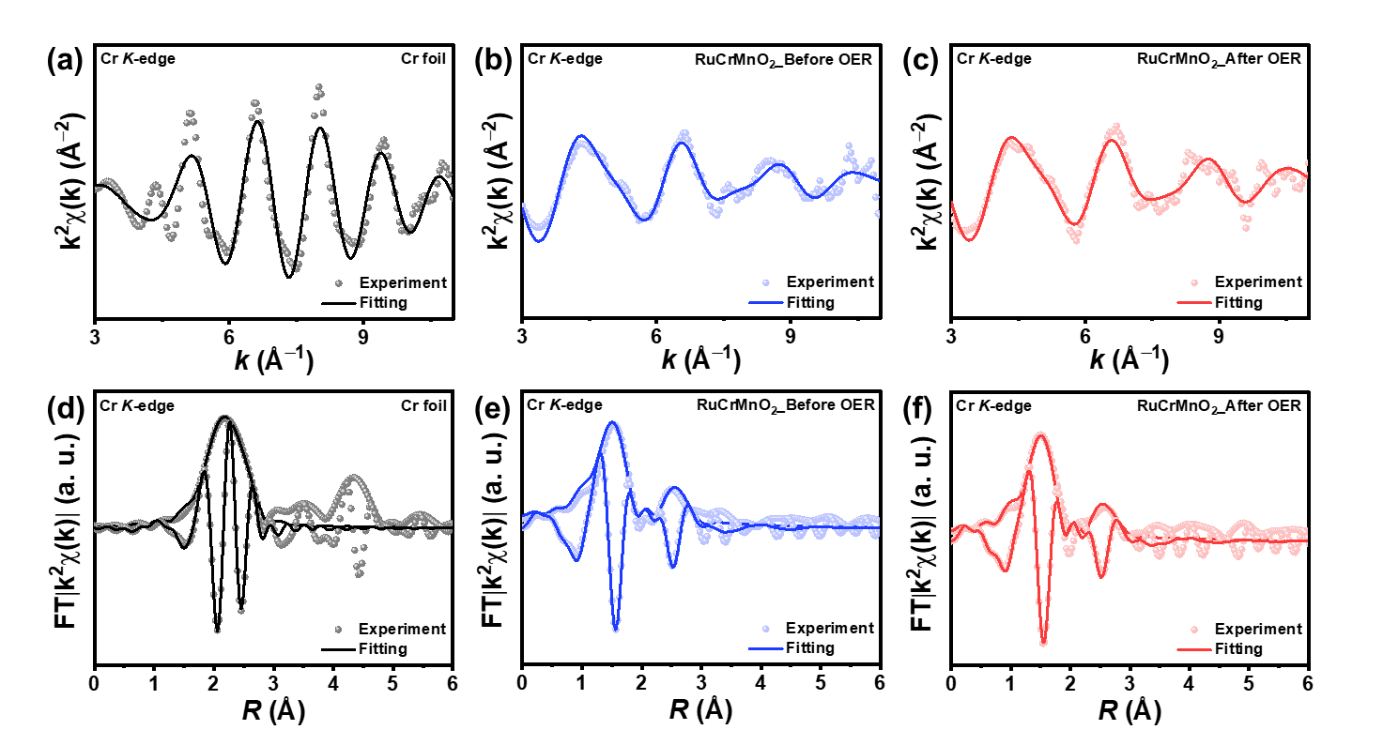
Fig. S8. (a-c) Cr K-edge EXAFS χ(k) spectra in k-space with k² weighting, and (d-f) Fourier-transformed Cr K-edge EXAFS spectra in R-space obtained from k²-weighted χ(k). Solid dots denote the experimental data, and solid lines represent the fitted curves obtained from structural modeling.

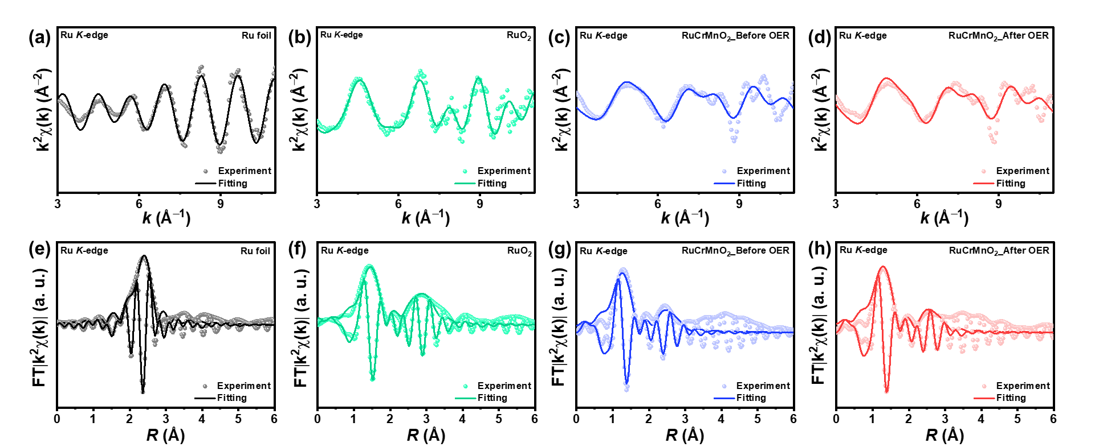
Fig. S9. (a-d) Ru K-edge EXAFS χ(k) spectra in k-space with k² weighting, and (e-h) Fourier-transformed Ru K-edge EXAFS spectra in R-space obtained from k²-weighted χ(k). Solid dots denote the experimental data, and solid lines represent the fitted curves obtained from structural modeling.

Table S3. EXAFS fitting parameters of (RuCrMn)O₂-400 before and after OER at the Mn K-edges with reference samples.
Catalysts | Bonding | CN | R | σ² | E₀ | R-factor
Mn foil | Mn−Mn | 12* | 2.676 | 0.006 | 7.086 | 0.027
β−MnO₂ | Mn−O | 6* | 1.869 | 0.002 | −1.310 | 0.029
β−MnO₂ | Mn−Mn₁ | 2* | 2.862 | 0.003 | −1.310 | 0.029
β−MnO₂ | Mn−Mn₂ | 8* | 3.421 | 0.004 | −1.310 | 0.029
(RuCrMn)O₂  before OER | Mn−O | 4.859 | 1.869 | 0.004 | −4.837 | 0.039
(RuCrMn)O₂  before OER | Mn−M | 1.543 | 2.845 | 0.006 | −4.837 | 0.039
(RuCrMn)O₂  after OER | Mn−O | 6.325 | 1.868 | 0.004 | −5.515 | 0.038
(RuCrMn)O₂  after OER | Mn−M | 1.433 | 2.854 | 0.009 | −5.515 | 0.038
-
S₀² = 0.54(fixed), Hanning window, k-weight = 2, and k-range = 3–11 Å⁻¹. * denotes a fixed parameter.

Table S4. EXAFS fitting parameters of (RuCrMn)O₂-400 before and after OER at the Cr K-edges with reference samples.
Catalysts | Bonding | CN | R | σ² | E₀ | R-factor
Cr foil | Cr−Cr₁ | 8* | 2.488 | 0.008 | -8.5210 | 0.007
Cr foil | Cr−Cr₂ | 6* | 2.852 | 0.004 | -8.5210 | 0.007
(RuCrMn)O₂  before OER | Cr−O | 2.720 | 1.926 | 0.002 | 2.564 | 0.016
(RuCrMn)O₂  before OER | Cr−M | 1.929 | 3.004 | 0.010 | 2.564 | 0.016
(RuCrMn)O₂  after OER | Cr−O | 3.073 | 1.949 | 0.002 | 2.250 | 0.049
(RuCrMn)O₂  after OER | Cr−M | 2.085 | 3.006 | 0.011 | 2.250 | 0.049

S₀² = 0.80(fixed), Hanning window, k-weight = 2, and k-range = 3–11 Å⁻¹. * denotes a fixed parameter.

Table S5. EXAFS fitting parameters of (RuCrMn)O₂-400 before and after OER at the Ru K-edges with reference samples.
Catalysts | Bonding | CN | R | σ² | E₀ | R-factor
Ru foil | Ru−Ru | 12* | 2.674 | 0.004 | −1.926 | 0.029
RuO₂ | Ru−O | 6* | 1.969 | 0.002 | −3.529 | 0.039
RuO₂ | Ru−Ru₁ | 2* | 3.174 | 0.004 | −3.529 | 0.039
RuO₂ | Ru−Ru₂ | 6* | 3.531 | 0.002 | −3.529 | 0.039
(RuCrMn)O₂  before OER | Ru−O | 3.226 | 1.809 | 0.002 | −13.76 | 0.049
(RuCrMn)O₂  before OER | Ru−M | 2.490 | 3.002 | 0.004 | −13.76 | 0.049
(RuCrMn)O₂  after OER | Ru−O | 3.549 | 1.808 | 0.002 | −12.92 | 0.049
(RuCrMn)O₂  after OER | Ru−M | 2.345 | 3.018 | 0.005 | −12.92 | 0.049

S₀² = 0.64(fixed), Hanning window, k-weight = 2, and k-range = 3–11 Å⁻¹. * denotes a fixed parameter.

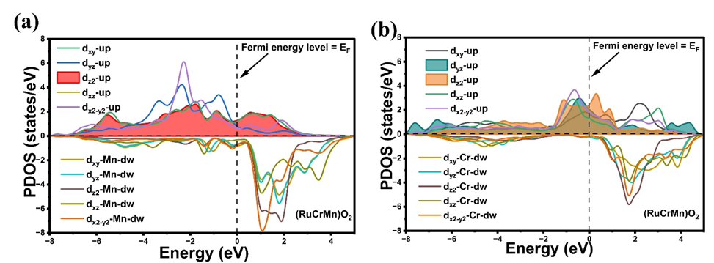
Fig. S10. Spin-resolved projected density of states (PDOS) of (a) Mn-3d, and (b) Cr-3d orbitals in (RuCrMn)O₂, highlighting orbital contributions, spin polarization, and their influence on electronic states near the Fermi level (E_{f}).
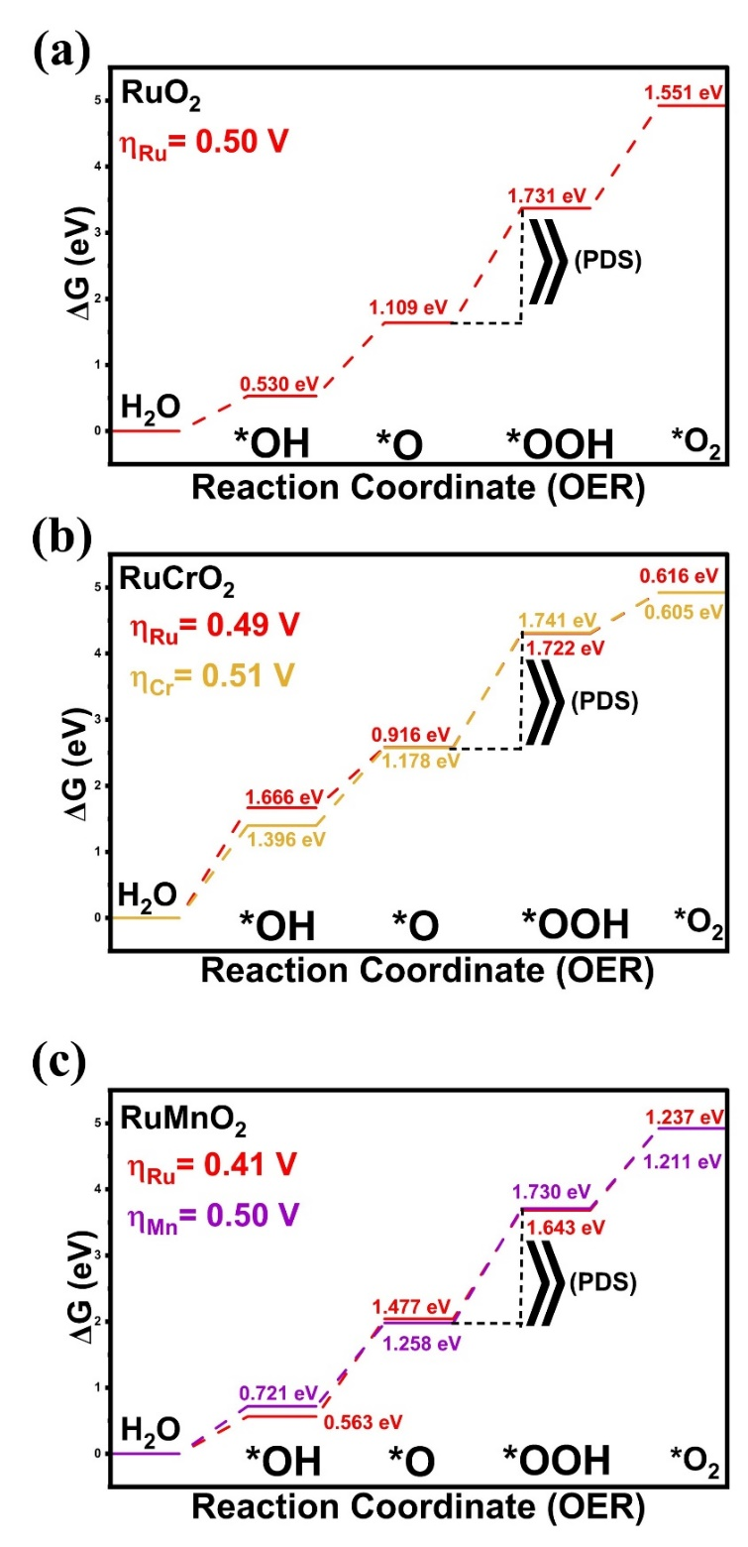
Fig. S11. DFT-derived OER free-energy diagrams and potential-determining steps (PDS) for RuO₂, RuCrO₂, and RuMnO₂ catalysts at different active sites.
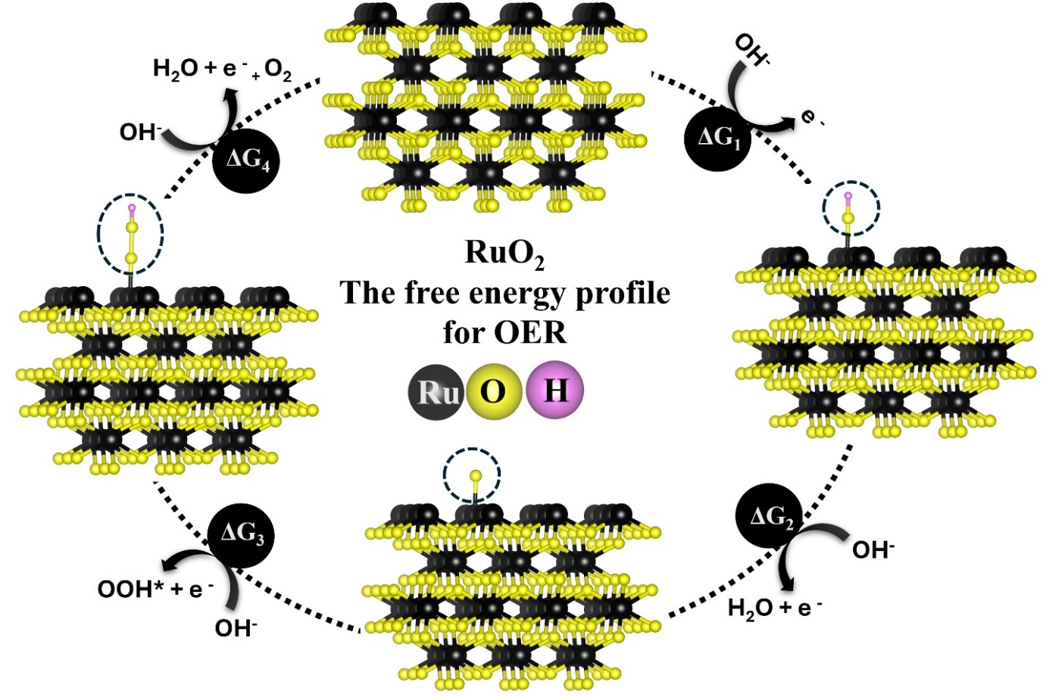
Fig. S12. Schematic illustration of the OER reaction pathway for RuO₂ at the Ru active site.

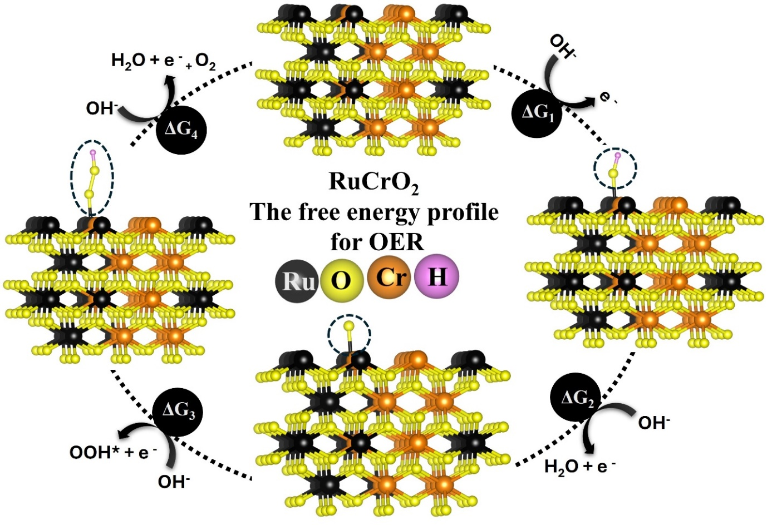
Fig. S13. Schematic illustration of the OER reaction pathway for RuCrO₂ at the Ru active site.

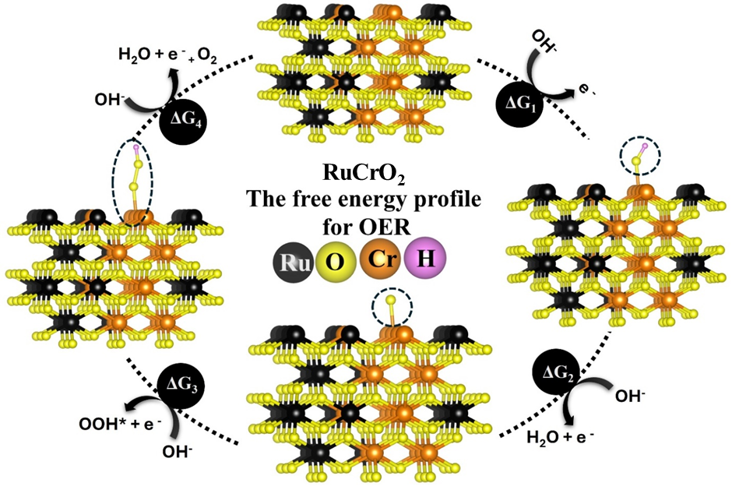
Fig. S14. Schematic illustration of the OER reaction pathway for RuCrO₂ at the Cr active site.

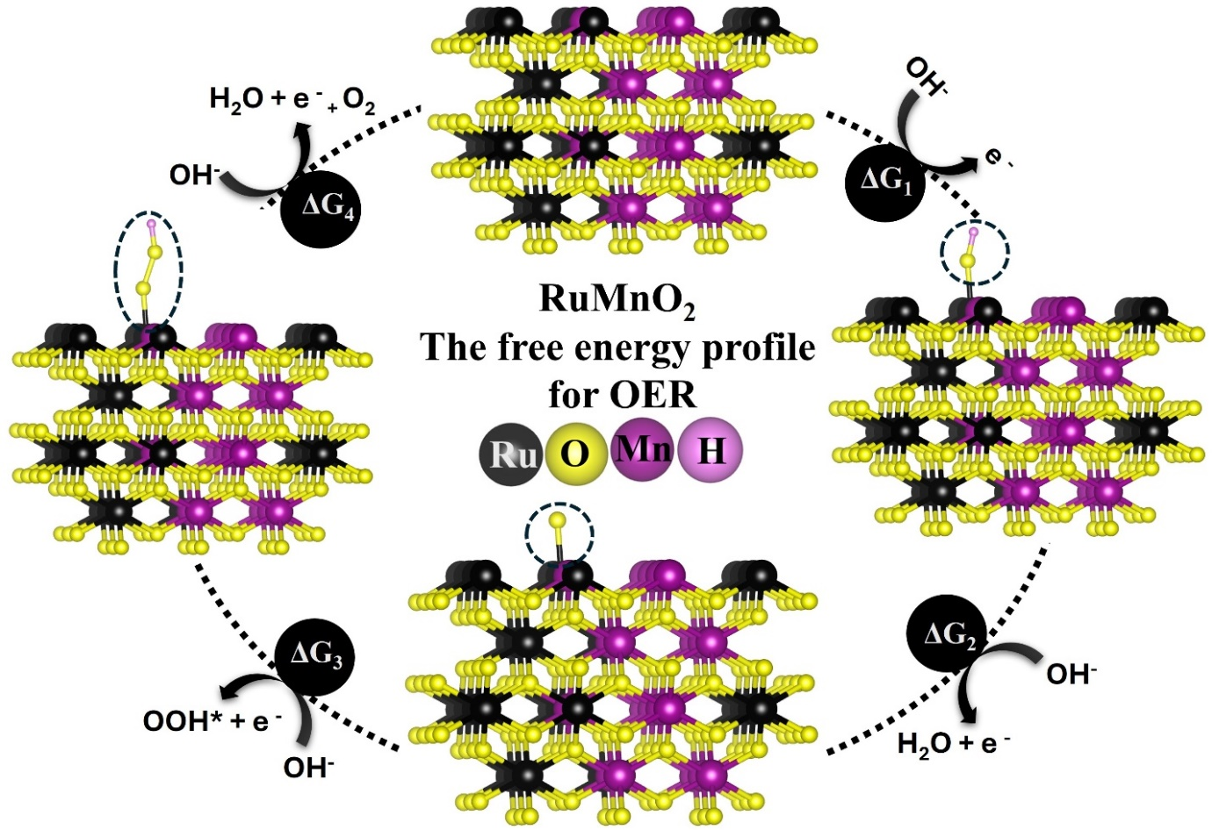
Fig. S15. Schematic illustration of the OER reaction pathway for RuMnO₂ at the Ru active site.

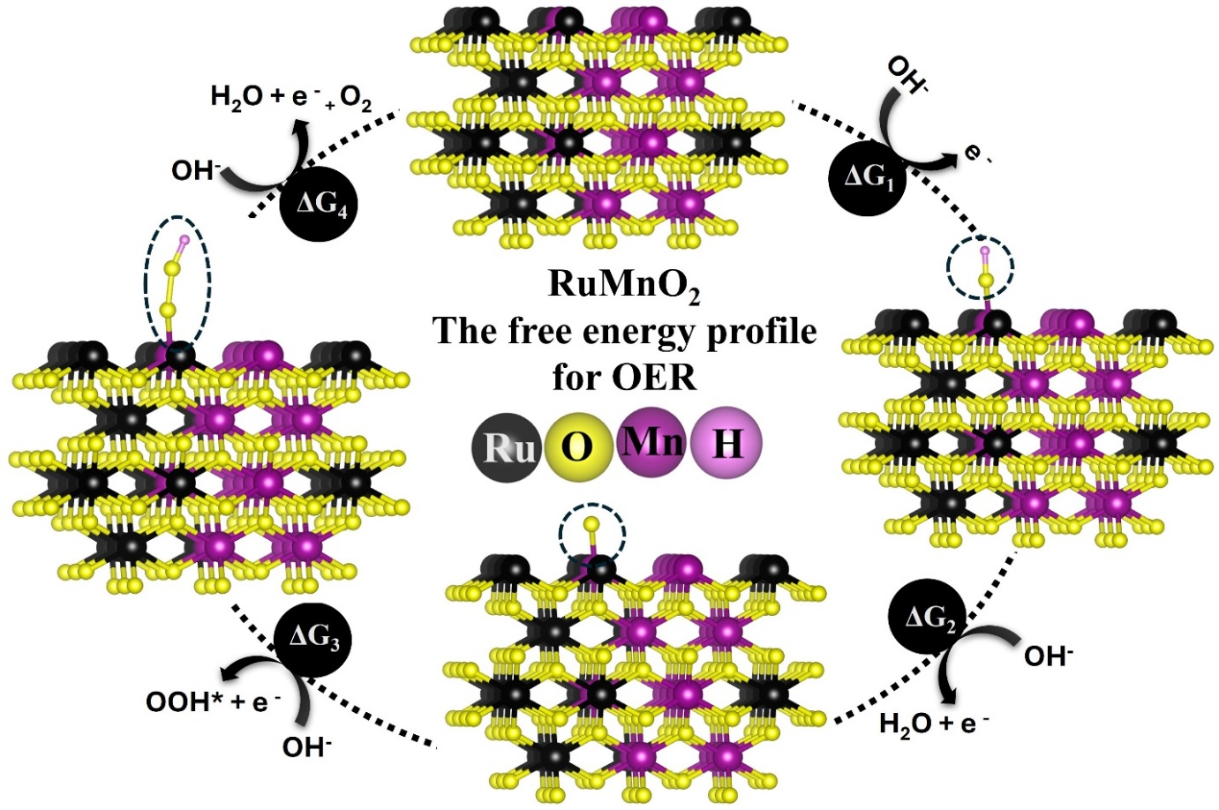
Fig. S16. Schematic illustration of the OER reaction pathway for RuMnO₂ at the Mn active site.

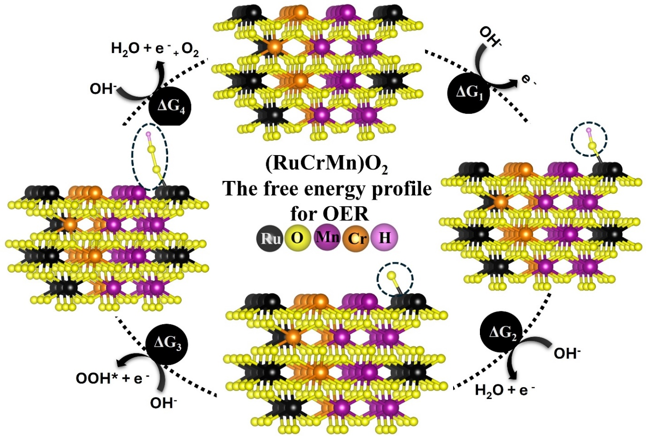
Fig. S17. Schematic illustration of the OER reaction pathway for (RuCrMn)O₂ at the Ru active site.

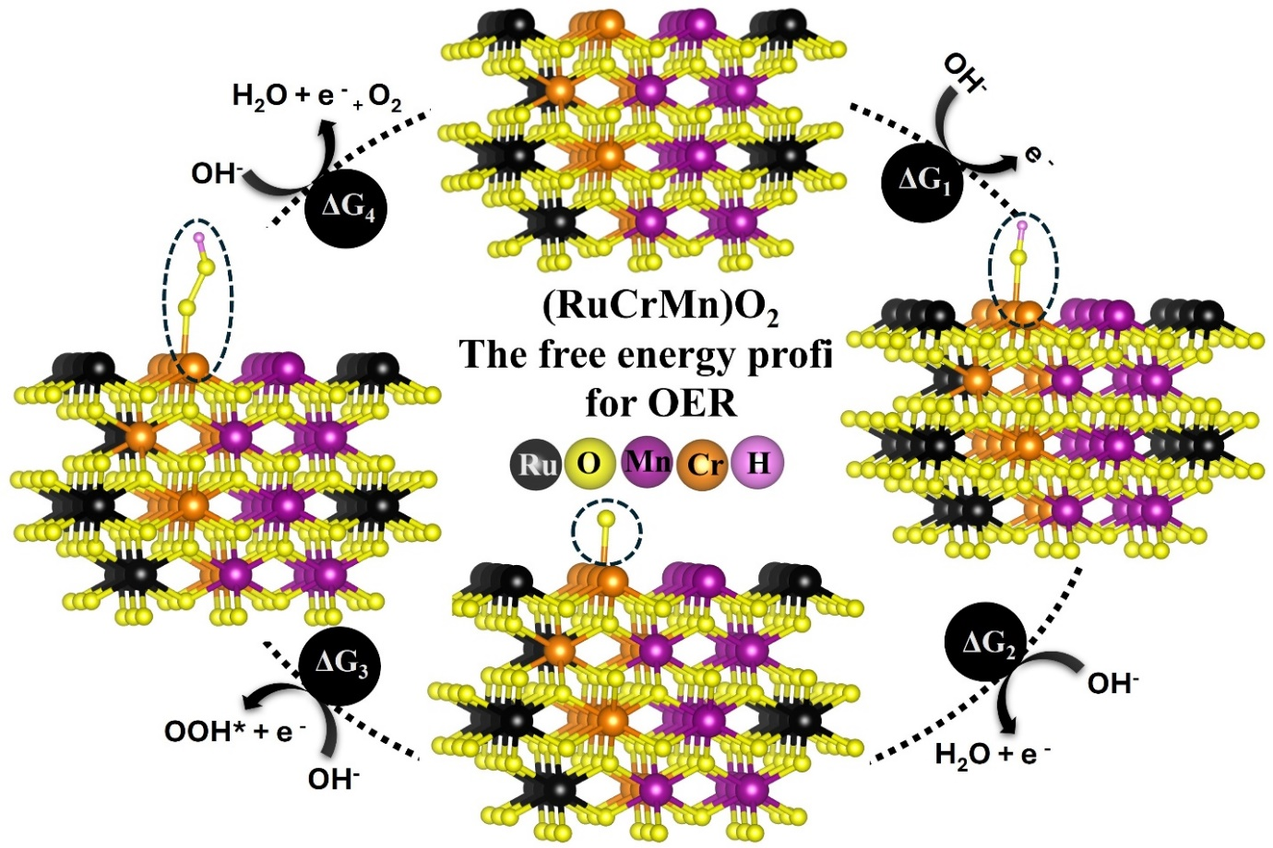
Fig. S18. Schematic illustration of the OER reaction pathway for (RuCrMn)O₂ at the Cr active site.

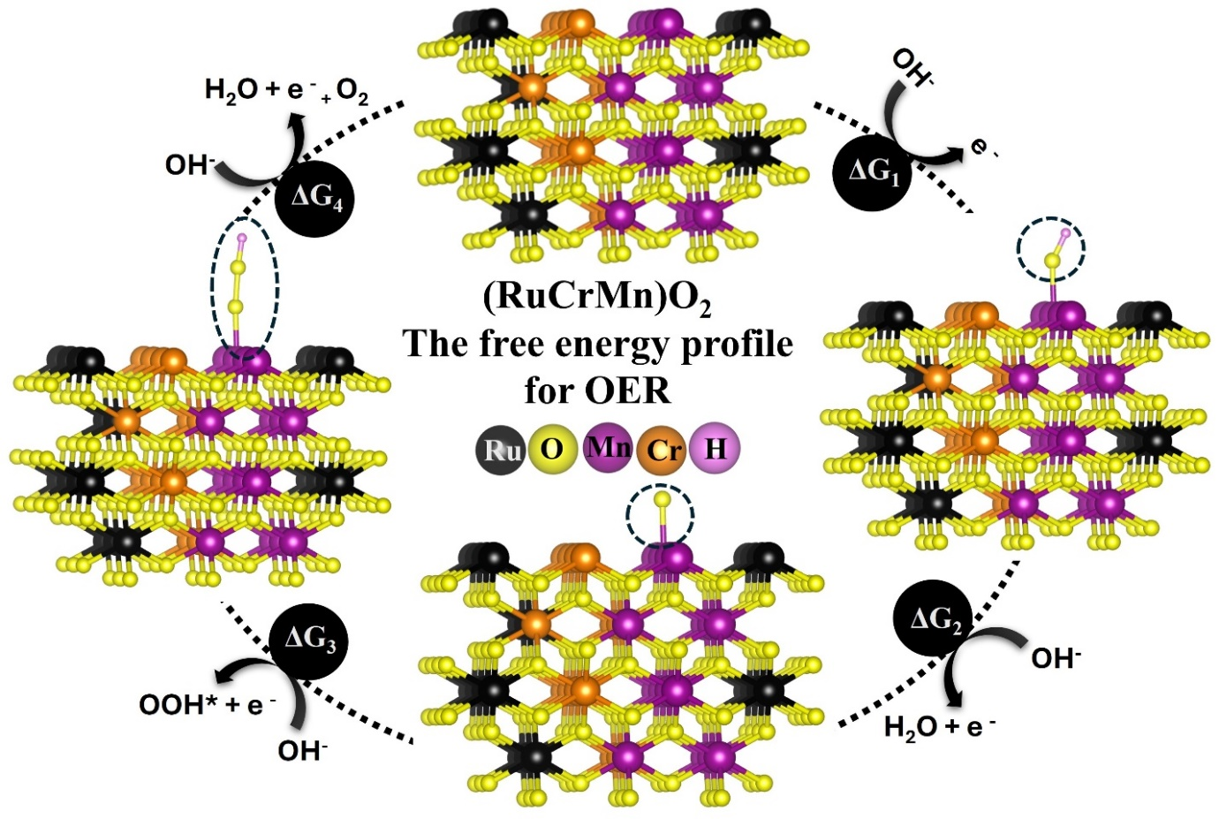
Fig. S19. Schematic illustration of the OER reaction pathway for (RuCrMn)O₂ at the Mn active site.

Catalysts | Formation energy (eV) | d-band center (eV)
RuO₂ | −5.133 | 0.873
RuCrO₂ | −4.776 | 1.317
RuMnO₂ | −4.858 | 0.628
(RuCrMn)O₂ | −5.308 | 0.571

Table S6. Calculated formation energies and d-band center positions of pristine and doped RuO₂-based electrocatalysts.

Catalysts | Adsorption site | Gibbs free energy change (eV) |  |  |  | OER  Overpotential  (η, V)
Catalysts | Adsorption site | ΔG₁ | ΔG₂ | ΔG₃ | ΔG₄ | OER  Overpotential  (η, V)
RuO₂ | Ru | 0.530 | 1.109 | 1.731 | 1.551 | 0.50
RuCrO₂ | Ru | 1.666 | 0.916 | 1.722 | 0.616 | 0.49
RuCrO₂ | Cr | 1.396 | 1.178 | 1.741 | 0.605 | 0.51
RuMnO₂ | Ru | 0.563 | 1.477 | 1.643 | 1.237 | 0.41
RuMnO₂ | Mn | 0.721 | 1.258 | 1.730 | 1.211 | 0.51
(RuCrMn)O₂ | Ru | 0.858 | 0.840 | 1.623 | 1.599 | 0.39
(RuCrMn)O₂ | Cr | 0.524 | 1.099 | 1.710 | 1.587 | 0.48
(RuCrMn)O₂ | Mn | 1.051 | 0.552 | 1.688 | 1.629 | 0.46

Table S7. Gibbs free energy changes (ΔG) for individual OER elementary steps and the corresponding theoretical overpotentials on RuO₂-based catalysts at various metal active sites.

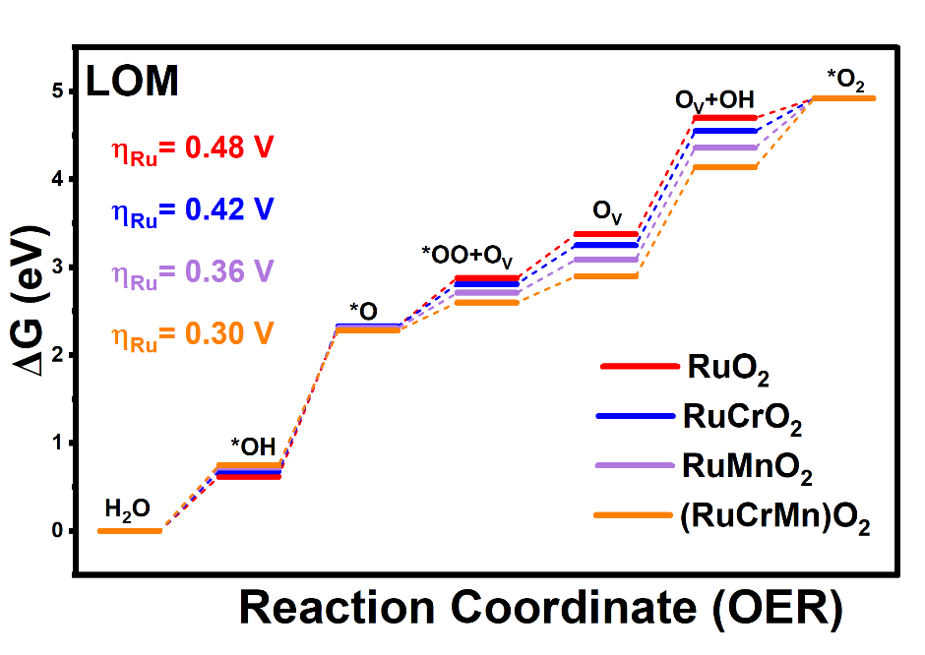
Fig. S20. Calculated Gibbs free-energy profiles for the oxygen evolution reaction via the lattice oxygen mechanism (LOM) on RuO₂, RuCrO₂, RuMnO₂, and (RuCrMn)O₂ at the Ru active site.

Table S8. Calculated Gibbs free-energy changes (ΔG) and theoretical OER overpotentials of RuO₂-based catalysts via the lattice oxygen mechanism (LOM) at Ru active sites.
Catalysts | Gibbs free energy change (eV) |  |  |  |  |  | OER  Overpotential  (η, V)
Catalysts | ΔG₁ | ΔG₂ | ΔG₃ | ΔG₄ | ΔG₅ | ΔG₆ | OER  Overpotential  (η, V)
*RuO₂ | 0.62 | 1.71 | 0.55 | 0.50 | 1.32 | 0.22 | 0.48 V
*RuCrO₂ | 0.68 | 1.65 | 0.48 | 0.44 | 1.30 | 0.37 | 0.42 V
*RuMnO₂ | 0.72 | 1.59 | 0.40 | 0.38 | 1.27 | 0.56 | 0.36 V
*(RuCrMn)O₂ | 0.75 | 1.53 | 0.32 | 0.30 | 1.24 | 0.78 | 0.30 V

