Additional file 1

Table of contents of the
instructional unit Statistics as Bridge between Mathematics and Science

Instructional unit: Statistics as Bridge between Mathematics and Science – Table of contents

The sports physiologist and statistics

Measuring condition (pp. 5-10)
Introduction of the authentic professional practice of a sports physiologist, who advises clients on how to improve their physical condition. Students learn to measure their fellow students’ heart rates and to model their data to find a measure for their physical condition.
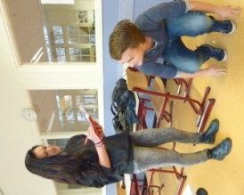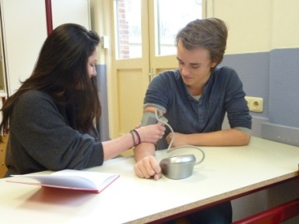

Figure 1. Students measuring physical condition using a sphygmomanometer (right figure).

Scatterplots
Introduction of scatterplots to visualize the relation between two variables.

Figure 2. Scatterplot to visualize the relation between Age and the peak heart rate.

The role of statistics in improving condition (pp. 6-18)

Heart rate and condition
Physiological background information on the relation between heart rates and physical condition.

The threshold point
Background on the threshold point as the heart rate someone can maintain over a longer period of time without the muscles reaching the metabolic threshold (between aerobic and anaerobic metabolism). Also background on training schemes based on the threshold point.

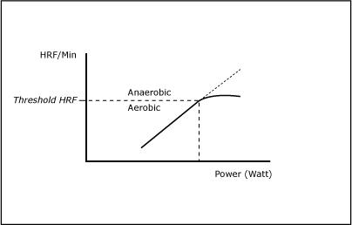
Figure 3. Model to predict the threshold point.

General equations and variation
Introduction of some common formulas for the peak heart rate depending on age). Students compare these with their own modelling results; an informal introduction to variability.

Statistics and individual improvement of condition (pp. 19-23)
Tasks for students to reason about how to determine their own threshold points in a gym.

Model of the heart rate
Introduction of the model of the relationship between the heart rate and power output when using a treadmill. Tasks to understand the model.

The Conconi Test to determine the threshold point
Activity for students with the Conconi Test to determine the threshold point of a fellow student using linear regression. A regression line is drawn by eye-balling.

Scatterplot (pp. 24-35)
Introductory tasks about variability in relation to scatterplots.

Data variation
Tasks to investigate variables other than the heart rate in relation to physical condition. Students practise with scatterplots and have to reason about variability.

Correlation and regression
Correlation (positive, negative and absent) is introduced and students practise with it informally.

In the last two research cycles we included at this point a sampling task to confront students with variability and “shuttling” between the contextual and statistical spheres.

Statistics and water management
The professional practice of monitoring dyke heights is introduced. Students see a video with accompanying questions and get information on dykes constructed in order to prevent flooding (pp. 36-38).

Monitoring heights of dykes (pp. 39-42)

How do you decide when to heighten a dyke?
Introduction of scatterplots as a means to decide when to heighten a dyke. Students are asked how such scatterplots can help and to reason about the variability around the regression line.

Levee Patrollers
Students learn how to recognize and explain problems with dykes. When in practice data analysis predicts problems at a dyke position, a Levee Patroller is sent to investigate the situation. Students play an interactive game which is used to train real Levee Patrollers. This game involves a virtual dyke with a lot of problems and heavy weather. The intention is to detect, report and explain the problems.

Regression lines (pp. 43-50)

Recognizing a trend
Students get real data of dyke heights and are asked to find a trend.
Again students have to reason about regression lines and variability around regression lines in relation to this professional practice to draw inferences about when to heighten a dyke.

Regression lines and Excel
Students learn to use Excel for plotting scatterplots, and learn to produce relevant basic calculations with Excel, such as sum, mean etcetera.

Regression lines and residuals
Students learn to use Excel to calculate residuals.

A measurement for variation
Students learn to calculate the standard deviation using Excel.

Variation and safety margin
Students reason about safety margins and how to include them in their Excel drawings and calculations.

Regression coefficients (pp. 51-70)

The central point
Student learn to use Excel to determine the central point 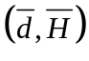of correlated data with d as number of days and H as deformation of heights.

Calculations using sigma-notation for summation
Introduction of the sigma notation (∑). Student practise with calculations with sigmas.

The least square method
Student use special software (TI-Nspire) to draw a scatterplot and have to draw the best possible line. Using the sum of squares option of the software they improve their regression line before using the option of showing the software’s regression line. Students have to understand and reason about the least square method.

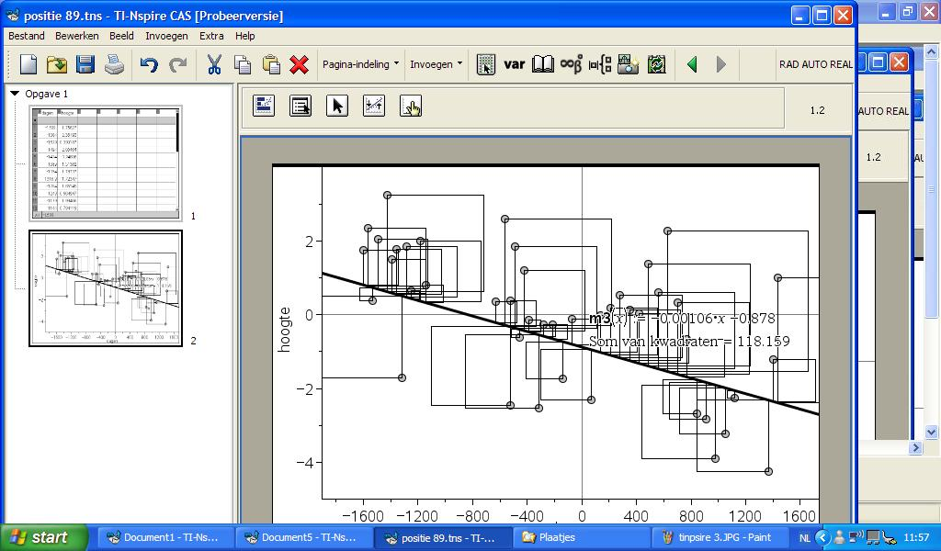

Figure 4. Screenshot TI-Nspire

Regression coefficients
Students practise with derivations. Students learn how to find a system of normal equations by calculating the derivatives of the sum of squares. By solving the system the regression coefficients are determined.

Excel and regression coefficients
Students learn how to use Excel to produce the regression coefficients.

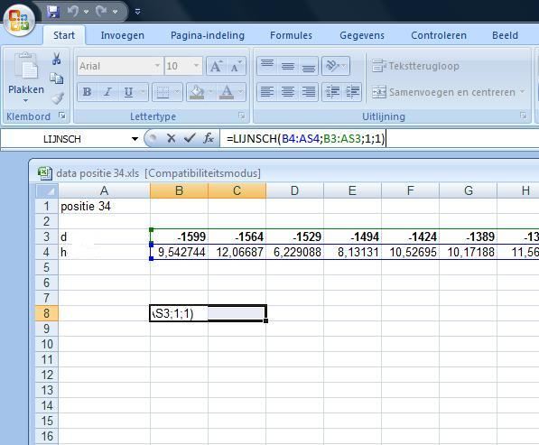
Figure 5. Screenshot Excel to instruct the students how to calculate the regression coefficients with the Linest function (Dutch: Lijnsch).

Correlation coefficient (pp. 71-76)

A measure for a relation
Mathematical background on correlation and how to use Excel to calculate the correlation. In the last task of this section the students get data of three dyke positions. They are asked to decide which position has to be heightened first (there is only money to heighten one position). When students draw scatterplots it is obvious that one position could wait. To decide which of the two other positions has to be heightened they first have to use correlation and regression.

In the last two research cycles we included at this point another sampling task to confront students with variability and “shuttling” between the contextual and statistical spheres.

Reflection (p. 77)
In this section we asked the students to make connections between the first two chapters. We asked explicitly how the techniques learned in chapter two could be used in chapter 1 where they constructed regression lines by eye-balling.

The role of correlation and regression in laboratories

Calibration (pp. 78-87)
Introduction of the professional practice of calibrating thermometers. Students practise with “precision” (small variability) and “correctness” (correct average in repeated measures). Students learn when it is possible to calibrate an instrument and the role of correlation and regression. In this chapter there are no examples of how to use correlation and regression. Students can show whether they are able to apply their knowledge in this new situation.
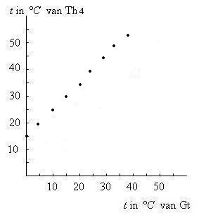
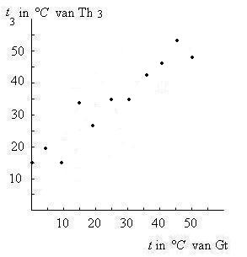

Figure 6. Pictures to show the difference between precise and correct.

Extra Tasks (pp. 88-93)
Some tasks to use correlation and regression in activities from other professional practices in laboratories.

