Appendices
International Journal of STEM Education

Appendices for
Academic social comparison: a promising new target to reduce fear of negative evaluation in large-enrollment college science courses

This supplement contains the following:
Item | Page
Approach to assumptions of mediation analysis | 3
Continuous variable moments | 4
Scatter plots of scale distribution by selected identities | 4
XM interaction plot for LGBTQ+ single mediator model | 5
General model for multi-mediator models | 5
Gender single-mediator model full SEM output | 6
Gender multi-mediator model full SEM output | 6
LGBTQ+ single-mediator model full SEM output | 6
LGBTQ+ multi-mediator model full SEM output | 7
EXPLORATORY: LGBTQ+ single mediator model XM interaction full SEM output | 7
EXPLORATORY: Imai’s R mediation package XM interaction for LGBTQ+ single mediator model | 7
Sensitivity Analysis Plot for single mediator model (R mediation package): Gender | 8
Sensitivity Analysis Plot for single mediator model (R mediation package): LGBTQ+ status | 8
Adapted fear of negative evaluation scale as seen by participant | 9
Adapted academic social comparison scale items as seen by participant | 10
Identity questions as seen by participant | 11
Adapted academic social comparison scale confirmatory factor analysis (CFA) | 12
Adapted academic social comparison scale confirmatory factor analysis modification indices (MI) | 12
Adapted Brief Fear of Negative Evaluation scale confirmatory factor analysis (CFA) | 13
Adapted Brief Fear of Negative Evaluation scale confirmatory factor analysis modification indices (MI) | 13
Post hoc analyses: linear regression output | 13
Appendices references | 14

Approach to assumptions of mediation analysis
Our assumptions | Our considerations
Error assumptions  Each method of estimating a mediation effect requires  - Predictor variables are uncorrelated with error in each equation  - Errors are uncorrelated across equations  - Predictor variables in one equation are uncorrelated with the error in another equation | Residuals were examined for unusual distributions prior to analysis. This assumption was met in diagnostics.
Reliable and valid measures | We ran CFAs and generated McDonald’s Omega for both measures used.
No omitted influences | Sensitivity analysis suggests that we are at reduced risk for unaccounted for confounds.
Normally distributed variables | This assumption was met in diagnostics.
Data are a random sample of the population of interest | Our sample is representative of our target population (undergraduate STEM majors in active science learning classrooms at R1 institutions).
Coefficients reflect true casual relations and the correct functional form | Possible confounding variables, although unlikely, are discussed. All relationships were consistent with linear relations between variables.
Temporal order is correct (X occurs before M which occurs before Y) | Guided by cognitive theory, negative thought processes create negative emotions. In our case, social comparison is a negative thought process and the negative emotion generated from that is fear of negative evaluation. Therefore, we are exploring this descriptive mediation analysis model with academic social comparison as the mediator rather than the outcome.  Although our mediation analysis is using cross-sectional data, we believe that the demographic variables within our models (gender, LGBTQ+ status) are fairly stable over time, and are typically established prior to one’s concept of academic social comparison and fear of negative evaluation.
Homogeneous effects across subgroups, with no moderator effects | We checked for moderator effects where negative suppression was found (XM interaction) and disaggregated our mediation via simple slopes to meet the homogeneous effects assumption for interpretation. Evaluating the z-scores, we determined the XM interaction to be minor to the interpretation of our research questions.

Continuous variable moments
N = 909 | Mean | Sd | Median | Min | Max | Range | Skew | Kurtosis | Se
FNE | 2.18 | 0.91 | 2.00 | 1 | 5 | 4 | 0.69 | -0.10 | 0.03
SCS | 5.91 | 1.86 | 5.82 | 1 | 10 | 9 | -0.10 | -0.41 | 0.06
Group Fit | 5.71 | 2.06 | 5.50 | 1 | 10 | 9 | 0.06 | -0.50 | 0.07
Attract | 6.46 | 2.14 | 6.67 | 1 | 10 | 9 | -0.40 | -0.36 | 0.07
Rank | 5.71 | 2.17 | 5.75 | 1 | 10 | 9 | -0.18 | -0.53 | 0.07

Scatter plots of scale distribution by selected identities
 | Fear of negative evaluation | Social comparison
Gender identity | 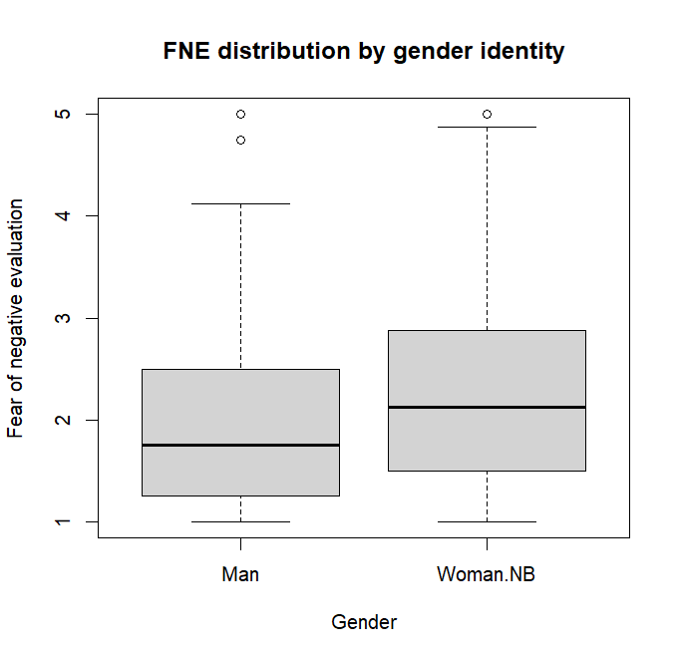 | 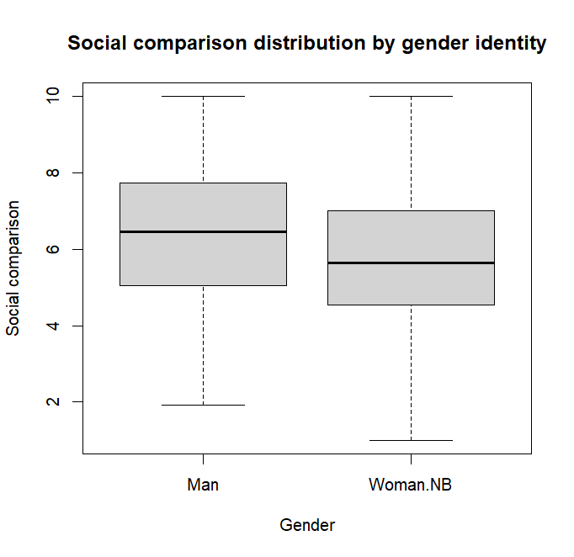
LGBTQ+ identity | 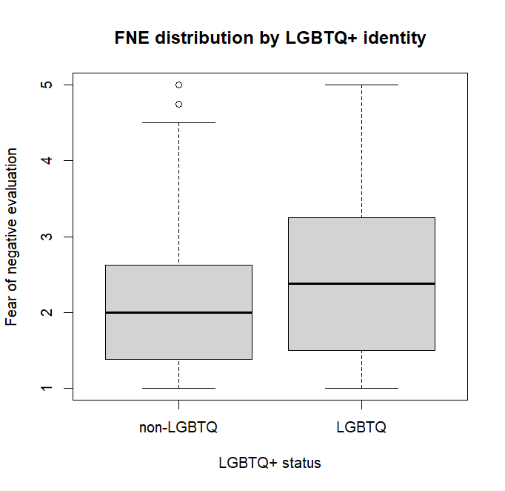 | 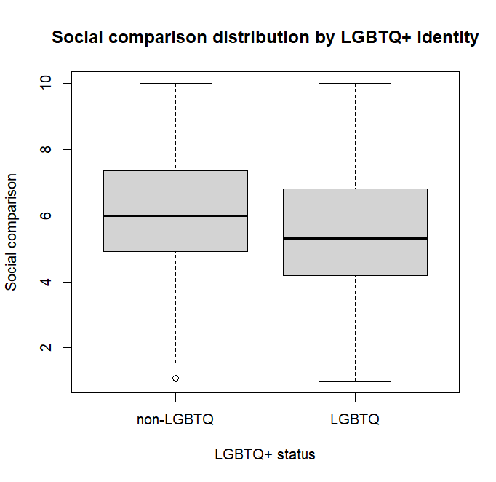

XM interaction plot for LGBTQ+ single mediator model
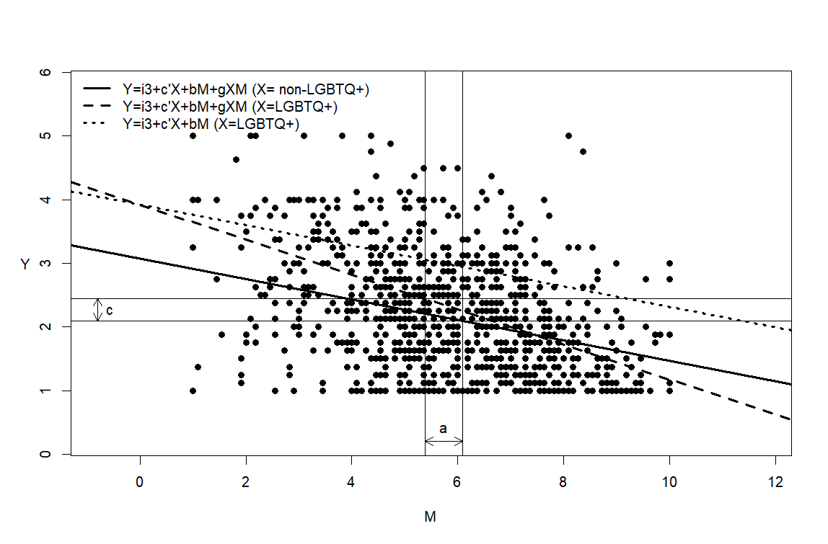

General model for multi-mediator models
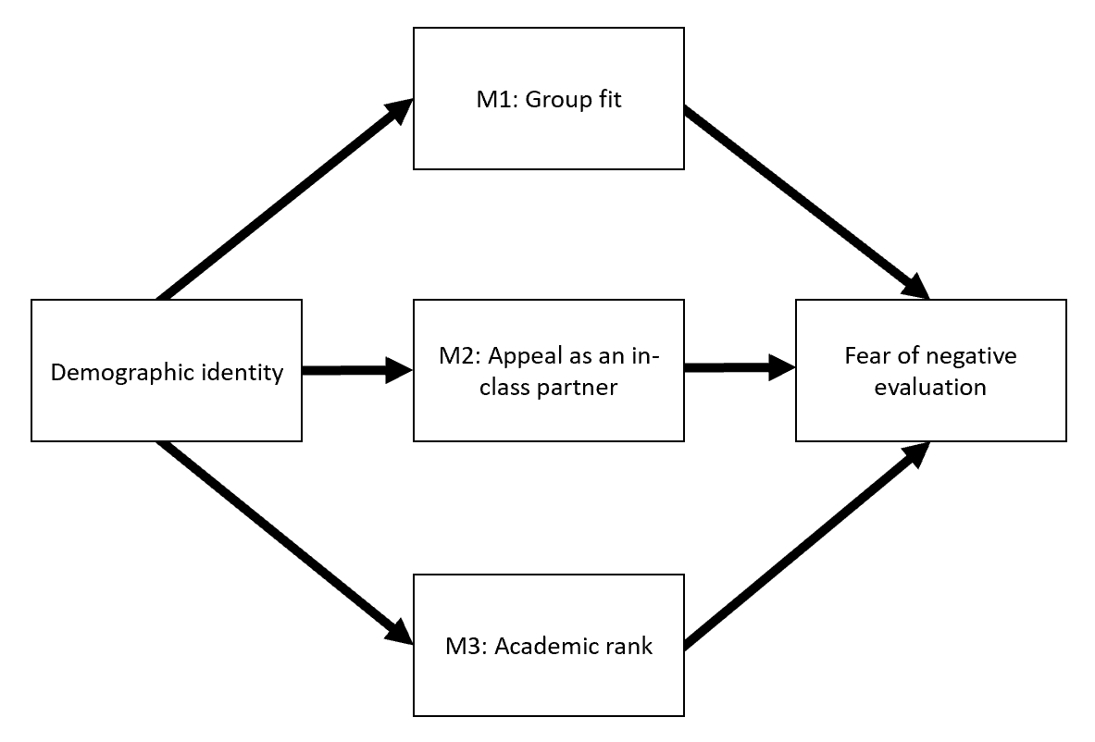

Gender single-mediator model full SEM output
Lhs | Op | Rhs | Label | Est | Se | Z | P-value | CI Lower | CI Upper
M | ~ | X | a | -0.577 | 0.133 | -4.332 | 0.000 | -0.838 | -0.316
Y | ~ | X | cp | 0.206 | 0.060 | 3.412 | 0.001 | 0.088 | 0.324
Y | ~ | M | b | -0.193 | 0.015 | -13.012 | 0.000 | -0.223 | -0.164
M | ~~ | M |  | 3.404 | 0.160 | 21.319 | 0.000 | 3.091 | 3.717
Y | ~~ | Y |  | 0.684 | 0.032 | 21.319 | 0.000 | 0.621 | 0.747
X | ~~ | X |  | 0.211 | 0.000 | NA | NA | 0.211 | 0.211
ab | := | a*b | ab | 0.112 | 0.027 | 4.110 | 0.000 | 0.058 | 0.165
total | := | cp+(a*b) | total | 0.318 | 0.065 | 4.882 | 0.000 | 0.190 | 0.445

Gender multi-mediator model full SEM output
Lhs | Op | Rhs | Label | Est | Se | Z | P-value | CI Lower | CI Upper
M1 | ~ | X | a1 | -0.693 | 0.147 | -4.727 | 0.000 | -0.980 | -0.406
M2 | ~ | X | a2 | -0.301 | 0.154 | -1.949 | 0.051 | -0.604 | 0.002
M3 | ~ | X | a3 | -0.668 | 0.155 | -4.315 | 0.000 | -0.972 | -0.365
Y | ~ | X | cp | 0.195 | 0.061 | 3.228 | 0.001 | 0.077 | 0.314
Y | ~ | M1 | b1 | -0.113 | 0.020 | -5.750 | 0.000 | -0.152 | -0.075
Y | ~ | M2 | b2 | -0.029 | 0.018 | -1.605 | 0.108 | -0.065 | 0.006
Y | ~ | M3 | b3 | -0.052 | 0.018 | -2.864 | 0.004 | -0.088 | -0.017
M1 | ~~ | M2 |  | 2.840 | 0.172 | 16.504 | 0.000 | 2.503 | 3.178
M1 | ~~ | M3 |  | 2.895 | 0.173 | 16.695 | 0.000 | 2.555 | 3.235
M2 | ~~ | M3 |  | 2.931 | 0.181 | 16.230 | 0.000 | 2.577 | 3.285
M1 | ~~ | M1 |  | 4.120 | 0.193 | 21.319 | 0.000 | 3.741 | 4.499
M2 | ~~ | M2 |  | 4.577 | 0.215 | 21.319 | 0.000 | 4.156 | 4.997
M3 | ~~ | M3 |  | 4.600 | 0.216 | 21.319 | 0.000 | 4.178 | 5.023
Y | ~~ | Y |  | 0.680 | 0.032 | 21.319 | 0.000 | 0.618 | 0.743
X | ~~ | X |  | 0.211 | 0.000 | NA | NA | 0.211 | 0.211
ab1 | := | a1*b1 | ab1 | 0.078 | 0.021 | 3.651 | 0.000 | 0.036 | 0.120
ab2 | := | a2*b2 | ab2 | 0.009 | 0.007 | 1.239 | 0.215 | -0.005 | 0.023
ab3 | := | a3*b3 | ab3 | 0.035 | 0.015 | 2.386 | 0.017 | 0.006 | 0.064
total | := | cp+(ab1)+(ab2)+(ab3) | total | 0.318 | 0.065 | 4.882 | 0.000 | 0.190 | 0.445

LGBTQ+ single-mediator model full SEM output
Lhs | Op | Rhs | Label | Est | Se | Z | P-value | CI Lower | CI Upper
M | ~ | X | a | -0.700 | 0.142 | -4.926 | 0.000 | -0.978 | -0.421
Y | ~ | X | cp | 0.212 | 0.065 | 3.278 | 0.001 | 0.085 | 0.339
Y | ~ | M | b | -0.193 | 0.015 | -12.922 | 0.000 | -0.222 | -0.164
M | ~~ | M |  | 3.384 | 0.159 | 21.319 | 0.000 | 3.073 | 3.695
Y | ~~ | Y |  | 0.685 | 0.032 | 21.319 | 0.000 | 0.622 | 0.748
X | ~~ | X |  | 0.185 | 0.000 | NA | NA | 0.185 | 0.185
ab | := | a*b | ab | 0.135 | 0.029 | 4.603 | 0.000 | 0.077 | 0.192
total | := | cp+(a*b) | total | 0.347 | 0.070 | 4.994 | 0.000 | 0.211 | 0.483

LGBTQ+ multi-mediator model full SEM output
Lhs | Op | Rhs | Label | Est | Se | Z | P-value | CI Lower | CI Upper
M1 | ~ | X | a1 | -0.434 | 0.076 | -5.730 | 0.000 | -0.583 | -0.286
M2 | ~ | X | a2 | -0.249 | 0.077 | -3.252 | 0.001 | -0.400 | -0.099
M3 | ~ | X | a3 | -0.290 | 0.077 | -3.794 | 0.000 | -0.440 | -0.140
Y | ~ | X | cp | 0.198 | 0.065 | 3.054 | 0.002 | 0.071 | 0.325
Y | ~ | M1 | b1 | -0.229 | 0.041 | -5.637 | 0.000 | -0.309 | -0.149
Y | ~ | M2 | b2 | -0.056 | 0.039 | -1.439 | 0.150 | -0.132 | 0.020
Y | ~ | M3 | b3 | -0.122 | 0.040 | -3.089 | 0.002 | -0.200 | -0.045
M1 | ~~ | M2 |  | 0.634 | 0.039 | 16.430 | 0.000 | 0.559 | 0.710
M1 | ~~ | M3 |  | 0.648 | 0.039 | 16.709 | 0.000 | 0.572 | 0.724
M2 | ~~ | M3 |  | 0.626 | 0.039 | 16.168 | 0.000 | 0.550 | 0.702
M1 | ~~ | M1 |  | 0.964 | 0.045 | 21.319 | 0.000 | 0.875 | 1.053
M2 | ~~ | M2 |  | 0.987 | 0.046 | 21.319 | 0.000 | 0.897 | 1.078
M3 | ~~ | M3 |  | 0.983 | 0.046 | 21.319 | 0.000 | 0.893 | 1.074
Y | ~~ | Y |  | 0.681 | 0.032 | 21.319 | 0.000 | 0.618 | 0.744
X | ~~ | X |  | 0.185 | 0.000 | NA | NA | 0.185 | 0.185
ab1 | := | a1*b1 | ab1 | 0.100 | 0.025 | 4.018 | 0.000 | 0.051 | 0.148
ab2 | := | a2*b2 | ab2 | 0.014 | 0.011 | 1.316 | 0.188 | -0.007 | 0.035
ab3 | := | a3*b3 | ab3 | 0.036 | 0.015 | 2.395 | 0.017 | 0.006 | 0.065
total | := | cp+(ab1)+(ab2)+(ab3) | total | 0.347 | 0.070 | 4.994 | 0.000 | 0.211 | 0.483

EXPLORATORY: LGBTQ+ single mediator model XM interaction full SEM output
Lhs | Op | Rhs | Label | Est | Se | Z | P-value | CI Lower | CI Upper
m | ~ | x | a | -0.700 | 0.142 | -4.926 | 0.000 | -0.978 | -0.421
y | ~ | x | cp | 0.847 | 0.064 | 13.175 | 0.000 | 0.721 | 0.973
y | ~ | m | b | -0.161 | 0.015 | -10.865 | 0.000 | -0.190 | -0.132
y | ~ | m:x |  | -0.114 | 0.011 | -10.474 | 0.000 | -0.135 | -0.093
m | ~~ | m |  | 3.384 | 0.159 | 21.319 | 0.000 | 3.073 | 3.695
y | ~~ | y |  | 0.676 | 0.032 | 21.319 | 0.000 | 0.614 | 0.738
m:x | ~~ | m:x |  | 6.299 | 0.295 | 21.319 | 0.000 | 5.720 | 6.878
x | ~~ | x |  | 0.185 | 0.000 | NA | NA | 0.185 | 0.185
ab | := | a*b | ab | 0.113 | 0.025 | 4.487 | 0.000 | 0.063 | 0.162
total | := | cp+(a*b) | total | 0.960 | 0.067 | 14.230 | 0.000 | 0.828 | 1.092

EXPLORATORY: Imai’s R mediation package XM interaction for LGBTQ+ single mediator model
Effects |  | Estimate | 95% CI |  | P-value
ACME | non-LGBTQ+ | 0.110 | 0.06 | 0.17 | <0.001 | ***
ACME | LGBTQ+ | 0.188 | 0.11 | 0.28 | <0.001 | ***
ADE | non-LGBTQ+ | 0.152 | 0.01 | 0.28 | 0.038 | *
ADE | LGBTQ+ | 0.230 | 0.10 | 0.36 | 0.004 | **
Total Effect |  | 0.340 | 0.19 | 0.48 | <0.001 | ***
Prop. Mediated | non-LGBTQ+ | 0.320 | 0.21 | 0.55 | <0.001 | ***
Prop. Mediated | LGBTQ+ | 0.553 | 0.35 | 0.96 | <0.001 | ***
ACME | average | 0.149 | 0.09 | 0.22 | <0.001 | ***
ADE | average | 0.191 | 0.05 | 0.32 | 0.016 | *
Prop. Mediated | average | 0.436 | 0.28 | 0.73 | <0.001 | ***

Sensitivity Analysis Plot for single mediator model (R mediation package): Gender
Men = 0; Women and NB = 1
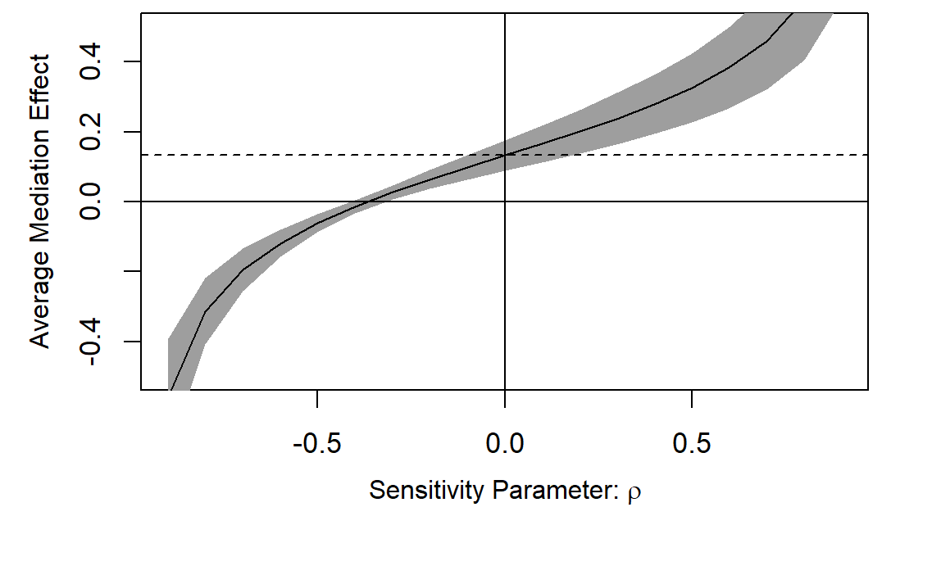
Note: LGBTQ+ status could be a potential confound for the effect of social comparison on gender, provided that sexual orientation and LGBTQ+ status can overlap. A correlation of -0.4 between social comparison and FNE residuals would be needed to render the mediated effect zero, suggesting that confounding is an unlikely explanation of the observed mediated effect.

Sensitivity Analysis Plot for single mediator model (R mediation package): LGBTQ+ status
X = LGBTQ+ | X = non-LGBTQ+
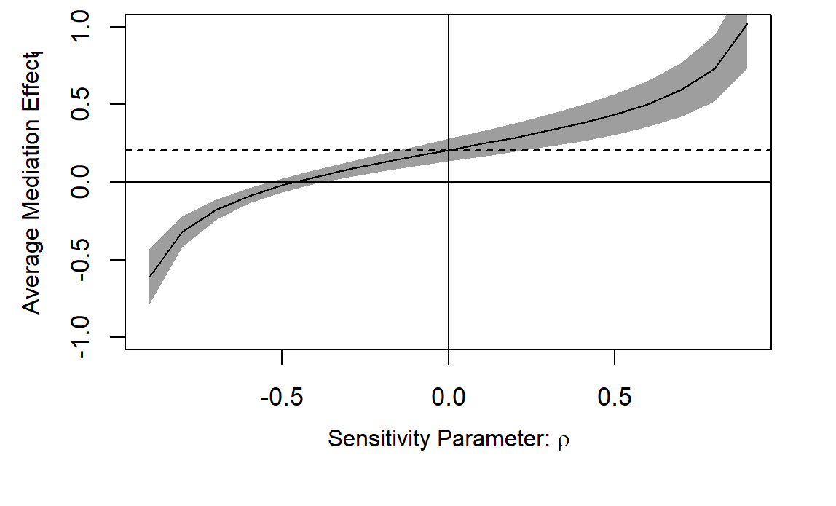 | 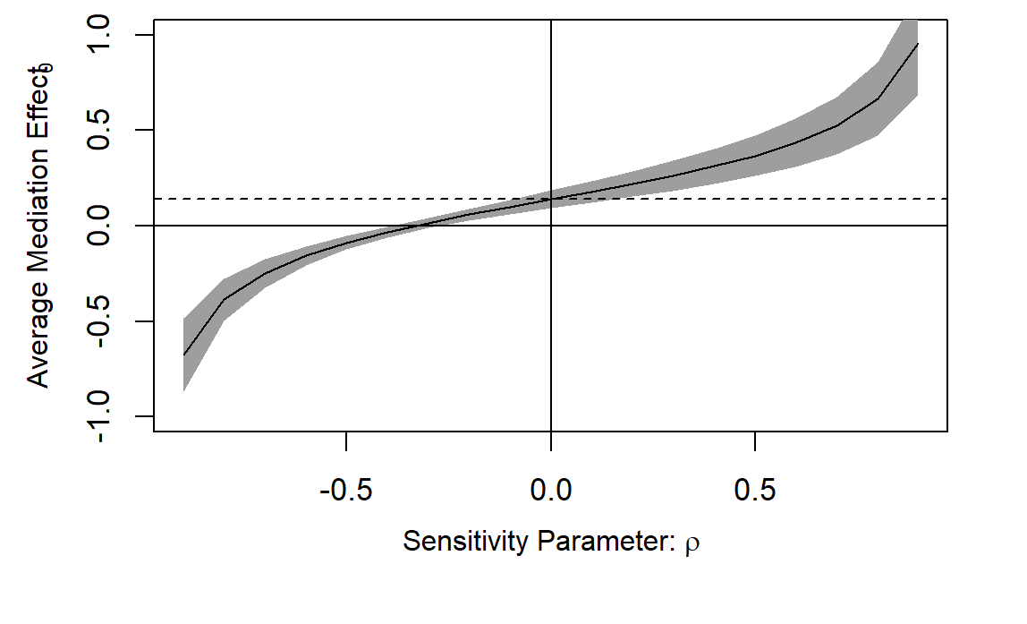
Note: Gender could be a potential confound for the effect of social comparison on LGBTQ+ status, provided that sexual orientation and LGBTQ+ status can overlap. A correlation of -0.3 between social comparison and FNE residuals would be needed to render the mediated effect zero, suggesting that confounding is an unlikely explanation of the observed mediated effect for those who do not identify as LGBTQ+. A correlation of -0.5 between social comparison and FNE residuals would be needed to render the mediated effect zero, suggesting that confounding is an unlikely explanation of the observed mediated effect for those who do identify as LGBTQ+.

Adapted fear of negative evaluation scale as seen by participant
Please answer the following questions about your experiences in your large-enrollment (100 students or more) college science courses.

Not at all characteristic of me (1) | Slightly characteristic of me (2) | Moderately characteristic of me (3) | Very characteristic of me (4) | Extremely characteristic of me (5)
I worry about what my classmates in large-enrollment college science courses will think of me even when I know it doesn’t make any difference. (1)
I am frequently afraid of my classmates in my large-enrollment college science courses noticing my shortcomings. (2)
I am afraid that my classmates in my large-enrollment college science courses will not approve of me. (3)
I am afraid that my classmates in my large-enrollment college science courses will be critical of me. (4)
When I am talking with a classmate in my large-enrollment college science courses, I worry about what they may be thinking about me. (5)
I am usually worried about what kind of impression I make in my large-enrollment college science courses. (6)
Sometimes I think I am too concerned with what my classmates think of me in my large-enrollment college science courses. (7)
I often worry that I will say or do the wrong things in my large-enrollment college science courses. (8)

Adapted academic social comparison scale items as seen by participant
Q11 Please select a number at a point which best describes the way in which you see yourself in comparison to others.
For example: Short 1 2 3 4 5 6 7 8 9 10 Tall
If you select 3 this means you see yourself as shorter than others; if you select 5 (middle) about average; and select 7 somewhat taller.
If you understand the above instructions, please proceed. Select one number on each line according to how you see yourself in relation to others.
Compared to other science majors I feel…
 | 1 | 2 | 3 | 4 | 5 | 6 | 7 | 8 | 9 | 10
Left out |  |  |  |  |  |  |  |  |  |  | Accepted
Different |  |  |  |  |  |  |  |  |  |  | Same
Unconfident |  |  |  |  |  |  |  |  |  |  | Confident
Outsider |  |  |  |  |  |  |  |  |  |  | Insider
Unlikeable as an in-class partner |  |  |  |  |  |  |  |  |  |  | Likable as an in-class partner
Undesirable as an in-class partner |  |  |  |  |  |  |  |  |  |  | Desirable as an in-class partner
Unattractive as an in-class partner |  |  |  |  |  |  |  |  |  |  | Attractive as an in-class partner
Academically inferior |  |  |  |  |  |  |  |  |  |  | Academically superior
Academically incompetent |  |  |  |  |  |  |  |  |  |  | Academically competent
Academically untalented |  |  |  |  |  |  |  |  |  |  | Academically talented
Academically weaker performance |  |  |  |  |  |  |  |  |  |  | Academically stronger performance

Identity questions as seen by participant

Please select the major that is closest to yours. If you have more than one major, please choose all that apply.
- Biology
- Biochemistry
- Chemistry
- Physics
- Geosciences
- Engineering
- Mathematics or Statistics
- Computer science
- Another STEM major, please describe
- A major outside of science, technology, engineering, or math, please describe

With regard to gender, I most closely identify as:
- Woman
- Man
- Gender-queer or non-binary
- A gender not listed, please describe
- Decline to state

I most closely identify as
- American Indian or Alaska Native
- Asian or Asian American
- Black or African American
- Hispanic, Latino/a/x, or of Spanish origin
- Native Hawaiian
- Pacific Islander
- White
- An identity not listed, please describe
- Decline to state

What is your parent/guardian's highest completed level of education? If you have more than one parent/guardian with differing levels of education, choose the parent/guardian with the highest completion level.
- Did not complete high school
- High school diploma or GED
- Some college but no degree
- Associate degree (for example: AA, AS)
- Bachelor's degree (for example: BA, AB, BS)
- Master's degree (for example: MA, MS, MEng, MEd, MSW, MBA)
- Higher than a Master's degree (for example: PhD, MD, JD)
- Other (please describe)
- Decline to state

What is your best guess for the yearly income of the household in which you grew up?
- Low income (less than $25,000)
- Middle-low income ($25,000 - $49,999)
- Middle income ($50,000 - $99,999)
- Middle-high income ($100,000 - $199,999)
- High income ($200,000 or higher)
- Decline to state

Please indicate the language you spoke at home when you were growing up.
- English
- Spanish
- Mandarin
- Tagalog
- Vietnamese
- French
- Arabic
- Korean
- A language not listed, please specify
- Decline to state

Do you identify as a member of the LGBTQ+ community (e.g., lesbian, gay, bisexual, trans, queer/questioning, intersex, asexual/aromantic)?
- Yes
- No
- Decline to state

Do you identify as having a disability?
- Yes
- No
- Decline to state

Adapted academic social comparison scale confirmatory factor analysis (CFA)
Fit indices | Data-Model Fit | Accepted Cutoff*
Chi-square | 222.060, df = 41, p = 0.00 | p>0.05
SRMR | 0.037 | ≤ 0.080
CFI | 0.978 | ≥ 0.950
TLI | 0.971 | ≥ 0.950
RMSEA (90% confidence) | 0.070 (0.061 – 0.079) | ≤ 0.080
*As suggested by (Hancock et al., 2018). Though the chi-square test indicates poor model fit, this test is widely considered to be overly stringent and nearly always fails with larger sample sizes. All other fit indices demonstrate (SRMR, CFI, TLI, and RMSEA) indicate acceptable model fit.

Adapted academic social comparison scale confirmatory factor analysis modification indices (MI)
Lhs | Op | Rhs | Mi | Epc | Sepc Lv | Sepc All | Sepc Nox
rank | =~ | SCSgroupfit3 | 113.945 | 0.571 | 1.080 | 0.432 | 0.432
SCSgroupfit2 | ~~ | SCSgroupfit4 | 28.091 | 0.508 | 0.508 | 0.258 | 0.258
SCSgroupfit2 | ~~ | SCSgroupfit3 | 26.560 | -0.551 | -0.551 | -0.224 | -0.224
SCSgroupfit2 | ~~ | SCSrank3 | 25.367 | -0.315 | -0.315 | -0.211 | -0.211
rank | =~ | SCSgroupfit2 | 24.215 | -0.264 | -0.500 | -0.204 | -0.204
SCSgroupfit3 | ~~ | SCSrank4 | 24.071 | 0.312 | 0.312 | 0.206 | 0.206
SCSgroupfit1 | ~~ | SCSgroupfit2 | 12.696 | 0.364 | 0.364 | 0.159 | 0.159
SCSrank1 | ~~ | SCSrank2 | 10.316 | -0.166 | -0.166 | -0.152 | -0.152
rank | =~ | SCSgroupfit1 | 10.130 | -0.162 | -0.307 | -0.128 | -0.128
appeal | =~ | SCSrank4 | 9.420 | -0.088 | -0.183 | -0.076 | -0.076
Note: Item 3 in group fit (“SCSgroupfit3”) was evaluated for removal from the construct, however, it is not generally recommended to remove items from CFA constructs unless guided by theory and strong background literature (Hancock et al., 2018). Given the novelty of this adapted scale, we did not feel comfortable removing the item for the sake of increasing already acceptable fit.

Adapted brief fear of negative evaluation confirmatory factor analysis (CFA)
Fit indices | Data-Model Fit | Accepted Cutoff*
Chi-square | 271.60, df = 20, p = 0.00 | p > 0.05
SRMR | 0.034 | ≤ 0.080
CFI | 0.955 | ≥ 0.950
TLI | 0.937 | ≥ 0.950
RMSEA (90% confidence) | 0.118 (0.105 – 0.130) | ≤ 0.080
*As suggested by (Hancock et al., 2018). Though the chi-square test indicates poor model fit, this test is widely considered to be overly stringent and nearly always fails with larger sample sizes. The TLI and RMSEA also indicates poor model fit, but other fit indices (SRMR and CFI) indicate acceptable model fit.

Adapted brief fear of negative evaluation confirmatory factor analysis modification indices (MI)
Lhs | Op | Rhs | Mi | Epc | Sepc Lv | Sepc All | Sepc Nox
fne5 | ~~ | fne6 | 53.636 | 0.119 | 0.119 | 0.276 | 0.276
fne5 | ~~ | fne7 | 42.077 | 0.108 | 0.108 | 0.250 | 0.250
fne3 | ~~ | fne4 | 35.584 | 0.078 | 0.078 | 0.253 | 0.253
fne2 | ~~ | fne3 | 34.770 | 0.081 | 0.081 | 0.240 | 0.240
fne2 | ~~ | fne6 | 33.947 | -0.091 | -0.091 | -0.226 | -0.226
fne3 | ~~ | fne6 | 28.565 | -0.079 | -0.079 | -0.205 | -0.205
fne2 | ~~ | fne5 | 26.167 | -0.077 | -0.077 | -0.204 | -0.204
fne2 | ~~ | fne7 | 25.260 | -0.081 | -0.081 | -0.199 | -0.199
fne6 | ~~ | fne7 | 23.212 | 0.084 | 0.084 | 0.181 | 0.181
fne6 | ~~ | fne8 | 20.448 | 0.081 | 0.081 | 0.167 | 0.167

Post hoc analyses: linear regression output
post.hoc.model1 <- lm(SCSgroupfit ~ gender + major + gender:major)
Term | Estimate | Sd Error | Statistic | P-value
(Intercept) | 6.199 | 0.154 | 40.250 | 0.000
Woman.NB | -0.735 | 0.180 | -4.082 | 0.000
major.biochem | -0.120 | 0.352 | -0.341 | 0.733
major.chem | 0.264 | 0.380 | 0.694 | 0.488
major.geosci/phys | -0.887 | 0.605 | -1.467 | 0.143
Woman.NB:major.biochem | 0.230 | 0.440 | 0.523 | 0.601
Woman.NB:major.chem | -0.163 | 0.492 | -0.331 | 0.740
Woman.NB:major.geosci/phys | 0.912 | 0.734 | 1.243 | 0.214

post.hoc.model2 <- lm(SCSgroupfit ~ LGBTQ + major + LGBTQ:major)
Term | Estimate | Sd Error | Statistic | P-value
(Intercept) | 5.859 | 0.091 | 64.056 | 0.000
LGBTQ | -0.792 | 0.183 | -4.323 | 0.000
major.biochem | 0.192 | 0.238 | 0.806 | 0.421
major.chem | 0.360 | 0.268 | 1.344 | 0.179
major.geosci/phys | -0.279 | 0.439 | -0.636 | 0.525
LGBTQ:major.biochem | -0.488 | 0.501 | -0.974 | 0.330
LGBTQ:major.chem | -0.567 | 0.592 | -0.958 | 0.338
LGBTQ:major.geosci/phys | 0.429 | 0.699 | 0.614 | 0.539

Appendices references

Hancock, G. R., Stapleton, L. M., & Mueller, R. O. (Eds.). (2018). The Reviewer’s Guide to Quantitative Methods in the Social Sciences (2nd ed.). Routledge. https://doi.org/10.4324/9781315755649

