Appendix A

Survey Questions (Ekmekci, et al., 2024)

Teaching Self-Efficacy Questions (Tschannen-Moran & Hoy, 2001)

Please answer the following questions related to your beliefs about your capabilities in any teaching context (Remember to answer based on the last year you taught in K-12 if you no longer teach in K-12).

How much can you do to craft good questions for students?
How much can you do to implement a variety of assessment strategies?
How much can you do to provide an alternate explanation when students are confused?
How much can you do to implement alternative strategies in your classroom?
How much can you do to motivate students who show low interest in school work?
How much can you do to get students to believe they can do well in school work?
How much can you do to help students value learning?
How much can you do to assist families in helping their children do well in school?
Response Scale: 1 =nothing; 2=very little; 3=some degree; 4=quite a bit; 5=a great deal

Teacher-School Fit Questions (Pogodzinski et al., 2013; Baard et al., 2004)

Please indicate how much you agree or disagree with the following statements (Remember to answer based on the last year you taught in K-12 if you no longer teach in K-12).

I identify with other teachers throughout my school.
My professional goals are the same as those of other teachers throughout my school.
I matter to other teachers throughout my school.
My principal tries to understand how I see things before suggesting a new way to do things.
My principal encourages me to ask questions.
My principal conveys confidence in my ability to do well at my job.
I feel understood by my principal.
I feel that my principal provides me with choices and options.
Response Scale: 1=Strongly disagree to 5=Strongly agree

Leadership Engagement Questions (Watt et al., 2009)

Please mark an option that best describes your level of participation in the following activities within the past 12 months (Remember to answer based on the last year you taught in K-12 if you no longer teach in K-12).

Help design school policy
Involved in campus level decision-making
Plan school improvement
Help make personnel decisions
Involved in selecting types of professional development
Influence school budgeting
Response Scale: 1=not yet; 2=rarely; 3=sometimes; 4=often

Diversity Dispositions Questions (Schulte et al., 2008)

Please indicate how much you agree or disagree with the following statements (Remember to answer based on the last year you taught in K-12 if you no longer teach in K-12).

I look for new ways to teach difficult material.
I am reflective about how my actions affect student achievement.
I continually search for new knowledge within my content area.
I am responsible for creating an atmosphere where all students feel free to openly exchange ideas, thoughts, and opinions.
I believe in setting high standards for all students.
I am passionate about my own learning.
I believe that diversity enhances student knowledge.
Response Scale: 1=Strongly disagree to 5=Strongly agree

Community Connections Questions (Schulte et al., 2008)

Please indicate how much you agree or disagree with the following statements (Remember to answer based on the last year you taught in K-12 if you no longer teach in K-12).

I encourage my students to give back to their community.
I work to establish positive school-community relationships.
I am involved in the community where I teach.
I help my students make connections in their community.
It is important that I attend activities in my students’ neighborhoods.
I see myself as a part of the community in my role as a teacher.
I welcome community members into my classes to share their skills.
I collaborate on providing community service opportunities for my students.
Response Scale: 1=Strongly disagree to 5=Strongly agree

Appendix B

Social Network Analysis Questions (Polizzi et al., 2019; 2021)

Section 1 - Network Ties
To help you prepare for the upcoming survey items, we have provided a diagram explaining critical aspects of social networks that you will be asked about:
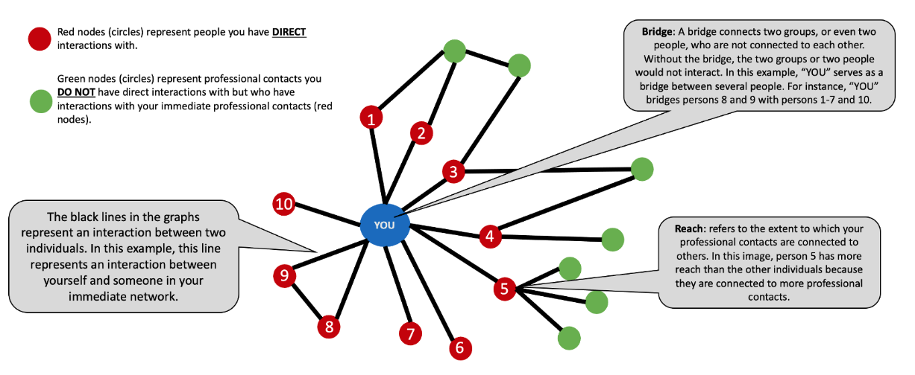
Answer the question below as completely as possible. Full names are encouraged but not required. You are welcome to use nicknames/pseudonyms, abbreviations, or titles but make to sure choose distinct identifiers that you will remember during the survey. Additional blanks will appear if needed, up to 15 contacts. Leave unused fields blank (please do not type NA) and hit the next button to proceed to the next question.

Who do you interact with related to teaching and/or education?

This includes face-to-face or electronic interactions with "individuals" (not groups of people; i.e., put John, David etc. rather than word "teachers") at your school/district, state and/or national level. This could be personal or professional "adult" contacts (not students). Interactions may also include positive/negative, giving/receiving, or obligatory/optional interactions (Remember to answer based on the last year you taught in K-12 if you no longer teach in K-12).
Contact 1: _____________
Contact 2: _____________
Contact 3: _____________
Contact 4: _____________
Contact 5: _____________
Contact 6: _____________
Contact 7: _____________
Contact 8: _____________
Contact 9: _____________
Contact 10: ____________
Contact 11: ____________
Contact 12: ____________
Contact 13: ____________
Contact 14: ____________
Contact 15: ____________

Select the contact(s) from the list below that apply to the following question. Click the next button to proceed to the next question.

Of the choices below, who does Contact 1 interact with related to teaching and/or education?*
Contact 2: ___
Contact 3: ___
Contact 4: ___
Contact 5: ___
Contact 6: ___
Contact 7: ___
Contact 8: ___
Contact 9: ___
Contact 10: ___
Contact 11: ___
Contact 12: ___
Contact 13: ___
Contact 14: ___
Contact 15: ___

*This question is repeated for each of the Contact 2 through Contact 15 (as apply).

Section 2 - Network Scales
In this section of the survey, we ask about your perceptions of the pattern of interactions in your professional network related to teaching and/or education. As you are probably aware, we can represent the structure of professional interactions as a network in which a small circle is used to represent a person, and a line between two circles indicates that those two people have professional interactions.

In the diagram below, there are two groups of people. The large circle that connects the two groups can be thought of as a bridge. A bridge connects two groups, or even two people, who are not connected to each other. Without the bridge, the two groups or two people would not interact.
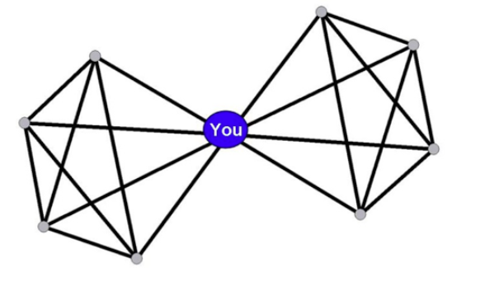
Using the scale below, please rate the extent to which you think you occupy a bridge position in your personal network of professional contacts related to teaching and/or education.

 | Zero |  |  |  | Many
In my network I occupy _____ bridge positions

Some of your professional contacts may have few other professional contacts that they could reach out to (pictured on the left). However, others might have many of their own contacts and greater reach (pictured on the right).
 | Zero | Few |  |  | Many
My contacts have ____ professional contacts
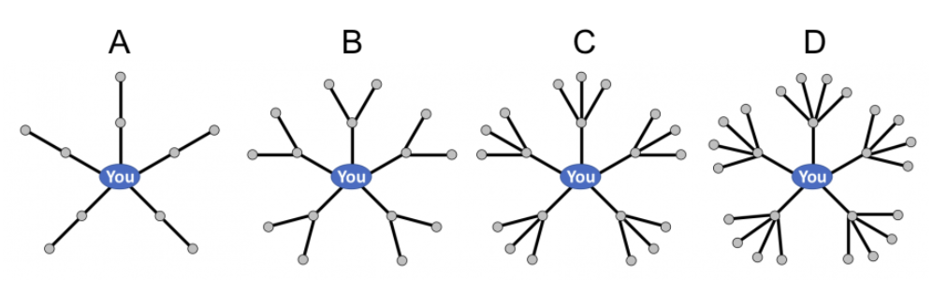In your opinion, which of the network diagrams above best approximates the reach in your personal network of professional contacts related to teaching and/or education? Please make your selection by clicking one of the options below.

For each contact, indicate how geographically close the contact is relative to your location. Select only the closest distance.
 | This contact is in the same ______ as me.
 | School/Workplace | District/County | State | Nation/International
Contact 1
Contact 2
Contact 3
Contact 4
Contact 5
Contact 6
Contact 7
Contact 8
Contact 9
Contact 10
Contact 11
Contact 12
Contact 13
Contact 14
Contact 15

The SNA questions above were related to Teaching Networks. The same questions were repeated for Teacher Leadership Networks. Teacher Leadership Network is introduced at the beginning of the Teacher Leadership Network Questions as follows:

In this section, you will answer questions about your teacher leadership. Teacher leadership may be broadly defined as the active involvement of teachers in the improvement of school culture and instruction and ultimately student learning through their participation in school-wide decision-making, and promotion of their teaching and learning expertise (York-Barr & Duke, 2004). Leadership activities include but not limited to mentoring new teachers, helping with school policy, leading school committees etc.

