Supplementary Material
The Transdisciplinary STEM Practices (T-STEMP) Assessment

Design phase | Key design challenges in this phase | Item NO. | Item
Identify the problems | Identifying the problems (n = 2) | Item 1-1 | Item 1-1 Ming is a third-grade elementary school student. His favorite marble accidentally rolled under the double bed in his room, which was made of solid wood with a mattress on top. Ming wants to retrieve the marble but cannot reach it by hand. There are many immovable items piled under the bed. What problems does Ming need to solve before retrieving the marble? For example, he needs to know the height of the bed.  Your answer: ____________________________.
Identify the problems | Identifying the problems (n = 2) | Item 9-1 | Item 9-1 Mr. Bai designed a racetrack and asked his students to create electric toy cars to complete the race. Based on the figure, what challenges might Mr. Bai's students encounter on the racetrack?  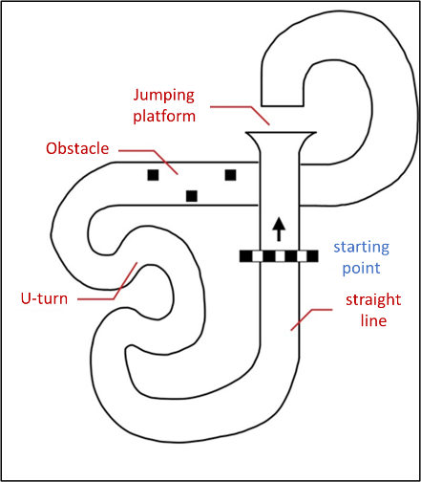  Your answer: ____________________________.
Identify the problems | Identifying the variables (n = 2) | Item 2 | Item 2 If you want to build a wire-controlled car that can run fast, what factors do you think would affect its speed? You can refer to the figures below. Identify two factors and explain why you think they would influence the car's speed.  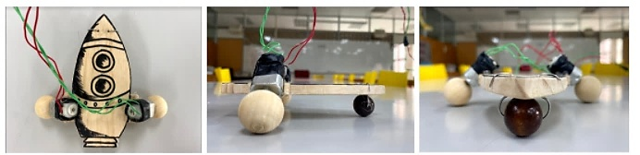  Your answer:  Factor 1 (__________, because __________).  Factor 2 (__________, because __________).
Identify the problems | Identifying the variables (n = 2) | Item 10 | Item 10 If we want the wire-controlled car to travel in a straight line without veering, what factors could influence its direction? Observe the two figures and identify two variables, explaining why you believe these variables would affect the car's trajectory.  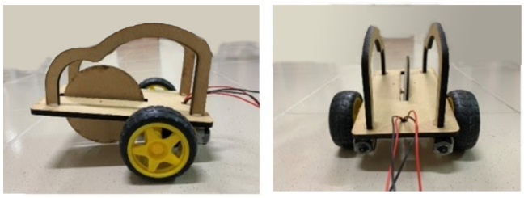  Your answer:  Factor 1 (__________, because __________).  Factor 2 (__________, because __________).
Identify the problems | Setting goals (n = 2) | Item 1-2 | Item 1-2 Suppose you want to build a wire-controlled car to help Ming collect marbles. What functions should this car have, and why?  Your answer: ____________________________.
Identify the problems | Setting goals (n = 2) | Item 9-2 | Item 9-2 If a student wants to win the competition, what functions does his/her car need? Why?"  Your answer: ____________________________.
Develop plans | Proposing feasible plans (n = 2) | Item 1-3 | Item 1-3 Propose at least three methods for collecting marbles that could be applied to the wire-controlled car, and explain the reasons for each.  Your answer: ____________________________.
Develop plans | Proposing feasible plans (n = 2) | Item 11 | Item 11 Propose a method that allows for real-time speed adjustments of the wire-controlled car during the journey, and explain the reasons.  Your answer: ____________________________.
Develop plans | Weighing the plans’ pros and cons (n = 3) | Item 4 | Item 4 Refer to the figures to compare the functions, advantages, and disadvantages of building a controller with one pair of nails versus three pairs of nails.  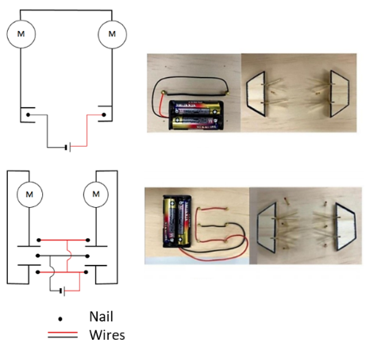  Your answer: ____________________________.
Develop plans | Weighing the plans’ pros and cons (n = 3) | Item 12 | Item 12 Figure A shows a "three-wheeled" wire-controlled car. What are the advantages and disadvantages of this design compared to the ball-wheel car in Figure B?  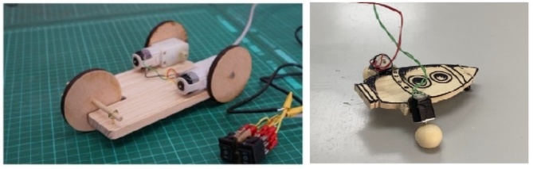  Figure A Figure B  Your answer:  Advantages: ___________________________________.  Disadvantages: ___________________________________.
Develop plans | Weighing the plans’ pros and cons (n = 3) | Item 20 | Item 20 If the wire-controlled car is changed to include four wheels, with each wheel equipped with a small motor, is this design feasible? What might be the potential advantages and disadvantages?  Your answer:  □ Feasible □ Not feasible  Advantages: ___________________________________.  Disadvantages: ___________________________________.
Develop plans | Identifying the best solution (n = 2) | Item 13 | Item 13 With an adequate supply of materials and sufficient funding, what type of front-wheel design do you think would be most suitable? Why?  Your answer: ____________________________.
Develop plans | Identifying the best solution (n = 2) | Item 21 | Item 21 Wei noticed that the wire-controlled car was running too fast and wanted to slow it down. His team suggested three methods:  - Use iron blocks to increase the car's weight.  - Replace the tires with treaded ones.  - Switch from AA batteries to AAA batteries.  Which method do you think would be the most effective?  □ Method 1 □ Method 2 □ Method 3  Why? ______________________________________.  Please explain why the other two methods are less effective: _______________________________________________.
Implement plans, models, and prototypes | Technical problem of processing (n = 2) | Item 6 | Item 6* As shown in the figure, please propose two processing methods to ensure that the tilt angles of the two motors are consistent.  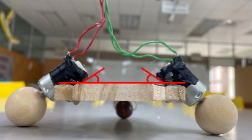  Your answer:  Method 1: _______________; how: ___________________.  Method 2: _______________; how: ___________________.
Implement plans, models, and prototypes | Technical problem of processing (n = 2) | Item 14 | Item 14 You need to make wheels for a wire-controlled car. The material provided is a piece of wood measuring 20 cm long, 20 cm wide, and 5 mm thick. Briefly describe which hand tools or machines you would use, and explain how to process the wood to create four wheels of identical size and shape.  Your answer: ____________________________.
Implement plans, models, and prototypes | Trouble-shooting (n = 4) | Item 3-1 | Item 3-1 As shown in the figure, when the two rear motors of the wire-controlled car rotate, the car struggles to move forward. This issue is not due to idling or jamming. Identify two possible reasons: one related to scientific principles and the other to the production process.  Your answer: ____________________________.
Implement plans, models, and prototypes | Trouble-shooting (n = 4) | Item 5 | Item 5 As shown in the figures, when small wooden beads are used as wheels, it was found that the wire-controlled car cannot move forward if the motor is placed flat on the car body. Please suggest one possible reason why the car cannot move forward and explain your reasoning.  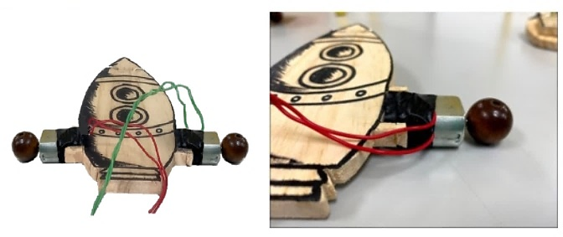  Your answer: ____________________________.
Implement plans, models, and prototypes | Trouble-shooting (n = 4) | Item 15 | Item 15 As shown in the figures, during the test, the two-foot pegs hit the nails, but the motors failed to turn. Propose two possible reasons why the motors did not function and explain your reasoning.  Your answer: ____________________________.
Implement plans, models, and prototypes | Trouble-shooting (n = 4) | Item 22 | Item 22 As shown in the figures, the car does not move in a straight line but either veers off course before proceeding forward or continues to deviate. Please discuss the reasons for the wire-controlled car's deviation with respect to the following:  - Scientific principles.  - The manufacturing processes.  - The design of the wire-controlled car.  Your answer: ____________________________.
Implement plans, models, and prototypes | Improving the solution (n = 2) | Item 3-2 | Item 3-2 Building on the issues identified in Item 3-1, propose a design solution to address one of the identified causes and ensure the car moves forward successfully.  Your answer: ____________________________.
Implement plans, models, and prototypes | Improving the solution (n = 2) | Item 16 | Item 16 As shown in the figure, if the car's wheels get stuck in a groove while moving, what modifications could be made to the wire-controlled car to prevent it from getting stuck in the same way next time?  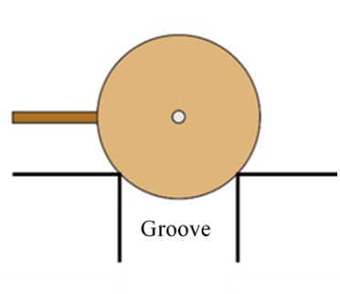  Your answer: ____________________________.
Evaluate and test | Predicting the effectiveness (n = 2) | Item 7 | Item 7* Assuming the motor speed is 13,000 revolutions per minute, and the wheels have a radius of 1.5 cm, theoretically, how far can the car travel forward in 6 seconds?  Your answer: ____________________________.
Evaluate and test | Predicting the effectiveness (n = 2) | Item 17 | Item 17  Explanation:  The current consumed by a motor is directly related to the torque it provides (torque is a rotational force, which can be thought of as the strength required for physical rotation). For a wire-controlled car, selecting a specific type of tire determines the torque the motor must supply. Generally, higher torque requires more current, resulting in slower rotational speed; conversely, lower torque requires less current, leading to faster rotational speed.  Question:  Today, Xiang-Xiang selected tires that require a torque of 1.8 mN-m to rotate. A single 1.5V AAA battery provides approximately 6000 joules of energy. The toy car race is expected to last at least 2 hours, and the car uses two motors.  How many AAA batteries does Xiang-Xiang need to complete the race? Please detail your evaluation method.  Refer to the data in Table 2.  Use the following formulas:  P=IV (Power = Current × Voltage)  E=Pt (Energy = Power × Time)  Your answer: ____________________________.
Evaluate and test | Analyzing the data (n = 2) | Item 8 | Item 8* The table shows the time taken by three wire-controlled cars to travel straight for 500 cm. Please analyze which car is the fastest and explain why.  Your answer: Car: _______________; why: ___________________.
Evaluate and test | Analyzing the data (n = 2) | Item 18 | Item 18 After conducting several tests, Xiang-Xiang compiled data using the same motor and battery. The table below shows the results. If he wants to select the wheel diameter that allows the car to run the fastest, which diameter should he choose? Describe your analysis process.  Your answer:  □ Wheel with a diameter of 1.0 cm  □ Wheel with a diameter of 1.5 cm  □ Wheel with a diameter of 2.0 cm  □ Wheel with a diameter of 2.5 cm  Your analysis process: _______________________________.
Evaluate and test | Testing the result (n = 2) | Item 1-4 | Item 1-4 As shown in the figures below, does this wire-controlled car (height 14cm) meet the predefined goal described in Item 1-1?  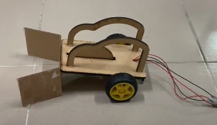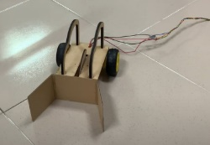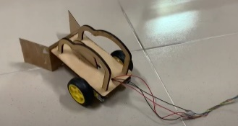  Your answer:  □ Achieved □ Not Achieved  Please briefly explain whether this wire-controlled car "achieved" or "did not achieve" the predefined goal.  _________________________________________________________.
Evaluate and test | Testing the result (n = 2) | Item 19 | Item 19 A student designed three wire-controlled cars and seeks your help in creating a testing method to determine which car performs best in "stable, straight-line, high-speed movement." Describe your testing method, the process, and the parameters (data and information) to be collected.  Your answer: ____________________________.
Note: This assessment was originally in Chinese and has been translated into English for publication. The original problem scenarios in Items 1-4, 3-1, 15, and 22 were presented in a video. In this Supplementary Material, figures are used instead of videos for publication.
Note*: Items 6, 7, and 8 are adapted from Fang, S. C., Yang, K. L., & Fan, S. C. (2023). A conceptual framework for assessing transdisciplinary STEM practices. Research in Science & Technological Education, 1–22. https://doi.org/10.1080/02635143.2023.2264781

