Supplementary Online Appendix to the Manuscript:
Putting the Pieces of the Puzzle Together in Modeling Gendered Educational Choices

Supplementary to the Section Methods

Table OA.1 presents the five sets of predictors used in the present study and indicates whether they reflect central constructs within the five conceptual frameworks that guided our research. For example, all five frameworks identify gender (female) as a key predictor of educational and career choices, although they may differ in the mechanisms proposed to explain gender disparities. Gottfredson’s Theory of Circumscription and Compromise (TCC), for example, describes a career decision-making process constrained by the gender typicality of available options, and Eccles et al.’s Expectancy-Value Theory (EVT) emphasizes the psychological costs associated with choosing a gender-atypical occupation. Both frameworks suggest that individuals tend to avoid occupations that are not typical for their gender, as such choices may violate social norms and pose a threat to one’s gender identity (see, e.g., Lauermann et al., 2017; Parker et al., 2012).

Table OA.1
Overview of Predictor Variables Used in the Study and Related Conceptual Frameworks
 | TCC | EVT | IE-FRM | DEM | GCM | Additional predictor
Demographic
Female | $$√$$ | $$√$$ | $$√$$ | $$√$$ | $$√$$
SES  - SES composite score  - Immigration background | $$√$$ | $$√$$ |  | $$√$$
Female $×$ SES | $$√$$ |  |  | $$√$$
Twelve vs. thirteen years of schooling | $$√$$ |  |  |  |  | $$√$$
Achievement
Math test score |  | $$√$$ | $$√$$ | $$√$$
Math grade |  | $$√$$ | $$√$$ | $$√$$
Language arts test score |  | $$√$$ | $$√$$ | $$√$$
Language arts grade |  | $$√$$ | $$√$$ | $$√$$
Math $×$ Language arts test scores |  |  | $$√$$
Motivation
Math self-concept | $$√$$ | $$√$$ | $$√$$ | $$√$$
Math intrinsic value | $$√$$ | $$√$$
Language arts self-concept | $$√$$ | $$√$$ | $$√$$ | $$√$$
Language arts intrinsic value | $$√$$ | $$√$$
School self-concept |  | $$√$$ | $$√$$ | $$√$$
Math self-concept $×$ Intrinsic value |  | $$√$$
Language arts self-concept $×$ Intrinsic value |  | $$√$$
Math $×$ Language arts self-concept |  | $$√$$ | $$√$$ | $$√$$
Math $×$ Language arts intrinsic value |  | $$√$$
Career expectations
Gendered career aspirations: Proportion of female job incumbents |  |  |  |  |  | $$√$$
STEM career aspirations | $$√$$
PTEM career aspirations | $$√$$
TE career aspirations | $$√$$
Expected log income |  |  |  |  |  | $$√$$
Meaning of work goals
Agentic/Economic goals |  |  |  |  | $$√$$
Communal/Social goals |  |  |  |  | $$√$$
Agentic $×$Communal |  |  |  |  | $$√$$
Expressive goals |  |  |  |  |  | $$√$$
Expressive $×$Agentic |  |  |  |  |  | $$√$$
Expressive $×$Communal |  |  |  |  |  | $$√$$

Table OA.2 for all variables the names within NEPS, our variable names, the items and the possible responses. The latter two first in English and the original Version in German.

Table OA.2
NEPS Items
Variable name in NEPS | Variable name in the study | Translated item | Translated item response | Original German item | Original German item response
Demographic
t700031 | Gender | Are you ... "Please mark with a cross where applicable." | ...male?  ...female? | Sind Sie ... «Zutreffendes bitte ankreuzen.» | ...männlich? ...weiblich?
t34006a | Study_desk* | Does your home have a desk for studying? | - Yes  - No | Gibt es bei Ihnen zu Hause einen Schreibtisch zum Lernen? | - Ja  - Nein
t34006b | Room* | … a room for you alone? | See above | ... ein Zimmer für Sie allein? | Siehe oben
t34006c | LernSoft* | ... learning software? | See above | ... Lern‐Software? | Siehe oben
t34006d | ClassLit* | ... classical literature (e.g. by Goethe)? | See above | ... klassische Literatur (z.B. von Goethe)? | Siehe oben
t34006e | Poems* | ... books with poems? | See above | ... Bücher mit Gedichten? | Siehe oben
t34006f | Art* | ... works of art (e.g. paintings)? | See above | ... Kunstwerke (z.B. Gemälde)? | Siehe oben
t34006g | HelpBooks* | ... books that are helpful for homework? | See above | ... Bücher, die bei Hausaufgaben hilfreich sind? | Siehe oben
t34006h | Dictionary* | ... a dictionary? | See above | ... ein Wörterbuch? | Siehe oben
p510001 | income.w1.5.7 | Now it's all about the income of your entire household: What is the monthly household income of all household members today? Please enter the net amount, i.e. after deduction of taxes and social security contributions. Please include regular payments such as pensions, housing benefit, child benefit, BAföG, maintenance payments, unemployment benefit, etc.! | Numeric value | Jetzt geht es um alle Einkünfte Ihres gesamten Haushalts: Wie hoch ist das monatliche Haushaltseinkommen aller Haushaltsmitglieder heute? Bitte geben Sie den Netto‐Betrag an, also nach Abzug von Steuern und Sozialabgaben. Regelmäßige Zahlungen wie Renten, Wohngeld, Kindergeld, BAföG, Unterhaltszahlungen, Arbeitslosengeld usw. rechnen Sie bitte dazu! | Numerischer Wert
p731904_g4 | ses.par1.isco.w1 | Please tell me what your current occupation is: | Text field | Sagen Sie mir bitte, welche berufliche Tätigkeit Sie derzeit ausüben: | Textfeld
p731954_g4 | ses.par2.isco.w1 | Please tell me what your partner's current occupation is | Text field | Sagen Sie mir bitte, welche berufliche Tätigkeit Ihr Partner derzeit ausübt. | Textfeld
p406000_g1 | born.in.ger.child.w157 | Was <name of target child> born in Germany? | - Yes  - No | Ist <Name des Zielkindes> in Deutschland geboren? | - Ja  - Nein
p400000_g1 | born.in.ger.respond.w157 | Where were you born? | - In Germany / in the territory of present-day Germany  - In former German eastern territories  - Abroad / in another country  - Don't know | Wo sind Sie geboren? | - In Deutschland / im Gebiet des heutigen Deutschlands  - In früheren deutschen Ostgebieten  - Im Ausland / in einem anderen Land  - weiß nicht
p403000 | born.in.ger.part.w157 | Where was your partner born? | See above plus  - Specification refused | Wo ist Ihr Partner geboren? | Siehe oben plus  - Angabe verweigert
p400500_g1 | Generational status | NEPS* | – | NEPS* | –
Competences
t724101 | Language Arts Grade | What grade did you get in your last school report in German? | 1 to 6 | Welche Note hatten Sie im letzten Jahreszeugnis in Deutsch? | 1 bis 6
t724111 | Language Arts Grade (second wave only) | What grade did you get in your last semester report card in German? | See above | Welche Note hattest du im letzten Halbjahreszeugnis in Deutsch? | Siehe oben
t724102 | Math grade | What grade did you get in your last annual report in math? | See above | Welche Note hatten Sie im letzten Jahreszeugnis in Mathematik? | Siehe oben
t724112 | Math grade (second wave only) | What grade did you get in your last semester report card in math? | See above | Welche Note hattest du im letzten Halbjahreszeugnis in Mathematik? | Siehe oben
reg12_sc1u | Language arts NEPS competence test score | Reading competence: WLE (uncorrected) | NEPS* | Lesekompetenz: WLE (unkorrigiert) | NEPS*
mag12_sc1u | Math NEPS competence test score | Mathematical competence: WLE (uncorrected) | NEPS* | Mathematische Kompetenz: WLE (unkorrigiert) | NEPS*
Motivation
t66000a | Language arts self-concept item 1 | How do you rate yourself at school? I'm a hopeless case in German. "Please check one box in each line." | - Does not apply at all (1)  - Tends not to apply (2)  - Tends to apply (3)  - fully applies (4) | Wie schätzen Sie sich in der Schule ein? Im Fach Deutsch bin ich ein hoffnungsloser Fall. «Bitte in jeder Zeile ein Kästchen anklicken.» | - Trifft gar nicht zu (1)  - Trifft eher nicht zu (2)  - Trifft eher zu (3)  - Trifft völlig zu (4)
t66000b | Language arts self-concept item 2 | … I'm a quick learner in German. | See above | Im Fach Deutsch lerne ich schnell. | Siehe oben
t66000c | Language arts self-concept item 3 | I get good grades in German. | See above | Im Fach Deutsch bekomme ich gute Noten. | Siehe oben
t66001a | Math self-concept item 1 | To what extent do the following statements apply to you? ⊲ I simply enjoy puzzling out a mathematical problem. "Please check one box in each line." | See above | Wie sehr treffen folgende Aussagen auf dich zu? ⊲ An einem mathematischen Problem zu knobeln, macht mir einfach Spaß. «Bitte in jeder Zeile ein Kästchen ankreuzen.» | Siehe oben
t66001b | Math self-concept item 2 | Mathematics is one of my best subjects. | See above | Mathematik ist eines meiner besten Fächer. | Siehe oben
t66001c | Math self-concept item 3 | I've always been good at math | See above | Ich war schon immer gut in Mathematik | Siehe oben
t66002a | School self-concept item 1 | How do you rate yourself at school? I learn quickly in most school subjects. "Please check one box in each line." | See above | Wie schätzen Sie sich in der Schule ein? In den meisten Schulfächern lerne ich schnell. «Bitte in jeder Zeile ein Kästchen anklicken.» | Siehe oben
t66002b | School self-concept item 2 | I do well in class tests in most school subjects. | See above | In den meisten Schulfächern schneide ich in Klassenarbeiten gut ab. | Siehe oben
t66002c | School self-concept item 3 | I'm good at most school subjects. | See above | Ich bin in den meisten Schulfächern gut. | Siehe oben
t66208a | Intrinsic value language arts item 1 | How much do the following statements apply to you? ⊲ I simply enjoy reading texts and writing them myself | See above | Wie sehr treffen folgende Aussagen auf dich zu? ⊲ Texte zu lesen und selbst zu verfassen, macht mir einfach Spaß | Siehe oben
t66208b | Intrinsic value language arts item 2 | … It means a lot to me to become more familiar with the German language and literature. | See above | … Es bedeutet mir viel, mit der deutschen Sprache und Literatur vertrauter zu werden. | Siehe oben
t66208c | Intrinsic value language arts item 3 | … I really enjoy learning new things about myself and the world while reading books. | See above | … Ich habe große Freude daran, beim Bücherlesen Neues über mich und die Welt zu lernen. | Siehe oben
t66208d | Intrinsic value language arts item 4 | … I am also prepared to spend some of my free time getting to know the German language and literature better. | See above | … Ich bin bereit, auch einen Teil meiner Freizeit dafür zu verwenden, die deutsche Sprache und Literatur besser kennen zu lernen. | Siehe oben
t66201a | Intrinsic value math item 1 | To what extent do the following statements apply to you? ⊲ I simply enjoy puzzling out a mathematical problem. | See above | Wie sehr treffen folgende Aussagen auf dich zu? ⊲ An einem mathematischen Problem zu knobeln, macht mir einfach Spaß. | Siehe oben
t66201b | Intrinsic value math item 2 | … When I'm working on a mathematical problem, it can happen that I don't even notice how time flies. | See above | … Wenn ich an einem mathematischen Problem sitze, kann es passieren, dass ich gar nicht merke, wie die Zeit verfliegt. | Siehe oben
t66201c | Intrinsic value math item 3 | If I can learn something new in math, I'm prepared to spend my free time on it. | See above | Wenn ich in Mathematik etwas Neues dazulernen kann, bin ich bereit, auch Freizeit dafür zu verwenden. | Siehe oben
t66201d | Intrinsic value math item 4 | Mathematics is one of the most important things for me personally. | See above | Mathematik gehört für mich persönlich zu den wichtigsten Dingen. | Siehe oben
Career aspirations
t31160a_g2 | Career aspiration | Think about everything you know right now. What profession do you think you will actually have later? "If you are not yet sure, then enter the profession that you think is most likely." | Open-ended | Denken Sie einmal an alles, was Sie gerade wissen. Welchen Beruf werden Sie wohl später tatsächlich haben? «Wenn Sie sich noch nicht sicher sind, dann geben Sie den Beruf ein, der Ihrer Meinung nach am wahrscheinlichsten ist.» | Offenes Ende
t513021 | Expected income | Expected income for future profession [EUR per month] | Numeric value | Erwartetes Einkommen zukünftiger Beruf [EUR pro Monat] | Numerischer Wert
Meaning of work beliefs |  | Below is a list of some of the things that can be important to you in your job. How important are these things to you personally, regardless of your current situation? ⊲ p) the feeling of doing something meaningful "Please check one box in each line." | Please answer on a scale from 1 to 6. '1' means that the aspect is very unimportant to you, '6' means that it is very important to you. You can use the numbers in between to grade your judgement. | Im Folgenden sind einige Dinge aufgelistet, die einem bei einer Berufstätigkeit wichtig sein können. Wie wichtig sind diese Dinge für dich persönlich, unabhängig von deiner aktuellen Situation? ⊲ p) das Gefühl, etwas Sinnvolles zu tun «Bitte in jeder Zeile ein Kästchen ankreuzen.» | Bitte antworten Sie auf einer Skala von 1 bis 6. ’1’ bedeutet, dass Ihnen der Aspekt sehr unwichtig ist, ’6’ bedeutet, dass er Ihnen sehr wichtig ist. Mit den Zahlen dazwischen können Sie Ihr Urteil abstufen.
t66210k | Expressive goals item 1 | Doing something meaningful | See above | Sinnvolles tun | Siehe oben
t66210f | Expressive goals item 2 | Interesting work | See above | Interessante Arbeit | Siehe oben
t66210e | Expressive goals item 3 | Varied responsibilities | See above | vielfältige Aufgaben | Siehe oben
t66210c | Economic goals item 1 | Promotion opportunities | See above | Aufstiegsmöglichkeiten | Siehe oben
t66210g | Economic goals item 2 | Job security | See above | Arbeitsplatzsicherheit | Siehe oben
t66210h | Economic goals item 3 | Good pay | See above | Gute Bezahlung | Siehe oben
t66210l | Communal goals item 1 | Useful work | See above | Nützliche Arbeit | Siehe oben
t66210n | Communal goals item 2 | Help others | See above | Anderen helfen | Siehe oben
t66210p | Communal goals item 3 | Doing something meaningful | See above | Sinnvolles tun | Siehe oben
Note: The items are from the NEPS codebook and were translated from the original German wording into English. NEPS*: Generated by NEPS.

Variables with measurements at different times

The first table in the online appendix (Table OA3) summarizes the measurement time points of each of the variables. For some, we have several measurement points, while for a few there is only one. The regression analyses in Tables OA4 through OA5 elucidate the nuanced effects of reform on grades, competency test scores, self-concept, and gendered career aspirations within STEM contexts. This subsection aims to assess whether the point of measurement contributes incremental information or whether the timing of these variables insignificantly influences STEM major choice. This evaluation involves regressing variables with different points of measurement on STEM major choice (including a female dummy to ensure an overall stable regression fit), followed by a combined model incorporating all measurements of that variable. Should the timing of the measurement prove unimportant, no meaningful improvement in explained variation (as indicated by adjusted R², AIC, and BIC) is expected. This analysis is applied to German and math grades over three waves in Table OA4, to language arts and math competence test scores over three waves in Table OA5, and to self-concept and gendered career aspirations over two and three waves in Table OA6.

Table OA.3
Overview Variables and Waves
Variables | Wave 1: Begin 9th Grade | Wave 2: End of 9th Grade |  | Wave 3: Begin of 10th Grade | Wave 5: Begin of 11th Grade | Wave 7: Begin of 12th Grade | Wave 8: Begin of 13th Grade
Female | x
Immigration background | x
School years |  |  |  |  |  |  | x
SES | x
German grade | x |  | x | x | x
Math grade | x |  | x | x | x
German competence score | x |  |  | x |  | x
Math competence score | x |  |  | x |  | x
German self-concept | x |  |  |  |  | x
Math self-concept | x |  |  |  |  | x
School self-concept | x |  |  |  |  | x
Reading interest |  |  | x
Math interest |  |  | x
Expressive goal |  |  |  | x
Economic goal |  |  |  | x
Social goal |  |  |  | x
Career aspirations |  |  | x | x | x | x
Expected income |  |  | x | x |  | x

Table OA.4 shows in the first column (“First measurement”) a regression of those variables which are measurement at least twice with their first measurement and in the second column (“Last measurement”) with the last measurement of those variables. Comparing the same variables with different time points shows a range of Δβ = [0.001; 0.050]. The maximum of 0.05 is for language arts self-concept. Another difference is, that the coefficient of school self-concept was negative for the first measurement while positive for the last. However, both are not statistically significant. There is no case in which a coefficient is just significant for one of the measurements.

Table OA.4

Regression results: Waves – Self-concept and gendered career aspirations – STEM
 | First measurement | Last measurement
(Intercept) | 0.619*** | 0.591***
 | (0.020) | (0.024)
Female | -0.097*** | -0.020
 | (0.019) | (0.016)
Verbal self-concept W1 | -0.022*
 | (0.009)
Verbal self-concept W7 |  | -0.072***
 |  | (0.009)
Math self-concept W1 | 0.086***
 | (0.010)
Math self-concept W7 |  | 0.067***
 |  | (0.009)
School self-concept W1 | -0.014
 | (0.009)
School self-concept W7 |  | 0.007
 |  | (0.008)
Reading test score W1 | -0.023**
 | (0.008)
Reading test score W7 |  | -0.038***
 |  | (0.008)
Math test score W1 | 0.023**
 | (0.009)
Math test score W7 |  | 0.056***
 |  | (0.009)
Grade German W1 | 0.034***
 | (0.010)
Grade German W5 |  | 0.023**
 |  | (0.009)
Grade math W1 | -0.008
 | (0.010)
Grade math W5 |  | -0.008
 |  | (0.009)
Gendered career aspiration W2 | -0.045***
 | (0.004)
Gendered career aspiration W7 |  | -0.051***
 |  | (0.004)
STEM career aspiration W2 | 0.179***
 | (0.024)
STEM career aspiration W7 |  | 0.222***
 |  | (0.024)
R2 | 0.236 | 0.367
Adj.R2 | 0.234 | 0.365
N | 4383 | 4383

W1 = Begin of 9th grade; W2 = End of 9th grade; W3 = Begin of 10th grade; W5 = Begin of 11th grade; W7 = End of 12th or 13th grade. ***p < 0.001; **p < 0.01; *p < 0.05; ⁺p < 0.1

Auxiliar Regression Results for the Socio-economic Status

Table OA.5
PCA Metrics Summary Across Models
Metric | Model 1 | Model 2 | Model 3 | Model 4 | Model 5 | Model 6
Sum of goods | 0.636 | 0.697 | 0.834 | - | - | -
Educational background of parents | 0.859 | 0.871 | 0.834 | 0.881 | 0.922 | 1
Parental HISEI | 0.876 | 0.882 | - | 0.893 | 0.922 | -
Parental income | 0.832 | - | - | 0.856 | - | -
Proportion Var by PC1 | 2.602 | 2.022 | 1.393 | 2.307 | 1.698 | 1
RMSR | 0.119 | 0.172 | 0.304 | 0.117 | 0.151 | -
Fit based upon off diagonal values | 0.951 | 0.892 | 0.402 | 0.968 | 0.953 | -
Note:
Model 1 includes sum of goods, parental education background, parental HISEI, and parental categorized income.
Model 2 includes sum of goods, parental education background, parental HISEI.
Model 3 includes sum of goods, parental education background (like in Hanushek et al., 2022).
Model 4 includes parental education background, parental HISEI, and parental categorized income.
Model 5 includes parental education background, parental HISEI.
Model 6 is just the variable parental education background.

Table OA.6
Correlation between outcome variables, students gender, as well as three different versions of the SES variable
 | STEM | PTEM | TE | STEMM | Ratio | Female | SES_1 | SES_2 | SES_3
STEM | 1.00 | 0.93 | 0.75 | 0.90 | -0.75 | -0.32 | -0.07 | -0.07 | -0.08
PTEM | 0.93 | 1.00 | 0.81 | 0.84 | -0.81 | -0.34 | -0.07 | -0.07 | -0.07
TE | 0.75 | 0.81 | 1.00 | 0.68 | -0.81 | -0.32 | -0.10 | -0.10 | -0.09
STEMM | 0.90 | 0.84 | 0.68 | 1.00 | -0.61 | -0.27 | -0.03 | -0.03 | -0.04
Ratio | -0.75 | -0.81 | -0.81 | -0.61 | 1.00 | 0.41 | 0.07 | 0.09 | 0.09
Female | -0.32 | -0.34 | -0.32 | -0.27 | 0.41 | 1.00 | 0.04 | 0.06 | 0.08
SES_1 | -0.07 | -0.07 | -0.10 | -0.03 | 0.07 | 0.04 | 1.00 | 0.97 | 0.89
SES_2 | -0.07 | -0.07 | -0.10 | -0.03 | 0.09 | 0.06 | 0.97 | 1.00 | 0.94
SES_3 | -0.08 | -0.07 | -0.09 | -0.04 | 0.09 | 0.08 | 0.89 | 0.94 | 1.00
Note: Data uses the first imputated dataset.
SES_1 is the first PC using sum of goods, parental education background, parental HISEI, and parental categorized income.
SES_2 is the first PC using sum of goods, parental education background, parental HISEI.
SES_3 is the first PC using sum of goods, parental education background (like in Hanushek et al., 2022). Correlation show very little differences between the three different SES variables.

Table OA.7
Regression results explaining PTEM using different SES variables
 | Model 1 | Model 2 | Model 3 | Model 4 | Model 5 | Model 6
(Intercept) | 0.328*** | 0.328*** | 0.328*** | 0.328*** | 0.328*** | 0.328***
 | (0.007) | (0.007) | (0.007) | (0.007) | (0.007) | (0.007)
SES_1 | -0.025**
 | (0.008)
SES_2 |  | -0.026**
 |  | (0.009)
SES_3 |  |  | -0.031***
 |  |  | (0.008)
SES_4 |  |  |  | -0.019*
 |  |  |  | (0.009)
SES_5 |  |  |  |  | -0.018*
 |  |  |  |  | (0.009)
SES_6 |  |  |  |  |  | -0.016*
 |  |  |  |  |  | (0.008)
R2 | 0.003 | 0.003 | 0.004 | 0.002 | 0.002 | 0.001
Adj.R2 | 0.003 | 0.003 | 0.004 | 0.001 | 0.001 | 0.001
BIC (null) | -4 | -6 | -11 | 1 | 1 | 3
N | 4383 | 4383 | 4383 | 4383 | 4383 | 4383
Note:
SES_1 is the first PC using sum of goods, parental education background, parental HISEI, and parental categorized income.
SES_2 is the first PC using sum of goods, parental education background, parental HISEI.
SES_3 is the first PC using sum of goods, parental education background (like in Hanushek et al., 2022).
SES_4 is the first PC using parental education background, parental HISEI, and parental categorized income.
SES_5 is the first PC using parental education background, parental HISEI.
SES_6 is just the variable parental education background.
***p < 0.001; **p < 0.01; *p < 0.05; +p < 0.1

Table OA.8
Regression results explaining PTEM using three SES variables interacted with female
 | Model 1 | Model 2 | Model 3 | Model 4 | Model 5 | Model 6
(Intercept) | 0.497*** | 0.497*** | 0.496*** | 0.497*** | 0.496*** | 0.496***
 | (0.011) | (0.011) | (0.011) | (0.011) | (0.011) | (0.011)
ses_pca1 | -0.020* |  |  | -0.023⁺
 | (0.008) |  |  | (0.013)
Female | -0.321*** | -0.320*** | -0.319*** | -0.321*** | -0.320*** | -0.319***
 | (0.014) | (0.014) | (0.014) | (0.014) | (0.014) | (0.014)
ses_pca2 |  | -0.018* |  |  | -0.025⁺
 |  | (0.008) |  |  | (0.013)
ses_pca3 |  |  | -0.018* |  |  | -0.026*
 |  |  | (0.007) |  |  | (0.012)
ses_pca1 $×$ Female |  |  |  | 0.006
 |  |  |  | (0.015)
ses_pca2 $×$ Female |  |  |  |  | 0.012
 |  |  |  |  | (0.015)
ses_pca3 $×$ Female |  |  |  |  |  | 0.017
 |  |  |  |  |  | (0.015)
R2 | 0.119 | 0.119 | 0.119 | 0.119 | 0.119 | 0.119
Adj.R2 | 0.119 | 0.118 | 0.118 | 0.119 | 0.118 | 0.118
BIC (null) | -539 | -538 | -537 | -531 | -530 | -531
N | 4383 | 4383 | 4383 | 4383 | 4383 | 4383
Note:
SES_1 is the first PC using sum of goods, parental education background, parental HISEI, and parental categorized income.
SES_2 is the first PC using sum of goods, parental education background, parental HISEI.
SES_3 is the first PC using sum of goods, parental education background (like in Hanushek et al., 2022). SES_4 to SES_6 are not included anymore due to their worse fit above.
***p < 0.001; **p < 0.01; *p < 0.05; ⁺p < 0.1

Table OA.9
Mapping Diekman’s (2010) Agentic and Communal Goal Congruity Items with the NEPS Meaning of Work Items
Agentic (Diekman, 2010) | Economic (NEPS) | Expressive (NEPS) | Communal (Diekman, 2010) | Communal (NEPS)
Power | Promotion opportunities | – | Helping others | Helping others
Recognition | Promotion opportunities | – | Serving humanity | Useful for society
Achievement | Promotion opportunities | – | Serving community | Useful for society
Mastery |  | Match with capabilities (skills & tasks) | Working with people | –
Self-promotion | Promotion opportunities |  | Connection with others | –
Independence |  | Independence/ Self-determinations; Diverse tasks | Attending to others | –
Individualism | – | Diverse tasks | Caring for others | Helping others
Status | Promotion opportunities; Good pay | – | – | Useful work
Intimacy | – | – | – | –
Focus on the self |  | Independence/ Self-determinations | – | –
Spiritual rewards | – | – | – | –
Success | Promotion opportunities | – | – | –
Financial rewards | Good pay | – | – | –
Self-direction | – | Independence/ Self-determinations | – | –
Demonstrating skill or competence | – | Match with capabilities (skills & tasks) | – | –
Competition | Promotion opportunities |  | – | –
– | Job security | Interesting work content | – | –
Note. Text

Univariate PRE Analysis

Here, we report the univariate PRE results. The results were very similar to the multivariate PRE results and further underscored that gendered career aspirations emerged as the most incremental predictor for all outcomes, except for women predicting STEMM, where math self-concept played an even more prominent role. Aside from gendered career aspirations, language arts self-concept and math self-concept, along with field-specific career aspirations, were always influential predictors. Additionally, the importance of math competence test scores and math interest varied across different outcomes, showing an exchange in hierarchy between them. For example, for women predicting STEM, math competence held higher importance, whereas math interest was more crucial when predicting PTEM. Interestingly, math interest was a significant factor for women predicting TE but not for men, while math competence played a key role for men predicting STEMM but not for women. Furthermore, while LASSO selected only gendered career aspirations for women predicting students' major choices, the PRE identified several other relevant predictors. In general, the variable importance confirms the LASSO selection, except that the social mean of work is selected less often compared to LASSO (Table Univariate1).

Focusing then on the prediction rules derived from the prediction rule ensembles (PRE), the Tables Univariate2 to Univariate5 shows which variable combinations were most important and that particularly interactions gendered career aspirations, self-concept in language arts and mathematics, field-specific career aspirations, as well as math interest consistently influence important choices across outcomes. These findings point to the critical role of gendered career aspirations in shaping students' academic trajectories, regardless of the specific major they choose.

More specifically, Table Univariate2 shows which combination of variables was selected how often to predict each outcome for each group shown in the column heading. For both males and females, gendered career aspirations consistently interacted with language arts self-concept and math self-concept to predict all outcomes. In addition, specific field career aspirations also showed a consistent interaction with gendered career aspirations as well as language arts and math self-concept and gendered career aspirations. Also, gendered career aspirations and math interest were always selected for the outcome gender-typicality of students' major choice.

For males, the results mirrored those for females, with gendered career aspirations playing a central role and consistently interacting with language arts and math self-concept. Also, the interactions of gendered career aspirations and language arts self-concept with field-specific career aspirations were consistent across outcomes. Again, the interaction of language arts and math self-concept was also selected.

For females, the interaction of gender-specific career aspirations with language arts and math self-concept remained a consistent predictor across outcomes. In contrast to before, only the combination of language arts self-concept and math competency test scores was selected for all outcomes except TE. This combination was selected only for males, predicting STEM and PTEM. Previously, no achievement measure was selected, only motivational variables. Achievement seems to play a greater role for women than for men.

When looking at the order of outcomes by group, additional insights can be seen in Table 8. For example, in predicting STEM outcomes, the interaction of gendered career aspirations with both language arts self-concept and math self-concept was consistent for both genders. When we focus on what was selected for males but not for females, and vice versa, we see the following differences: The interaction between gender and domain interactions, between gender career aspirations and mathematics interest, and between language arts (reading) literacy and domain career aspirations were selected for males but not for females. Conversely, the combination of field-specific career aspirations and math and language arts interest was selected for women.

In predicting PTEM scores, similar observations were made, with general career aspirations, language arts self-concept, and math self-concept being significant influencers for both genders. However, for males, final grades in language arts and math played a role in predicting PTEM outcomes. This suggests that for males, academic achievement may also be an important aspect of PTEM career aspirations. For women, the results reflected similar trends, with the addition of field-specific PTEM career aspirations playing a significant role.

For the TE outcome, the patterns remained largely consistent with the previous results for both genders, while the addition of TE-specific career aspirations became significant for men. For women, the interaction between gender-specific career aspirations and interest in mathematics was observed.

Regarding STEMM and GenStu outcomes, the interactions of gendered career aspirations, language arts self-concept, and math self-concept remained consistently influential for both genders. Females, however, showed a unique interplay of variables, such as language arts self-concept with expected log income for STEMM and the interaction between language arts self-concept and STEM-specific career aspirations for GenStu.

Focusing on variable combinations that were selected only for certain outcomes or for one group but not the other, indicating their unique influences, the interaction between language arts (reading) competence test score and STEM-specific career aspirations is selected only for males in predicting STEM outcomes, but not for females or for any other outcome. Similarly, the combination of STEM-specific career aspirations and interest in language arts is selected only for females in predicting STEM outcomes, but not for males or in any other outcome.

It's worth noting that most of the variable combinations mentioned are selected not just once, but multiple times, indicating multiple important cutoffs. Therefore, for a better overview, we have plotted the rules for 5 important variable combinations explaining STEM majors in Figure Univariate1 (Figure Univariate2 includes the plots for all other outcomes). In particular, there is an interaction effect of self-concept in language arts and gendered career aspirations. When males have a low ratio (<3) of gender-specific career aspirations, they appear to have the highest likelihood of choosing STEM, and their levels of verbal or math concept do not appear to affect the likelihood of choosing STEM much. Only at higher levels of gender-specific career aspirations (>3) do verbal and math self-concept start to play a role, with the former having a negative and the latter a positive effect on the likelihood of choosing STEM.

For females, verbal and math self-concept always have an effect on the likelihood of choosing STEM, with the former having a negative and the latter a positive effect on the likelihood of choosing STEM. Higher levels of gender-specific career aspirations are negatively associated with the likelihood of choosing STEM. A similar pattern is seen when math self-concept is exchanged for interest in math and STEM career aspirations. The patterns are also similar for the other outcomes (Figure Univariate 2)

Table OA.10
Variable Importance via Prediction Rule Ensemble
 | Variables importance
 | Men and Women |  |  |  |  | Men |  |  |  |  | Women
Variables | STEM | PTEM | TE | STEMM | Ratio | STEM | PTEM | TE | STEMM | Ratio | STEM | PTEM | TE | STEMM | Ratio
Gendered career aspi. | 1.02 | 0.77 | 1.18 | 0.92 | 9.45 | 0.80 | 0.89 | 0.82 | 0.79 | 8.00 | 0.49 | 0.45 | 1.20 | 0.26 | 5.82
Language arts self-concept | 0.70 | 0.43 | 0.56 | 0.42 | 3.66 | 0.47 | 0.52 | 0.40 | 0.31 | 4.97 | 0.43 | 0.40 | 0.40 | 0.27 | 2.59
Math self-concept | 0.64 | 0.47 | 0.72 | 0.65 | 2.70 | 0.48 | 0.53 | 0.30 | 0.66 | 2.93 | 0.33 | 0.33 | 0.30 | 0.48 | 2.52
STEM career aspi. | 0.51 |  |  | 0.51 |  | 0.40 |  |  | 0.42 |  | 0.41 |  |  | 0.28 | 0.50
PTEM career aspi. |  | 0.33 |  |  | 0.02 |  | 0.41 |  |  |  |  | 0.36 |  |  | 0.70
TE career aspi. |  |  | 0.36 |  | 1.43 |  |  | 0.37 |  | 1.97 |  |  | 0.37
Math test score | 0.20 | 0.21 |  | 0.20 |  | 0.12 | 0.09 |  | 0.07 |  | 0.32 | 0.10 |  | 0.20 | 0.20
Language arts test score |  | 0.09 | 0.12 |  |  | 0.10 |  | 0.10 |  | 0.71
German grade |  | 0.11 | 0.03 |  |  |  | 0.07 |  |  |  |  | 0.09 |  |  | 0.19
Math Grade |  |  |  |  |  |  | 0.05
Lanugage arts intrinsic value |  |  | 0.14 |  | 0.62 |  |  | 0.10 |  | 0.77 | 0.08 |  |  |  | 0.22
Math intrinsic value | 0.14 | 0.22 | 0.13 | 0.19 | 0.75 | 0.06 | 0.14 |  |  |  | 0.17 | 0.19 | 0.19 | 0.15 | 1.03
Economic goals |  |  |  |  | 0.59 |  |  |  |  |  |  |  |  |  | 0.94
Social goals |  |  | 0.06 |  | 0.99 |  |  |  |  |  |  |  |  |  | 1.23
Expected log income |  | 0.07 |  |  |  |  |  |  |  |  |  |  |  | 0.10
Female | 0.07 | 0.08 | 0.21 |  | 1.34
Note: Variable importance: Coefficient times explained standard deviation. Ratio = Female student ratio of study fields. Aspi. = aspirations

Table OA.11
Combined rules, ordered by the three groups both men and women, men, and women
 | Men and women |  |  |  |  | Men |  |  |  |  | Women
Variables | STEM | PTEM | TE | STEMM | Ratio | STEM | PTEM | TE | STEMM | Ratio | STEM | PTEM | TE | STEMM | Ratio
Gendered career aspi. & Gendered career aspi. |  |  |  |  | 2 |  |  |  |  |  |  |  | 1 |  | 3
Gendered career aspi. & Language arts self-concept | 2 | 3 | 8 | 2 | 8 | 3 | 3 | 5 | 1 | 6 | 2 | 4 | 3 | 1 | 6
Gendered career aspi. & Math self-concept | 4 | 7 | 7 | 9 | 6 | 4 | 5 | 3 | 5 | 3 | 4 | 5 | 3 | 3 | 6
Gendered career aspi. & STEM career aspi. | 2 |  |  | 2 |  | 2 |  |  | 2
Gendered career aspi. & PTEM career aspi. |  | 3 |  |  |  |  | 2
Gendered career aspi. & TE career aspi. |  |  | 2 |  | 1 |  |  | 2 |  | 2
Gendered career aspi. & Math intrinsic value | 1 | 4 | 1 | 2 |  | 1 | 1 |  |  |  |  | 4 | 2
Gendered career aspi. & Math test score | 2 | 3 |  | 2 |  | 1 | 1 |  | 2 |  | 3 | 1 |  | 1
Gendered career aspi. & Lanugage arts intrinsic value |  |  | 3 |  | 1 |  |  | 2 |  | 1 |  |  |  |  | 1
Gendered career aspi. & Language arts test score |  |  | 1 |  |  |  |  | 1 |  | 1
Gendered career aspi. & German grade |  |  |  |  |  |  | 1
Gendered career aspi. & Math grade |  |  |  |  |  |  | 1
Gendered career aspi. & Social goals |  |  | 1 |  | 1 |  |  |  |  |  |  |  |  |  | 1
Language arts self-concept & Language arts self-concept |  |  |  |  | 1
Language arts self-concept & Math self-concept | 2 | 3 | 3 | 1 | 1 | 3 | 3 | 1 | 2 | 2 | 1 | 1 |  | 1
Language arts self-concept & STEM career aspi. | 3 |  |  | 3 |  | 1 |  |  | 1 |  | 2 |  |  |  | 1
Language arts self-concept & PTEM career aspi. |  | 2 |  |  | 1 |  | 1 |  |  |  |  | 1 |  |  | 1
Language arts self-concept & TE career aspi. |  |  | 2 |  | 1 |  |  | 2 |  | 1
Language arts self-concept & Math intrinsic value |  | 1 |  |  |  |  |  |  |  |  |  |  |  |  | 1
Language arts self-concept & Math test score | 1 | 3 |  | 2 |  | 1 | 2 |  |  |  | 3 | 1 |  | 3 | 1
Language arts self-concept & German grade |  | 1
Language arts self-concept & Expected log income |  |  |  |  |  |  |  |  |  |  |  |  |  | 1
Math self-concept & Math self-concept | 1 | 2 | 2 |  | 1 |  |  |  |  |  |  |  |  |  | 1
Math self-concept & STEM career aspi. |  |  |  | 3 |  | 2 |  |  | 3 |  | 2 |  |  | 3
Math self-concept & PTEM career aspi. |  | 1 |  |  |  |  | 1 |  |  |  |  | 2
Math self-concept & Math intrinsic value |  |  |  | 2 |  |  | 1 |  |  |  |  |  |  | 1
Math self-concept & Math test score |  |  |  |  |  |  |  |  |  |  |  |  |  | 1
Math self-concept & Lanugage arts intrinsic value |  |  | 1
Math self-concept & German grade |  | 1 | 1 |  |  |  |  |  |  |  |  |  |  |  | 1
Math self-concept & Social goals |  |  |  |  |  |  |  |  |  |  |  |  |  |  | 1
Math self-concept & Expected log income |  |  |  |  |  |  |  |  |  |  |  |  |  | 1
STEM career aspi. & Math intrinsic value | 2 |  |  | 2 |  |  |  |  |  |  | 3 |  |  | 3 | 2
STEM career aspi. & Math test score |  |  |  |  |  |  |  |  |  |  |  |  |  | 1
STEM career aspi. & Lanugage arts intrinsic value |  |  |  |  |  |  |  |  |  |  | 1
PTEM career aspi. & PTEM career aspi. |  |  |  |  |  |  |  |  |  |  |  | 1
PTEM career aspi. & Math intrinsic value |  | 3 |  |  |  |  |  |  |  |  |  | 1
PTEM career aspi. & German grade |  |  |  |  |  |  |  |  |  |  |  | 1
PTEM career aspi. & Social goals |  |  |  |  |  |  |  |  |  |  |  |  |  |  | 2
TE career aspi. & TE career aspi. |  |  |  |  |  |  |  |  |  |  |  |  | 1
TE career aspi. & Language arts test score |  |  | 1
Math intrinsic value & PTEM career aspi. |  |  |  |  |  |  | 1
Math intrinsic value & Math intrinsic value |  | 1 | 2 |  | 1 |  |  |  |  |  |  |  |  |  | 1
Math intrinsic value & Lanugage arts intrinsic value |  |  |  |  | 1
Math intrinsic value & Social goals |  |  |  |  |  |  |  |  |  |  |  |  |  |  | 1
Math test score & Math test score |  | 1
Math test score & German grade |  | 1
Language arts test score & STEM career aspi. |  |  |  |  |  | 1
Language arts test score & Language arts test score |  | 1
Social goals & Social goals |  |  |  |  | 1
Expected log income & Expected log income |  | 1
Ratio = Female student ratio of study fields.

Table OA.12
Combined rules, ordered by the five outcome variables
 | STEM |  |  | PTEM |  |  | TE |  |  |  | STEMM |  |  |  | Ratio
Variables | Both | Men | Women | Both | Men | Women | Both | Men | Women | Both |  | Men | Women | Both |  | Men | Women
Gendered career aspi. & Gendered career aspi. |  |  |  |  |  |  |  |  | 1 |  |  |  |  | 2 |  |  | 3
Gendered career aspi. & Language arts self-concept | 2 | 3 | 2 | 3 | 3 | 4 | 8 | 5 | 3 | 2 |  | 1 | 1 | 8 |  | 6 | 6
Gendered career aspi. & Math self-concept | 4 | 4 | 4 | 7 | 5 | 5 | 7 | 3 | 3 | 9 |  | 5 | 3 | 6 |  | 3 | 6
Gendered career aspi. & STEM career aspi. | 2 | 2 |  |  |  |  |  |  |  | 2 |  | 2
Gendered career aspi. & PTEM career aspi. |  |  |  | 3 | 2
Gendered career aspi. & TE career aspi. |  |  |  |  |  |  | 2 | 2 |  |  |  |  |  | 1 |  | 2
Gendered career aspi. & Math intrinsic value | 1 | 1 |  | 4 | 1 | 4 | 1 |  | 2 | 2
Gendered career aspi. & Math test score | 2 | 1 | 3 | 3 | 1 | 1 |  |  |  | 2 |  | 2 | 1
Gendered career aspi. & Lanugage arts intrinsic value |  |  |  |  |  |  | 3 | 2 |  |  |  |  |  | 1 |  | 1 | 1
Gendered career aspi. & Language arts test score |  |  |  |  |  |  | 1 | 1 |  |  |  |  |  |  |  | 1
Gendered career aspi. & German grade |  |  |  |  | 1
Gendered career aspi. & Math grade |  |  |  |  | 1
Gendered career aspi. & Social goals |  |  |  |  |  |  | 1 |  |  |  |  |  |  | 1 |  |  | 1
Language arts self-concept & Language arts self-concept |  |  |  |  |  |  |  |  |  |  |  |  |  | 1
Language arts self-concept & Math self-concept | 2 | 3 | 1 | 3 | 3 | 1 | 3 | 1 |  | 1 |  | 2 | 1 | 1 |  | 2
Language arts self-concept & STEM career aspi. | 3 | 1 | 2 |  |  |  |  |  |  | 3 |  | 1 |  |  |  |  | 1
Language arts self-concept & PTEM career aspi. |  |  |  | 2 | 1 | 1 |  |  |  |  |  |  |  | 1 |  |  | 1
Language arts self-concept & TE career aspi. |  |  |  |  |  |  | 2 | 2 |  |  |  |  |  | 1 |  | 1
Language arts self-concept & Math intrinsic value |  |  |  | 1 |  |  |  |  |  |  |  |  |  |  |  |  | 1
Language arts self-concept & Math test score | 1 | 1 | 3 | 3 | 2 | 1 |  |  |  | 2 |  |  | 3 |  |  |  | 1
Language arts self-concept & German grade |  |  |  | 1
Language arts self-concept & Expected log income |  |  |  |  |  |  |  |  |  |  |  |  | 1
Math self-concept & Math self-concept | 1 |  |  | 2 |  |  | 2 |  |  |  |  |  |  | 1 |  |  | 1
Math self-concept & STEM career aspi. |  | 2 | 2 |  |  |  |  |  |  | 3 |  | 3 | 3
Math self-concept & PTEM career aspi. |  |  |  | 1 | 1 | 2
Math self-concept & Math intrinsic value |  |  |  |  | 1 |  |  |  |  | 2 |  |  | 1
Math self-concept & Math test score |  |  |  |  |  |  |  |  |  |  |  |  | 1
Math self-concept & Lanugage arts intrinsic value |  |  |  |  |  |  | 1
Math self-concept & German grade |  |  |  | 1 |  |  | 1 |  |  |  |  |  |  |  |  |  | 1
Math self-concept & Social goals |  |  |  |  |  |  |  |  |  |  |  |  |  |  |  |  | 1
Math self-concept & Expected log income |  |  |  |  |  |  |  |  |  |  |  |  | 1
STEM career aspi. & Math intrinsic value | 2 |  | 3 |  |  |  |  |  |  | 2 |  |  | 3 |  |  |  | 2
STEM career aspi. & Math test score |  |  |  |  |  |  |  |  |  |  |  |  | 1
STEM career aspi. & Lanugage arts intrinsic value |  |  | 1
PTEM career aspi. & PTEM career aspi. |  |  |  |  |  | 1
PTEM career aspi. & Math intrinsic value |  |  |  | 3 |  | 1
PTEM career aspi. & German grade |  |  |  |  |  | 1
PTEM career aspi. & Social goals |  |  |  |  |  |  |  |  |  |  |  |  |  |  |  |  | 2
TE career aspi. & TE career aspi. |  |  |  |  |  |  |  |  | 1
TE career aspi. & Language arts test score |  |  |  |  |  |  | 1
Math intrinsic value & PTEM career aspi. |  |  |  |  | 1
Math intrinsic value & Math intrinsic value |  |  |  | 1 |  |  | 2 |  |  |  |  |  |  | 1 |  |  | 1
Math intrinsic value & Lanugage arts intrinsic value |  |  |  |  |  |  |  |  |  |  |  |  |  | 1
Math intrinsic value & Social goals |  |  |  |  |  |  |  |  |  |  |  |  |  |  |  |  | 1
Math test score & Math test score |  |  |  | 1
Math test score & German grade |  |  |  | 1
Language arts test score & STEM career aspi. |  | 1
Language arts test score & Language arts test score |  |  |  | 1
Social goals & Social goals |  |  |  |  |  |  |  |  |  |  |  |  |  | 1
Expected log income & Expected log income |  |  |  | 1
Ratio = Female student ratio of study fields. Aspi. = aspirations

Table OA.13
Ordered rules for STEM
 | Both |  |  | Men |  |  | Women
Description | Imp | Coef | SD | Imp | Coef | SD | Imp | Coef | SD
Gendered carrer aspi. & Language arts self-concept
Gendered carrer aspi. > 4 & Language arts self-concept > 3 |  |  |  |  |  |  | 0.15 | -0.36 | 0.41
Gendered carrer aspi. <= 6 & Language arts self-concept <= 9 |  |  |  |  |  |  | 0.16 | 0.33 | 0.49
Gendered carrer aspi. > 1 & Language arts self-concept > 6 | 0.39 | -0.79 | 0.49 | 0.12 | -0.24 | 0.49
Gendered carrer aspi. > 3 & Language arts self-concept > 3 | 0.04 | 0.09 | 0.48
Gendered carrer aspi. > 1 & Language arts self-concept > 3 |  |  |  | 0.26 | -0.53 | 0.49
Gendered carrer aspi. <= 3 & Language arts self-concept <= 7 |  |  |  | 0.08 | 0.17 | 0.48
Gendered carrer aspi. & Math self-concept
Gendered carrer aspi. <= 6 & Math self-concept > 3 |  |  |  |  |  |  | 0.08 | -0.17 | 0.45
Math self-concept > 6 & Gendered carrer aspi. <= 7 |  |  |  |  |  |  | 0.09 | 0.20 | 0.44
Math self-concept > 3 & Gendered carrer aspi. <= 5 |  |  |  |  |  |  | 0.11 | 0.28 | 0.39
Math self-concept > 3 & Gendered carrer aspi. <= 7 |  |  |  |  |  |  | 0.11 | 0.23 | 0.49
Gendered carrer aspi. > 3 & Math self-concept <= 9 | 0.26 | -0.53 | 0.48 | 0.03 | -0.06 | 0.50
Gendered carrer aspi. <= 5 & Math self-concept > 3 | 0.14 | -0.28 | 0.48
Math self-concept > 4 & Gendered carrer aspi. <= 7 | 0.17 | 0.34 | 0.50
Gendered carrer aspi. <= 5 & Math self-concept > 2 | 0.26 | 0.52 | 0.49
Math self-concept <= 9 & Gendered carrer aspi. > 1 |  |  |  | 0.12 | -0.25 | 0.48
Gendered carrer aspi. > 1 & Math self-concept <= 7 |  |  |  | 0.03 | 0.06 | 0.50
Gendered carrer aspi. <= 3 & Math self-concept > 2 |  |  |  | 0.32 | 0.65 | 0.50
Gendered carrer aspi. & STEM carrer aspi.
Gendered carrer aspi. > 1 & STEM carrer aspi. <= 0 | 0.42 | -0.97 | 0.43 | 0.28 | -0.57 | 0.49
Gendered carrer aspi. > 2 & STEM carrer aspi. <= 0 | 0.03 | -0.06 | 0.46 | 0.12 | -0.23 | 0.50
Gendered carrer aspi. & Math competence test score
Gendered carrer aspi. > 5 & Math competence test score <= 6 |  |  |  |  |  |  | 0.03 | 0.06 | 0.47
Gendered carrer aspi. > 4 & Math competence test score <= 5 |  |  |  |  |  |  | 0.07 | 0.15 | 0.46
Gendered carrer aspi. > 4 & Math competence test score <= 6 |  |  |  |  |  |  | 0.18 | -0.46 | 0.40
Gendered carrer aspi. > 3 & Math competence test score <= 6 | 0.12 | -0.25 | 0.48
Gendered carrer aspi. > 2 & Math competence test score <= 5 | 0.07 | -0.14 | 0.50
Gendered carrer aspi. > 1 & Math competence test score <= 5 |  |  |  | 0.12 | -0.24 | 0.50
Gendered carrer aspi. & Math interest
Gendered carrer aspi. > 1 & Math interest <= 4 | 0.16 | -0.32 | 0.50
Gendered carrer aspi. > 1 & Math interest <= 3 |  |  |  | 0.12 | -0.25 | 0.46
Language arts self-concept & Math self-concept
Language arts self-concept <= 8 & Math self-concept > 3 |  |  |  |  |  |  | 0.07 | 0.14 | 0.48
Math self-concept > 4 & Language arts self-concept <= 8 | 0.08 | -0.16 | 0.49
Math self-concept > 3 & Language arts self-concept <= 8 | 0.23 | 0.46 | 0.50 | 0.15 | 0.31 | 0.49
Math self-concept > 3 & Language arts self-concept <= 7 |  |  |  | 0.02 | -0.03 | 0.50
Math self-concept > 4 & Language arts self-concept <= 9 |  |  |  | 0.14 | 0.28 | 0.49
STEM carrer aspi. & Language arts self-concept
STEM carrer aspi. <= 0 & Language arts self-concept > 6 | 0.15 | 0.29 | 0.50 |  |  |  | 0.03 | -0.06 | 0.46
STEM carrer aspi. <= 0 & Language arts self-concept > 4 | 0.01 | 0.03 | 0.48 |  |  |  | 0.10 | -0.23 | 0.42
STEM carrer aspi. <= 0 & Language arts self-concept > 3 | 0.30 | -0.66 | 0.46 | 0.06 | -0.11 | 0.50
Math competence test score & Language arts self-concept
Math competence test score > 4 & Language arts self-concept <= 9 |  |  |  |  |  |  | 0.10 | 0.20 | 0.49
Math competence test score > 3 & Language arts self-concept <= 8 |  |  |  |  |  |  | 0.13 | 0.27 | 0.50
Math competence test score <= 5 & Language arts self-concept > 6 |  |  |  |  |  |  | 0.13 | -0.28 | 0.49
Math competence test score > 4 & Language arts self-concept <= 8 | 0.20 | 0.41 | 0.50 | 0.12 | 0.26 | 0.48
Math self-concept & STEM carrer aspi.
Math self-concept <= 8 & STEM carrer aspi. <= 0 |  |  |  | 0.02 | -0.05 | 0.50 | 0.02 | 0.04 | 0.44
STEM carrer aspi. <= 0 & Math self-concept <= 9 |  |  |  |  |  |  | 0.19 | -0.47 | 0.41
Math self-concept <= 7 & STEM carrer aspi. <= 0 |  |  |  | 0.12 | -0.24 | 0.50
Math self-concept & Female
Math self-concept > 3 & Female <= 0 | 0.15 | 0.31 | 0.47
STEM carrer aspi. & Language arts competence test score
STEM carrer aspi. <= 0 & Language arts interest > 4 |  |  |  |  |  |  | 0.16 | -0.32 | 0.50
STEM carrer aspi. & Language arts interest
STEM carrer aspi. <= 0 & Language arts test score > 3 |  |  |  | 0.20 | -0.41 | 0.50
STEM carrer aspi. & Math interest
STEM carrer aspi. <= 0 & Math interest <= 5 | 0.10 | -0.21 | 0.49 |  |  |  | 0.05 | -0.11 | 0.45
STEM carrer aspi. <= 0 & Math interest <= 6 |  |  |  |  |  |  | 0.06 | -0.14 | 0.42
STEM carrer aspi. <= 0 & Math interest <= 4 |  |  |  |  |  |  | 0.23 | -0.48 | 0.48
Math interest <= 4 & STEM carrer aspi. <= 0 | 0.02 | -0.03 | 0.50
Note: Aspi. = aspirations

Figure OA.1:
Pairplots of prediction rule ensembles explaining STEM major choice

Panel A: Both | Panel B: Men | Panel C: Women
Career aspirations and verbal self-concept
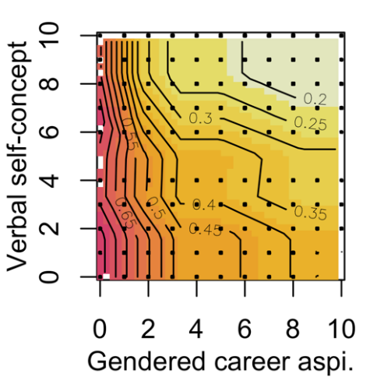 | 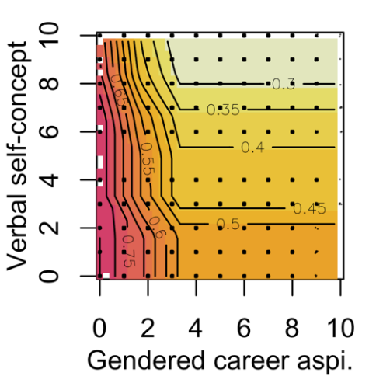 | 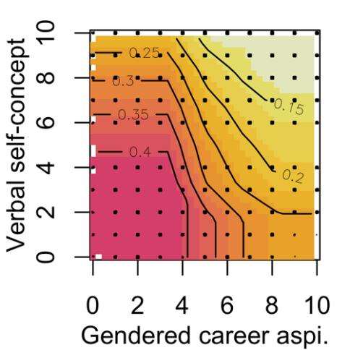
Career aspirations and math self-concept
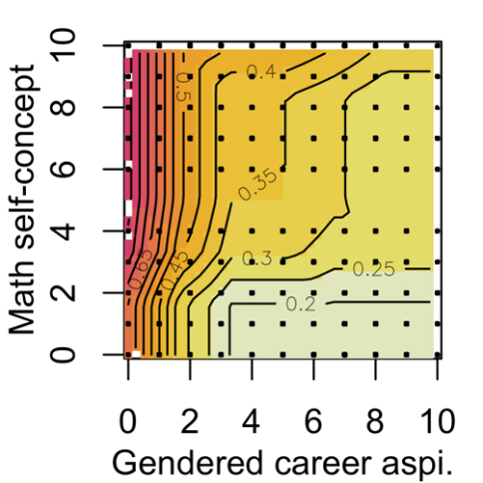 | 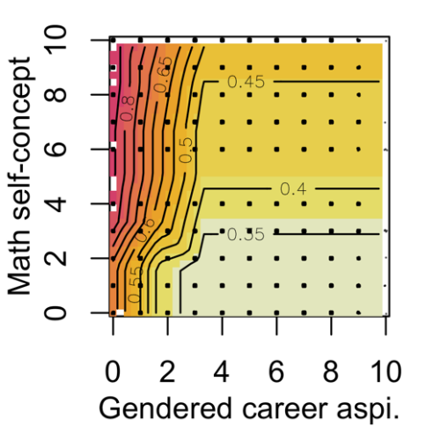 | 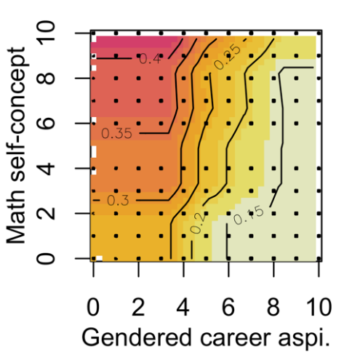
Career aspirations and math interest
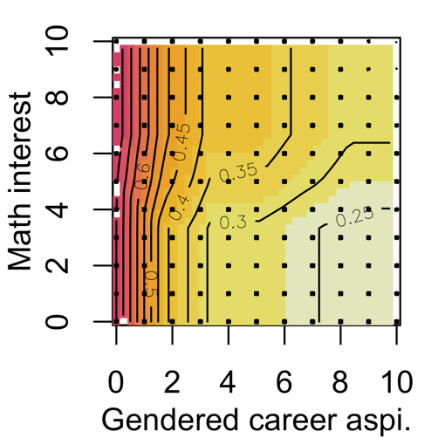 | 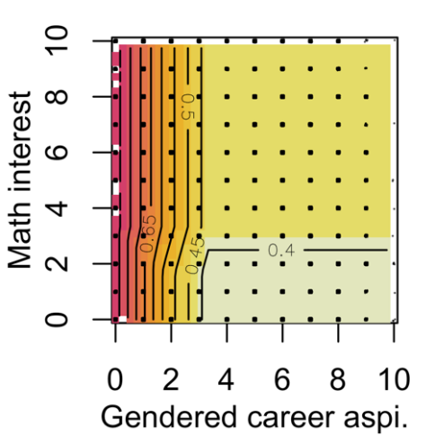 | 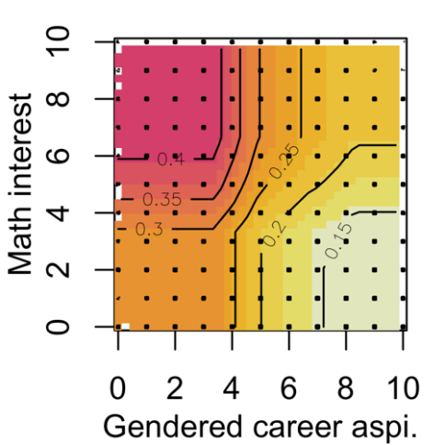
Career aspirations and STEM career aspirations
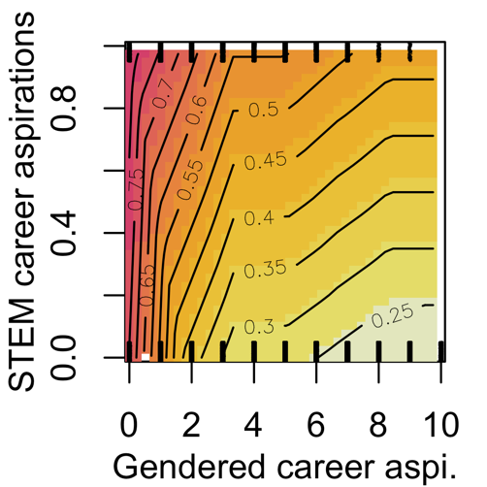 | 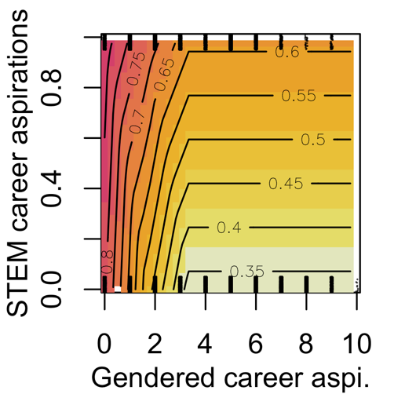 | 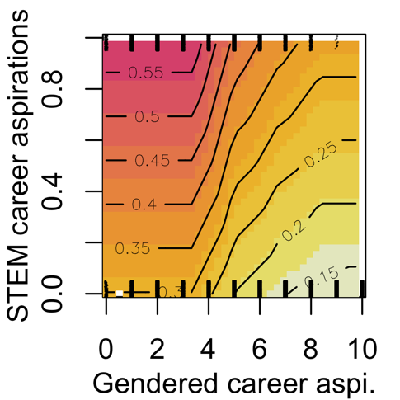
Verbal self-concept and math self-concept
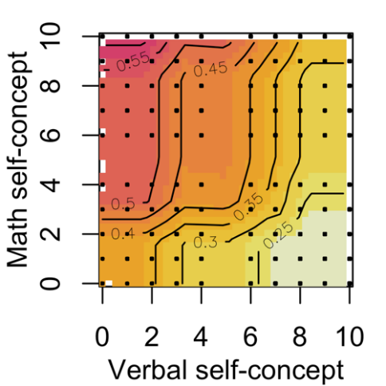 | 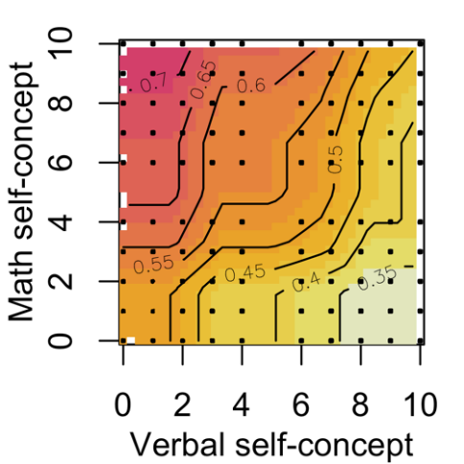 | 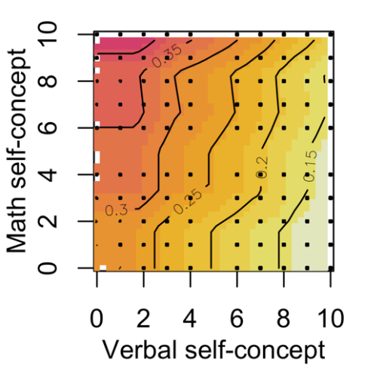
Note: The variables were linearly transformed for the ensemble analysis of the prediction rules. Each non-binary variable is transformed to a 0 to 10 scale to facilitate interpretation of the graphs. Thus, 0 indicates lowest self-concept and interest and 10 indicates highest self-concept and interest. Gendered career aspirations are equal to 0 for male-dominated career aspirations, 5 for gender-balanced career aspirations, and 10 for female-dominated career aspirations. STEM career aspirations are either 0 for non-STEM career aspirations and 1 for STEM career aspirations. The color ranges from yellow = low coefficient to red = high coefficient. The numbers on the lines indicate the coefficient for that domain.

Figure OA.2:
Pairplots of prediction rule ensembles for other study outcomes

Panel A: Both | Panel B: Men | Panel C: Women | Panel D: Both | Panel E: Men | Panel F: Women
PTEM |  |  | TE
Career aspirations and verbal self-concept
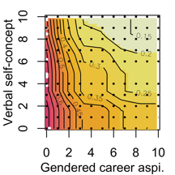 | 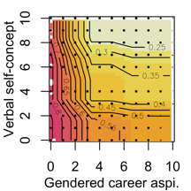 | 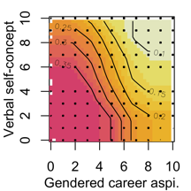 | 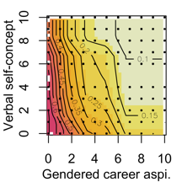 | 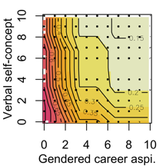 | 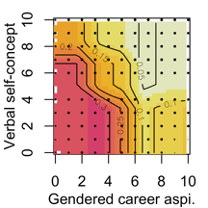
Career aspirations and math self-concept
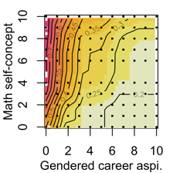 | 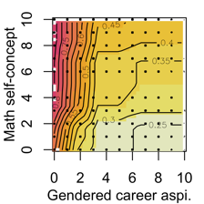 | 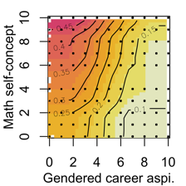 | 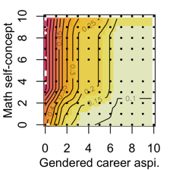 | 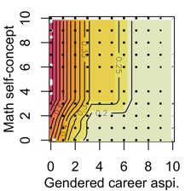 | 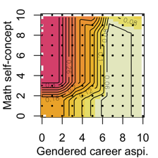
Career aspirations and math interest
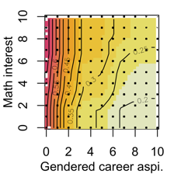 | 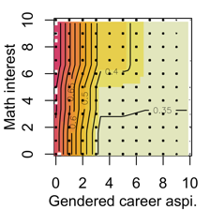 | 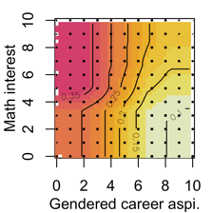 | 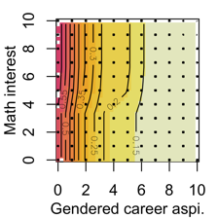 | 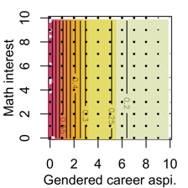 | 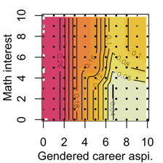
Career aspirations and PTEM career aspirations |  |  | Career aspirations and TE career aspirations
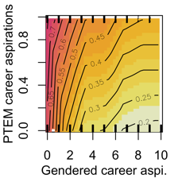 | 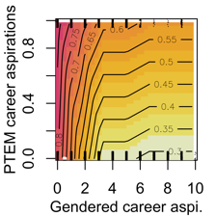 | 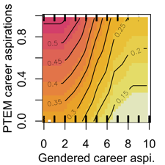 | 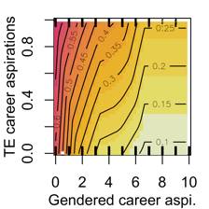 | 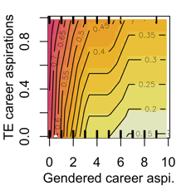 | 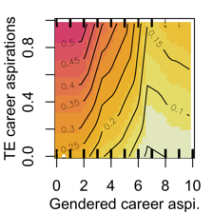
Verbal self-concept and math self-concept
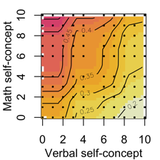 | 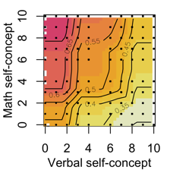 | 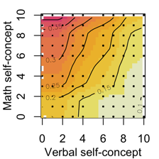 | 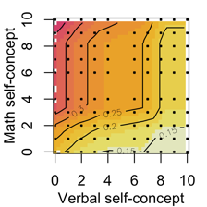 | 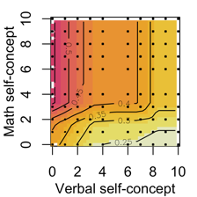 | 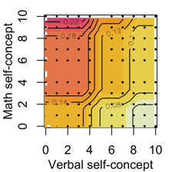
STEMM |  |  | Female student ratio of study fields
Career aspirations and verbal self-concept

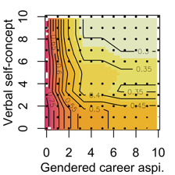 | 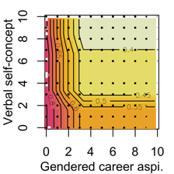 | 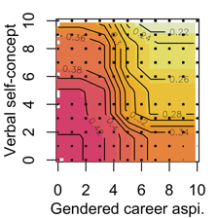 | 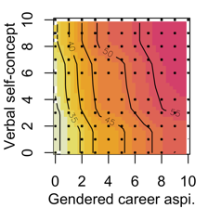 | 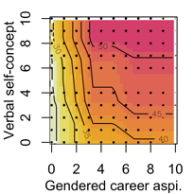 | 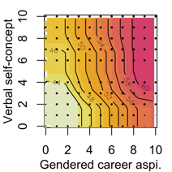
Career aspirations and math self-concept
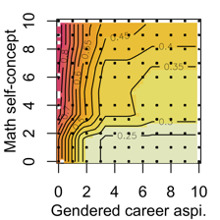 | 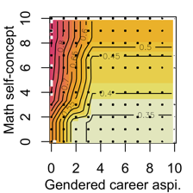 | 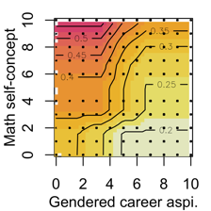 | 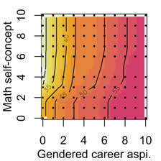 | 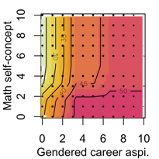 | 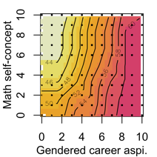
Career aspirations and math interest
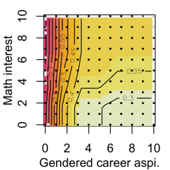 | 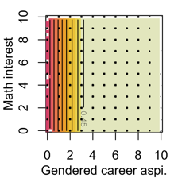 | 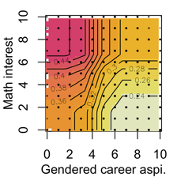 | 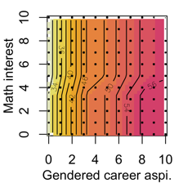 | 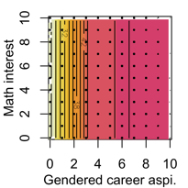 | 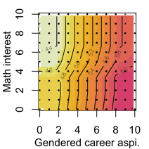
Career aspirations and PTEM career aspirations |  |  | Career aspirations and TE career aspirations
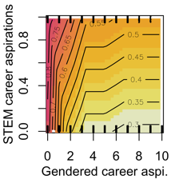 | 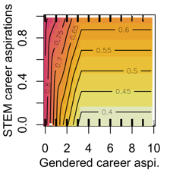 | 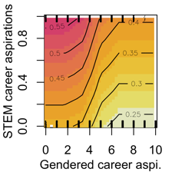 | 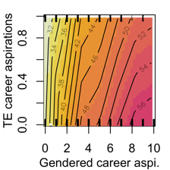 | 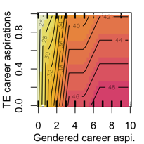 | 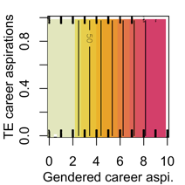
Verbal self-concept and math self-concept
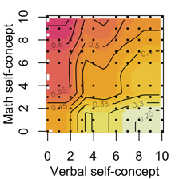 | 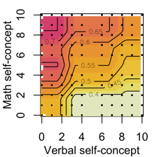 | 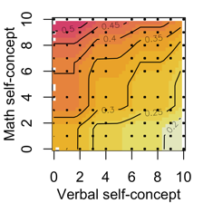 | 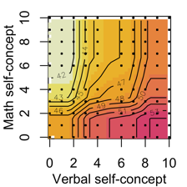 | 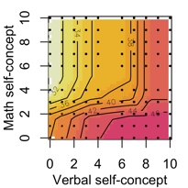 | 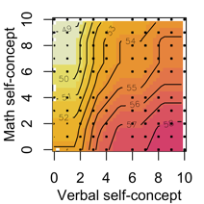
Note: The variables were linearly transformed for the ensemble analysis of the prediction rules. Each non-binary variable is transformed to a 0 to 10 scale to facilitate interpretation of the graphs. Thus, 0 indicates lowest self-concept and interest and 10 indicates highest self-concept and interest. Gendered career aspirations are equal to 0 for male-dominated career aspirations, 5 for gender-balanced career aspirations, and 10 for female-dominated career aspirations. STEM career aspirations are either 0 for non-STEM career aspirations and 1 for STEM career aspirations. Same for PTEM and TE career aspirations. The color ranges from yellow = low coefficient to red = high coefficient. The numbers on the lines indicate the coefficient for that domain.

Supplementary to the Section Results

Correlation Results

Table OA13 presents correlations between the outcome variables and all other variables of interest. Associations were as expected, specifically the high positive correlations between the STEM-related majors as well the negative correlations with the female ratio in study field. The negative correlations are lower for PTEM and TE (both -.81) than for STEMM (-.61) due to the higher ratio of women in life sciences and medicine fields. In line with this, female students are more likely to choose college majors that are typical for their gender, as indicated by the proportion of female students on the country-level (.40). Similarly, achievement, motivation, and meanings of work variable show all associations as expected, i.e. positive correlations between good or high math achievement, motivation, and economic meaning of work with STEM-related majors, and negative correlations between good or high German achievement, motivation, and expressive and social meanings of work. Lastly, also the different career expectations all show to be expected associations, i.e. positive correlations of STEM-related career aspirations with STEM-related majors but negative correlation of gendered career aspirations with STEM-related majors and vice versa for female ratio in study fields.

Table OA.13:
Correlations with the Outcome Variables
Variables | Correlations
 | STEM | STEMM | PTEM |  | TE | Female student ratio in study field
Outcomes
STEM | 1 | .90 | .93 |  | .75 | -.75
STEMM | .90 | 1 | .84 |  | .68 | -.61
PTEM | .93 | .84 | 1 |  | .81 | -.81
TE | .75 | .68 | .81 |  | 1 | -.81
Female ratio in study field | -.75 | -.61 | -.81 |  | -.81 | 1
Demographic
Female | -.32 | -.27 | -.34 |  | -.33 | .40
SES | -.05 | -.02 | -.05 |  | -.07 | .07
Immigr. Bkg. | -.01 | .00 | -.02 |  | -.02 | .03
Twelve vs. thirteen years of schooling | .02 | .00 | .01 |  | .00 | .00
Achievement
German grade | .18 | .11 | .19 | .18 |  | -.20
Math grade | -.19 | -.22 | -.19 | -.13 |  | .15
Reading test score | -.05 | .00 | -.05 | -.09 |  | .07
Math test score | .27 | .28 | .27 | .18 |  | -.23
Motivation
Verbal self-concept | -.28 | -.22 | -.29 |  | -.26 | .29
Math self-concept | .31 | .34 | .31 |  | .25 | -.30
School self-concept | -.01 | .06 | -.02 |  | -.04 | .03
Verbal interest | -.22 | -.18 | -.22 |  | -.23 | .26
Math interest | .29 | .29 | .29 |  | .22 | -.27
Meaning of work beliefs
Communal goals | -.11 | -.07 | -.11 | -.11 |  | .16
Agentic goals | .02 | .00 | .03 | .08 |  | -.10
Expressive goals | -.02 | -.02 | -.03 | -.03 |  | .03
Career expectations
Gendered career aspiration | -.39 | -.32 | -.43 |  | -.44 | .52
STEM career aspiration | .40 | .34 | .38 |  | .31 | -.32
PTEM career aspiration | .34 | .29 | .36 |  | .36 | -.33
TE career aspiration | .29 | .24 | .31 |  | .38 | -.31
Expected log income | .09 | .10 | .10 |  | .09 | -.11
Note. STEM = science, technology, engineering, math major; STEM = science, technology, engineering, math, medicine major; PTEM = physics, technology, engineering, math major (excluding life and social sciences); TE = technology (computer science/information technology), engineering; SES = an index for socioeconomic status combining parental education and available goods in the home environment (see Hanushek et al., 2022).

Hierarchical Inclusion of Predictors and Interactions

Table OA.14 shows the hierarchical regression results with all regression results which result in Table 3 in the manuscript.
Table OA.14
Hierarchical Regression Analyses Results
 | Men and Women |  |  |  |  |  |  |  |  |  |  |  |  | Men | Women
 | Model 1 | Model 2 | Model 3 | Model 4 | Model 5 | Model 6 | Model 7 | Model 8 | Model 9 | Model 10 | Model 11 | Model 12 | Model 13 | Model 14 | Model 15
(Intercept) | 0.525*** | 0.522*** | 0.522*** | 0.436*** | 0.426*** | 0.415*** | 0.406*** | 0.402*** | 0.403*** | 0.347*** | 0.334*** | 0.312*** | 0.215** | 0.294* | 0.077
 | (0.012) | (0.012) | (0.013) | (0.013) | (0.012) | (0.013) | (0.013) | (0.013) | (0.014) | (0.013) | (0.014) | (0.013) | (0.078) | (0.115) | (0.096)
Female | -0.312*** | -0.308*** | -0.308*** | -0.152*** | -0.126*** | -0.117*** | -0.120*** | -0.114*** | -0.114*** | -0.004 | -0.094*** | -0.016 | -0.012
 | (0.015) | (0.015) | (0.015) | (0.017) | (0.016) | (0.016) | (0.016) | (0.017) | (0.017) | (0.018) | (0.016) | (0.017) | (0.017)
SES |  | -0.034** | -0.022** | -0.018* | -0.011 | -0.009 | -0.009 | -0.010 | -0.010 | -0.014* | -0.011 | -0.014* | -0.014* | -0.020⁺ | -0.008
 |  | (0.011) | (0.008) | (0.007) | (0.007) | (0.007) | (0.007) | (0.007) | (0.007) | (0.007) | (0.007) | (0.007) | (0.007) | (0.010) | (0.009)
Female × SES |  | 0.024
 |  | (0.015)
Immigration background |  |  | -0.010
 |  |  | (0.019)
Thirtheen school years |  |  | 0.013 | 0.035* | 0.032* | 0.029⁺ | 0.030* | 0.029⁺ | 0.029⁺ | 0.031* | 0.028⁺ | 0.030* | 0.031* | 0.038⁺ | 0.028
 |  |  | (0.016) | (0.016) | (0.015) | (0.015) | (0.015) | (0.015) | (0.015) | (0.015) | (0.015) | (0.015) | (0.014) | (0.022) | (0.018)
Math test score |  |  |  | 0.132*** | 0.092*** | 0.090*** | 0.089*** | 0.088*** | 0.088*** | 0.064*** | 0.067*** | 0.056*** | 0.056*** | 0.043** | 0.066***
 |  |  |  | (0.009) | (0.010) | (0.010) | (0.010) | (0.010) | (0.010) | (0.010) | (0.010) | (0.010) | (0.010) | (0.015) | (0.012)
Reading test score |  |  |  | -0.051*** | -0.037*** | -0.032*** | -0.032*** | -0.033*** | -0.033*** | -0.028** | -0.034*** | -0.030*** | -0.029*** | -0.028* | -0.028*
 |  |  |  | (0.010) | (0.009) | (0.009) | (0.009) | (0.009) | (0.009) | (0.009) | (0.009) | (0.009) | (0.009) | (0.013) | (0.012)
Math × Reading test score |  |  |  | 0.011
 |  |  |  | (0.007)
Math grade |  |  |  | -0.071*** | -0.010 | -0.004 | -0.005 | -0.006 | -0.006 | -0.004 | -0.005 | -0.004 | -0.004 | -0.013 | 0.006
 |  |  |  | (0.008) | (0.010) | (0.010) | (0.010) | (0.010) | (0.010) | (0.009) | (0.009) | (0.009) | (0.009) | (0.016) | (0.012)
German grade |  |  |  | 0.082*** | 0.031** | 0.025** | 0.024** | 0.027** | 0.027** | 0.020* | 0.024** | 0.019* | 0.019* | 0.019 | 0.019⁺
 |  |  |  | (0.009) | (0.009) | (0.009) | (0.009) | (0.009) | (0.009) | (0.009) | (0.009) | (0.009) | (0.009) | (0.013) | (0.012)
Math × German grades |  |  |  | -0.032*** | -0.029*** | -0.021** | -0.020** | -0.020** | -0.020** | -0.020** | -0.018** | -0.018** | -0.018** | -0.016⁺ | -0.017⁺
 |  |  |  | (0.007) | (0.006) | (0.007) | (0.007) | (0.007) | (0.007) | (0.006) | (0.006) | (0.006) | (0.006) | (0.010) | (0.009)
Math self-concept |  |  |  |  | 0.093*** | 0.086*** | 0.088*** | 0.087*** | 0.087*** | 0.068*** | 0.074*** | 0.063*** | 0.062*** | 0.077*** | 0.059***
 |  |  |  |  | (0.010) | (0.010) | (0.010) | (0.010) | (0.010) | (0.010) | (0.010) | (0.010) | (0.010) | (0.016) | (0.013)
Math interest |  |  |  |  |  | 0.036*** | 0.032*** | 0.032*** | 0.032*** | 0.024** | 0.026** | 0.022** | 0.022** | 0.016 | 0.032**
 |  |  |  |  |  | (0.008) | (0.008) | (0.008) | (0.008) | (0.008) | (0.008) | (0.008) | (0.008) | (0.012) | (0.011)
Verbal self-concept |  |  |  |  | -0.094*** | -0.081*** | -0.084*** | -0.084*** | -0.084*** | -0.069*** | -0.076*** | -0.067*** | -0.067*** | -0.071*** | -0.067***
 |  |  |  |  | (0.010) | (0.009) | (0.009) | (0.009) | (0.009) | (0.009) | (0.009) | (0.009) | (0.009) | (0.013) | (0.012)
Reading interest |  |  |  |  |  | -0.007 | -0.007
 |  |  |  |  |  | (0.008) | (0.008)
Math self-concept × interest |  |  |  |  |  |  | 0.024*** | 0.023*** | 0.022*** | 0.018** | 0.018** | 0.017* | 0.017** | -0.002 | 0.032***
 |  |  |  |  |  |  | (0.007) | (0.007) | (0.007) | (0.007) | (0.007) | (0.006) | (0.006) | (0.010) | (0.009)
Verbal self-concept × interest |  |  |  |  |  |  | -0.005
 |  |  |  |  |  |  | (0.007)
Math × Verbal self-concept |  |  |  |  |  | -0.030*** | -0.026*** | -0.025** | -0.025** | -0.016* | -0.020** | -0.014* | -0.014* | 0.002 | -0.027**
 |  |  |  |  |  | (0.007) | (0.008) | (0.007) | (0.007) | (0.007) | (0.007) | (0.007) | (0.007) | (0.011) | (0.010)
Communal goal |  |  |  |  |  |  |  | -0.028*** | -0.028*** | -0.012 | -0.025** | -0.014⁺ | -0.014⁺ | -0.014 | -0.015
 |  |  |  |  |  |  |  | (0.008) | (0.008) | (0.007) | (0.008) | (0.008) | (0.008) | (0.011) | (0.010)
Agentic goal |  |  |  |  |  |  |  | 0.012 | 0.013
 |  |  |  |  |  |  |  | (0.007) | (0.008)
Expressive goal |  |  |  |  |  |  |  | 0.014⁺ | 0.015⁺ | 0.010 | 0.015⁺ | 0.009 | 0.009 | 0.009 | 0.009
 |  |  |  |  |  |  |  | (0.008) | (0.008) | (0.007) | (0.008) | (0.007) | (0.007) | (0.011) | (0.009)
Communal × Agentic |  |  |  |  |  |  |  |  | -0.000
 |  |  |  |  |  |  |  |  | (0.006)
Communal × Expressive |  |  |  |  |  |  |  |  | -0.003
 |  |  |  |  |  |  |  |  | (0.007)
Agentic × Expressive |  |  |  |  |  |  |  |  | 0.001
 |  |  |  |  |  |  |  |  | (0.006)
Genderered career aspiration |  |  |  |  |  |  |  |  |  | -0.155*** |  | -0.116*** | -0.115*** | -0.152*** | -0.069***
 |  |  |  |  |  |  |  |  |  | (0.011) |  | (0.011) | (0.011) | (0.015) | (0.014)
STEM career aspirations |  |  |  |  |  |  |  |  |  |  | 0.320*** | 0.224*** | 0.225*** | 0.200*** | 0.267***
 |  |  |  |  |  |  |  |  |  |  | (0.024) | (0.025) | (0.025) | (0.028) | (0.043)
Expected log income |  |  |  |  |  |  |  |  |  |  |  |  | 0.012 | 0.002 | 0.024*
 |  |  |  |  |  |  |  |  |  |  |  |  | (0.010) | (0.014) | (0.012)
R2 | 0.105 | 0.108 | 0.108 | 0.226 | 0.273 | 0.279 | 0.282 | 0.285 | 0.285 | 0.351 | 0.344 | 0.377 | 0.377 | 0.352 | 0.260
Adj.R2 | 0.105 | 0.107 | 0.107 | 0.224 | 0.271 | 0.277 | 0.279 | 0.282 | 0.282 | 0.349 | 0.342 | 0.374 | 0.375 | 0.347 | 0.255
BIC (null) | -479 | -476 | -466 | -1047 | -1306 | -1319 | -1324 | -1335 | -1303 | -1763 | -1716 | -1930 | -1925 | -767 | -566
AIC (null) | -3249 | -3258 | -3254 | -3867 | -4140 | -4171 | -4183 | -4200 | -4193 | -4628 | -4581 | -4802 | -4803 | -2002 | -2862
N | 4383 | 4383 | 4383 | 4383 | 4383 | 4383 | 4383 | 4383 | 4383 | 4383 | 4383 | 4383 | 4383 | 2068 | 2315
Number of parameters | 1 | 3 | 4 | 9 | 11 | 14 | 15 | 16 | 20 | 16 | 16 | 17 | 18 | 17 | 17
***p < 0.001; **p < 0.01; *p < 0.05; ⁺p < 0.1

LASSO Regression Results

LASSO-based analyses to support the relevance of gendered career aspirations: To validate the OLS results without relying on p-values but in explanatory power, we employed stacked LASSO with all the main variables included in Table 1 (Du et al., 2022). The LASSO analysis confirms the significant role of gendered career aspirations across fields, consistently selecting STEM-related career aspirations and self-concept in reading and math. Interestingly, LASSO selects in general fewer variables, while highlighting the importance of German grades as a positive predictor for STEM fields, possibly indicating a general academic ability effect. Differences between the outcome variables only relate to students’ competencies and meanings of work. That is, e.g., the social meaning of work was selected only for STEM and TE, while the economic meaning of work was selected only for TE.

In Table OA.LASSO.1 we already included many of our variables, but not all, as the number of estimated parameters is already quite high. LASSO now allows us to include general school self-concept and German and math grades, but still with a smaller subset of selected variables in the post-LASSO regressions compared to Model 16 in Table 3, or Model 17 for men and Model 18 for women in Table 3. LASSO selected at most 14 main effects for TE, including both men and women in the sample, and only one main effect (gendered career aspirations) for the share of women in field of study. The results confirm the importance of gendered career aspirations, as they are always selected (and statistically significant in the post-LASSO regressions). Similarly, STEM-related career aspirations and self-concept in reading and math (expected for female share in field of study for the female sub-sample) were always selected. Interest in mathematics was selected most often (except for TE for men and women, and female share of majors for men and women), but it is still not significant for men. Therefore, reducing the number of parameters did not improve the efficiency of the estimation. The verbal and math competencies are most often selected, but never for the female share of fields of study. German grade, which could have been a proxy for verbal competence (and selected instead of the verbal competence), was additionally selected for STEM and PTEM in all three samples, as well as for TE for both males and females. Surprisingly, the coefficient is positive, increasing the likelihood of studying a STEM-related major. This could be a residual effect, showing generally better grades in school after already controlling for verbal competence. Similarly, math grade is selected only for males and explains STEM, PTEM, and STEMM with a negative (but mostly insignificant) coefficient. This highlights that the competency test scores and grades (partially) explain different variation in the STEM-related major outcomes. The economic MOW was chosen to explain TE for all three samples, which is appropriate since occupations in TE tend to be well paid and studying in such a field is the direct route to such an occupation. Having a social MOW reduced the probability of majoring in TE, especially for women. The gender dummy was always selected in the subsample that included both men and women, but for STEMM. Furthermore, it was only significant in explaining the female share of majors, which was also the case before in Table 4. Although our variables can explain the gender difference for STEMM, they do not fully explain the gender difference for the female share of fields of study. SES was never selected, and the dummy variables for whether students had 13 (G9) or 12 (G8) years of schooling were selected to explain STEM.

Table OA.LASSO.1
Stacked LASSO Results

 | Both |  |  |  |  | Men |  |  |  |  | Women
 | STEM | PTEM | TE | STEMM | Female student  ratio | STEM | PTEM | TE | STEMM | Female student  ratio | STEM | PTEM | TE | STEMM | Female student  ratio
Gendered career aspi. | -0.118*** | -0.140*** | -0.137*** | -0.102*** | 0.429*** | -0.153*** | -0.178*** | -0.195*** | -0.141*** | 0.484*** | -0.073*** | -0.089*** | -0.072*** | -0.049** | 0.410***
 | (0.011) | (0.010) | (0.009) | (0.010) | (0.019) | (0.015) | (0.015) | (0.014) | (0.015) | (0.026) | (0.014) | (0.013) | (0.012) | (0.015) | (0.027)
STEM career aspi. | 0.228*** |  |  | 0.202*** |  | 0.199*** |  |  | 0.180*** |  | 0.276*** |  |  | 0.246***
 | (0.025) |  |  | (0.025) |  | (0.029) |  |  | (0.029) |  | (0.043) |  |  | (0.044)
PTEM career aspi. |  | 0.212*** |  |  |  |  | 0.181*** |  |  |  |  | 0.254***
 |  | (0.028) |  |  |  |  | (0.031) |  |  |  |  | (0.047)
TE career aspi. |  |  | 0.246*** |  |  |  |  | 0.222*** |  |  |  |  | 0.284***
 |  |  | (0.030) |  |  |  |  | (0.034) |  |  |  |  | (0.050)
Self-concept reading | -0.070*** | -0.070*** | -0.060*** | -0.068*** | 0.169*** | -0.072*** | -0.077*** | -0.070*** | -0.064*** | 0.177*** | -0.062*** | -0.058*** | -0.043*** | -0.057***
 | (0.009) | (0.009) | (0.008) | (0.008) | (0.015) | (0.012) | (0.012) | (0.011) | (0.011) | (0.020) | (0.012) | (0.011) | (0.009) | (0.011)
Self-concept math | 0.060*** | 0.059*** | 0.043*** | 0.086*** | -0.146*** | 0.076*** | 0.066*** | 0.054*** | 0.092*** | -0.169*** | 0.038*** | 0.041*** | 0.031*** | 0.071***
 | (0.008) | (0.008) | (0.008) | (0.009) | (0.014) | (0.015) | (0.015) | (0.011) | (0.016) | (0.022) | (0.011) | (0.010) | (0.008) | (0.012)
Language arts interest |  |  | -0.003 |  |  |  |  | -0.010 |  |  | -0.005 |  | -0.004
 |  |  | (0.007) |  |  |  |  | (0.012) |  |  | (0.010) |  | (0.007)
Math interest | 0.025** | 0.025*** | 0.003 | 0.028*** |  | 0.015 | 0.016 |  | 0.018 |  | 0.033** | 0.031** | 0.017* | 0.034**
 | (0.008) | (0.007) | (0.007) | (0.008) |  | (0.012) | (0.011) |  | (0.012) |  | (0.011) | (0.010) | (0.009) | (0.012)
Competence language arts | -0.029*** | -0.029*** | -0.034*** |  |  | -0.029* | -0.032** | -0.035** | -0.026* |  | -0.028* | -0.028* | -0.027**
 | (0.009) | (0.009) | (0.008) |  |  | (0.013) | (0.012) | (0.011) | (0.013) |  | (0.012) | (0.011) | (0.009)
Competence math | 0.054*** | 0.049*** | 0.017* | 0.042*** |  | 0.043** | 0.044** |  | 0.045** |  | 0.062*** | 0.049*** | 0.021* | 0.052***
 | (0.010) | (0.009) | (0.009) | (0.009) |  | (0.014) | (0.014) |  | (0.015) |  | (0.012) | (0.011) | (0.009) | (0.012)
Grade German | 0.017* | 0.020* | 0.007 |  |  | 0.020 | 0.023⁺ |  |  |  | 0.020⁺ | 0.024*
 | (0.008) | (0.008) | (0.008) |  |  | (0.013) | (0.013) |  |  |  | (0.011) | (0.010)
Grade math |  |  |  |  |  | -0.020 | -0.025⁺ |  | -0.014
 |  |  |  |  |  | (0.015) | (0.014) |  | (0.014)
MoW – Economics |  |  | 0.024*** |  |  |  |  | 0.033*** |  |  |  |  | 0.016*
 |  |  | (0.006) |  |  |  |  | (0.010) |  |  |  |  | (0.007)
MoW – Social | -0.012 |  | -0.014* |  |  |  |  |  |  |  | -0.014 |  | -0.016*
 | (0.007) |  | (0.007) |  |  |  |  |  |  |  | (0.010) |  | (0.008)
Exp. log income | 0.011 |  | 0.007 | 0.018⁺ |  |  |  |  |  |  | 0.022⁺ | 0.017 |  | 0.036*
 | (0.010) |  | (0.009) | (0.011) |  |  |  |  |  |  | (0.012) | (0.011) |  | (0.016)
Female | -0.008 | -0.015 | -0.014 |  | 0.218***
 | (0.017) | (0.017) | (0.016) |  | (0.033)
G9 instead of G8 | 0.028⁺ |  |  |  |  | 0.036 |  |  |  |  | 0.025
 | (0.015) |  |  |  |  | (0.022) |  |  |  |  | (0.018)
(Intercept) | 0.224** | 0.305*** | 0.162* | 0.228** | -0.115*** | 0.306*** | 0.290*** | 0.196*** | 0.356*** | -0.078*** | 0.106 | 0.130 | 0.162*** | 0.060 | 0.190***
 | (0.078) | (0.012) | (0.069) | (0.084) | (0.022) | (0.014) | (0.012) | (0.011) | (0.013) | (0.023) | (0.096) | (0.087) | (0.012) | (0.126) | (0.022)
R2 | 0.372 | 0.392 | 0.363 | 0.307 | 0.405 | 0.350 | 0.372 | 0.346 | 0.320 | 0.347 | 0.247 | 0.243 | 0.219 | 0.198 | 0.162
Adj.R2 | 0.370 | 0.391 | 0.361 | 0.306 | 0.404 | 0.346 | 0.369 | 0.343 | 0.317 | 0.347 | 0.243 | 0.240 | 0.215 | 0.196 | 0.162
N | 4383 | 4383 | 4383 | 4383 | 4383 | 2068 | 2068 | 2068 | 2068 | 2068 | 2315 | 2315 | 2315 | 2315 | 2315
Number of parameters | 13 | 10 | 14 | 7 | 4 | 11 | 9 | 8 | 9 | 3 | 12 | 9 | 10 | 7 | 1
Standard errors in parenthesis. All non-binary variables are standardized. Female student ratio: Female student ratio of study field. ***p < 0.001; **p < 0.01; *p < 0.05; ⁺p < 0.1

Univariate Partial Dependency Plots Corresponding to Table 3

Figures OA.3–5 show the effect of the variables on the respective outcomes for the full sample, the male sample, and the female sample respectively and thereby show how the variables influence the respective outcomes.

Figure OA.3:
Partial Dependency Plots of Multivariate Prediction Rule Ensembles – Full Sample
Panel A:  STEM | Panel B:  PTEM | Panel C:  TE | Panel D:  STEMM | Panel E: Gender typical studies
Gendered career aspirations
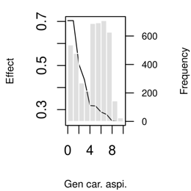 | 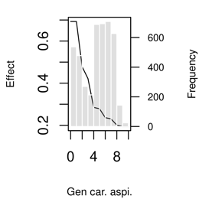 | 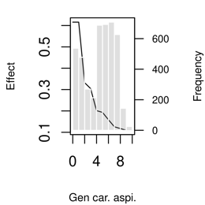 | 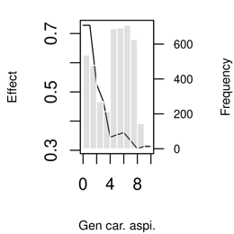 | 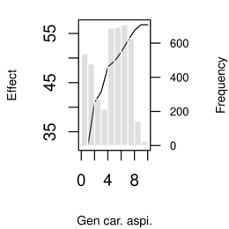
Verbal self-concept
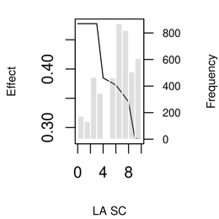 | 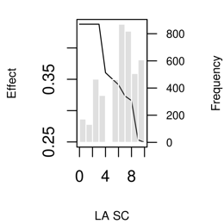 | 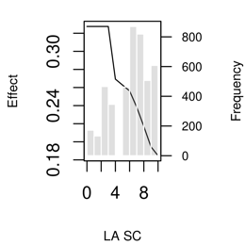 | 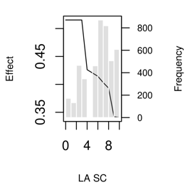 | 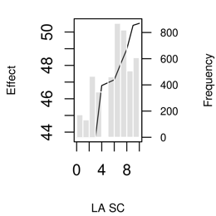
Math self-concept
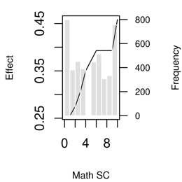 | 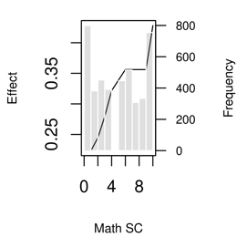 | 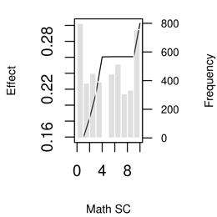 | 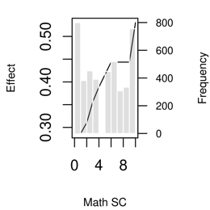 | 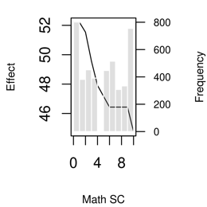
TE career aspirations
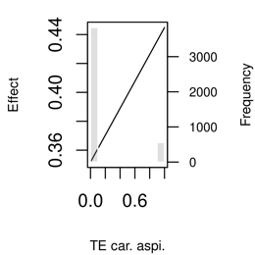 | 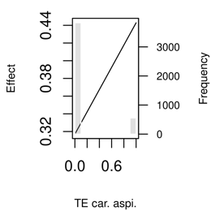 | 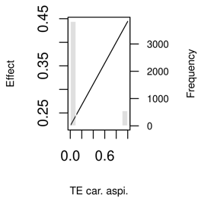 | 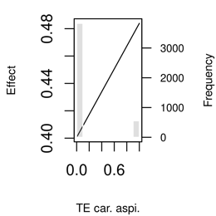 | 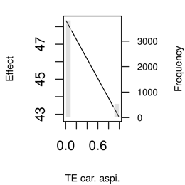
Female
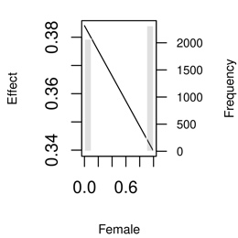 | 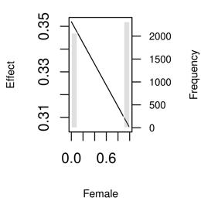 | 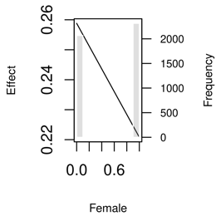 | 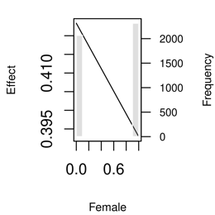 | 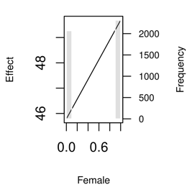
Communal goals
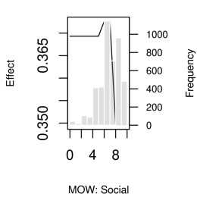 | 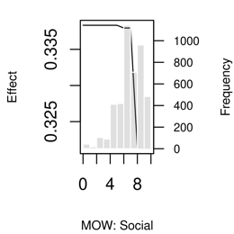 | 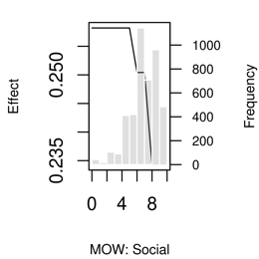 | 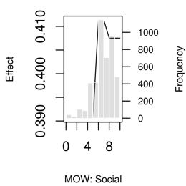 | 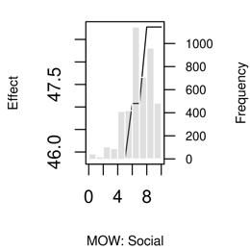
Math test score
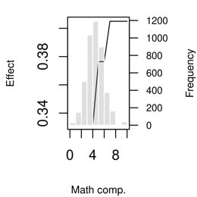 | 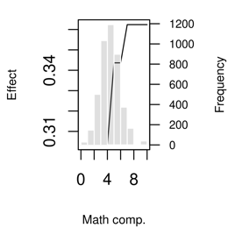 | 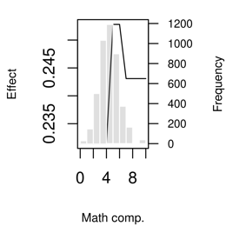 | 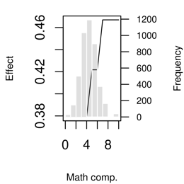 | 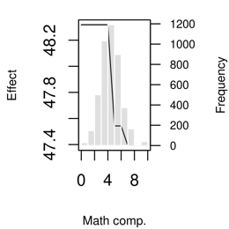
STEM career aspirations
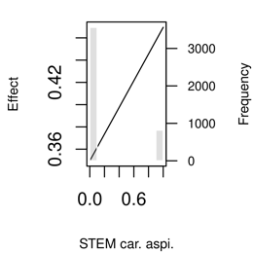 | 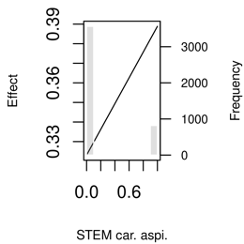 | 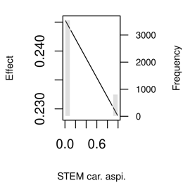 | 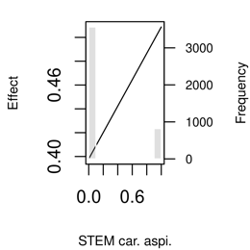 | 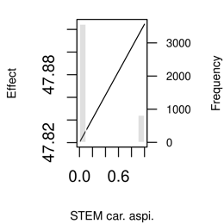
Math interest
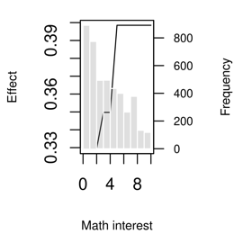 | 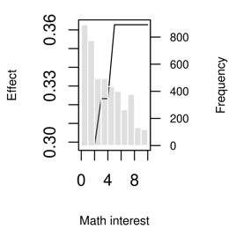 | 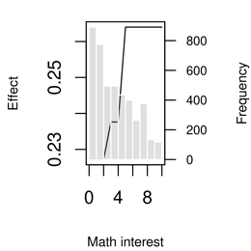 | 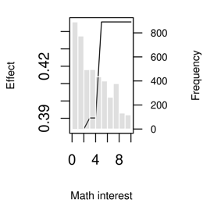 | 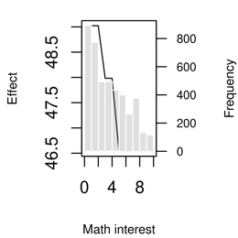
Verbal interest
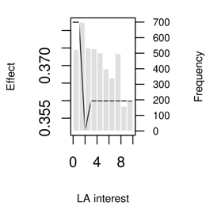 | 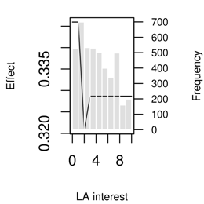 | 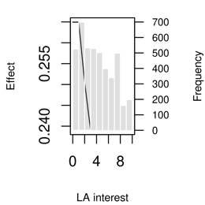 | 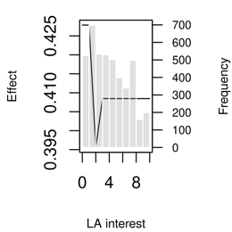 | 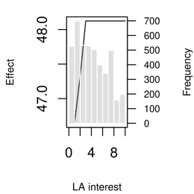
Agentic goals
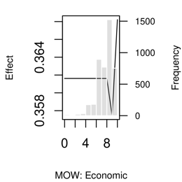 | 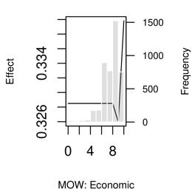 | 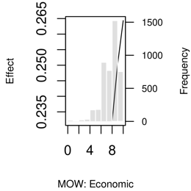 | 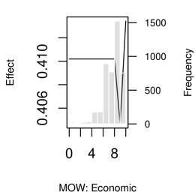 | 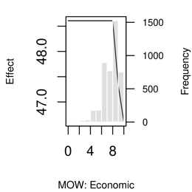
Reading test score
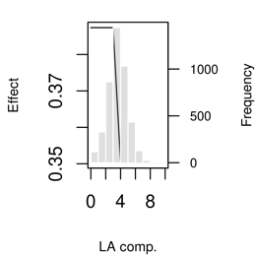 | 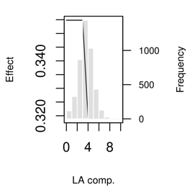 | 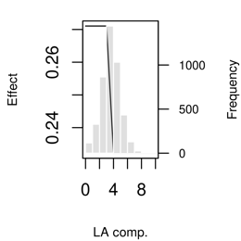 | 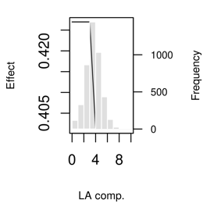 | 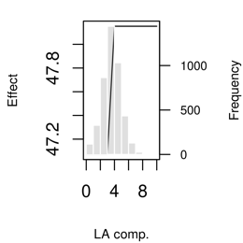
German Grade
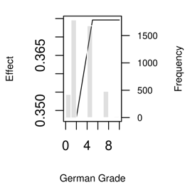 | 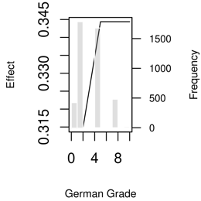 | 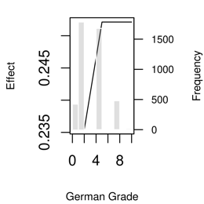 | 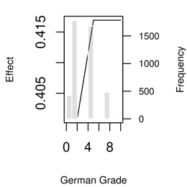 | 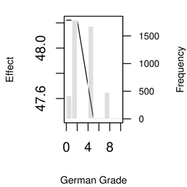
School self-concept
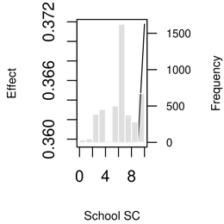 | 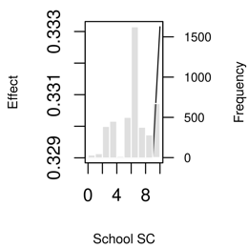 | 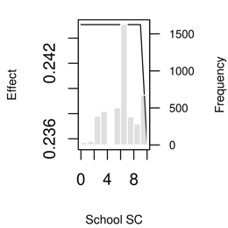 | 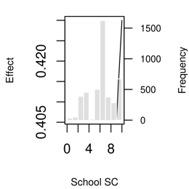 | 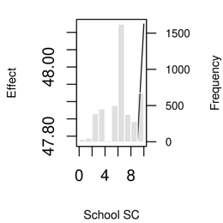

Figure OA.4:
Partial Dependency Plots of Multivariate Prediction Rule Ensembles – Male Sample
Panel A:  STEM | Panel B:  PTEM |  | Panel C:  TE | Panel D:  STEMM |  | Panel E: Gender typical studies
Gendered career aspirations
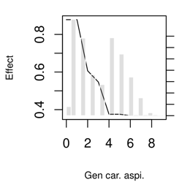 | 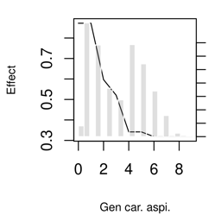 |  | 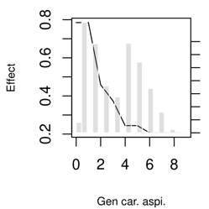 | 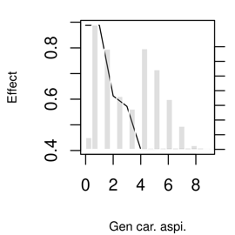 |  | 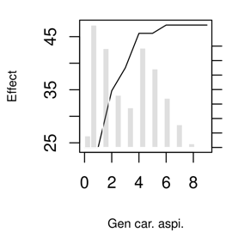
Math self-concept
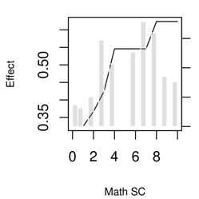 | 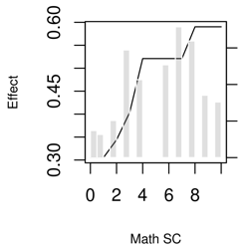 |  | 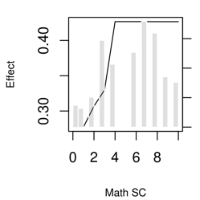 | 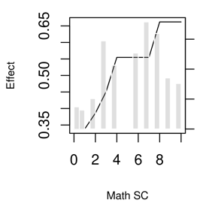 |  | 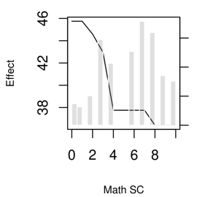
Verbal self-concept
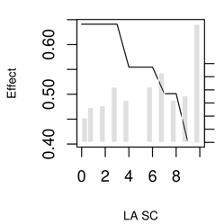 | 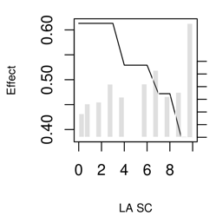 |  | 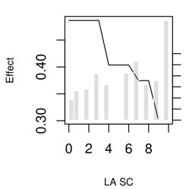 | 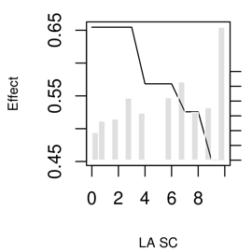 |  | 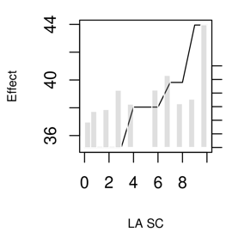
TE career aspirations
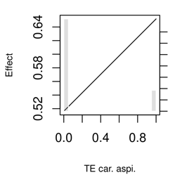 | 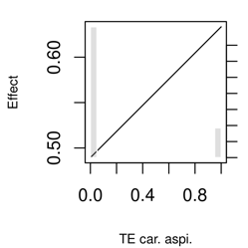 |  | 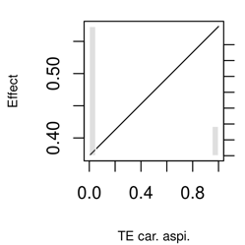 | 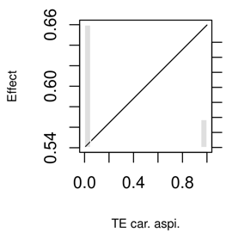 |  | 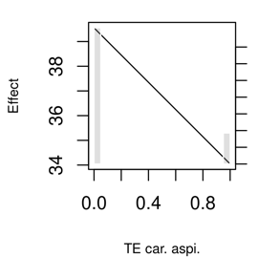
Language arts competence test score results
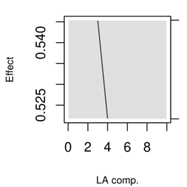 | 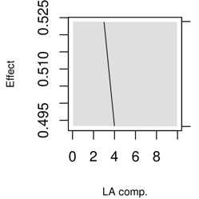 |  | 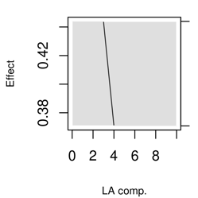 | 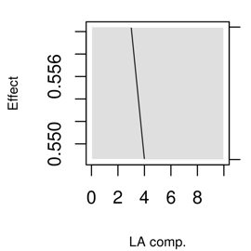 |  | 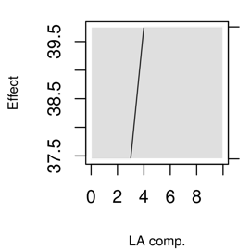
Math grade
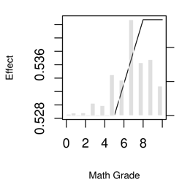 | 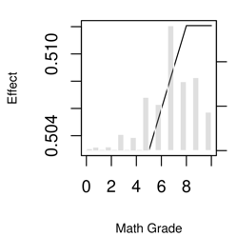 |  | 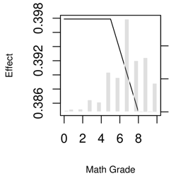 | 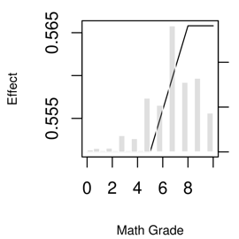 |  | 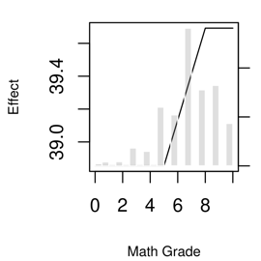
Figure OA.5:
Partial Dependency Plots of Multivariate Prediction Rule Ensembles – Female Sample
Panel A:  STEM | Panel B:  PTEM |  | Panel C:  TE | Panel D:  STEMM |  | Panel E: Gender typical studies
Gendered career aspirations
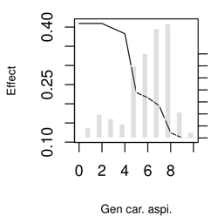 | 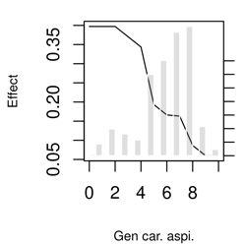 |  | 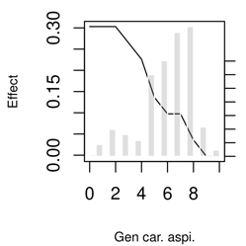 | 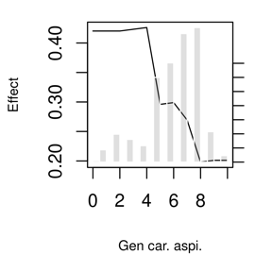 |  | 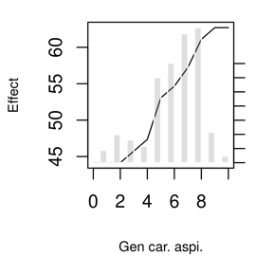
Verbal self-concept
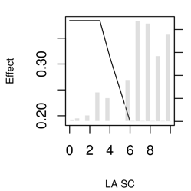 | 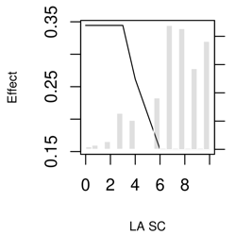 |  | 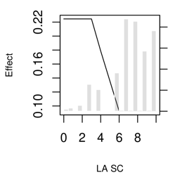 | 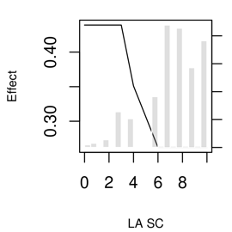 |  | 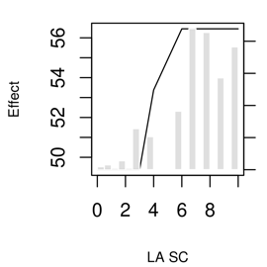
STEM career aspirations
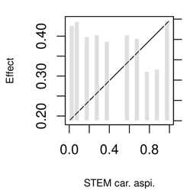 | 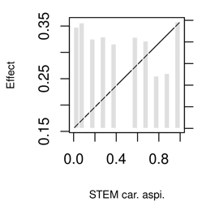 |  | 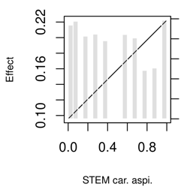 | 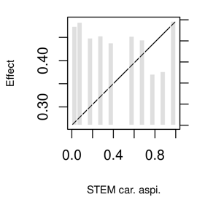 |  | 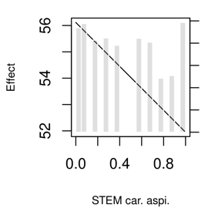
Math interest
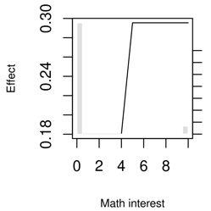 | 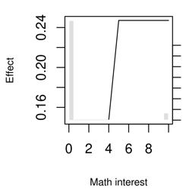 |  | 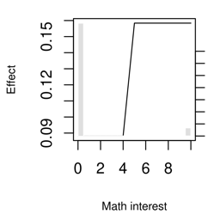 | 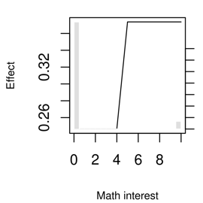 |  | 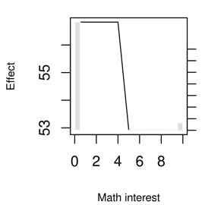
Math self-concept
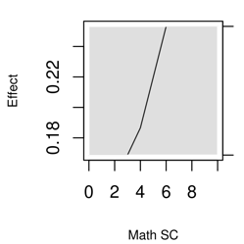 | 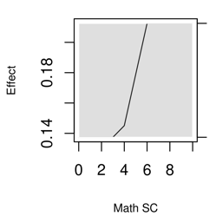 |  | 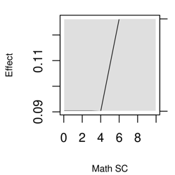 | 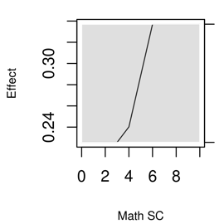 |  | 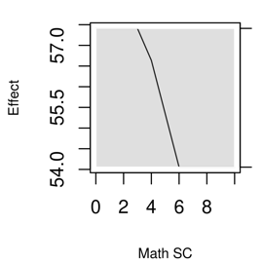
Communal goals
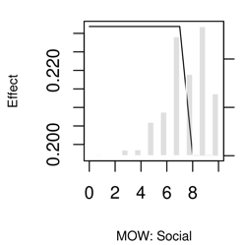 | 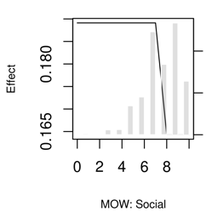 |  | 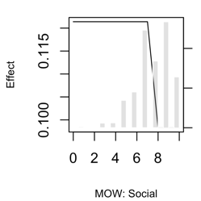 | 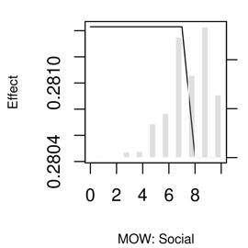 |  | 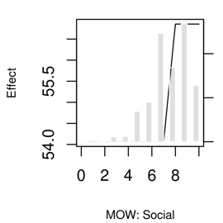

Bivariate Partial Dependency Plots for STEM subfields

The PRE rules further shows that while STEM and STEMM are very similar of rule importance and coefficients (Table 6 in the manuscript), going from STEM over PTEM to TE introduced some minor differences, similar to the case of the importance of variables in Table 5 in the manuscript. I.e., the combination of gendered and STEM career aspirations was more important for STEM and STEMM, while the combination of gendered and TE career aspirations was more important for PTEM (4th rank) and TE (1st rank). For TE that combination was even more important than the combination of gendered career aspirations and the domain-specific self-concepts. Additionally, for TE also the linear term of career aspirations had high importance (rank 9th), highlighting that female-dominated career aspirations may discourage majoring in STEM irrespective of any other expectancies or interests. Partial dependency plots (Figure 2) also show a very similar picture, but the contour lines for PTEM and TE were less vertical than for STEM, while they are even more vertical for STEMM.

Figure 2:
Pairplots of prediction rule ensembles for other study outcomes
Panel A: Both | Panel B: Men | Panel C: Women | Panel D: Both | Panel E: Men | Panel F: Women
PTEM |  |  | TE
- Gendered career aspirations and verbal self-concept
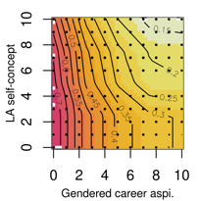 | 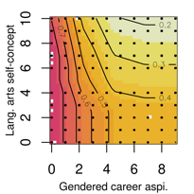 | 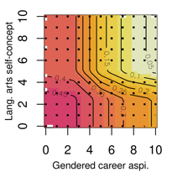 | 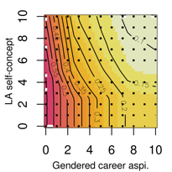 | 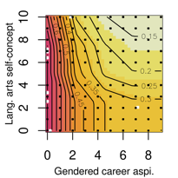 | 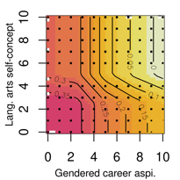
- Gendered career aspirations and math self-concept
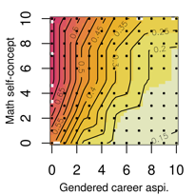 | 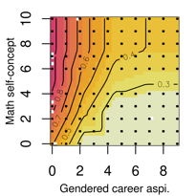 | 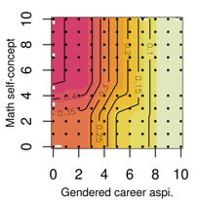 | 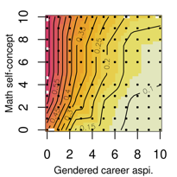 | 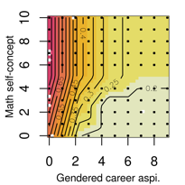 | 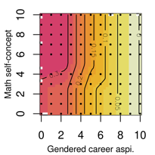
- Gendered career aspirations and STEM career aspirations
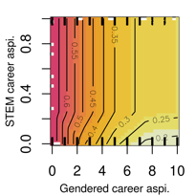 | 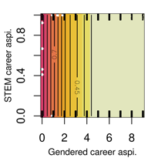 | 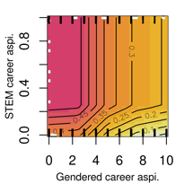 | 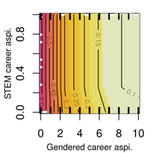 | 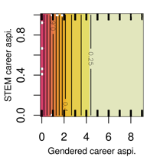 | 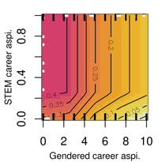
- Gendered career aspirations and TE career aspirations
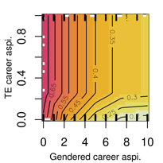 | 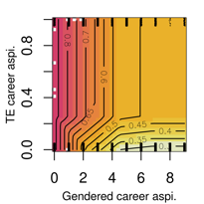 | 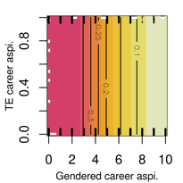 | 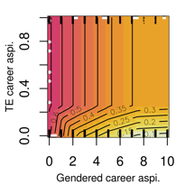 | 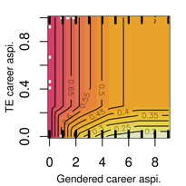 | 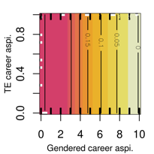
- Gendered career aspirations and communal work beliefs
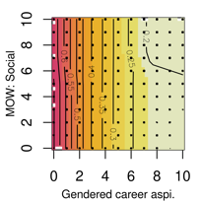 | 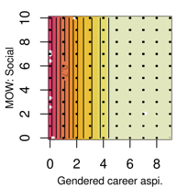 | 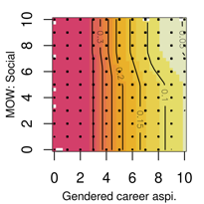 | 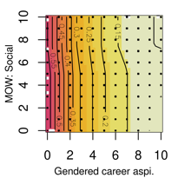 | 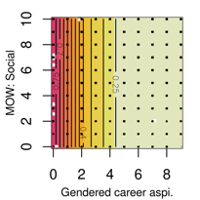 | 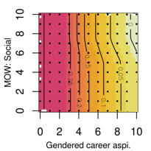
STEMM |  |  | Female student ratio of field of study
- Gendered career aspirations and verbal self-concept
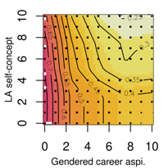 | 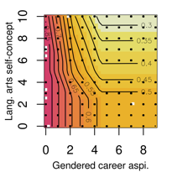 | 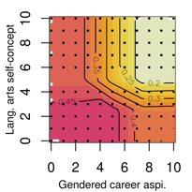 | 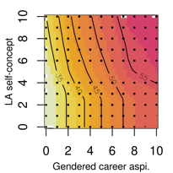 | 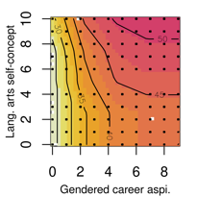 | 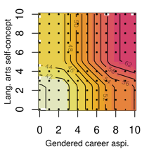
- Gendered career aspirations and math self-concept
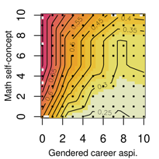 | 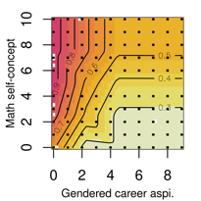 | 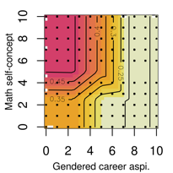 | 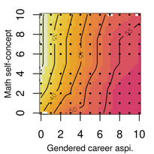 | 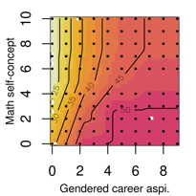 | 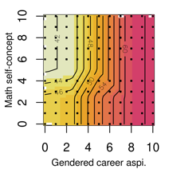
- Gendered career aspirations and STEM career aspirations
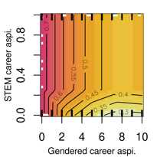 | 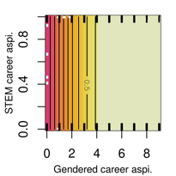 | 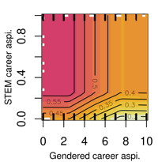 | 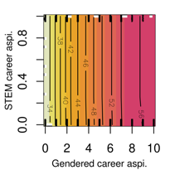 | 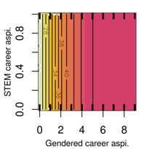 | 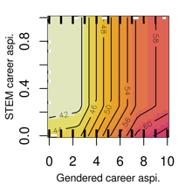
- Gendered career aspirations and TE career aspirations
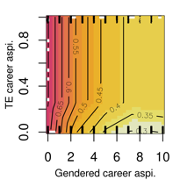 | 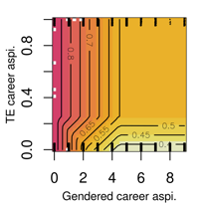 | 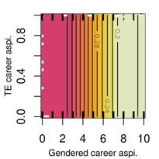 | 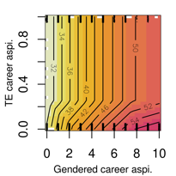 | 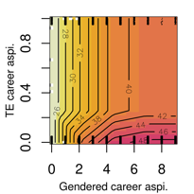 | 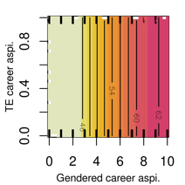
- Gendered career aspirations and communal goal beliefs
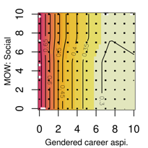 | 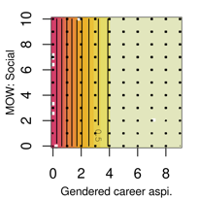 | 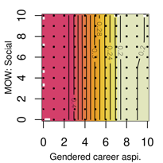 | 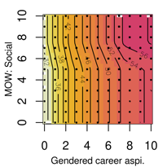 | 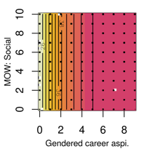 | 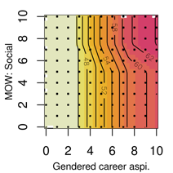
Note: The variables were linearly transformed for the ensemble analysis of the prediction rules. Each non-binary variable is transformed to a 0 to 10 scale to facilitate interpretation of the graphs. Thus, 0 indicates lowest self-concept and interest and 10 indicates highest self-concept and interest. Gendered career aspirations are equal to 0 for male-dominated career aspirations, 5 for gender-balanced career aspirations, and 10 for female-dominated career aspirations. STEM career aspirations are either 0 for non-STEM career aspirations and 1 for STEM career aspirations. Same and TE career aspirations. The color ranges from yellow = low coefficient to red = high coefficient. The numbers on the lines indicate the coefficient for that domain. Plain orange plots indicate that this variable combination was not selected as a rule for the respective sample.

