Exploring STEM identity profiles among undergraduate STEM students and their relationships with gender, discipline, persistence and engagement: a latent profile analysis

Supplemental Material

Additional cluster analyses

In this supplemental material, we report two additional cluster analyses carried out on our dataset to demonstrate the clear advantages of archetype analysis. The first one is based on a divisive (i.e. top-down) hierarchical cluster analysis (HCA) carried out with the Ward method, while the other one is based on a more traditional type of latent profile analysis approach based on the maximization of the separation between profiles by focusing on the profile-specific means vector (Spurk et al., 2020).

Hierarchical cluster analysis
The analysis returned the dendrogram in Figure S1. The y-axis reports the Ward dissimilarity measure. An inspection of the dendrogram shows that the cut which produces more stable clusters is at about a dissimilarity measure of 6, leading to only three clusters. The subsequent cut at a dissimilarity measure of 4 does not produce stable clusters. Hence, the solution with three clusters should be selected in this analysis. Figure S2 shows the distribution of the indicator variables’ means across the three identified clusters. Students in the first cluster (N= 187, 16.8%) have all negative values of the indicator variables means. Therefore, this cluster is similar to Archetype A5, which we called Detached in the Archetype Analysis. We retained this name also for hierarchical analysis. Students in the second cluster (N= 523, 46.9%) have all positive values of the indicator variables means. Therefore, these students are highly identified with STEM. We did not find such a cluster in the archetype analysis, so we called it with a new name “Identified”. The third cluster (N = 404, 36.3%) features students with an average score in the utility value of STEM contents but scores slightly lower than the average for all the remaining indicator variables. Also this cluster was not found in the archetype analysis, so we introduced the new name “Utilitarian”. Overall, the hierarchical cluster analysis yields to three well-distinct clusters which, however, do not allow an insightful interpretation of the differences among the population related to the six chosen indicator variables given their high numerosity. While it is possible to carry on further subdivisions, the interpretation would result in single variable variations around their average values that would be more difficult to interpret (Author, 2025).
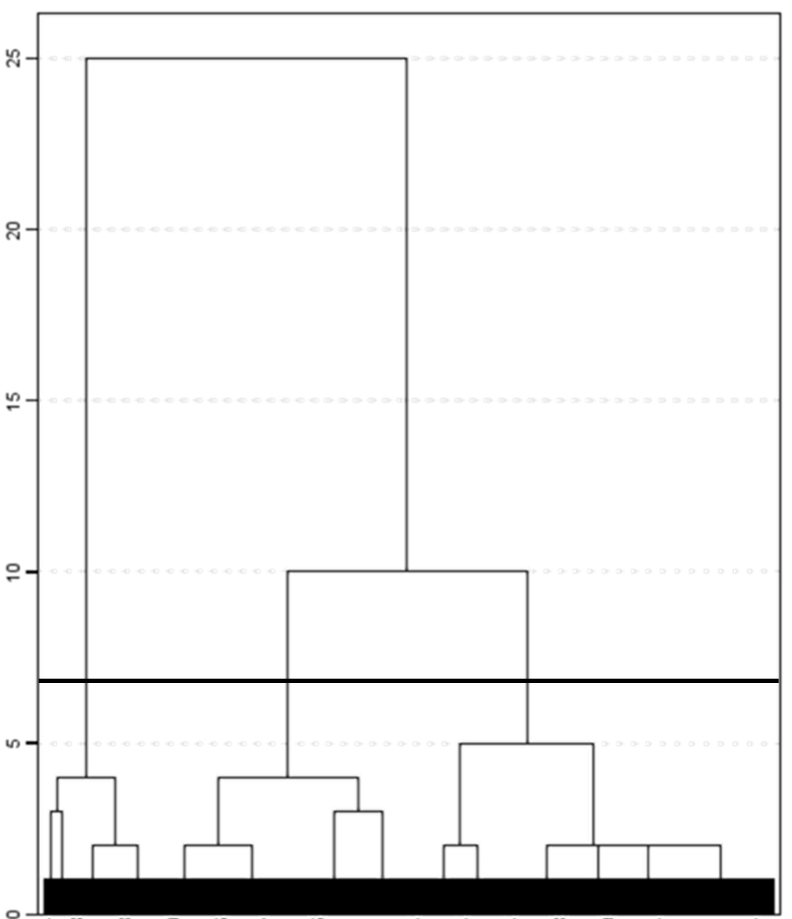
Figure S1. Dendrogram obtained from the hierarchical cluster analysis on the dataset used in this study. Cut at three cluster is indicated with the black solid line.
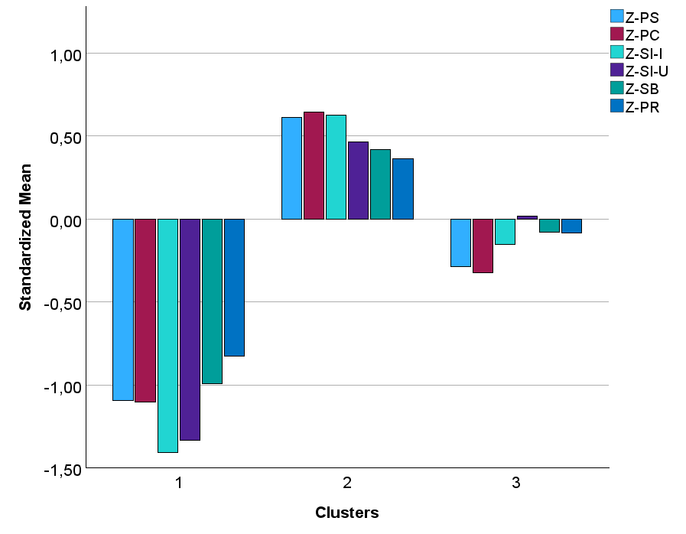
Figure S2. Means plot of the indicator variables for the profiles of STEM identity extracted with the hierarchical cluster analysis. PS = Perception of the self as a STEM person; PC = Perceived Competence; SI-I = Students’ Interest: Intrinsic; SI-U = Students’ Interest: Utility; SB = Sense of Belonging; PR = Perceived Recognition. Cluster 1: Detached, Cluster 2: Identified; Cluster 3: Utilitarian.

Means vector latent profile analysis
To estimate the latent profiles in this analysis, means and variances of the profile indicators were freely estimated in all profiles. In this case, to obtain the optimal number of profiles in the data, multiple statistical indicators were used: Akaike Information Criterion (AIC), the Bayesian information criterion (BIC), the Consistent AIC (CAIC), the sample-adjusted BIC (ABIC), the adjusted Lo, Mendell, and Rubin's (2001) likelihood ratio test (aLMR), and the Bootstrap Likelihood Ratio Test (BLRT), with a lower value of the AIC, CAIC, BIC and ABIC suggesting a better model and a significant p value of the aLMR and BLRT tests indicating that the k-1-profile model should be rejected in favor of a k-profile model. Finally, we assessed how well the profiles were separated using the value of entropy as indicator.
In this case, the analysis of fit indices suggests a 5-profile solution (Figure S3), thus it is possible to make a closer comparison with the archetype analysis solution. Profile 1 (2.2%) is characterized by very low values in all indicators, similarly to the Detached Archetype, so we adopted the same name, Detached. Profile 2 (43.9%) is characterized by values greater than the average for all indicators, so we labelled it Identified, as in the hierarchical cluster analysis. Profile 3 (8.7%) is very similar to Profile 1, with the only difference that the indicator variables have higher values, yet lower than the average. Thus, we labelled it Disengaged. Profile 4 (12.7%) has average values of STEM self-perception and self-efficacy, but very low levels of interest and low levels of recognition, so we labeled Indifferent. Finally, Profile 5 (32.5%) has low levels of STEM self-perception and self-efficacy but high levels of identified interest, so we labelled it Utilitarian, as in the hierarchical cluster analysis. Overall, the results of the means vector latent profile analysis yield to a very populated cluster of STEM identified persons, whose differences in the six indicators remain hidden. Moreover, the solution yields to two very similar clusters (Detached and Disengaged) which are characterized by low values in all the six indicators. One of them, Disengaged, is very lowly populated, i.e., well below the recommended threshold of 5% (Spurk et al., 2020). In conclusion, also the results of this analysis are less interpretable and insightful than those obtained with the Archetype Analysis.
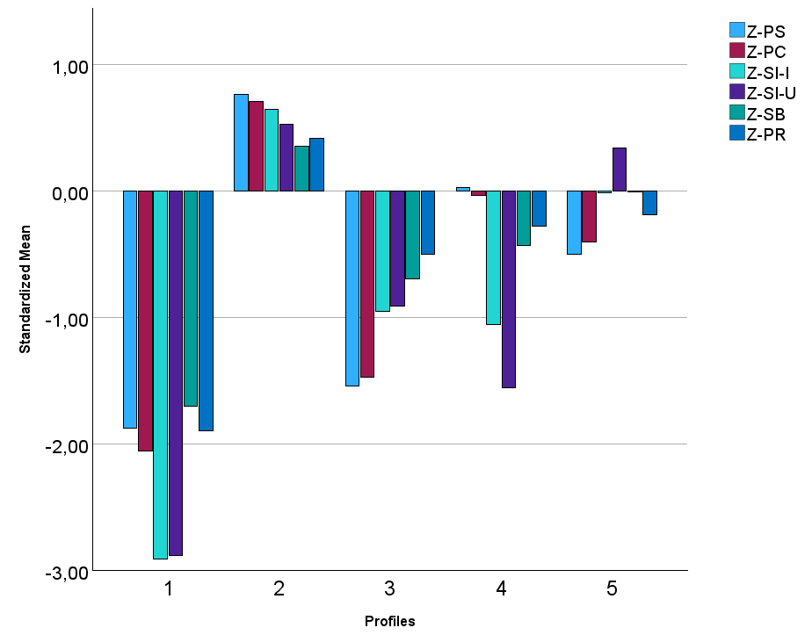

Figure S3. Means plot of the indicator variables for the profiles of STEM identity extracted with the hierarchical cluster analysis. PS = Perception of the self as a STEM person; PC = Perceived Competence; SI-I = Students’ Interest: Intrinsic; SI-U = Students’ Interest: Utility; SB = Sense of Belonging; PR = Perceived Recognition. Profile 1: Disengaged, Profile 2: Identified; Profile: Disengaged; Profile 4: Indifferent; Profile 5: Utilitarian

References

Author (2025)
Spurk, D., Hirschi, A., Wang, M., Valero, D., & Kauffeld, S. (2020). Latent profile analysis: A review and “how to” guide of its application within vocational behavior research. Journal of Vocational Behavior, 120, Article 103445. https://doi.org/10.1016/j.jvb.2020.103445

