UI HEALTH FAIR SURVEY 2017
Q1. How old are you? I am ______________ years old
Q2. What gender are you? Male Female
Q3. Where do you live? On a farm In the country, but not on a farm In town
Q4. How many children under the age of 18 currently live in your home? ___________ children
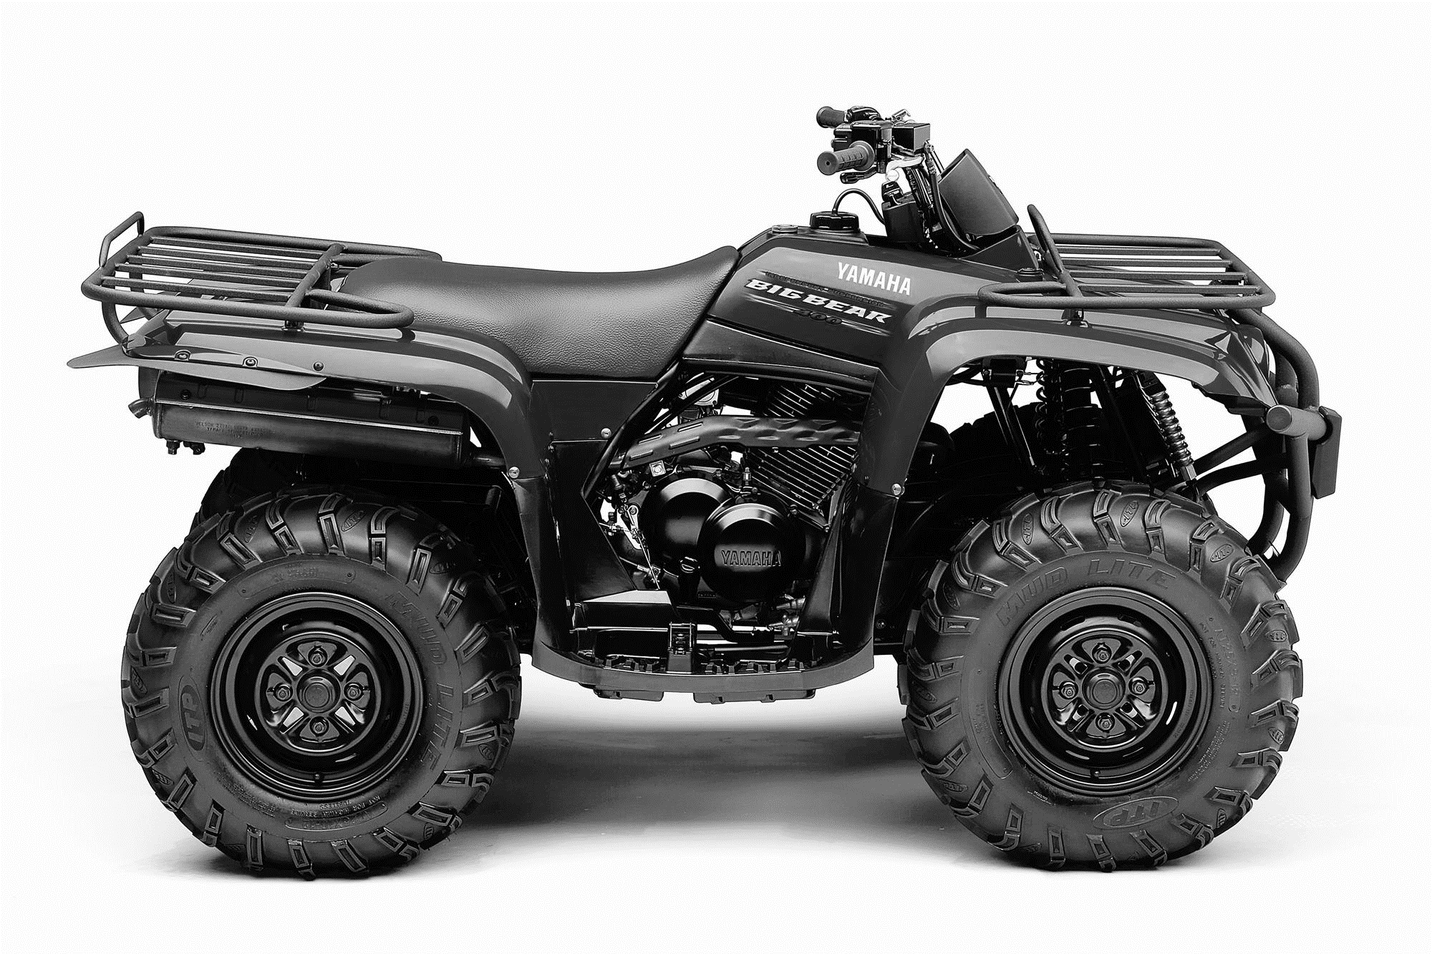
Fill out the rest of the survey for up to your 5 oldest children under the age of 18.
ALL-TERRAIN VEHICLE (ATV)
Q5. Does your family currently own an ATV? No Yes
Q6. Please indicate how often persons living in your home have worn a helmet when riding on an ATV in the past year.
 |  |  |  | Check percent of the time a helmet was worn for any persons who rode an ATV in the past year.
 | Age (years) | Gender  (M/F) | Didn’t ride on an ATV in past year | 0%  Never | 1-25% | 26-50% | 51-75% | 76-99% | 100%  Always
You
Spouse/Partner
Child 1
Child 2
Child 3
Child 4
Child 5
If no one in your family has ridden an ATV in the past year, go to Question 10. Otherwise continue.
Q7. On a scale of 1-10, how important do you think it is for your child/children to wear a helmet when riding on an ATV? Circle the number for your answer.
1 2 3 4 5 6 7 8 9 10
Not at all Very
important important
Q8. What thoughts do you have about helmet use by your children when they are riding on an ATV? Check all that apply. (Continued on other side)
I don’t feel they always need to wear an ATV helmet because:
☐ They don’t ride very often.
☐ They only ride in places I think are safe.
☐ I or another responsible person ride on the ATV with them and always ride safely.
☐ I or another responsible person watch them riding to make sure they are riding safely.
☐ They have been riding for some time without a serious injury and I trust they can ride safely.
☐ I think crashes happen because people ride recklessly and I make sure my children do not.
☐ Other: __________________________________________________________________________________________________

I would like them to always wear an ATV helmet, but factors that decrease my effectiveness in enforcing helmet use include:
☐ My spouse/significant other is not supportive of enforcing helmet use.
☐ I do not have appropriate helmets for them to use.
☐ The children they ride with don’t wear helmets.
☐ I am not around when they ride ATVs.
☐ My children will not listen to me when I tell them to wear a helmet.
☐ I do not have specific consequences for when my children don’t wear a helmet.
☐ I have problems enforcing the consequences for when my children don’t wear a helmet.
☐ There are no helmet laws requiring them to wear ATV helmets.
☐ Other: __________________________________________________________________________________________________

Q9. Have you found an effective way to get your child/children to always wear a helmet when they ride on an ATV? If so, please share.

BICYCLE
Q10. Please indicate how often persons living in your home have worn a helmet when riding a bicycle in the past year.
 |  |  |  | Check percent of the time a helmet was worn for any persons who rode a bicycle in the past year.
 | Age (years) | Gender  (M/F) | Didn’t ride a bicycle in past year | 0%  Never | 1-25% | 26-50% | 51-75% | 76-99% | 100%  Always
You
Spouse/Partner
Child 1
Child 2
Child 3
Child 4
Child 5
If no one in your family has ridden a bicycle in the past year, you have finished the survey. Thank You. Otherwise continue.

Q11. On a scale of 1-10, how important do you think it is for your child/children to wear a helmet when riding a bicycle? Circle the number for your answer.
1 2 3 4 5 6 7 8 9 10
Not at all Very
important important
Q12. What thoughts do you have about helmet use by your children when they are riding a bicycle? Check all that apply.

I don’t feel they always need to wear a bicycle helmet because:
☐ They don’t ride very often.
☐ They only ride in places I think are safe.
☐ They ride as a passenger with an adult who always rides safely.
☐ I or another responsible person watch them riding to make sure they are riding safely.
☐ They have been riding for some time without a serious injury and I trust they can ride safely.
☐ I think crashes happen because people ride recklessly and I make sure my children do not.
☐ Other: __________________________________________________________________________________________________

I would like them to always wear a bicycle helmet, but factors that decrease my effectiveness in enforcing helmet use include:
☐ My spouse/significant other is not supportive of enforcing helmet use.
☐ I do not have appropriate helmets for them to use.
☐ The children they ride with don’t wear helmets.
☐ I am not around when they ride.
☐ My children will not listen to me when I tell them to wear a helmet.
☐ I do not have specific consequences for when my children don’t wear a helmet.
☐ I have problems enforcing the consequences for when my children don’t wear a helmet.
☐ There are no helmet laws requiring them to wear bicycle helmets.
☐ Other: __________________________________________________________________________________________________

Q13. Have you found an effective way to get your child/children to always wear a helmet when they ride a bicycle? If so, please share.

THANK YOU FOR COMPLETING OUR SURVEY

