eTable 1: Qualifying Codes by Mortality Type
Despair Type | ICD 10 Codesª
Suicide | X60 X61 X62 X63 X64 X65 X66 X67 X68 X69 X70 X71 X72 X73 X74 X75 X76 X77 X78 X79 X80 X81 X82 X83 X84 Y87.0
Alcohol-related | E24.4 F10.0 F10.1 F10.2 F10.3 F10.4 F10.5 F10.6 F10.7 F10.8 F10.9 G31.2 G62.1 G72.1 I42.6 K29.2 K70.0 K70.1 K70.2 K70.3 K70.4 K70.9 K85.2 K86.0 R78.0 T51.0 X45 X65 Y15
Drug-related | F11.0 F11.1 F11.2 F11.3 F11.4 F11.5 F11.7 F11.8 F11.9 F12.0 F12.1 F12.2 F12.3 F12.4 F12.5 F12.7 F12.8 F12.9 F13.0 F13.1 F13.2 F13.3 F13.4 F13.5 F13.7 F13.8 F13.9 F14.0 F14.1 F14.2 F14.3 F14.4 F14.5 F14.7 F14.8 F14.9 F15.0 F15.1 F15.2 F15.3 F15.4 F15.5 F15.7 F15.8 F15.9 F16.0 F16.1 F16.2 F16.3 F16.4 F16.5 F16.7 F16.8 F16.9 F18.0 F18.1 F18.2 F18.3 F18.4 F18.5 F18.7 F18.8 F18.9 F19.0 F19.1 F19.2 F19.3 F19.4 F19.5 F19.7 F19.8 F19.9 G21.1 G44.4 J70.2 J70.3 J70.4 K85.3 M87.1 R50.2 R78.1 R78.2 R78.3 R78.4 R78.5 T40.0 T40.1 T40.2 T40.3 T40.4 T40.5 T40.6 T40.7 T40.8 T40.9 T42.3 T42.4 T42.6 T43.6 X40 X41 X42 X43 X44 X60 X61 X62 X64 X85 Y10 Y11 Y12 Y13 Y14

eFigure 1: Map of Veteran Suicide, Alcohol-Related and Drug-Related Standardized Mortality Ratio (SMR) by county for 2009-2020. Counties with mortality counts <10 were suppressed.
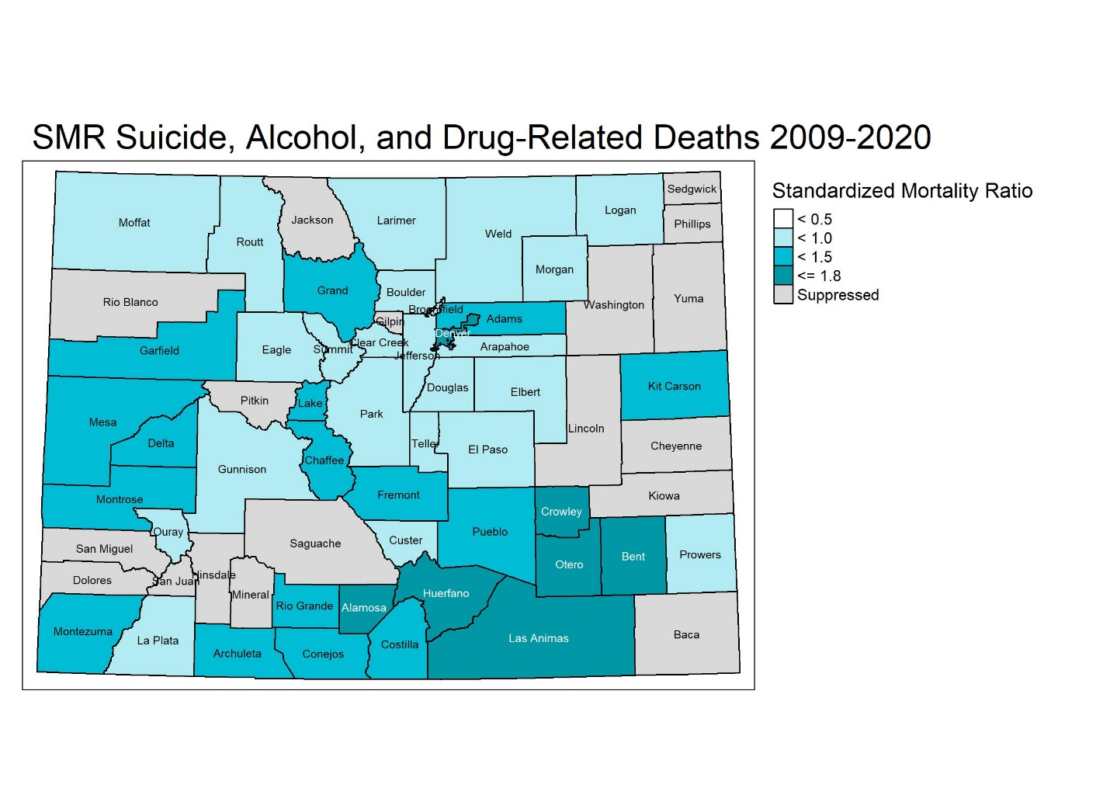

eTable 2: Global Moran’s I Results for County SMR by Qualifying Veteran Deaths Overall and by Mortality Type (i.e., Suicide, Alcohol-Related, and Drug-Related) and Year. Significant Moran’s I indicated significant spatial dependence of variable.
 |  | At Least 2 Neighbors |  | Queen Contiguity
Mortality Type | Year | Moran's I | P-value | Moran's I | P-value
Overall | 2009-2020 | 0.081 | 0.08 | 0.037 | 0.22
Overall | 2009-2014 | 0.028 | 0.23 | 0.014 | 0.34
Despair | 2015-2020 | 0.070 | 0.10 | 0.038 | 0.20
Suicide | 2009-2020 | -0.012 | 0.42 | -0.055 | 0.69
Suicide | 2009-2014 | -0.003 | 0.37 | -0.041 | 0.58
Suicide | 2015-2020 | -0.030 | 0.52 | -0.062 | 0.72
Alcohol-related | 2009-2020 | 0.126 | 0.02 | 0.121 | 0.04
Alcohol-related | 2009-2014 | 0.082 | 0.07 | 0.094 | 0.07
Alcohol-related | 2015-2020 | 0.112 | 0.03 | 0.115 | 0.04
Drug-related | 2009-2020 | -0.005 | 0.43 | 0.003 | 0.40
Drug-related | 2009-2014 | -0.007 | 0.45 | 0.022 | 0.31
Drug-related | 2015-2020 | -0.038 | 0.62 | -0.047 | 0.66

eTable 3: CDC Wonder Query Results by Age for Colorado general adult population, 2009-2020.
Age | Population | Overallª | Suicide^{b} | Alcohol-related^{c} | Drug-related^{d}
18 | 846,547 | 225 | 151 | 35 | 72
19 | 868,010 | 300 | 177 | 42 | 131
20 | 849,869 | 320 | 181 | 60 | 134
21 | 859,455 | 370 | 203 | 69 | 163
22 | 892,204 | 442 | 231 | 98 | 203
23 | 920,956 | 474 | 229 | 95 | 228
24 | 949,057 | 503 | 253 | 107 | 222
25 | 972,120 | 518 | 233 | 113 | 272
26 | 987,945 | 565 | 247 | 146 | 296
27 | 998,810 | 611 | 230 | 174 | 310
28 | 999,864 | 638 | 251 | 181 | 323
29 | 997,666 | 608 | 237 | 174 | 298
30 | 992,225 | 633 | 228 | 206 | 310
31 | 974,860 | 623 | 250 | 182 | 296
32 | 970,052 | 626 | 223 | 229 | 314
33 | 955,746 | 638 | 240 | 225 | 290
34 | 946,716 | 698 | 227 | 256 | 338
35 | 931,941 | 630 | 224 | 226 | 310
36 | 915,738 | 673 | 227 | 271 | 313
37 | 907,298 | 624 | 214 | 250 | 266
38 | 899,340 | 637 | 200 | 247 | 298
39 | 897,252 | 720 | 266 | 291 | 314
40 | 883,359 | 705 | 229 | 299 | 303
41 | 872,053 | 701 | 241 | 311 | 268
42 | 861,561 | 743 | 221 | 313 | 328
43 | 854,771 | 726 | 204 | 361 | 295
44 | 852,194 | 747 | 228 | 355 | 299
45 | 856,263 | 802 | 225 | 405 | 326
46 | 855,839 | 851 | 236 | 458 | 315
47 | 862,816 | 926 | 273 | 492 | 314
48 | 866,049 | 976 | 258 | 501 | 364
49 | 871,376 | 1,030 | 266 | 575 | 354
50 | 868,403 | 959 | 230 | 535 | 332
51 | 865,565 | 1,049 | 263 | 632 | 324
52 | 863,900 | 1,109 | 259 | 666 | 349
53 | 864,880 | 1,136 | 267 | 704 | 322
54 | 869,758 | 1,168 | 272 | 709 | 348
55 | 868,451 | 1,079 | 222 | 662 | 330
56 | 862,829 | 1,159 | 256 | 719 | 343
57 | 851,550 | 1,214 | 279 | 739 | 334
58 | 838,610 | 1,153 | 254 | 726 | 330
59 | 820,773 | 1,144 | 236 | 752 | 306
60 | 799,740 | 1,043 | 221 | 689 | 233
61 | 777,005 | 1,041 | 204 | 706 | 238
62 | 761,252 | 923 | 171 | 621 | 219
63 | 722,747 | 870 | 162 | 607 | 169
64 | 692,557 | 784 | 142 | 531 | 175
65 | 659,475 | 785 | 140 | 551 | 170
66 | 626,731 | 631 | 127 | 434 | 120
67 | 590,571 | 600 | 133 | 413 | 103
68 | 554,582 | 484 | 109 | 328 | 83
69 | 518,886 | 469 | 93 | 326 | 87
70 | 484,264 | 400 | 86 | 279 | 62
71 | 449,732 | 396 | 95 | 271 | 55
72 | 415,282 | 370 | 97 | 230 | 67
73 | 381,977 | 317 | 97 | 191 | 44
74 | 345,705 | 289 | 73 | 199 | 37
75 | 321,413 | 248 | 69 | 157 | 32
76 | 299,133 | 233 | 63 | 147 | 35
77 | 277,725 | 179 | 58 | 108 | 18
78 | 256,269 | 204 | 68 | 120 | 26
79 | 238,016 | 177 | 53 | 109 | 30
80 | 222,141 | 181 | 69 | 97 | 20
81 | 207,156 | 149 | 62 | 74 | 24
82 | 191,283 | 137 | 54 | 65 | 25
83 | 176,986 | 124 | 44 | 74 | 14
84 | 163,006 | 105 | 42 | 52 | 19
85+ | 974358 | 628 | 270 | 269 | 133
Total | 49,852,663 | 43,220 | 12,643 | 22,239 | 14,423
ª Query available at: https://wonder.cdc.gov/controller/saved/D77/D288F827
^{b} Query available at: https://wonder.cdc.gov/controller/saved/D77/D288F857
^{c} Query available at: https://wonder.cdc.gov/controller/saved/D77/D275F294
^{d} Query available at: https://wonder.cdc.gov/controller/saved/D77/D275F297

