Supplementary material for "Neighborhood collective efficacy and environmental exposure to firearm homicide among a national sample of adolescents”

Amanda J. Aubel, Angela Bruns, Xiaoya Zhang, Shani Buggs, and Nicole Kravitz-Wirtz

Methods. Neighborhood collective efficacy items from the Future of Families and Child Wellbeing Study (FFCWS), Wave 6 Teen and Primary Caregiver Interview………………………………………….Page 1

Table S1. Predicted probability of adolescents’ past-year exposure to firearm homicide within 800 meters of their home by race/ethnicity, household income & neighborhood collective efficacy (n=1,888)………
………………………………………………………………………………………………………..Page 2

Table S2. Predicted probability of adolescents’ past-year exposure to firearm homicide within 800 meters of their home by race/ethnicity, household income & neighborhood collective efficacy (n=2,161) ………
………………………………………………………………………………………………………..Page 3

Table S3. Crosstabulation of neighborhood collective efficacy tertiles based on primary caregivers’ reports and adolescents’ reports (n=1,626)………………………………………………………….Page 4

Figure S1a. Distribution of primary caregivers’ collective efficacy scores (n=1,736) ……………Page 5

Figure S1b. Distribution of adolescents’ collective efficacy scores (n=1,829) ….………………...Page 5

Table S4. Predicted probability of adolescents’ past-year exposure to firearm homicide within 800 meters of their home by race/ethnicity, household income & adolescents’ reports of neighborhood collective efficacy (n=1,829) …………………………………………………………………………………..Page 6

Figure S2. Predicted probability of adolescents’ past-year exposure to firearm homicide within 800 meters of their home by race/ethnicity, household income & adolescents’ reports of neighborhood collective efficacy (n=1,829)………………………………………………………………………...Page 7

Table S5. Predicted probability of adolescents’ past-year exposure to firearm homicide within 800 meters of their home by race/ethnicity, household income & neighborhood collective efficacy (n=1,736) ……………………………………………………………………………………………Page 8

Methods. Neighborhood collective efficacy items from the Future of Families and Child Wellbeing Study (FFCWS), Wave 6 Teen and Primary Caregiver Interview

Social cohesion and trust

Now I’m going to read some statements about your neighborhood and the people who live there. For each statement, please tell me if you strongly agree, somewhat agree, somewhat disagree, or strongly disagree.

 | Strongly agree (1) | Somewhat agree  (2) | Somewhat disagree (3) | Strongly disagree (4) | Refused | Don’t know
People around here are willing to help their neighbors
This is a close-knit neighborhood
People in this neighborhood generally don’t get along with each other*
People in this neighborhood do not share the same values*
*Reverse-coded

Informal social control

For each item I read, please tell me whether your neighbors would be very likely, somewhat likely, not very likely, or very unlikely to do something or get involved.

 | Very likely  (1) | Somewhat likely  (2) | Not very likely  (3) | Very unlikely (4) | Refused | Don’t know
If children were skipping school and hanging out on the street
If children were spray painting buildings with graffiti
If children were showing disrespect to an adult
If a fight broke out in front of the house or building
If the fire station closest to the neighborhood was threatened and its budget was cut**
**Only asked of primary caregivers

Table S1. Predicted probability of adolescents’ past-year exposure to firearm homicide within 800 meters of their home by race/ethnicity, household income & neighborhood collective efficacy (n=1,888)*
Income x Collective efficacy | Race/ethnicity | Coefficient | 95% CI
Income x Collective efficacy | Race/ethnicity | Coefficient | Lower | Upper
Poor-  Low collective efficacy | Black, Non-Hispanic | 0.6163 | 0.4909 | 0.7418
Poor-  Low collective efficacy | Latinx/Hispanic | 0.5765 | 0.4007 | 0.7523
Poor-  Low collective efficacy | Other/Multiracial, Non-Hispanic | 0.5496 | 0.2694 | 0.8299
Poor-  Low collective efficacy | White, Non-Hispanic | 0.2675 | 0.1217 | 0.4133
Poor-  Moderate collective efficacy | Black, Non-Hispanic | 0.4028 | 0.2414 | 0.5643
Poor-  Moderate collective efficacy | Latinx/Hispanic | 0.3638 | 0.1852 | 0.5423
Poor-  Moderate collective efficacy | Other/Multiracial, Non-Hispanic | 0.3389 | 0.0537 | 0.6241
Poor-  Moderate collective efficacy | White, Non-Hispanic | 0.1330 | 0.0274 | 0.2386
Poor-  High collective efficacy | Black, Non-Hispanic | 0.3470 | 0.1981 | 0.4960
Poor-  High collective efficacy | Latinx/Hispanic | 0.3105 | 0.1734 | 0.4476
Poor-  High collective efficacy | Other/Multiracial, Non-Hispanic | 0.2876 | 0.0376 | 0.5377
Poor-  High collective efficacy | White, Non-Hispanic | 0.1078 | 0.0303 | 0.1853
Near poor-  Low collective efficacy | Black, Non-Hispanic | 0.5570 | 0.3903 | 0.7237
Near poor-  Low collective efficacy | Latinx/Hispanic | 0.5159 | 0.2838 | 0.7480
Near poor-  Low collective efficacy | Other/Multiracial, Non-Hispanic | 0.4886 | 0.2162 | 0.7610
Near poor-  Low collective efficacy | White, Non-Hispanic | 0.2223 | 0.0640 | 0.3807
Near poor-  Moderate collective efficacy | Black, Non-Hispanic | 0.3456 | 0.1530 | 0.5382
Near poor-  Moderate collective efficacy | Latinx/Hispanic | 0.3092 | 0.0928 | 0.5255
Near poor-  Moderate collective efficacy | Other/Multiracial, Non-Hispanic | 0.2863 | 0.0269 | 0.5458
Near poor-  Moderate collective efficacy | White, Non-Hispanic | 0.1072 | 0.0040 | 0.2104
Near poor-  High collective efficacy | Black, Non-Hispanic | 0.2938 | 0.1511 | 0.4364
Near poor-  High collective efficacy | Latinx/Hispanic | 0.2607 | 0.1102 | 0.4111
Near poor-  High collective efficacy | Other/Multiracial, Non-Hispanic | 0.2402 | 0.0349 | 0.4454
Near poor-  High collective efficacy | White, Non-Hispanic | 0.0864 | 0.0170 | 0.1558
Middle-to-high income-  Low collective efficacy | Black, Non-Hispanic | 0.3646 | 0.2318 | 0.4975
Middle-to-high income-  Low collective efficacy | Latinx/Hispanic | 0.3272 | 0.1608 | 0.4936
Middle-to-high income-  Low collective efficacy | Other/Multiracial, Non-Hispanic | 0.3036 | 0.0914 | 0.5159
Middle-to-high income-  Low collective efficacy | White, Non-Hispanic | 0.1154 | 0.0275 | 0.2034
Middle-to-high income-  Moderate collective efficacy | Black, Non-Hispanic | 0.1942 | 0.0827 | 0.3057
Middle-to-high income-  Moderate collective efficacy | Latinx/Hispanic | 0.1696 | 0.0568 | 0.2824
Middle-to-high income-  Moderate collective efficacy | Other/Multiracial, Non-Hispanic | 0.1548 | -0.0003 | 0.3098
Middle-to-high income-  Moderate collective efficacy | White, Non-Hispanic | 0.0519 | 0.0045 | 0.0994
Middle-to-high income-  High collective efficacy | Black, Non-Hispanic | 0.1596 | 0.0766 | 0.2425
Middle-to-high income-  High collective efficacy | Latinx/Hispanic | 0.1386 | 0.0654 | 0.2117
Middle-to-high income-  High collective efficacy | Other/Multiracial, Non-Hispanic | 0.1261 | 0.0049 | 0.2472
Middle-to-high income-  High collective efficacy | White, Non-Hispanic | 0.0414 | 0.0074 | 0.0754
*Sample includes adolescents whose primary caregivers answered more than 50% of collective efficacy items in each subscale (social cohesion and informal social control).
Table S2. Predicted probability of adolescents’ past-year exposure to firearm homicide within 800 meters of their home by race/ethnicity, household income & neighborhood collective efficacy (n=2,161)*
Income x Collective efficacy | Race/ethnicity | Coefficient | 95% CI
Income x Collective efficacy | Race/ethnicity | Coefficient | Lower | Upper
Poor-  Low collective efficacy | Black, Non-Hispanic | 0.6247 | 0.5061 | 0.7434
Poor-  Low collective efficacy | Latinx/Hispanic | 0.5882 | 0.4059 | 0.7705
Poor-  Low collective efficacy | Other/Multiracial, Non-Hispanic | 0.5716 | 0.2837 | 0.8595
Poor-  Low collective efficacy | White, Non-Hispanic | 0.3012 | 0.1458 | 0.4565
Poor-  Moderate collective efficacy | Black, Non-Hispanic | 0.3993 | 0.2270 | 0.5716
Poor-  Moderate collective efficacy | Latinx/Hispanic | 0.3632 | 0.1692 | 0.5572
Poor-  Moderate collective efficacy | Other/Multiracial, Non-Hispanic | 0.3476 | 0.0468 | 0.6485
Poor-  Moderate collective efficacy | White, Non-Hispanic | 0.1468 | 0.0337 | 0.2599
Poor-  High collective efficacy | Black, Non-Hispanic | 0.3542 | 0.2061 | 0.5022
Poor-  High collective efficacy | Latinx/Hispanic | 0.3200 | 0.1689 | 0.4711
Poor-  High collective efficacy | Other/Multiracial, Non-Hispanic | 0.3054 | 0.0346 | 0.5762
Poor-  High collective efficacy | White, Non-Hispanic | 0.1243 | 0.0397 | 0.2089
Near poor-  Low collective efficacy | Black, Non-Hispanic | 0.5666 | 0.4019 | 0.7313
Near poor-  Low collective efficacy | Latinx/Hispanic | 0.5287 | 0.2923 | 0.7651
Near poor-  Low collective efficacy | Other/Multiracial, Non-Hispanic | 0.5117 | 0.2347 | 0.7887
Near poor-  Low collective efficacy | White, Non-Hispanic | 0.2528 | 0.0858 | 0.4198
Near poor-  Moderate collective efficacy | Black, Non-Hispanic | 0.3430 | 0.1437 | 0.5422
Near poor-  Moderate collective efficacy | Latinx/Hispanic | 0.3093 | 0.0859 | 0.5328
Near poor-  Moderate collective efficacy | Other/Multiracial, Non-Hispanic | 0.2950 | 0.0264 | 0.5636
Near poor-  Moderate collective efficacy | White, Non-Hispanic | 0.1190 | 0.0103 | 0.2278
Near poor-  High collective efficacy | Black, Non-Hispanic | 0.3010 | 0.1525 | 0.4495
Near poor-  High collective efficacy | Latinx/Hispanic | 0.2698 | 0.1065 | 0.4332
Near poor-  High collective efficacy | Other/Multiracial, Non-Hispanic | 0.2566 | 0.0331 | 0.4802
Near poor-  High collective efficacy | White, Non-Hispanic | 0.1003 | 0.0243 | 0.1763
Middle-to-high income-  Low collective efficacy | Black, Non-Hispanic | 0.3553 | 0.2233 | 0.4873
Middle-to-high income-  Low collective efficacy | Latinx/Hispanic | 0.3211 | 0.1540 | 0.4881
Middle-to-high income-  Low collective efficacy | Other/Multiracial, Non-Hispanic | 0.3064 | 0.0946 | 0.5182
Middle-to-high income-  Low collective efficacy | White, Non-Hispanic | 0.1249 | 0.0245 | 0.2252
Middle-to-high income-  Moderate collective efficacy | Black, Non-Hispanic | 0.1804 | 0.0669 | 0.2939
Middle-to-high income-  Moderate collective efficacy | Latinx/Hispanic | 0.1588 | 0.0463 | 0.2714
Middle-to-high income-  Moderate collective efficacy | Other/Multiracial, Non-Hispanic | 0.1500 | -0.0018 | 0.3018
Middle-to-high income-  Moderate collective efficacy | White, Non-Hispanic | 0.0539 | 0.0031 | 0.1047
Middle-to-high income-  High collective efficacy | Black, Non-Hispanic | 0.1537 | 0.0811 | 0.2262
Middle-to-high income-  High collective efficacy | Latinx/Hispanic | 0.1348 | 0.0680 | 0.2016
Middle-to-high income-  High collective efficacy | Other/Multiracial, Non-Hispanic | 0.1271 | 0.0083 | 0.2458
Middle-to-high income-  High collective efficacy | White, Non-Hispanic | 0.0449 | 0.0089 | 0.0809
*Sample includes adolescents who were interviewed in 2014 and had less than 1 year of data from the Gun Violence Archive.
Table S3. Crosstabulation of neighborhood collective efficacy tertiles based on primary caregivers’ reports and adolescents’ reports (n=1,626)
 | Weighted % (Unweighted N)
 | Adolescents’ report
Primary caregivers’ report | High collective efficacy | Moderate collective efficacy | Low collective  efficacy
High collective efficacy | 19.19 (280) | 8.76 (167) | 7.30 (131)
Moderate collective efficacy | 11.38 (188) | 10.90 (194) | 10.95 (165)
Low collective efficacy | 10.17 (111) | 8.75 (186) | 12.61 (204)

Figure S1a. Distribution of primary caregivers’ collective efficacy scores (n=1,736)
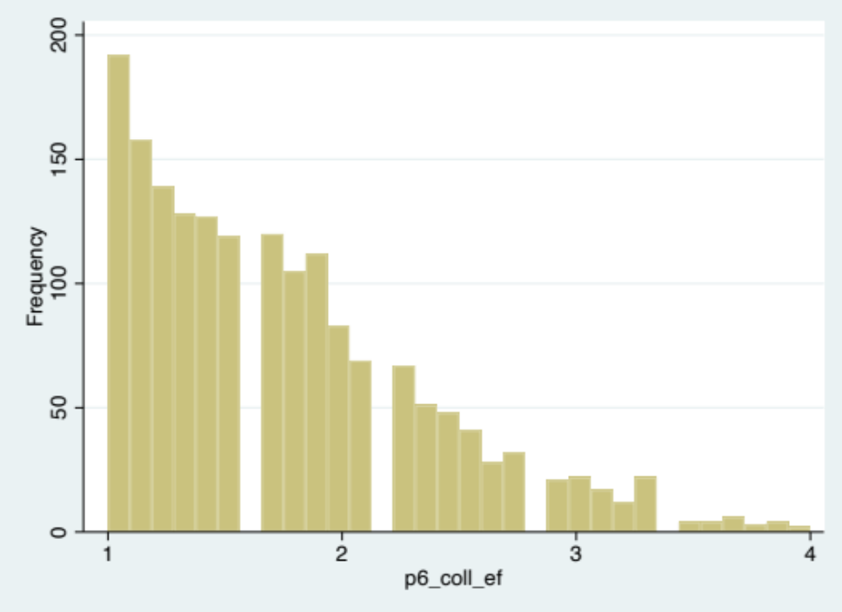
Note: Lower scores indicate higher collective efficacy.
Median = 1.67; Interquartile range = (1.22-2.11).

Figure S1b. Distribution of adolescents’ collective efficacy scores (n=1,829)
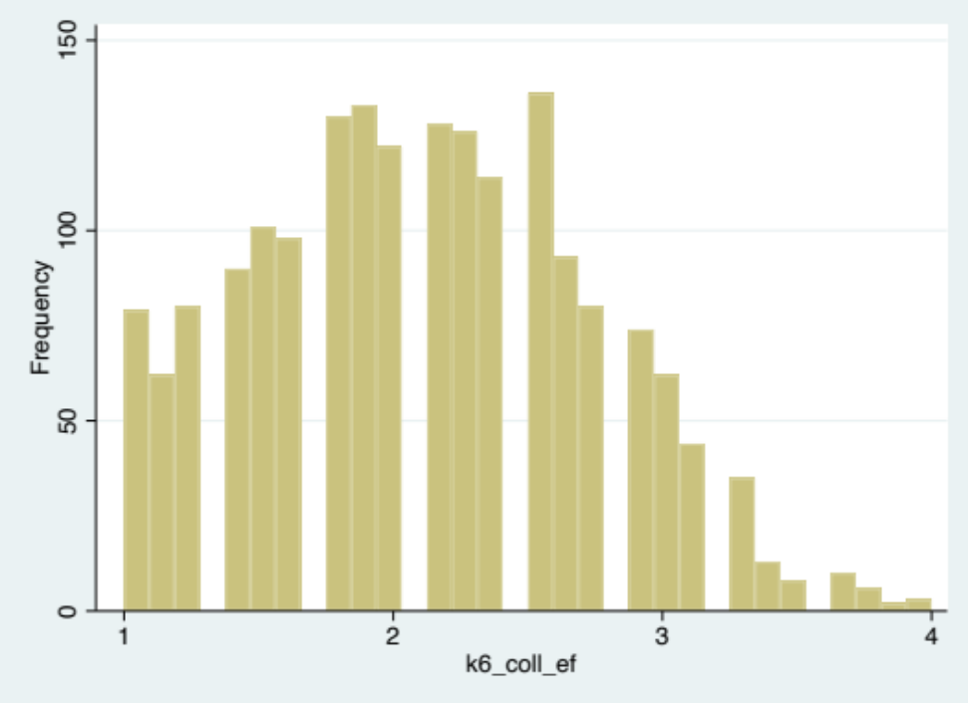
Note: Lower scores indicate higher collective efficacy.
Median = 2.13; Interquartile range = (1.63-2.50).

Table S4. Predicted probability of adolescents’ past-year exposure to firearm homicide within 800 meters of their home by race/ethnicity, household income & adolescents’ reports of neighborhood collective efficacy (n=1,829)
Income x Collective efficacy | Race/ethnicity | Coefficient | 95% CI
Income x Collective efficacy | Race/ethnicity | Coefficient | Lower | Upper
Poor-  Low collective efficacy | Black, Non-Hispanic | 0.5176 | 0.3515 | 0.6836
Poor-  Low collective efficacy | Latinx/Hispanic | 0.4924 | 0.2932 | 0.6917
Poor-  Low collective efficacy | Other/Multiracial, Non-Hispanic | 0.4424 | 0.1738 | 0.7111
Poor-  Low collective efficacy | White, Non-Hispanic | 0.1661 | 0.0491 | 0.2832
Poor-  Moderate collective efficacy | Black, Non-Hispanic | 0.5026 | 0.3513 | 0.6539
Poor-  Moderate collective efficacy | Latinx/Hispanic | 0.4775 | 0.3107 | 0.6443
Poor-  Moderate collective efficacy | Other/Multiracial, Non-Hispanic | 0.4277 | 0.1258 | 0.7297
Poor-  Moderate collective efficacy | White, Non-Hispanic | 0.1580 | 0.0316 | 0.2845
Poor-  High collective efficacy | Black, Non-Hispanic | 0.4604 | 0.2898 | 0.6311
Poor-  High collective efficacy | Latinx/Hispanic | 0.4356 | 0.1737 | 0.6975
Poor-  High collective efficacy | Other/Multiracial, Non-Hispanic | 0.3869 | 0.0790 | 0.6949
Poor-  High collective efficacy | White, Non-Hispanic | 0.1368 | 0.0367 | 0.2369
Near poor-  Low collective efficacy | Black, Non-Hispanic | 0.4699 | 0.3207 | 0.6190
Near poor-  Low collective efficacy | Latinx/Hispanic | 0.4450 | 0.2020 | 0.6879
Near poor-  Low collective efficacy | Other/Multiracial, Non-Hispanic | 0.3960 | 0.1808 | 0.6112
Near poor-  Low collective efficacy | White, Non-Hispanic | 0.1414 | 0.0319 | 0.2508
Near poor-  Moderate collective efficacy | Black, Non-Hispanic | 0.4550 | 0.2722 | 0.6378
Near poor-  Moderate collective efficacy | Latinx/Hispanic | 0.4302 | 0.1807 | 0.6797
Near poor-  Moderate collective efficacy | Other/Multiracial, Non-Hispanic | 0.3818 | 0.1031 | 0.6605
Near poor-  Moderate collective efficacy | White, Non-Hispanic | 0.1342 | 0.0085 | 0.2600
Near poor-  High collective efficacy | Black, Non-Hispanic | 0.4135 | 0.2052 | 0.6218
Near poor-  High collective efficacy | Latinx/Hispanic | 0.3894 | 0.0716 | 0.7071
Near poor-  High collective efficacy | Other/Multiracial, Non-Hispanic | 0.3428 | 0.0510 | 0.6345
Near poor-  High collective efficacy | White, Non-Hispanic | 0.1158 | 0.0061 | 0.2254
Middle-to-high income-  Low collective efficacy | Black, Non-Hispanic | 0.2751 | 0.1261 | 0.4241
Middle-to-high income-  Low collective efficacy | Latinx/Hispanic | 0.2555 | 0.1128 | 0.3982
Middle-to-high income-  Low collective efficacy | Other/Multiracial, Non-Hispanic | 0.2192 | 0.0537 | 0.3847
Middle-to-high income-  Low collective efficacy | White, Non-Hispanic | 0.0658 | 0.0111 | 0.1206
Middle-to-high income-  Moderate collective efficacy | Black, Non-Hispanic | 0.2633 | 0.0920 | 0.4346
Middle-to-high income-  Moderate collective efficacy | Latinx/Hispanic | 0.2443 | 0.0956 | 0.3929
Middle-to-high income-  Moderate collective efficacy | Other/Multiracial, Non-Hispanic | 0.2091 | 0.0009 | 0.4173
Middle-to-high income-  Moderate collective efficacy | White, Non-Hispanic | 0.0623 | -0.0014 | 0.1260
Middle-to-high income-  High collective efficacy | Black, Non-Hispanic | 0.2318 | 0.1352 | 0.3285
Middle-to-high income-  High collective efficacy | Latinx/Hispanic | 0.2144 | 0.0698 | 0.3591
Middle-to-high income-  High collective efficacy | Other/Multiracial, Non-Hispanic | 0.1825 | 0.0185 | 0.3465
Middle-to-high income-  High collective efficacy | White, Non-Hispanic | 0.0531 | 0.0166 | 0.0896
Figure S2. Predicted probability of adolescents’ past-year exposure to firearm homicide within 800 meters of their home by race/ethnicity, household income & adolescents’ reports of neighborhood collective efficacy (n=1,829)

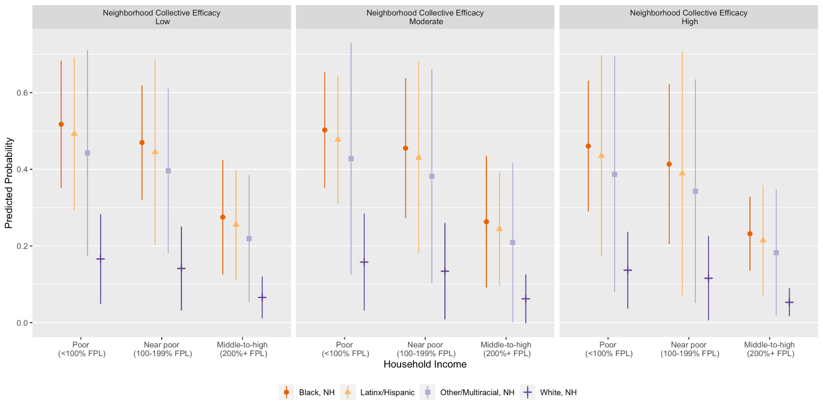

Table S5. Predicted probability of adolescents’ past-year exposure to firearm homicide within 800 meters of their home by race/ethnicity, household income & neighborhood collective efficacy (n=1,736)
Income x Collective efficacy | Race/ethnicity | Coefficient | 95% CI
Income x Collective efficacy | Race/ethnicity | Coefficient | Lower | Upper
Poor-  Low collective efficacy | Black, Non-Hispanic | 0.6183 | 0.4885 | 0.7481
Poor-  Low collective efficacy | Latinx/Hispanic | 0.5905 | 0.4022 | 0.7788
Poor-  Low collective efficacy | Other/Multiracial, Non-Hispanic | 0.5726 | 0.2782 | 0.8671
Poor-  Low collective efficacy | White, Non-Hispanic | 0.3010 | 0.1390 | 0.4630
Poor-  Moderate collective efficacy | Black, Non-Hispanic | 0.3906 | 0.2179 | 0.5633
Poor-  Moderate collective efficacy | Latinx/Hispanic | 0.3633 | 0.1736 | 0.5530
Poor-  Moderate collective efficacy | Other/Multiracial, Non-Hispanic | 0.3465 | 0.0406 | 0.6523
Poor-  Moderate collective efficacy | White, Non-Hispanic | 0.1456 | 0.0285 | 0.2627
Poor-  High collective efficacy | Black, Non-Hispanic | 0.3492 | 0.1966 | 0.5018
Poor-  High collective efficacy | Latinx/Hispanic | 0.3233 | 0.1705 | 0.4760
Poor-  High collective efficacy | Other/Multiracial, Non-Hispanic | 0.3074 | 0.0310 | 0.5838
Poor-  High collective efficacy | White, Non-Hispanic | 0.1249 | 0.0367 | 0.2130
Near poor-  Low collective efficacy | Black, Non-Hispanic | 0.5611 | 0.3907 | 0.7316
Near poor-  Low collective efficacy | Latinx/Hispanic | 0.5323 | 0.2945 | 0.7702
Near poor-  Low collective efficacy | Other/Multiracial, Non-Hispanic | 0.5140 | 0.2268 | 0.8012
Near poor-  Low collective efficacy | White, Non-Hispanic | 0.2537 | 0.0812 | 0.4262
Near poor-  Moderate collective efficacy | Black, Non-Hispanic | 0.3360 | 0.1410 | 0.5310
Near poor-  Moderate collective efficacy | Latinx/Hispanic | 0.3105 | 0.0937 | 0.5274
Near poor-  Moderate collective efficacy | Other/Multiracial, Non-Hispanic | 0.2950 | 0.0204 | 0.5697
Near poor-  Moderate collective efficacy | White, Non-Hispanic | 0.1186 | 0.0074 | 0.2298
Near poor-  High collective efficacy | Black, Non-Hispanic | 0.2975 | 0.1483 | 0.4468
Near poor-  High collective efficacy | Latinx/Hispanic | 0.2738 | 0.1119 | 0.4357
Near poor-  High collective efficacy | Other/Multiracial, Non-Hispanic | 0.2595 | 0.0278 | 0.4911
Near poor-  High collective efficacy | White, Non-Hispanic | 0.1012 | 0.0223 | 0.1801
Middle-to-high income-Low collective efficacy | Black, Non-Hispanic | 0.3510 | 0.2116 | 0.4903
Middle-to-high income-Low collective efficacy | Latinx/Hispanic | 0.3250 | 0.1516 | 0.4983
Middle-to-high income-Low collective efficacy | Other/Multiracial, Non-Hispanic | 0.3091 | 0.0951 | 0.5230
Middle-to-high income-Low collective efficacy | White, Non-Hispanic | 0.1257 | 0.0239 | 0.2275
Middle-to-high income-Moderate collective efficacy | Black, Non-Hispanic | 0.1763 | 0.0607 | 0.2918
Middle-to-high income-Moderate collective efficacy | Latinx/Hispanic | 0.1600 | 0.0464 | 0.2736
Middle-to-high income-Moderate collective efficacy | Other/Multiracial, Non-Hispanic | 0.1504 | -0.0038 | 0.3046
Middle-to-high income-Moderate collective efficacy | White, Non-Hispanic | 0.0538 | 0.0014 | 0.1063
Middle-to-high income-High collective efficacy | Black, Non-Hispanic | 0.1519 | 0.0759 | 0.2280
Middle-to-high income-High collective efficacy | Latinx/Hispanic | 0.1375 | 0.0683 | 0.2068
Middle-to-high income-High collective efficacy | Other/Multiracial, Non-Hispanic | 0.1291 | 0.0085 | 0.2496
Middle-to-high income-High collective efficacy | White, Non-Hispanic | 0.0455 | 0.0085 | 0.0824

