Additional File 2. Supplementary Methods and Tables: SVI-10

Supplementary Table 1. Vulnerability indicators included in the CDC-SVI and SVI-10

Supplementary Table 2. Exploratory Factor Analysis of CDC-SVI: Factor Loadings

Supplementary Figure 1. Scree plot and parallel analysis for factor retention

Supplementary Figure 2. Map of County-level Social Vulnerability Index-10 (SVI-10) tertiles in Puerto Rico, 2018-2022

Supplementary Table 3. Tertiles Comparison: SVI-10 by CDC-SVI

Supplementary Table 1. Vulnerability indicators included in the CDC-SVI¹ and SVI-10²
CDC-SVI | SVI-10
Theme 1: Socioeconomic Status
Percentage of Persons Below 150% Poverty | Percentage of Persons Below 150% Poverty
Percentage of Persons Unemployed | Percentage of Persons Unemployed
Housing Cost Burden | Housing Cost Burden
Percentage of Persons with No High School Diploma | Percentage of Persons with No High School Diploma
Percentage of Persons with No Health Insurance | Percentage of Persons with No Health Insurance
Theme 2: Household Composition
Percentage of Persons Aged 65 & Older | Percentage of Persons Aged 65 & Older
Percentage of Personas Aged 17 & Younger | Aged 17 & Younger
Percentage of Civilian Noninstitutionalized Population with a Disability | Percentage of Civilian Noninstitutionalized Population with a Disability
Percentage of Single-Parent Households with Children under 18 | Single-Parent Households
Percentage of Persons (Age 5+) who “speak English less than well”
Theme 3: Racial/Ethnic Minority Status
Percentage Minority (Hispanic or Latino (of any race); Black and African American, Not Hispanic or Latino; American Indian and Alaska Native, Not Hispanic or Latino; Asian, Not Hispanic or Latino; Native Hawaiian and Other Pacific Islander, Not Hispanic or Latino; Two or More Races, Not Hispanic or Latino; Other Races, Not Hispanic or Latino) | -
Theme 4: Housing Type & Transportation
Percentage of Housing in Structures with 10 or More Units
Percentage of Mobile Homes
Percentage of Occupied Housing Units with More People than Rooms | Percentage of Occupied Housing Units with More People than Rooms
Percentage of Households with No Vehicle Access
Percentage of Persons in Group Quarters

¹Agency for Toxic Substances and Disease Registry. CDC SVI. 2024. US Centers for Disease Control and Prevention, Agency for Toxic Substances and Disease Registry. CDC SVI Data & Documentation Download. Available from: https://www.atsdr.cdc.gov/place-health/php/svi/svi-data-documentation-download.html
²Indicators excluded from the SVI-10 were removed due to low factor loadings, high complexity, or lack of theoretical relevance for the context of Puerto Rico. Theme 3 (Racial/Ethnic Minority Status) was excluded entirely, given that nearly all of PR’s population identifies as Hispanic/Latino.

Supplementary Table 2. Exploratory Factor Analysis of CDC-SVI: Factor Loadings¹
Variable | Factor 1 | Factor 2 | Factor 3 | Factor 4 | Communality (h2) | Uniqueness (u2) | Complexity
Percentage of Persons Below 150% Poverty | 0.82 | 0.00 | 0.11 | 0.36 | 0.81 | 0.19 | 1.40
Percentage of Persons Unemployed | 0.09 | 0.00 | 0.08 | 0.34 | 0.13 | 0.87 | 1.20
Housing Cost Burden | -0.66 | -0.08 | -0.08 | 0.29 | 0.53 | 0.47 | 1.40
Percentage of Persons with No High School Diploma | 0.82 | 0.09 | 0.00 | -0.02 | 0.69 | 0.31 | 1.00
Percentage of Persons with No Health Insurance | -0.43 | 0.01 | 0.60 | -0.09 | 0.56 | 0.44 | 1.90
Percentage of Persons Aged 65 & Older | 0.18 | 0.87 | -0.01 | -0.04 | 0.80 | 0.20 | 1.10
Percentage of Personas Aged 17 & Younger | 0.17 | -0.80 | 0.17 | 0.35 | 0.82 | 0.18 | 1.60
Percentage of Civilian Noninstitutionalized Population with a Disability | -0.09 | 0.03 | -0.43 | 0.02 | 0.20 | 0.80 | 1.10
Percentage of Single-Parent Households with Children under 18 | -0.40 | -0.23 | -0.03 | 0.45 | 0.41 | 0.59 | 2.50
Percentage of Persons (Age 5+) who “speak English less than well” | 0.84 | -0.25 | 0.03 | 0.31 | 0.86 | 0.14 | 1.50
Percentage Minority | 0.02 | -0.28 | -0.18 | 0.40 | 0.27 | 0.73 | 2.30
Percentage of Housing in Structures with 10 or More Units | -0.58 | 0.54 | 0.06 | 0.21 | 0.67 | 0.33 | 2.30
Percentage of Mobile Homes | 0.00 | 0.03 | 0.07 | -0.21 | 0.05 | 0.95 | 1.20
Percentage of Occupied Housing Units with More People than Rooms | 0.10 | -0.07 | 0.85 | -0.12 | 0.76 | 0.24 | 1.10
Percentage of Households with No Vehicle Access | 0.03 | 0.35 | 0.46 | 0.40 | 0.49 | 0.51 | 2.90
Percentage of Persons in Group Quarters | -0.18 | 0.14 | -0.15 | 0.20 | 0.11 | 0.89 | 3.70

¹Factor loadings were extracted using minimum residual estimation with varimax rotation. Bolded loadings indicate salient values ≥ |0.40|. Communalities (h2), uniqueness (u2), and item complexity are also shown. This table supports Figure S1 (Scree plot for factor retention based on parallel analysis).

Supplementary Figure 1. Scree plot and parallel analysis for factor retention¹

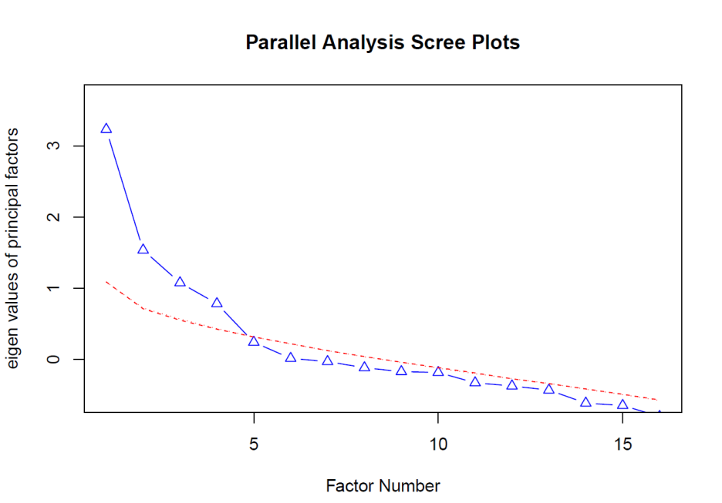
Figure Legend: A scree plot with parallel analysis (100 iterations) was used to determine the number of factors to retain. Four factors had eigenvalues exceeding those derived from simulated data, supporting a 4-factor solution for the SVI-10.

Supplementary Figure 2. Map of County-level Social Vulnerability Index-10 (SVI-10) tertiles in Puerto Rico, 2018-2022

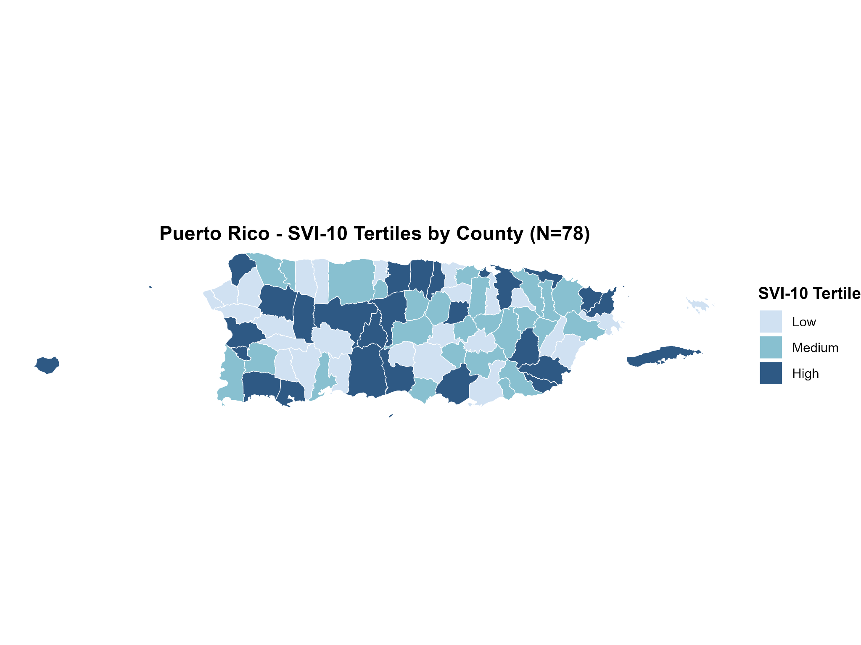
Figure Legend: Map of Puerto Rico’s 78 counties shaded by SVI-10 tertile, derived from EFA of CDC-SVI indicators. Lighter shades reflect lower social vulnerability; darker shades reflect higher vulnerability.

Supplementary Table 3. Tertiles Comparison: SVI-10 by SVI-16¹
 | CDC-Social Vulnerability Index, N_{county} (col %)
Social Vulnerability Index-10 | Low  N_{county}= 26  N_{decedents}= 472 | Medium  N_{county}=26  N_{decedents}=454 | High  N_{county}=26 N_{decedents}=545
Low  N_{county}= 26  N_{decedents}= 391 | 21 (80.8%) | 4 (15.4%) | 1 (3.8%)
Medium  N_{county}= 26  N_{decedents}= 551 | 5 (19.2%) | 18 (69.2%) | 3 (11.5%)
High  N_{county}= 26  N_{decedents}= 529 | 0 (0.0%) | 4 (15.4%) | 22 (84.2%)

¹ Cross-tabulation of counties and decedents across SVI-10 and CDC-SVI tertiles. Tertiles were assigned at the county level.

