Additional file 1

Nanjo KZ, Yoshida A (2017) Anomalous decrease of relatively large shocks and increase of the p and b values preceding the April 16, 2016, M7.3 earthquake in Kumamoto, Japan. Earth, Planets, and Space. doi:10.1186/s40623-017-0598-2

This file includes Appendix 1, Figures A1-A4, and Additional references.

Appendix 1: The EMR method and completeness estimate.

The EMR technique (Woessner and Wiemer 2005) was initially proposed by Ogata and Katsura (1993, 2006) who combined the GR law with a detection rate function. The statistical modeling is done separately for completely detected and incompletely detected parts of the frequency-magnitude distribution. The b and a values in the GR law are computed based on earthquakes above a certain magnitude (M_{cc}). For earthquakes whose magnitudes are smaller than M_{cc}, it is hypothesized that the detection rate depends on their magnitudes in such a way that large earthquakes are almost entirely detected while smaller ones are detected at lower rates. Ogata and Katsura (1993, 2006) and Woessner and Wiemer (2005) assumed that the detection rate was expressed by the cumulative function of the Normal distribution. Earthquakes with magnitudes greater than or equal to M_{cc} are assumed to be detected with a detection rate of one. To evaluate fitness of the model to data, the log-likelihood is computed by changing the value of M_{cc}. The best fitting model is the one that maximizes the log-likelihood.
Woessner and Wiemer (2005) pointed out that the choice of the cumulative function of the Normal distribution, based on visual inspection and modeling of a variety of catalogues, as well as comparisons to other possible functions, is problematic, because it is not based on physical reasoning. They suggested that such cases might exist for which the choice of another function is more appropriate. However, synthetic tests endorsed that estimates of M_{c} can be correct even if the cumulative function of the Normal distribution is replaced by the cumulative function of the Lognormal or Weibull distribution.
We compared the EMR method with three frequently-used techniques: the Maximum-curvature (MAC) method and two versions of the Goodness-of-fit (GOF) method (Wiemer and Wyss 2000, 2002). The MAC method defines M_{c} as the magnitude bin with the highest number of events. The GOF defines M_{c} as the lowest magnitude for which the goodness-of-fit is 90% or larger (GOF90, yellow) and 95% or larger (GOF95, green), where the goodness-of-fit is based on the residual indicating the deviance of the fitted GR law model from the observed data (Wiemer and Wyss 2000, 2002). We found that all of these techniques underestimated M_{c} (Fig. A1), that is, the EMR method gave the most conservative estimation of M_{c}, which was supposed to justify the use of the EMR method.
In contrast to the aforementioned catalog-based methods, a recently-introduced Probability-based Magnitude of Completeness (PMC) method (Schorlemmer and Woessner 2008) obtains the completeness from detection capabilities of the station network (e.g., Nanjo et al. 2010; Schorlemmer et al. 2010; Plenkers et al. 2011; Schorlemmer et al. 2017 submitted). These capabilities are derived from phase picks in the earthquake catalog provided by the network. The PMC method is computationally intensive and requires deep understanding of the seismic station network. Ideally, this method might be most appropriate to analyze data at productive seismicity times such as investigated in this study. To improve the current PMC approach to be applicable to those data will give further insights about the effect of the estimation of M_{c} on seismic parameter investigation.

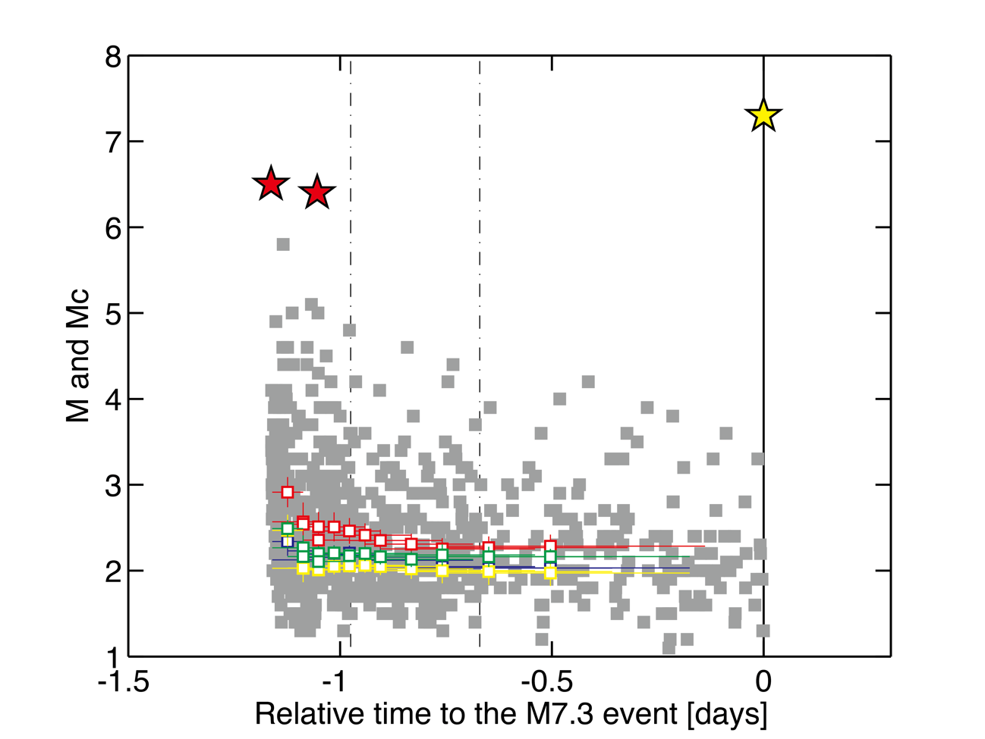
Fig. A1. Plot of M_{c} as a function of relative time to the M7.3 quake (vertical solid line) since the M6.5 quake in which a 200-event window was used. Uncertainty in M_{c} was according to the bootstrapping (Schorlemmer et al. 2003, 2004). Red square: M_{c} computed by using the EMR method (same as that in Fig. 1). For comparison, we estimated M_{c} by using other three methods (See Appendix 1): the MAC method (blue square), the GOF90 method (yellow square), and the GOF95 method (green square). Also included in this figure is the M-time diagram. Vertical dashed lines indicate the relative times, 0.98 and 0.67 days, to the M7.3 quake. Red stars: M6-class quakes (M6.5, M6.4), yellow star: the M7.3 quake.

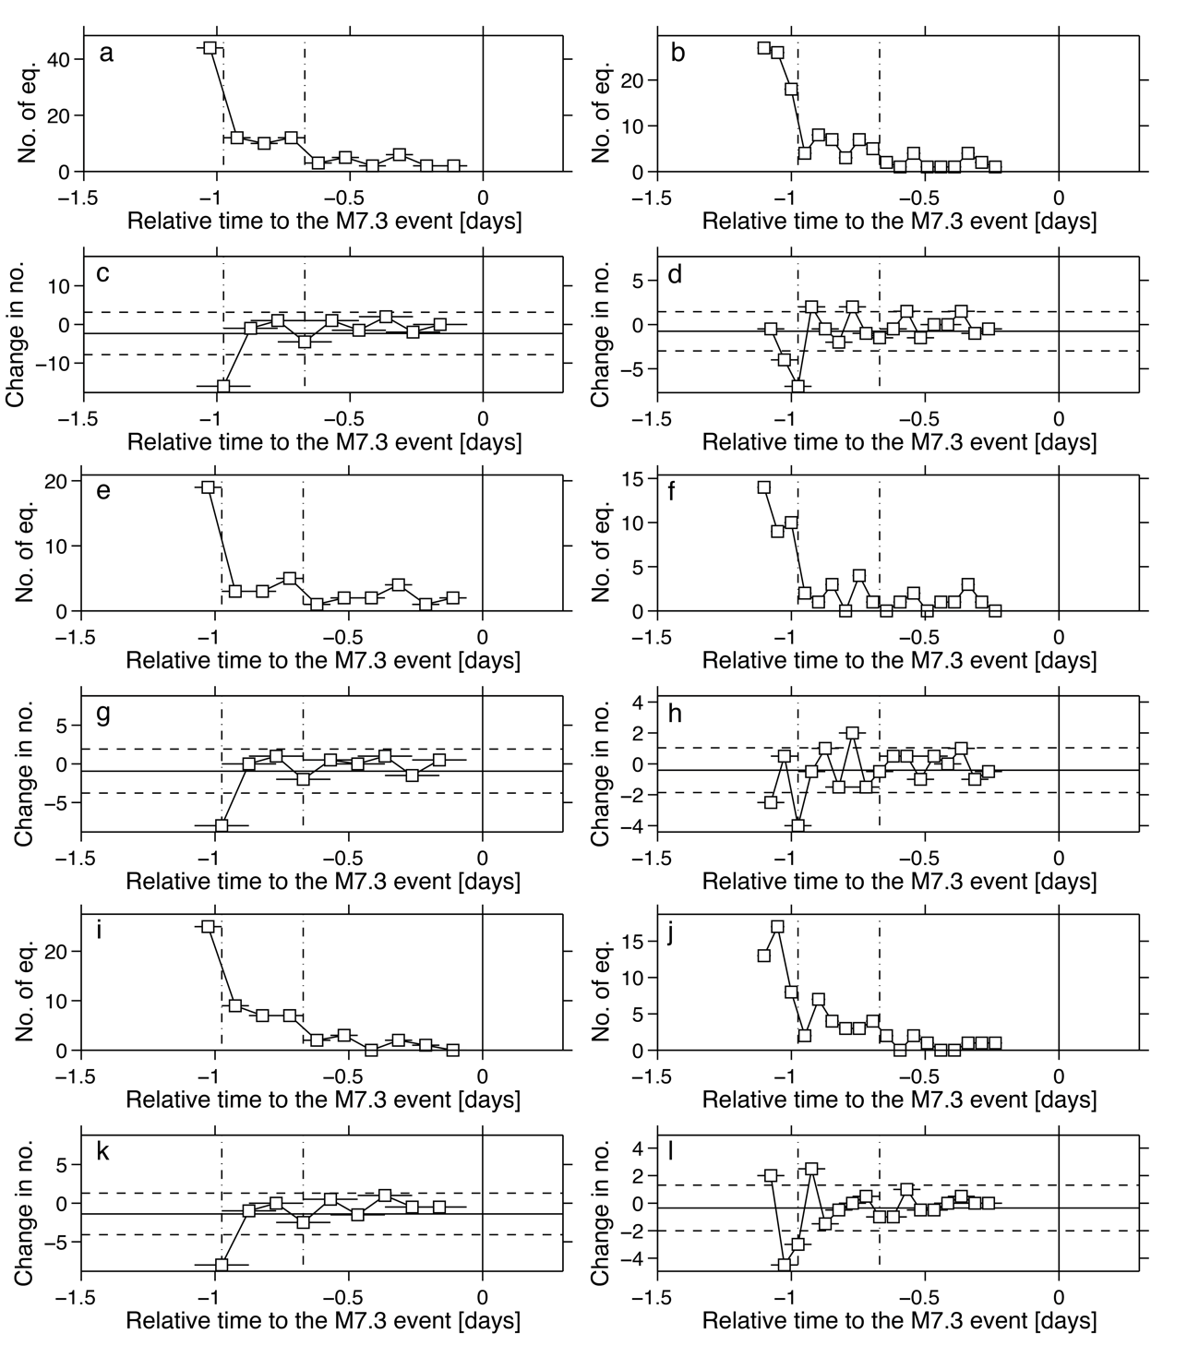
Fig. A2. Plots of the number (i.e., the rate of occurrence) (1st, 3rd, and fifth rows) and the change in the number (i.e., the change in rate of occurrence) (2nd, fourth, and sixth rows) of M ≥ 3 earthquakes as a function of relative time to the M7.3 quake. a-d: seismicity in the whole area, e-h: seismicity in the northern area (higher than 32.72° in latitude), and i-l seismicity in the southern area (lower than 32.72° in latitude). First column: time window of 0.10 days; second column: time window of 0.05 days. See also the caption of Fig. 2.
Fig. A3. Same as Fig. 4 except for calculating b, M_{c}, and σ values by sampling nearest 100 earthquakes at each node.
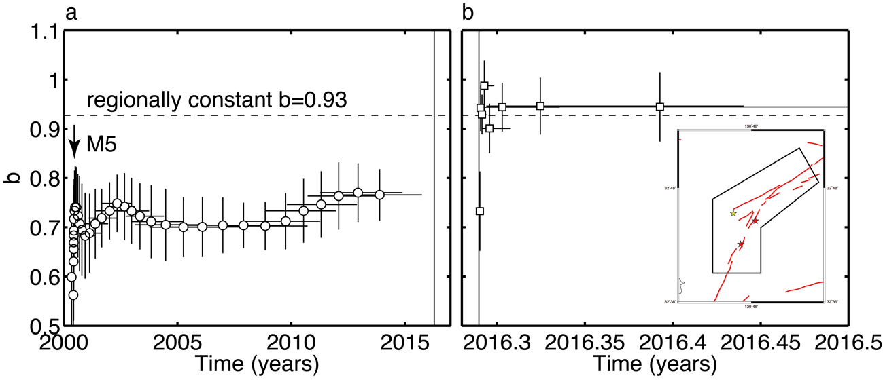
Fig. A4. Plot of b values as a function of time before the M6.5 quake (vertical line in a) and after the M7.3 quake (vertical line in b), as obtained from seismicity with depths 25 km or shallower in the polygon area shown in the inset of b. We used a moving window approach, whereby the window covered 500 events. Uncertainty were estimated according to bootstrapping (Schorlemmer et al. 2003, 2004). Horizontal line: regional average b = 0.93, as obtained by Nanjo et al. (2016). These authors averaged over the b values calculated from seismicity from 2000 to immediately before the M6.5 quake in a region (130-132° in longitude and 32-33.5° in latitude) wider than that used in this study. Large fluctuation in b, as indicated by arrow in a, is due to aftershocks of the 2000 M5 earthquake (Nanjo et al. 2016). The inset of b shows the polygon in which seismicity was used to calculate b values. Red stars: M6-class quakes (M6.5, M6.4), yellow star: M7.3 quake, red lines: traces of active faults.

Additional references
Nanjo KZ, Izutsu J, Orihara Y, Furuse N, Togo S, Nitta N, Okada T, Tanaka R, Kamogawa M, Nagao T (2016) Seismicity prior to the 2016 Kumamoto earthquakes. Earth Planets Space 68:187. doi:10.1186/s40623-016-0558-2
Nanjo KZ, Schorlemmer D, Woessner J, Wiemer S, Giardini D (2010) Earthquake detection capability of the Swiss Seismic Network. Geophys J Int 181:1713–1724. doi:10.1111/j.1365-246X.2010.04593.x
Ogata Y, Katsura K (1993) Analysis of temporal and spatial heterogeneity of magnitude frequency distribution inferred from earthquake catalogs. Geophys J Int 113:727–738
Ogata Y, Katsura K (2006) Immediate and updated forecasting of aftershock hazard. Geophys Res Lett 33:L10305. doi:10.1029/2006GL025888
Plenkers K, Schorlemmer D, Kwiatek G, the JAGUARS Research Group (2011) On the probability of detecting picoseismicity. Bull Seismol Soc Am 101(6):2579–2591. doi:10.1785/0120110017
Schorlemmer D, Hirata N, Ishigaki Y, Doi K, Nanjo KZ, Tsuruoka H, Beutin T, Euchner F, (2017 submitted) Earthquake detection probabilities in Japan. Bull Seismol Soc Am
Schorlemmer D, Mele F, Marzocchi W (2010) A completeness analysis of the national seismic network of Italy. J Geophys Res 115:B04308. doi:10.1029/2008JB006097
Schorlemmer D, Neri G, Wiemer S, Mostaccio A (2003) Stability and significance tests for b-value anomalies: Example from the Tyrrhenian Sea. Geophys Res Lett 30(16):1835. doi:10.1029/2003GL017335
Schorlemmer D, Wiemer S, Wyss M (2004) Earthquake statistics at Parkfield: 1. Stationarity of b values. J Geophys Res 109:B12307. doi:10.1029/2004JB003234
Schorlemmer D, Woessner J (2008) Probability of detecting an earthquake. Bull Seismol Soc Am 98(5):2103–2117. doi:10.1785/0120070105
Wiemer S, Wyss M (2000) Minimum magnitude of complete reporting in earthquake catalogs: Examples from Alaska, the Western United States, and Japan. Bull Seismol Soc Am 90:859–869. doi:10.1785/0119990114
Wiemer S, Wyss M (2002) Mapping spatial variability of the frequency-magnitude distributions of earthquakes. Adv Geophys 45:259– 302. doi:10.1016/S0065-2687(02)80007-3
Woessner J, Wiemer S (2005) Assessing the quality of earthquake catalogues: Estimating the magnitude of completeness and its uncertainty. Bull Seismol Soc Am 95:684–698. doi:10.1785/0120040007

