Why do aftershocks occur? –Relationship between mainshock rupture and aftershock sequence based on highly resolved hypocenter and focal mechanism distributions–

Additional File 1

Yohei Yukutake, Yoshihisa Iio

Earth, Planets and Space

Procedure of event selection for principal component analysis (PCA)
To select the events for PCA as objectively as possible, we followed these steps, after we divided the aftershock region into the northern and southern parts.

(1) We conducted PCA for the hypocenter data in each region.
(2) If the result meets the following three conditions, the best-fit plane was estimated.
i) Planarity of the hypocenter distribution is greater than or equal to 8.0
ii) Standard deviation of the plane orientation is less than or equal to 2.0º
iii) Number of event in the region is greater than or equal to 20
(3) If the result did not meet the conditions of i) or ii), we divided the region into smaller parts based on the hypocenter distribution, and conducted PCA for each small region again. If the result did not meet the condition of iii), we stopped the calculation for the region.

The process of (1)–(3) was repeated 4 times (Figs A1 and A2). The results of PCA are listed in Tables A1 and A2.

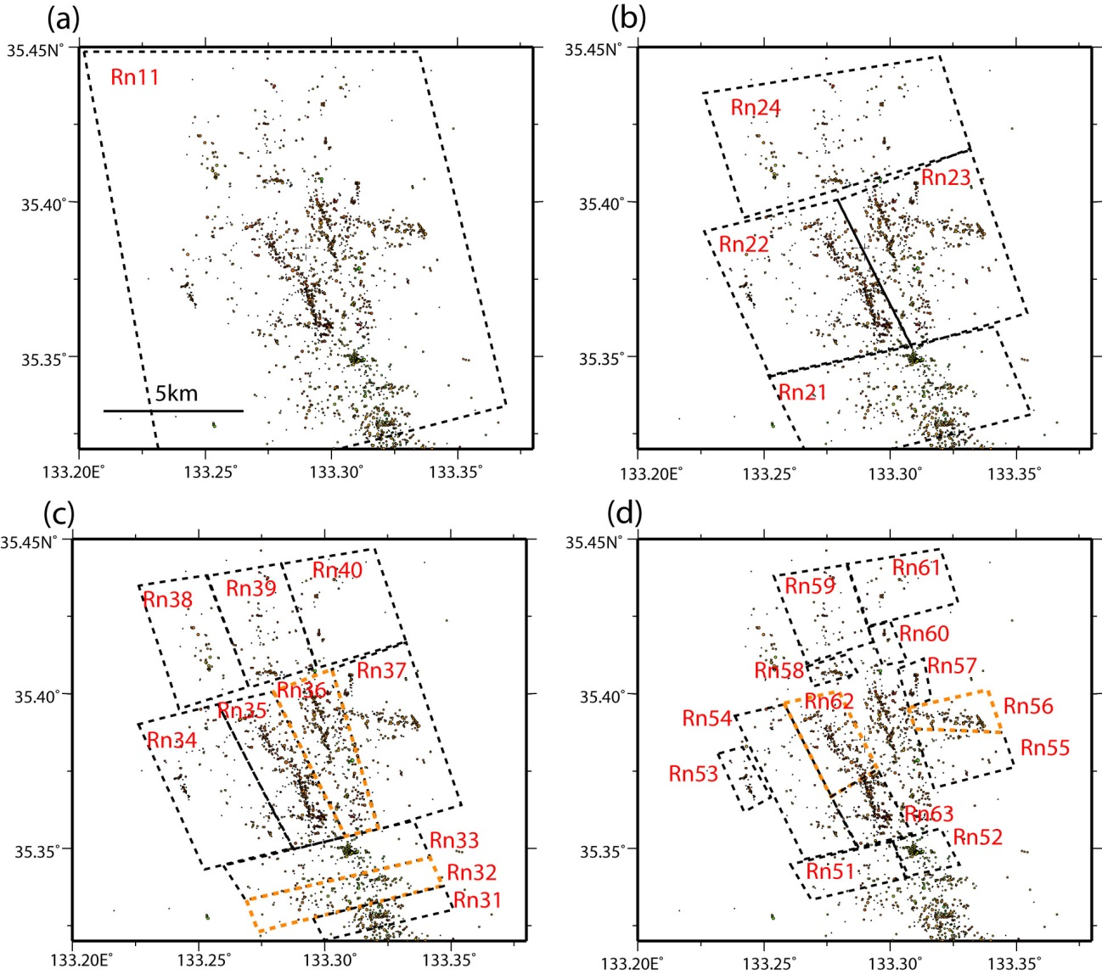
Figure A1. Procedure of event section for the northern part of aftershock region. The areas enclosed by dashed lines indicate regions used for event selection in each strep. The region shown by the orange lines shows the hypocenter distribution that meets three conditions (detailed in the text).

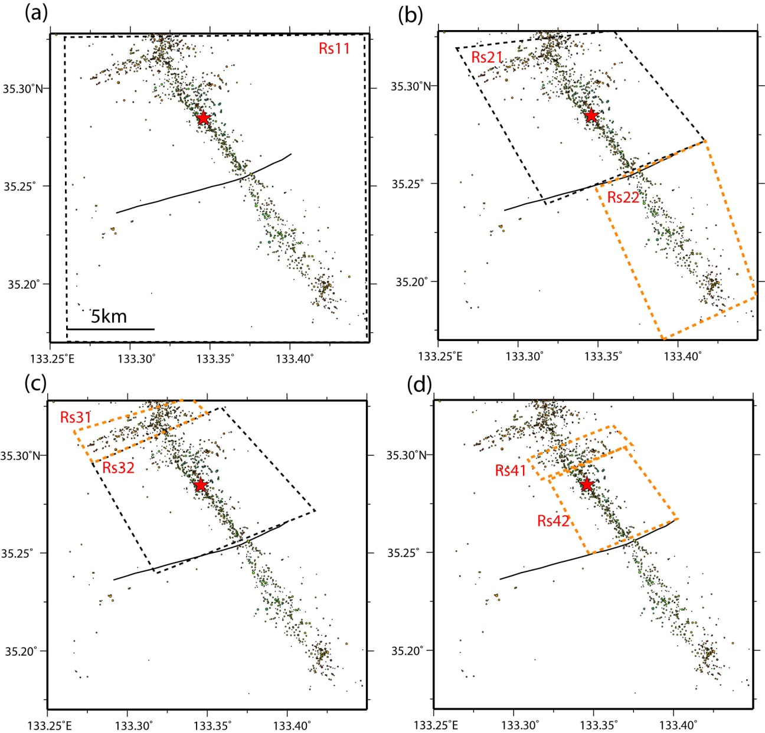
Figure A2. Procedure of event section for the southern part of aftershock region.

Table A1. Results of PCA for the northern part. Index number of region name is corresponding to that in Fig A1. The best-fit planes could be estimated in the region marked by yellow color.
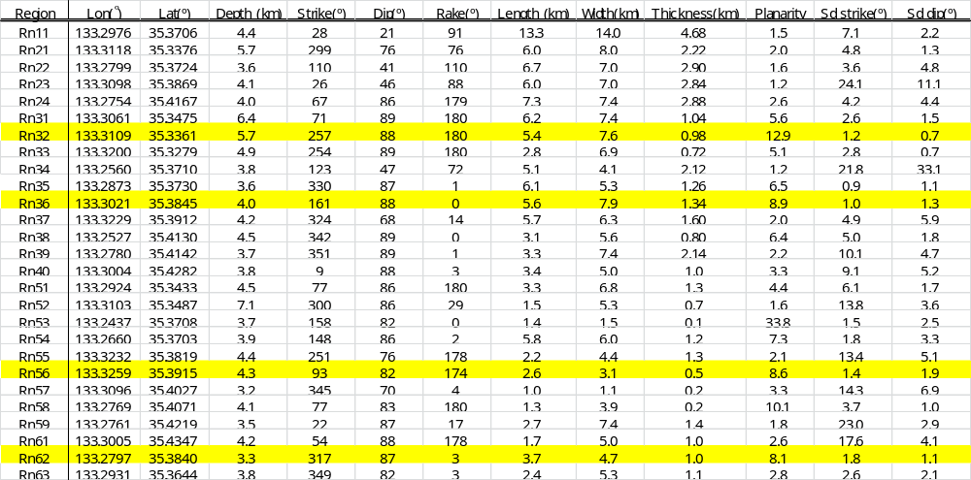

Table A2. Results of PCA for the southern part.
