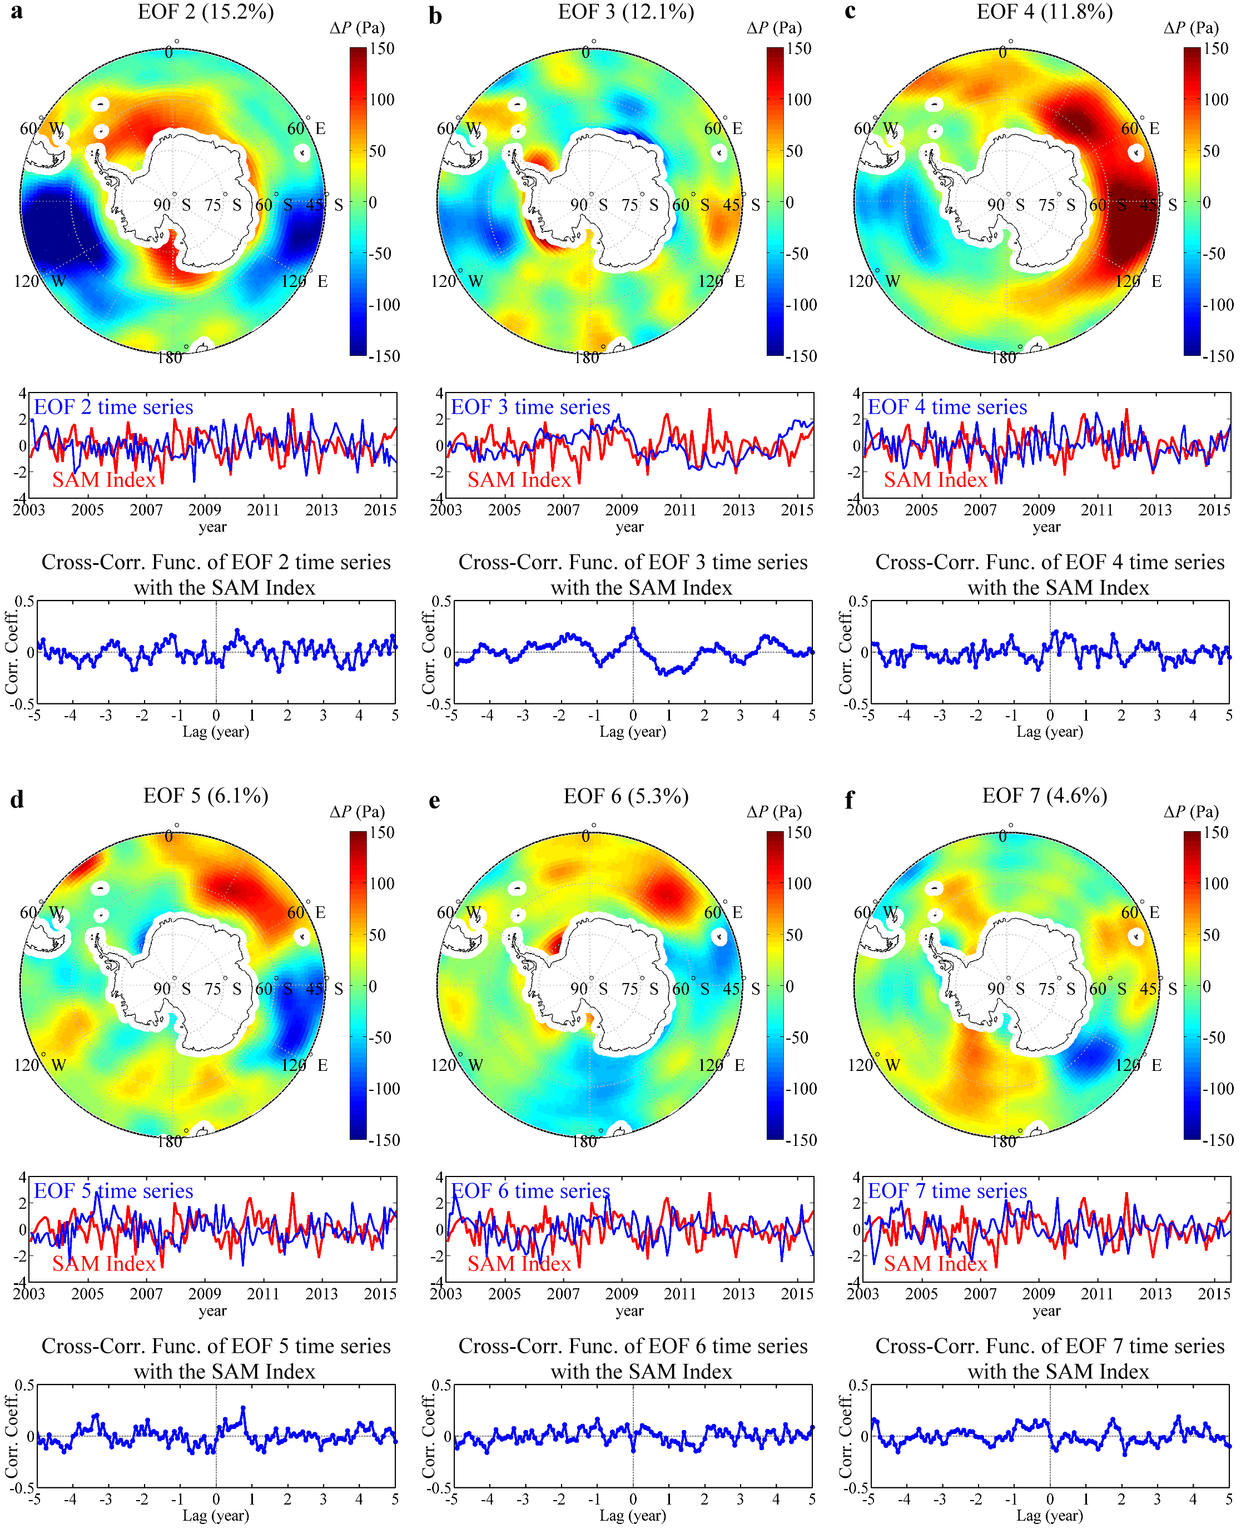
Additional file 1 The higher EOF mode solutions of the non-seasonal OBP (ΔP) from the GRACE GAD+GSM dataset. The spatial pattern shows the amplitude of fluctuation (with positive or negative polarity) at each location according to the corresponding time history and is manifested as the OBP variation in unit of Pa. The time series (the blue curves) are normalized and compared with the SAM Index (the red curve). For each mode, we also show the percentage of total variance. For the cross-correlation function, positive lags mean that the SAM Index leads the EOF mode time series.

