Additional file
Title: Redistribution of Sr and rare earth elements in the matrices of CV3 carbonaceous chondrites during aqueous alteration in their parent body

Author #1: Kaori Jogo, Division of Earth-System Sciences, Korea Polar Research Institute, 26 Songdomirae-ro, Yeonsu-gu, Incheon 21990, South Korea, kaorijogo@kopri.re.kr
Author #2: Motoo Ito, Kochi Institute for Core Sample Research, JAMSTEC B200 Monobe, Nankoku, Kochi 783-8502, Japan, motoo@jamstec.go.jp
Author #3: Tomoki Nakamura, Division of Earth and Planetary Materials Science, Tohoku University, Sendai, Miyagi 980-8578, Japan, tomoki@m.tohoku.ac.jp
Author #4: Sachio Kobayashi, Kochi Institute for Core Sample Research, JAMSTEC B200 Monobe, Nankoku, Kochi 783-8502, Japan, kobayashis@jamstec.go.jp
Author #5: Jong Ik Lee, Unit of Antarctic K-route Expedition, Korea Polar Research Institute, 26 Songdomirae-ro, Yeonsu-gu, Incheon 21990, South Korea, jilee@kopri.re.kr

Corresponding author: Kaori Jogo
Article type: Express letter

Methods
1. Mineralogy and petrology
Mineralogical and petrological characterization and X-ray mapping of the matrices were obtained with scanning electron microscopy (SEM) and field-emission electron probe microanalysis (FE-EPMA). A 25 nm-thick carbon film was applied to the sample surfaces prior to the SEM and FE-EPMA analyses in order to eliminate the electrostatic charge. The SEM (JSM-6610 at the Korea Polar Research Institute) was equipped with a backscattered electron imaging system and an energy dispersive X-ray spectrometer. The X-ray spectra were obtained at a 15 keV accelerating voltage and the beam current mode of ss50 that provided the finest probe diameter to identify minerals. X-ray chemical maps of the matrices were obtained with an FE-EPMA (JEOL JXA-8530F at Korea Polar Research Institute) equipped with a wavelength dispersive X-ray spectrometer under the conditions of 15 kV accelerating voltage and a 50 nA beam current. The magnetite modal abundances were counted by using backscattered electron or X-ray mapping images in order to check the correlations between REEs and Sr abundances of matrices with magnetite abundances (details are described in section 2.3 in the main text).

2. Chemical compositions of matrices
We analyzed the chemical components of the matrices (Na₂O, MgO, SiO₂, Al₂O₃, Cr₂O₃, MnO, FeO, NiO, K₂O, CaO, TiO₂, P₂O₅, SO₃) by FE-EPMA (JEOL JXA-8530F at Korea Polar Research Institute) followed by analysis of REEs, Sr and Ca abundances by secondary ion mass spectrometry (SIMS; CAMECA ims-6f at the Kochi Institute for Core Sample Research, JAMSTEC). Same matrix areas of ~80 × 80 μm² were measured by FE-EPMA and SIMS in order to check for correlations between REEs and Sr abundances of matrices with their chemical compositions (details are described in section 2.3 in the main text). We obtained 14 data from the CV3_{OxB} MET 00430 host matrix, 10 data from the CV3_{OxB} MET 01070 host matrix, 11 data from the CV3_{OxA} LAP 02206 host matrix, 5 data from the CV3_{Ox} A 881317 matrix 5, 5 data from the CV3_{Red} RBT 04143 matrix 5 and 3 data from the CV3_{Red} RBT 04143 matrix 6). We carefully chose matrix areas without Ca-Al-rich inclusions or Fe-oxide weathering veins for the measurements.
For the FE-EPMA analysis, we operated at 15 kV accelerating voltage and 10 nA beam current, and the focused electron beam was rastered over ~80 × 80 μm². The ZAF correction method was applied.
For the SIMS measurements, a focused ¹⁶O⁻ primary beam ~30 μm in diameter with an intensity of ~14 nA was rastered over ~80 × 80 μm². The primary ¹⁶O⁻ ions were accelerated with 13 keV to sputter the sample surface. Positive secondary ions with masses of 30 (³⁰Si⁺), 44 (⁴⁴Ca⁺), 88 (⁸⁸Sr⁺) and 138-175 (¹³⁸Ba⁺, ¹³⁹La⁺, ¹⁴⁰Ce⁺, ¹⁴¹Pr⁺, ¹⁴²Nd⁺, ¹⁴⁷Sm⁺, ¹⁵¹Eu⁺, ¹⁵³Eu⁺, ¹⁵⁸Gd⁺, ¹⁵⁹Tb⁺, ¹⁶³Dy⁺, ¹⁶⁵Ho⁺, ¹⁶⁶Er⁺, ¹⁶⁹Tm⁺, ¹⁷²Yb⁺ and ¹⁷⁵Lu⁺) were accelerated with -4.4 KeV, energy filtered using a -60 or -100 V offset with a 30 eV energy window. One analysis consists of 10 cycles of the measurement, and the acquisition times of all secondary ions were 1 s for ³⁰Si and ⁴⁴Ca, 2 s for ⁸⁸Sr and 10 s for REEs. Each run started after the stabilization of the secondary ion beam intensity following pre-sputtering. The measured REE abundances are corrected by the contributions of REE-monoxide and sensitivity factors for REEs relative to Si. Further details of the analytical procedure and data correction will be given elsewhere (Kobayashi and Ito, in preparation; Jogo et al., submitted). After the SIMS measurements, the size and depth of each spot were measured by a laser microscope at the Kochi Institute for Core Sample Research, JAMSTEC.

Table S1. Primary and secondary minerals in CV3 matrices
Sample |  | MET 00430 | MET 01074 | LAP 02206 | A 881317 | RBT 04143 | RBT 04143
Subtype |  | OxB | OxB | OxA | Ox | Red | Red
Matrix# |  | Host matrix | Host matrix | Host matrix | Matrix 5 | Matrix 5 | Matrix 6
Type |  | Type 1 | Type 1 | Type 2 | Type 2 | Type2 | Type 3
Ca-rich phase
 | kirschsteinite |  |  |  |  | + | +
 | Ca-pyroxene | + | + | + | + | + | +
 | Ca-phosphate |  |  |  | + | + | +
Fe-metal
 | FeNi-metal* |  |  |  | + | + | +
 | kamacite* |  |  |  |  | + | +
 | awaruite |  |  | +
Fe-sulfide
 | Fe,Ni-sulfide | + | + | + |  | + | +
 | Fe-sulfide |  |  |  |  | + | +
Others
 | fayalite | + | +
 | ferrous olivine | + | + | + | + | + | +
 | magnetite | + | + |  | + | + | +
 | phyllosilicate | + | +
 | sodalite |  |  | +
 | nepheline |  |  | +
 | plagioclase |  |  | +
*: primary mineral

Table S2. REE, Sr and Ca contents of CV3 matrices
Sample | MET 00430 |  | MET 01074 |  | LAP 02206 |  | A 881317 |  | RBT 04143 |  | RBT 04143
Subtype | OxB |  | OxB |  | OxA |  | Ox |  | Red |  | Red
Matrix | Host matrix |  | Host matrix |  | Host matrix |  | Matrix 5 |  | Matrix 5 |  | Matrix 6
Type | Type 1 |  | Type 1 |  | Type 2 |  | Type 2 |  | Type 2 |  | Type 3
N | 14 |  | 10 |  | 11 |  | 5 |  | 5 |  | 3
Data | average | 1σ | average | 1σ | average | 1σ | average | 1σ | average | 1σ | average | 1σ
ppm
La | 0.38 | 0.11 | 0.43 | 0.17 | 0.40 | 0.07 | 0.27 | 0.04 | 0.24 | 0.04 | 0.33 | 0.17
Ce | 0.83 | 0.29 | 0.98 | 0.42 | 0.83 | 0.14 | 0.61 | 0.08 | 0.55 | 0.07 | 0.66 | 0.34
Pr | 0.13 | 0.06 | 0.15 | 0.07 | 0.12 | 0.02 | 0.09 | 0.02 | 0.08 | 0.01 | 0.10 | 0.04
Nd | 0.71 | 0.24 | 0.79 | 0.31 | 0.70 | 0.13 | 0.49 | 0.09 | 0.43 | 0.10 | 0.52 | 0.24
Sm | 0.20 | 0.06 | 0.20 | 0.06 | 0.18 | 0.04 | 0.15 | 0.03 | 0.14 | 0.05 | 0.13 | 0.05
Eu | 0.11 | 0.05 | 0.10 | 0.06 | 0.11 | 0.03 | 0.06 | 0.06 | 0.05 | 0.03 | 0.05 | 0.02
Gd | 0.24 | 0.05 | 0.23 | 0.07 | 0.22 | 0.07 | 0.19 | 0.03 | 0.17 | 0.05 | 0.20 | 0.08
Tb | 0.05 | 0.01 | 0.04 | 0.01 | 0.04 | 0.01 | 0.05 | 0.01 | 0.02 | 0.01 | 0.02 | 0.01
Dy | 0.37 | 0.07 | 0.27 | 0.04 | 0.31 | 0.05 | 0.21 | 0.02 | 0.19 | 0.02 | 0.16 | 0.03
Ho | 0.08 | 0.01 | 0.06 | 0.01 | 0.06 | 0.01 | 0.05 | 0.01 | 0.04 | 0.01 | 0.03 | 0.01
Er | 0.20 | 0.06 | 0.19 | 0.04 | 0.21 | 0.05 | 0.17 | 0.03 | 0.17 | 0.03 | 0.12 | 0.01
Tm | 0.04 | 0.01 | 0.03 | 0.01 | 0.04 | 0.01 | 0.02 | 0.00 | 0.03 | 0.01 | 0.02 | 0.01
Yb | 0.26 | 0.06 | 0.27 | 0.05 | 0.25 | 0.05 | 0.20 | 0.03 | 0.22 | 0.08 | 0.12 | 0.00
Lu | 0.04 | 0.01 | 0.04 | 0.01 | 0.03 | 0.01 | 0.03 | 0.00 | 0.02 | 0.01 | 0.03 | 0.01
Sr | 24.73 | 10.53 | 17.52 | 7.70 | 7.81 | 2.75 | 14.92 | 3.22 | 7.26 | 2.29 | 10.37 | 6.43
Ca (wt%) | 2.97 | 1.05 | 2.64 | 1.10 | 1.30 | 0.86 | 1.09 | 0.78 | 1.40 | 0.22 | 1.58 | 1.19
REE/CI
La | 1.61 | 0.49 | 1.82 | 0.72 | 1.72 | 0.29 | 1.17 | 0.17 | 1.02 | 0.16 | 1.40 | 0.73
Ce | 1.37 | 0.48 | 1.62 | 0.69 | 1.38 | 0.23 | 1.00 | 0.14 | 0.92 | 0.12 | 1.09 | 0.56
Pr | 1.49 | 0.64 | 1.68 | 0.75 | 1.39 | 0.27 | 0.99 | 0.17 | 0.89 | 0.06 | 1.12 | 0.49
Nd | 1.58 | 0.53 | 1.74 | 0.67 | 1.56 | 0.28 | 1.08 | 0.21 | 0.94 | 0.22 | 1.16 | 0.52
Sm | 1.38 | 0.41 | 1.39 | 0.41 | 1.19 | 0.27 | 1.01 | 0.21 | 0.92 | 0.32 | 0.89 | 0.36
Eu | 1.93 | 0.87 | 1.84 | 1.01 | 1.99 | 0.59 | 1.15 | 1.13 | 0.97 | 0.55 | 0.89 | 0.31
Gd | 1.21 | 0.27 | 1.16 | 0.36 | 1.14 | 0.36 | 0.95 | 0.18 | 0.88 | 0.25 | 1.03 | 0.43
Tb | 1.40 | 0.31 | 1.00 | 0.26 | 1.10 | 0.29 | 1.34 | 0.27 | 0.66 | 0.15 | 0.66 | 0.16
Dy | 1.51 | 0.30 | 1.12 | 0.16 | 1.26 | 0.19 | 0.85 | 0.09 | 0.77 | 0.07 | 0.66 | 0.11
Ho | 1.45 | 0.25 | 1.00 | 0.16 | 1.17 | 0.15 | 0.88 | 0.10 | 0.80 | 0.18 | 0.62 | 0.15
Er | 1.26 | 0.37 | 1.21 | 0.26 | 1.30 | 0.34 | 1.09 | 0.20 | 1.05 | 0.21 | 0.77 | 0.05
Tm | 1.57 | 0.39 | 1.35 | 0.32 | 1.46 | 0.30 | 1.01 | 0.12 | 1.04 | 0.35 | 0.74 | 0.32
Yb | 1.61 | 0.39 | 1.66 | 0.29 | 1.51 | 0.33 | 1.21 | 0.19 | 1.35 | 0.46 | 0.75 | 0.01
Lu | 1.51 | 0.49 | 1.61 | 0.56 | 1.43 | 0.42 | 1.05 | 0.13 | 0.77 | 0.32 | 1.03 | 0.49
Sr | 3.17 | 1.35 | 2.25 | 0.99 | 1.00 | 0.35 | 1.91 | 0.41 | 0.93 | 0.29 | 1.33 | 0.82
Ca | 3.20 | 1.14 | 2.84 | 1.19 | 1.78 | 0.61 | 1.64 | 0.31 | 1.51 | 0.24 | 2.27 | 0.73
Sr/Yb/CI | 2.05 | 0.90 | 1.37 | 0.58 | 0.71 | 0.32 | 1.63 | 0.48 | 0.78 | 0.38 | 1.76 | 1.07
Average and 1σ: average and standard deviation of individual SIMS measurement data; N: number of data

Fig. S1. A back scattered electron image of CV3_{Red} RBT 04143. Fe-oxide weathering veins occur in fractures of the section. Clast boundaries between matrices 5 and 6 are described by dotted-lines.
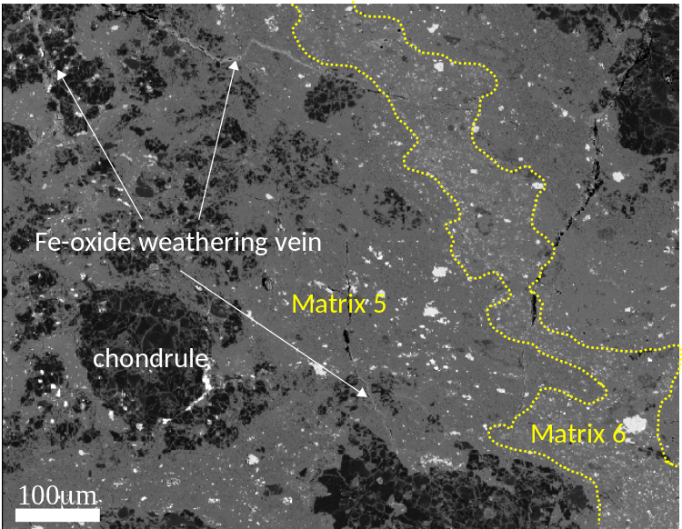

Fig. S2. Ce anomaly (the value obtained from interpolation between La and Nd) vs Ca (wt%), Nd (ppm) and Sr (ppm) of CV3 matrices. Error bars are 1σ. R²: correlation coefficient.
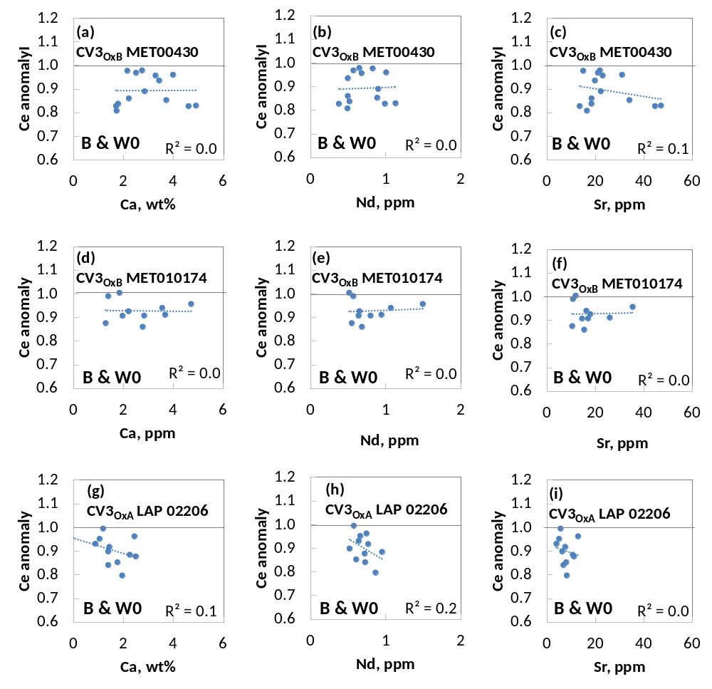

Fig. S2. Continued.
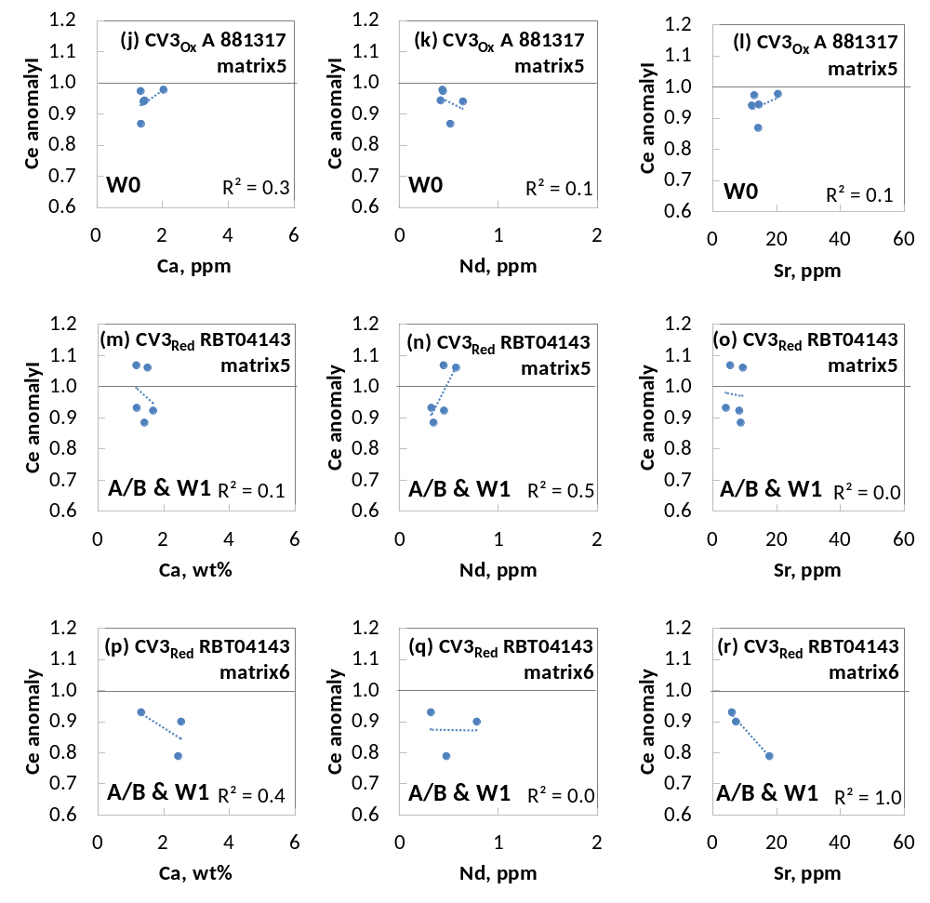

Fig. S3-1. S (blue square), Ni (red triangle), P (green circle), Al (blue square) and Na (green circle), and magnetite abundance (green square) vs La/CI plots of CV3_{OxB} MET 00430, CV3_{OxB} MET 01074 and CV3_{OxA} LAP 02206 host matrices. S, Ni, P, Al and Na contents are shown in wt% and magnetite abundance are shown in μm². Error bars are 1σ. The correlation coefficient (R²) for each correlation is shown by the same color of symbols.
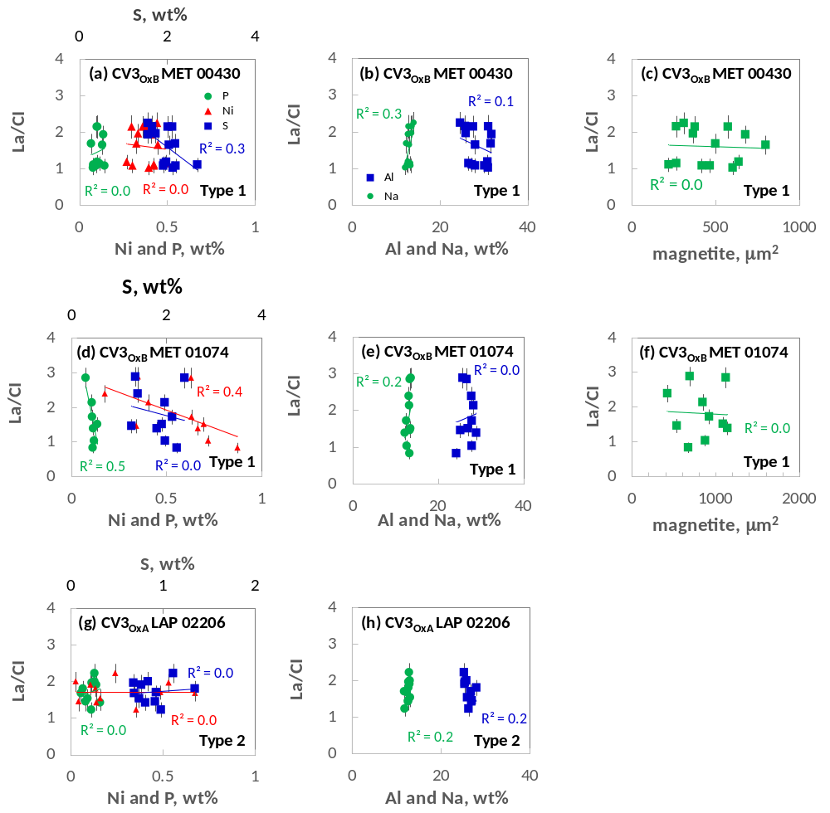

Fig. S3-2. S, Ni, P, Al and Na (wt%) and magnetite abundance (μm²) vs La/CI plots of CV3_{Ox} A 881317 matrix 5 and CV3_{Red} RBT 04143 matrices 5 and 6 . Error bars are 1σ. Symbols and notations are the same as Fig. S2-1.
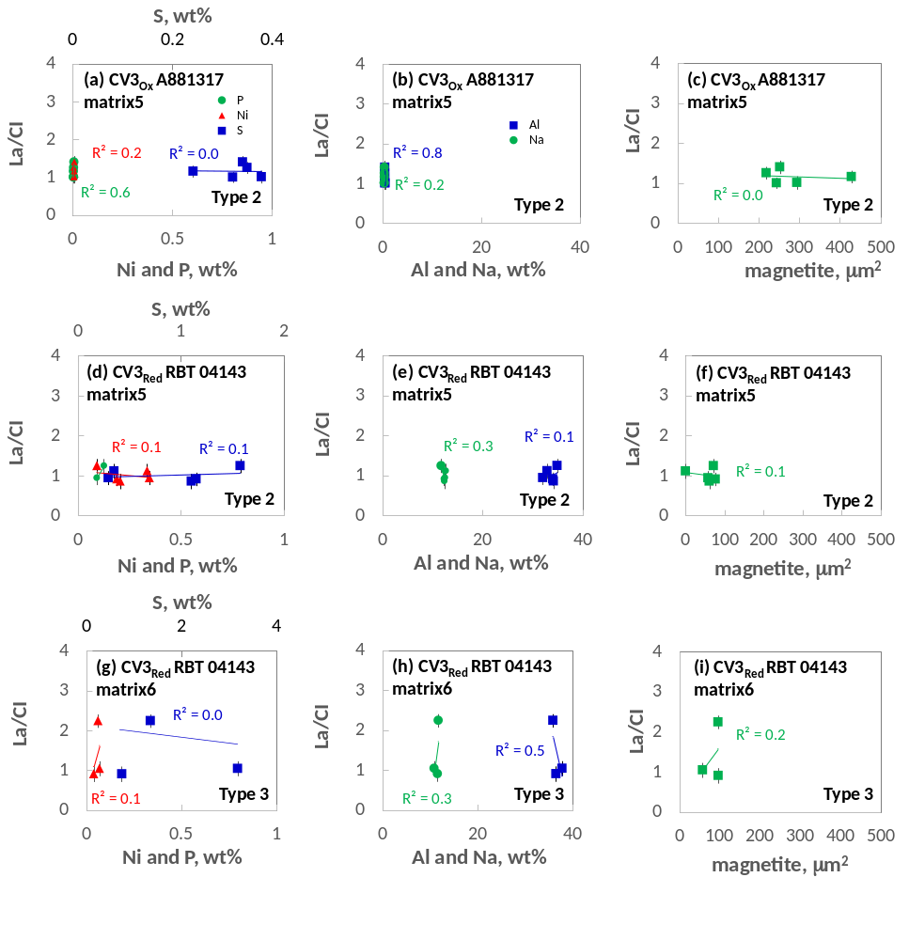

Fig. S4. Partition coefficients of Sr and REEs in phosphate, Ca-pyroxene, plagioclase, magnetite and olivine from melt. Data source: Kuhner et al., 1989; Nielsen et al., 1992; Kennedy et al., 1993; Prowatke and Klemme, 2006; Sun et al., 2017.
