Supplementary figures for “Aseismic fold growth in southwestern Taiwan detected by InSAR and GNSS” by Tsukahara and Takada.

Additional file 1: Figure S1
Interferometric pairs used in this study. Blue circles indicate image acquisition of ALOS/PALSAR. Black line indicates the interferometric pair.

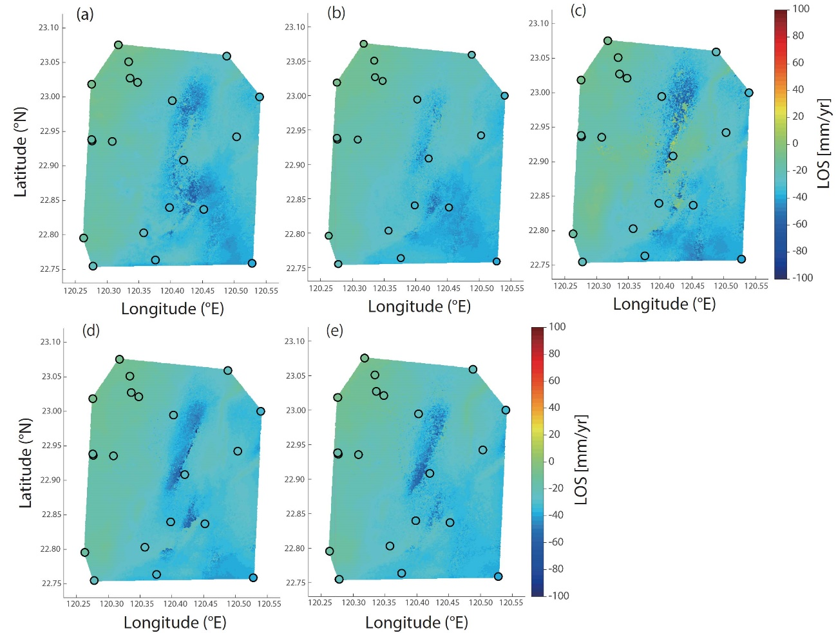
Additional file 2: Figure S2
Ascending interferograms corrected by GNSS. (a) 20070304-20091025. (b) 20070720-20100125. (c) 20080120-20100728. (d) 20080606-20110128. (e) 20080421-20110315. Details are listed in Table 1. Color indicates the length change velocity in the line of sight (LOS) direction. Colored circle indicates the LOS velocity measured at the GNSS station.

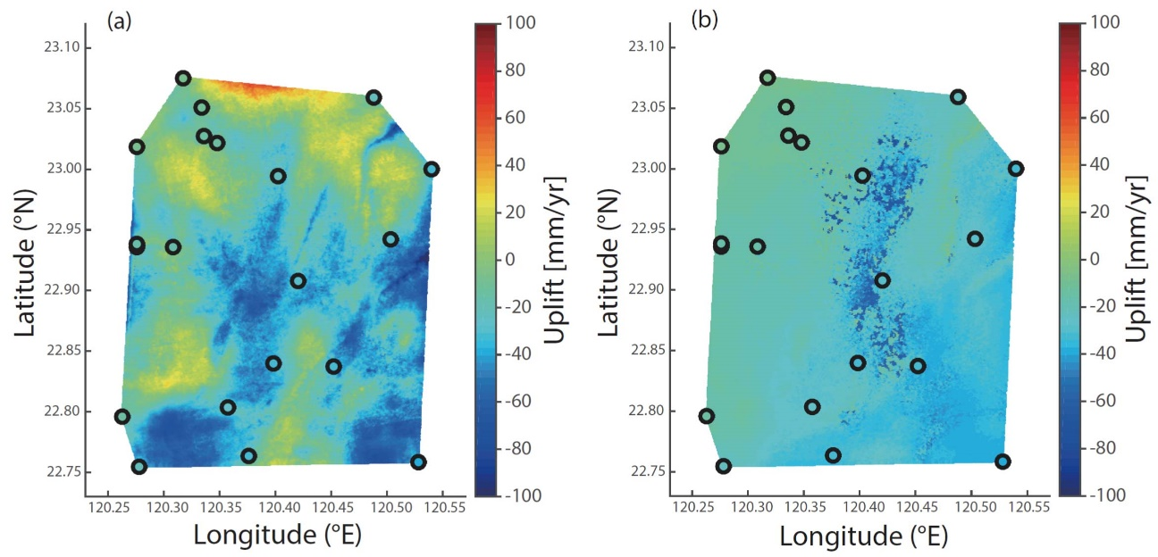

Additional file 3: Figure S3
Effect of temporal baseline on the interferograms corrected by GNSS. (a) 46 days (20090909-20091025). (b) 3.5 years (20070720-20110128). Color indicates the length change velocity in the line of sight (LOS) direction. Colored circle indicates the LOS velocity measured at the GNSS station.

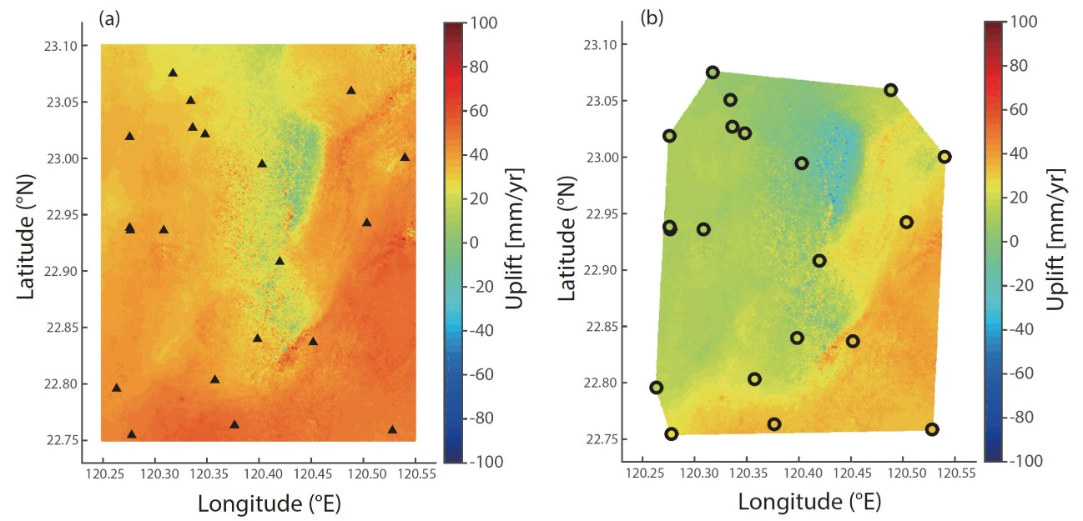

Additional file 4: Figure S4
GNSS correction of the descending interferogram (20070218-20081123). Color indicates the length change velocity in the line of sight (LOS) direction. Details are listed in Table 1. (a) Original interferogram. Black triangles indicate the GNSS station. (b) Corrected interferogram. Colored circle indicates the LOS velocity calculated from the GNSS data.

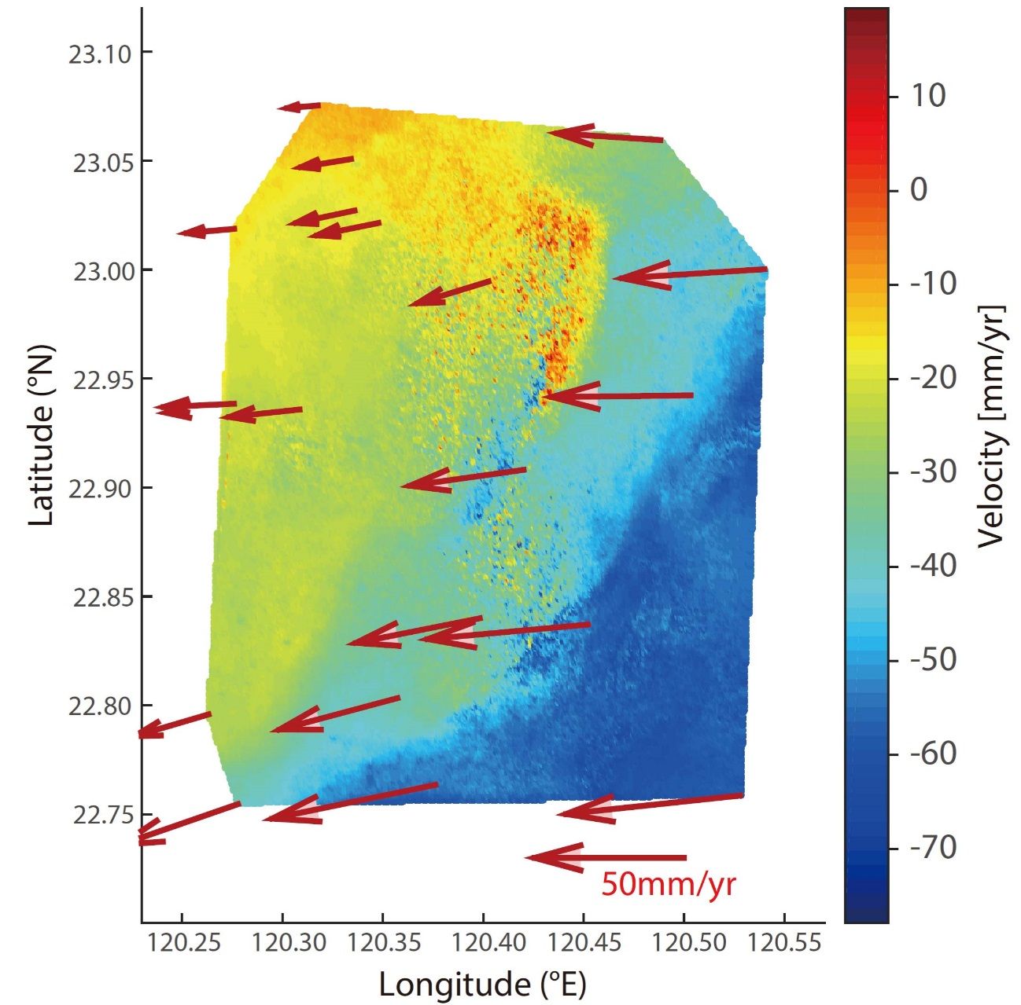
Additional file 5: Figure S5
Horizontal velocities in the study area. Red arrows indicate the horizontal velocity field with respect to S01R (Figure 1) obtained by GNSS measurements (Tsai et al., 2015). Colored image indicate quasi-EW velocity field obtained from InSAR analysis of ALOS data. Details are listed in Table 1.

Additional file 6: Figure S6
A simple fault model that accounts for the rapid deformation. (a) East-West component of displacement rate. (b) Uplift rate. Blue line indicates the displacement rate along AA’ in Figure 3a. Red circles represent numerical results calculated by the fault model. (c) Optimum fault model obtained from 2-D elastic dislocation theory. Arrows indicate the slip direction. Dip angle and slip rate are 65 degrees and 55 mm/yr, respectively.

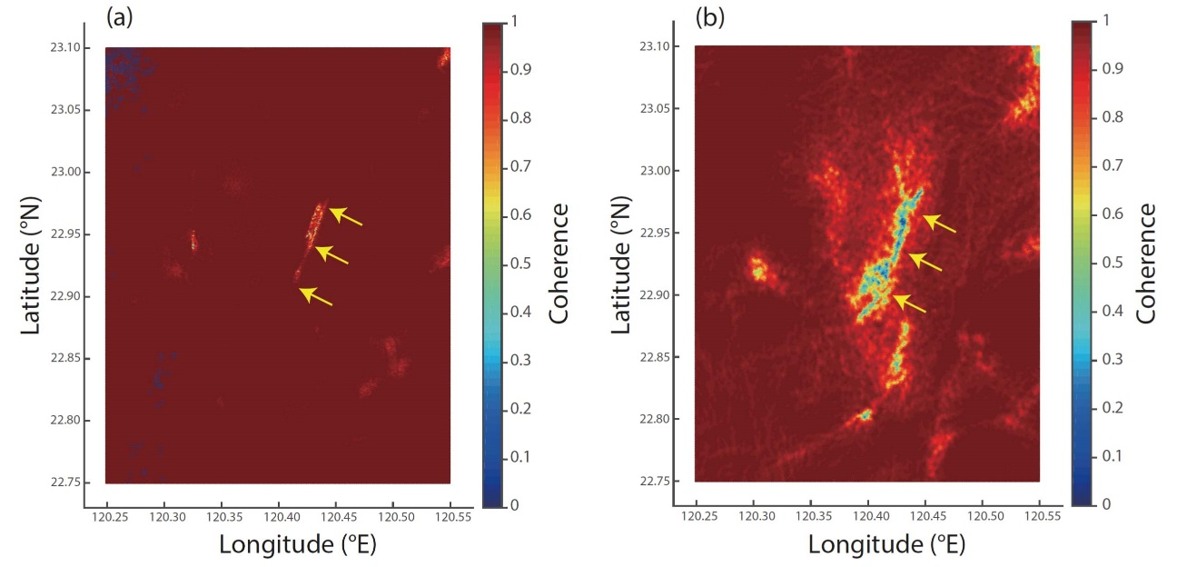

Additional file 7: Figure S7
Coherence of (a) coseismic interferogram of the Meinong earthquake (20151126-20160218) and (b) interseismic interferogram (20071020-20100312). Yellow arrows indicate a coherence loss associated with aseismic thrust faulting at the same location as indicated by red arrows in Figs. 3(a) and 4(a).

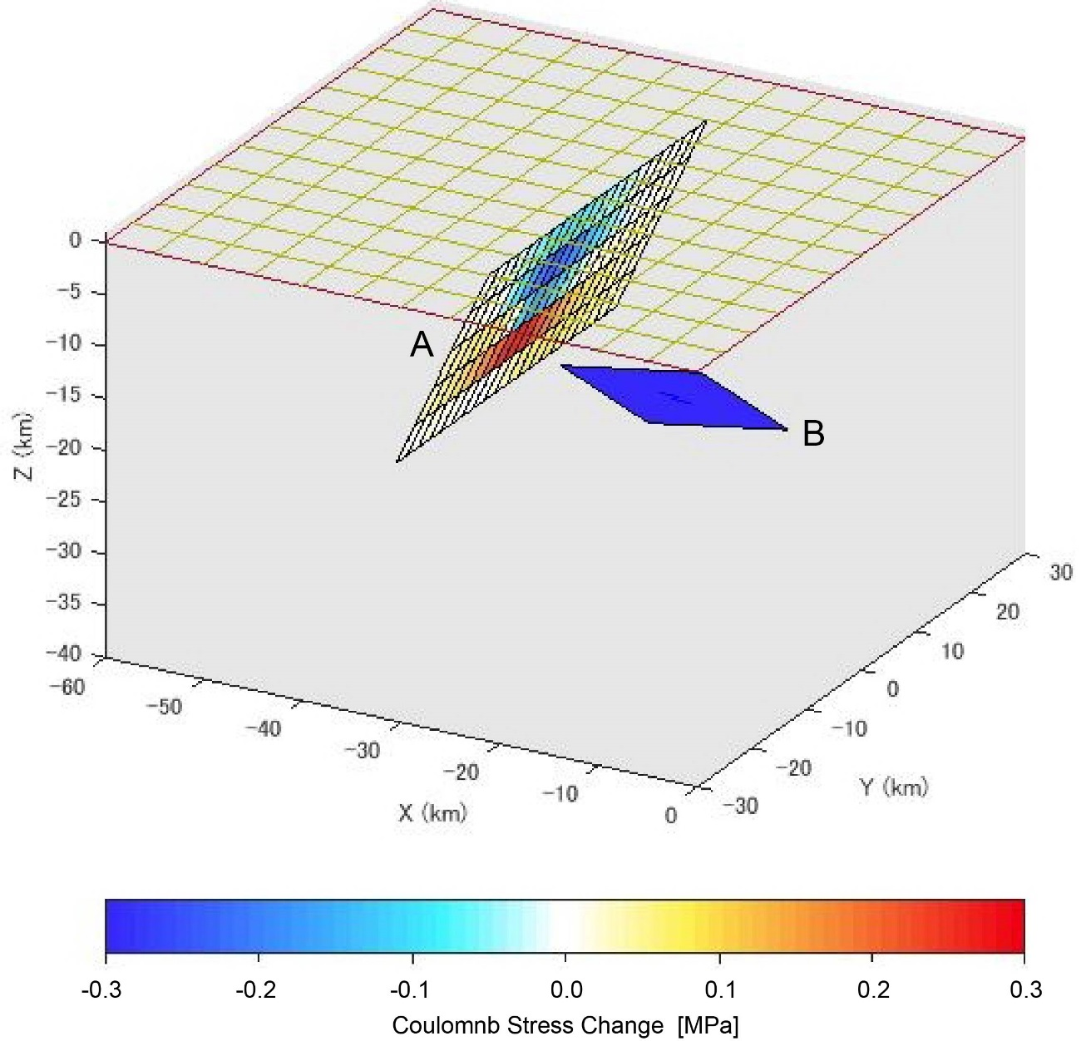
Additional file 8: Figure S8
Coulomb stress change on the aseismic thrust fault proposed in this study (A) due to coseismic slip on deeper (main) fault of the Meinong earthquake (B). For the receiver fault, we set the frictional coefficient as 0.3, and only calculated proximal part from the main fault. For the main fault (B), we approximated the fault patch as the asperity in the fault model inferred by Huang et al (2016b), which extends 15 km both in strike and dip directions. The moment magnitude of the main fault is set to 6.39, the same value as the one in Huang et al (2016b).

