Infrasonic wave accompanying a crack opening during the 2015 Hakone eruption

Additional File 1

Yukutake et al.

Earth, Planets and Space

Photos around the vents (Owakudani) taken using a time-lapse camera before and during the rapid tilt change.
Figure A1 shows photographs near the vents taken at 09:15:10 on June 27, 2015, (before the eruption) and at 07:32:45 on June 29, 2015 (during the rapid tilt change). Because of poor visibility in the Owakudani region (Figure A1), we could not obtain detailed visual observations of surface phenomena during the tilt change.

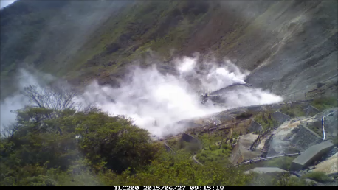

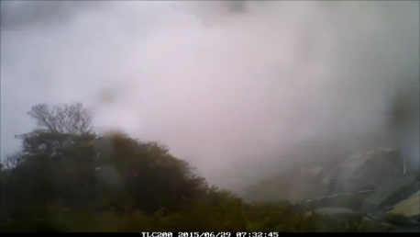
Figure A1. Photographs taken near the vents: (top) at 09:15:10 on June 27, 2015, and (bottom) at 07:32:45 on June 29, 2015 (during the tilt change).

