Resistivity characterisation of Hakone volcano, central Japan, by three-dimensional magnetotelluric inversion

Ryokei Yoshimura, Yasuo Ogawa, Yohei Yukutake, Wataru Kanda, Shogo Komori, Hideaki Hase, Tada-nori Goto, Ryou Honda, Masatake Harada, Tomoya Yamazaki, Masato Kamo, Shingo Kawasaki, Tetsuya Higa, Takeshi Suzuki, Yojiro Yasuda, Masanori Tani and Yoshiya Usui

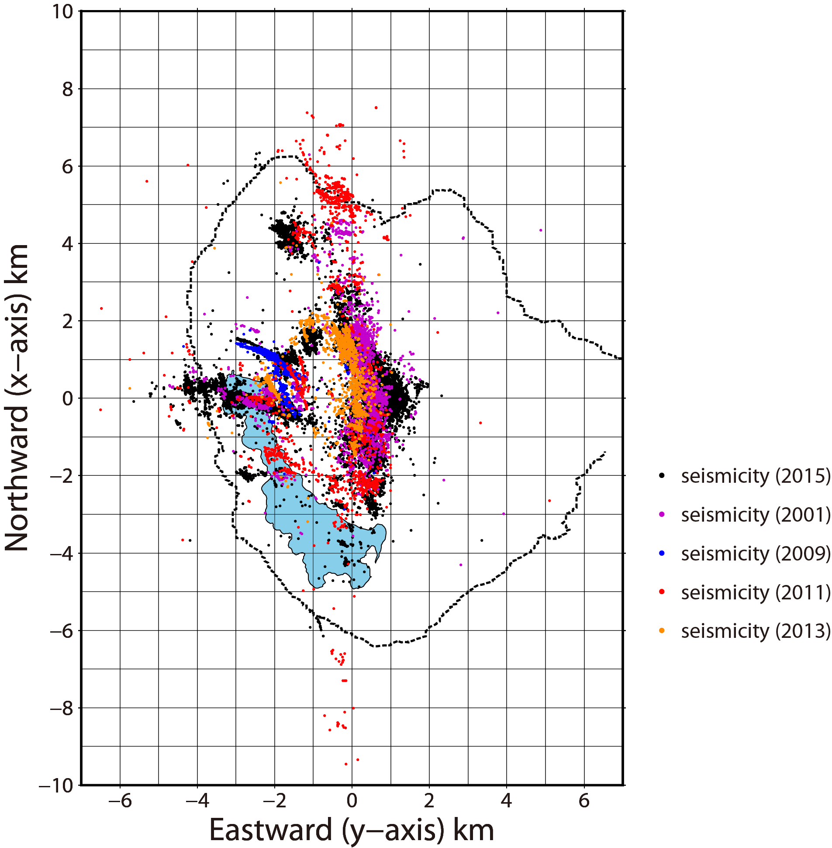
Additional Fig. S1 Map of relocated earthquake epicentres around the core region of the study area, as determined by the double-difference relocation method of: Yukutake et al. (2010) for 2001 swarm earthquakes (purple); Yukutake et al. (2011) for 2009 swarm earthquakes (blue); Yukutake et al. (2013) for 2011 remotely triggered activity (red); Yukutake et al. (2015) for 2013 swarm earthquakes (orange); and Yukutake et al. (2017) for 2015 swarm earthquakes (black). The dotted black line marks the present caldera rim of Hakone volcano. The shaded blue area is the surface extent of Lake Ashinoko. See Fig. 1 for further details on the location and details of this map relative to the entire study region.

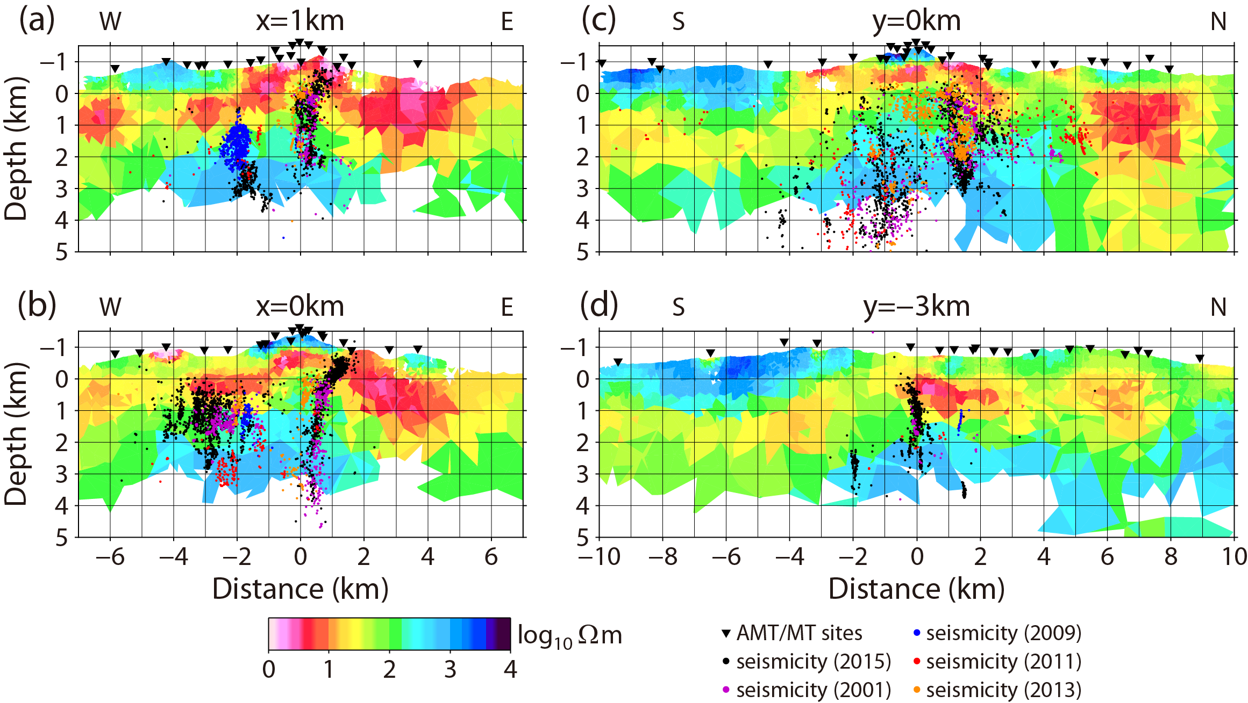

Additional Fig. S2 Vertical cross-sections of the three-dimensional resistivity structure, overlain by the hypocentres of several swarm epochs. Panels (a) and (b) are E–W profiles at X = 1 and 0 km, respectively. Panels (c) and (d) are N–S profiles at Y = 0 and –3 km, respectively. Panels (a) and (c) pass through the Owakudani geothermal area. Panels (b) and (d) pass through the Kojiri area. Earthquakes that are shown in Additional Fig. S1 and occurred within ±0.25 km of each profile are also plotted as coloured dots.

References
Yukutake Y, Honda R, Harada M, Arai R, Matsubara M (2015) A magma-hydrothermal system beneath Hakone volcano, central Japan, revealed by highly resolved velocity structures. Journal of Geophysical Research 120:3293-3308. https://doi.org/10.1002/2014JB011856

Yukutake Y, Honda R, Harada M, Doke R, Saito T, Ueno T, Sakai S, Morita Y (2017) Analyzing the continuous volcanic tremors detected during the 2015 phreatic eruption of the Hakone volcano. Earth Planets and Space 69:164. https://doi.org/10.1186/s40623-017-0751-y

Yukutake Y, Ito H., Honda R, Harada M., Tanada T., Yoshida A. (2011) Fluid‐induced swarm earthquake sequence revealed by precisely determined hypocenters and focal mechanisms in the 2009 activity at Hakone volcano, Japan. Journal of Geophysical Research 116:B04308. https://doi.org/10.1029/2010JB008036

Yukutake Y, Miyazawa M, Honda R, Harada M, Ito H, Sakaue M, Koketsu K, Yoshida A (2013) Remotely triggered seismic activity in Hakone volcano during and after the passage of surface waves from the 2011 M9.0 Tohoku-Oki earthquake. Earth and Planetary Science Letters 373:205-216. https://doi.org/10.1016/j.epsl.2013.05.004

Yukutake Y, Tanada T, Honda R, Harada M, Ito H, Yoshida A (2010) Fine fracture structures in the geothermal region of Hakone volcano, revealed by well-resolved earthquake hypocenters and focal mechanisms. Tectonophysics 489:104-118. https://doi.org/10.1016/j.tecto.2010.04.012

