Supplementary Material for

Preliminary paleomagnetic and rock magnetic results from 17-22 ka sediment of Jeju Island, Korea: Geomagnetic excursional behavior or rock magnetic anomalies?

Hyeon-Seon Ahn^{1,}*, Young Kwan Sohn¹, Jin-Young Lee², Jin Cheul Kim²

¹ Department of Geology and Research Institute of Natural Science, Gyeongsang National University (GNU), Jinju 52828, Republic of Korea
² Geologic Environment Division, Geo-Environmental Hazards and Quaternary Geology Research Center, Korea Institute of Geoscience and Mineral Resources (KIGAM), Daejeon 34132, Republic of Korea

* To whom correspondence should be addressed:
Hyeon-Seon Ahn
Department of Geology and Research Institute of Natural Science
Gyeongsang National University
501 Jinju-daero, Jinju
Gyeongsangnam-do, 52828, Republic of Korea
mitsuki_ahs@hotmail.com

This Supplementary Material file includes:
Figure S1
Tables S1 to S5
Figure S1. Comparison of paleomagnetic inclination data from East Asia (the GSDS section of Korea, this study; Erlongwan maar lake of NE China, Frank 2007; Lake Biwa of SW Japan, Hayashida et al. 2007; core GH98-1232 from the northwest off Hokkaido of NE Japan, Yamazaki et al. 2003) during the 15-25 ka period. The age model in the GSDS section are from Lim et al. (2015) (Figure 2 and Table S5; see text for details). All records but for the core GH98-1232 are presented with respect to their calibrated ¹⁴C dates. Alphabet letters surrounded circles denote the correlative features suggested from Frank (2007) and Hayashida et al. (2007). Yellow reverse triangles are same as in Figure 13. See text for details.
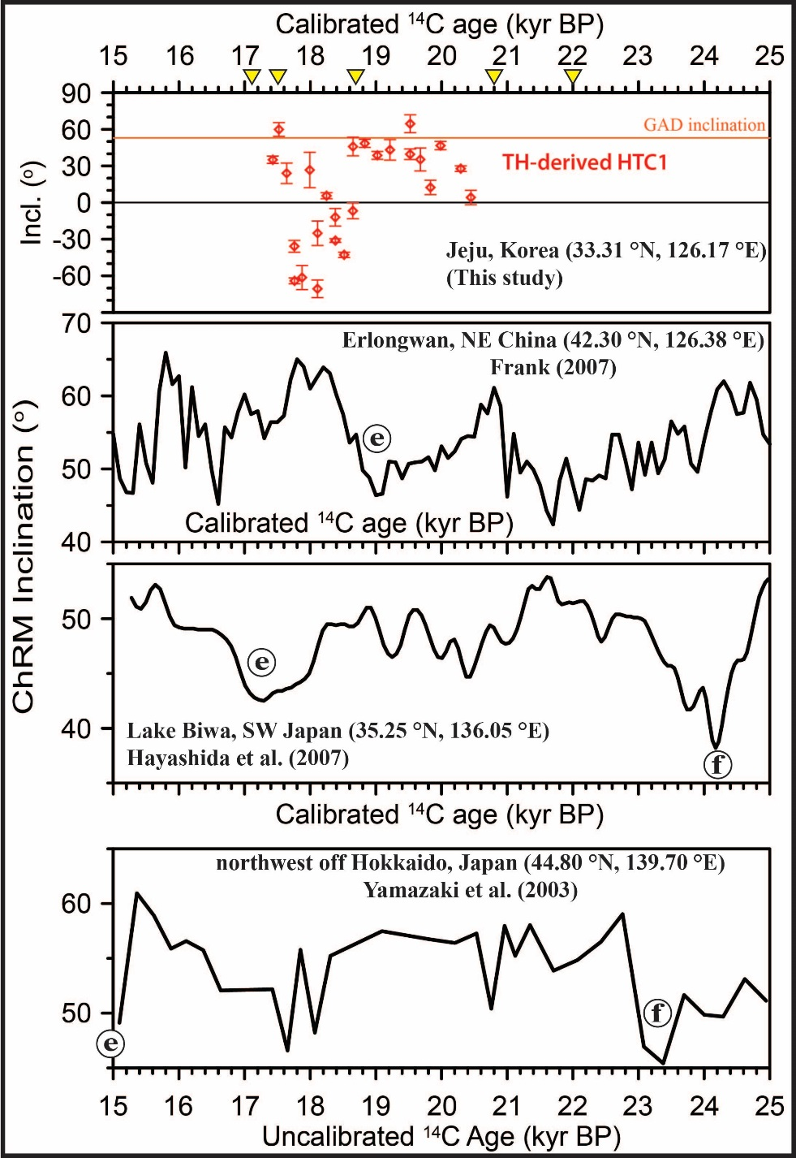

Table S1. Available age data of AMS ¹⁴C dating from the Gosan Formation sediments with different locations (GSDS and GSSW).

Table S2. Some rock magnetic properties for the GSDS1 samples.
k_{ARM} (in A/m), called anhysteretic remanence, was calculated following e.g. Banerjee et al. (1981), where 0.1 mT= 1000/4π A/m was used for the calculation. Q_{n}, called Koenigsberger ratio, was calculated as NRM₀/(k_{LF} · H), where H is the local geomagnetic field (48.8 μT= 38.8 A/m was used for the calculation) (Stacey 1967). GI denotes gyroremanent magnetization index as a measure to quantify the potential GRM effect, calculated as (NRM_{80mT} - NRM_{min})/(NRM₀ - NRM_{min}), where NRM_{80mT} is the NRM intensity at 80 mT (the highest demagnetization level in this study), NRM₀ is the initial intensity, and NRM_{min} is the minimum intensity reached during AF demagnetizations (Fu et al. 2008). For the other properties see text.

Table S3. Demagnetization behavior types, the HFC declinations and inclinations with the MADs, the DANGs for the HFCs, the reversal angles, and the calculated VGP positions, for NRM-SAFD results of the GSDS1 samples. "nd" denotes "not determined". See text for details.

Table S4. The LTC1, HTC1 and HTC2 declinations and inclinations with the MADs, the reversal angles, and the calculated VGP positions, for NRM-STHD results of the GSDS2 samples. "nd" denotes "not determined". See text for details.

Table S4. (continued)
Table S4. (continued)

Table S5. An estimated age-depth model data for the studied sediment (GSDS site) by means of interpolations between the AMS calibrated ¹⁴C ages (Lim et al. 2015).

