Additional Information

Characteristics of foreshock activity inferred from the JMA earthquake catalog

Koji Tamaribuchi¹, Yuji Yagi², Bogdan Enescu³ and Shiro Hirano⁴

¹Meteorological Research Institute, Japan Meteorological Agency, Tsukuba, Japan
²Faculty of Life and Environmental Sciences, University of Tsukuba, Tsukuba, Japan
³Department of Geophysics, Graduate School of Science, Kyoto University, Kyoto, Japan
⁴Department of Physical Science, College of Science and Engineering, Ritsumeikan University, Kusatsu, Japan

Contents of this file

Figure S1

An example of the cluster: the M6.6 central Tottori prefecture on October 21, 2016

In Figure S1, we show the earthquake sequence associated with an M6.6 event that occurred in the central Tottori Prefecture on October 21, 2016, as another example of clustering. In this case, the mainshock (M6.6) occurred at 14:07, but the foreshock activity, including a M4.2 event, started at 12:12, approximately 2 hours before the mainshock. The sequence comprises 26,156 events of which 19,814 (75.8%) were processed automatically. Because the number of foreshocks is limited (only 72 events), it is difficult to properly estimate the magnitude of the completeness and thus a reliable b-value in this case.

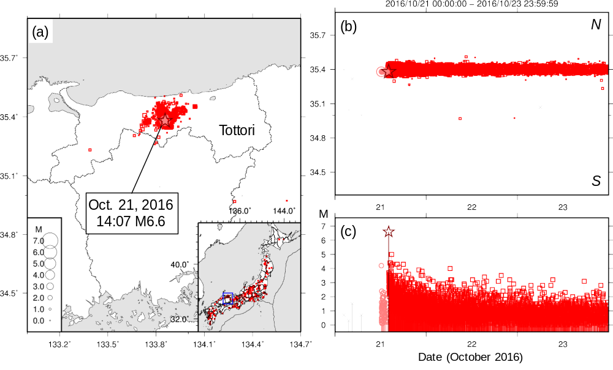
Figure S1 Space–time–magnitude distributions of the Central Tottori earthquake (from October 21, 2016 to October 23, 2016). a Epicentral distribution, b spatiotemporal distribution, and c magnitude versus time diagram. The light red open circles, red squares, and dark stars indicate foreshocks, aftershocks, and mainshock, respectively. The gray dots represent other clusters or singles.

