Supplementary Materials for

Lateral variation of the uppermost oceanic plate in the outer rise region of the Northwest Pacific Ocean inferred from Po-to-s converted waves

Takashi Tonegawa¹, Koichiro Obana¹, Gou Fujie¹, Shuichi Kodaira¹
[1] Japan Agency for Marine-Earth Environmental Science and Technology

Corresponding author: Takashi Tonegawa, tonegawa@jamstec.go.jp

Supplementary Figures
Figure S1
Figure S2
Figure S3
Figure S3

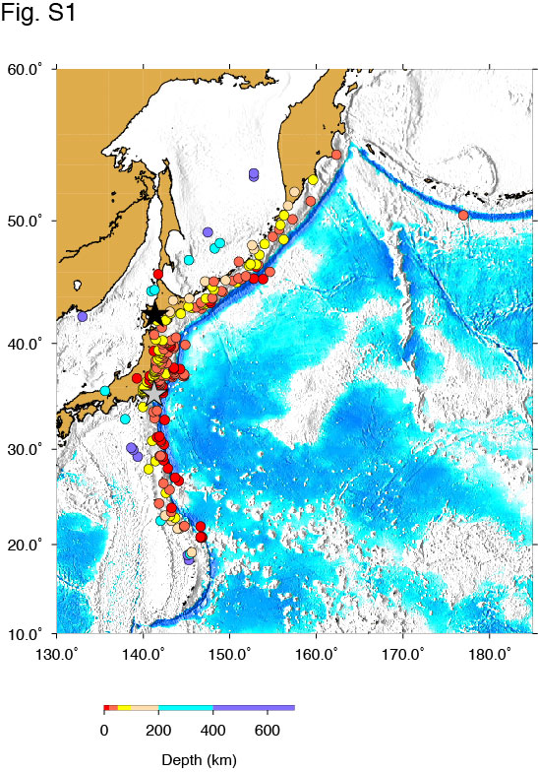
Figure S1. Event distribution for Po wave collection. Color indicates earthquake depth. Black and gray star represent events used in Fig. 3 (127 km depth with a magnitude of 4.9, 15:01, July 10, 2009) and Fig. S2 (22 km depth with a magnitude of 4.6, 22:13, May 28, 2015), respectively.
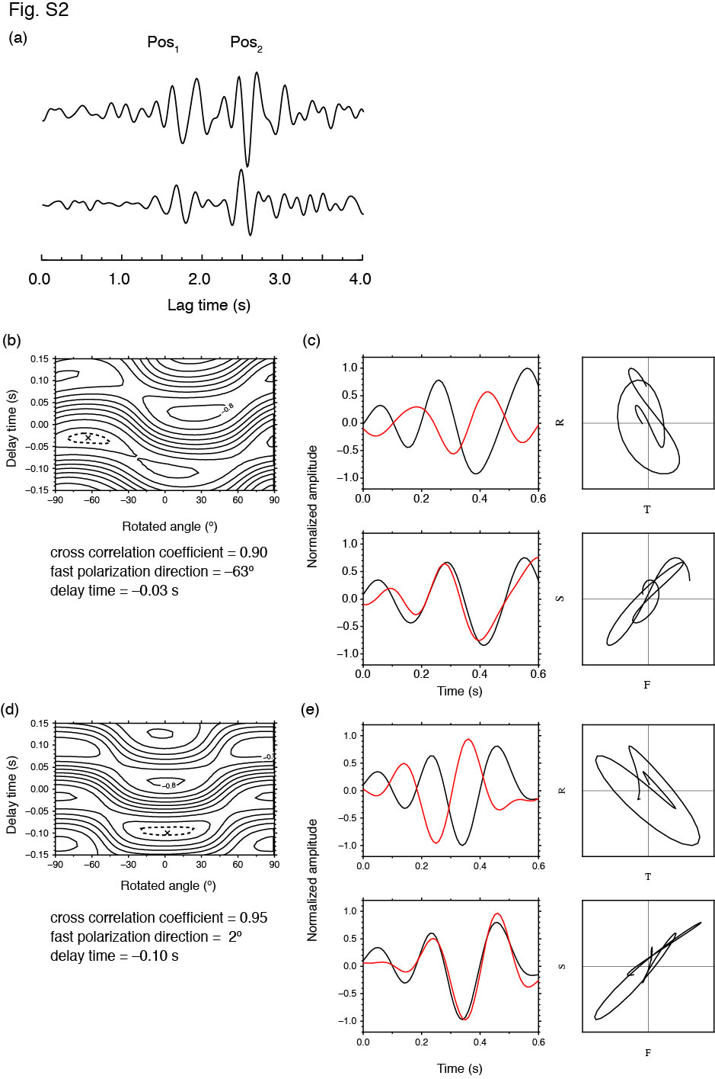
Figure S2. Examples of the anisotropy estimation at an OBS S65 (Fig. 7). (a) RCF (top) and TCF (bottom) for an event (see Fig. S1). (b) Contour plot of Pos₁ cross correlation coefficient as a function of delay time and fast polarization direction. (c) (top left) Pos₁ waveforms in the RCF (black) and TCF (red) and (top right) particle motion. Same as top panels, but for rotated and time-shifted waveforms with the splitting parameters estimated in Fig. S2b. (d) Same as Fig. S2b, but for Pos₂. (e) Same as Fig. S2c, but for Pos₂ with anisotropic effects at the sediment layer removed.
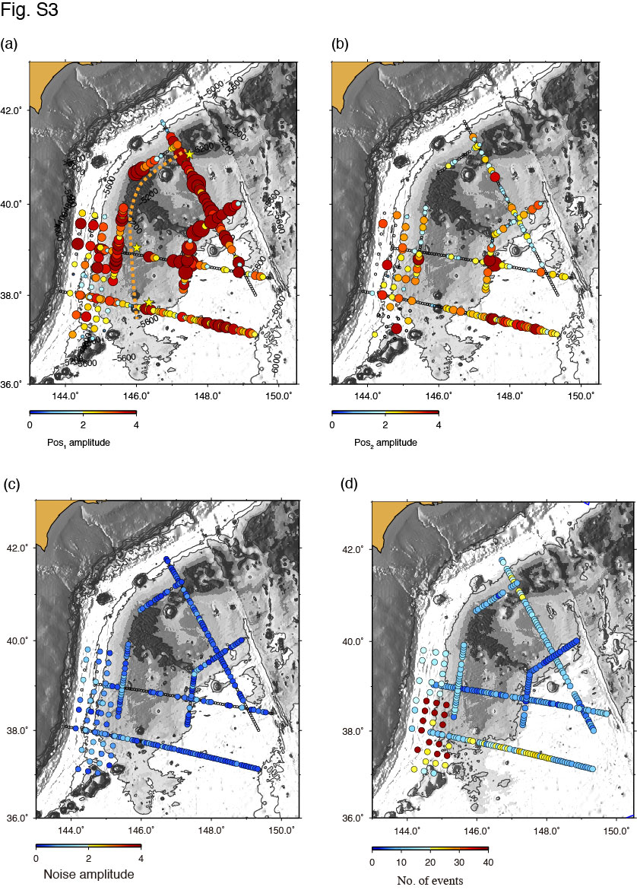
Figure S3. Geographical maps for obtained results. (a) Averaged amplitudes of Pos1 waves at each OBS, which are represented by both color and size of circles for display purpose. Yellow stars indicate the locations where Pos waves tend to be weak towards the trench. Orange dash line roughly represents the ridge line of the outer rise region. (b) Same as Fig. S3a, but for Pos2 waves. (c) Averaged amplitude of the noise at each OBS. (d) Number of the observed Pos waves at each OBS.

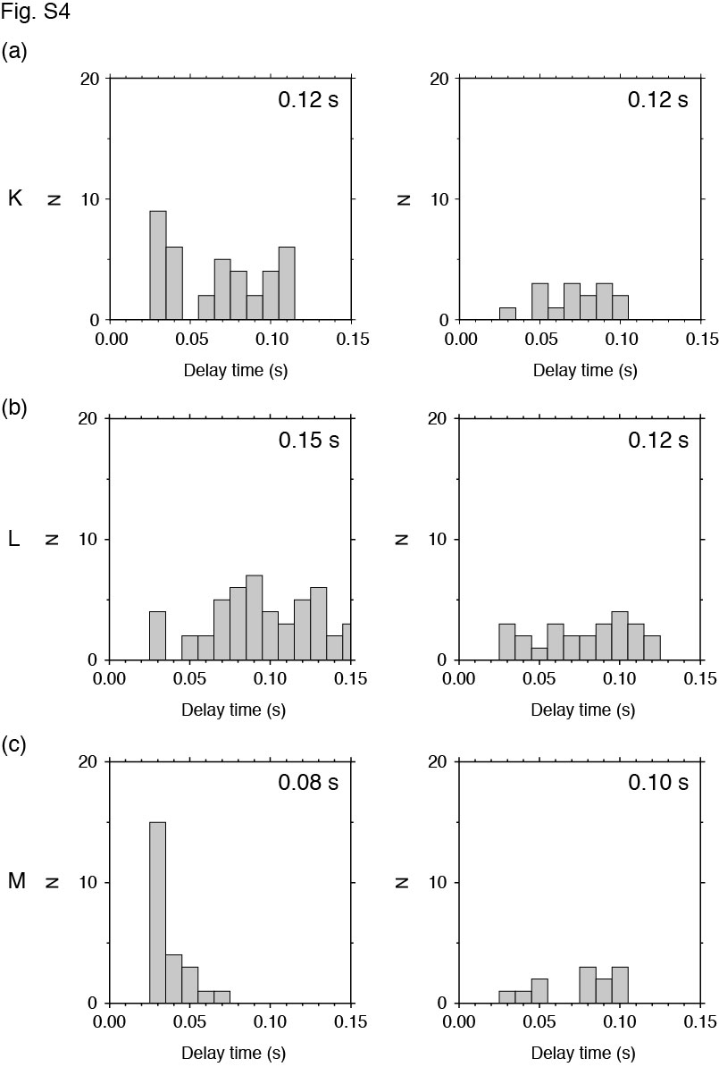
Figure S4. Histograms of delay time for regions K–M (row) and sediment and crustal layers (column). Numbers at the top right indicate time ranges searching for time delays in the contour map of cross correlation coefficient, determined by delay time distribution.

