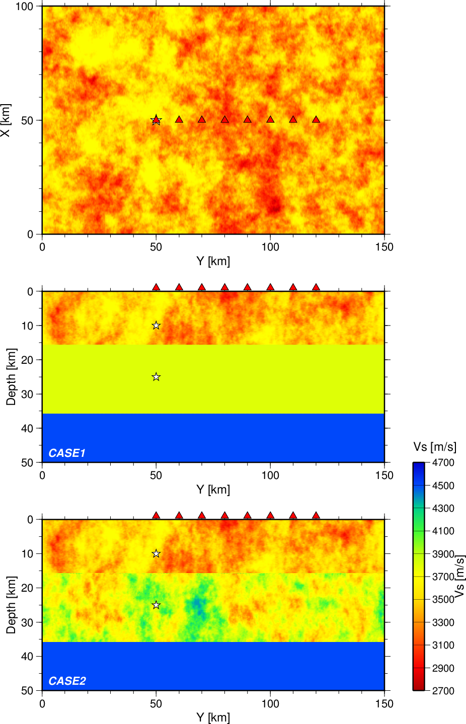
Figure S1. Velocity models used in the tests, showing the horizontal plane at depth of zero (top panel), vertical cross section views at X=50 km for CASE1 and CASE 2 (middle and bottom panels, respectively). Triangles and the stars denote the receivers and hypocenters, respectively. Grid spacing for the finite-difference simulations is 100 m and 50 m for the horizontal and vertical directions, respectively, down to the depth of 16 km, and it is three times larger in the deeper region.

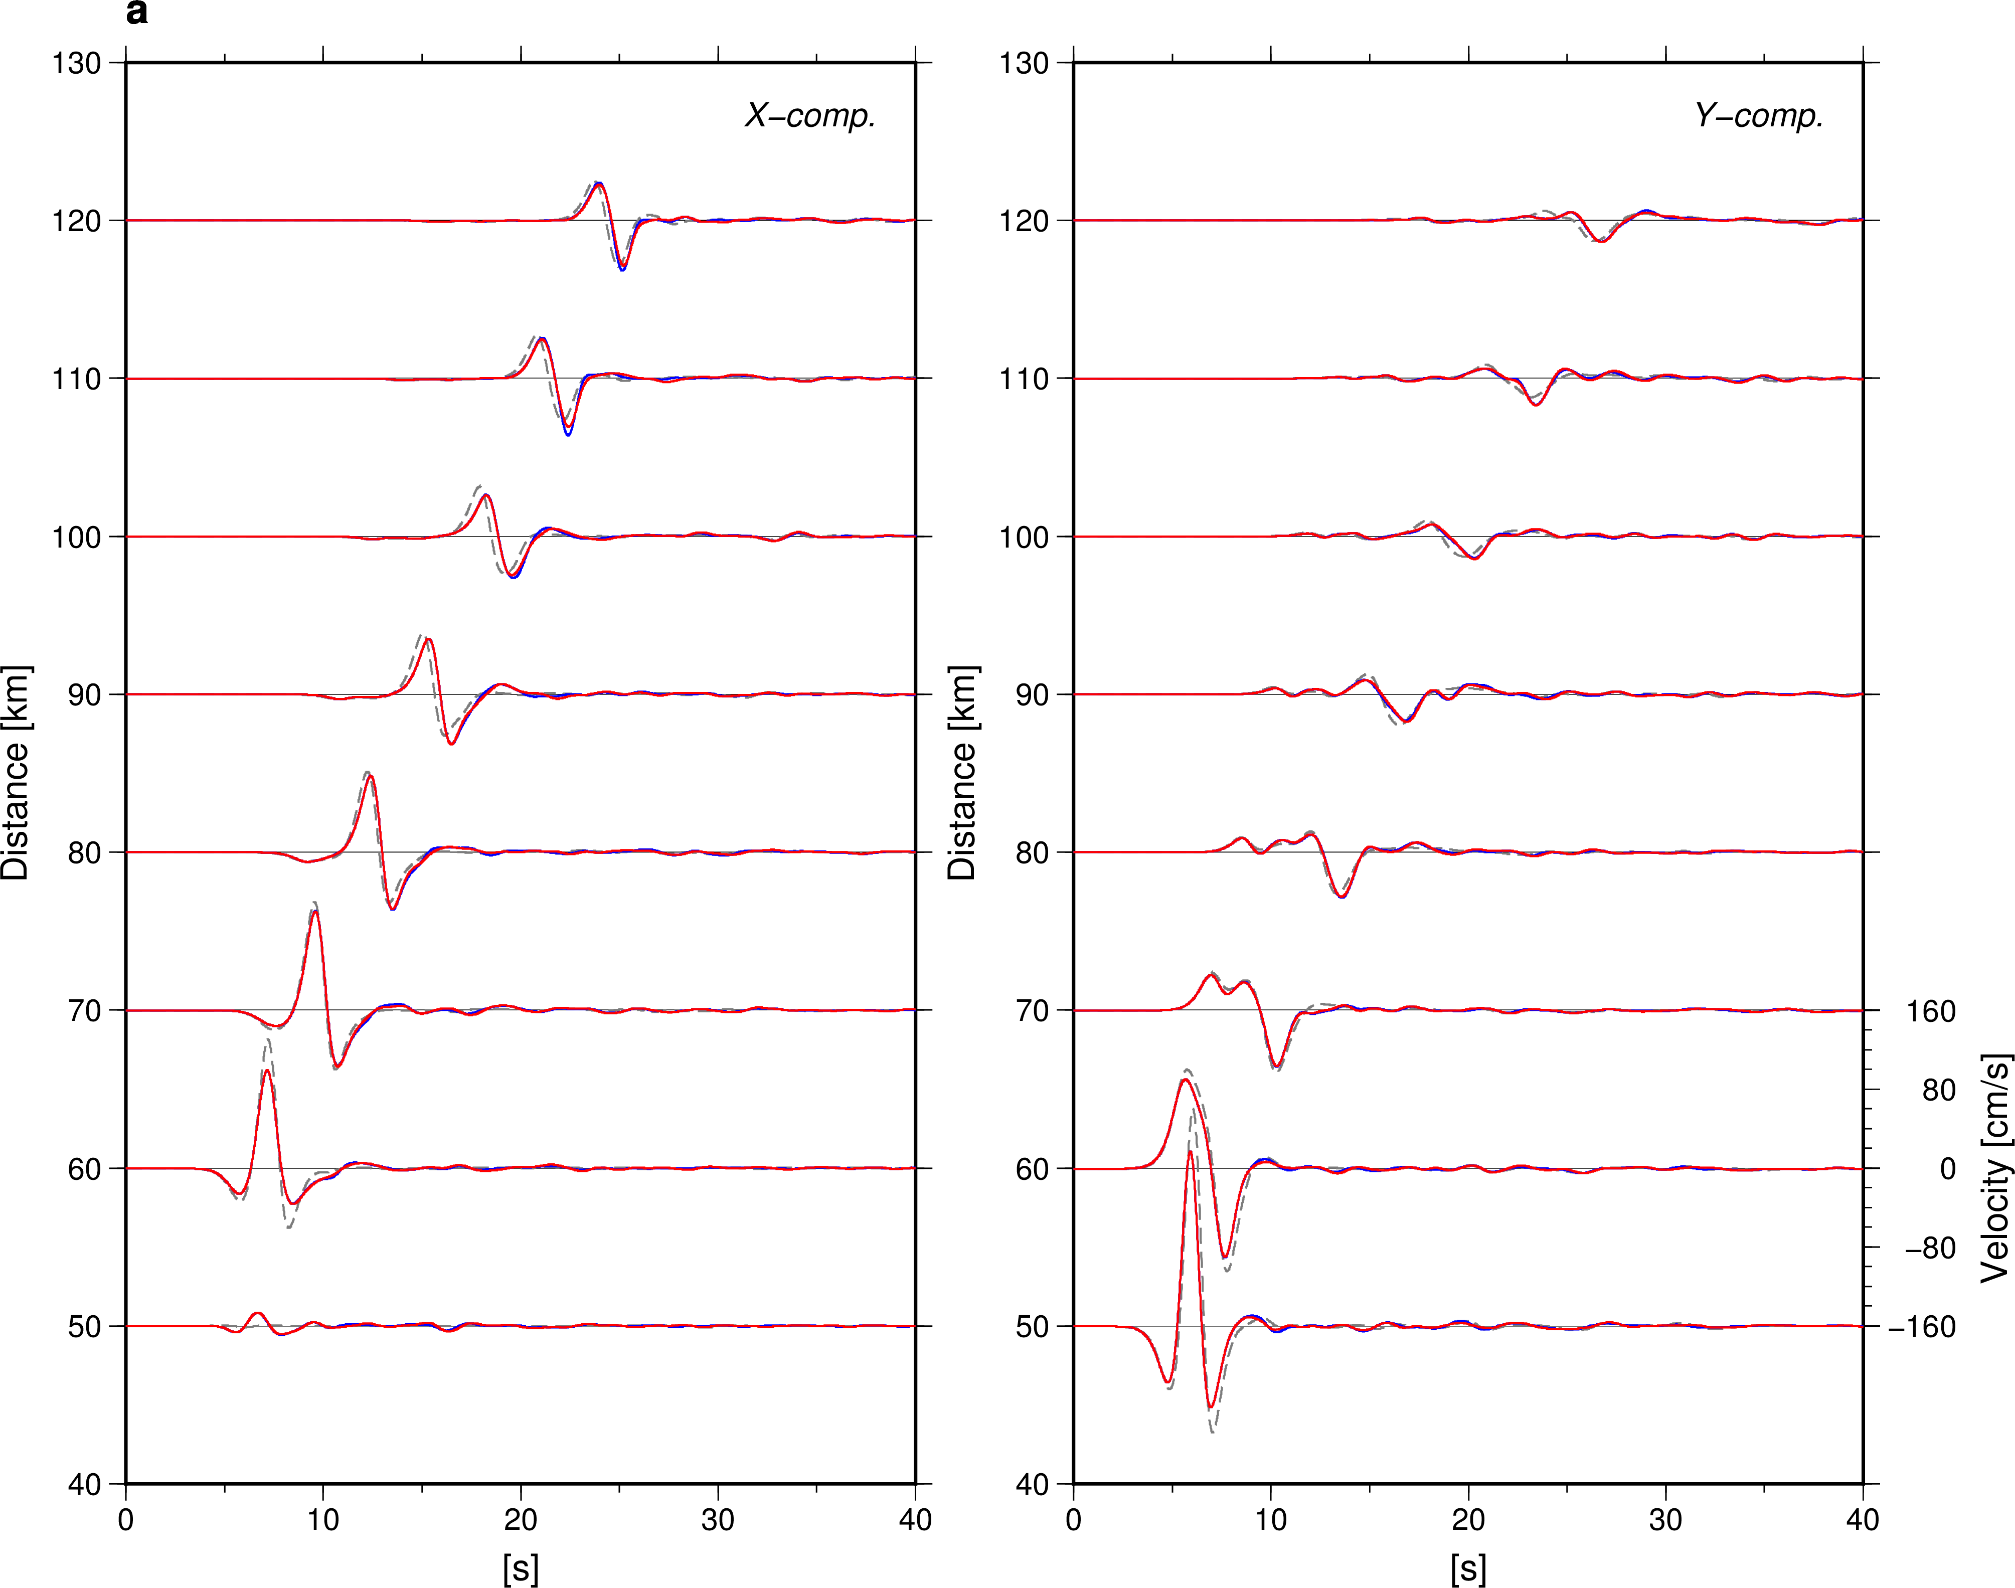

Figure S2. Velocity waveforms at the receivers for the source at the depth of (a) 10 km and (b) 25 km. Gray, red, and blue lines correspond to CASE0, CASE1, and CASE2, respectively. Waveforms are low-pass filtered at 1 Hz.

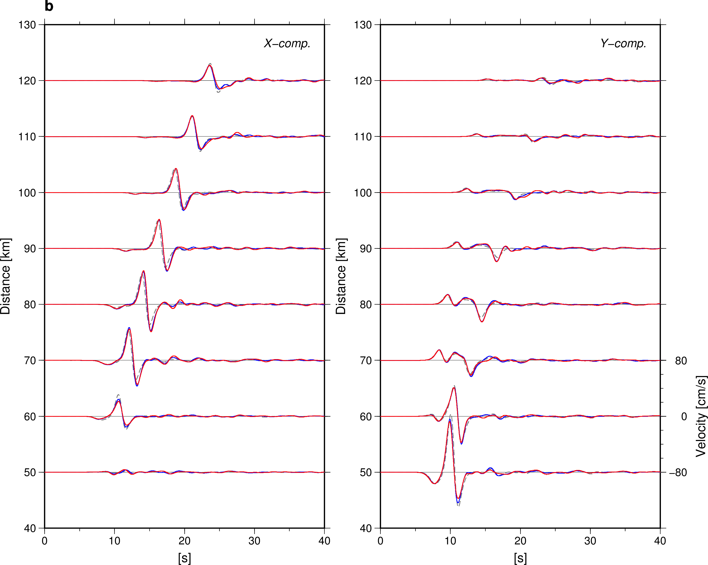
Figure S2. Continued.

Table 1. Point source models.
Depth [km] | Duration [s] | Strike, Dip, Rake [deg]
10 / 25 | 3.3 | 0, 90, 45

