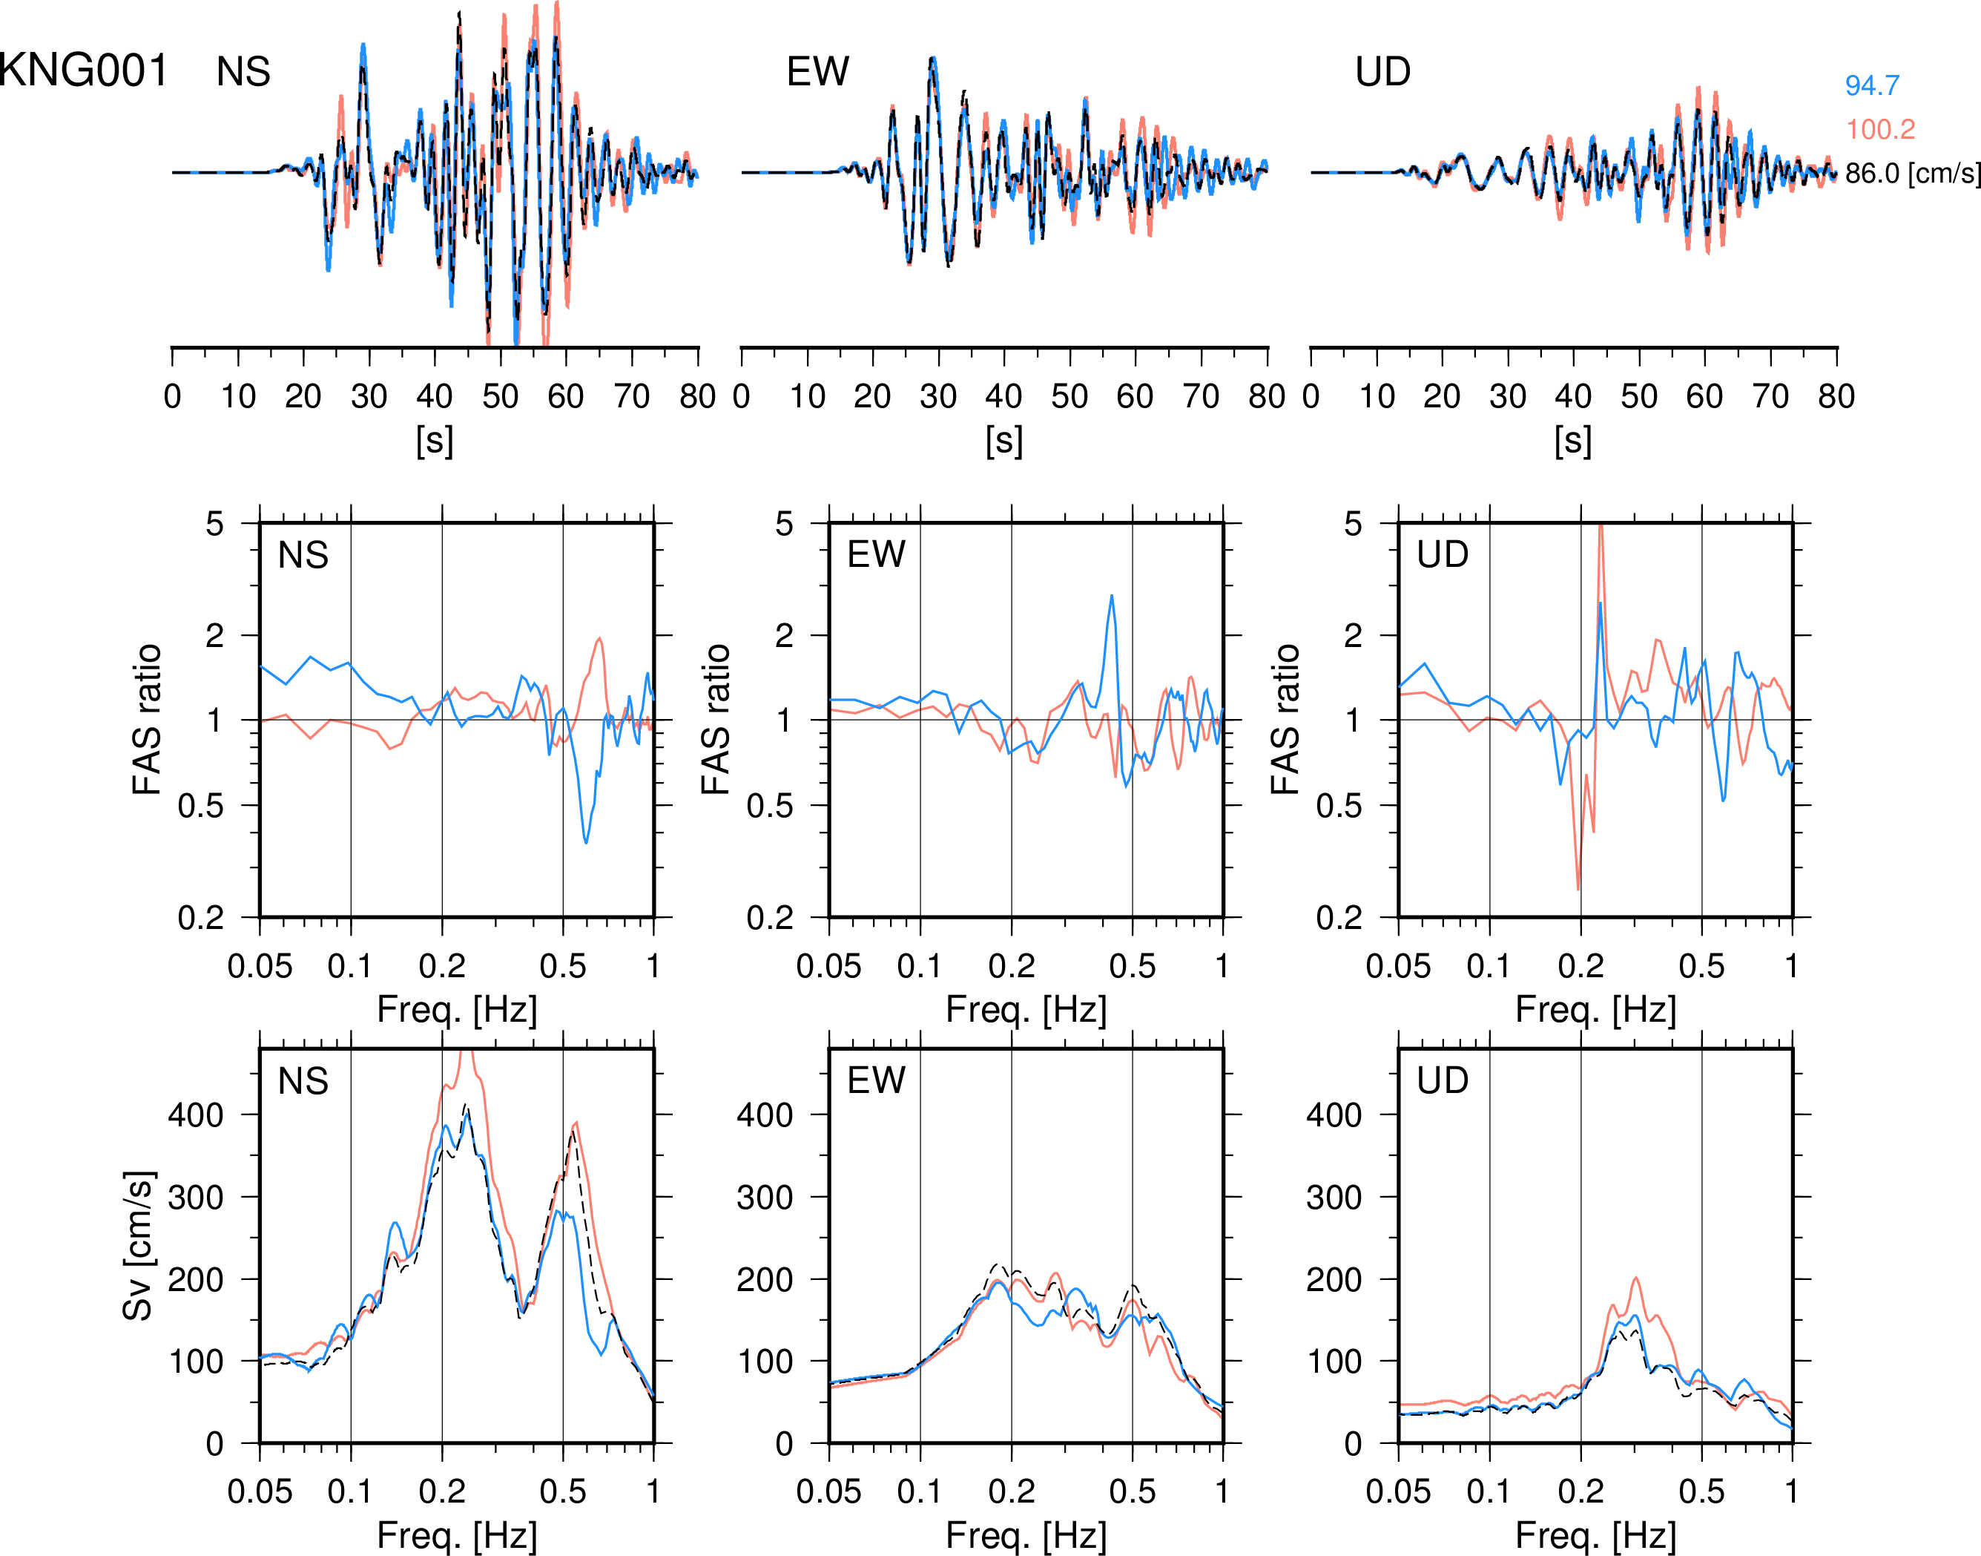
Figure S3. Additional examples of ground motion at shorter hypocentral distances for S2_3.3. See Figure 4 for other stations at larger distances. Velocity waveforms, Fourier amplitude spectral ratios (ratios of heterogeneous to homogeneous models), and 5% damped velocity response spectra using the homogeneous (black dashed lines) and heterogeneous (blue and red lines; representing two realizations with different random seeds) velocity models with a = 5 km at (a) KNG001 and (b) TKY001. Numbers on the right side of the waveforms denote the maximum amplitudes of three components. See Figure 1 for the location of the stations.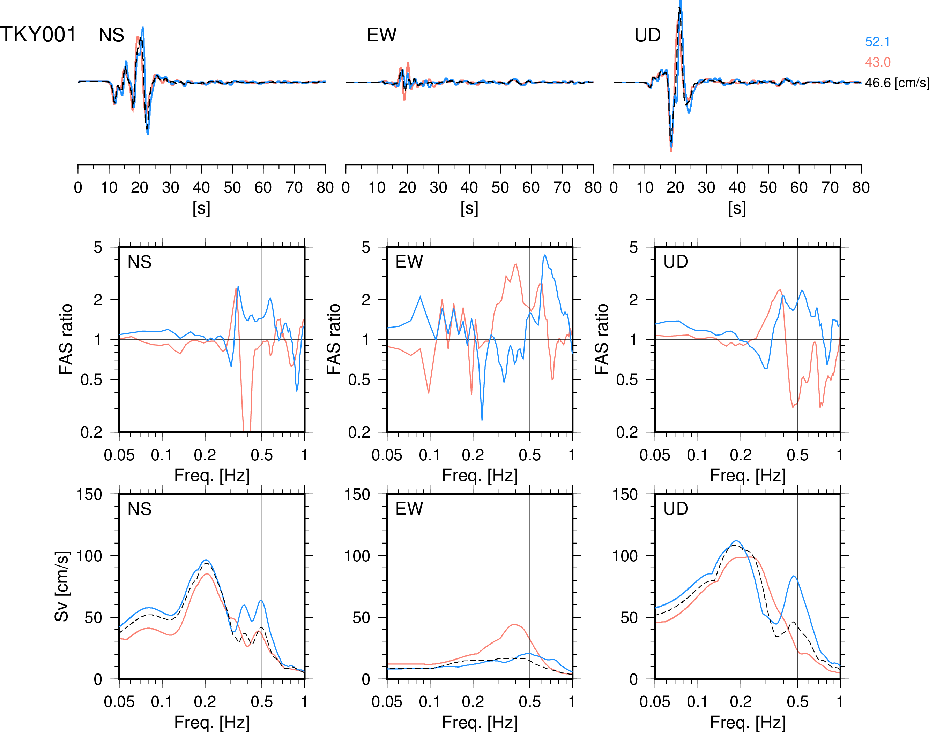
Figure S3. Continued.

