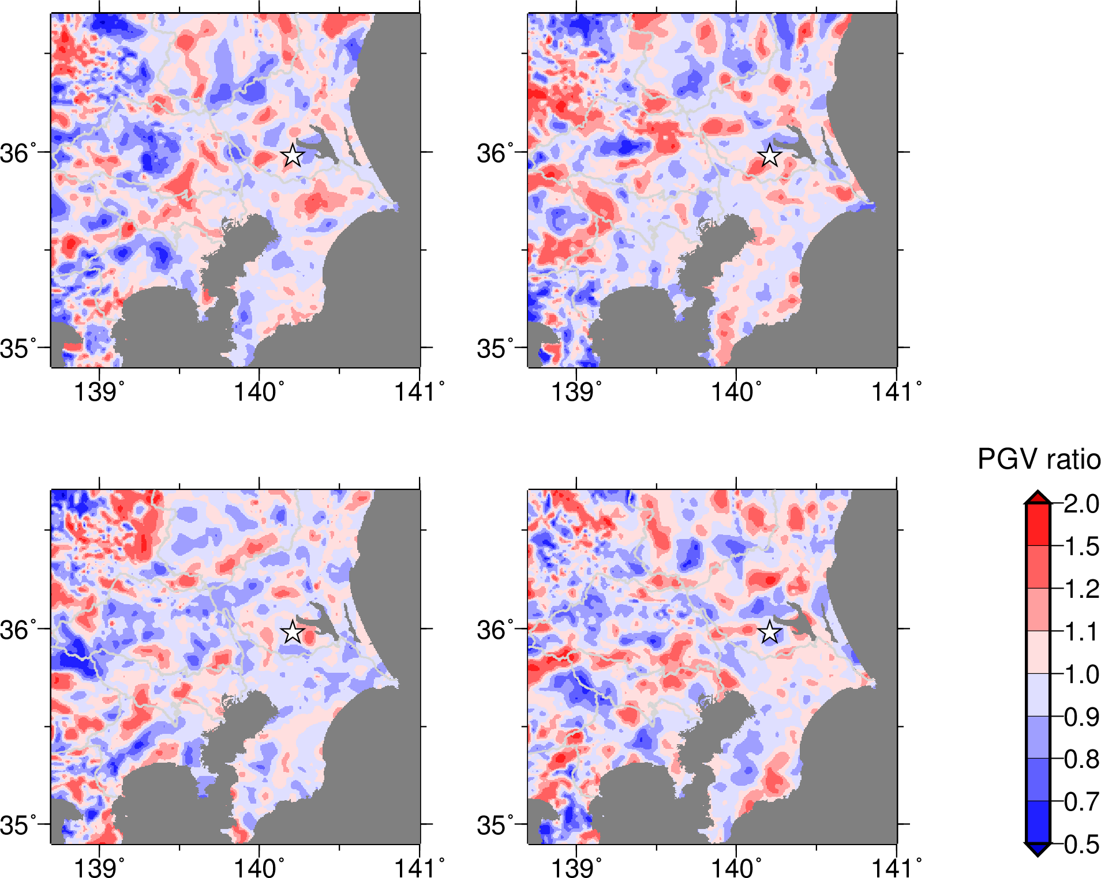
Figure S4. PGV ratio for four realizations of random heterogeneity that are different from that in Figure 6. Heterogeneous velocity model with a = 5km and the source model S1_3.3 are used.

