Supplementary Material for

Seismotectonics of the 2018 northern Osaka M6.1 earthquake and its aftershocks: joint movements on strike-slip and reverse faults in inland Japan

Miroslav Hallo¹, Ivo Opršal², Kimiyuki Asano³, František Gallovič¹
[1] Faculty of Mathematics and Physics, Charles University, Prague, Czech Republic
[2] The Institute of Technology and Business in České Budějovice, Czech Republic
[3] Disaster Prevention Research Institute, Kyoto University, Gokasho, Uji, Kyoto, Japan

Corresponding author: Miroslav Hallo, hallo@karel.troja.mff.cuni.cz

I – Velocity model of the northern Osaka area
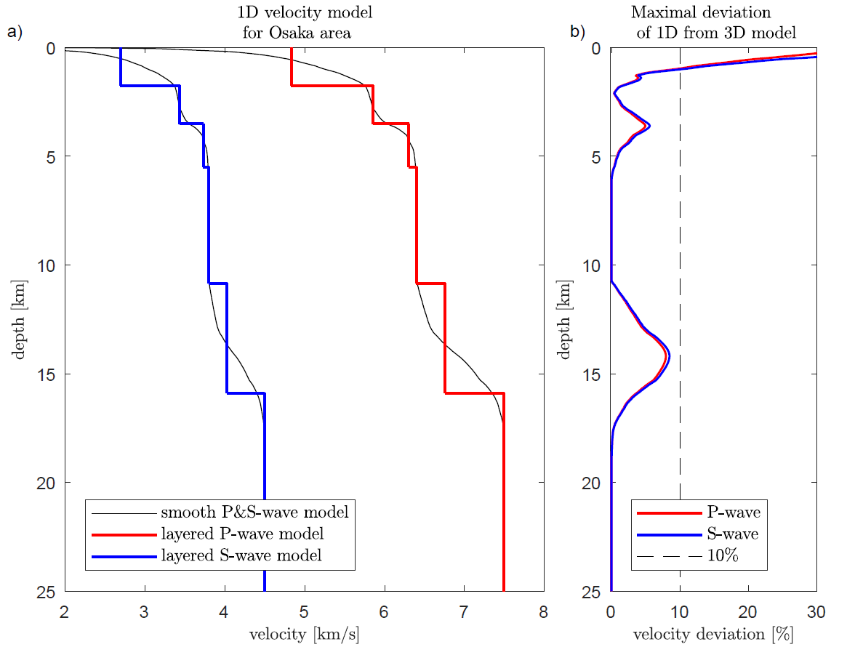
Fig. A1 a) 1D velocity model of the northern Osaka area determined from the 3D Japan Integrated Velocity Structure Model (Koketsu et al. 2012); b) Maximum horizontal deviation of the velocities of the determined 1D model from the original 3D model.

II – Fit of waveforms of the mainshock CMT inversion
The maximum likelihood solution of our Bayesian CMT inversion minimizes the difference between the recorded data and synthetics. Since the modeling uncertainty is included (approach by Hallo and Gallovič 2016), the solution minimizes so-called standardized residuals, i.e. waveforms multiplied by the triangular matrix from the Cholesky decomposition of the data covariance matrix (see Hallo and Gallovič 2016 for more details). Figs A2 and A3 show displacement and standardized waveform fits, respectively, for the maximum likelihood solution of the mainshock CMT. Note that the fit of the displacement waveforms (Fig. A2) is shown for illustration purpose as the inversion itself minimizes the difference between the standardized waveforms (Fig. A3).
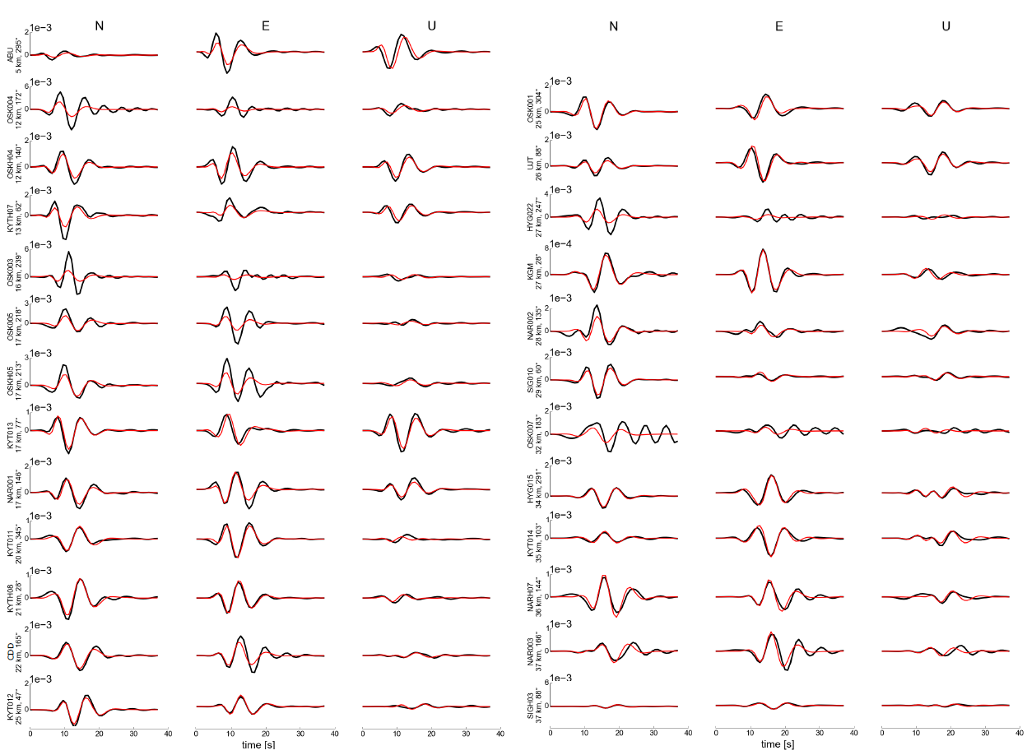
Fig. A2 Fit of the observed (black) and synthetic (red) displacement waveforms (in meters) for the M_{w}5.6 (M_{JMA}6.1) mainshock (18 June 2018). The synthetics correspond to the maximum likelihood solution inferred considering a non-diagonal covariance matrix describing the uncertainty of the velocity model. Stations are sorted by epicentral distance. Both data and synthetics are bandpass Butterworth filtered between 0.08 − 0.15 Hz. The displacement waveforms for each station are normalized to the largest value over all components.
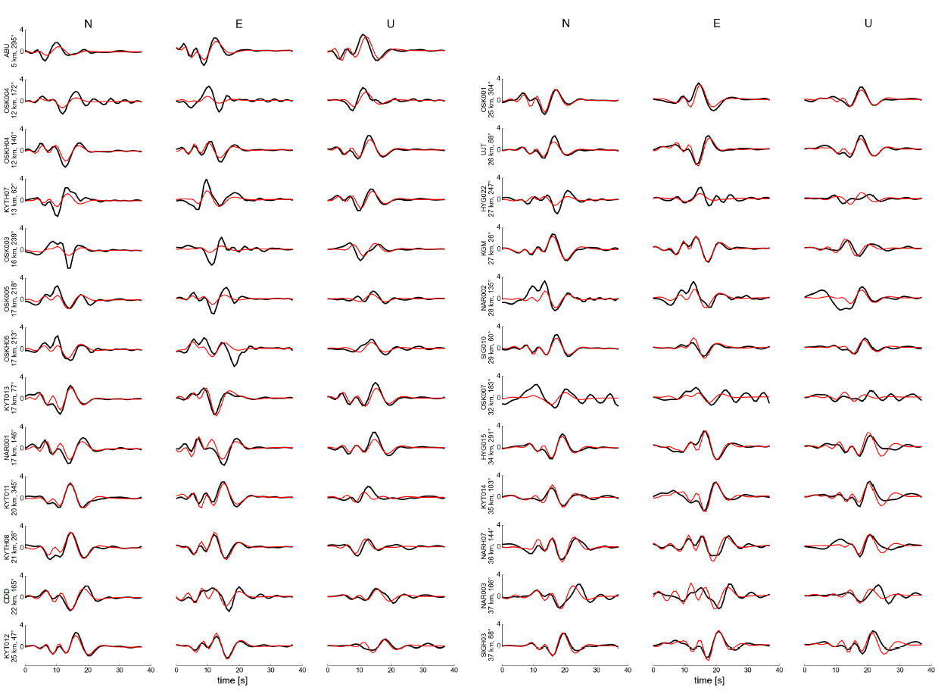
Fig. A3 The same as Fig. A2, but for standardized waveforms. Both data and synthetics are bandpass Butterworth filtered between 0.08 − 0.15 Hz prior the standardization by triangular matrix from the Cholesky decomposition of the employed non-diagonal covariance matrix considered in the inversion (see text).

III – Hypocenter location with uncertainty
Hypocenters of analyzed aftershocks are located by our code utilizing probabilistic approach of Tarantora (2005, pp. 253-256). The posterior probability density $p_{i}$ for i-th trial hypocenter location in 3D is determined by:
$p_{i}=const.exp\left(-\frac{1}{2}\sum_{j=1}^{N_{P}}{\frac{{\left(t_{P_{obs}}^{j}-t_{P_{cal}}^{ij}-t_{0}^{i}\right)}^{2}}{{\left(σ_{P}^{j}\right)}^{2}}}-\frac{1}{2}\sum_{j=1}^{N_{S}}{\frac{{\left(t_{S_{obs}}^{j}-t_{S_{cal}}^{ij}-t_{0}^{i}\right)}^{2}}{{\left(σ_{S}^{j}\right)}^{2}}}\right)$, (A1)
where $t_{P_{obs}}^{j}$ and $t_{S_{obs}}^{j}$ are observed arrival times of direct P- and S-waves on the station j. The synthetic arrival times $t_{P_{cal}}^{ij}$ and $t_{S_{cal}}^{ij}$ are computed by ray tracing of direct P- and S-waves in the 1D layered medium in Table 2. Origin time $t_{0}^{i}$ is determined for each tested position i as an arithmetic mean:
$t_{0}^{i}=\frac{1}{N_{P}+N_{S}}\left(\sum_{j=1}^{N_{P}}{\left(t_{P_{obs}}^{j}-t_{P_{cal}}^{ij}\right)}+\sum_{j=1}^{N_{S}}{\left(t_{S_{obs}}^{j}-t_{S_{cal}}^{ij}\right)}\right)$. (A2)
The posterior probability density function (PDF) is mapped in regular spatial Cartesian 3D grid, i.e. $\left(p_{xyz}\right)∈R^{m×n×k}$. As we use the Cartesian coordinates, the prior PDF on hypocenter location is uniform. The likelihood function is then governed by residuum of observed and synthetic arrival times. Finally, the posterior $p_{xyz}$ determined in discrete spatial points is normalized to one. We use the maximum likelihood spatial sample as the hypocenter location.
The uncertainties of the arrival times of P- and S-waves ($σ_{P}^{j}$ and $σ_{S}^{j}$, respectively) are pre-computed by Monte-Carlo simulations. Particularly, we perturb the 1D velocity model from Table 2 by 1000 random perturbations (see Fig. A4), and then compute the corresponding set of synthetic arrival times by the ray tracing. Following Tarantola (2005, pp. 164–170), we randomly vary logarithms of incompressibility modulus, shear modulus, and layer thicknesses. The parameters are changed independently of each other and also independently in all layers, assuming Gaussian distribution characterized by standard deviation of 10% of the initial (mean) velocity model. The resulting ensembles of 1000 arrival times have approximately Gaussian distribution for each source-receiver settings (see Fig. A5) with standard deviations$σ_{P}$ and $σ_{S}$ for the P- and S-waves, respectively. We pre-compute these uncertainties of the arrival times for source-receiver epicentral distances of 0 – 30 km and for assumed source depths of 6 – 14 km. The $σ_{P}$ and $σ_{S}$ dependent on the source-receiver settings and can be approximated by 3rd-degree polynomial for each assumed source depth (see Fig. A6).
The hypocenter location uncertainty is then estimated from marginal posterior PDFs at three Cartesian coordinate axes. Each marginal PDF have approximately Gaussian distribution with a standard deviation $σ$. We use value of $2σ$ (i.e., the confidence interval 95%) as a measure of uncertainty of the hypocenter locations.
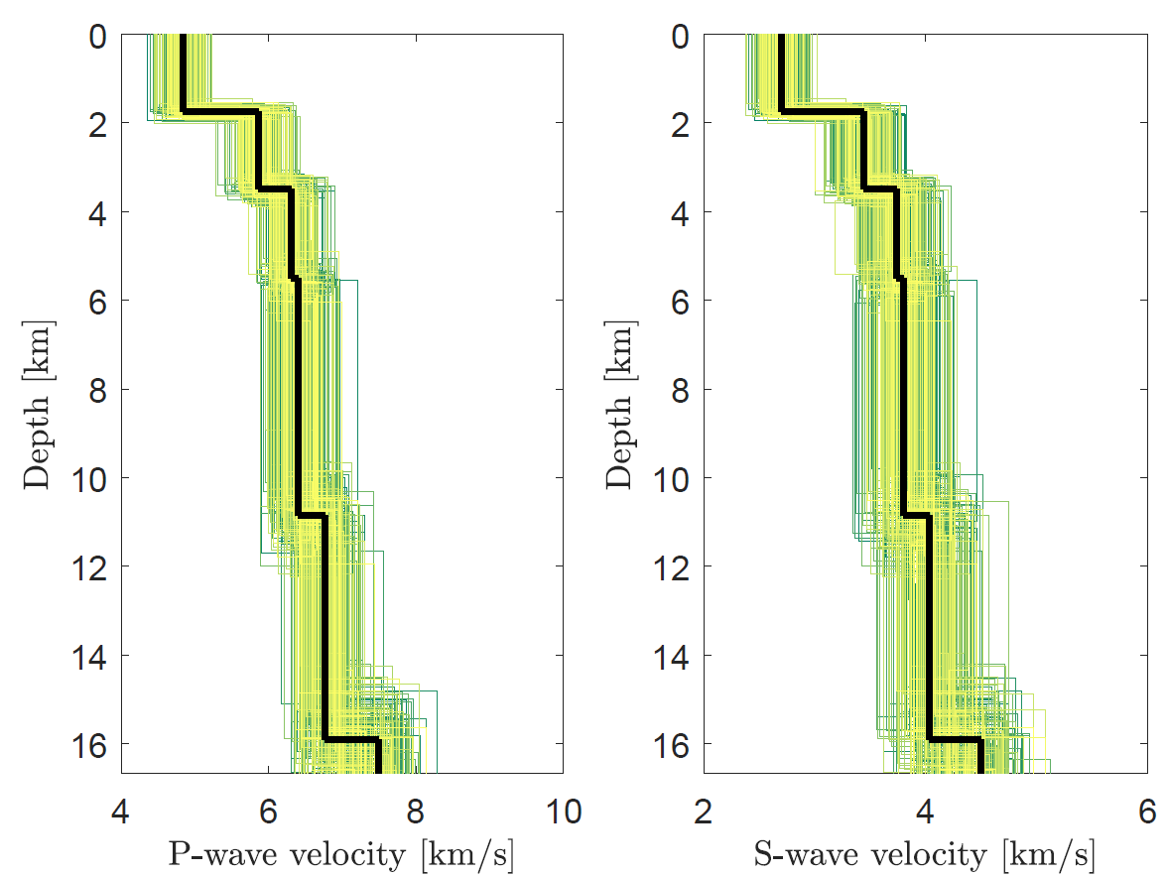
Fig. A4 Example of randomly perturbed velocity models with the standard deviation of 10%. Black solid lines are the mean P-/S-wave velocity profiles from Table 2 and lines in color are the P-/S-wave velocities of the perturbed models.
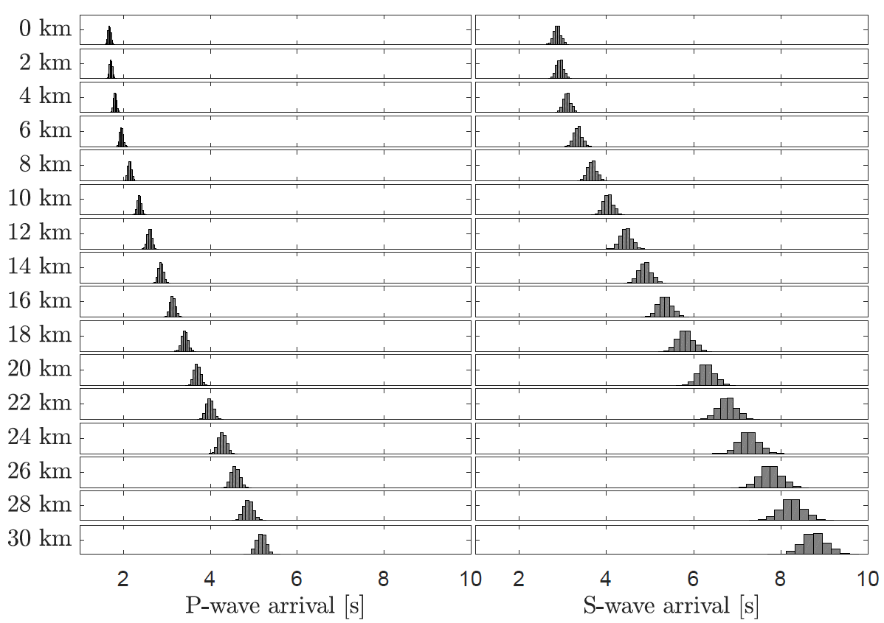
Fig. A5 Histograms of 1000 P-/S-wave arrival times obtained by ray-tracing in the randomly perturbed velocity models as shown in Fig. A4. The assumed source depth is 10 km, and the source-receiver epicentral distances range from 0 to 30 km (see y-axes labels).
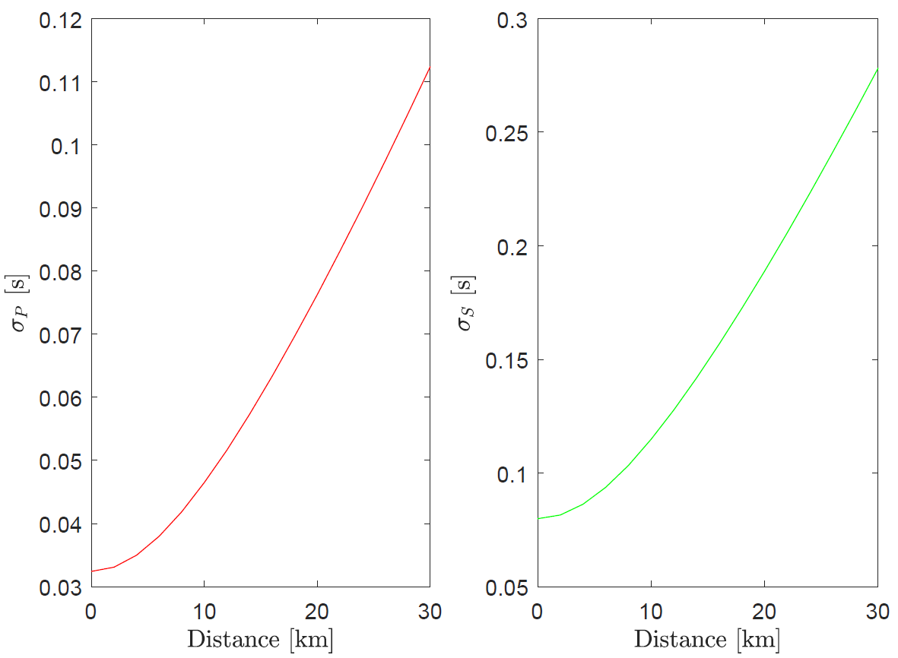
Fig. A6 Arrival time uncertainties $σ_{P}$ and $σ_{S}$ for the assumed source depth of 10 km. The dependence on source-receiver epicentral distance is approximated by a 3rd-degree polynomial (red and green lines for uncertainties of arrival times of P- and S-waves, respectively).

IV – List of aftershocks’ focal solutions
N | Date | M_{JMA} | Origin time  JST | Latitude  (deg) | Longitude  (deg) | Depth  (km) | Horiz. / vert.  uncertainty 2σ  (km) | Stike / Dip / Rake  (deg) | DC / CLVD  (%) | CLVD  uncertainty 2σ | Type | Class
1 | 18.6.2018 | 3.3 | 08:02:10.05 | 34.8343 | 135.6150 | 10.3 | 0.51 / 1.1 | 252 / 83 / -160 | 39 / 61 % | 22 % | strike-slip | C
2 | 18.6.2018 | 3.3 | 08:07:58.73 | 34.8552 | 135.6251 | 10.8 | 0.49 / 1.3 | 36 / 57 / 86 | 86 / -14 % | 15 % | reverse | A
3 | 18.6.2018 | 2.2 | 08:09:25.80 | 34.8588 | 135.6148 | 9.4 | 0.49 / 1.0 | 61 / 84 / 89 | 68 / 32 % | 33 % | reverse | C
4 | 18.6.2018 | 2.7 | 08:11:44.92 | 34.8370 | 135.6220 | 10.8 | 0.49 / 1.2 | 12 / 73 / -175 | 88 / -12 % | 40 % | strike-slip | A
5 | 18.6.2018 | 2.4 | 08:17:41.60 | 34.8540 | 135.6085 | 9.8 | 0.49 / 1.0 | 352 / 41 / 53 | 86 / -14 % | 25 % | reverse | A
6 | 18.6.2018 | 3.0 | 08:18:19.43 | 34.8490 | 135.6234 | 9.9 | 0.49 / 1.1 | 50 / 54 / 135 | 65 / -35 % | 23 % | reverse | B
7 | 18.6.2018 | 2.3 | 08:23:40.98 | 34.8344 | 135.6119 | 10.5 | 0.49 / 1.1 | 81 / 83 / 160 | 67 / -33 % | 31 % | strike-slip | B
8 | 18.6.2018 | 2.8 | 08:31:39.79 | 34.8404 | 135.6171 | 9.7 | 0.48 / 1.0 | 197 / 76 / -152 | 95 / 5 % | 29 % | odd | A
9 | 18.6.2018 | 2.3 | 08:33:44.33 | 34.8401 | 135.6217 | 10.3 | 0.50 / 1.1 | 44 / 55 / 132 | 82 / -18 % | 22 % | reverse | A
10 | 18.6.2018 | 2.1 | 08:36:22.42 | 34.8305 | 135.6022 | 9.0 | 0.46 / 1.0 | 258 / 82 / -152 | 86 / 14 % | 40 % | strike-slip | A
11 | 18.6.2018 | 2.6 | 08:38:42.63 | 34.8459 | 135.6257 | 10.7 | 0.49 / 1.2 | 26 / 59 / 121 | 88 / 12 % | 17 % | reverse | A
12 | 18.6.2018 | 3.3 | 08:42:06.81 | 34.8585 | 135.6240 | 10.8 | 0.49 / 1.2 | 39 / 45 / 97 | 67 / 33 % | 18 % | reverse | B
13 | 18.6.2018 | 2.3 | 08:48:25.06 | 34.8414 | 135.6302 | 10.7 | 0.51 / 1.3 | 16 / 38 / 67 | 91 / 9 % | 17 % | reverse | A
14 | 18.6.2018 | 2.4 | 08:50:56.96 | 34.8446 | 135.6324 | 10.8 | 0.53 / 1.3 | 1 / 26 / 65 | 74 / 26 % | 25 % | reverse | B
15 | 18.6.2018 | 2.4 | 09:13:02.29 | 34.8581 | 135.6096 | 8.8 | 0.49 / 1.0 | 359 / 38 / 101 | 72 / 28 % | 31 % | reverse | B
16 | 18.6.2018 | 2.8 | 10:03:22.03 | 34.8405 | 135.6246 | 10.4 | 0.48 / 1.1 | 44 / 70 / 143 | 82 / 18 % | 26 % | odd | A
17 | 18.6.2018 | 2.4 | 10:28:47.85 | 34.8279 | 135.6078 | 10.7 | 0.47 / 1.1 | 233 / 88 / -135 | 97 / -3 % | 18 % | odd | A
18 | 18.6.2018 | 2.6 | 10:59:55.17 | 34.8569 | 135.6275 | 10.9 | 0.49 / 1.3 | 44 / 39 / 106 | 71 / 29 % | 20 % | reverse | B
19 | 18.6.2018 | 2.3 | 11:01:19.80 | 34.8806 | 135.6062 | 8.8 | 0.51 / 1.0 | 57 / 65 / 120 | 84 / 16 % | 27 % | reverse | B
20 | 18.6.2018 | 2.0 | 11:08:42.88 | 34.8429 | 135.6198 | 10.5 | 0.52 / 1.1 | 262 / 17 / -163 | 95 / -5 % | 39 % | odd | B
21 | 18.6.2018 | 2.1 | 11:44:26.75 | 34.8393 | 135.6285 | 10.7 | 0.51 / 1.3 | 195 / 57 / -65 | 97 / 3 % | 55 % | odd | C
22 | 18.6.2018 | 2.4 | 12:20:07.13 | 34.8462 | 135.6154 | 9.6 | 0.48 / 1.0 | 345 / 50 / 45 | 64 / -36 % | 18 % | reverse | B
23 | 18.6.2018 | 3.3 | 12:36:51.03 | 34.8555 | 135.6333 | 9.9 | 0.51 / 1.1 | 234 / 90 / -165 | 73 / -27 % | 35 % | strike-slip | A
24 | 18.6.2018 | 2.7 | 12:41:49.56 | 34.8353 | 135.6126 | 9.4 | 0.47 / 1.0 | 2 / 33 / 49 | 92 / 8 % | 25 % | reverse | B
25 | 18.6.2018 | 3.0 | 12:52:04.58 | 34.8316 | 135.6165 | 10.7 | 0.49 / 1.2 | 241 / 78 / -167 | 80 / 20 % | 30 % | strike-slip | A
26 | 18.6.2018 | 2.7 | 13:11:26.29 | 34.8485 | 135.6391 | 10.7 | 0.51 / 1.3 | 352 / 30 / 57 | 67 / 33 % | 20 % | reverse | B
27 | 18.6.2018 | 2.2 | 13:29:14.97 | 34.8281 | 135.6039 | 10.2 | 0.47 / 1.1 | 64 / 86 / 147 | 97 / 3 % | 27 % | odd | A
28 | 18.6.2018 | 2.9 | 13:56:44.02 | 34.8365 | 135.6087 | 9.4 | 0.47 / 1.0 | 18 / 37 / 100 | 70 / -30 % | 26 % | reverse | B
29 | 18.6.2018 | 2.2 | 14:04:57.00 | 34.8291 | 135.6098 | 10.6 | 0.47 / 1.1 | 44 / 73 / 130 | 69 / -31 % | 18 % | odd | B
30 | 18.6.2018 | 2.2 | 14:15:10.00 | 34.8280 | 135.6089 | 10.5 | 0.51 / 1.1 | 51 / 88 / 139 | 85 / -15 % | 20 % | odd | A
31 | 18.6.2018 | 2.4 | 15:29:49.52 | 34.8556 | 135.6092 | 8.3 | 0.49 / 0.9 | 230 / 87 / -132 | 69 / -31 % | 29 % | odd | B
32 | 18.6.2018 | 3.5 | 16:31:48.26 | 34.8604 | 135.6118 | 9.9 | 0.50 / 1.0 | 29 / 57 / 80 | 88 / 12 % | 15 % | reverse | A
33 | 18.6.2018 | 2.2 | 17:14:59.65 | 34.8443 | 135.6393 | 11.1 | 0.50 / 1.3 | 48 / 67 / 131 | 88 / 12 % | 34 % | odd | B
34 | 18.6.2018 | 2.4 | 17:18:07.02 | 34.8516 | 135.6398 | 10.2 | 0.52 / 1.2 | 19 / 30 / 89 | 83 / 17 % | 22 % | reverse | B
35 | 18.6.2018 | 2.2 | 17:25:35.51 | 34.8338 | 135.6131 | 10.1 | 0.48 / 1.1 | 47 / 90 / 139 | 98 / 2 % | 26 % | odd | A
36 | 18.6.2018 | 2.3 | 19:20:12.15 | 34.8336 | 135.6241 | 8.2 | 0.48 / 1.0 | 68 / 60 / -167 | 73 / 27 % | 24 % | odd | B
37 | 18.6.2018 | 2.1 | 19:33:59.95 | 34.8273 | 135.6062 | 10.7 | 0.47 / 1.2 | 239 / 83 / -141 | 97 / 3 % | 25 % | odd | A
38 | 18.6.2018 | 2.0 | 19:43:00.25 | 34.8326 | 135.6257 | 7.9 | 0.45 / 1.0 | 52 / 75 / 168 | 50 / 50 % | 33 % | strike-slip | C
39 | 18.6.2018 | 2.2 | 21:40:19.57 | 34.8507 | 135.6255 | 10.0 | 0.52 / 1.1 | 16 / 47 / 111 | 89 / -11 % | 17 % | reverse | A
40 | 18.6.2018 | 2.2 | 22:33:40.73 | 34.8515 | 135.6083 | 8.5 | 0.47 / 0.9 | 239 / 59 / 170 | 61 / 39 % | 21 % | odd | B
41 | 19.6.2018 | 4.1 | 00:31:25.73 | 34.8618 | 135.6096 | 8.5 | 0.51 / 1.0 | 7 / 36 / 75 | 76 / 24 % | 28 % | reverse | B
42 | 19.6.2018 | 2.8 | 00:35:24.14 | 34.8584 | 135.6128 | 9.2 | 0.49 / 1.0 | 28 / 30 / 118 | 66 / 34 % | 32 % | reverse | B
43 | 19.6.2018 | 2.5 | 03:21:10.57 | 34.8652 | 135.6089 | 8.8 | 0.49 / 1.0 | 11 / 34 / 48 | 98 / 2 % | 26 % | reverse | B
44 | 19.6.2018 | 2.6 | 03:34:39.26 | 34.8546 | 135.6255 | 10.8 | 0.51 / 1.7 | 5 / 23 / 78 | 43 / 57 % | 27 % | reverse | C
45 | 19.6.2018 | 2.4 | 03:38:17.84 | 34.8585 | 135.6133 | 9.0 | 0.49 / 1.0 | 45 / 27 / 135 | 83 / 17 % | 33 % | reverse | B
46 | 19.6.2018 | 3.2 | 04:06:05.34 | 34.8277 | 135.6072 | 10.8 | 0.49 / 1.2 | 235 / 79 / -134 | 97 / 3 % | 21 % | odd | A
47 | 19.6.2018 | 3.9 | 04:53:10.98 | 34.8459 | 135.6311 | 10.7 | 0.49 / 1.2 | 43 / 44 / 100 | 72 / 28 % | 15 % | reverse | B
48 | 19.6.2018 | 2.6 | 06:14:04.97 | 34.8301 | 135.6125 | 10.8 | 0.49 / 1.2 | 247 / 76 / -149 | 70 / -30 % | 27 % | odd | A
49 | 19.6.2018 | 3.5 | 06:50:05.58 | 34.8537 | 135.6144 | 10.1 | 0.53 / 1.0 | 248 / 54 / 155 | 83 / 17 % | 25 % | odd | A
50 | 19.6.2018 | 2.2 | 07:00:29.17 | 34.8283 | 135.6074 | 10.3 | 0.47 / 1.1 | 237 / 85 / -143 | 64 / -36 % | 22 % | odd | B
51 | 19.6.2018 | 3.9 | 07:52:01.46 | 34.8479 | 135.6162 | 8.3 | 0.47 / 0.9 | 229 / 81 / -173 | 63 / -37 % | 43 % | strike-slip | B
52 | 19.6.2018 | 2.3 | 08:39:01.56 | 34.8575 | 135.6128 | 8.8 | 0.50 / 1.0 | 44 / 69 / 125 | 61 / -39 % | 26 % | reverse | B
53 | 19.6.2018 | 2.2 | 09:30:45.61 | 34.8284 | 135.6130 | 10.9 | 0.47 / 1.3 | 66 / 67 / 137 | 82 / -18 % | 20 % | odd | B
54 | 19.6.2018 | 2.3 | 11:03:34.16 | 34.8584 | 135.6163 | 9.6 | 0.52 / 1.0 | 25 / 43 / 97 | 80 / 20 % | 26 % | reverse | B
55 | 19.6.2018 | 2.7 | 11:49:50.02 | 34.8386 | 135.6198 | 10.1 | 0.49 / 1.1 | 51 / 71 / -176 | 79 / -21 % | 27 % | strike-slip | B
56 | 19.6.2018 | 2.0 | 11:59:52.61 | 34.8443 | 135.6108 | 8.1 | 0.46 / 0.9 | 40 / 71 / 146 | 92 / 8 % | 40 % | odd | C
57 | 19.6.2018 | 2.5 | 12:08:28.58 | 34.8366 | 135.6242 | 8.5 | 0.47 / 1.1 | 62 / 60 / -173 | 82 / 18 % | 29 % | odd | A
58 | 19.6.2018 | 2.5 | 12:42:23.43 | 34.8443 | 135.6073 | 8.5 | 0.48 / 0.9 | 20 / 57 / 92 | 83 / -17 % | 20 % | reverse | B
59 | 19.6.2018 | 2.0 | 12:47:59.75 | 34.8528 | 135.6159 | 8.4 | 0.47 / 1.0 | 42 / 71 / 117 | 95 / -5 % | 16 % | reverse | B
60 | 19.6.2018 | 3.1 | 14:15:38.89 | 34.8346 | 135.6072 | 7.9 | 0.46 / 0.9 | 48 / 76 / -176 | 65 / 35 % | 17 % | strike-slip | B
61 | 19.6.2018 | 2.3 | 18:23:37.41 | 34.8269 | 135.6027 | 10.7 | 0.50 / 1.1 | 265 / 75 / -154 | 86 / 14 % | 36 % | strike-slip | B
62 | 19.6.2018 | 2.2 | 21:00:32.36 | 34.8604 | 135.6149 | 8.9 | 0.49 / 1.0 | 50 / 39 / 136 | 99 / 1 % | 34 % | reverse | B
63 | 20.6.2018 | 3.4 | 03:47:38.61 | 34.8594 | 135.6163 | 9.7 | 0.50 / 1.0 | 353 / 47 / 41 | 90 / 10 % | 24 % | reverse | B
64 | 20.6.2018 | 3.2 | 05:28:29.65 | 34.8446 | 135.6327 | 10.8 | 0.50 / 1.2 | 11 / 25 / 73 | 66 / 34 % | 19 % | reverse | B
65 | 20.6.2018 | 2.1 | 08:39:20.40 | 34.8498 | 135.6227 | 9.7 | 0.53 / 1.1 | 253 / 84 / -165 | 31 / -69 % | 26 % | strike-slip | C
66 | 21.6.2018 | 2.4 | 04:26:40.66 | 34.8597 | 135.6206 | 9.7 | 0.50 / 1.1 | 350 / 21 / 97 | 61 / 39 % | 33 % | reverse | C
67 | 21.6.2018 | 2.2 | 06:14:19.08 | 34.8261 | 135.6075 | 10.8 | 0.52 / 1.2 | 53 / 83 / 143 | 72 / -28 % | 20 % | odd | B
68 | 21.6.2018 | 2.2 | 09:06:28.50 | 34.8601 | 135.6301 | 10.7 | 0.52 / 1.2 | 41 / 35 / 113 | 72 / 28 % | 21 % | reverse | B
69 | 21.6.2018 | 2.2 | 12:12:10.42 | 34.8254 | 135.6071 | 10.4 | 0.52 / 1.1 | 52 / 88 / 140 | 88 / -12 % | 22 % | odd | A
70 | 21.6.2018 | 2.8 | 19:13:50.51 | 34.8383 | 135.6340 | 11.2 | 0.51 / 1.3 | 263 / 90 / 147 | 44 / 56 % | 38 % | odd | C
71 | 21.6.2018 | 2.3 | 20:43:01.20 | 34.8640 | 135.6181 | 10.1 | 0.53 / 1.0 | 35 / 46 / 87 | 76 / 24 % | 20 % | reverse | B
72 | 22.6.2018 | 2.9 | 04:19:34.47 | 34.8557 | 135.6108 | 6.4 | 0.42 / 0.8 | 232 / 61 / 168 | 54 / -46 % | 66 % | odd | B
73 | 22.6.2018 | 2.5 | 20:09:58.52 | 34.8635 | 135.6316 | 10.6 | 0.50 / 1.2 | 14 / 30 / 84 | 57 / 43 % | 20 % | reverse | C
74 | 22.6.2018 | 2.3 | 22:42:34.64 | 34.8289 | 135.6119 | 10.8 | 0.51 / 1.2 | 246 / 77 / -149 | 82 / -18 % | 25 % | odd | A
75 | 23.6.2018 | 2.2 | 10:00:15.86 | 34.8335 | 135.6236 | 8.1 | 0.48 / 1.0 | 35 / 33 / 146 | 38 / -62 % | 25 % | reverse | C
76 | 23.6.2018 | 2.1 | 15:49:31.61 | 34.8435 | 135.6230 | 9.2 | 0.51 / 1.1 | 41 / 67 / 148 | 71 / 29 % | 32 % | odd | B
77 | 23.6.2018 | 4.0 | 23:08:46.46 | 34.8317 | 135.6253 | 8.1 | 0.45 / 1.0 | 57 / 83 / 177 | 54 / 46 % | 27 % | strike-slip | B
78 | 25.6.2018 | 2.2 | 07:37:05.21 | 34.8563 | 135.6178 | 10.7 | 0.49 / 1.2 | 51 / 81 / 148 | 87 / -13 % | 39 % | odd | B
79 | 25.6.2018 | 2.2 | 13:09:14.06 | 34.8784 | 135.5877 | 11.1 | 0.52 / 1.2 | 26 / 71 / 118 | 76 / 24 % | 41 % | reverse | C
80 | 25.6.2018 | 2.2 | 13:17:02.47 | 34.8470 | 135.6014 | 9.2 | 0.51 / 1.2 | 57 / 47 / 108 | 98 / -2 % | 24 % | reverse | B
81 | 26.6.2018 | 2.4 | 13:03:48.68 | 34.8945 | 135.5859 | 10.5 | 0.50 / 1.1 | 45 / 60 / 126 | 82 / -18 % | 31 % | reverse | B
82 | 26.6.2018 | 2.2 | 15:58:08.78 | 34.8448 | 135.6317 | 10.7 | 0.52 / 1.3 | 42 / 51 / 86 | 84 / 16 % | 14 % | reverse | B
83 | 27.6.2018 | 2.4 | 08:38:28.17 | 34.8231 | 135.5968 | 10.3 | 0.50 / 1.1 | 236 / 75 / -136 | 83 / 17 % | 23 % | odd | A
84 | 28.6.2018 | 2.8 | 17:53:43.63 | 34.8327 | 135.6149 | 10.6 | 0.50 / 1.1 | 255 / 71 / -176 | 70 / -30 % | 23 % | strike-slip | A
85 | 29.6.2018 | 2.3 | 06:35:11.37 | 34.8464 | 135.6392 | 10.8 | 0.52 / 1.4 | 31 / 60 / 147 | 91 / -9 % | 31 % | odd | C
86 | 29.6.2018 | 2.4 | 12:24:05.08 | 34.8928 | 135.5855 | 10.4 | 0.50 / 1.0 | 32 / 69 / 106 | 85 / 15 % | 21 % | reverse | B
87 | 29.6.2018 | 2.0 | 22:53:32.31 | 34.8740 | 135.6041 | 12.6 | 0.55 / 1.2 | 80 / 75 / 154 | 54 / -46 % | 35 % | strike-slip | B
88 | 30.6.2018 | 2.3 | 20:28:35.03 | 34.8467 | 135.6277 | 8.4 | 0.47 / 1.1 | 231 / 73 / 173 | 79 / 21 % | 29 % | strike-slip | A
89 | 1.7.2018 | 2.2 | 02:51:59.84 | 34.8592 | 135.6044 | 10.8 | 0.47 / 1.2 | 46 / 90 / 157 | 100 / 0 % | 30 % | strike-slip | B
90 | 1.7.2018 | 3.5 | 12:42:09.56 | 34.8596 | 135.6088 | 10.4 | 0.51 / 1.0 | 30 / 47 / 91 | 67 / 33 % | 21 % | reverse | B
91 | 1.7.2018 | 2.0 | 12:52:54.24 | 34.8606 | 135.6104 | 10.4 | 0.52 / 1.1 | 25 / 33 / 81 | 69 / 31 % | 25 % | reverse | C
92 | 2.7.2018 | 2.4 | 09:10:49.44 | 34.8488 | 135.6141 | 7.7 | 0.45 / 0.8 | 44 / 57 / 155 | 85 / 15 % | 23 % | odd | B
93 | 2.7.2018 | 2.0 | 23:47:10.32 | 34.8473 | 135.6446 | 10.7 | 0.52 / 1.4 | 356 / 18 / 72 | 44 / 56 % | 26 % | reverse | C
94 | 3.7.2018 | 2.7 | 01:07:57.28 | 34.8584 | 135.6160 | 10.5 | 0.49 / 1.1 | 354 / 64 / 52 | 82 / -18 % | 19 % | reverse | A
95 | 3.7.2018 | 2.4 | 01:49:09.77 | 34.8229 | 135.5975 | 9.8 | 0.48 / 1.1 | 15 / 51 / 88 | 97 / 3 % | 20 % | reverse | B
96 | 3.7.2018 | 2.0 | 01:58:09.06 | 34.8284 | 135.5924 | 9.9 | 0.52 / 1.0 | 245 / 73 / -162 | 97 / -3 % | 27 % | strike-slip | A
97 | 3.7.2018 | 2.0 | 08:15:21.54 | 34.8242 | 135.5941 | 9.6 | 0.49 / 1.1 | 21 / 47 / 90 | 84 / -16 % | 22 % | reverse | B
98 | 3.7.2018 | 2.2 | 21:01:04.54 | 34.8452 | 135.6227 | 8.5 | 0.49 / 1.0 | 202 / 84 / -160 | 68 / 32 % | 34 % | strike-slip | B
99 | 5.7.2018 | 2.0 | 04:04:51.71 | 34.8477 | 135.6231 | 8.0 | 0.49 / 1.1 | 38 / 50 / 99 | 79 / 21 % | 16 % | reverse | C
100 | 7.7.2018 | 2.2 | 10:49:27.26 | 34.8565 | 135.6171 | 5.5 | 0.43 / 0.9 | 23 / 38 / 106 | 38 / -62 % | 32 % | reverse | C
101 | 8.7.2018 | 3.9 | 15:45:40.59 | 34.8306 | 135.6230 | 7.8 | 0.45 / 1.1 | 42 / 53 / 158 | 89 / -11 % | 19 % | odd | B
102 | 14.7.2018 | 2.2 | 11:35:16.47 | 34.8405 | 135.6189 | 10.2 | 0.59 / 2.3 | 76 / 83 / 162 | 84 / 16 % | 39 % | strike-slip | A
103 | 15.7.2018 | 3.4 | 01:59:46.62 | 34.8256 | 135.5889 | 9.9 | 0.48 / 1.0 | 64 / 82 / -178 | 36 / 64 % | 24 % | strike-slip | C
104 | 15.7.2018 | 3.1 | 18:34:01.73 | 34.8269 | 135.6261 | 8.4 | 0.46 / 1.0 | 71 / 54 / 139 | 74 / -26 % | 25 % | reverse | B
105 | 16.7.2018 | 2.7 | 23:22:08.35 | 34.8629 | 135.6260 | 10.8 | 0.52 / 1.3 | 20 / 29 / 83 | 62 / 38 % | 23 % | reverse | C
106 | 17.7.2018 | 2.7 | 05:44:50.69 | 34.8604 | 135.6292 | 4.3 | 0.44 / 0.8 | 237 / 85 / 107 | 68 / -32 % | 45 % | odd | C
107 | 19.7.2018 | 2.8 | 17:43:06.30 | 34.8339 | 135.6087 | 7.0 | 0.42 / 0.9 | 71 / 57 / 169 | 88 / -12 % | 42 % | odd | B
108 | 19.7.2018 | 2.3 | 20:15:31.65 | 34.8250 | 135.6279 | 8.9 | 0.47 / 1.1 | 69 / 68 / 152 | 87 / 13 % | 24 % | odd | A

Tab. A1 List of all the analyzed aftershocks. Our locations are supplemented by their uncertainties. DC focal mechanism solutions are expressed by strike, dip and rake angles of nodal plane selected for stress field inversion (see text). The sum of absolute values of DC to CLVD results in 100% as we inferred deviatoric MTs. The categories of faulting type follow the definition by Frohlich (1992). The class category has the meaning of the solution quality (see the main text).

