Configuration and structure of the Philippine Sea Plate off Boso, Japan: Constraints on the shallow subduction kinematics, seismicity, and slow slip events

Aki Ito, Takashi Tonegawa, Naoki Uchida, Yojiro Yamamoto, Daisuke Suetsugu, Ryota Hino, Hiroko Sugioka, Koichiro Obana, Kazuo Nakahigashi, Masanao Shinohara

Additional File 1

Additional file 1 contents
Figure S1: Locations of stations.
Table S: Summary of JAMSTEC OBSs (BBOBSs and SPOBSs).
Table S2: Summary of ERI OBSs (LTOBSs).
Figure S2: Histogram of the magnitudes for local earthquakes.
Figure S3: Example of seismic record for a local earthquake.
Figure S4: Ray paths of seismic phases isolated from teleseismic P wave for seafloor observation.
Figure S5: Hypocenters determined by tomoDD.
Additional Note 1: Time-domain RFs.
Figure S6: Examples of time-domain RFs.
Figure S7: Results of the first RRT.
Figure S8: Results of the second RRT.

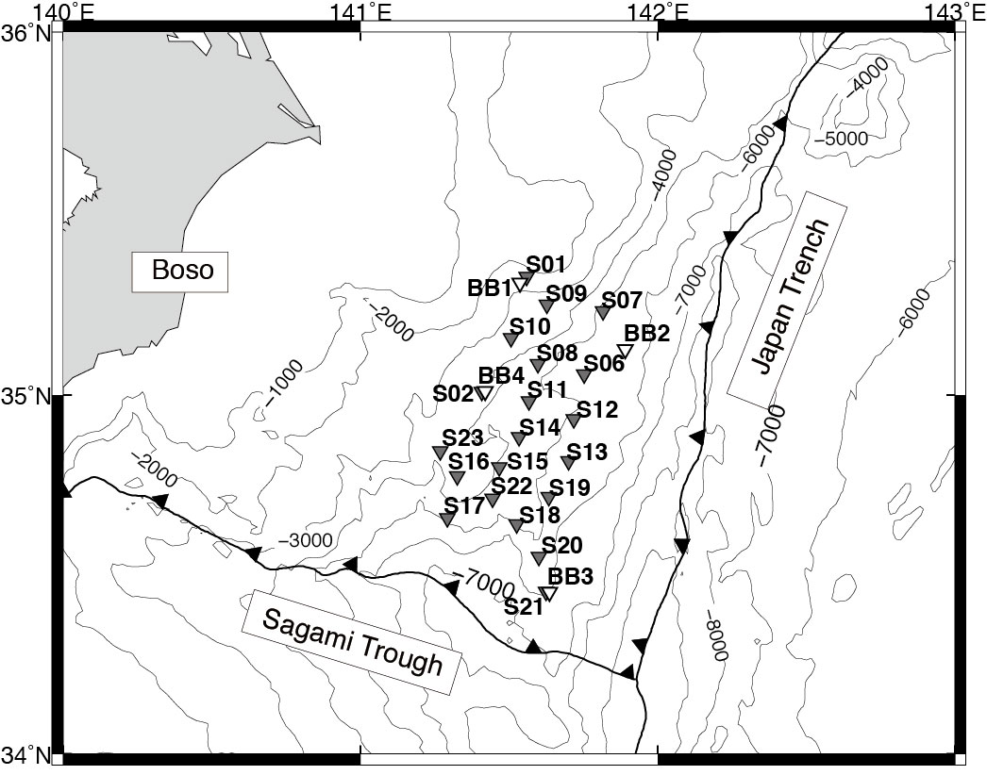
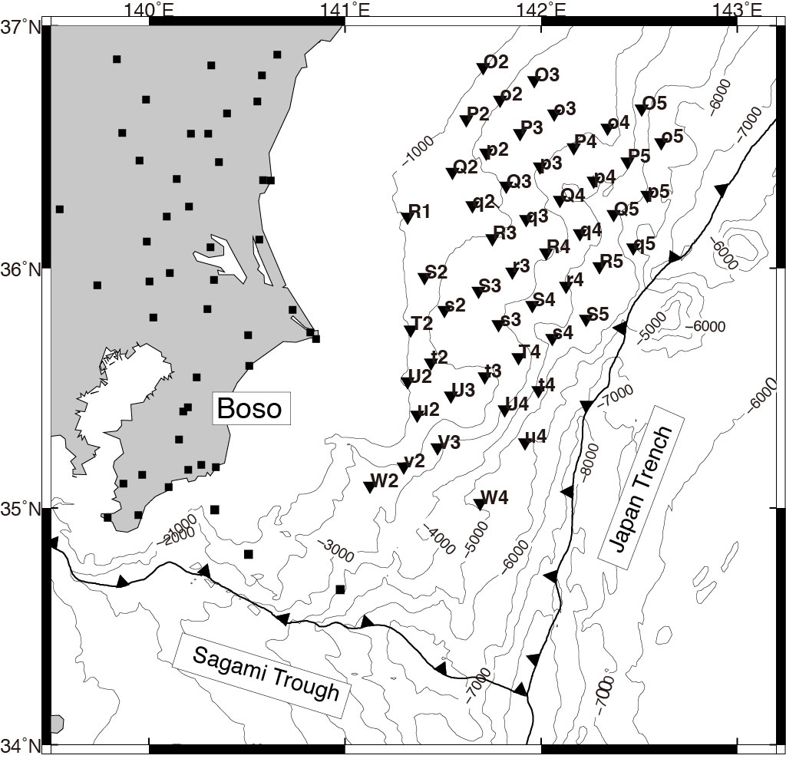
(a)
(b)

Figure S1. Locations of stations. (a) JAMSTEC OBSs. The white and gray triangles show the locations of the BBOBSs and SPOBSs, respectively. (b) ERI OBSs and land-based stations. The triangles show the locations of the LTOBSs. The squares indicate the land and cabled stations used in this study.

Table S1. Summary of JAMSTEC OBSs (BBOBSs and SPOBSs). Observation periods 1, 2, and 3 correspond to March 2012–March 2013, May 2012–March 2013, and December 2012–March 2013, respectively.
Station | Lat.  (° N) | Lon.  (° E) | Depth  (m) | Observation  Period | T_{PS}  (s) | Sensor Orientation  (°) | Number of events in RF analysis | Remarks
BB1 | 35.310 | 141.536 | 2864 | 1 | 1.2 | 271 | 33
BB2 | 35.126 | 141.891 | 5579 | 1 | 0.9 | 195 | 33
BB3 | 34.452 | 141.616 | 5922 | 1 |  |  |  | Sensor trouble
BB4 | 35.010 | 141.412 | 3827 | 1 | 1.1 | 41 | 23
S01 | 35.327 | 141.559 | 2540 | 1 | 1.2 | 300 | 52
S02 | 35.009 | 141.408 | 3780 | 1 | 1.3 | 100 | 47
S06 | 35.057 | 141.752 | 5532 | 1 | 1.3 | 320 | 57
S07 | 35.232 | 141.816 | 5392 | 1 | 1.2 | 30 | 68
S08 | 35.087 | 141.597 | 4683 | 1 | 1.6 | 80 | 57
S09 | 35.251 | 141.627 | 3549 | 1 | 2.0 | 80 | 54
S10 | 35.158 | 141.507 | 3536 | 1 | 1.7 | 80 | 58
S11 | 34.983 | 141.567 | 4657 | 2 | 1.2 |  |  | Unreliable orientation
S12 | 34.933 | 141.716 | 5327 | 2 | 1.6 | 150 | 47
S13 | 34.816 | 141.700 | 5605 | 2 | 1.0 | 20 | 62
S14 | 34.883 | 141.532 | 4342 | 2 | 1.1 |  |  | Unreliable orientation
S15 | 34.800 | 141.465 | 4085 | 2 |  |  |  | Internal clock error
S16 | 34.771 | 141.322 | 3385 | 2 | 1.8 | 40 | 32
S17 | 34.657 | 141.293 | 4897 | 2 | 1.2 | 30 | 51
S18 | 34.641 | 141.521 | 5005 | 2 | 1.0 | 10 | 48
S19 | 34.717 | 141.633 | 5386 | 2 | 1.4 | 30 | 36
S20 | 34.550 | 141.598 | 5557 | 2 | 1.9 | 330 | 52
S21 | 34.454 | 141.618 | 5907 | 3 | 1.2 |  |  | Insufficient data for RF
S22 | 34.715 | 141.444 | 4548 | 3 | 0.8 |  |  | Insufficient data for RF
S23 | 34.844 | 141.269 | 3674 | 3 | 1.2 |  |  | Insufficient data for RF

Table S2. Summary of ERI OBSs (LTOBSs). Observation periods 4 and 5 correspond to October 2011–August 2012 and April 2012–November 2012, respectively.

Station | Lat.  (° N) | Lon.  (° E) | Depth  (m) | Observation  Period | T_{PS}  (s) | Sensor Orientation  (°) | Number of events in RF analysis | Remarks
P3 | 36.558 | 141.893 | 2348 | 4 | 2.3 | 157 | 31
P5 | 36.442 | 142.441 | 3790 | 4 | 1.4 | 260 | 23
O2 | 36.829 | 141.705 | 1028 | 4 | 2.3 | 48 | 34
Q2 | 36.399 | 141.548 | 1722 | 4 | 2.4 | 230 | 26
Q4 | 36.283 | 142.097 | 3601 | 4 | 1.2 | 10 | 26
R1 | 36.213 | 141.320 | 1018 | 4 | 1.7 | 276 | 33
R3 | 36.124 | 141.751 | 2039 | 4 | 2.5 | 14 | 38
R5 | 36.008 | 142.297 | 4494 | 4 | 1.4 | 309 | 21
S2 | 35.963 | 141.405 | 1578 | 4 | 2.4 | 260 | 20
S4 | 35.848 | 141.954 | 3221 | 4 | 1.8 | 80 | 25
U2 | 35.529 | 141.319 | 1037 | 4 | 2.2 |  |  | Insufficient data for RF
U4 | 35.413 | 141.814 | 3148 | 4 | 1.2 | 261 | 33
V3 | 35.254 | 141.471 | 1160 | 4 | 1.5 | 338 | 39
W2 | 35.093 | 141.128 | 2492 | 4 | 1.6 | 324 | 16
W4 | 35.020 | 141.689 | 5231 | 4 | 1.3 |  |  | Insufficient data for RF
r3 | 35.986 | 141.853 | 2410 | 5 | 1.9 | 15 | 23
r4 | 35.928 | 142.127 | 3948 | 5 | 1.4 | 91 | 21
S3 | 35.906 | 141.680 | 2703 | 5 | 2.2 | 106 | 28
S5 | 35.790 | 142.228 | 4586 | 5 | 1.1 | 339 | 33
s2 | 35.826 | 141.508 | 2336 | 5 | 2.3 | 357 | 14
s3 | 35.768 | 141.782 | 2926 | 5 | 2.0 | 228 | 22
s4 | 35.710 | 142.056 | 4312 | 5 | 1.3 | 224 | 27
T2 | 35.746 | 141.335 | 1218 | 5 | 2.2 | 304 | 20
T4 | 35.631 | 141.885 | 2382 | 5 | 1.3 | 280 | 21
t2 | 35.608 | 141.438 | 1757 | 5 | 2.3 | 279 | 20
t3 | 35.551 | 141.712 | 1666 | 5 | 2.0 | 181 | 21
t4 | 35.493 | 141.987 | 4420 | 5 | 1.2 | 17 | 24
R4 | 36.066 | 142.025 | 2882 | 5 | 2.5 | 224 | 14
q2 | 36.261 | 141.649 | 1729 | 5 | 2.1 | 259 | 39
o2 | 36.696 | 141.791 | 1998 | 5 | 2.0 | 222 | 25
o3 | 36.638 | 142.066 | 2409 | 5 | 2.8 | 180 | 27
o4 | 36.580 | 142.340 | 2707 | 5 | 2.1 | 254 | 21
o5 | 36.521 | 142.613 | 5758 | 5 | 1.2 | 288 | 10

Table S2. Summary of ERI OBSs (LTOBSs). (continued)

Station | Lat.  (° N) | Lon.  (° E) | Depth  (m) | Observation  Period | T_{PS}  (s) | Sensor Orientation (°) | Number of events in RF analysis | Remarks
O3 | 36.776 | 141.965 | 2434 | 5 | 2.6 | 43 | 13
O5 | 36.659 | 142.513 | 4435 | 5 | 0.9 | 276 | 18
p2 | 36.478 | 141.720 | 2099 | 5 | 1.0 | 98 | 17
p3 | 36.421 | 141.994 | 3132 | 5 | 1.5 | 342 | 29
p4 | 36.363 | 142.268 | 3995 | 5 | 2.5 | 15 | 21
p5 | 36.304 | 142.542 | 5158 | 5 | 1.2 | 75 | 19
P2 | 36.616 | 141.618 | 1559 | 5 | 1.6 | 149 | 23
P4 | 36.501 | 142.167 | 3178 | 5 | 1.6 | 154 | 21
q3 | 36.203 | 141.923 | 2206 | 5 | 1.5 | 15 | 21
q4 | 36.145 | 142.197 | 3556 | 5 | 1.4 | 42 | 21
q5 | 36.086 | 142.471 | 5580 | 5 | 0.9 |  |  | Low quality data
Q3 | 36.341 | 141.821 | 2093 | 5 | 1.9 | 114 | 27
Q5 | 36.225 | 142.370 | 4894 | 5 | 0.5 | 285 | 26
u2 | 35.391 | 141.368 | 1360 | 5 | 2.1 | 302 | 12
u4 | 35.275 | 141.917 | 5692 | 5 | 1.0 | 67 | 33
U3 | 35.471 | 141.540 | 1621 | 5 | 2.1 | 110 | 24
v2 | 35.173 | 141.299 | 2192 | 5 | 0.8 | 163 | 14

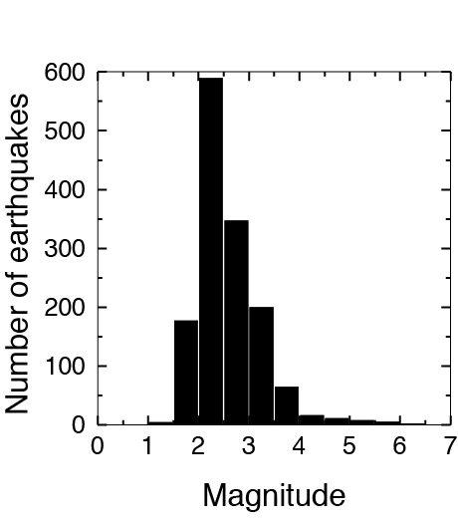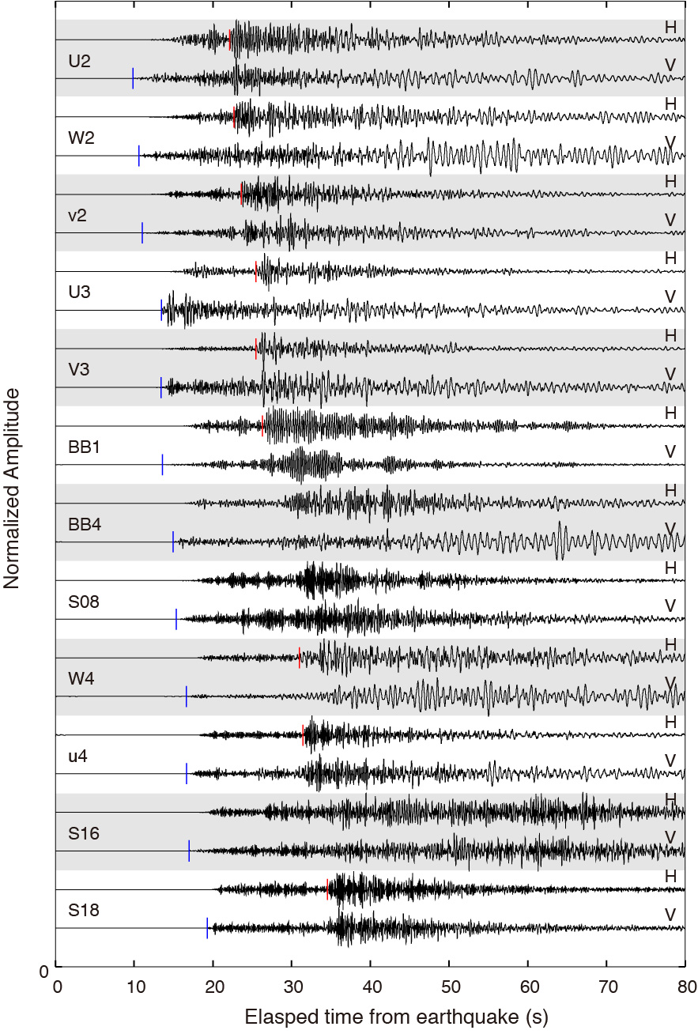
Figure S2. Histogram of the magnitudes for local earthquakes. Bar width is 0.5. Magnitudes for eight of 1430 earthquakes analyzed in this study were not determined by JMA.

Figure S3. Example of seismic record for a local earthquake. The vertical and one horizontal components of the velocity seismogram are shown. A 1.0 Hz high-pass filter is applied to each component. Each trace is normalized by maximum amplitude. The picked onset times of P- and S- waves arrivals are presented with blue and red vertical lines, respectively. The origin time of the earthquake is 08:12:1.04 UTC on May 5 2012 and the hypocenter is 35.526° E, 140.952° N by the JMA. The depth and magnitude are 40.56 km and 4.4, respectively.
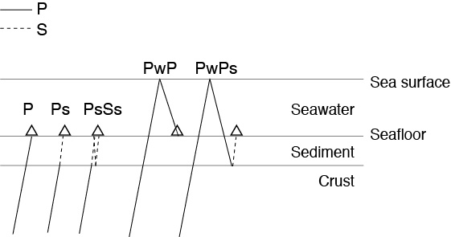
Figure S4. Ray paths of seismic phases isolated from teleseismic P wave for seafloor observation. Ps and PwPs (multiple reflections caused by a seawater layer) are emerged in the radial component with large amplitude, while PsSs (multiple reflections in the sediment) has a relatively small amplitude. PwP (reflected-P wave from sea surface) can be seen in the vertical component.

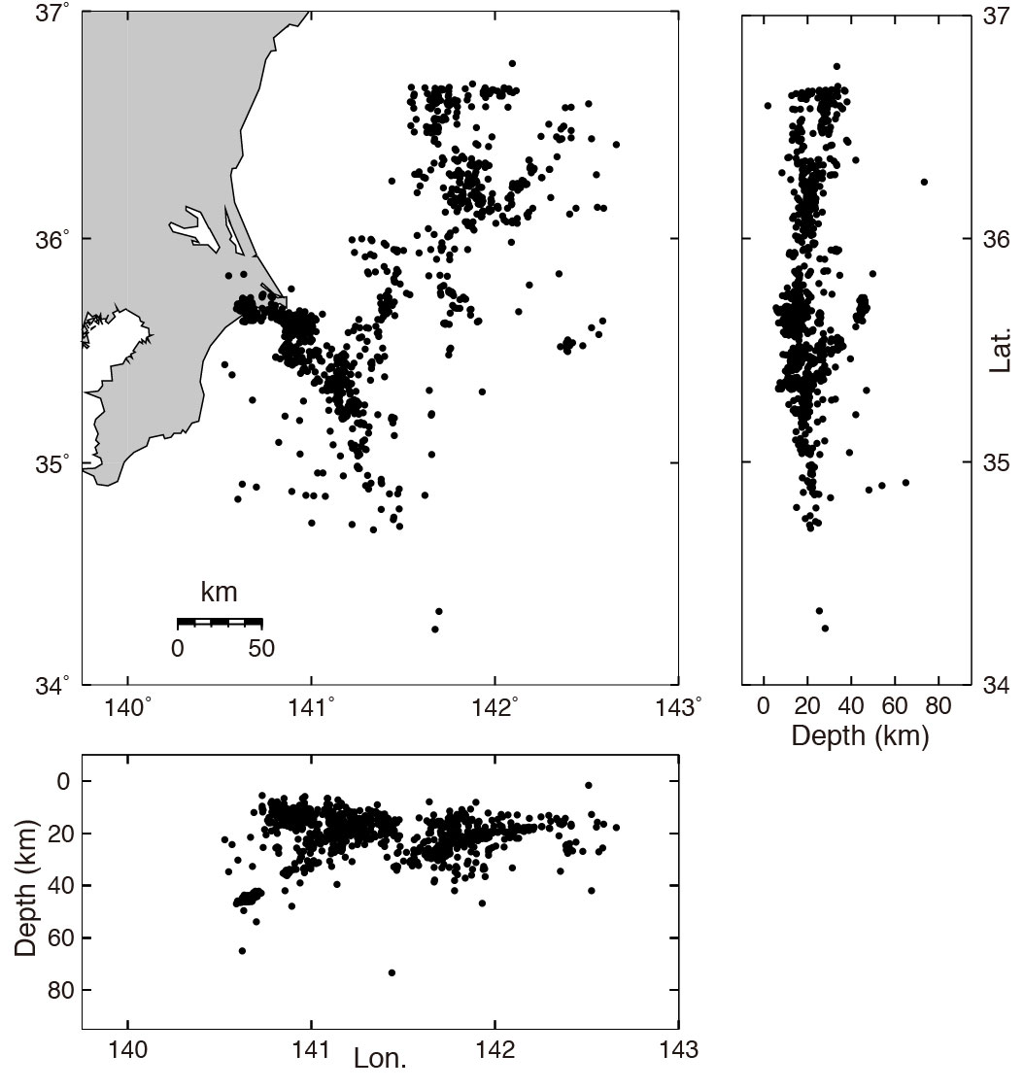
Figure S5. Hypocenters determined by tomoDD. The lower and right panels show the E–W and N–S vertical sections, respectively.

Additional Note 1: Time-domain RFs

Figure S6a shows the time-domain RFs of the OBSs within a 50-km-wide box on both sides of the A–A′ profile in Figure 4. Each box corresponds to a single OBS, and the RFs are arranged in order of back azimuth within the boxes. The picked P arrival time corresponds to a lag time of 0 s. The first positive peaks (in red), which are observed at a lag time of 0–3 s, nearly correspond to the measured Tps (the differential travel time of the P- and S-waves in the shallow sediments above the Cretaceous layer) for each OBS. We rearranged each RF by subtracting the Tps at each OBS from the time-domain RFs in Figure S6b, which means that 0 s corresponds to the top of the Cretaceous layer. Removing the effect of the lateral variation of the sedimentary layers made the interpretation of the signals of the time-domain RFs easier.
Several peaks are apparent in Figure S6b. These peaks can contain Ps-waves converted from the real structure and/or multiple reflections associated with the seawater and marine sediments. We indicate the theoretical travel times of the Ps-waves converted at the upper boundary of the PAC and PwPs (multiple reflections caused by a seawater layer). PwPs is likely present in the RF image for the seafloor observation (Tonegawa et al. 2019). The theoretical travel times are calculated using a one-dimensional velocity model derived from the tomographic results in this study and the depth of the upper boundary of the PAC in Nakajima et al. (2009).
Compared to the theoretical travel times, the Ps-waves converted at a lag time of 0–4 s in Figure S6b are likely attributable to the upper boundary of the PAC (Nakajima et al. 2009) or nearby velocity discontinuities. At shorter lag times, several peaks were also observed. The multiple reflection PwPs, whose arrival times vary as a function of the water depth, is evident with a lag time of 3–9 s. These observations indicate that the upper boundary of the PAC or the interfaces in its vicinity can be imaged after the depth conversion of the RFs. The interfaces shallower than the PAC are also likely to be imaged in the depth-domain RFs. PwPs may appear under the upper boundary of the PAC on the depth-domain RFs; therefore, it does not affect our discussion focusing on the interfaces above the PAC.
Figures S6c and S6d show the time-domain RFs of the OBSs in the area where the PHS is subducted (Uchida et al. 2009) using the RFs after subtracting Tps. The OBSs north and south of 35° N are plotted in Figures S6c and S6d, respectively. There is no significant difference in quality between the time-domain RFs of BBOBSs (BB #) and SPOBSs (S ##) in Figure S6c.
Several peaks were evident at lag times shorter than the theoretical travel times of the Ps-waves converted at the upper boundary of the PAC north of 35° N (Figure S6c). Therefore, interfaces shallower than the PAC can be imaged after the depth conversion of the RFs in that region. Conversely, distinct peaks were difficult to observe south of 36° N (Figure S6d).

The time-domain RFs in Figures S6b, S6c, and S6d were used to make the depth-domain RFs in Figures 9a, 9d, and 9e, respectively.

Reference
Tonegawa T, Miura S, Ishikawa A, Sano T, Suetsugu D, Isse T, Shiobara H, Sugioka H, Ito A, Ishihara Y, Tanaka S, Obayashi M, Yoshimitsu J, Kobayashi T (2019) Characterization of crustal and uppermost-mantle seismic discontinuities in the Ontong Java Plateau. J Geophys Res doi: 10.1029/2018JB016970.

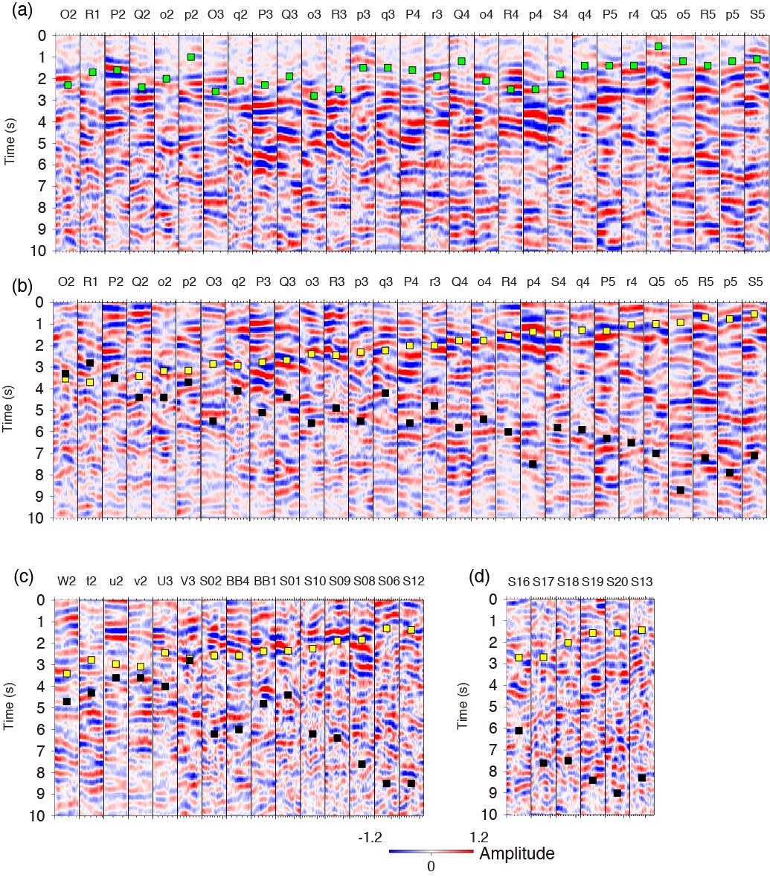
Figure S6. Examples of time-domain RFs. Red represents positive RF amplitudes, indicating a velocity increase downward, while blue represents negative RF amplitudes, indicating a velocity decrease downward. (a) RFs of OBSs within a 50-km-wide box on both sides of the A–A′ profile in Figure 4. The green square indicates the lag times of the measured Tps. (b) RFs rearranged by subtracting Tps at each OBS from the time-domain RFs in panel (a). The yellow and black squares indicate the lag times of the theoretical Ps-wave at the top of the PAC and PwPs, respectively. (c) Rearranged RFs of OBSs north of 35° N in the area where the PHS exists (Uchida et al. 2009). (d) Rearranged RFs OBSs south of 35° N in the area where the PHS exists.

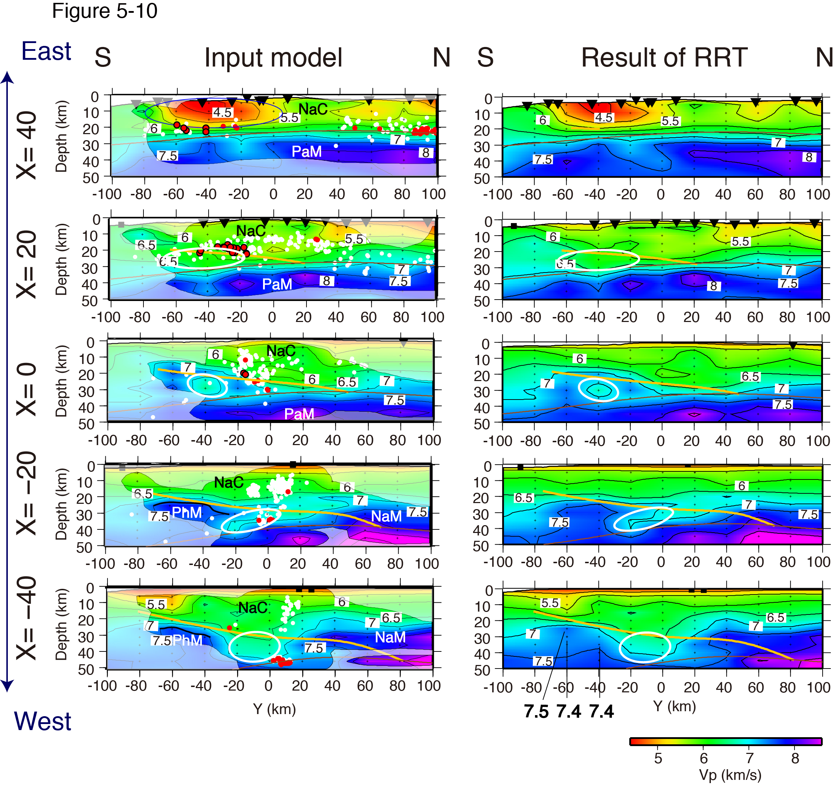
Figure S7. Results of the first RRT. Panels in the left and right columns show the resulting velocity structures and the restoring models, respectively.

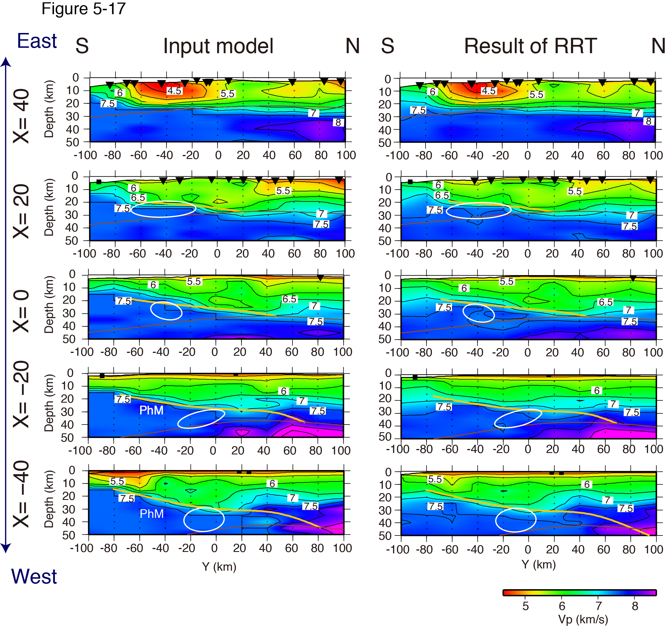
Figure S8. Results of the second RRT. Panels in the left and right columns show the assumed velocity structures without a low-velocity zone in the PHS mantle and the restoring models, respectively.

