Table S1 Information for the earthquakes with M$≥3.5$ in the Kilauea area in the study time period (from United States Geological Survey earthquake catalog).
No. | Date and time | Longitude | Latitude | Depth (km) | Magnitude
1 | 2017-03-05T16:06:32.330 | -155.236 | 19.387 | 2.18 | 3.52 (ml)
2 | 2017-03-05T16:13:18.870 | -155.232 | 19.384 | 2.34 | 3.88 (ml)
3 | 2017-03-05T16:17:19.050 | -155.231 | 19.387 | 2.34 | 3.53 (ml)
4 | 2017-03-23T20:27:29.120 | -155.172 | 19.289 | 8.34 | 4.49 (ml)
5 | 2017-04-12T18:29:24.640 | -155.271 | 19.388 | 2.69 | 3.53 (ml)
6 | 2017-06-08T17:01:19.350 | -155.116 | 19.335 | 7.13 | 5.28 (ml)
7 | 2017-10-15T06:36:20.240 | -155.300 | 19.436 | 6.32 | 3.57 (ml)
8 | 2018-05-01T12:39:11.860 | -155.092 | 19.275 | 5.90 | 4.22 (ml)
9 | 2018-05-01T22:07:42.130 | -154.986 | 19.342 | 0.81 | 3.66 (ml)
10 | 2018-05-03T09:22:39.110 | -154.851 | 19.381 | 9.37 | 3.57 (ml)
11 | 2018-05-03T20:30:56.500 | -155.065 | 19.349 | 6.93 | 5.10 (mw)
12 | 2018-05-04T21:32:44.310 | -155.027 | 19.347 | 6.93 | 5.40 (mw)
13 | 2018-05-04T21:38:23.880 | -155.017 | 19.343 | 1.32 | 4.35 (ml)
14 | 2018-05-04T21:41:53.640 | -154.975 | 19.334 | 0.19 | 3.71 (ml)
15 | 2018-05-04T21:43:53.780 | -155.015 | 19.337 | 5.66 | 3.83 (ml)
16 | 2018-05-04T22:32:54.370 | -154.993 | 19.318 | 2.06 | 6.90 (mw)

Figure S1 Amplitude spectrum of raw seismic records for Station (a) HAT, (b) HLPD, (c) JCUZ, (d) MLOD, (e) NPOC, (f) PAUD, (g) RIMD, and (h) SDH. Station locations are shown in Figure 1. Black dashed line indicates the eruption time; and black boxes denote the frequency bands used in the study.
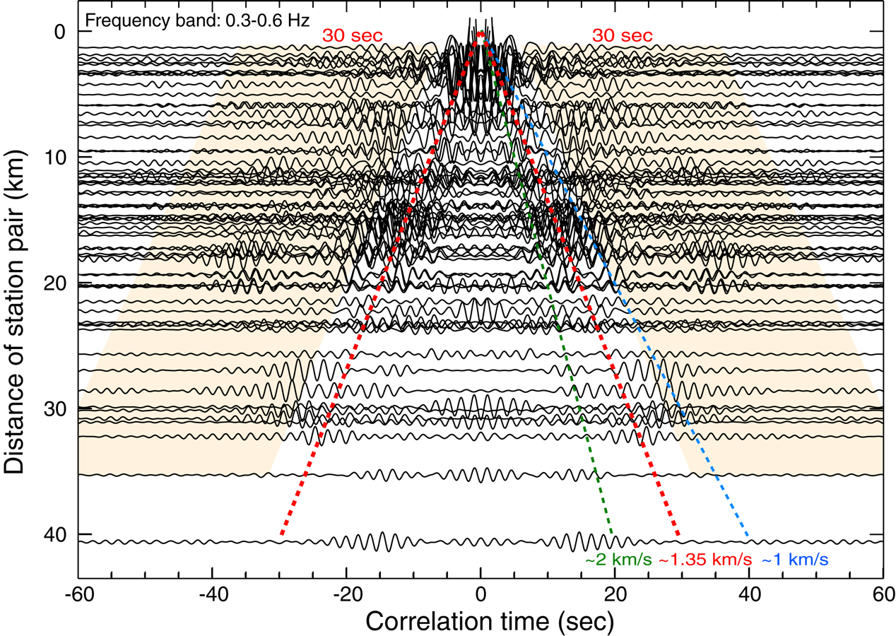
Figure S2 Retrieved surface-wave signals and the selected coda windows. Dashed lines indicate the arrival times calculated with different phase velocities (blue: ~1 km/s, red: ~1.35 km/s, green: ~2 km/s). Yellowish shaded zones represent the coda windows used for the analysis.

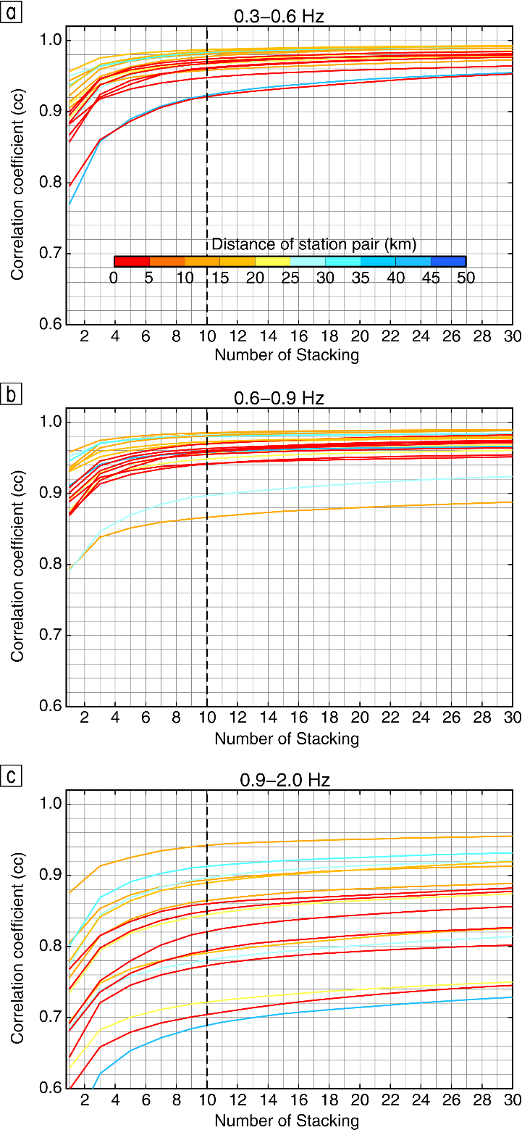
Figure S3 Stacking length tests of constructing the daily cross correlation functions in frequency bands of (a) 0.3-0.6 Hz, (b) 0.6-0.9 Hz and (c) 0.9-2.0 Hz. Dashed line marks the choice of 10-day stacking. Colors represent the distance of station pairs.
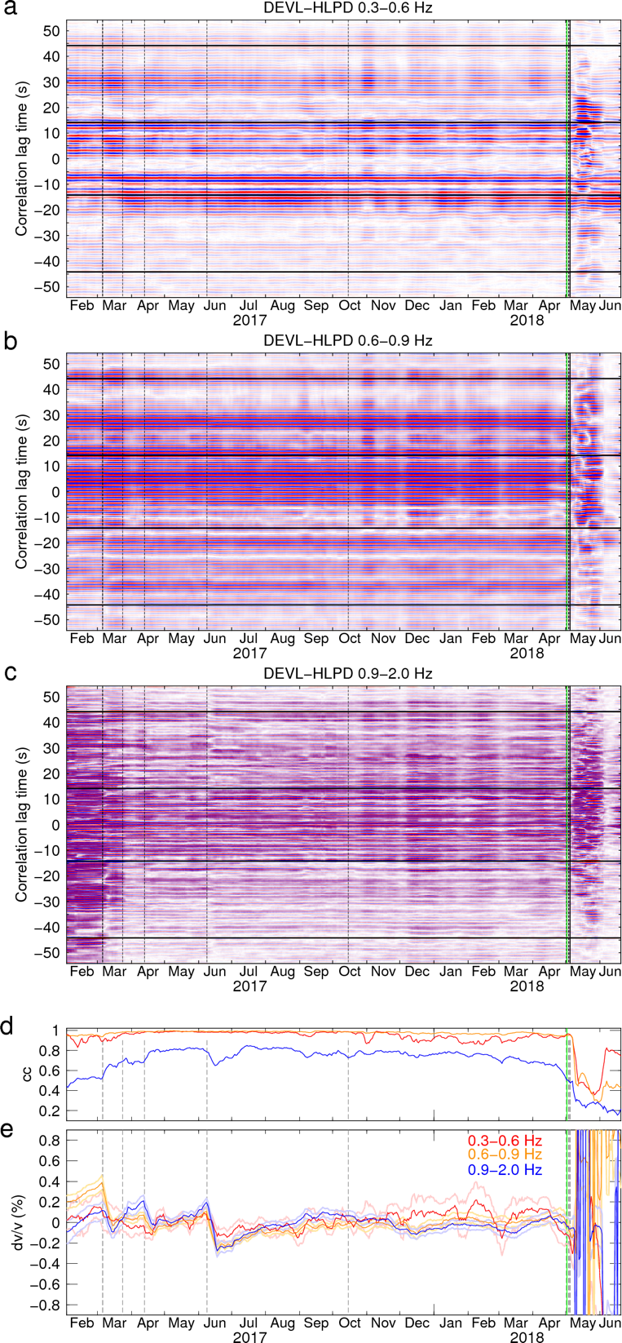
Figure S4 Daily correlograms in frequency bands of (a) 0.3-0.6 Hz, (b), 0.6-0.9 Hz, and (c) 0.9-2.0 Hz, and the estimated (d) cc and (e) dv/v time series for the station pair DEVL-HLPD. Vertical dashed lines show the occurrence times of the earthquakes (𝑀 $≥3.5$). In (a)-(c), the green line marks the 2018 eruption time. Horizontal black lines mark the used coda time windows for dv/v analysis. In (d) and (e), red, orange, and blue curves represent the cc and dv/v results of 0.3-0.6 Hz, 0.6-0.9 Hz, and 0.9-2.0 Hz frequency bands, respectively. Light color curves are the errors of the estimated dv/v.

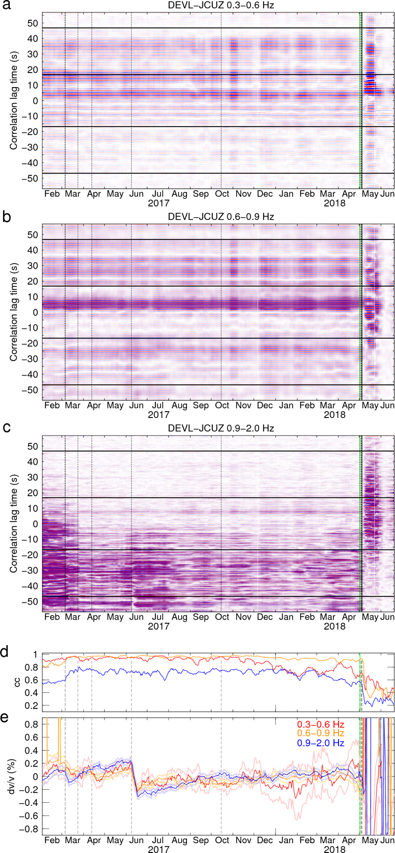
Figure S5 Daily correlograms in frequency bands of (a) 0.3-0.6 Hz, (b), 0.6-0.9 Hz, and (c) 0.9-2.0 Hz, and the estimated (d) cc and (e) dv/v time series for the station pair DEVL-JCUZ. Detailed captions refer to Figure S4.

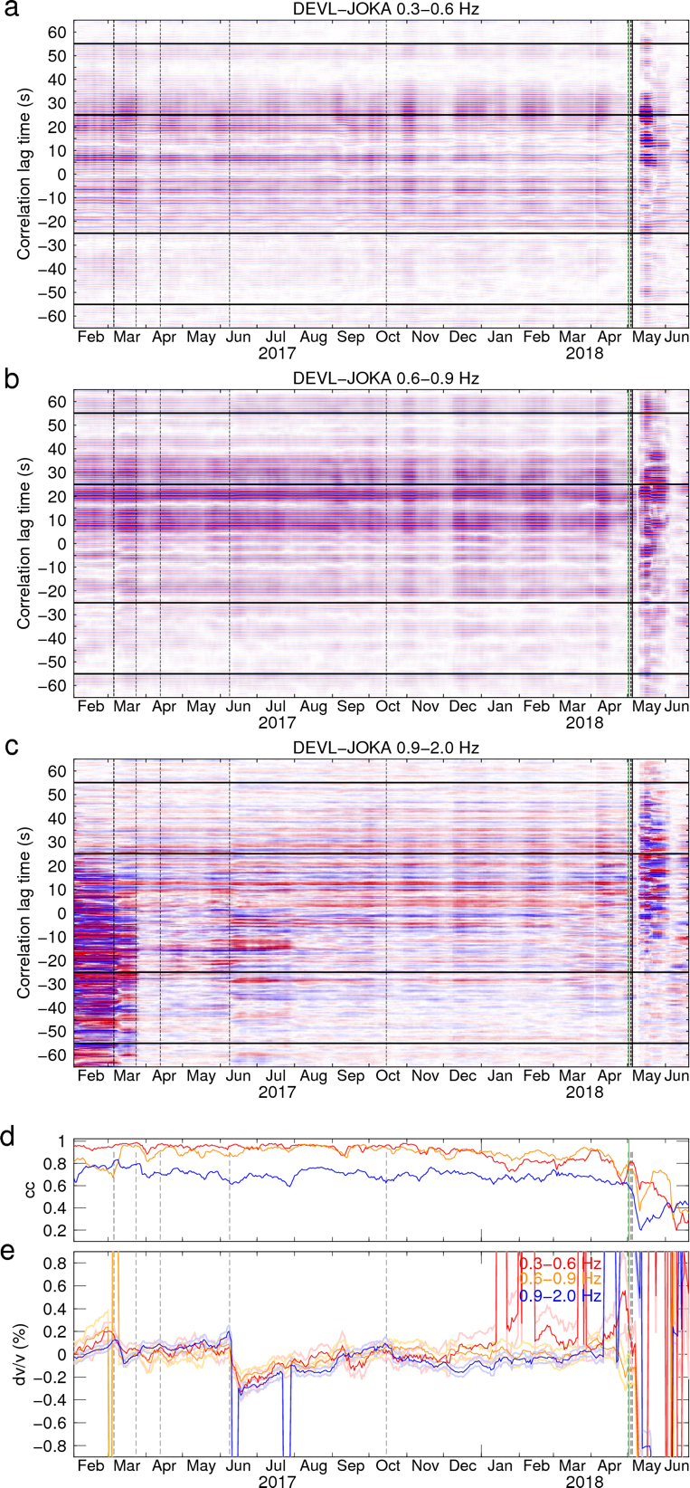
Figure S6 Daily correlograms in frequency bands of (a) 0.3-0.6 Hz, (b), 0.6-0.9 Hz, and (c) 0.9-2.0 Hz, and the estimated (d) cc and (e) dv/v time series for the station pair DEVL-JOKA. Detailed captions refer to Figure S4.

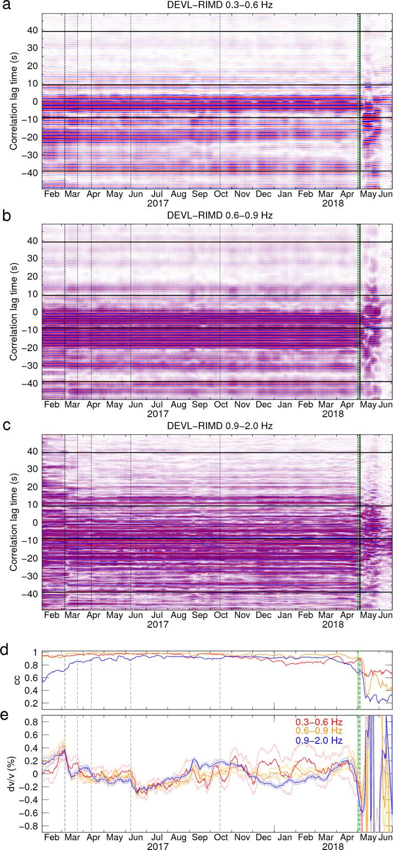
Figure S7 Daily correlograms in frequency bands of (a) 0.3-0.6 Hz, (b), 0.6-0.9 Hz, and (c) 0.9-2.0 Hz, and the estimated (d) cc and (e) dv/v time series for the station pair DEVL-RIMD. Detailed captions refer to Figure S4.

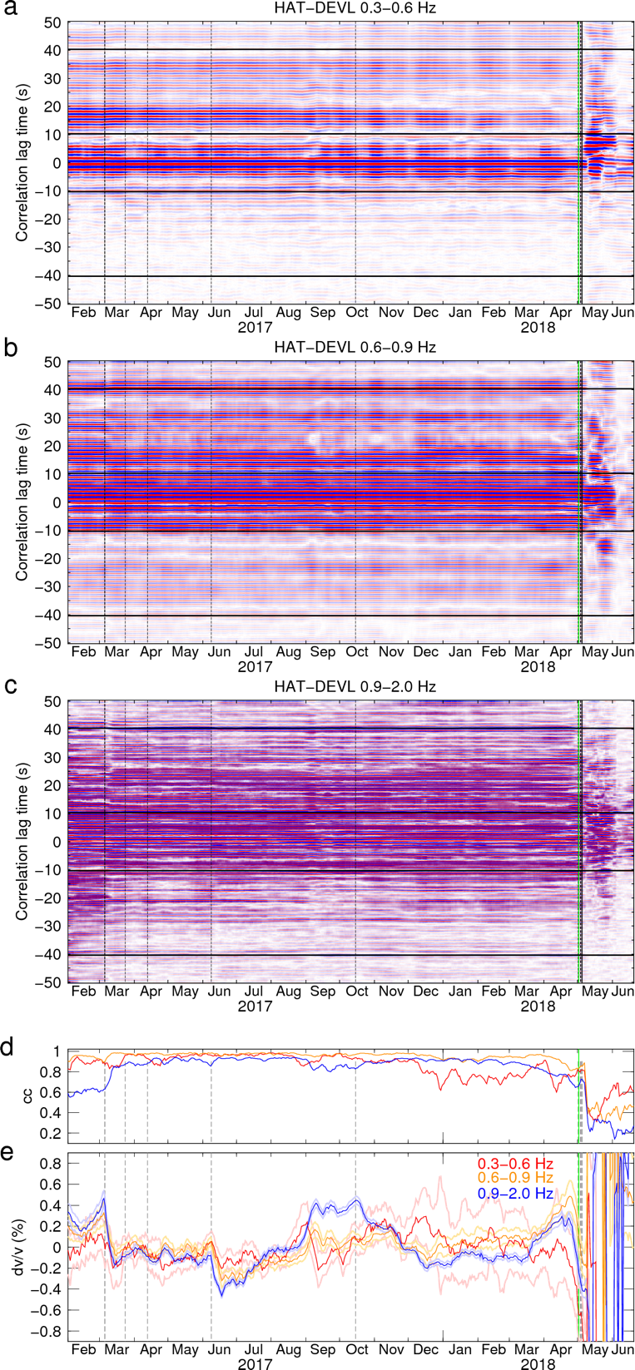
Figure S8 Daily correlograms in frequency bands of (a) 0.3-0.6 Hz, (b), 0.6-0.9 Hz, and (c) 0.9-2.0 Hz, and the estimated (d) cc and (e) dv/v time series for the station pair HAT-DEVL. Detailed captions refer to Figure S4.

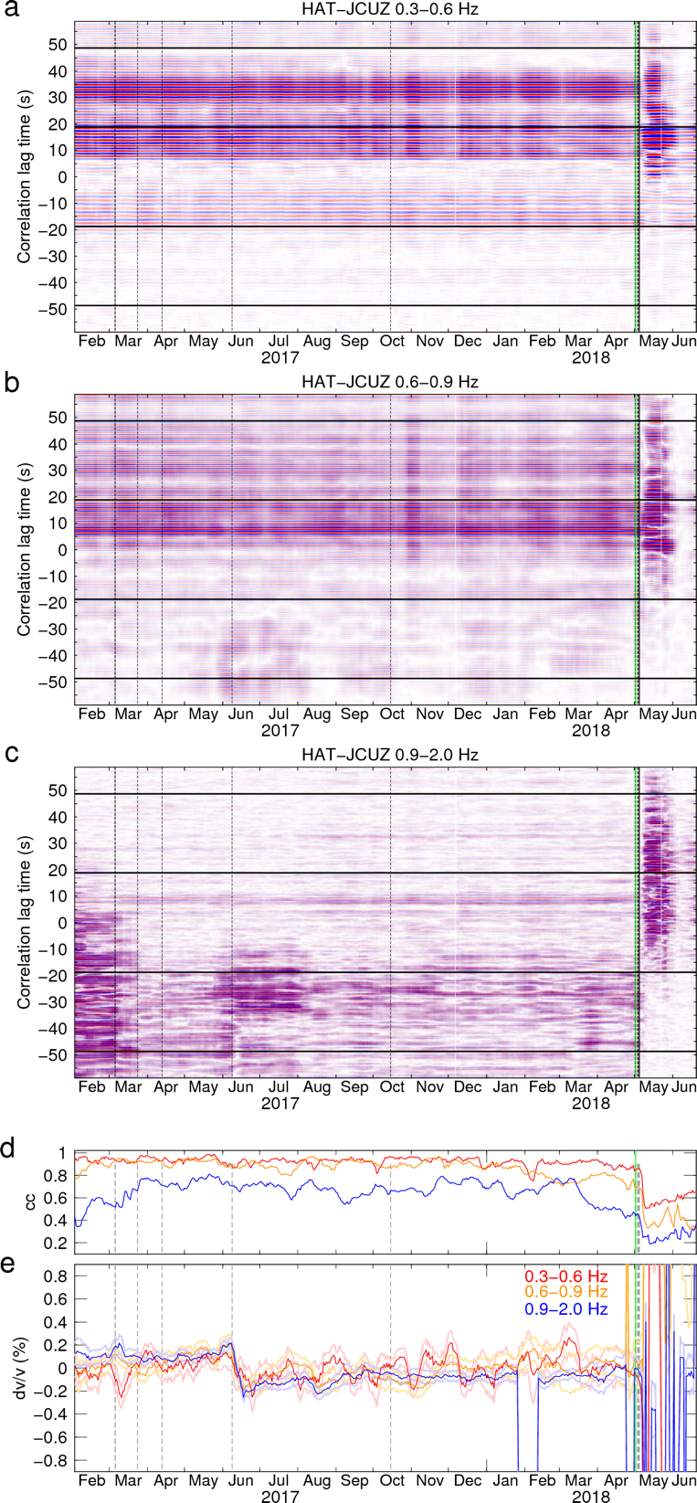
Figure S9 Daily correlograms in frequency bands of (a) 0.3-0.6 Hz, (b), 0.6-0.9 Hz, and (c) 0.9-2.0 Hz, and the estimated (d) cc and (e) dv/v time series for the station pair HAT-JCUZ. Detailed captions refer to Figure S4.

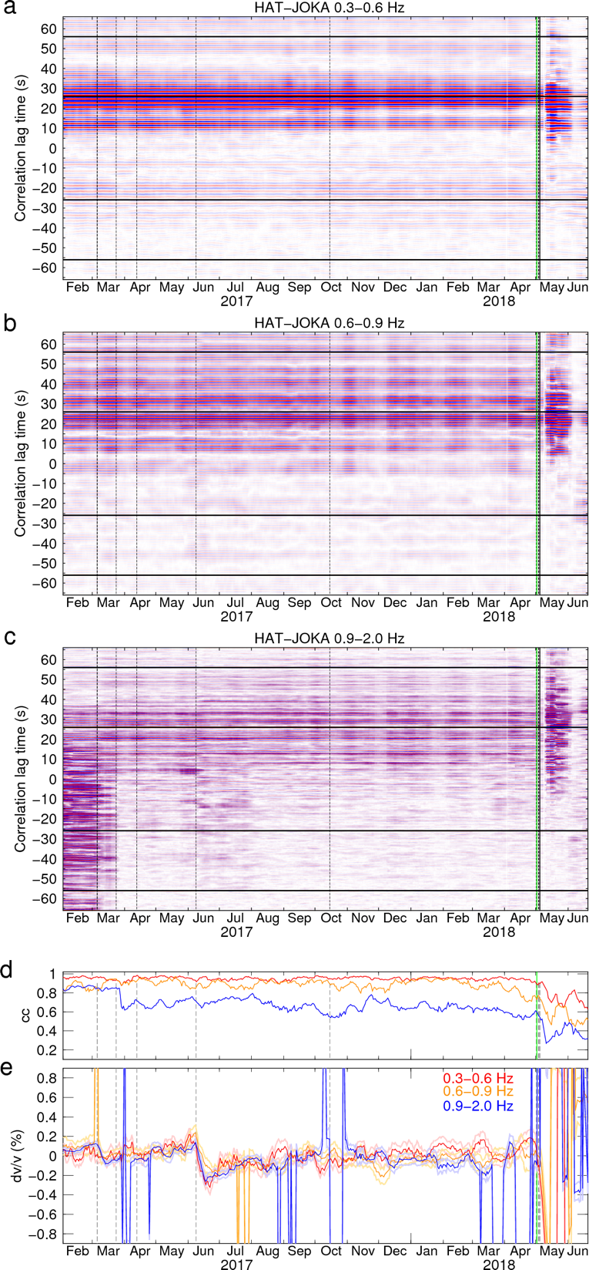
Figure S10 Daily correlograms in frequency bands of (a) 0.3-0.6 Hz, (b), 0.6-0.9 Hz, and (c) 0.9-2.0 Hz, and the estimated (d) cc and (e) dv/v time series for the station pair HAT-JOKA. Detailed captions refer to Figure S4.

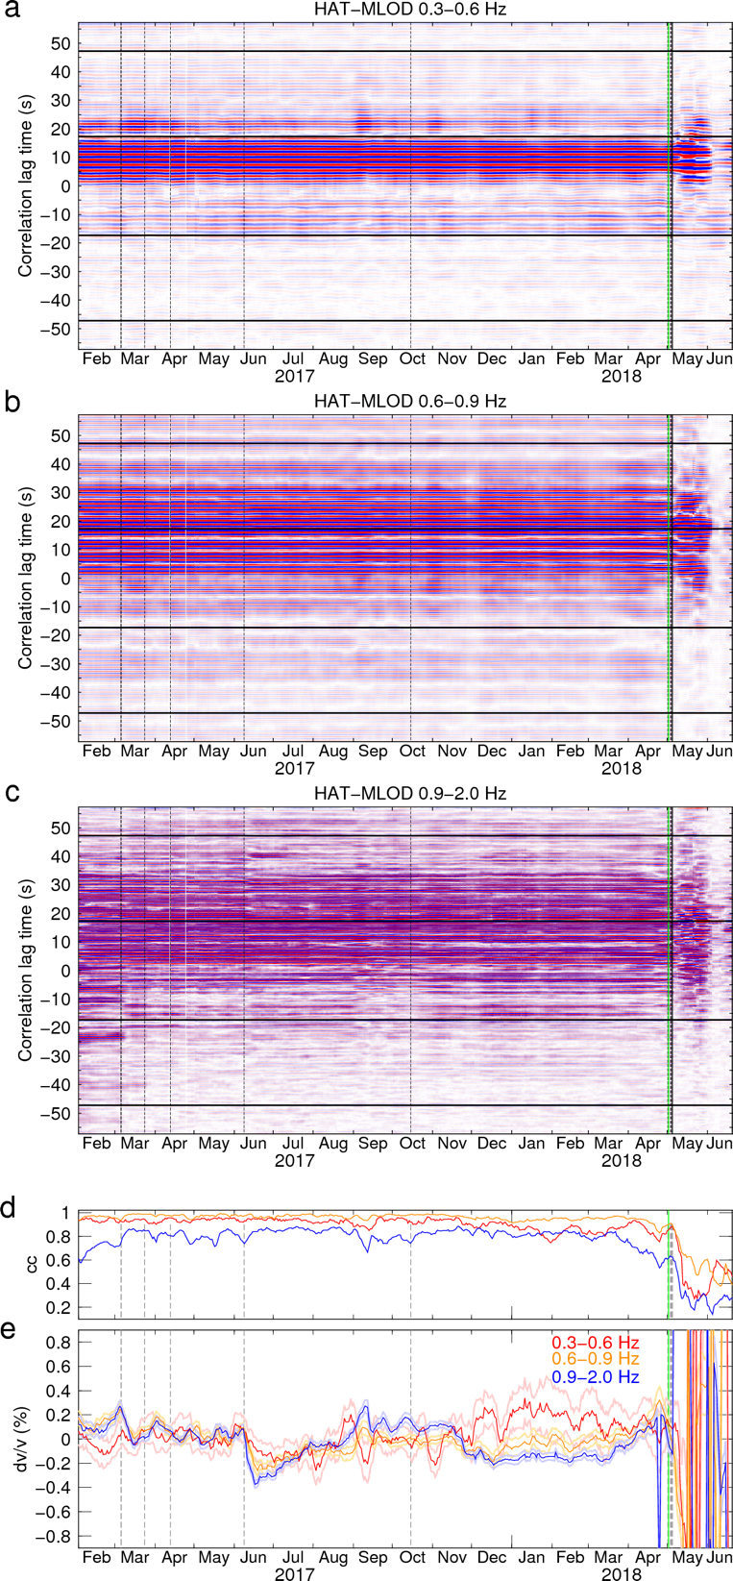
Figure S11 Daily correlograms in frequency bands of (a) 0.3-0.6 Hz, (b), 0.6-0.9 Hz, and (c) 0.9-2.0 Hz, and the estimated (d) cc and (e) dv/v time series for the station pair HAT-MLOD. Detailed captions refer to Figure S4.

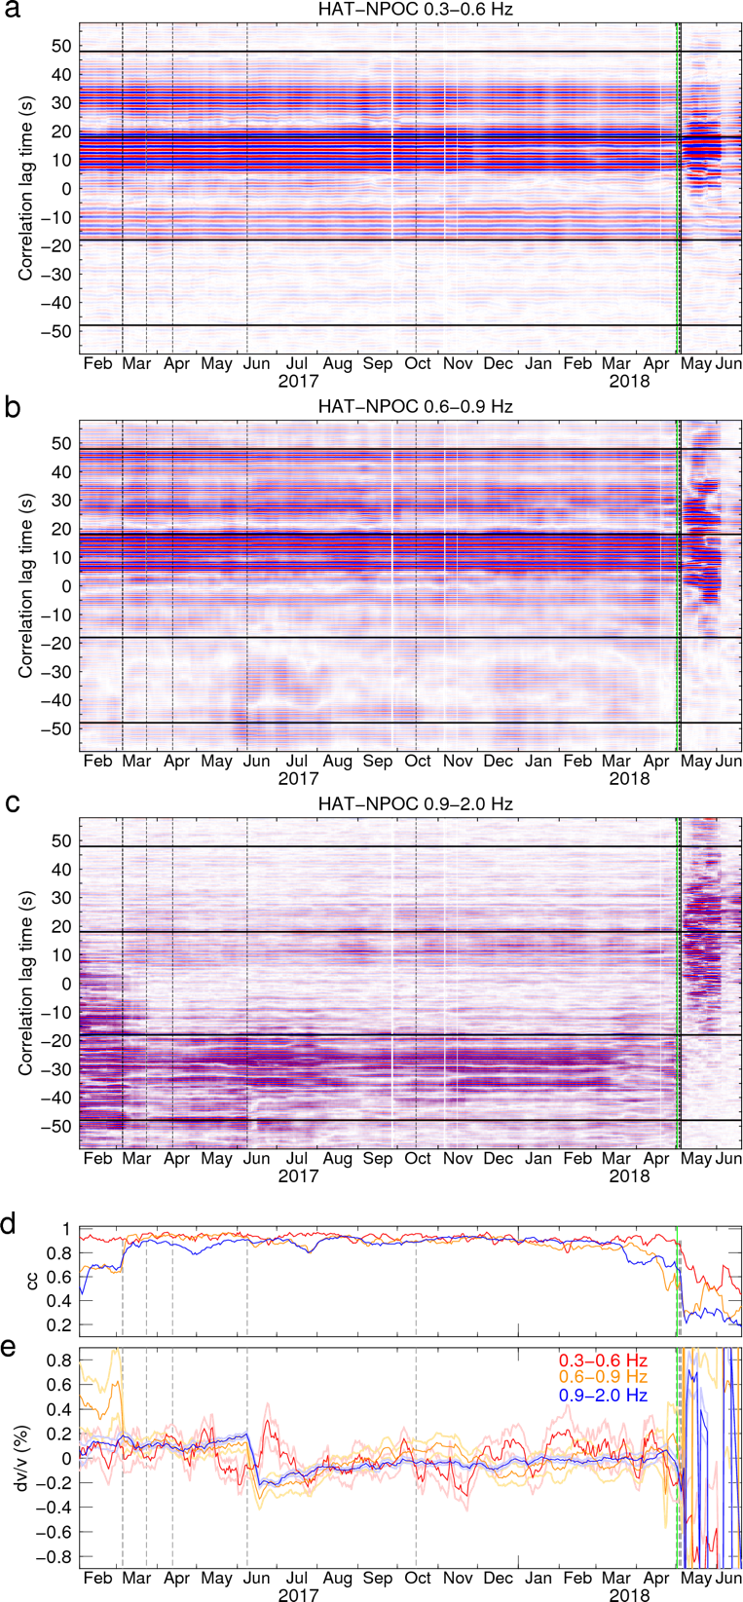
Figure S12 Daily correlograms in frequency bands of (a) 0.3-0.6 Hz, (b), 0.6-0.9 Hz, and (c) 0.9-2.0 Hz, and the estimated (d) cc and (e) dv/v time series for the station pair HAT-NPOC. Detailed captions refer to Figure S4.

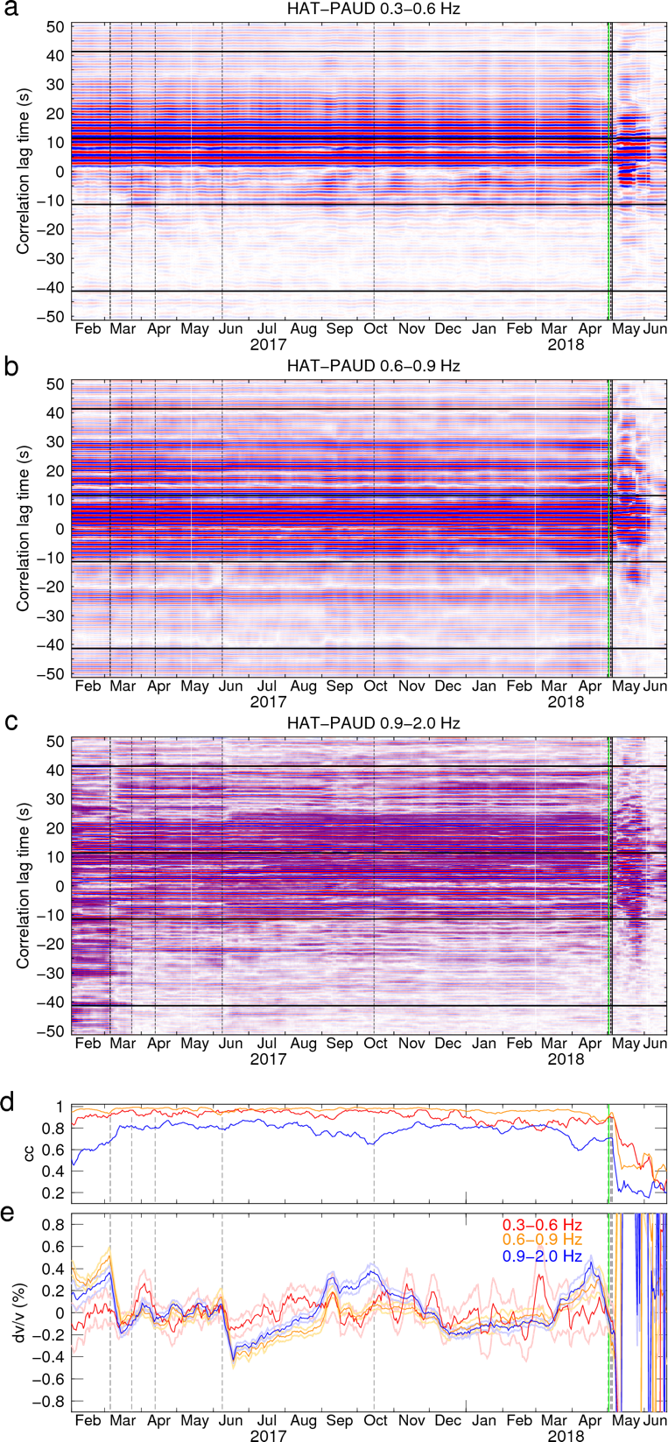
Figure S13 Daily correlograms in frequency bands of (a) 0.3-0.6 Hz, (b), 0.6-0.9 Hz, and (c) 0.9-2.0 Hz, and the estimated (d) cc and (e) dv/v time series for the station pair HAT-PAUD. Detailed captions refer to Figure S4.

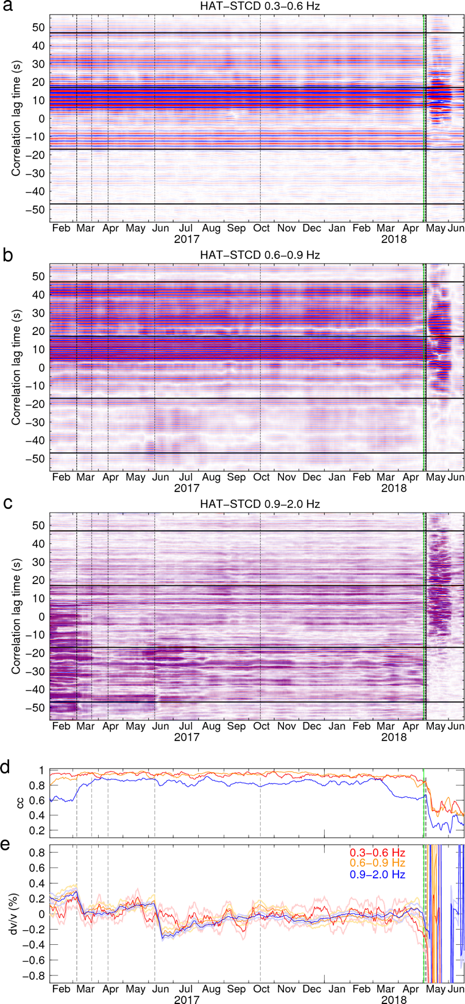
Figure S14 Daily correlograms in frequency bands of (a) 0.3-0.6 Hz, (b), 0.6-0.9 Hz, and (c) 0.9-2.0 Hz, and the estimated (d) cc and (e) dv/v time series for the station pair HAT-STCD. Detailed captions refer to Figure S4.

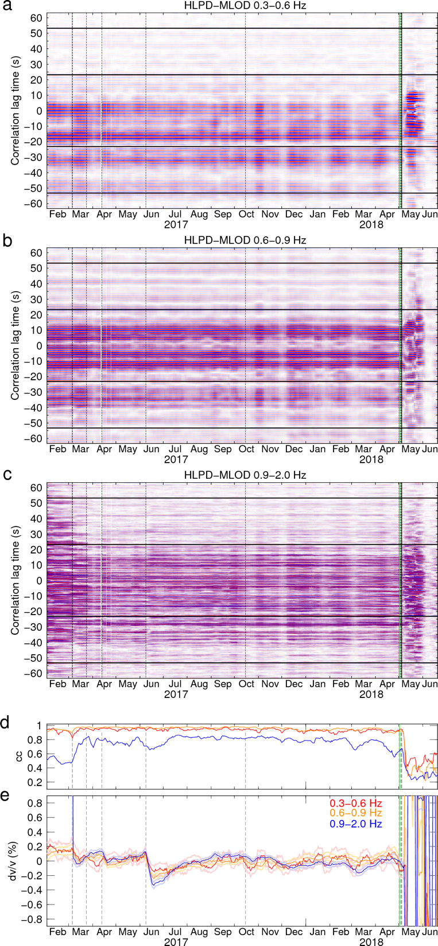
Figure S15 Daily correlograms in frequency bands of (a) 0.3-0.6 Hz, (b), 0.6-0.9 Hz, and (c) 0.9-2.0 Hz, and the estimated (d) cc and (e) dv/v time series for the station pair HLPD-MLOD. Detailed captions refer to Figure S4.

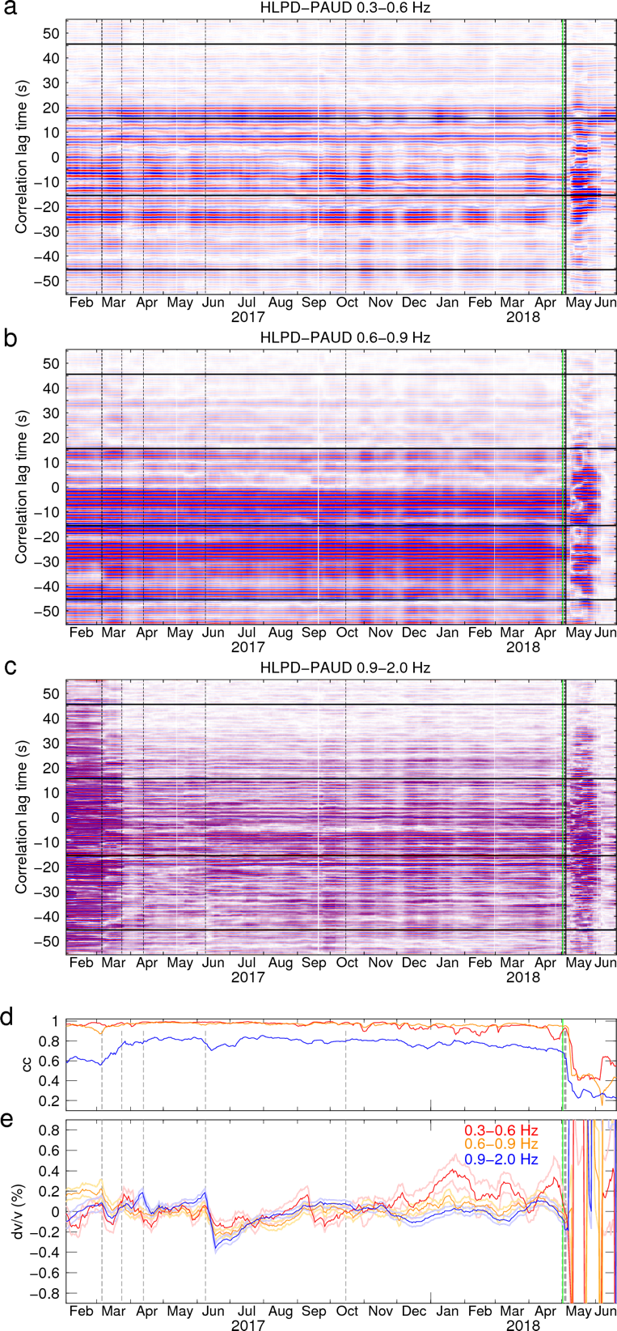
Figure S16 Daily correlograms in frequency bands of (a) 0.3-0.6 Hz, (b), 0.6-0.9 Hz, and (c) 0.9-2.0 Hz, and the estimated (d) cc and (e) dv/v time series for the station pair HLPD-PAUD. Detailed captions refer to Figure S4.

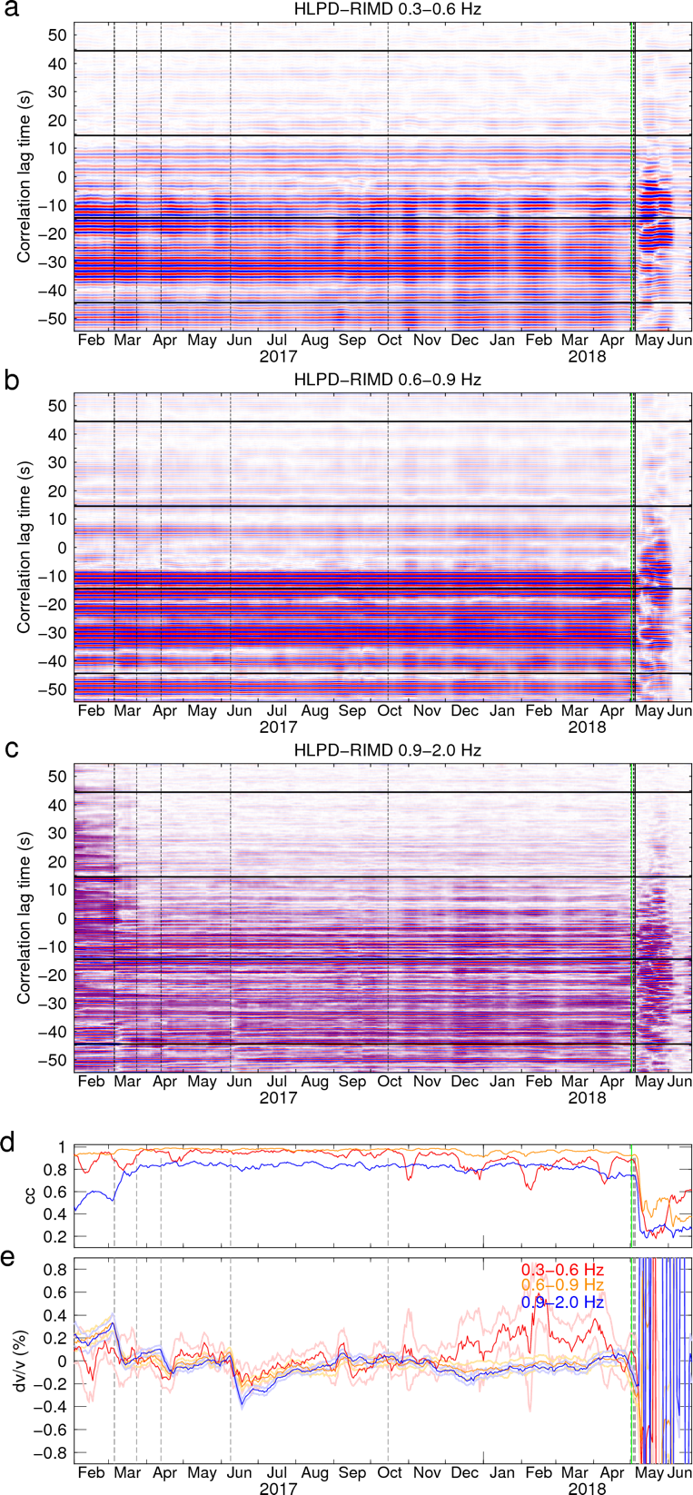
Figure S17 Daily correlograms in frequency bands of (a) 0.3-0.6 Hz, (b), 0.6-0.9 Hz, and (c) 0.9-2.0 Hz, and the estimated (d) cc and (e) dv/v time series for the station pair HLPD-RIMD. Detailed captions refer to Figure S4.

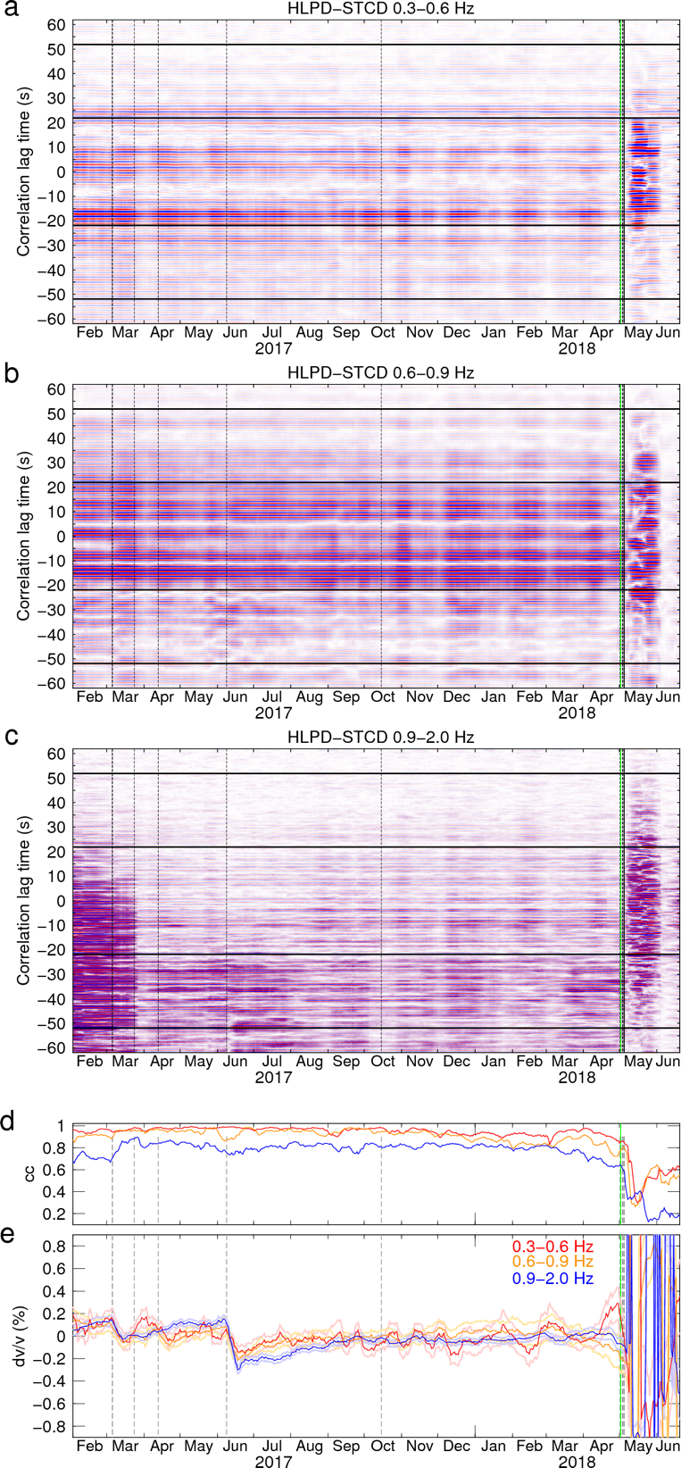
Figure S18 Daily correlograms in frequency bands of (a) 0.3-0.6 Hz, (b), 0.6-0.9 Hz, and (c) 0.9-2.0 Hz, and the estimated (d) cc and (e) dv/v time series for the station pair HLPD-STCD. Detailed captions refer to Figure S4.
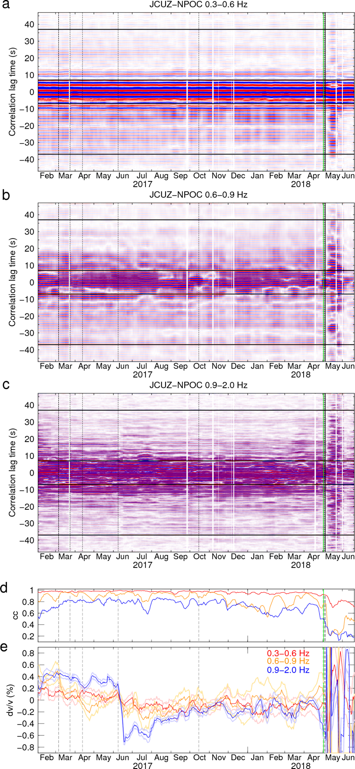
Figure S19 Daily correlograms in frequency bands of (a) 0.3-0.6 Hz, (b), 0.6-0.9 Hz, and (c) 0.9-2.0 Hz, and the estimated (d) cc and (e) dv/v time series for the station pair JCUZ-NPOC. Detailed captions refer to Figure S4.

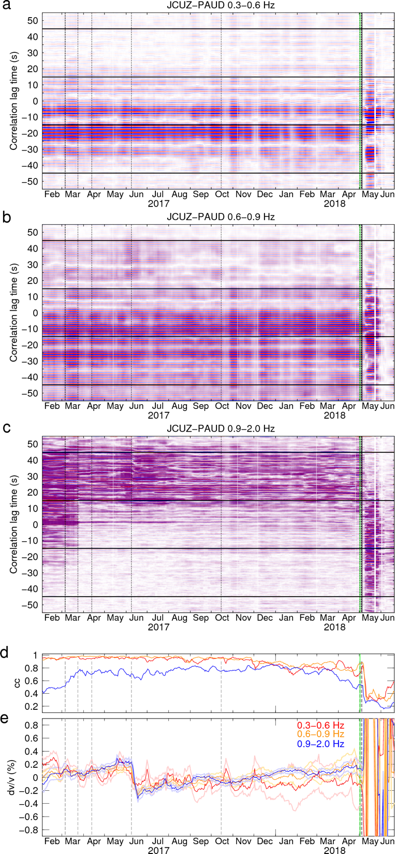
Figure S20 Daily correlograms in frequency bands of (a) 0.3-0.6 Hz, (b), 0.6-0.9 Hz, and (c) 0.9-2.0 Hz, and the estimated (d) cc and (e) dv/v time series for the station pair JCUZ-PAUD. Detailed captions refer to Figure S4.

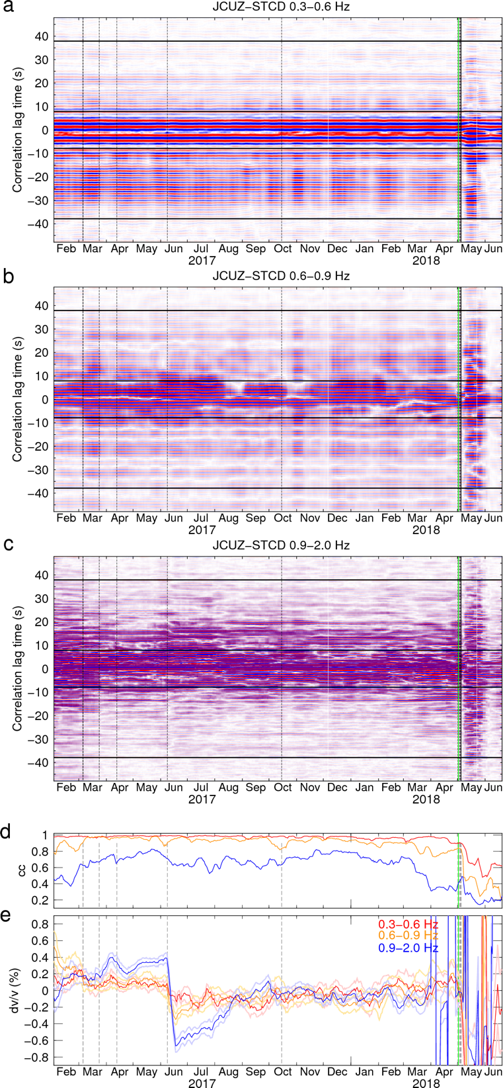
Figure S21 Daily correlograms in frequency bands of (a) 0.3-0.6 Hz, (b), 0.6-0.9 Hz, and (c) 0.9-2.0 Hz, and the estimated (d) cc and (e) dv/v time series for the station pair JCUZ-STCD. Detailed captions refer to Figure S4.

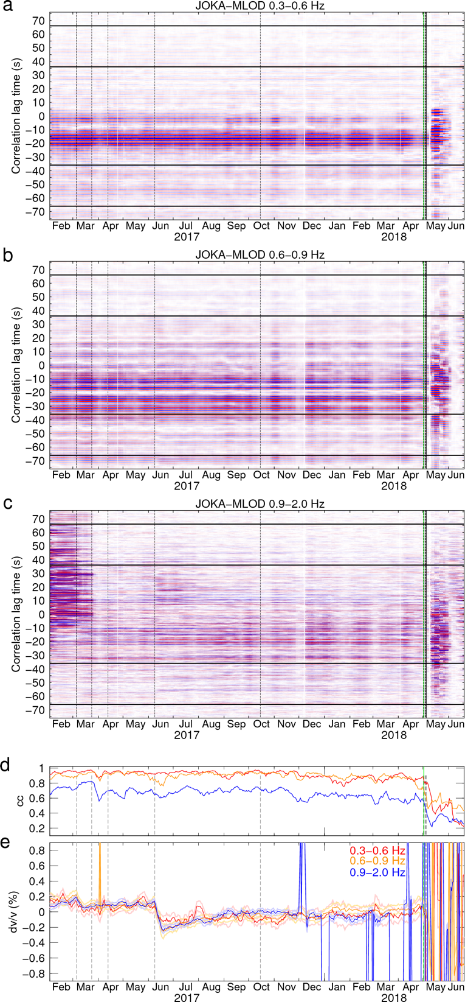
Figure S22 Daily correlograms in frequency bands of (a) 0.3-0.6 Hz, (b), 0.6-0.9 Hz, and (c) 0.9-2.0 Hz, and the estimated (d) cc and (e) dv/v time series for the station pair JOKA-MLOD. Detailed captions refer to Figure S4.

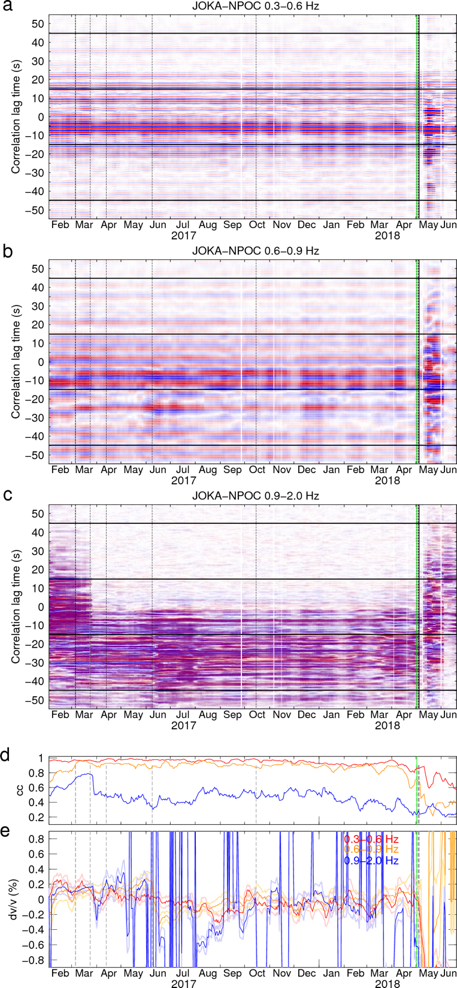
Figure S23 Daily correlograms in frequency bands of (a) 0.3-0.6 Hz, (b), 0.6-0.9 Hz, and (c) 0.9-2.0 Hz, and the estimated (d) cc and (e) dv/v time series for the station pair JOKA-NPOC. Detailed captions refer to Figure S4.

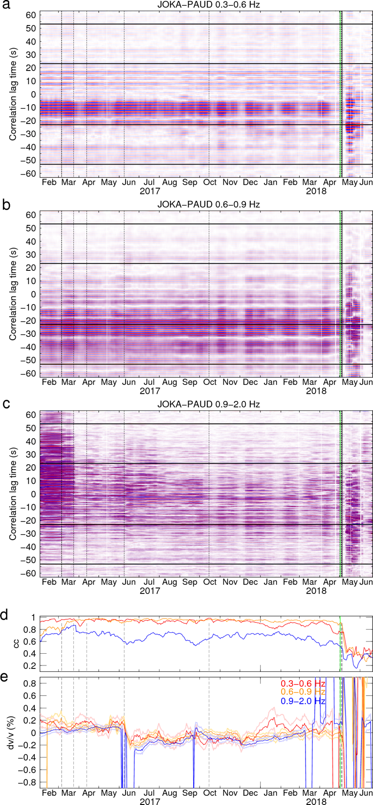
Figure S24 Daily correlograms in frequency bands of (a) 0.3-0.6 Hz, (b), 0.6-0.9 Hz, and (c) 0.9-2.0 Hz, and the estimated (d) cc and (e) dv/v time series for the station pair JOKA-PAUD. Detailed captions refer to Figure S4.

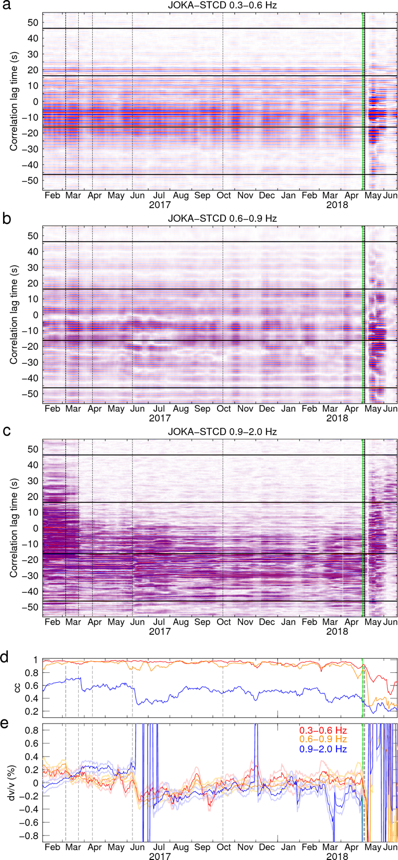
Figure S25 Daily correlograms in frequency bands of (a) 0.3-0.6 Hz, (b), 0.6-0.9 Hz, and (c) 0.9-2.0 Hz, and the estimated (d) cc and (e) dv/v time series for the station pair JOKA-STCD. Detailed captions refer to Figure S4.

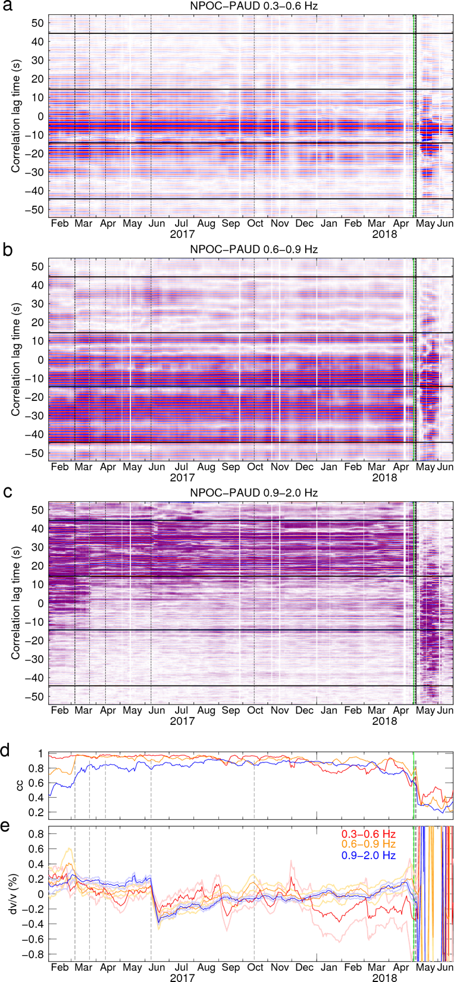
Figure S26 Daily correlograms in frequency bands of (a) 0.3-0.6 Hz, (b), 0.6-0.9 Hz, and (c) 0.9-2.0 Hz, and the estimated (d) cc and (e) dv/v time series for the station pair NPOC-PAUD. Detailed captions refer to Figure S4.

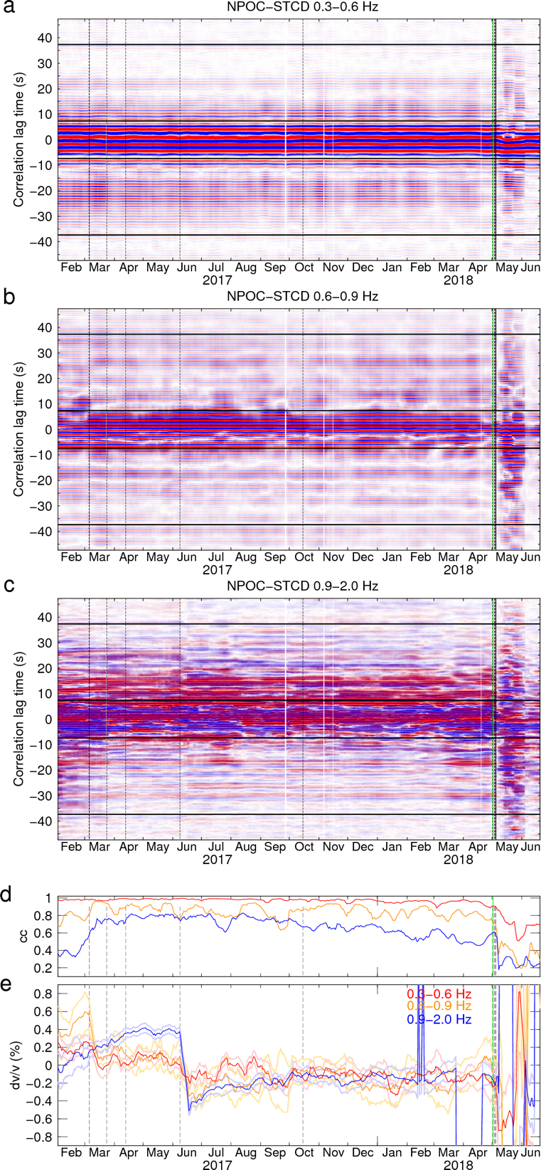
Figure S27 Daily correlograms in frequency bands of (a) 0.3-0.6 Hz, (b), 0.6-0.9 Hz, and (c) 0.9-2.0 Hz, and the estimated (d) cc and (e) dv/v time series for the station pair NPOC-STCD. Detailed captions refer to Figure S4.

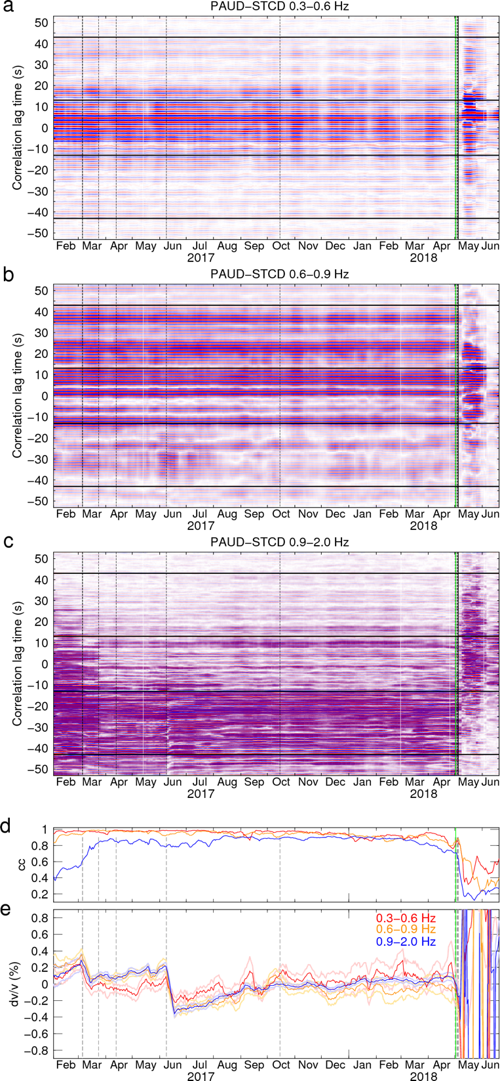
Figure S28 Daily correlograms in frequency bands of (a) 0.3-0.6 Hz, (b), 0.6-0.9 Hz, and (c) 0.9-2.0 Hz, and the estimated (d) cc and (e) dv/v time series for the station pair PAUD-STCD. Detailed captions refer to Figure S4.

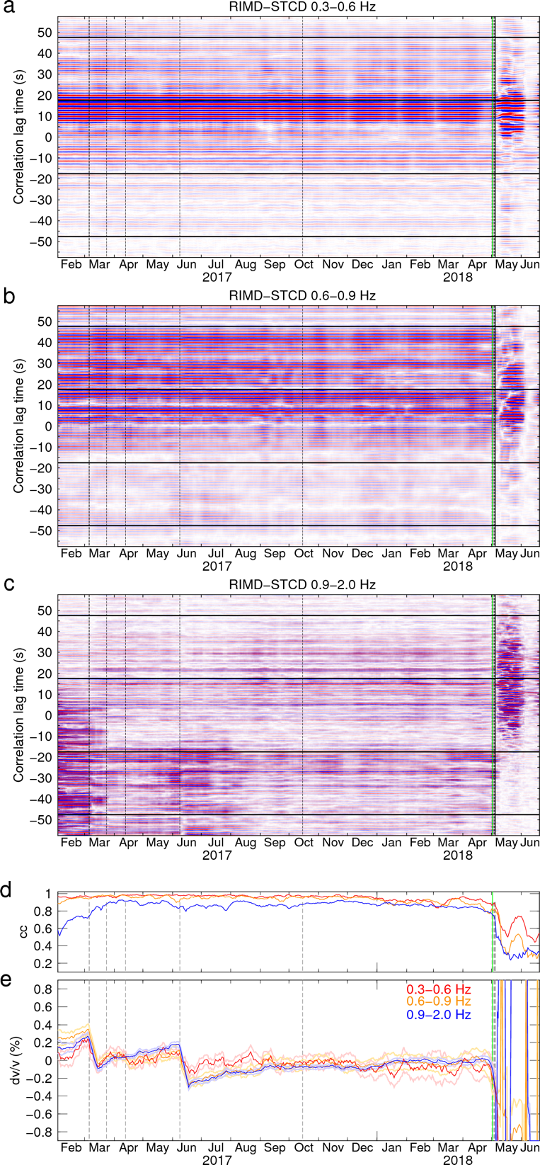
Figure S29 Daily correlograms in frequency bands of (a) 0.3-0.6 Hz, (b), 0.6-0.9 Hz, and (c) 0.9-2.0 Hz, and the estimated (d) cc and (e) dv/v time series for the station pair RIMD-STCD. Detailed captions refer to Figure S4.

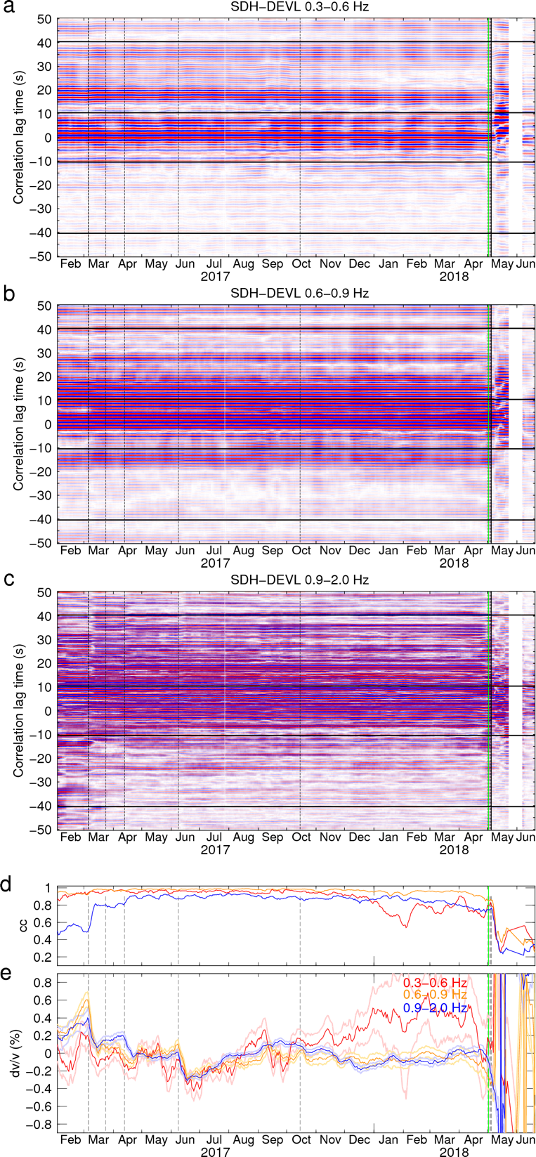
Figure S30 Daily correlograms in frequency bands of (a) 0.3-0.6 Hz, (b), 0.6-0.9 Hz, and (c) 0.9-2.0 Hz, and the estimated (d) cc and (e) dv/v time series for the station pair SDH-DEVL. Detailed captions refer to Figure S4.

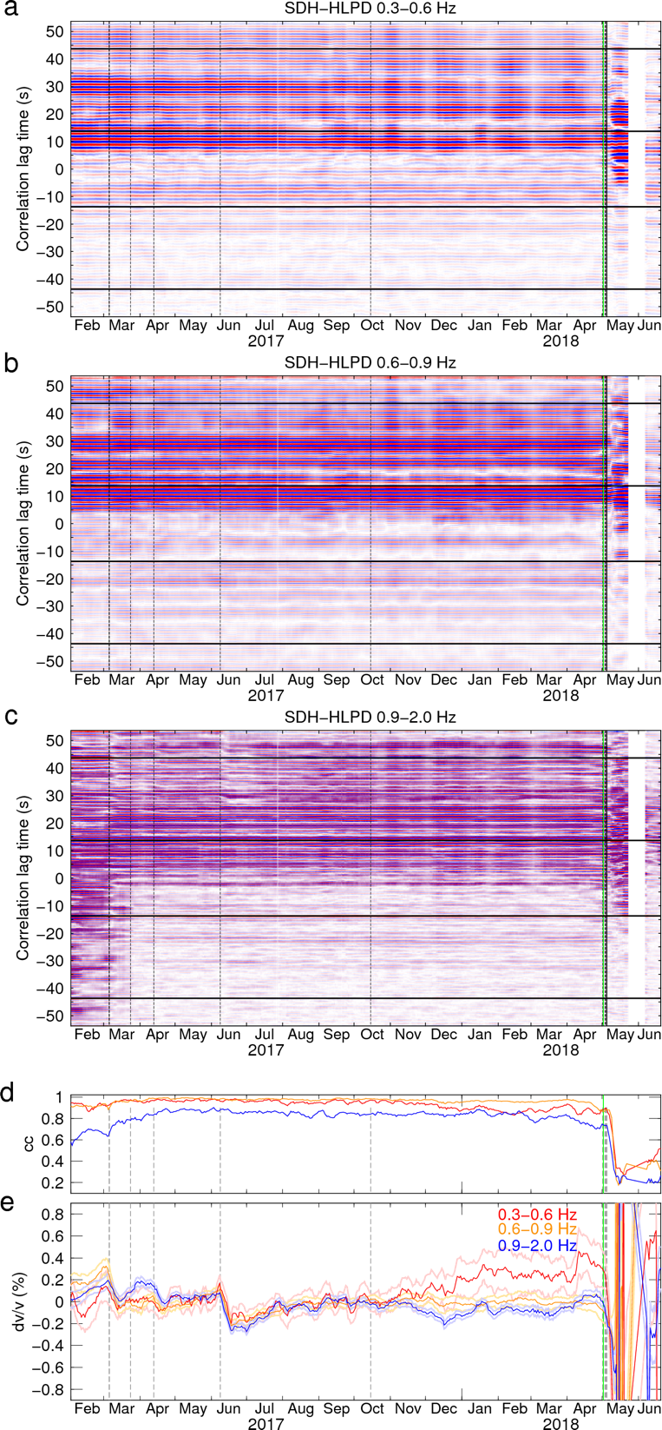
Figure S31 Daily correlograms in frequency bands of (a) 0.3-0.6 Hz, (b), 0.6-0.9 Hz, and (c) 0.9-2.0 Hz, and the estimated (d) cc and (e) dv/v time series for the station pair SDH-HLPD. Detailed captions refer to Figure S4.

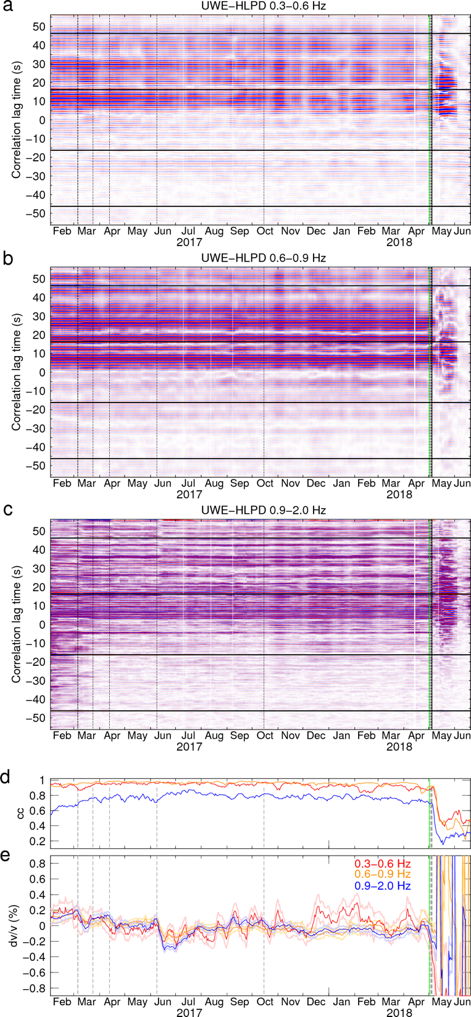
Figure S32 Daily correlograms in frequency bands of (a) 0.3-0.6 Hz, (b), 0.6-0.9 Hz, and (c) 0.9-2.0 Hz, and the estimated (d) cc and (e) dv/v time series for the station pair UWE-HLPD. Detailed captions refer to Figure S4.

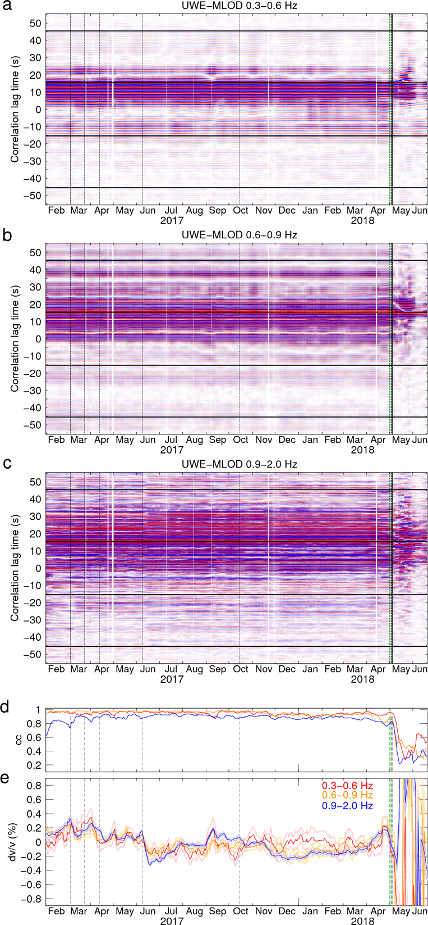
Figure S33 Daily correlograms in frequency bands of (a) 0.3-0.6 Hz, (b), 0.6-0.9 Hz, and (c) 0.9-2.0 Hz, and the estimated (d) cc and (e) dv/v time series for the station pair UWE-MLOD. Detailed captions refer to Figure S4.

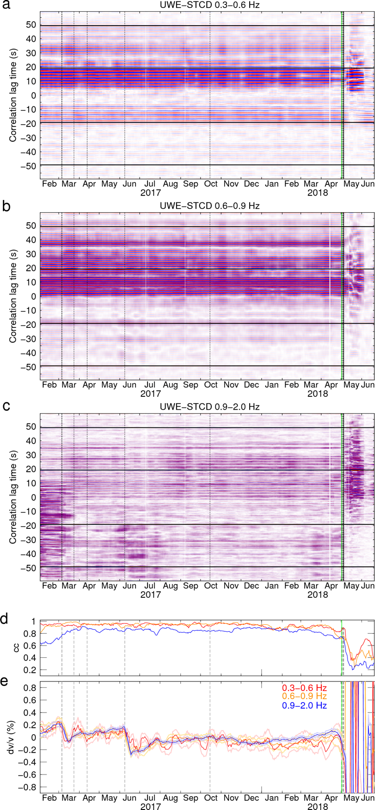
Figure S34 Daily correlograms in frequency bands of (a) 0.3-0.6 Hz, (b), 0.6-0.9 Hz, and (c) 0.9-2.0 Hz, and the estimated (d) cc and (e) dv/v time series for the station pair UWE-STCD. Detailed captions refer to Figure S4.

