Additional Materials for

Unmixing biogenic and terrigenous magnetic mineral components in red clay of the Pacific Ocean using principal component analyses of first-order reversal curve diagrams and paleoenvironmental implications

Toshitsugu Yamazaki¹, Wei Fu¹, Takaya Shimono², and Yoichi Usui³
[1] Atmosphere and Ocean Research Institute, The University of Tokyo, Kashiwa, Japan
[2] Geological Survey of Japan, National Institute of Advanced Industrial Science and Technology, Tsukuba, Japan
[3] Volcanoes and Earth's Interior Research Center, Research Institute of Marine Geodynamics, Japan Agency for Marine-Earth Science and Technology, Yokosuka, Japan

Corresponding author: Toshitsugu Yamazaki (yamazaki@aori.u-tokyo.ac.jp)

Additional Figures
Figure S1
Figure S2
Figure S3
Figure S4
Figure S5
Figure S6

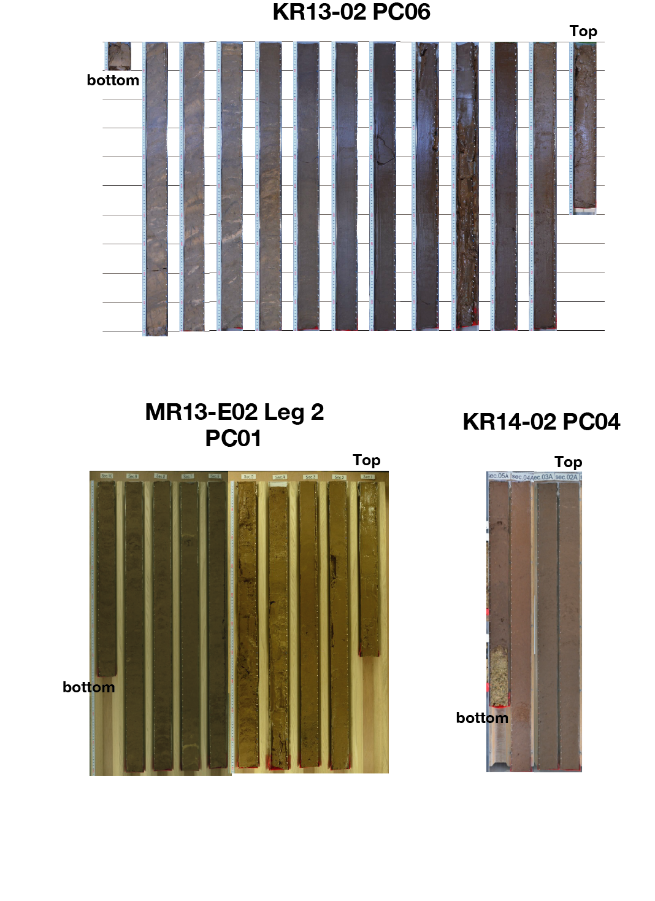
Fig. S1. Photos of three piston cores from the western North Pacific Ocean. Length of each section is approximately 1 m. Sections from the top to the bottom of the core are aligned from the right to the left.

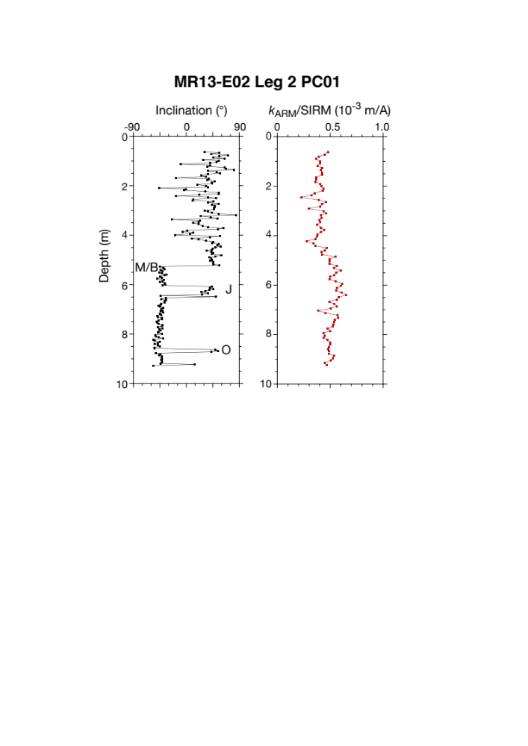

Fig. S2. Inclination of remanent magnetization and k_{ARM}/SIRM for core MR13-E02 Leg 2 PC01. (Left) Inclination after alternating-field demagnetization at a peak field of 20 mT. The scatter of the data above ~4.5 m is most likely due to physical disturbance of the core during coring. Cores below 9.3 m were not measured because of severe physical disturbance. M/B: Matuyama-Brunhes transition, J: Jaramillo subchron, O: Olduvai subchron. (Right) The ratio of ARM susceptibility to SIRM (k_{ARM}/SIRM).

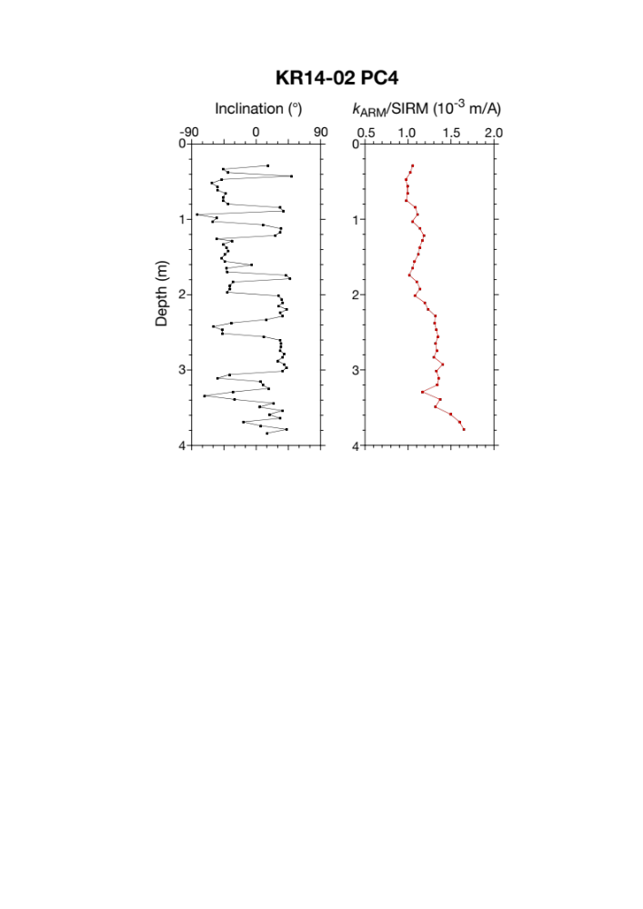
Fig. S3. Inclination of remanent magnetization and k_{ARM}/SIRM for core KR14-02 PC04. (Left) Inclination after alternating-field demagnetization at a peak field of 20 mT. (Right) The ratio of ARM susceptibility to SIRM (k_{ARM}/SIRM).

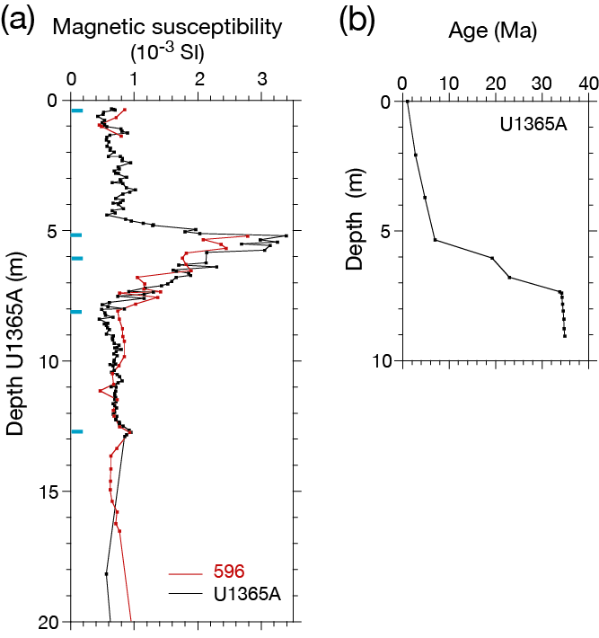
Fig. S4. Age estimation of IODP Hole U1365A sediments, South Pacific Ocean. (a) Intercore correlation between IODP Hole U1365A (black) and DSDP Hole 596 (red) based on magnetic susceptibility (MS). Blue ticks indicate the tie points. Depths of Hole 596 were converted to those of Hole U1365A based on the MS correlation. MS data were reported by Shimono and Yamazaki (2016). (b) Age model for Hole U1365A sediments, which was transferred from the Os-isotope age model for Site 596 (Ohta et al. 2020) based on the intercore correlation.
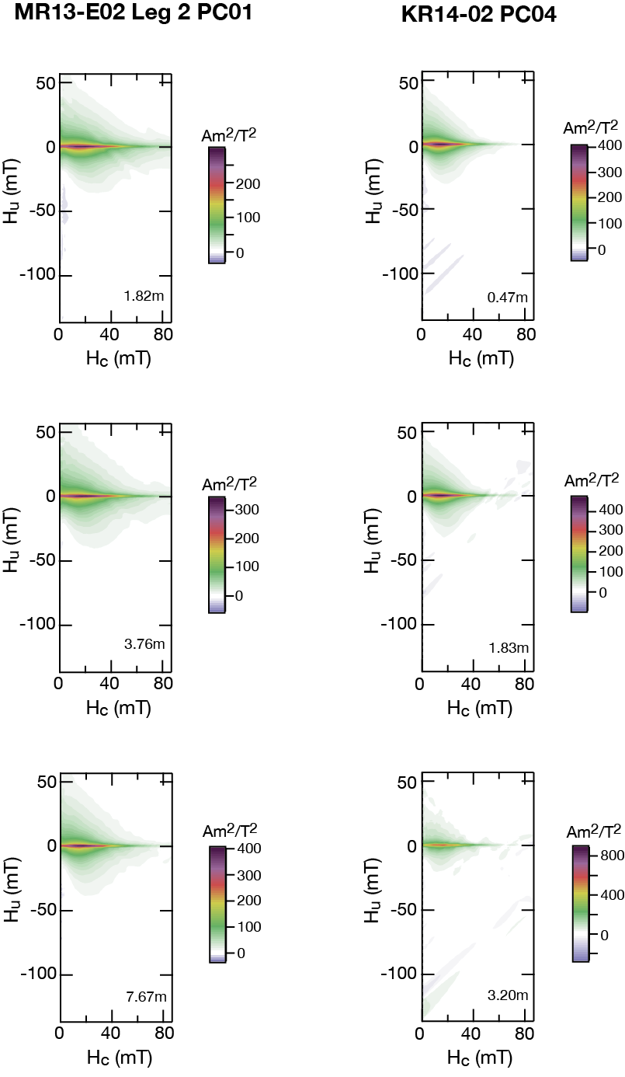
Fig. S5. Examples of FORC diagrams for two cores from the western North Pacific. Cores MR13-E02 Leg 2 PC01 (left) and KR14-02 PC04 (right).
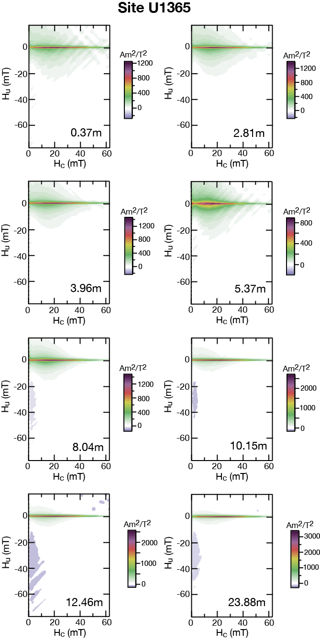
Fig. S6. Examples of FORC diagrams for IODP Hole U1365A, South Pacific Ocean.

