Additional information
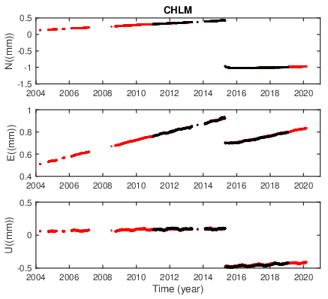
Figure S1. Displacement time series of GPS site CHLM of NGL’s solution and ours. The red dots indicate the NGL solution and the black dots indicate our solution.
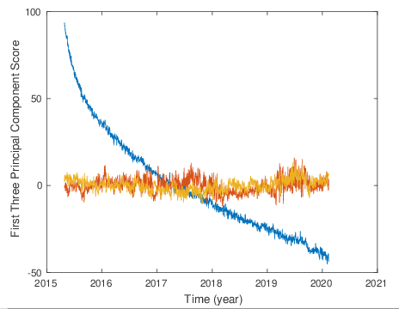
Figure S2. The principal component analysis of the GPS displacement time series after the 2015 Gorkha earthquake. The blue line is the first principal component, which represents the postseismic deformation signal. The red and yellow lines are the second and third principal components, which represent the unmodeled signal or noise.

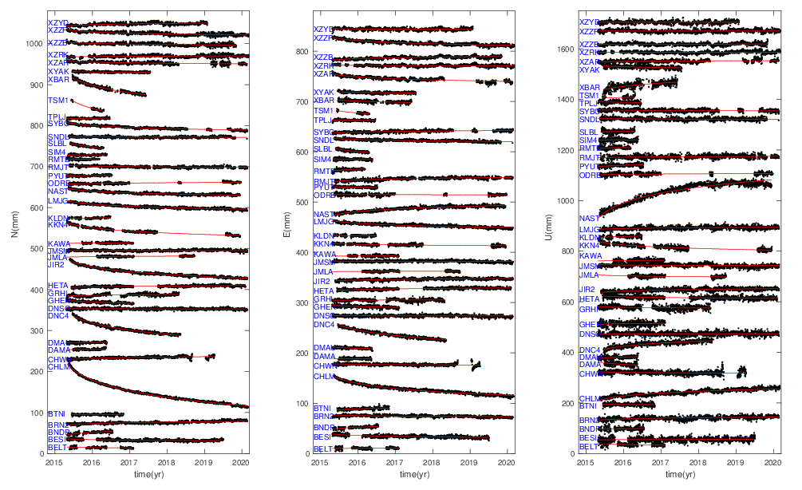
Figure S3. The postseismic displacement time series extracted from continuous 39 cGPS sites in NEU directions. The black dots are the observed GPS postseismic displacements and red lines are the parametric models of the postseismic displacements (Nikolaidis, 2002).

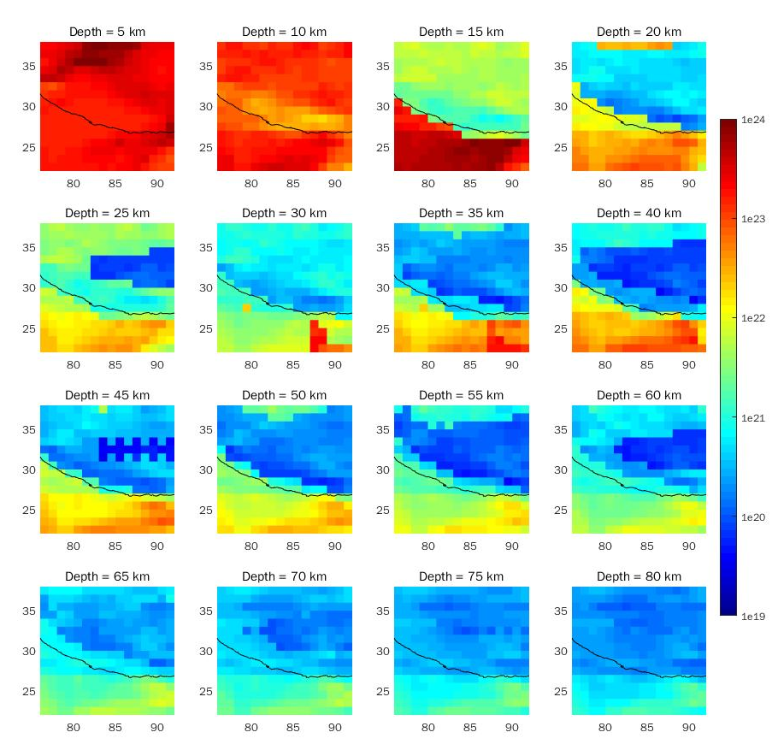
Figure S4. Viscosity distribution of the Himalayan region (data from Sun et al. (2013). The black line denotes the MFT trace.

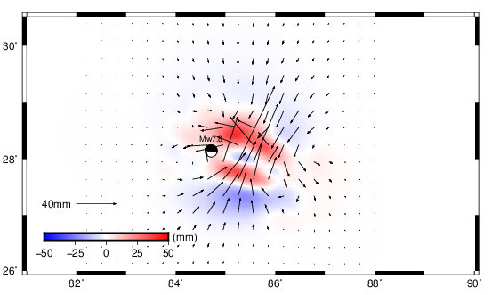 | 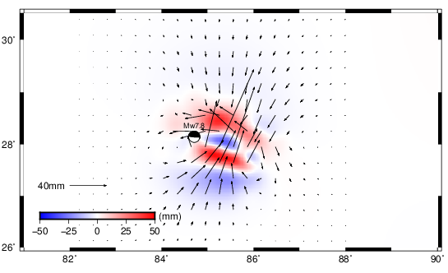
Figure S5. The predicted viscoelastic relaxation for the flat layered model by 3D FEM method (left) and the software PSGRN/PSCMP (right). The black arrows denote the horizontal component and the color scale denotes the vertical component.
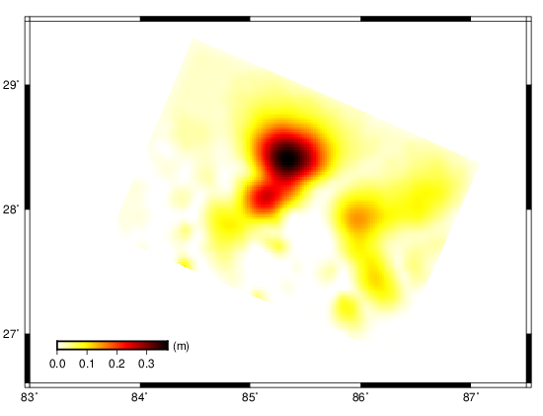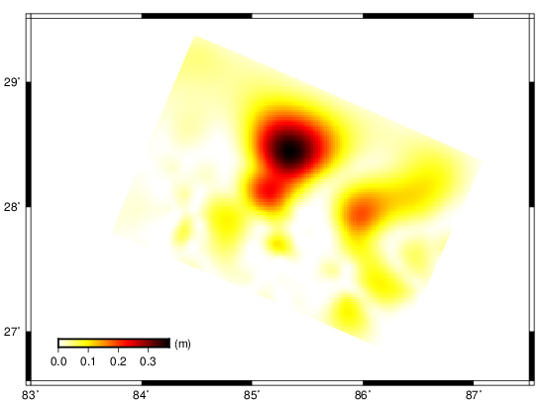
Figure S6. The inverted afterslip distribution for flat layered model by FEM method (left) and the software SDM (right)
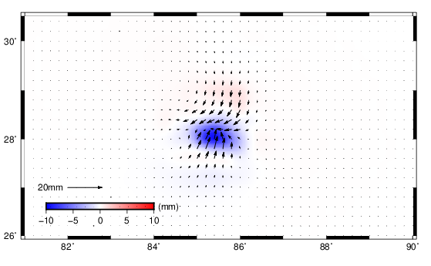
Figure S7. The predicted viscoelastic relaxation for Maxwell rheology in horizontal (black arrows) and vertical (color) component.

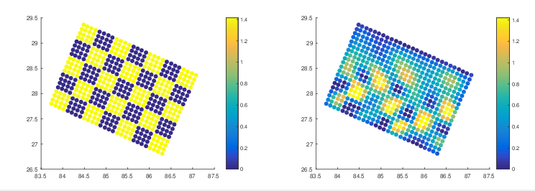
Figure S8. Results of checkered pattern board analysis (left) and recovered slip pattern by GPS data (right)
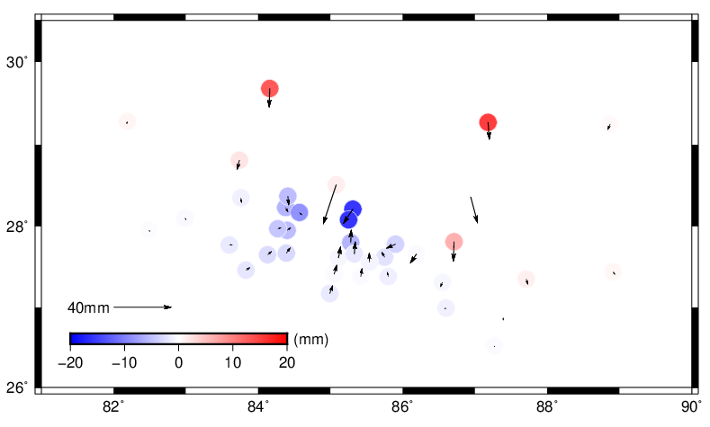

Figure S9. The predicted viscoelastic relaxation by software VISCO2.5D based on the rheological structure and effective viscosity of Zhao et al. (2017). The arrows indicate the horizontal component and the color represents the vertical component.

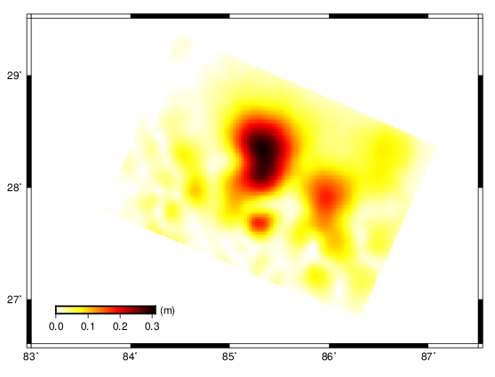
Figure S10. The inverted afterslip for the flat layered model without viscoelastic relaxation. The color denotes the afterslip distribution.

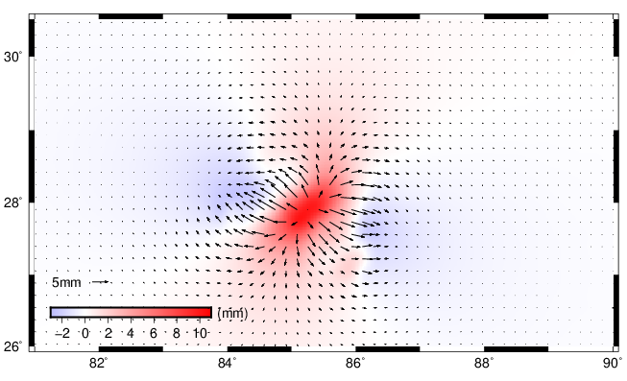
Figure S11. Predicted surface displacements due to poroelastic rebound. The color represents the vertical motion. The arrows denote the horizontal motion.

