Source model for the Mw 6.0 earthquake in Jiashi, China on 19 January 2020 from Sentinel-1A InSAR data

Additional File

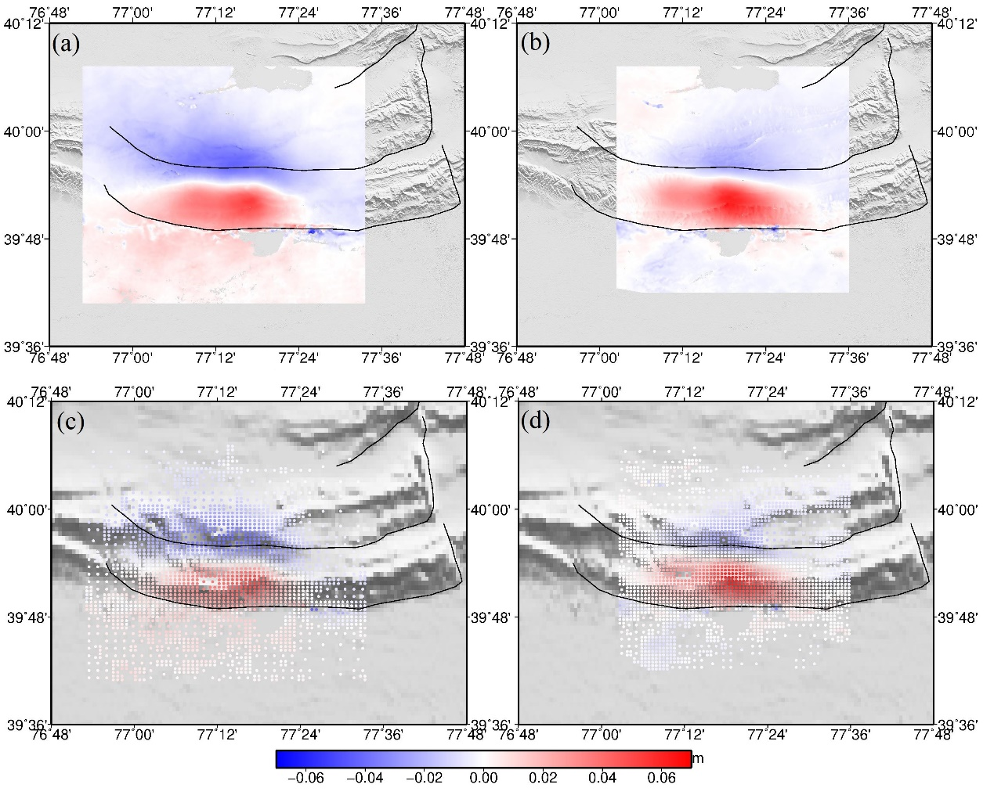
Figure S1. (a) and (c) represent observations of ascending and descending data. (b) and (d) represent the down-sampled results of ascending and descending data.

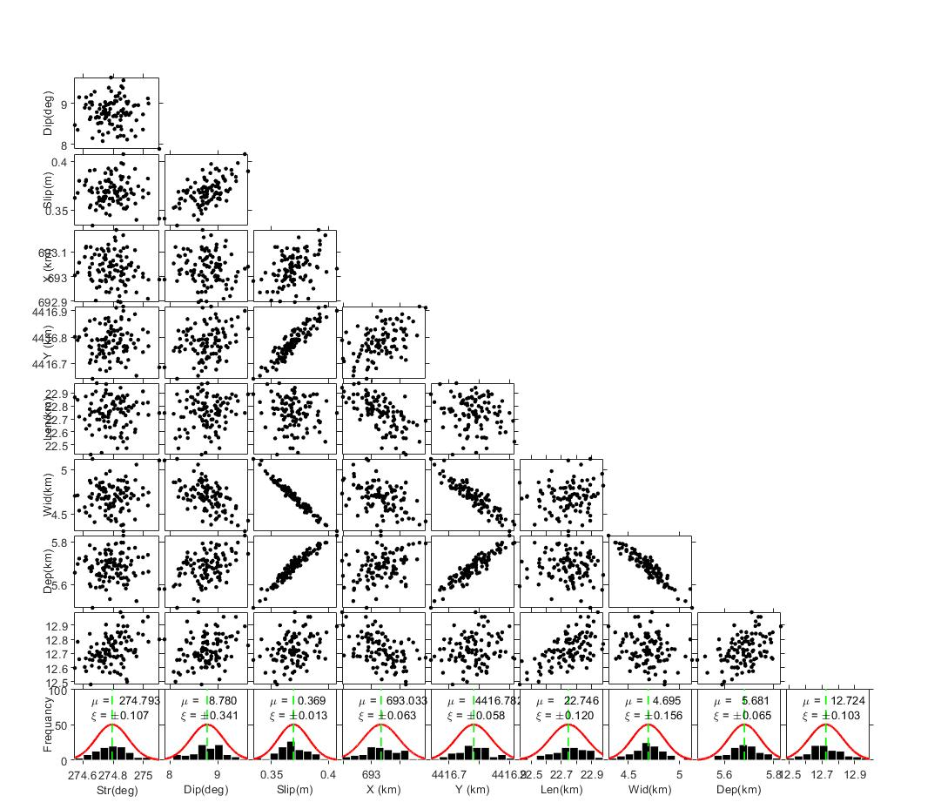
Figure S2. Uncertainties of the fault parameters computed using the Monte Carlo method. X and Y coordinates are in UTM (zone 43). X, Y, and Depth represent the location of the midpoint of the top boundary of the fault plane.

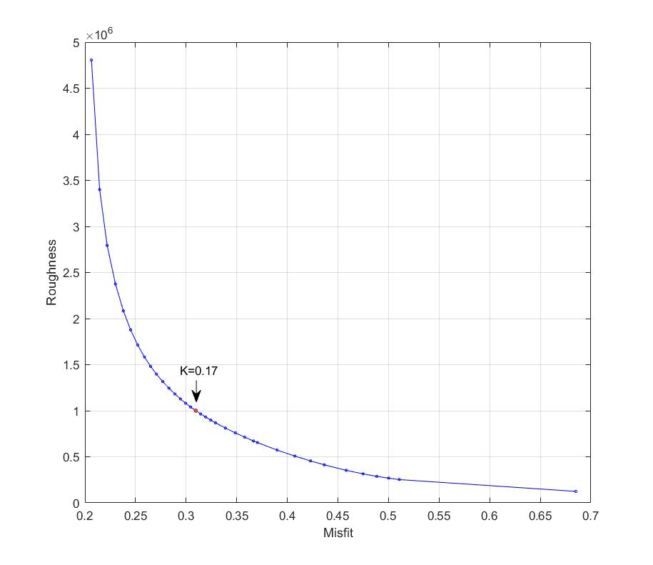
Figure S3. Trade-off curve of relative fitting and roughness for the planar fault.

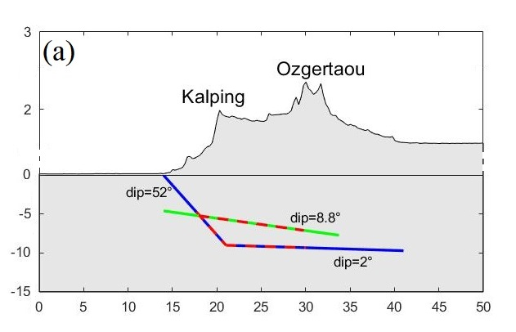
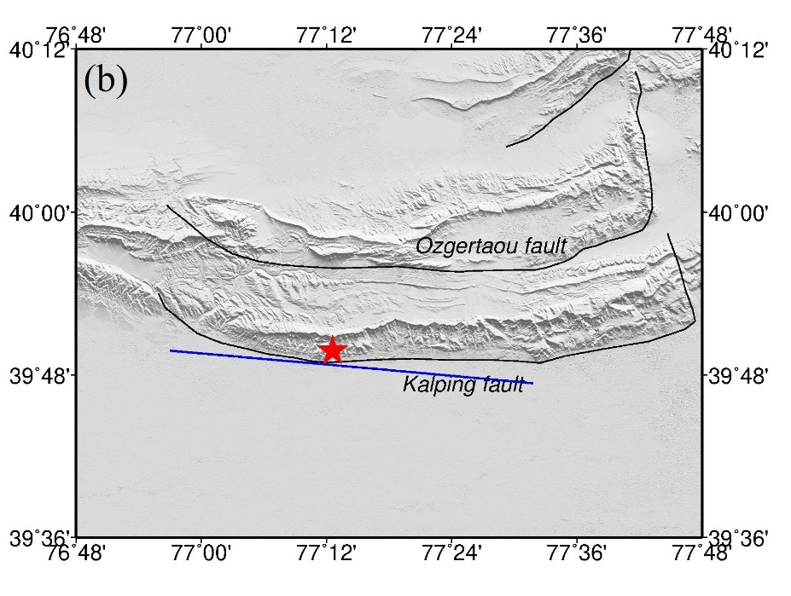

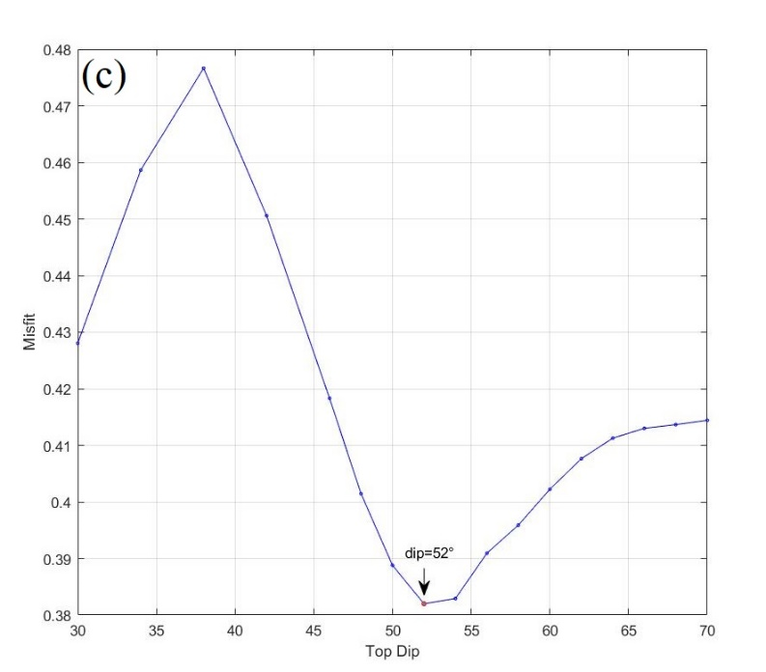
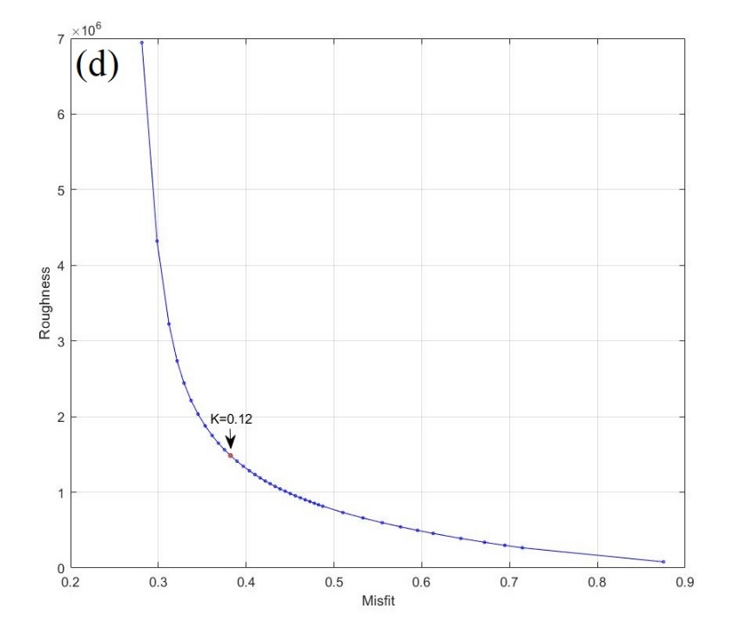

Figure S4. (a) The geometry of the planar fault and the listric fault. The green line represents the planar fault. The blue line represents the listric fault. The dashed red lines represent the rupture of the Jiashi earthquake on the two faults, respectively. For the listric fault, the dip of the ramp segment is set to 52° determined by a grid search (c). Based on the results of deep seismic-reflection profiles, the dip of the flat segment is set to 2°, and the depth of the top boundaries of the flat segment is set to 9 km. The width of the flat segment is set to 20 km. The elevation difference is magnified 10 times to represent the topography. (b) The surface rupture (the blue line) of the listric fault, which is fixed based on the fault datasets from the Institute of Geology, CEA. Its strike is fixed at 274.8° based on the nonlinear inversion. (c) Distribution of misfit and various top dip angle. (d) Trade-off curve of relative fitting and roughness for the listric fault.

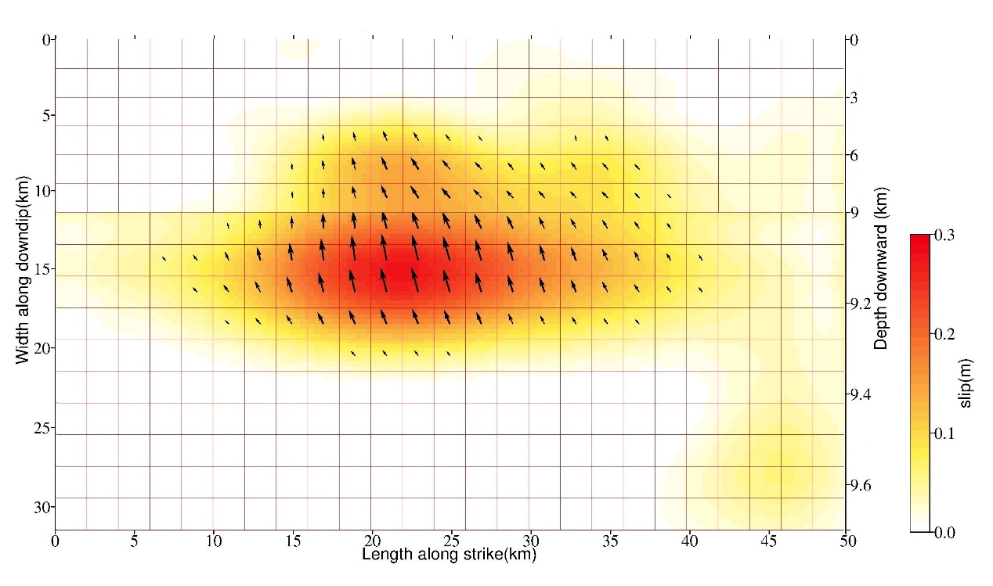
Figure S5 Coseismic slip model of the Jiashi earthquake with the listric fault. The depth of 9 km is the boundary between the ramp segment and the flat segment.

