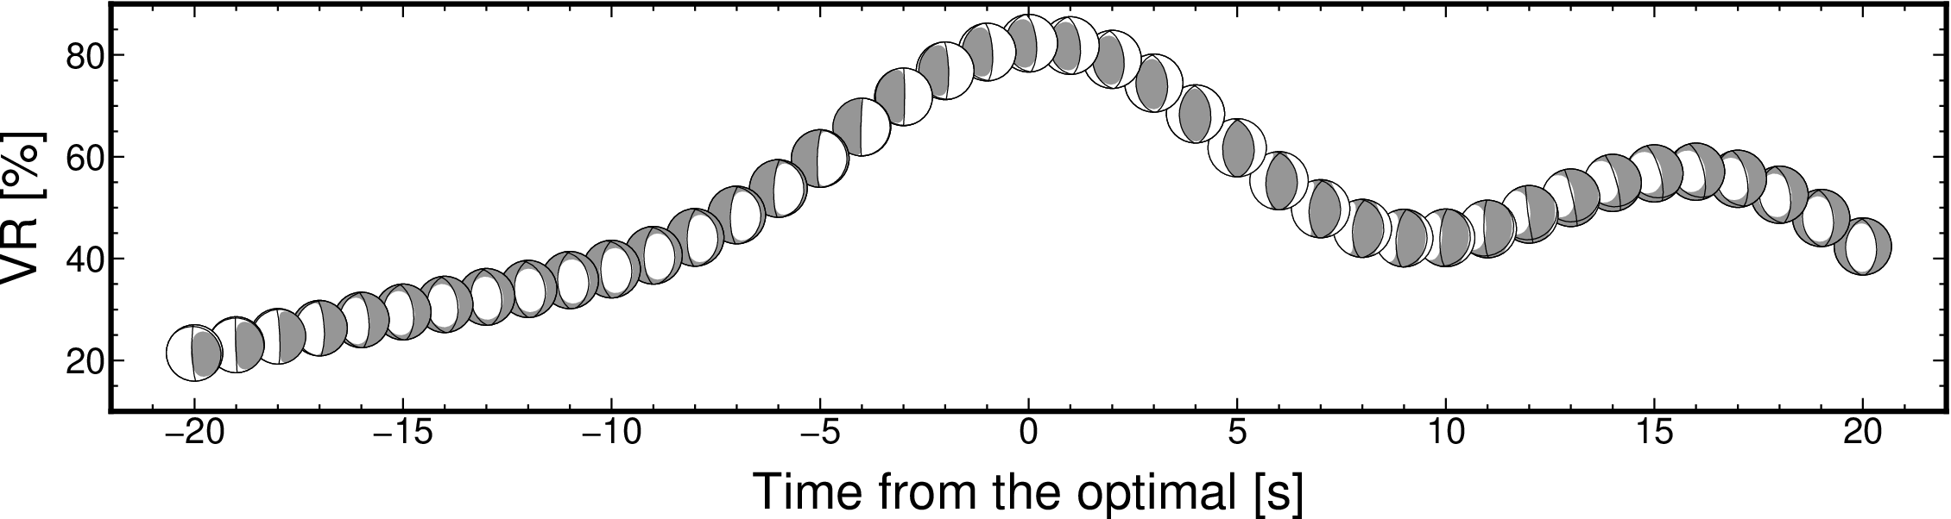
Figure S1. CMT solutions at the optimal source grid as a function of centroid time. The used event and CMT settings are same as in Figure 2b-d. The time is measured from the optimal centroid time.

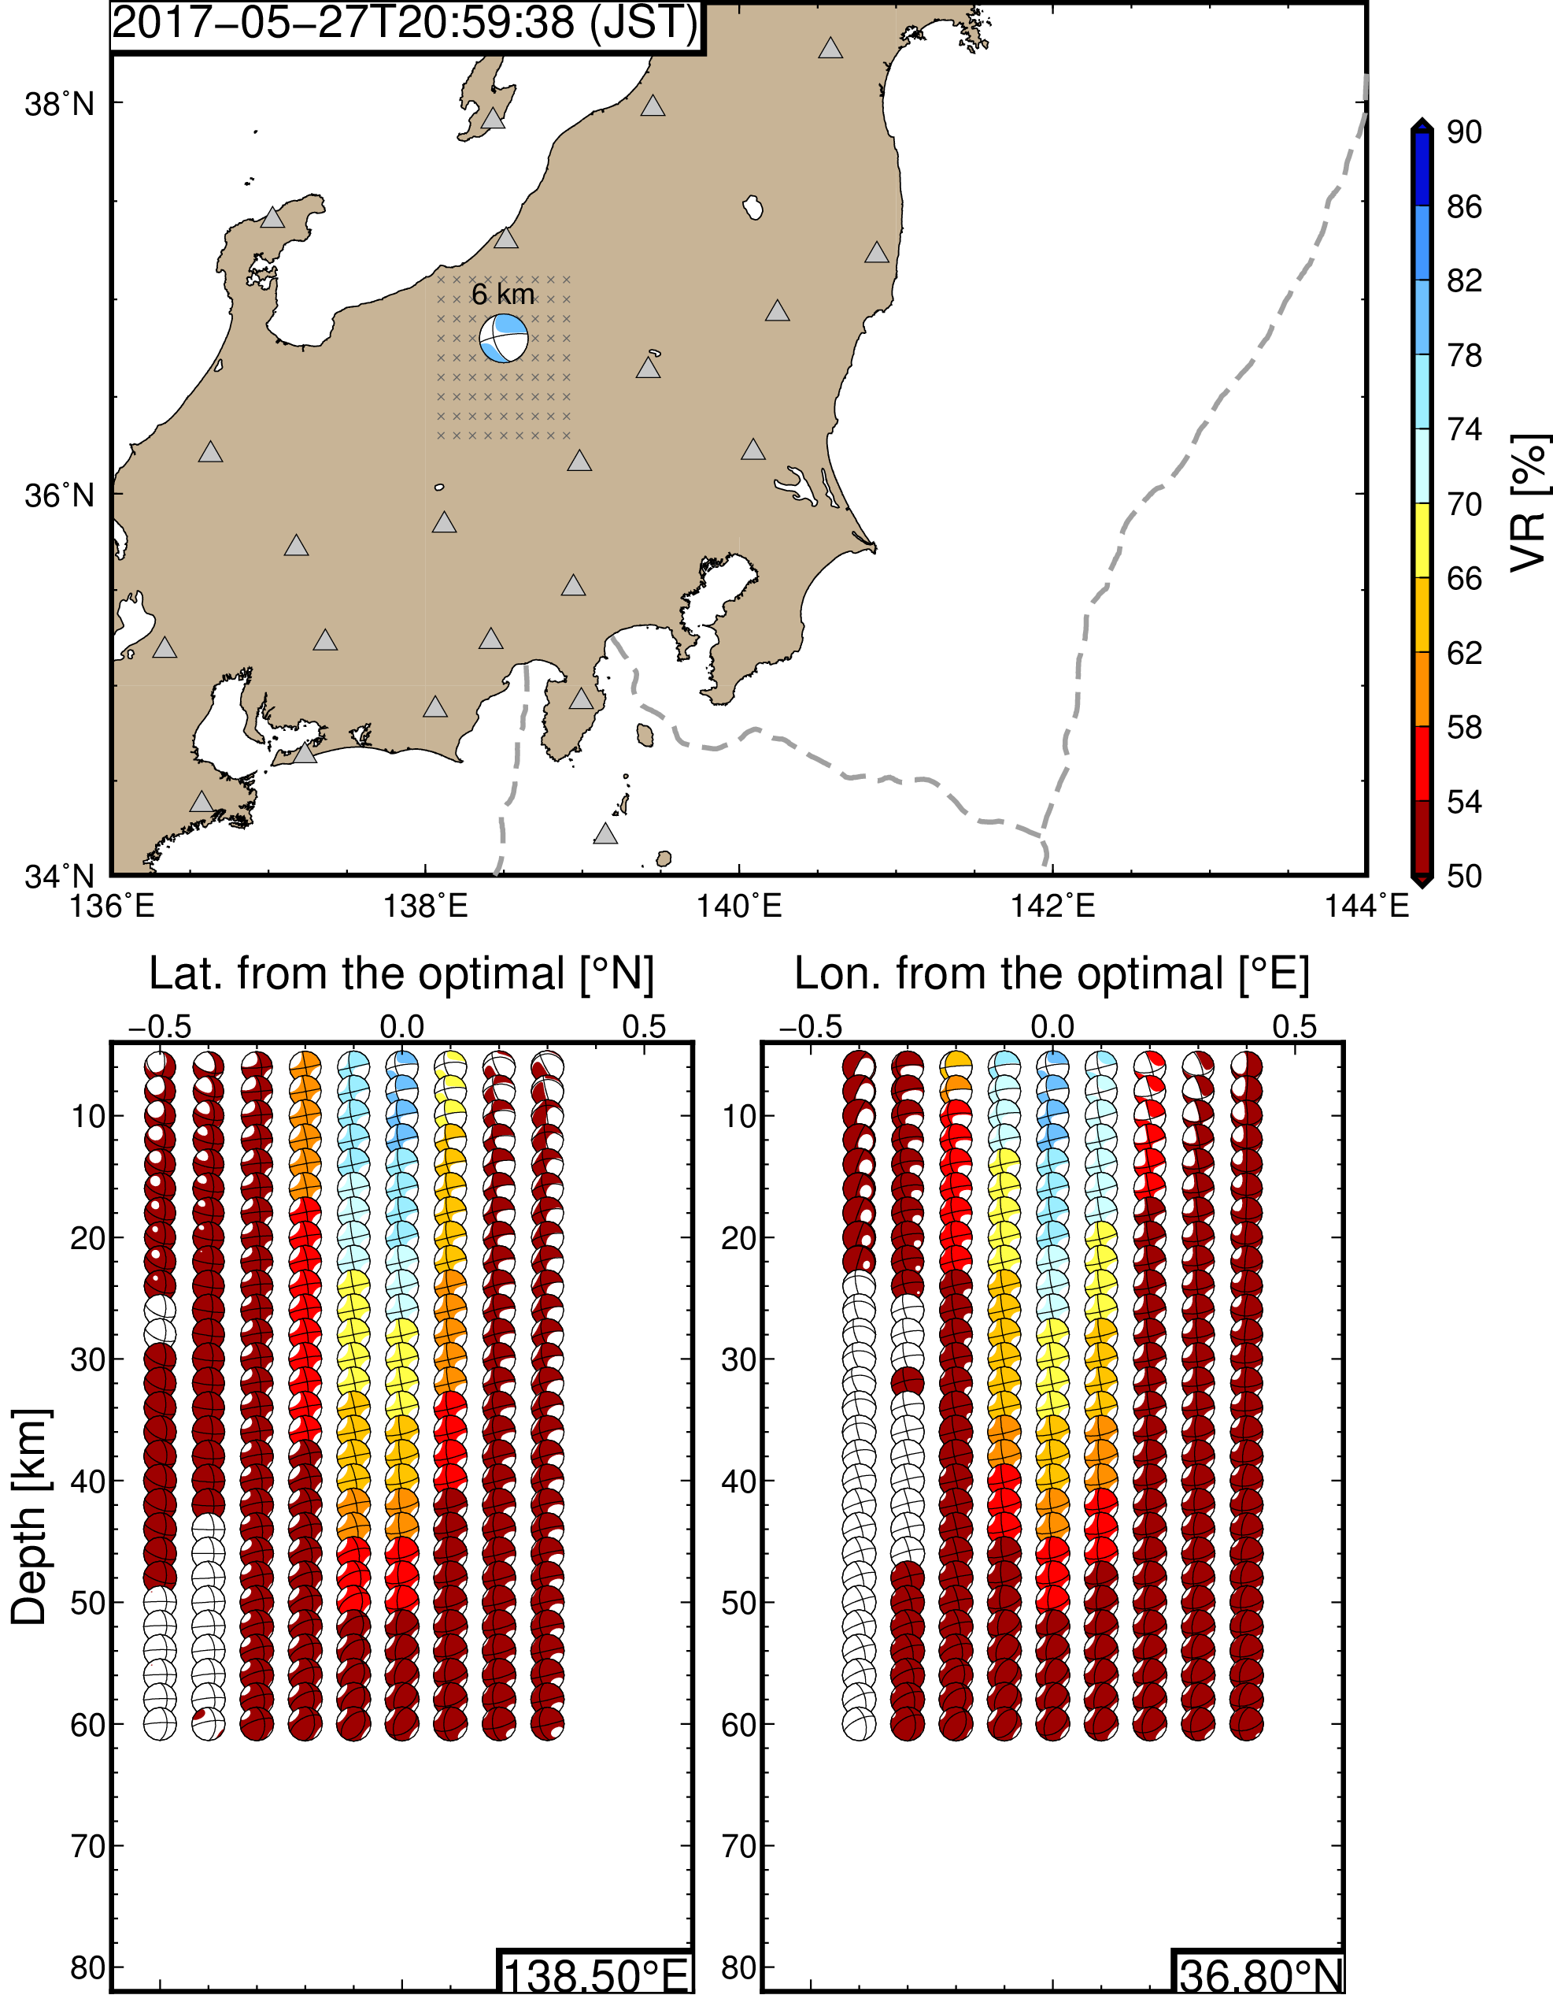
Figure S2. Same figure as Figure 2bc but for an earthquake occurred at a shallower depth. This earthquake occurred on 27th May 2017. Detailed source parameter and inversion settings are available at https://doi.org/10.5281/zenodo.3926884

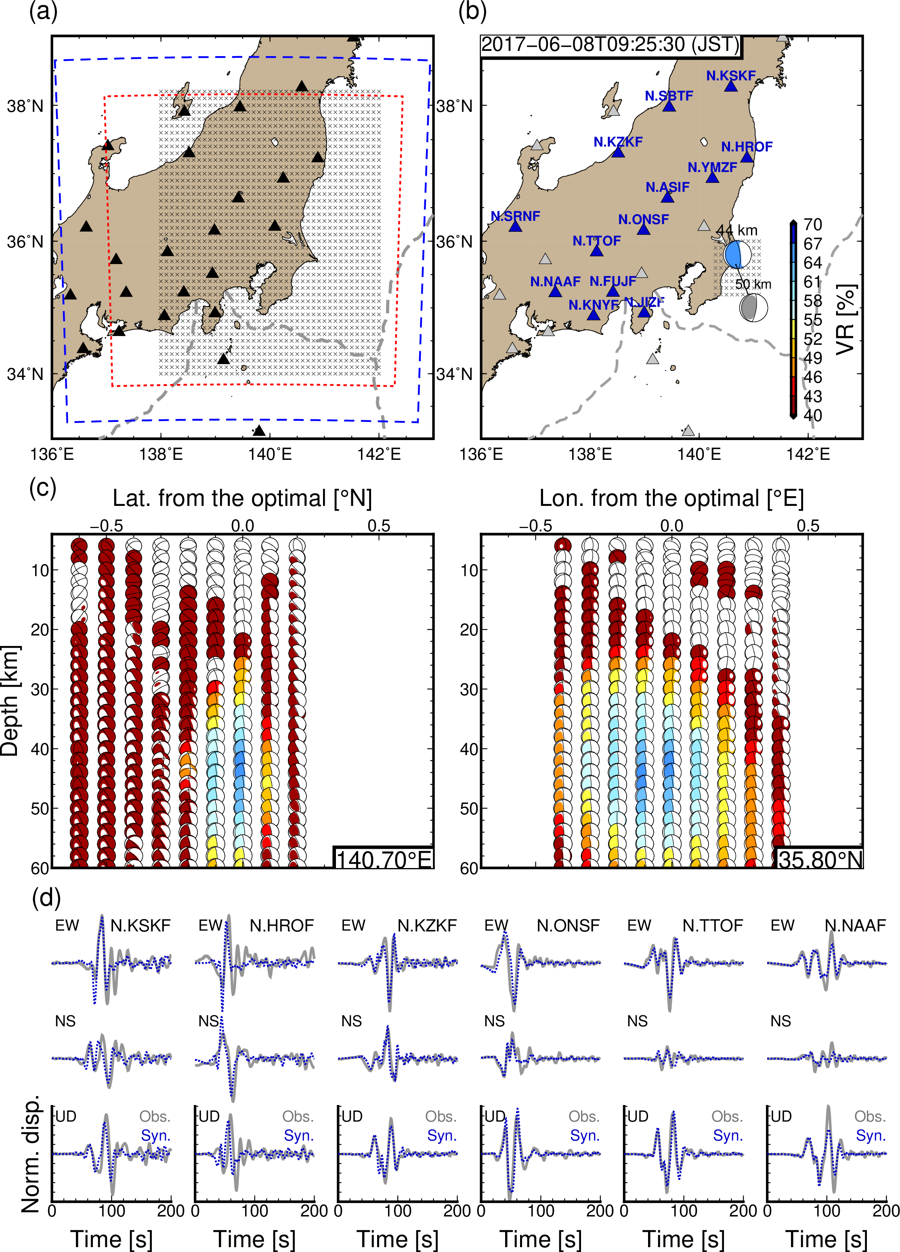
Figure S3. Same figure as Figure 2 but for percids of 10—100 s.

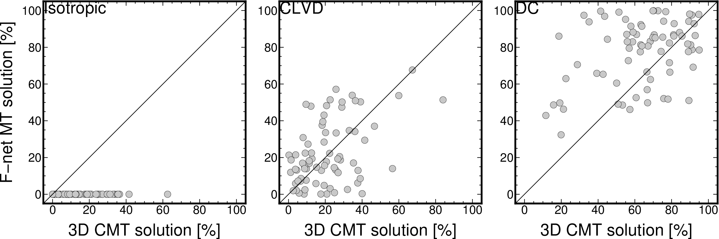
Figure S4. Comparisons of percentages of each component between our and F-net catalogs. We estimated contributions of isotropic, compensated linear vector dipole (CLVD) and double couple (DC) components for each CMT solutions.

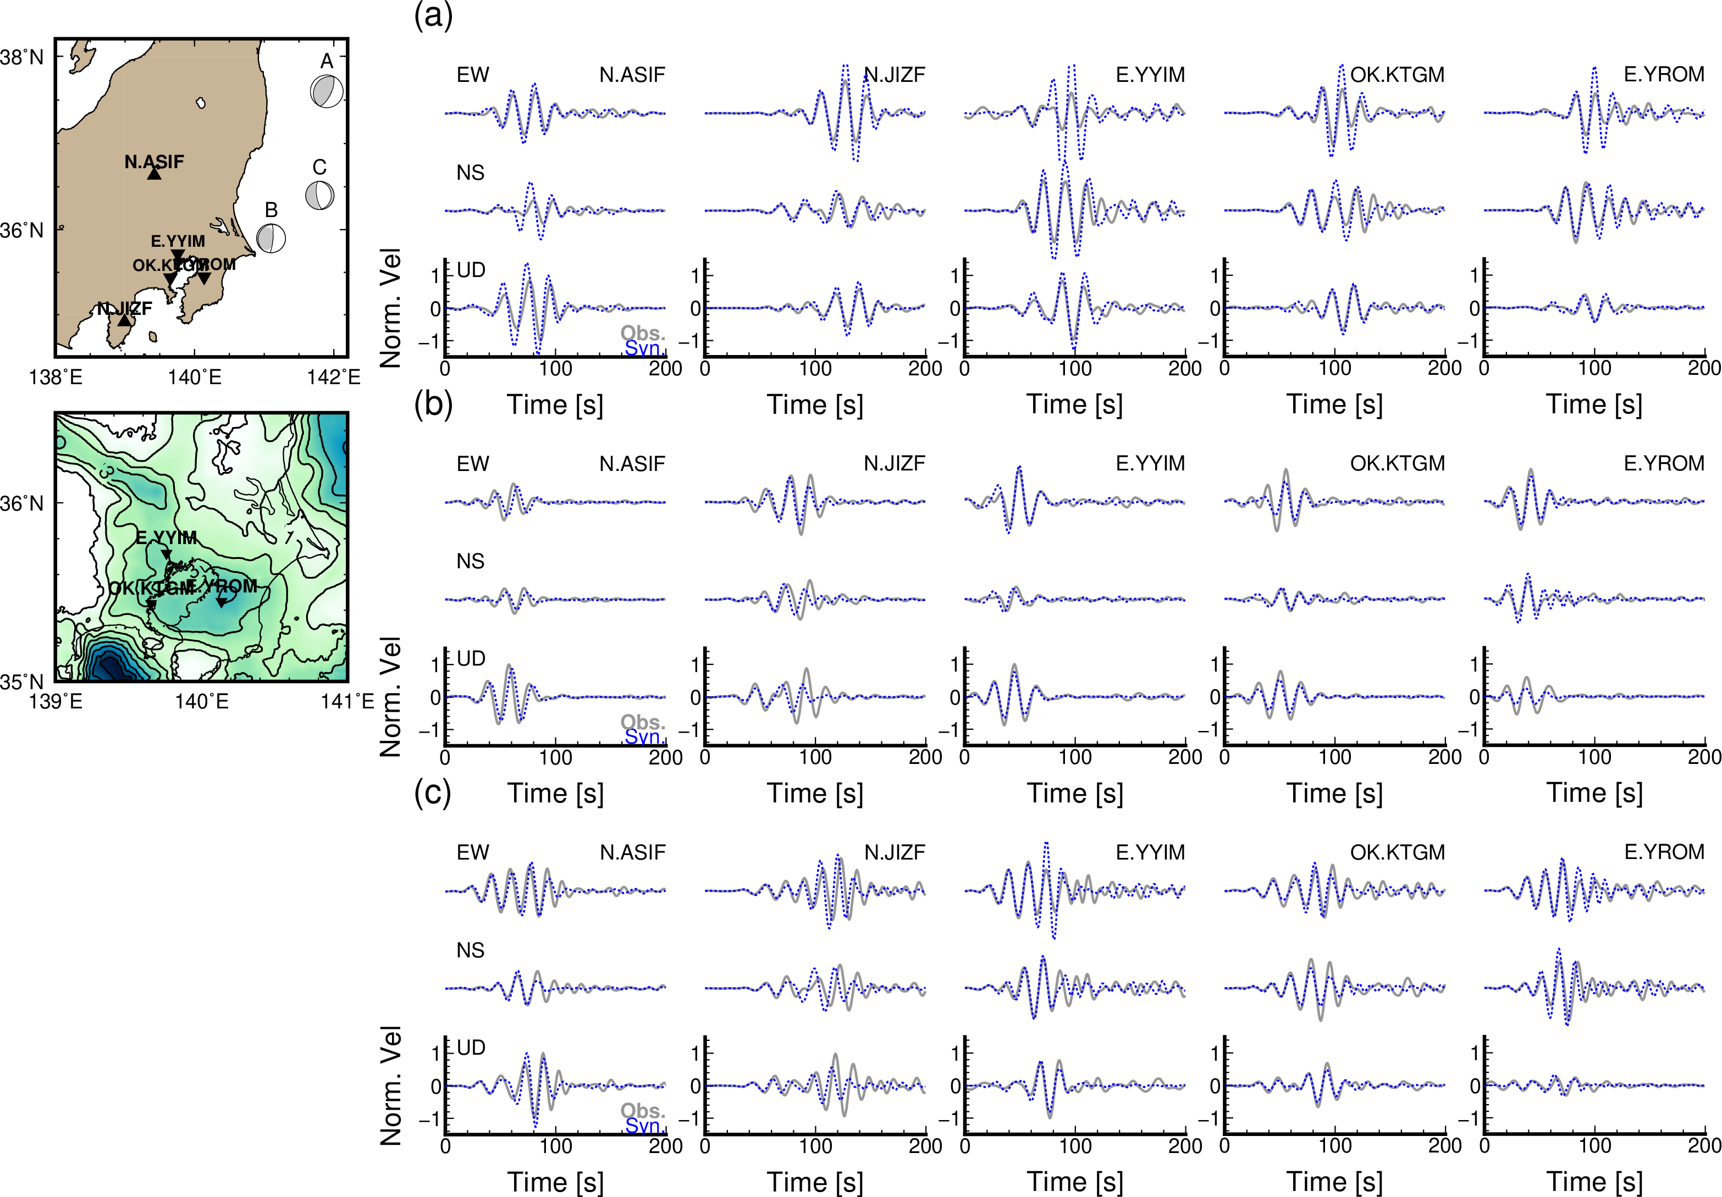
Figure S5. Comparisons between observed and simulated seismograms for periods of 15—30 s. This figure is similar as Figure 9 but simulation result using F-net MT solutions. We selected two F-net (N.ASIF and N.JIZF) and three MeSO-net (E.YYIM, OK.KTGM, and E.YROM) stations. Amplitudes at each station were normalized by the maximum amplitudes of observed seismograms for periods of 15-30 s at each station. (a) Event A, (b) Event B, and (c) Event C. Gray and blue dotted lines are the observed and simulated seismograms, respectively. Left panels show used stations and bedrock depths of the JIVSM. Color for bedrock depths is similar as Figure 1.

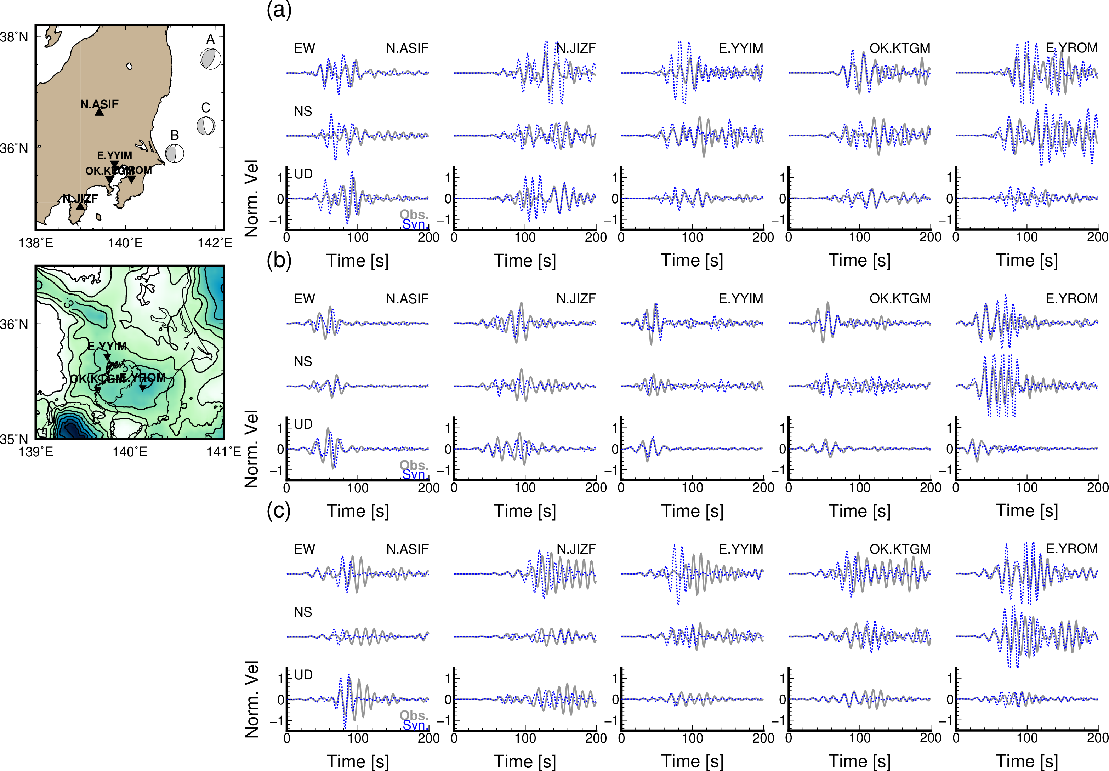
Figure S6. Comparisons between observed and simulated seismograms for periods of 10—20 s. This figure is similar as Figure 10 but simulation result using F-net MT solutions. We selected two F-net (N.ASIF and N.JIZF) and three MeSO-net (E.YYIM, OK.KTGM, and E.YROM) stations. Amplitudes at each station were normalized by the maximum amplitudes of observed seismograms for periods of 15-30 s at each station. (a) Event A, (b) Event B, and (c) Event C. Gray and blue dotted lines are the observed and simulated seismograms, respectively. Left panels show used stations and bedrock depths of the JIVSM. Color for bedrock depths is similar as Figure 1.

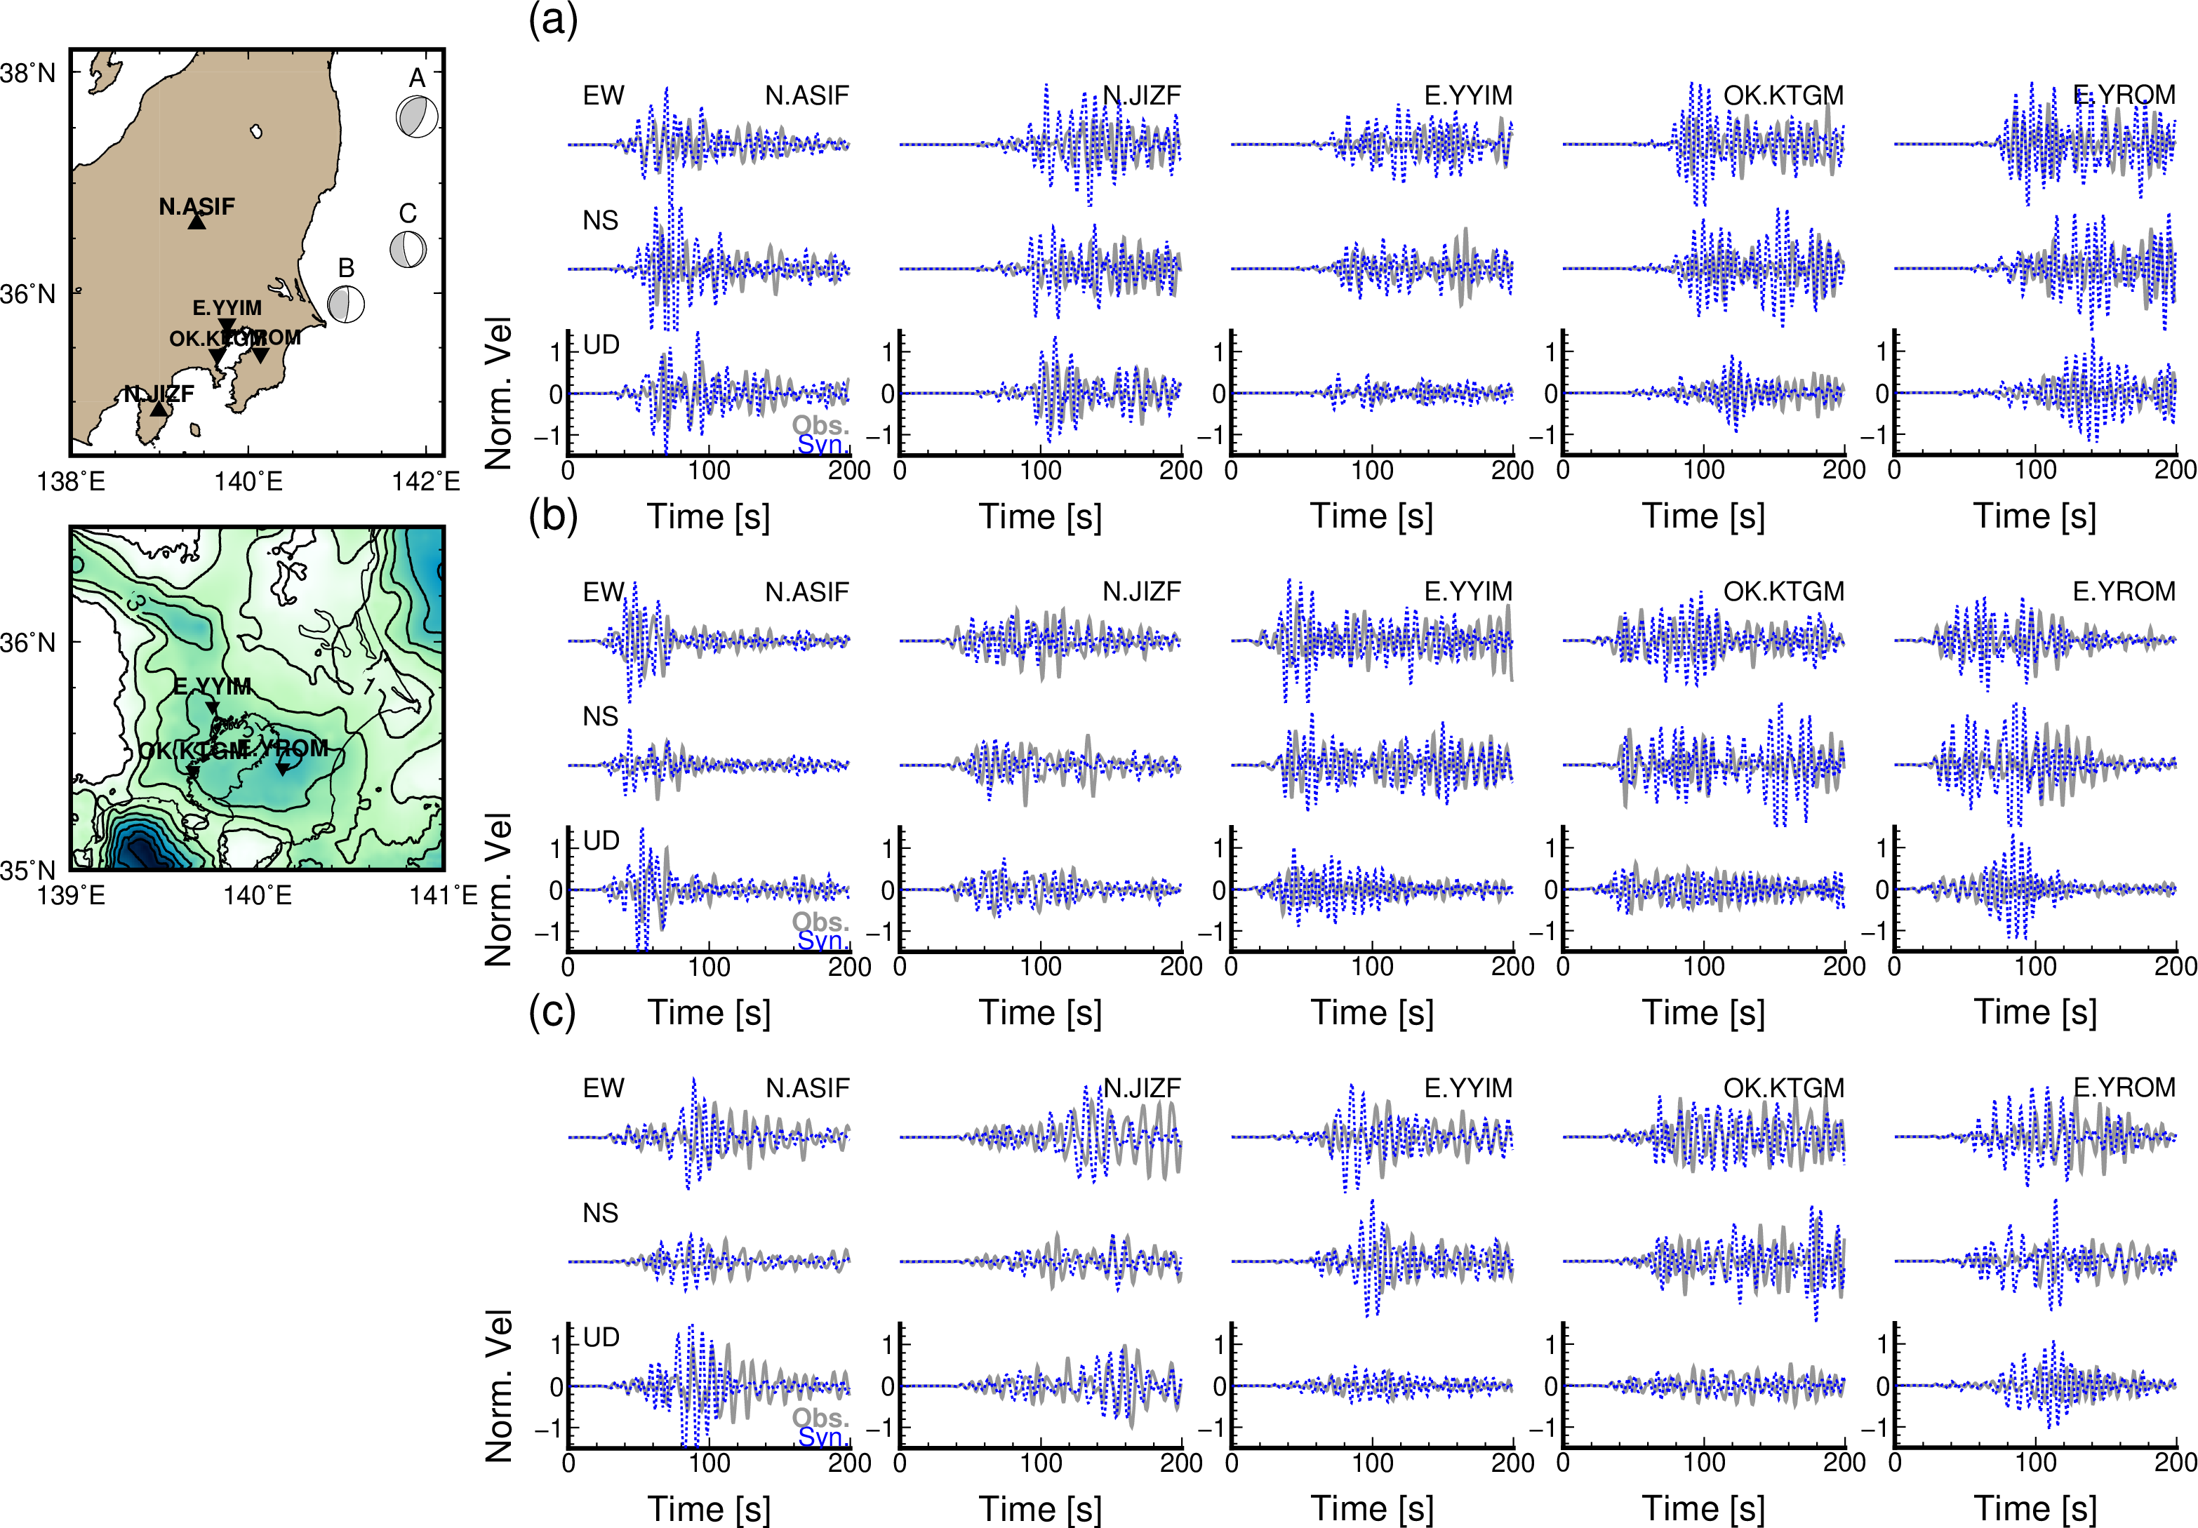
Figure S7. Comparisons between observed and simulated seismograms for periods of 5—16 s. This figure is similar as Figure 11 but simulation result using F-net MT solutions. We selected two F-net (N.ASIF and N.JIZF) and three MeSO-net (E.YYIM, OK.KTGM, and E.YROM) stations. Amplitudes at each station were normalized by the maximum amplitudes of observed seismograms for periods of 15-30 s at each station. (a) Event A, (b) Event B, and (c) Event C. Gray and blue dotted lines are the observed and simulated seismograms, respectively. Left panels show used stations and bedrock depths of the JIVSM. Color for bedrock depths is similar as Figure 1.

Table S1. Source parameters of long-period ground motions for evaluating amplitude differences between the JIVSM and F-net 1D model. Detailed information are available in our 3D CMT catalog.
Origin time  (JST) | Lon. [°] | Lat. [°] | Depth  [km] | Mw | Mw diff.  from F-net
2017-06-08  09:25:28 | 140.8 | 35.7 | 48 | 4.73 | -0.21
2017-11-17  10:02:45 | 141.4 | 37.2 | 44 | 4.36 | -0.31
2018-01-05  11:02:23 | 140.9 | 35.9 | 40 | 4.35 | -0.27
2018-01-10  07:20:47 | 141.2 | 35.4 | 24 | 4.93 | -0.25
2018-03-13  15:46:29 | 140.7 | 35.8 | 46 | 4.80 | -0.21
2018-05-17  12:12:30 | 140.8 | 35.8 | 42 | 5.10 | -0.28
2018-07-10  14:23:42 | 141.6 | 36.3 | 22 | 4.50 | -0.23
2018-07-18  16:44:53 | 141.2 | 36.0 | 32 | 4.47 | -0.21
2018-08-07  19:56:05 | 141.0 | 35.6 | 32 | 4.35 | -0.25
2018-11-28  20:14:54 | 141.0 | 36.4 | 40 | 4.26 | -0.21
2019-02-03  04:10:14 | 141.0 | 35.7 | 34 | 4.58 | -0.29
2019-07-07  03:51:56 | 140.8 | 35.7 | 42 | 4.22 | -0.20

