Supplementary file:

Source modeling and spectral analysis of the Crete tsunami of 2 May 2020 along the Hellenic Subduction Zone, offshore Greece

Mohammad Heidarzadeh^{*1}, Aditya Riadi Gusman²

¹Department of Civil & Environmental Engineering, Brunel University London, Uxbridge UB8 3PH, UK
²GNS Science, 1 Fairway Drive, Avalon, Lower Hutt 5010, New Zealand

* Address for correspondence: mohammad.heidarzadeh@brunel.ac.uk

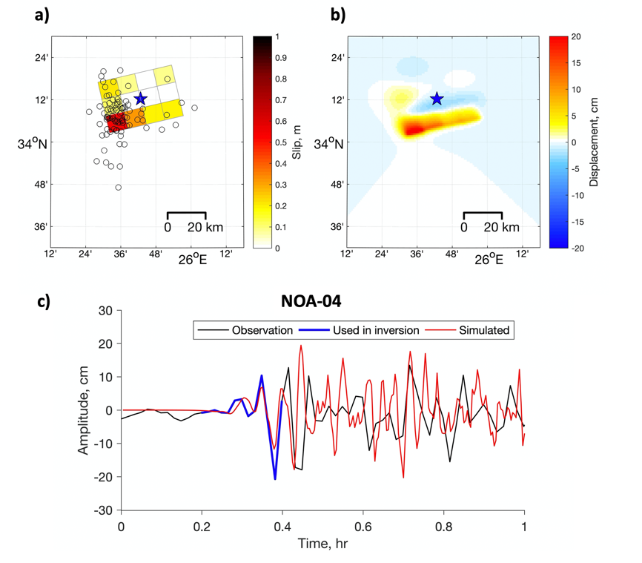

Figure S1. a) The slip distribution inverted from the observed tsunami waveforms at NOA-04 with fault centered at the epicenter (blue star). b) The calculated seafloor displacement from the slip distribution. c) Tsunami waveform comparison between observation (black) and simulation (red). The blue waveform indicates part of the observed waveform that was used for the inversion.

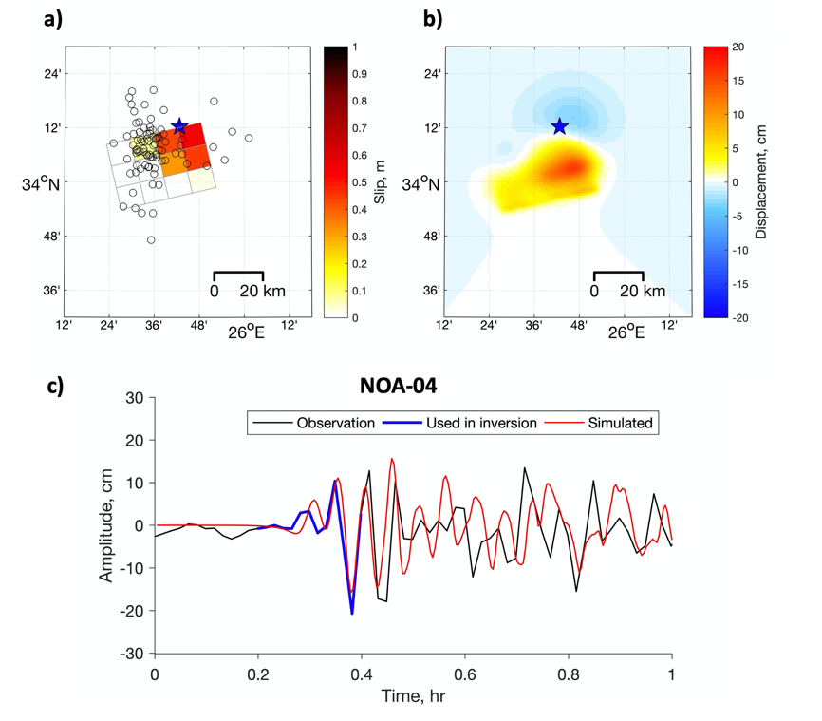

Figure S2. a) The slip distribution inverted from the observed tsunami waveforms at NOA-04 with fault centered at centroid location of the GCMT solution. b) The calculated seafloor displacement from the slip distribution. c) Tsunami waveform comparison between observation (black) and simulation (red). The blue waveform indicates part of the observed waveform that was used for the inversion.

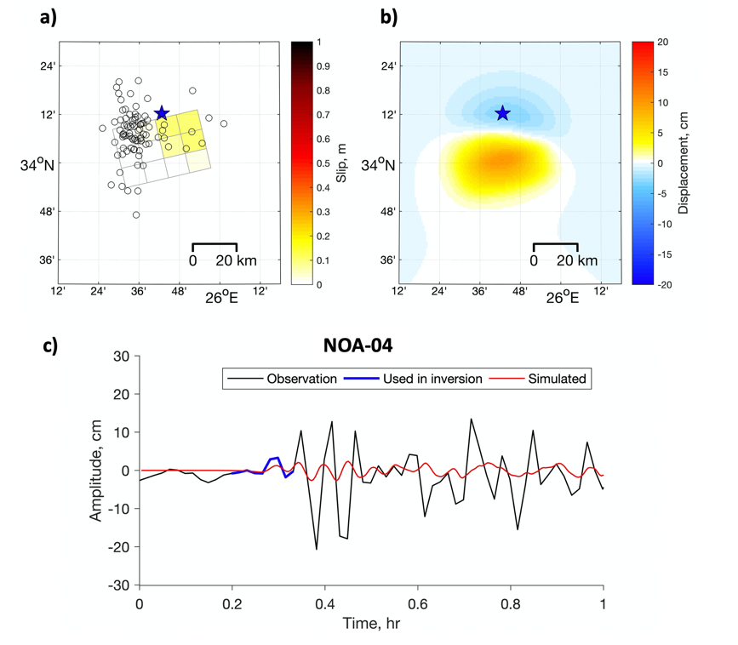

Figure S3. a) The slip distribution inverted from the first tsunami wave cycle at NOA-04. b) The calculated seafloor displacement from the slip distribution. c) Tsunami waveform comparison between observation (black) and simulation (red). The blue waveform indicates part of the observed waveform that was used for the inversion.

