Additional file 1
(1) Equilibrium test for ilmenite-titanomagnetite pairs.

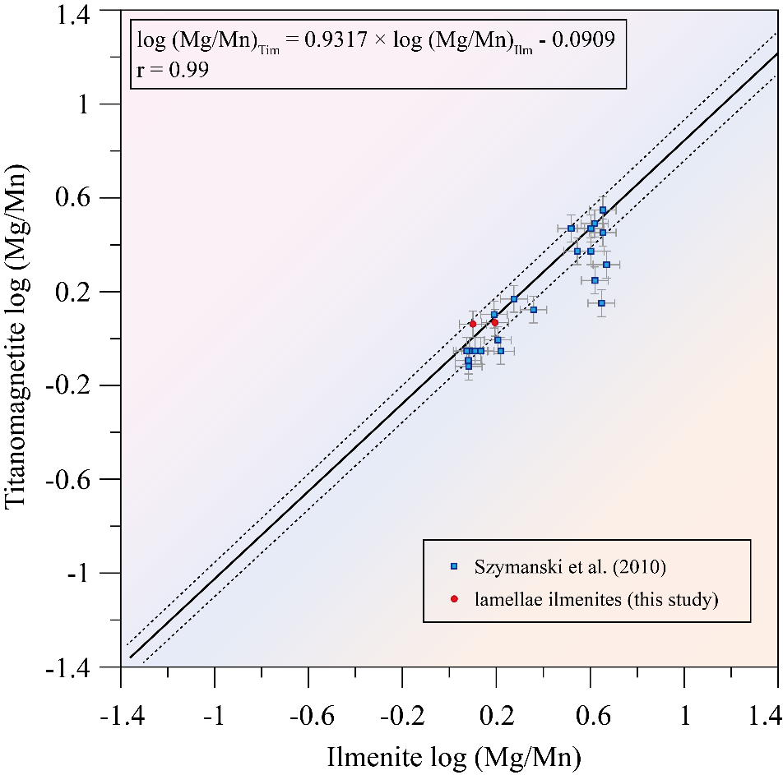
Fig.S1. Equilibrium test plot (Bacon & Hirschmann, 1988) for ilmenite-titanomagnetite pairs reported in Table 4 of (Szymanski et al., 2010) (blue dots) and lamellae ilmenites in this study (red dots). Error bars of data points are typical EPMA analytical uncertainty according to the compilation of Bacon & Hirschmann (1988).

Table S1: Equilibrium test data.
 | No. | Ilm |  | Tim |  | Equilibrium  or not | T [°C] | fO₂ [ΔQFM]
 | No. | Mg | Mn | Mg | Mn | Equilibrium  or not | T [°C] | fO₂ [ΔQFM]
1 | A | 1.12 | 1.53 | 0.4 | 0.8 | Y | 836 | 0.97
2 | B | 1.31 | 1.39 | 0.4 | 0.8 | N | 840 | 0.66
3 | C | 1.29 | 1.41 | 0.5 | 0.9 | Y | 868 | 0.72
4 | D | 1.15 | 0.61 | 0.5 | 0.3 | Y | 788 | 0.46
5 | E | 0.96 | 1.4 | 0.5 | 1.1 | Y | 769 | -0.27
6 | F | 1.18 | 1.1 | 0.5 | 0.6 | Y | 805 | 0.68
7 | G | 1.27 | 1.44 | 0.5 | 0.7 | Y | 823 | 0.89
8 | x | 1.6 | 0.63 | 0.4 | 0.5 | N | 771 | 0.65
9 | y | 1.45 | 0.61 | 0.3 | 0.3 | N | 762 | 0.59
10 | a | 1.37 | 1.77 | 0.6 | 1.2 | Y | 846 | 0.18
11 | b | 1.34 | 1.95 | 0.6 | 1.4 | Y | 777 | -0.51
12 | c | 1.17 | 1.69 | 0.7 | 1.4 | Y | 917 | 0.67
13 | d | 1.2 | 1.78 | 0.6 | 1.2 | Y | 877 | 0.42
14 | 1 | 1.8 | 0.7 | 0.8 | 0.4 | Y | 752 | 0.17
15 | 2 | 1.9 | 0.8 | 0.7 | 0.4 | Y | 759 | -0.04
16 | 3 | 2 | 1 | 0.8 | 0.6 | Y | 782 | 0.04
17 | 4 | 1.8 | 0.7 | 0.8 | 0.5 | Y | 767 | -0.06
18 | 5 | 1.3 | 1 | 0.3 | 0.4 | Y | 785 | 0.62
19 | 6 | 1.6 | 0.7 | 1 | 0.6 | Y | 745 | 0.08
20 | 7 | 1.6 | 0.6 | 0.7 | 0.6 | N | 747 | -0.07
21 | 8 | 1.6 | 0.7 | 0.8 | 0.6 | Y | 756 | -0.05
Note: Ilm = ilmenite, Tim = titanomagnetite, Y = equilibrium, N = not equilibrium. The order numbers (No.) are in consistent with the original text.

(2) BSE image of NWA 5790.

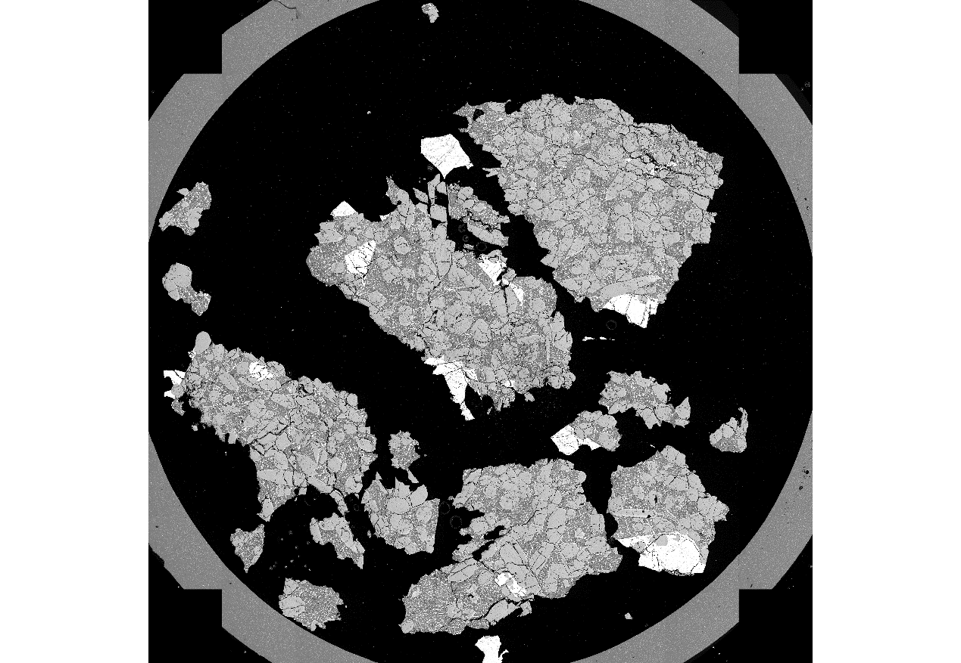
Fig.S2. Contrast-enhanced BSE image of NWA 5790 thin-section. The diameter of the rounded mount is 1 cm.

(3) Close-system modelling.
The figures presented below are all modelling results in a close-system. For open-system results, please refer to the main text.

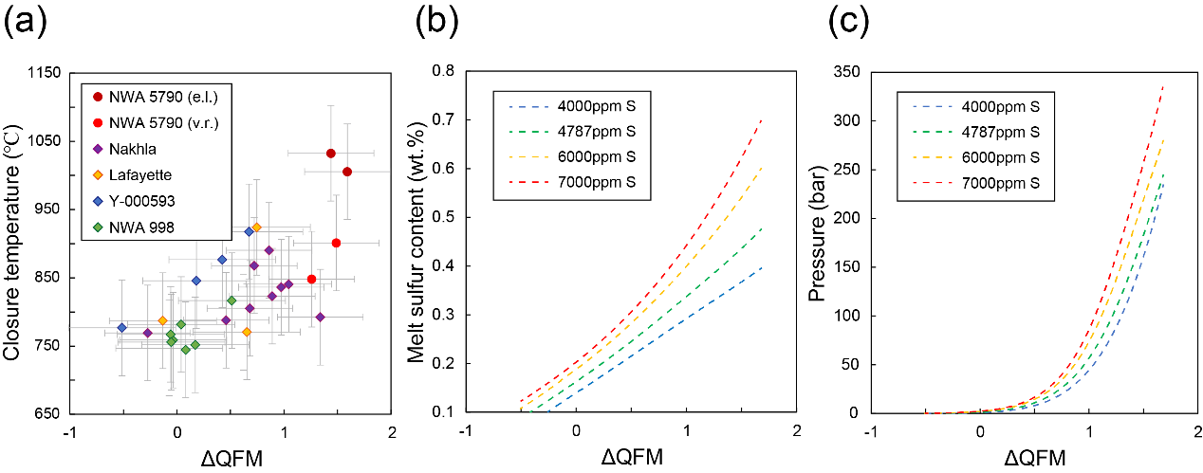
Fig.S3. (a) Closure temperature and fO₂ (relative to QFM buffer) for NWA 5790 nakhlite titanomagnetite–ilmenite pairs in this study (red dots), compared to closure temperature and fO₂ from titanomagnetite–ilmenite pairs in nakhlites from the literature (Boctor et al., 1976; Bunch and Reid, 1975; Sautter et al., 2002; Szymanski et al., 2010; Treiman and Irving, 2008). All closure temperatures and fO₂ were recalculated using geothermometer and oxybarometer in Sauerzapf et al. (2008). Error bars for temperature and fO₂ are ±70°C and ±0.5log fO₂ unit, respectively. (b) Total sulphur content vs. fO₂ (expressed as ΔQFM) degassing simulations. (c) Pressure vs. fO₂ (expressed as ΔQFM) degassing simulations. Degassing models calculated by D-Compress are in close C–S–O–H system.

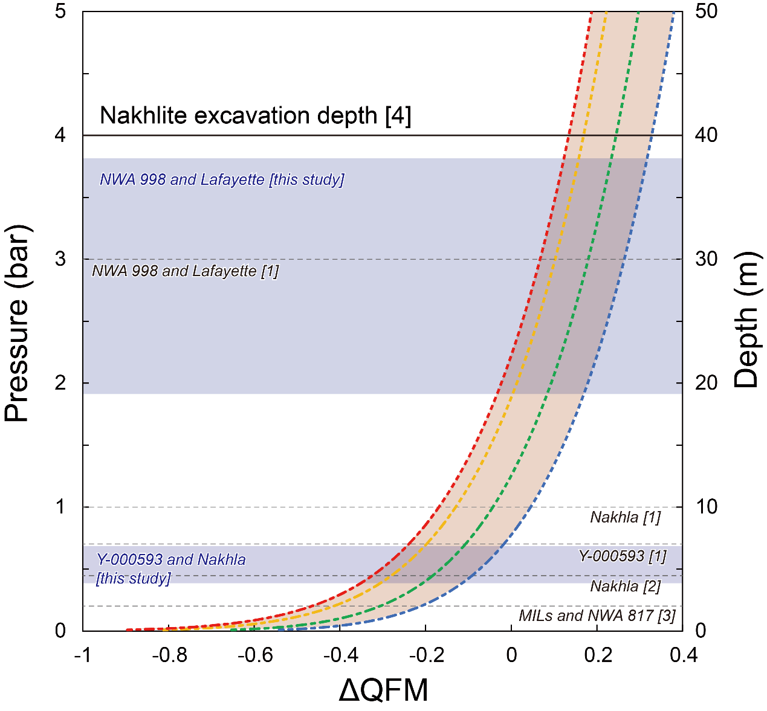
Fig.S4. Total sulphur content vs. fO₂ (expressed as ΔQFM) degassing simulations at 0.04–5 bar. Degassing models calculated with D-Compress are shown for a close C–S–O–H system. At the pressure range below 1 bar, the analytical continuation of the modelled curves was utilised to describe the relationship between pressure and fO₂ based on the criterion R² = 1. The burial depths are cited from [1] Mikouchi et al. (2006); [2] Mikouchi and Miyamoto (2002); [3] Mikouchi et al. (2012). The nakhlite excavation depth is cited from [4] Cohen et al. (2017). In this study, the light blue regions are estimated to be the burial depth range of NWA 998 and Lafayette (ca. 30–40m) and Y-000593 and Nakhla (< 7 m).

