Additional Figures for

Detection of low-frequency earthquakes by the matched filter technique using the product of mutual information and correlation coefficient
Ryo Kurihara, Aitaro Kato, Sumito Kurata and Hiromichi Nagao
Corresponding author: Ryo Kurihara (rkuri@eri.u-tokyo.ac.jp)

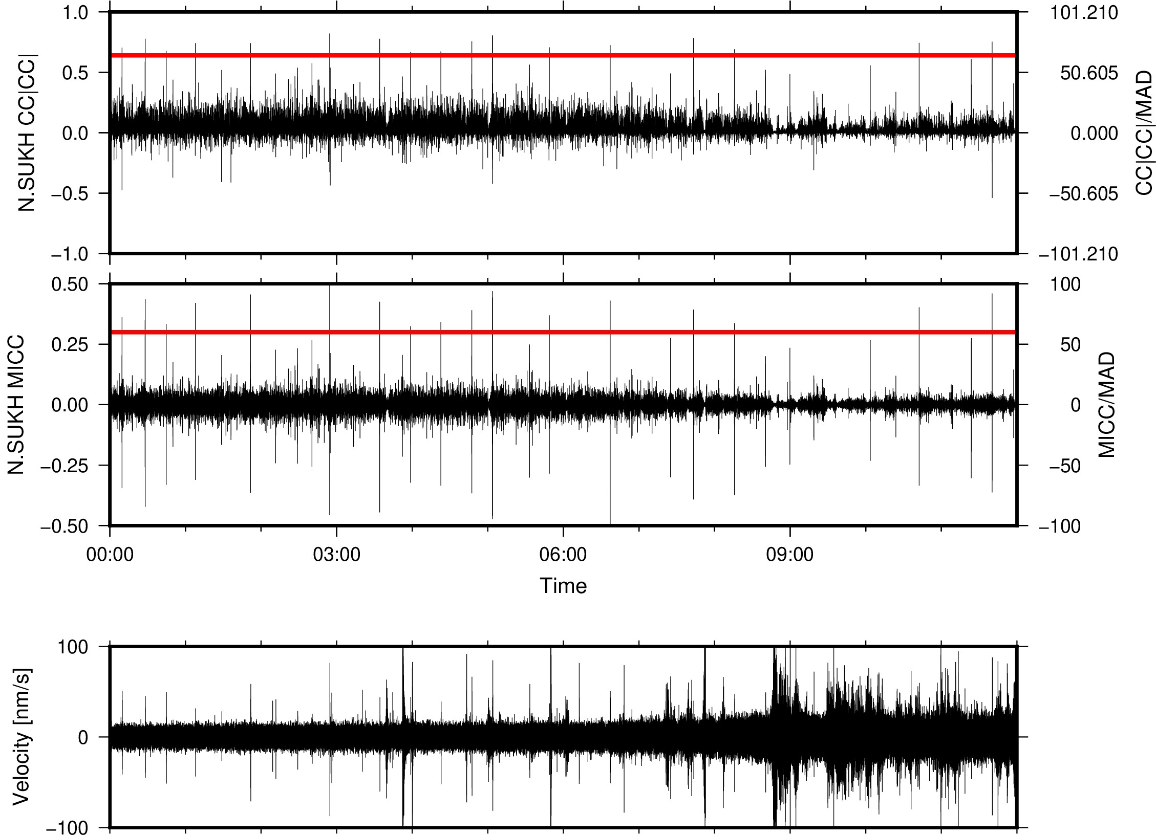
Figure S1 Values of CC|CC| (Gibbons, 2021) and MICC from 0:00 to 12:00 on December 21, 2010. The right axis shows each index after normalization by the MAD. The MAD is calculated using the half-day waveform data.

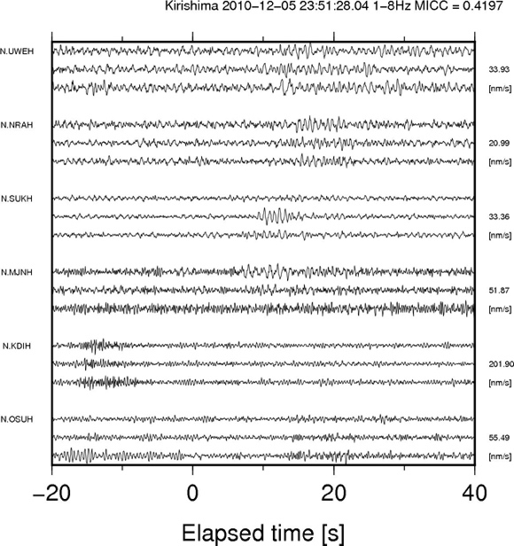
Figure S2. Three-components, 1–8 Hz bandpass-filtered waveforms of the earthquake recorded at the six stations. Three waveforms E-W, N-S, U-D components are plotted from top. Each waveform is normalized by the maximum absolute amplitude, which is written in the right of the Figure.

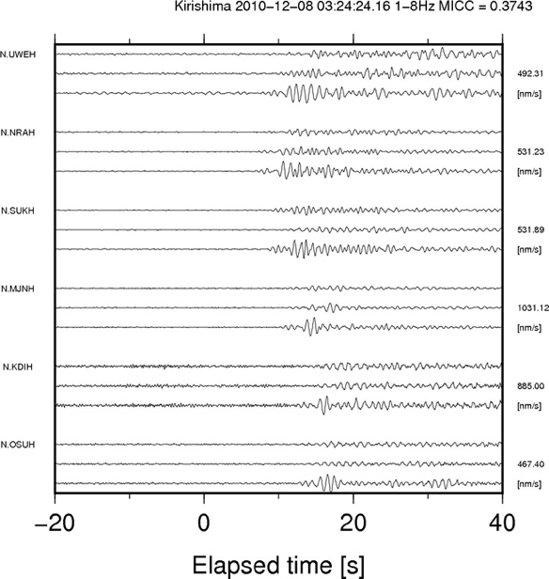
Figure S3. Three-components, 1–8 Hz bandpass-filtered waveforms of a mis-detected event of surface wave recorded at the six stations.

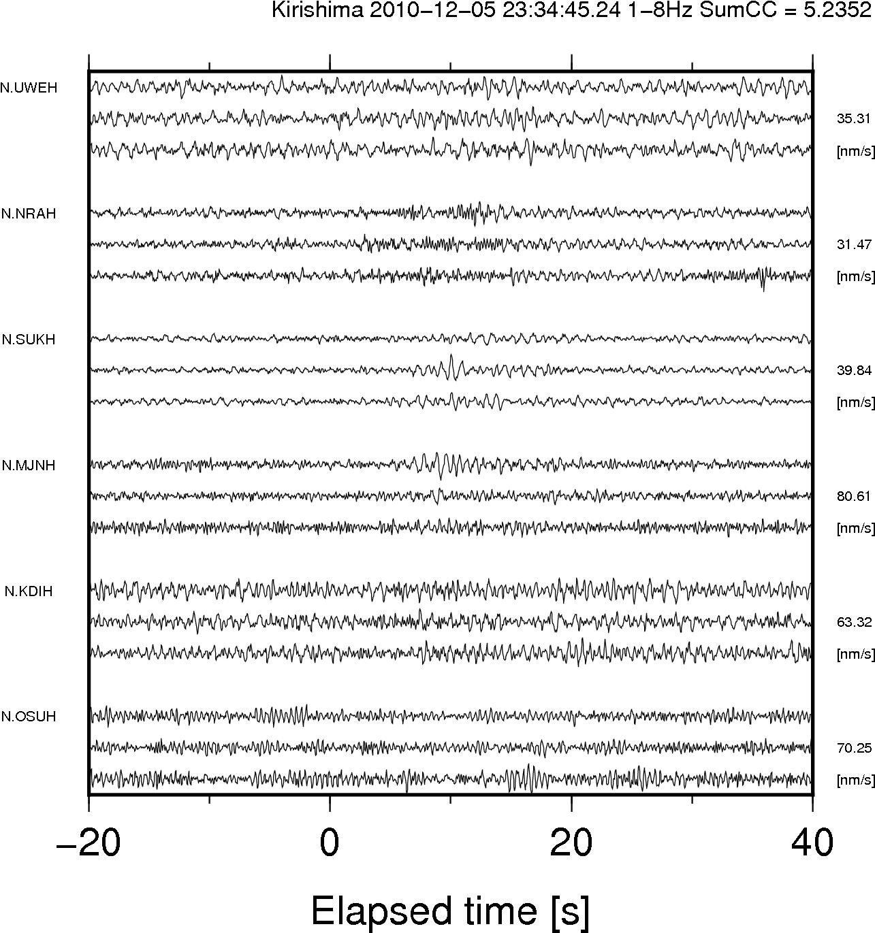
Figure S4. Three-components, 1–8 Hz bandpass-filtered waveforms of a false negative event, which is detected by summed CC and not detected by MICC at N.SUKH, at six stations.

