Supplementary figures for

“Three-dimensional deformation and its uncertainty derived by integrating multiple SAR data analysis methods”

Yu Morishitaª , Tomokazu Kobayashiª

ªGeospatial Information Authority of Japan, 1 Kitasato, Tsukuba, Ibaraki, Japan

Corresponding author: Yu Morishita (morishita-y96pt@mlit.go.jp)

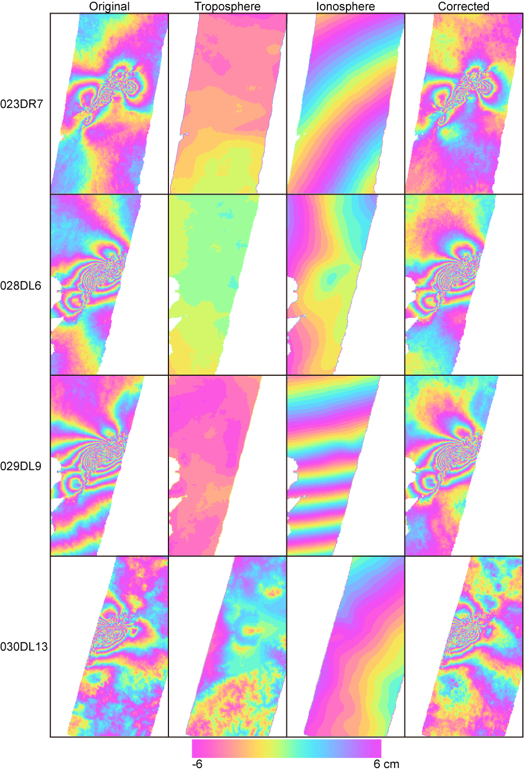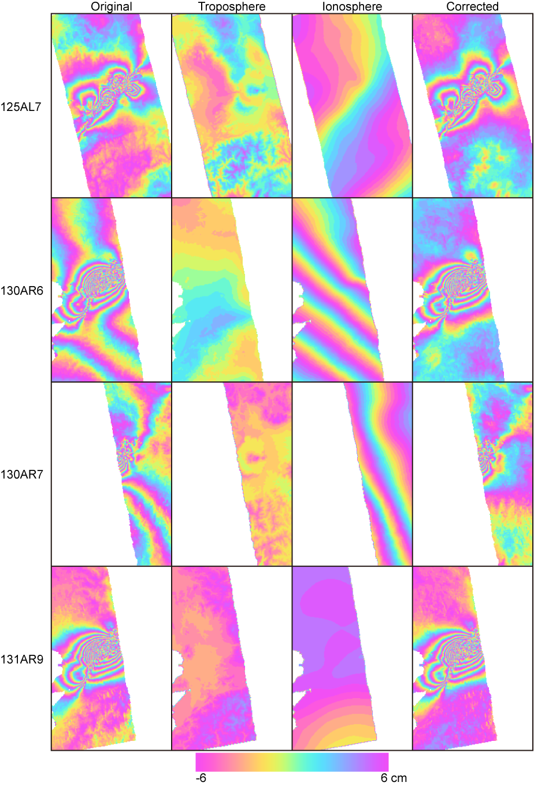
(a) Kumamoto

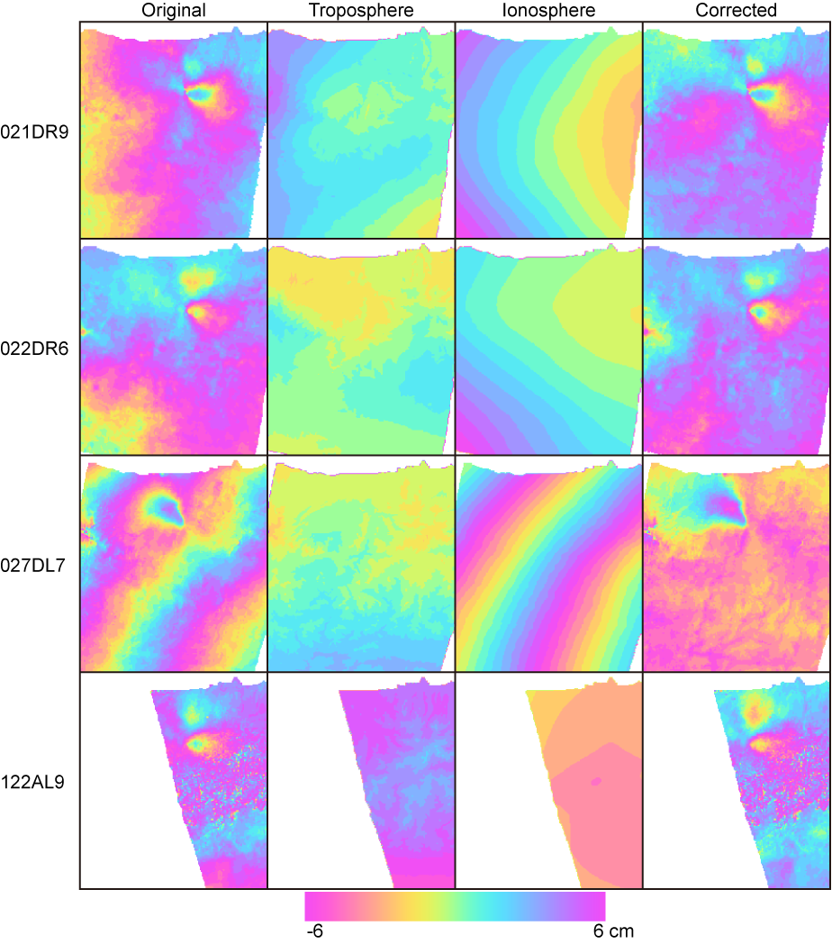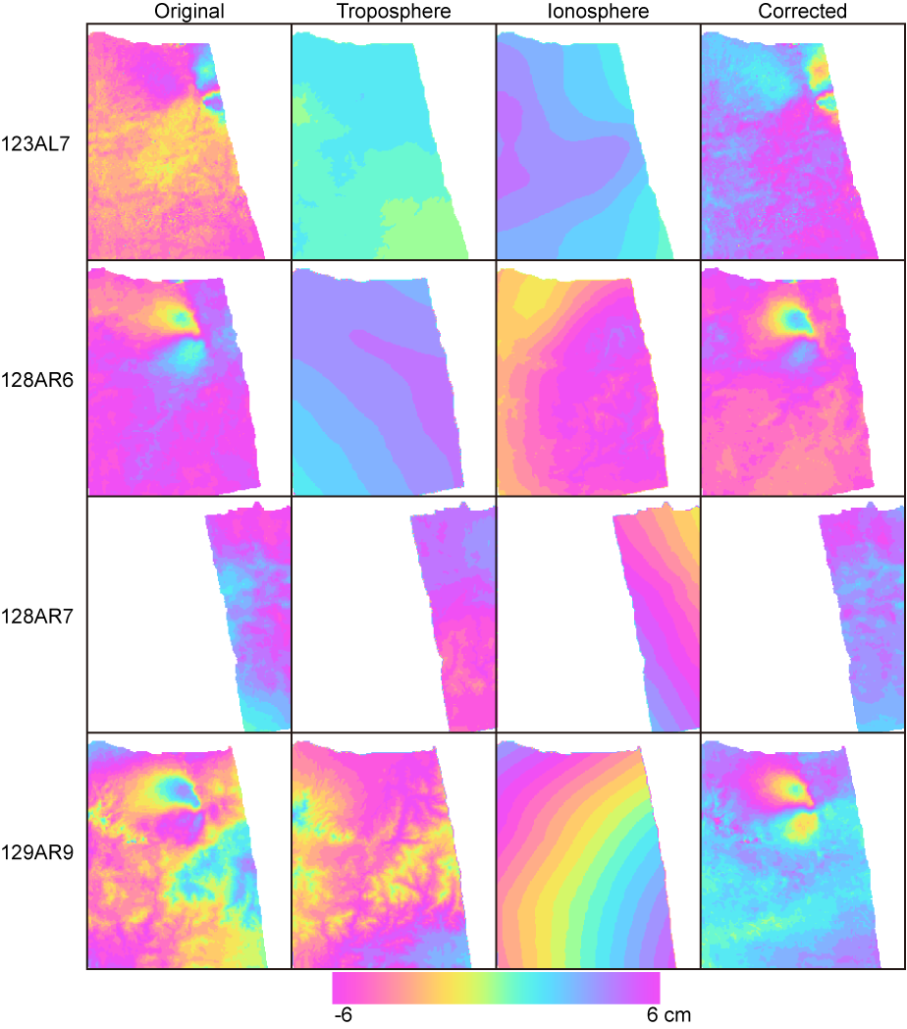
(b) Tottori
Figure S1. Wrapped interferograms before and after tropospheric and ionospheric noise correction and their resulting corrections. (a) Kumamoto, (b) Tottori.
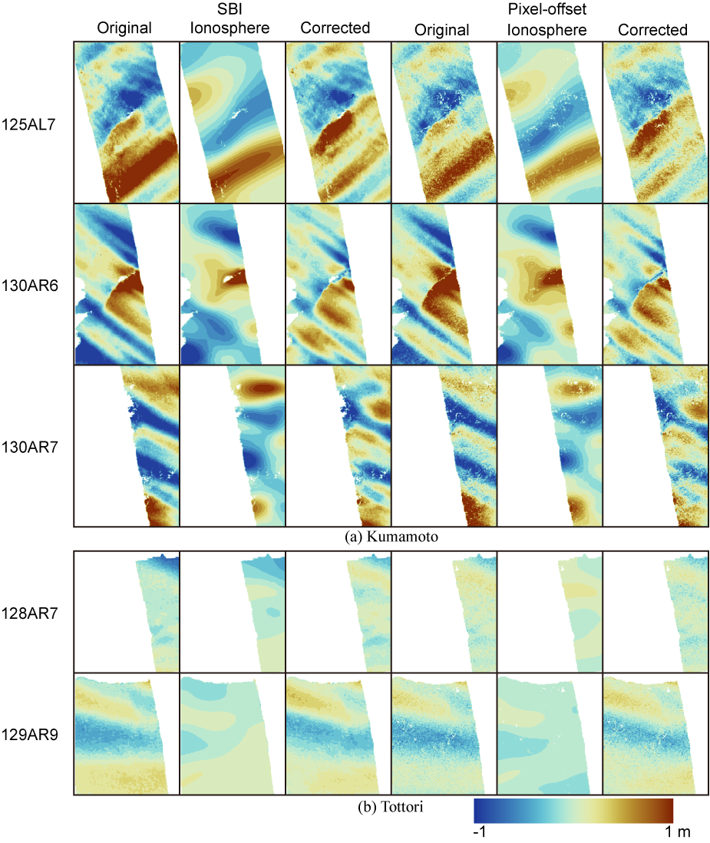
Figure S2. Azimuth deformation data with significant ionospheric noise from SBI and the pixel offset method before and after ionospheric noise correction and their corrections. (a) Kumamoto, (b) Tottori.
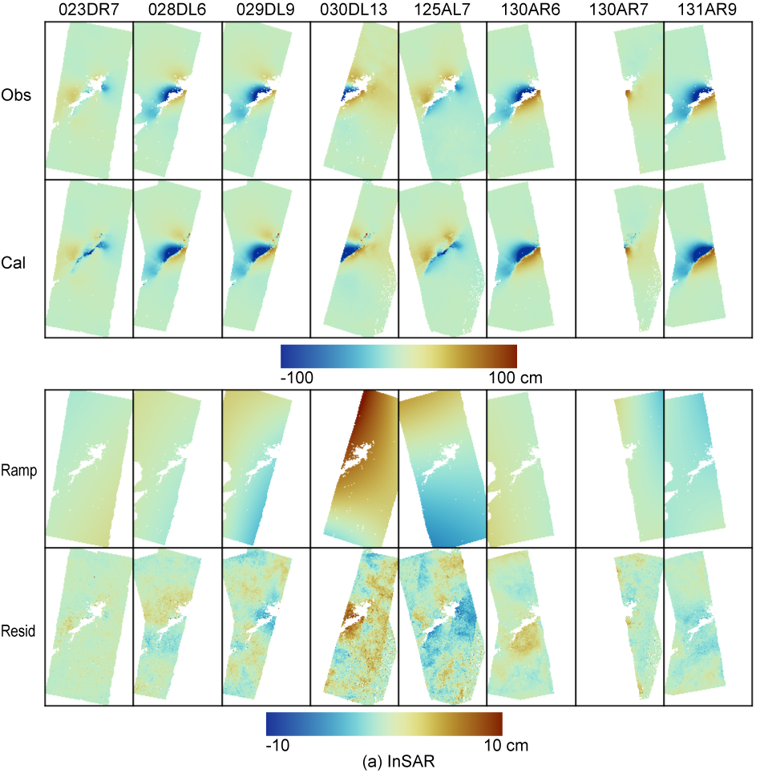
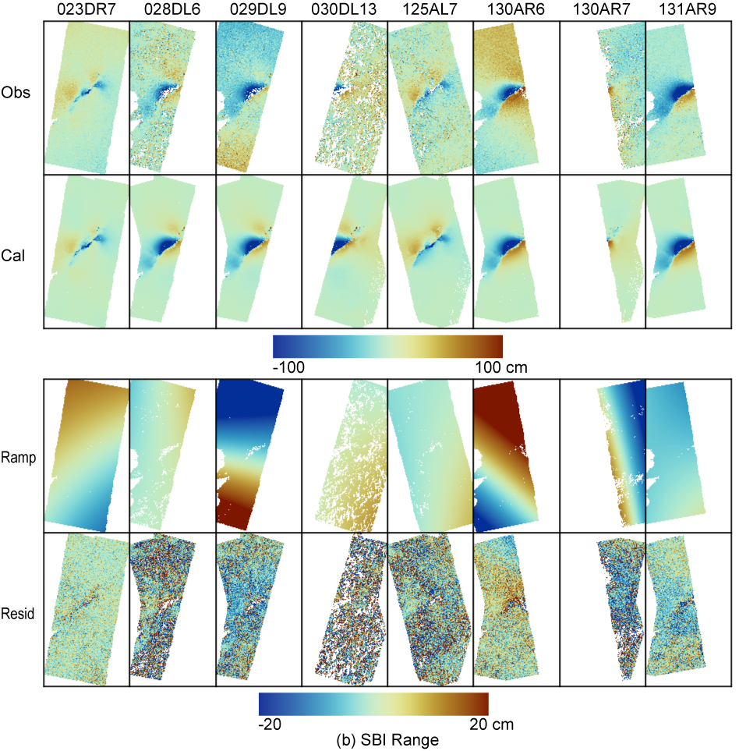
Figure S3. Observations, calculations, ramps, and residuals for each deformation dataset in the 3D decomposition for Kumamoto. (a) InSAR. (b) Range SBI.
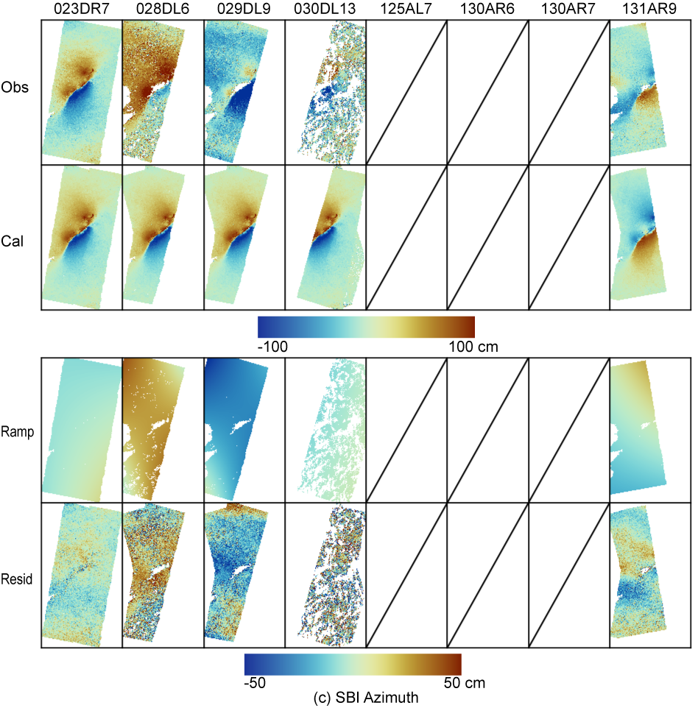
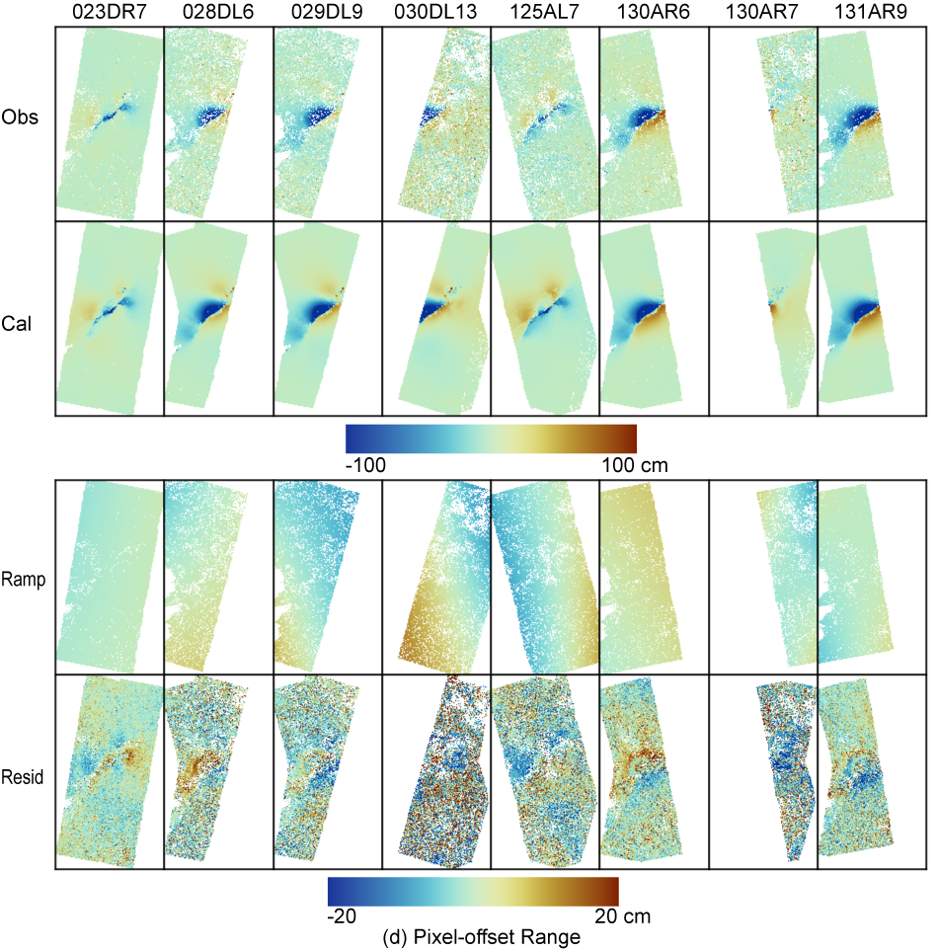
Figure S3 cont. Observations, calculations, ramps, and residuals for each deformation dataset in the 3D decomposition for Kumamoto. (c) Azimuth SBI. (d) Range offset.

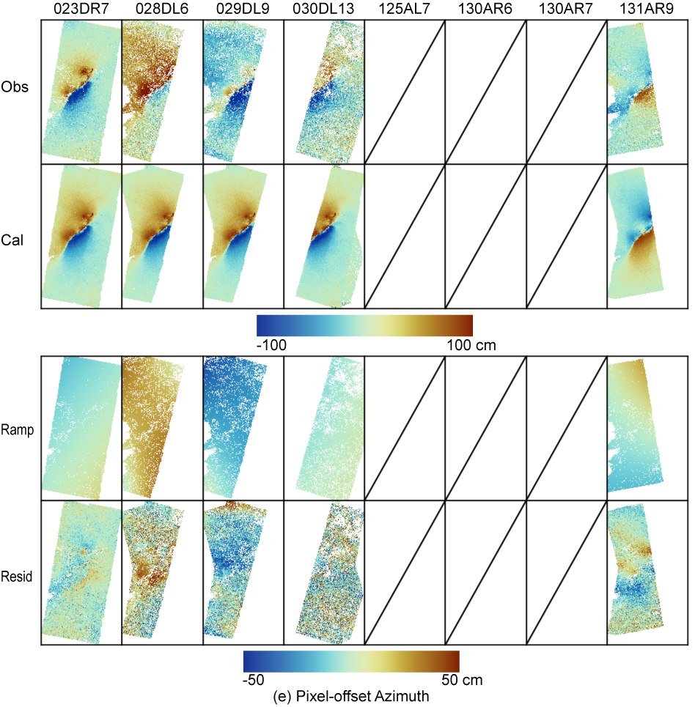
Figure S3 cont. Observations, calculations, ramps, and residuals for each deformation dataset in the 3D decomposition for Kumamoto. (e) Azimuth offset.

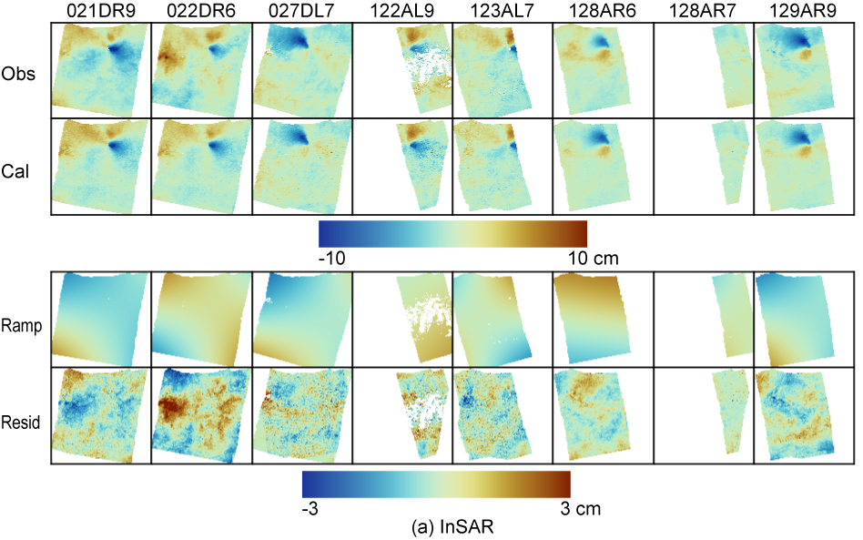
Figure S4. Observations, calculations, ramps, and residuals for each deformation dataset in the 3D decomposition for Tottori. (a) InSAR.

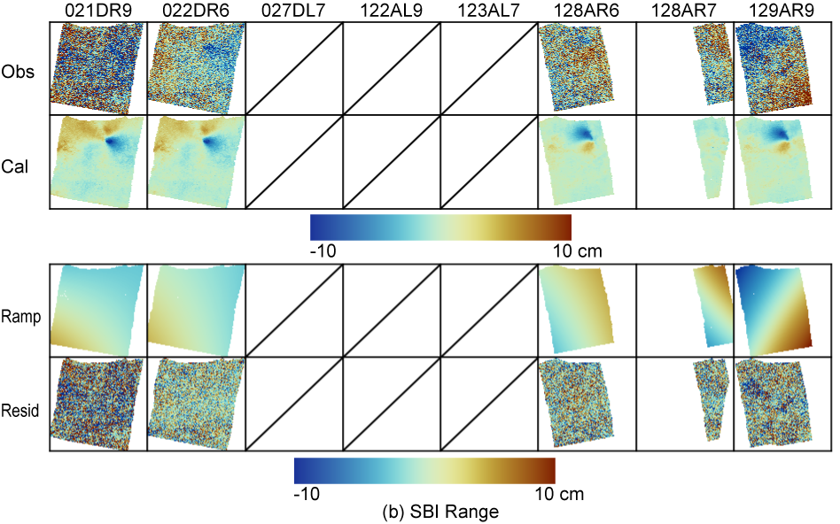
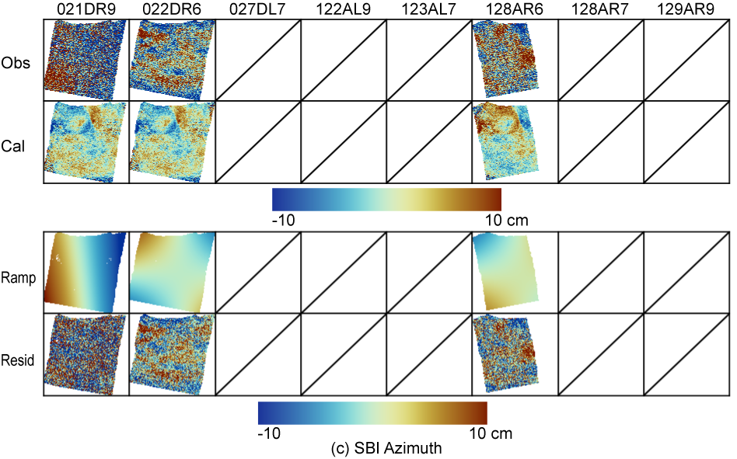
Figure S4 cont. Observations, calculations, ramps, and residuals for each deformation dataset in the 3D decomposition for Tottori. (b) Range SBI. (c) Azimuth SBI.
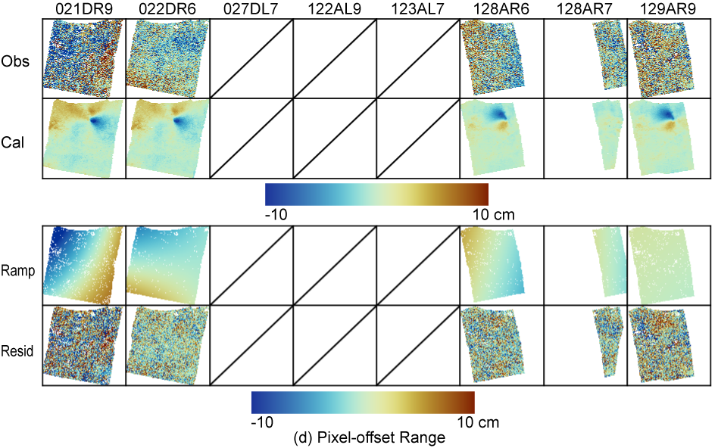
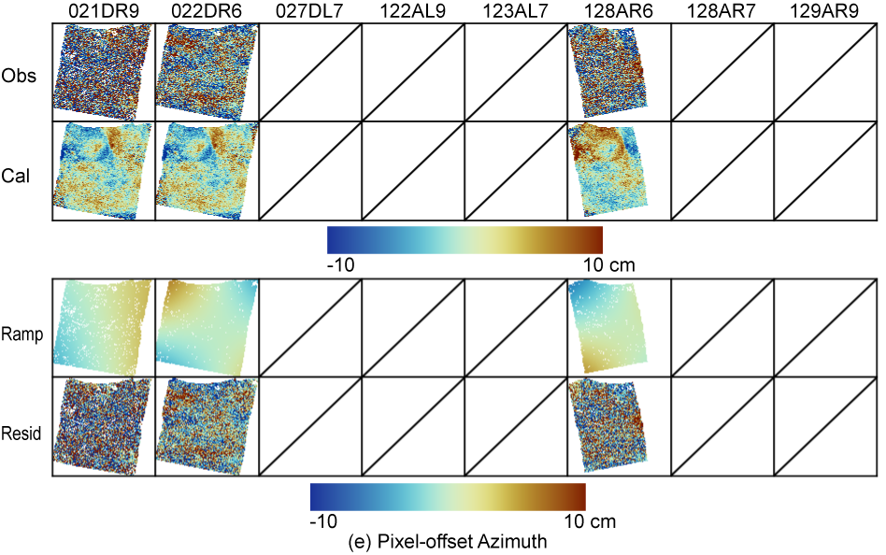
Figure S4 cont. Observations, calculations, ramps, and residuals for each deformation dataset in the 3D decomposition for Tottori. (d) Range offset. (e) Azimuth offset.

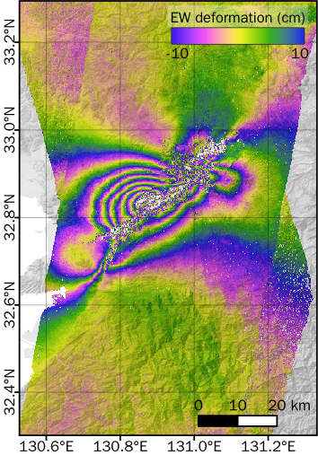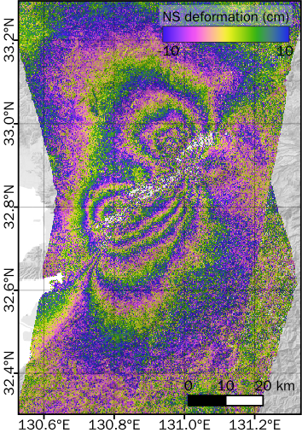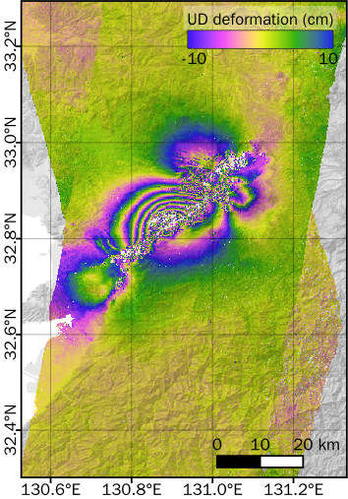
(a) (b) (c).
Figure S5. Same as Fig. 3a–c but rewrapped to 20 cm/cycle to visualize small changes.

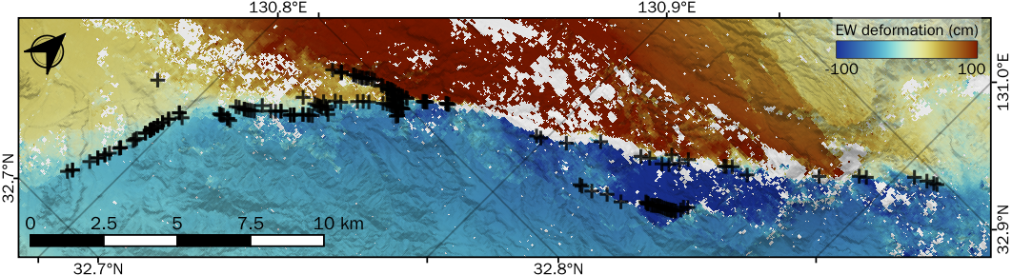
(a)
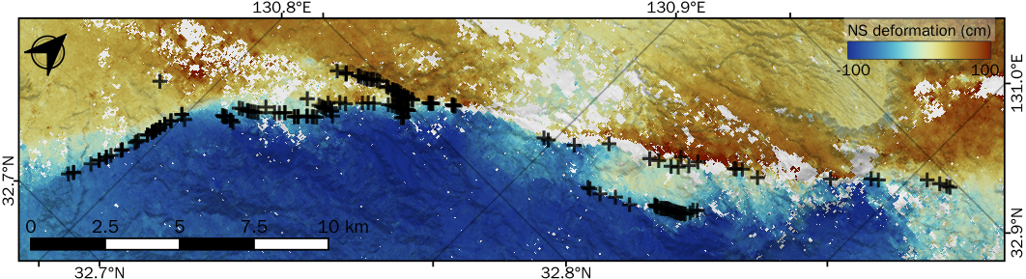
(b)
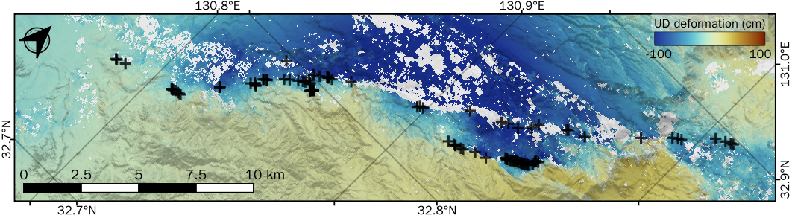
(c)
Figure S6. As for Fig. 6(a)(b)(d) but with the SAR-derived deformation masked.

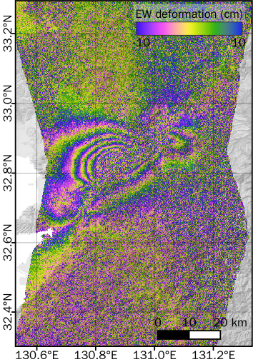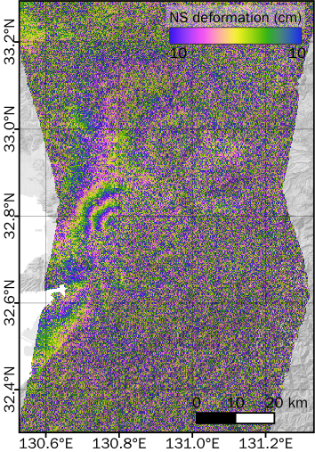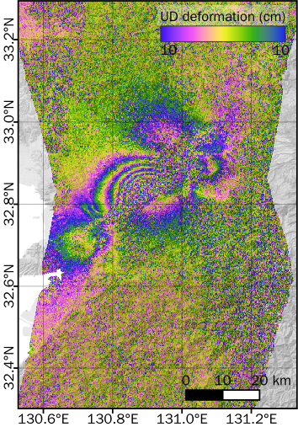
(a) (b) (c).
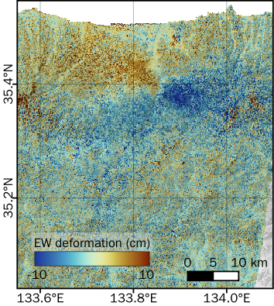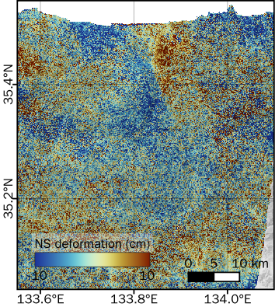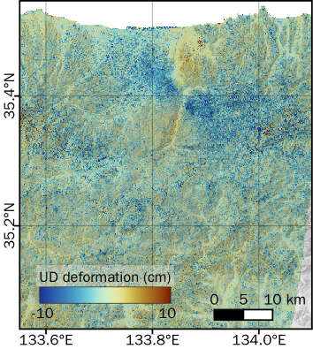
(d) (e) (f)

Figure S7. 3D deformation derived without weighting. (a)–(c) Kumamoto. The data are rewrapped to 20 cm/cycle to visualize small changes. (d)–(f) Tottori.
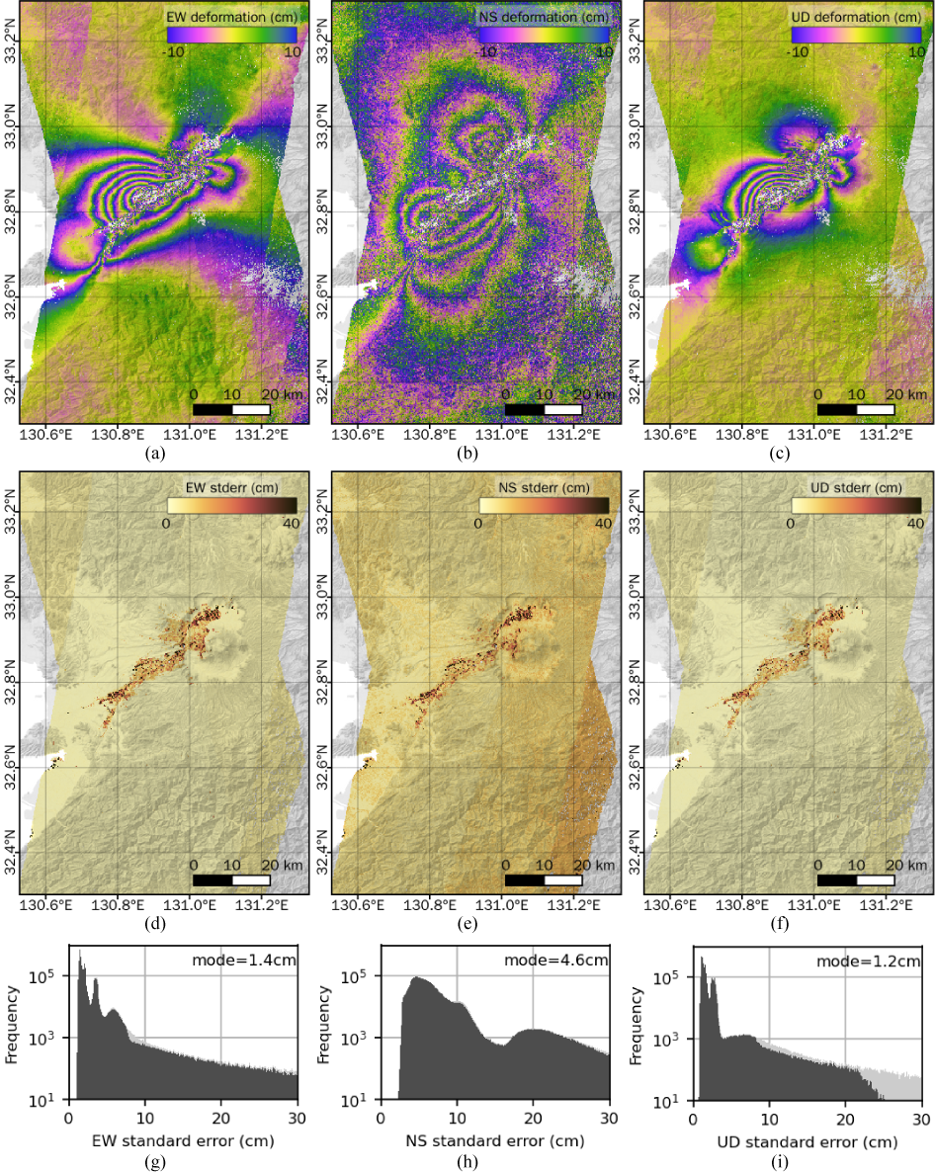
Figure S8. (a)–(c) 3D deformation decomposed from all data including noisy data with significant decorrelation or azimuth ionospheric noise (Table 1 and Fig. S2) and masked based on noise metrics for Kumamoto. The data are rewrapped to 20 cm/cycle to visualize small changes. (d)–(f) Estimated standard errors of the 3D components. (g)–(i) Histograms of the standard errors of the 3D components. The light-gray parts denote the frequency distribution including the masked pixels.

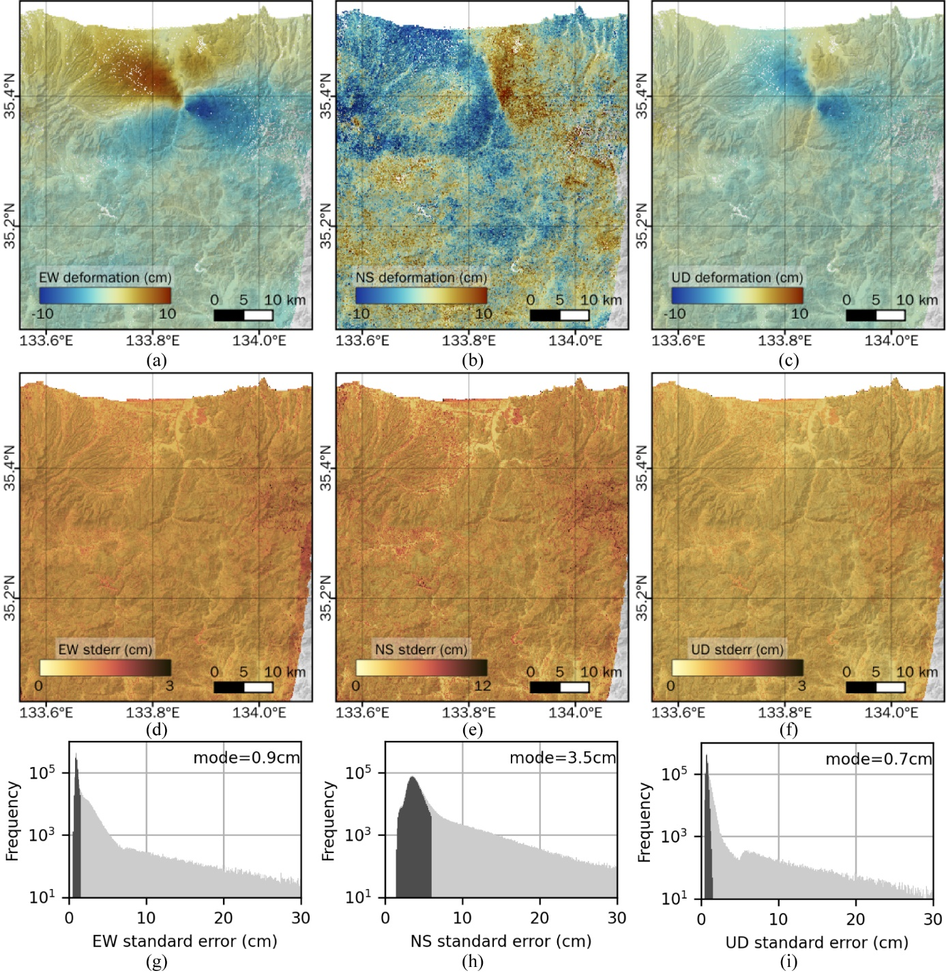
Figure S9. As for Fig. S8 but for Tottori.

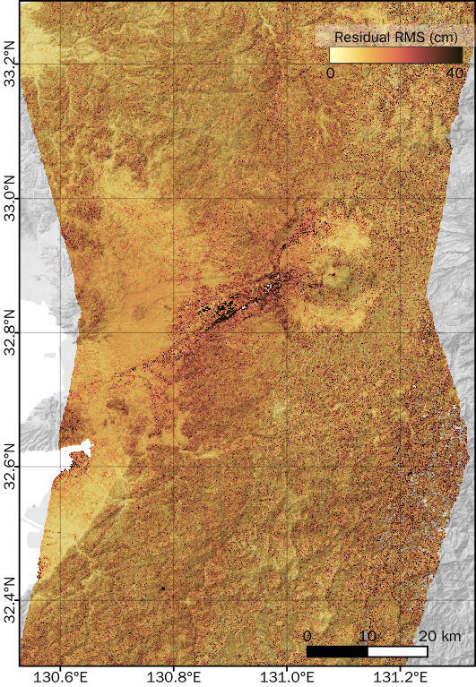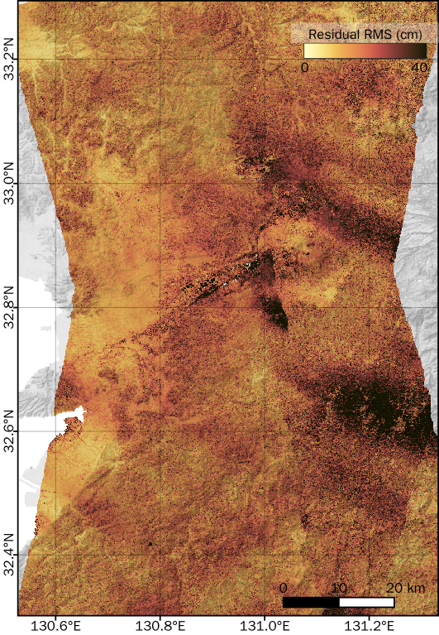
(a) and (b)
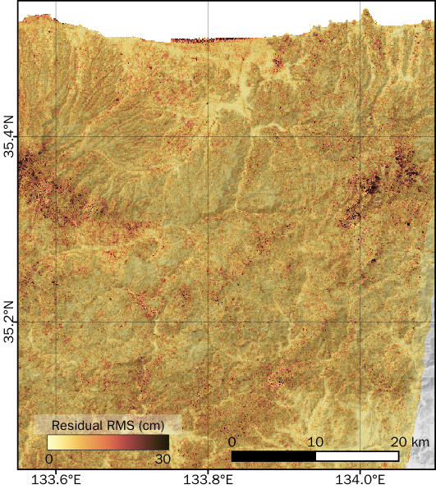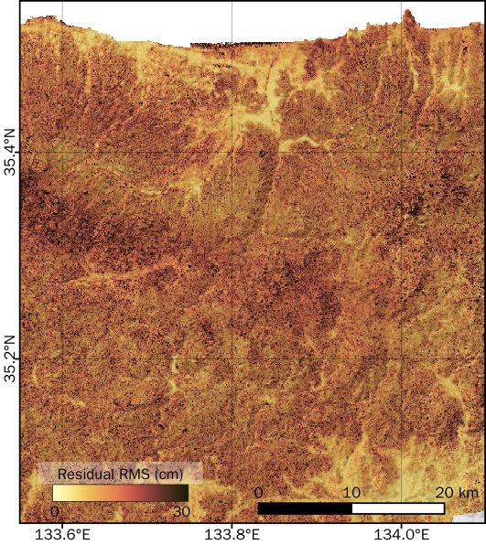
(c) (d)
Figure S10. RMS of the residuals. (a), (b) Derived from all methods without and with noisy data for Kumamoto, respectively. (c), (d) Derived from all methods without and with noisy data for Tottori, respectively.

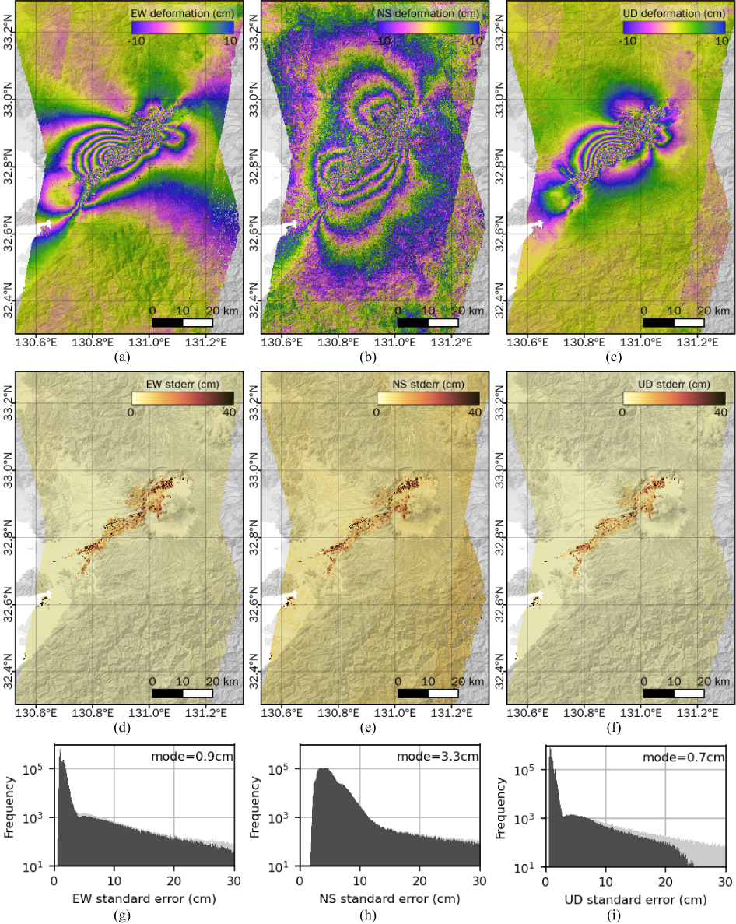
Figure S11. (a)–(c) 3D deformation derived using conventional deramping instead of iterative deramping and masked based on noise metrics for Kumamoto. The data are rewrapped to 20 cm/cycle to visualize small changes. (d)–(f) Estimated standard errors of the 3D components. (g)–(i) Histograms of the standard errors of the 3D components. The light-gray parts denote the frequency distribution including the masked pixels.

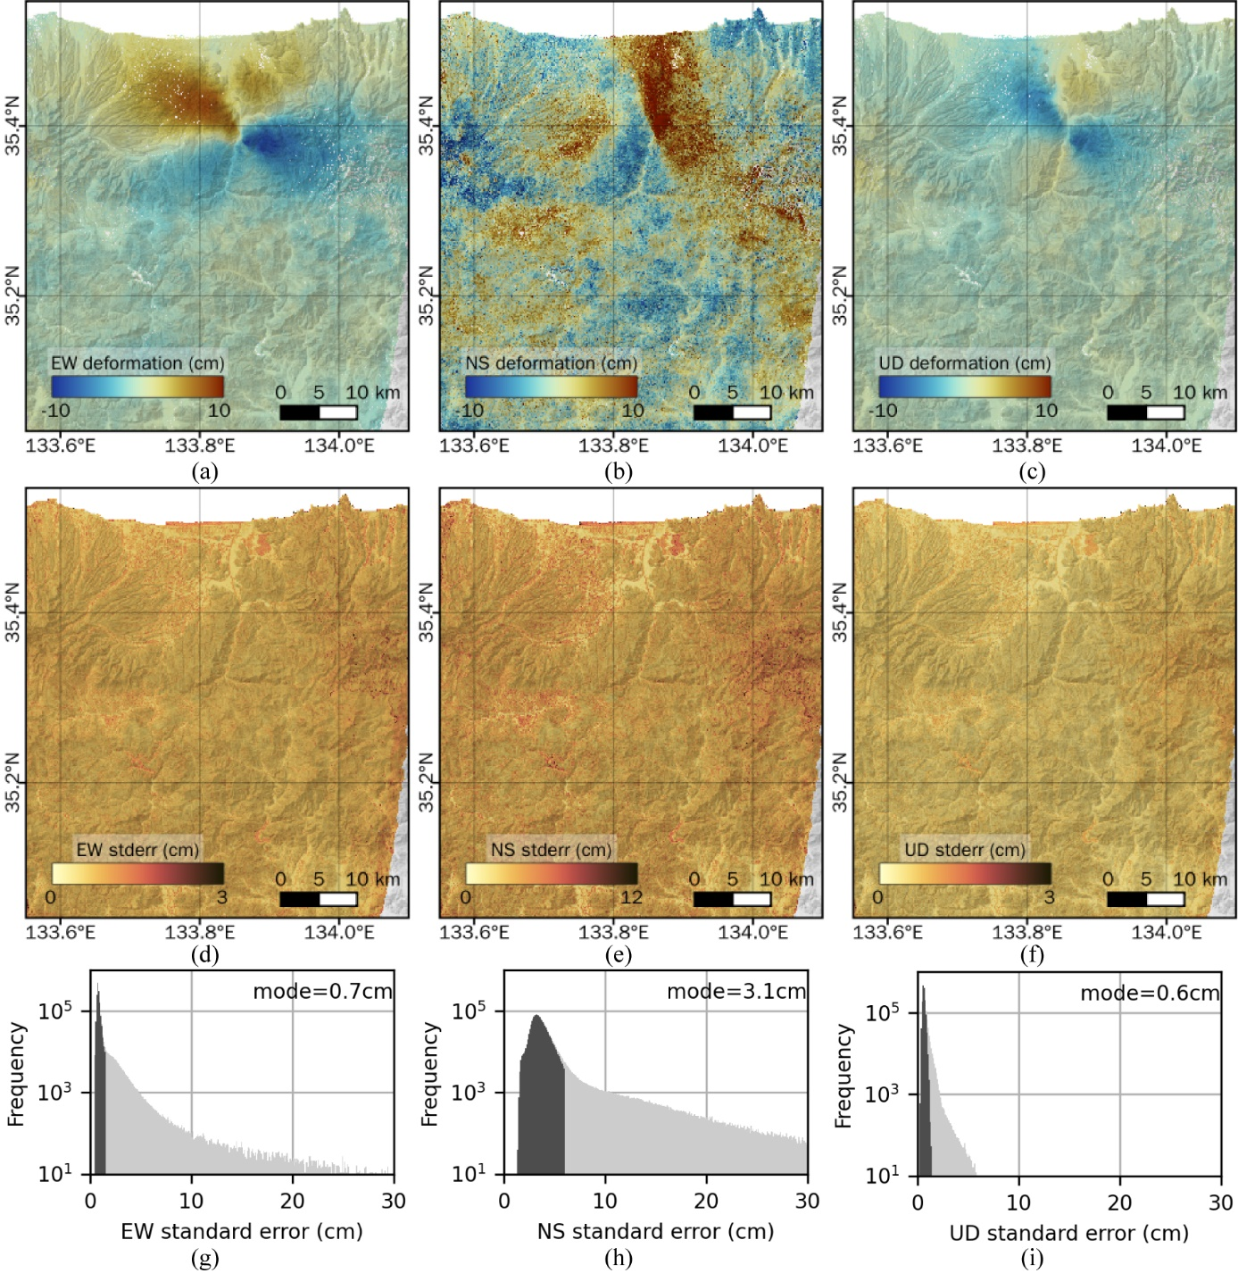
Figure S12. As for Fig. S11 but for Tottori.

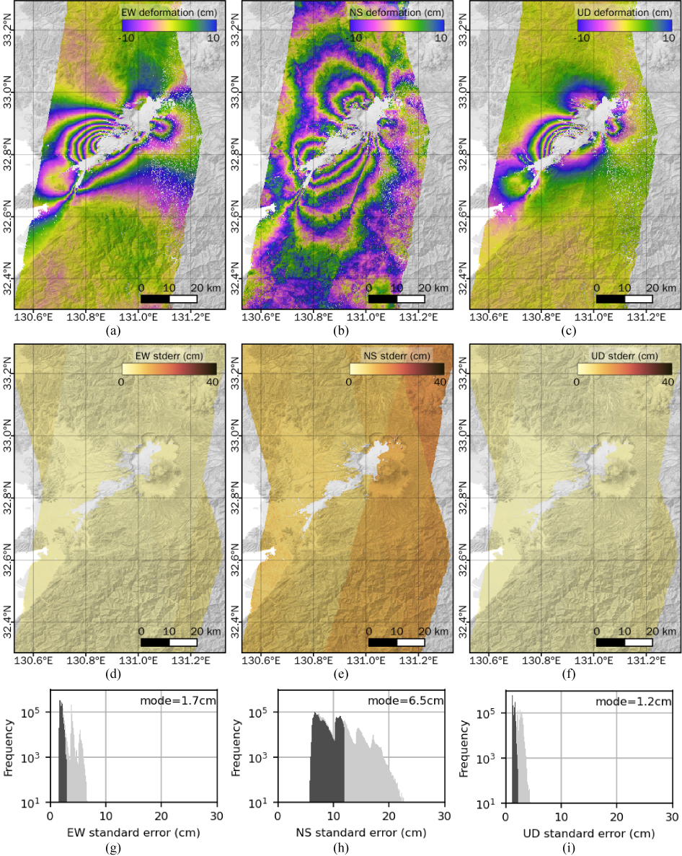
Figure S13. (a)–(c) 3D deformation decomposed from InSAR data alone and masked based on noise metrics for Kumamoto. The data are rewrapped to 20 cm/cycle to visualize small changes. (d)–(f) Estimated standard errors of the 3D components. (g)–(i) Histograms of the standard errors of the 3D components. The light-gray parts denote the frequency distribution including the masked pixels.

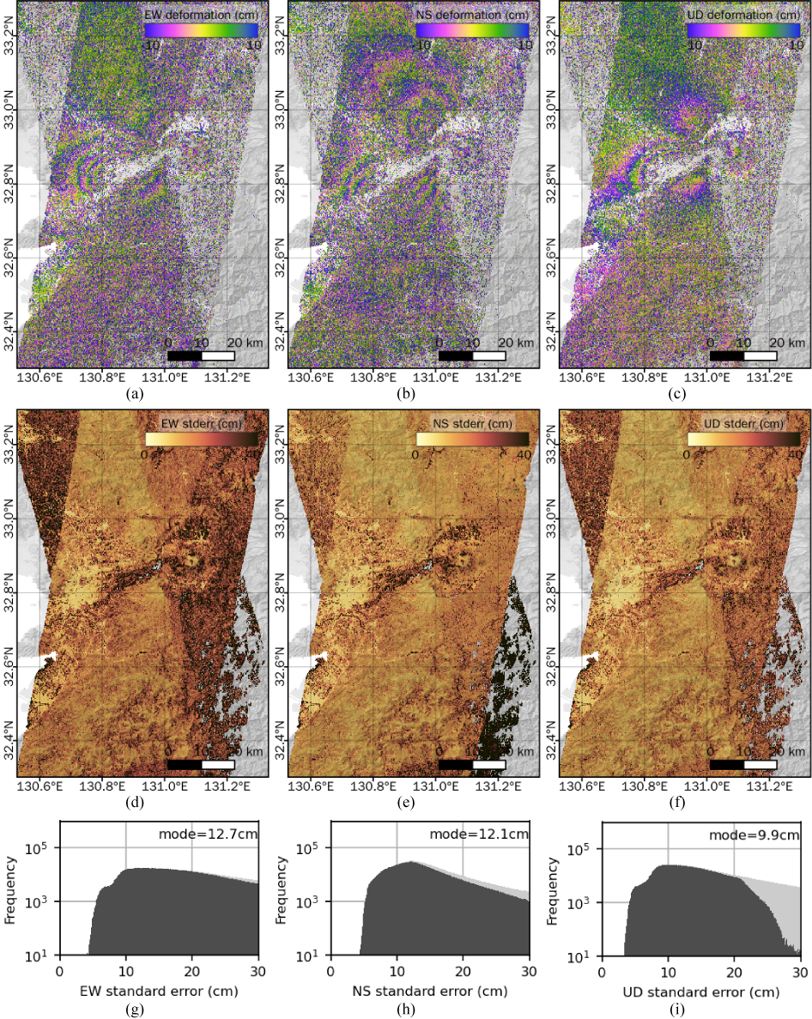
Figure S14. (a)–(c) 3D deformation decomposed from SBI data alone and masked based on noise metrics for Kumamoto. The data are rewrapped to 20 cm/cycle to visualize small changes. (d)–(f) Estimated standard errors of the 3D components. (g)–(i) Histograms of the standard errors of the 3D components. The light-gray parts denote the frequency distribution including the masked pixels.

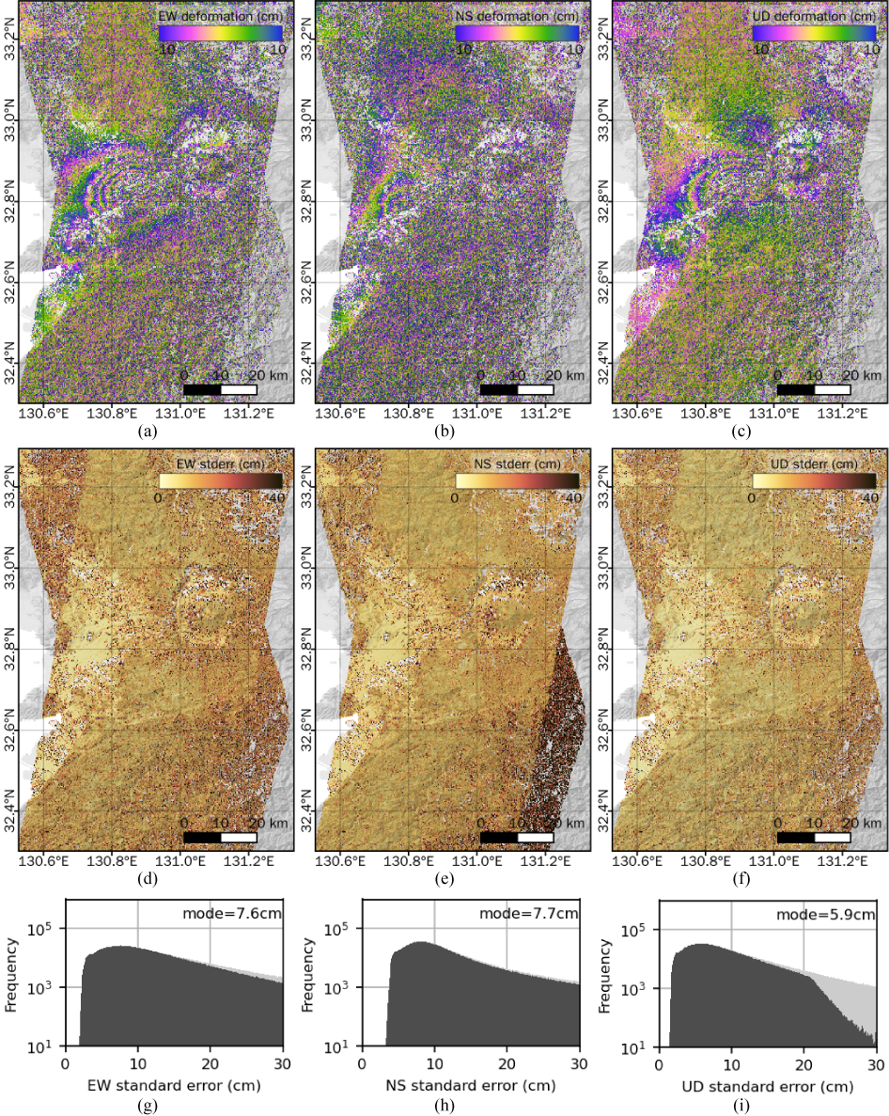
Figure S15. (a)–(c) 3D deformation decomposed from only the pixel offset data and masked based on noise metrics for Kumamoto. The data are rewrapped to 20 cm/cycle to visualize small changes. (d)–(f) Estimated standard errors of the 3D components. (g)–(i) Histograms of the standard errors of the 3D components. The light-gray parts denote the frequency distribution including the masked pixels.

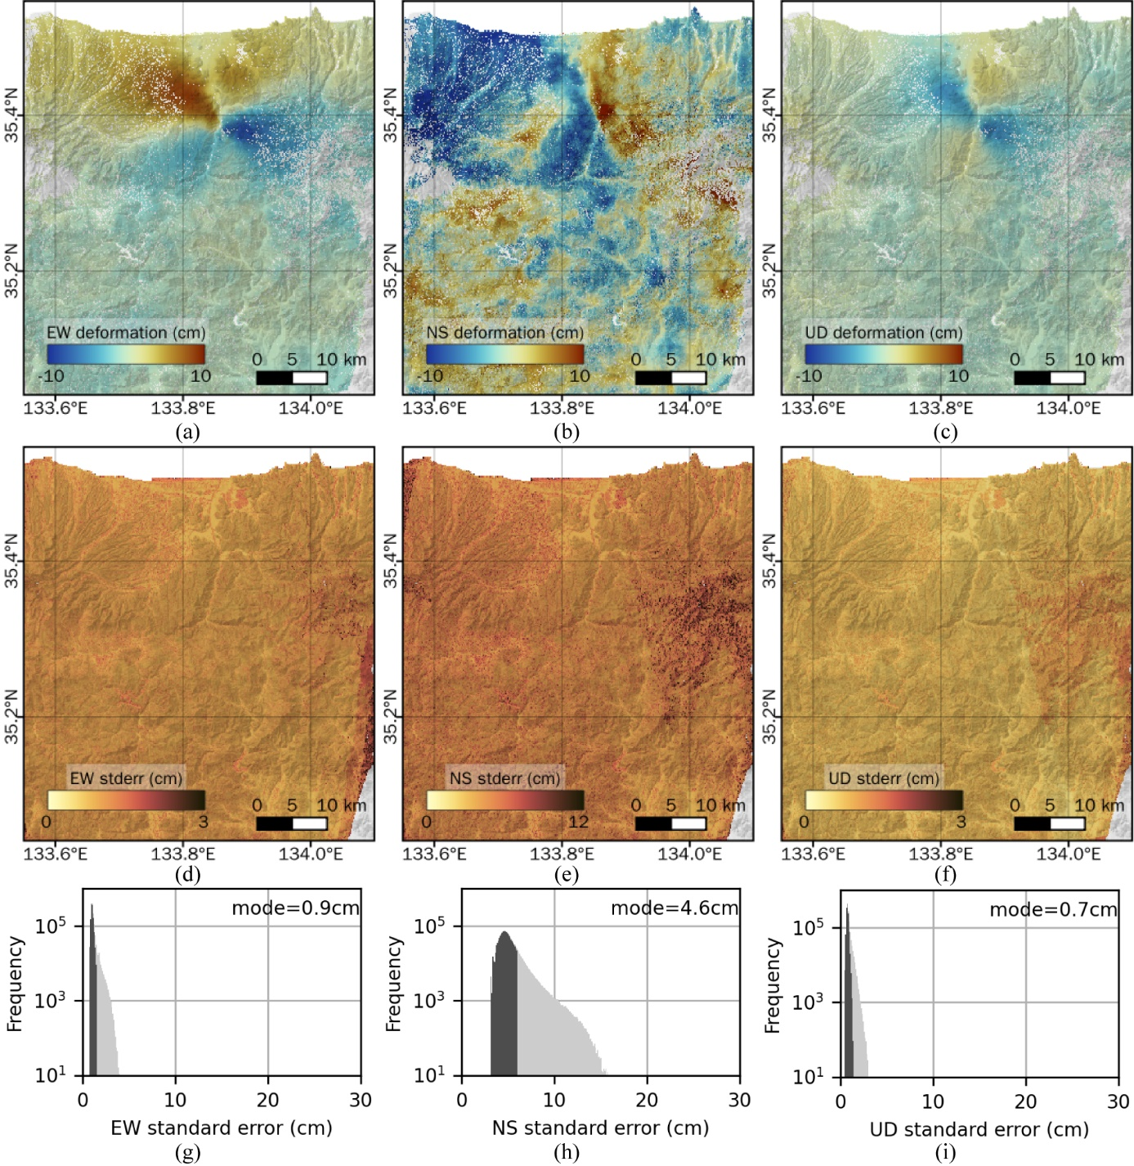
Figure S16. As for Fig. S13 but for Tottori.

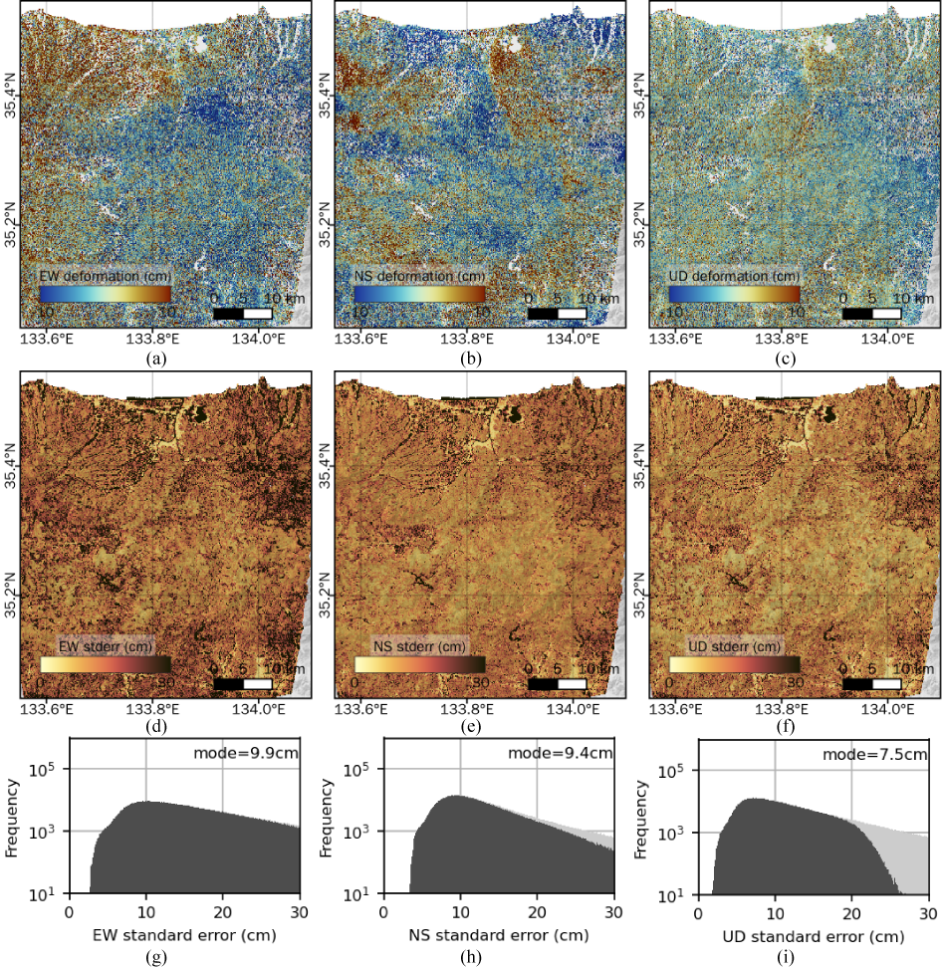
Figure S17. As for Fig. S14 but for Tottori.

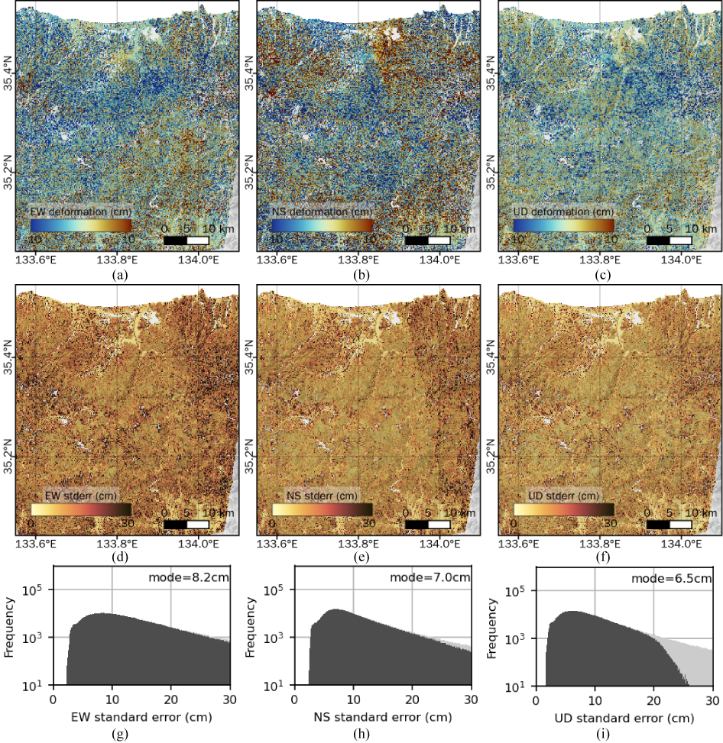
Figure S18. As for Fig. S15 but for Tottori.

