Additional file 1
1 Statistical analysis of geomagnetic storm
This section statistically analyzed geomagnetic storm events by the Dst index. Fig. S1 shows the distribution of the Dst index from 1957 to 2020; the orange line denotes the boundary of the geomagnetic storm (Dst <= -50 nT), and the light blue line denotes the boundary of the strong geomagnetic storm (Dst <= -100 nT). The findings show that geomagnetic storms did not appear frequently. The probability of a strong storm is less than 1% per day.
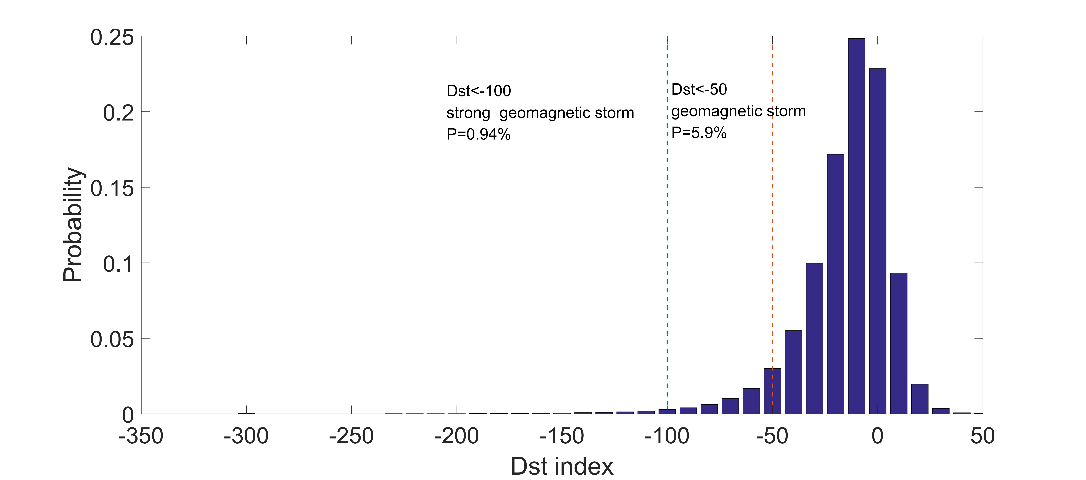
Fig. S1 Distribution of strong storms based on the Dst index between 1957 and 2020; the orange line denotes Dst at (<= -50 nT), and the light blue line denotes Dst at (<= -100 nT).

Fig. S2 shows the monthly count of strong geomagnetic storms. One hour was recorded as one count in this figure. For example, a 3-hour storm is counted as three storms. The high probability of a strong geomagnetic storm occurred around April and October. Fig. S3 shows the yearly count of geomagnetic storms that occurred each year. Fig. S4 shows the FFT result of the yearly count of storms from 1957 to 2020. There is a 10.7-year peak, which corresponds to the 11-year solar cycle.
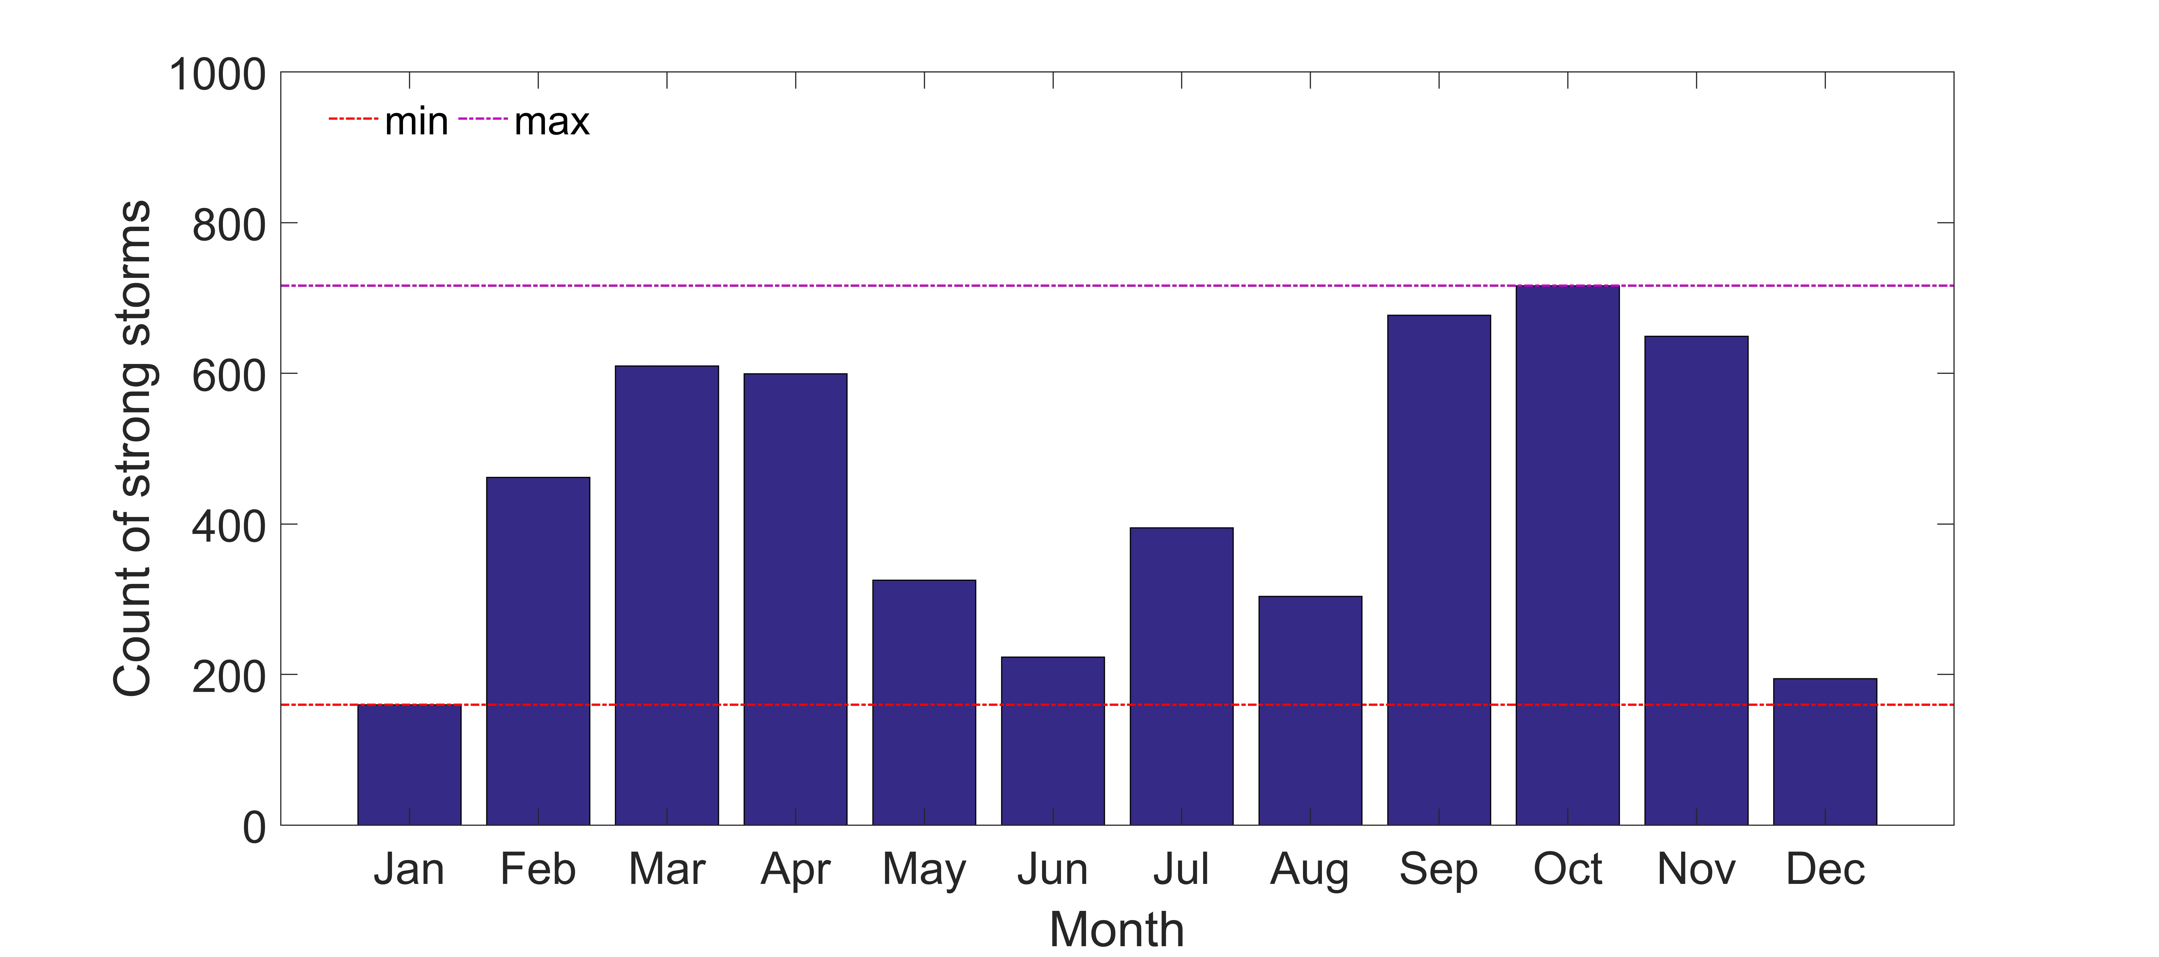
Fig. S2 Monthly cumulative count of strong geomagnetic storms based on the Dst index from 1957 to 2020.
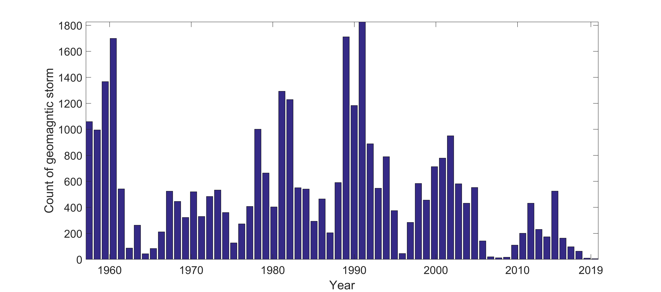
Fig. S3 Yearly cumulative count of geomagnetic storms based on the Dst index from 1957 to 2020.
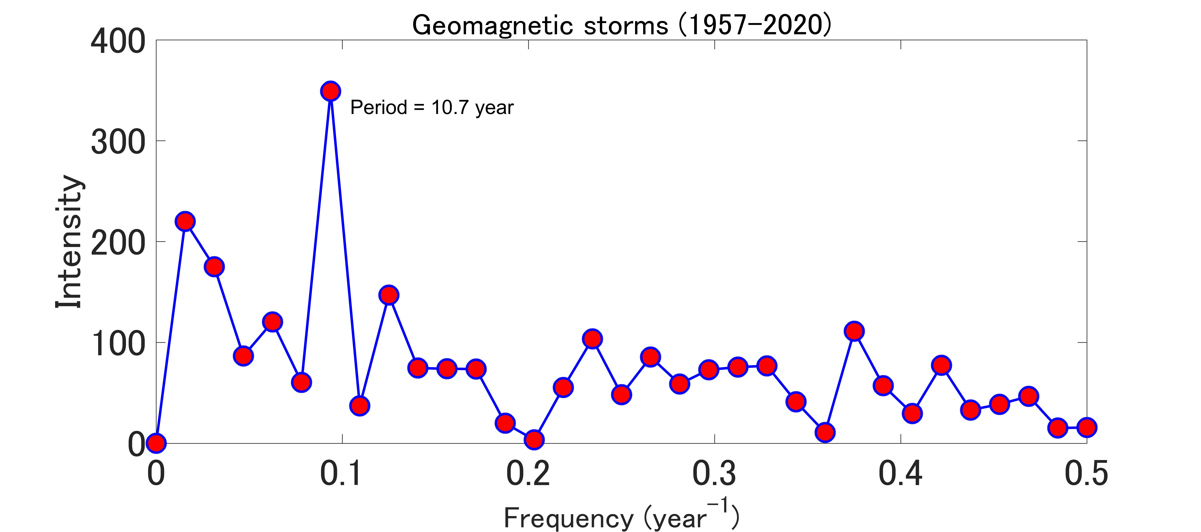
Fig. S4 Periods calculated by Fourier analysis using the yearly count of geomagnetic storms from 1957 to 2020.

This section concludes that the geomagnetic storm has a seasonal and 11-year solar cycle, and the strong geomagnetic storms do not occur frequently.

2 Supplementary information for TNV48
Fig. S5 shows the variation in the Dst index. We can confirm that the geomagnetic storm started at approximately 18:00 on June 21 and ended at approximately 00:00 on June 24.
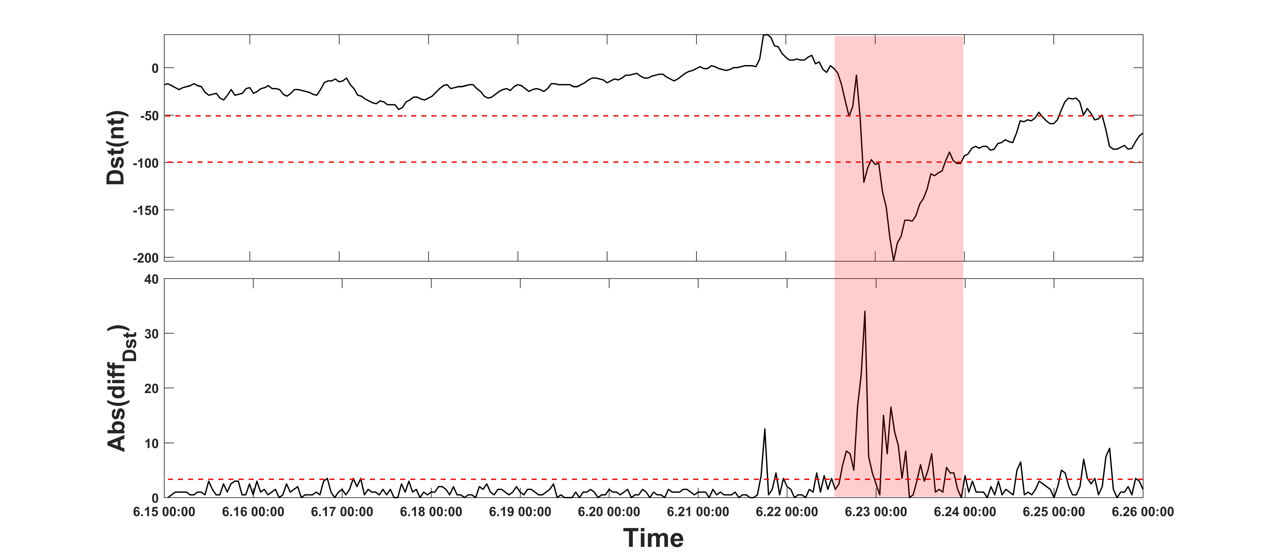
Fig. S5 Variation in the Dst index. The upper figure shows the variation in the Dst index. The lower figure shows the absolute value of Diff(Dst); the red dashed line denotes 1.5σ (σ is the standard deviation). The horizontal axis denotes the time in UTC.

