Additional Materials
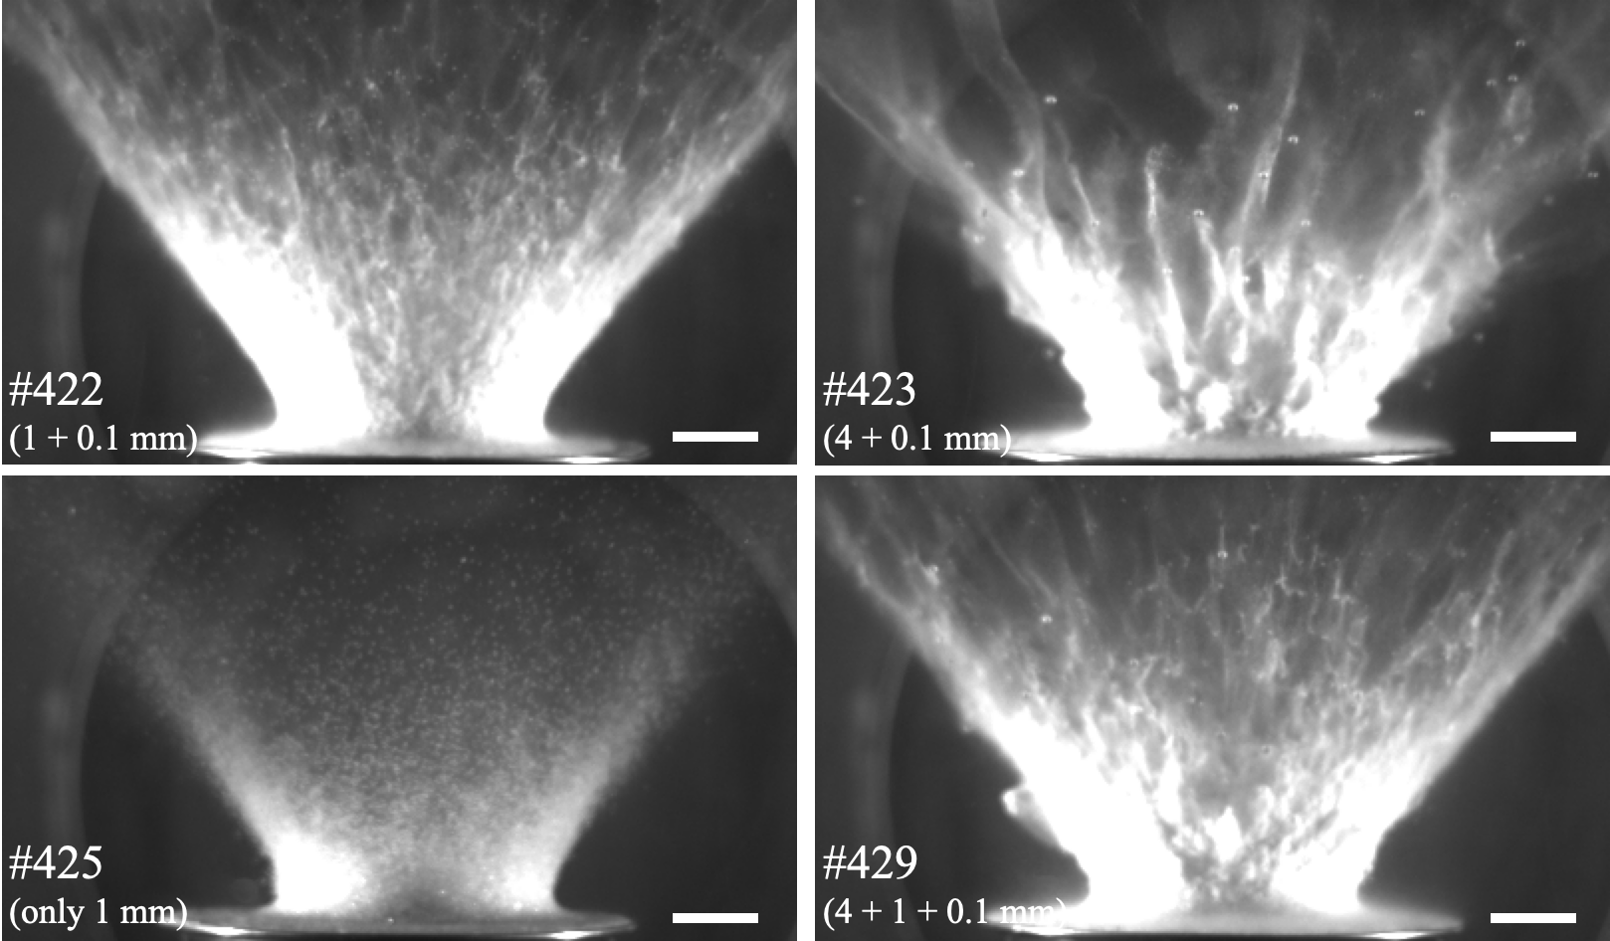
Fig. S1 The ejecta curtain observed by Kadono et al. (2019) at 28 ms after the impact. Horizontal white bar indicates 50 mm. The impact conditions except for the target are the same as those in our experiment.

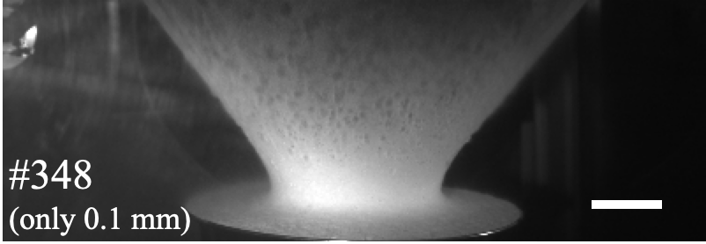
Fig. S2 The ejecta curtain observed by Kadono et al. (2020a) at 28 ms after the impact. Horizontal white bar indicates 50 mm. The impact conditions except for the target are the same as those in our experiment.

