S1 (a). Location of the MT sites in this study. The red rectangle is the sill-like pressure model of the ground inflation from 2016 to 2017 (Faculty of Science, Hokkaido Univ. 2019). M20 and M24 were calculated using the horizontal geomagnetic field data at M22 or M25, assuming a plane wave approximation for the magnetic field incident to the ground based on magnetotelluric theory.
S1 (b). The overall calculation area used for the inversion (left panel) and the close-up view of the central area. The cells corresponding to the atmosphere were omitted from the figure.
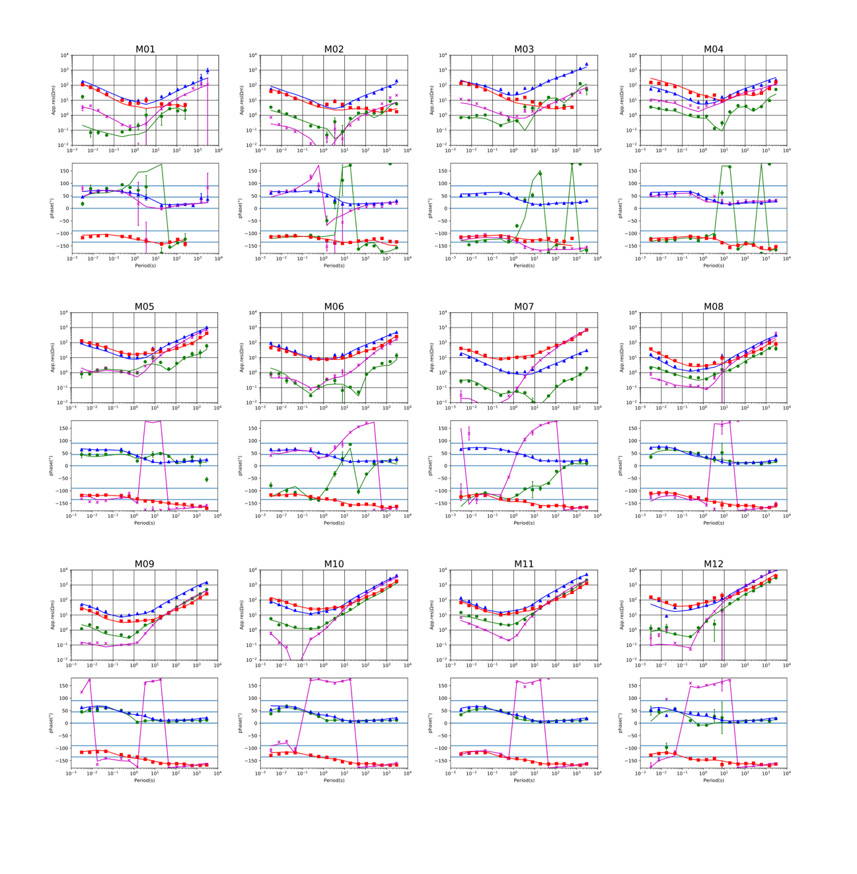
S2. Apparent resistivities and phases at all sites in the survey. The dots indicate the observed data, while the solid lines represent synthetic ones from the optimal resistivity model shown in Fig. 3.
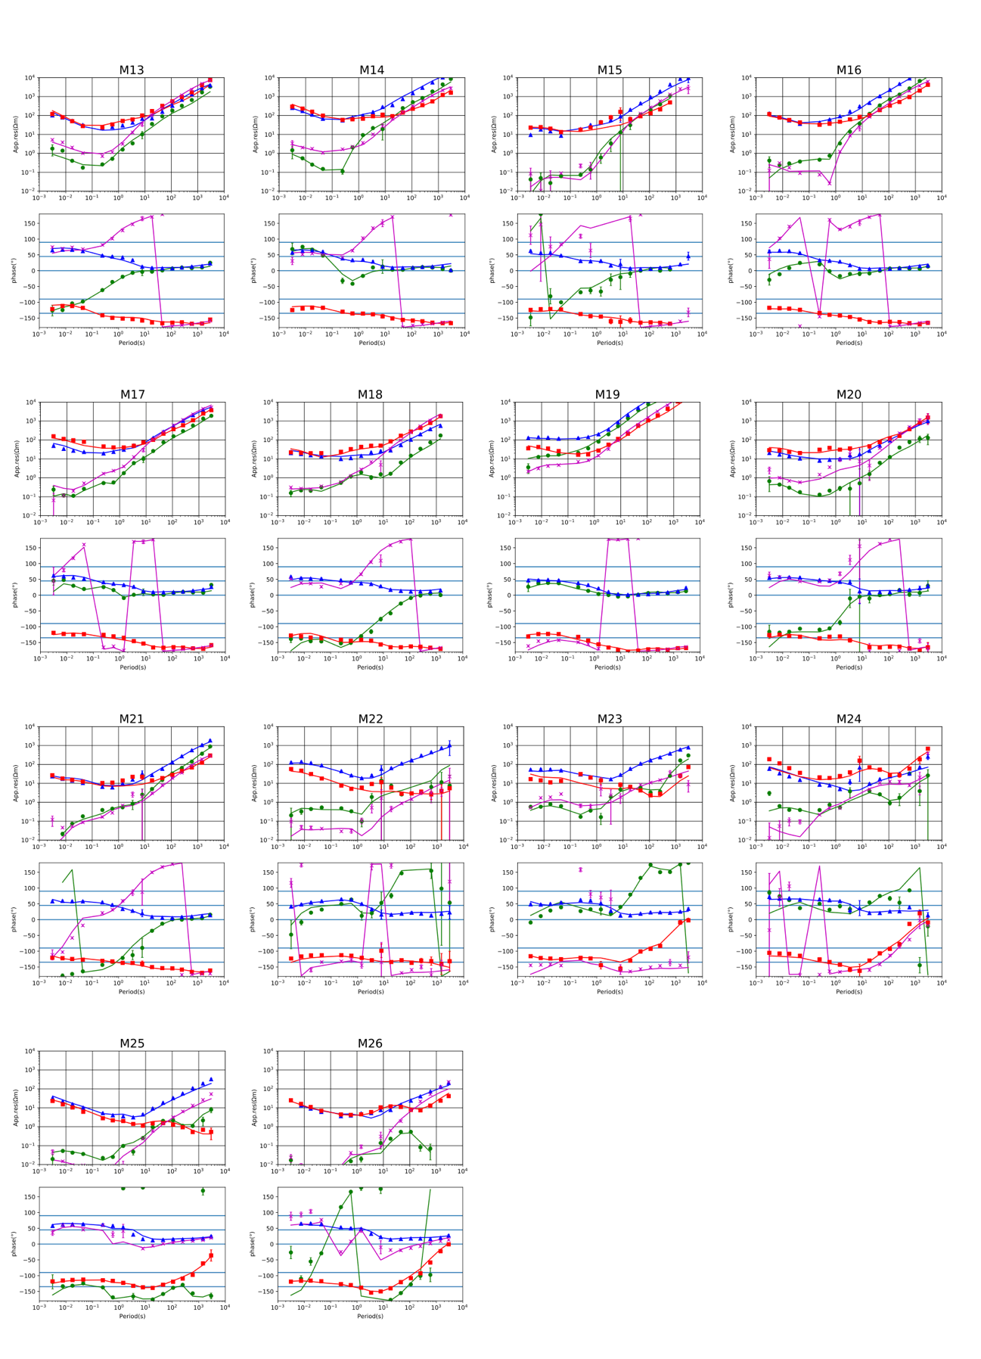
S2. (continued).

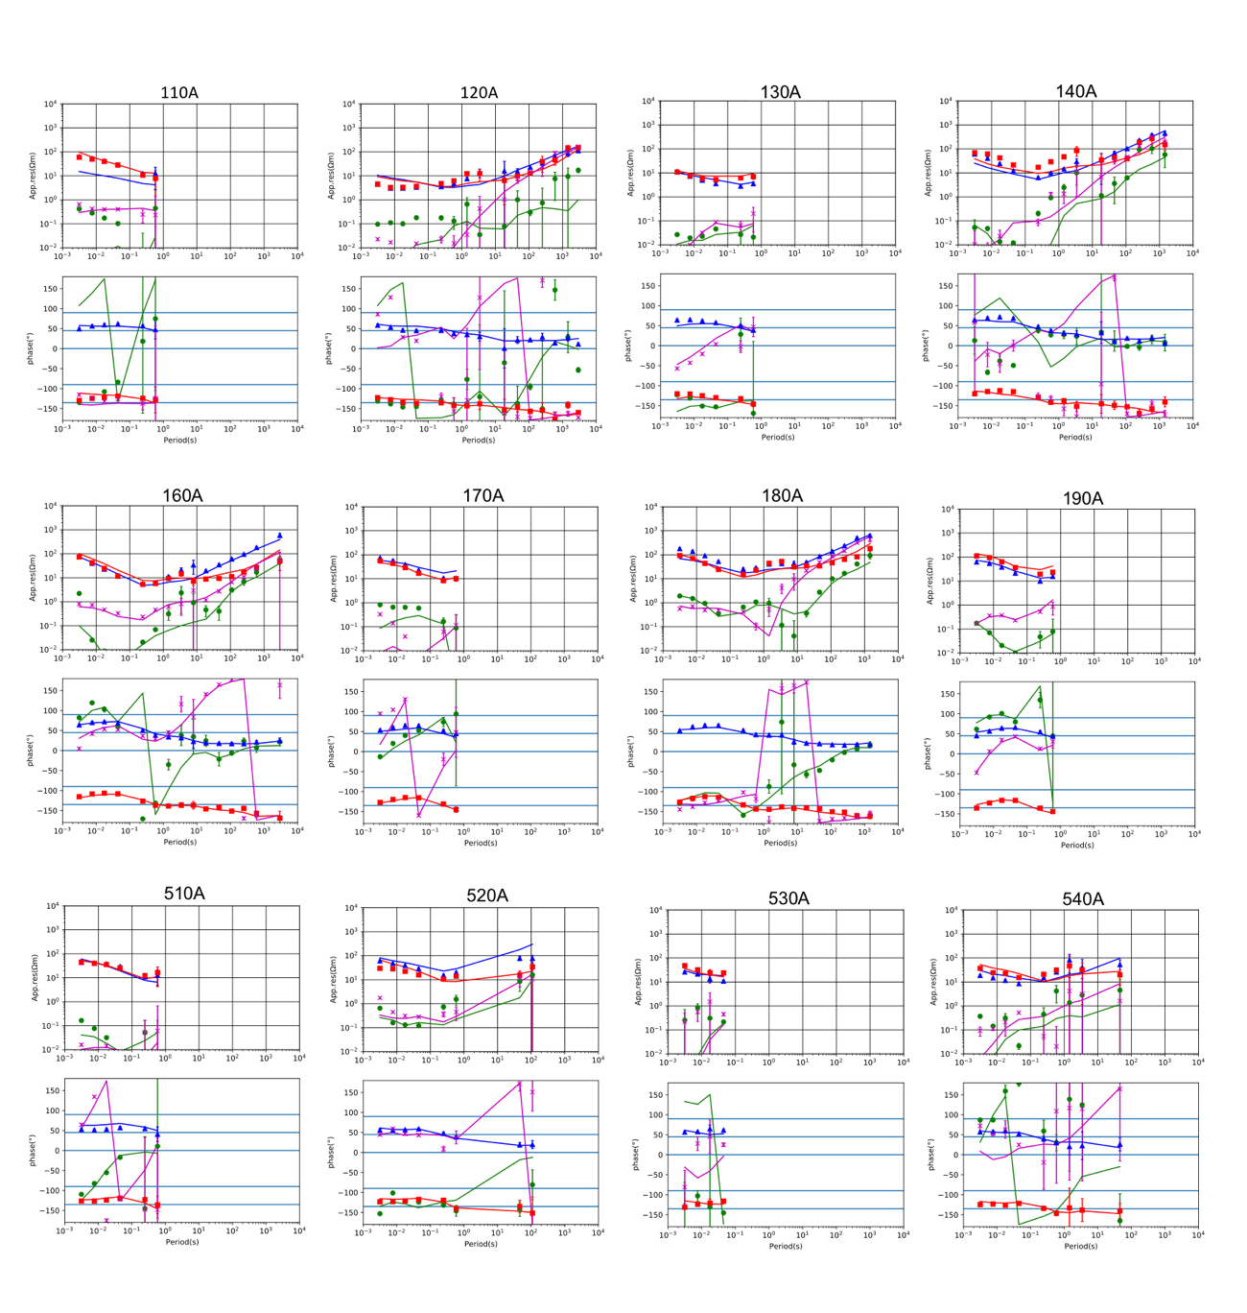
S2. (continued).

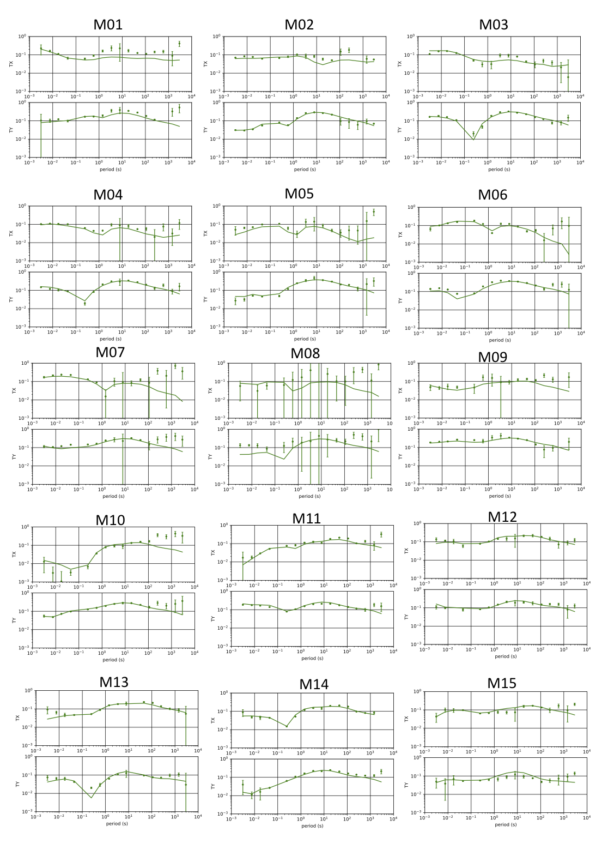
S3. Tipper curves at all sites in this survey. The dots indicate the observed data, while the solid lines represent synthetic ones from the optimal resistivity model shown in Fig. 3.

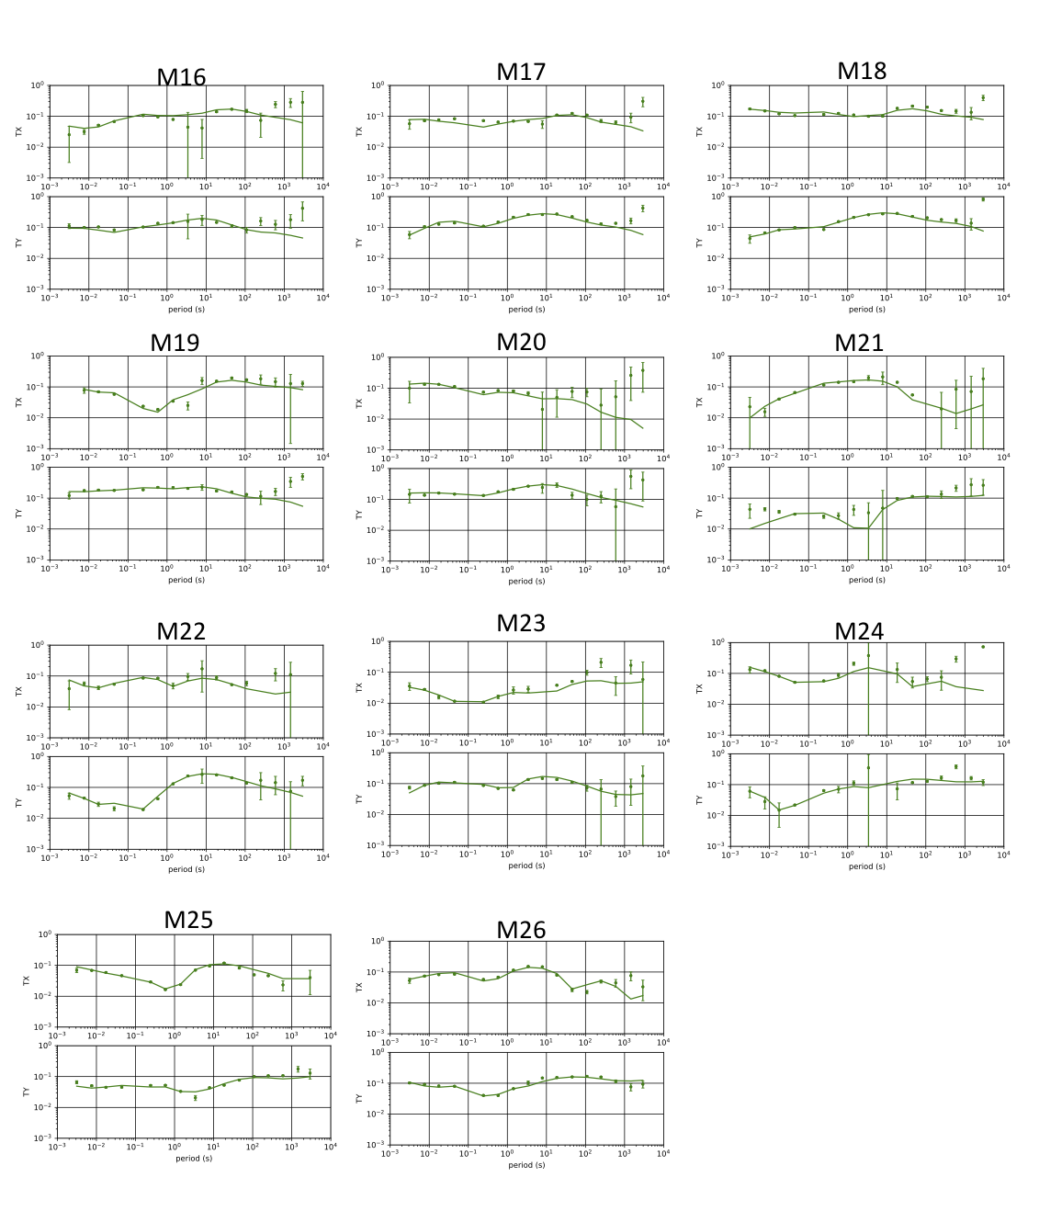
S3. (continued).

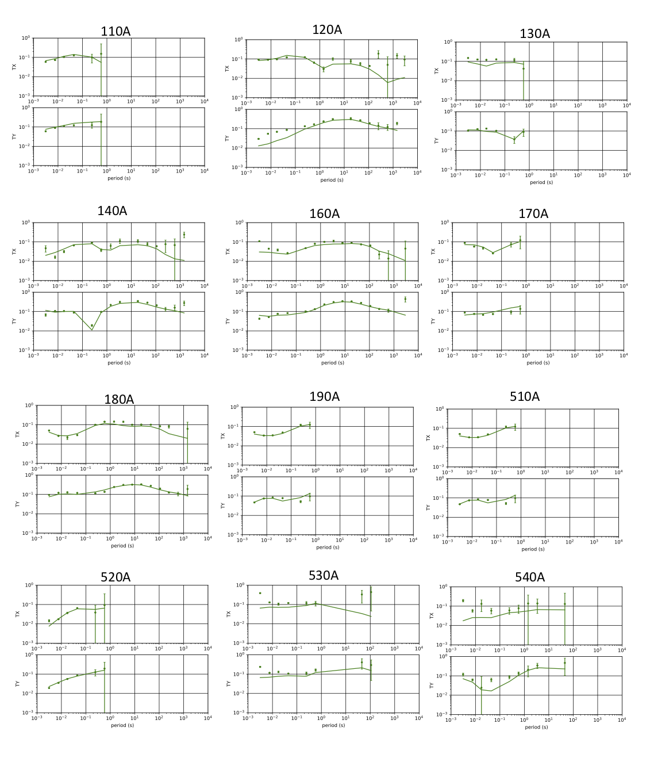
S3. (continued).

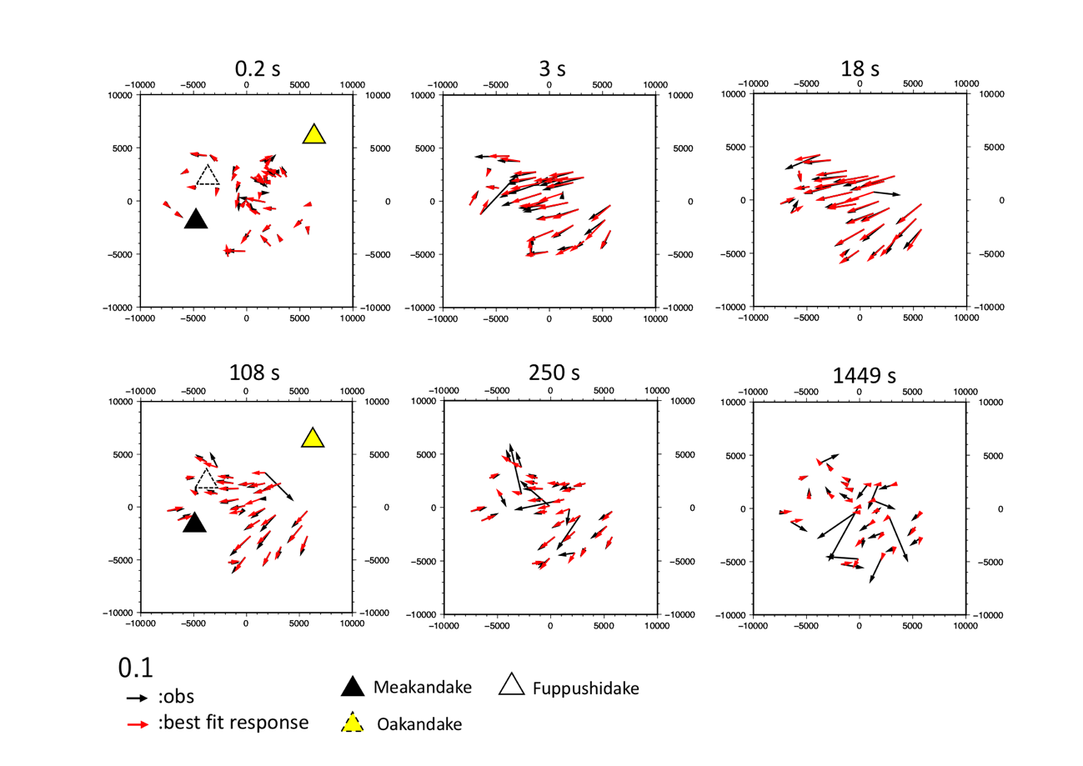
S4. (a)Distribution of the induction vectors（observation and the best model response）．
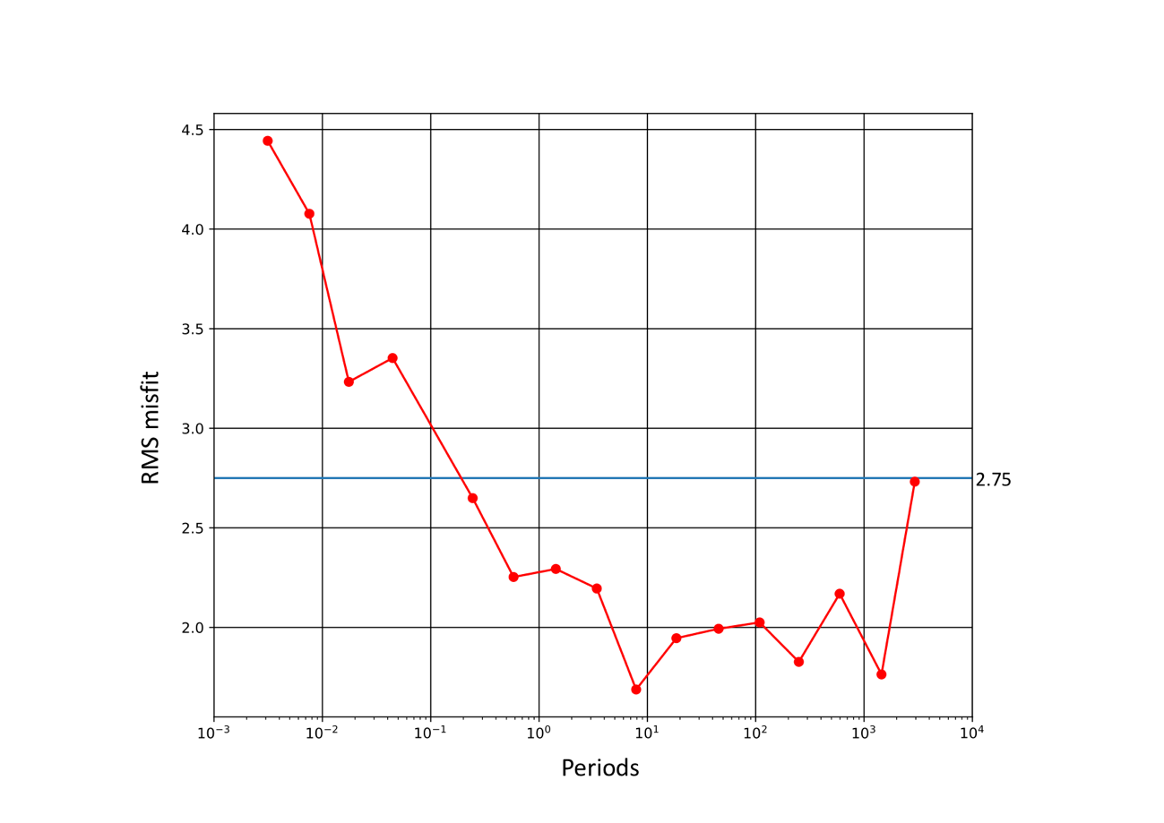
S4 (b). The plot of RMS misfit for each period.
S5. The cross section (E-W) of the modified model in the example of C1 sensitivity tests.

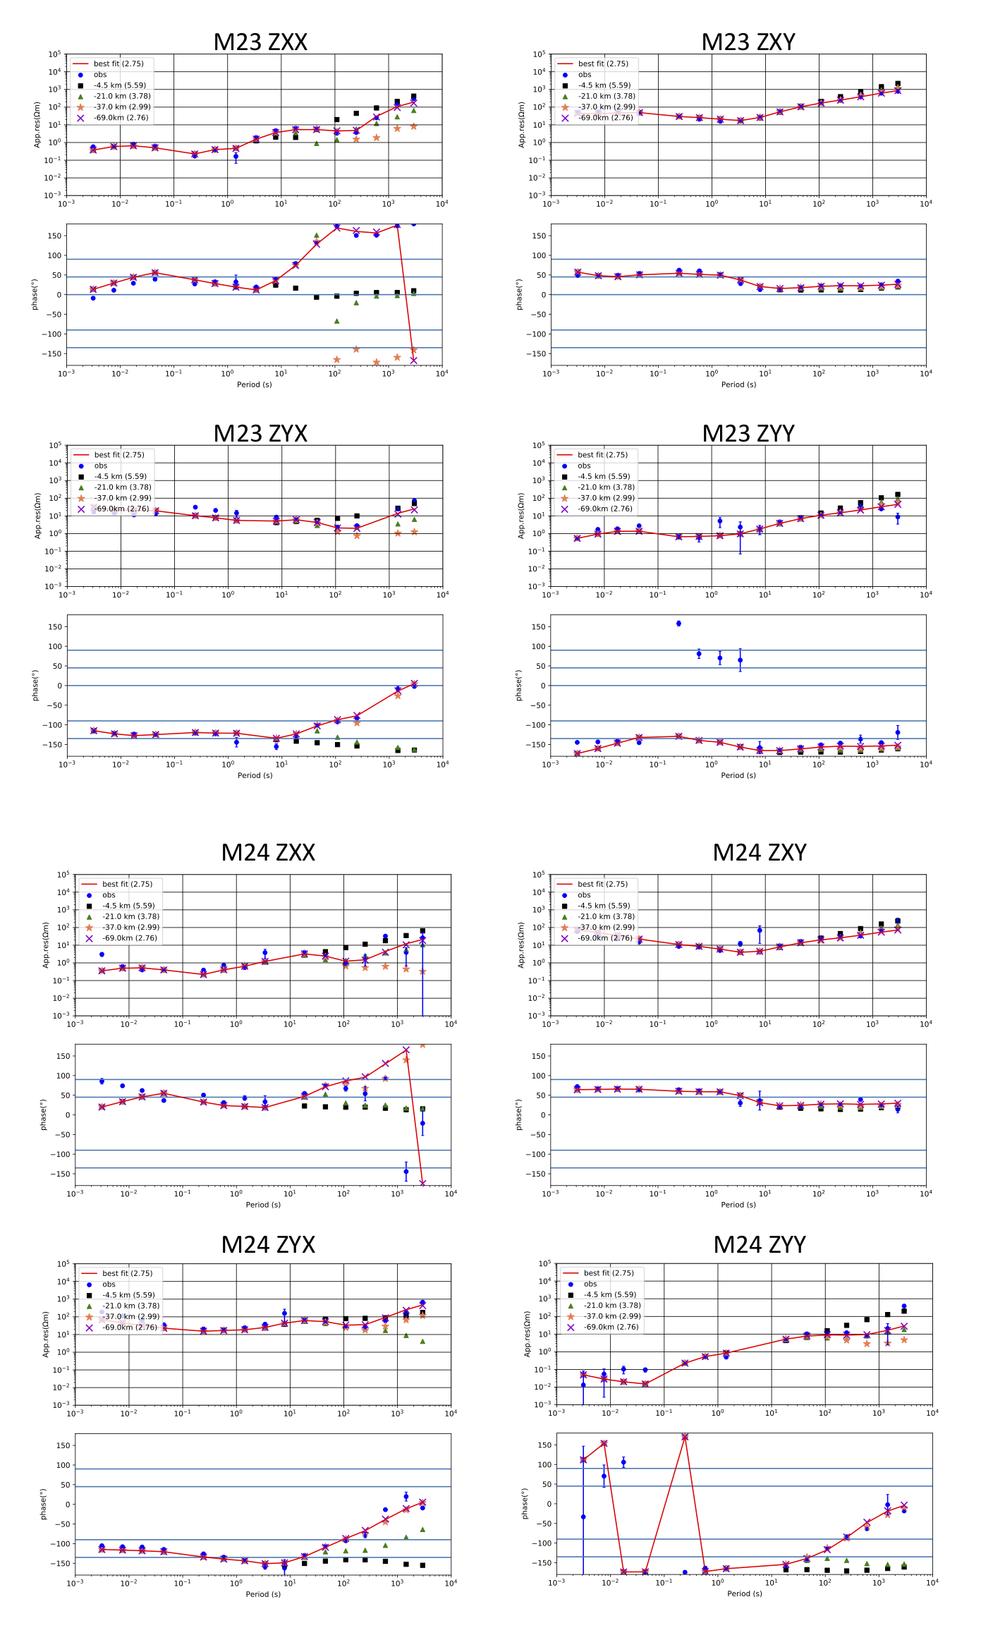
S6 (a). The response curves of the full impedance components at site M23, M24, M25 and M26 when the lower limit of C1 was varied. Each symbol in the figures represents the model response when D_{max} is varied. The values in parentheses are the RMS misfit values for the model.
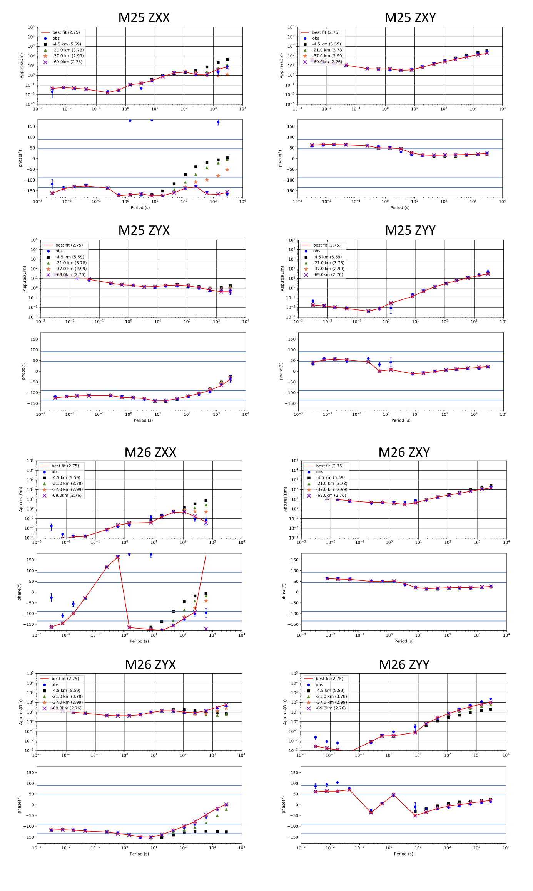
S6 (a). (continued).

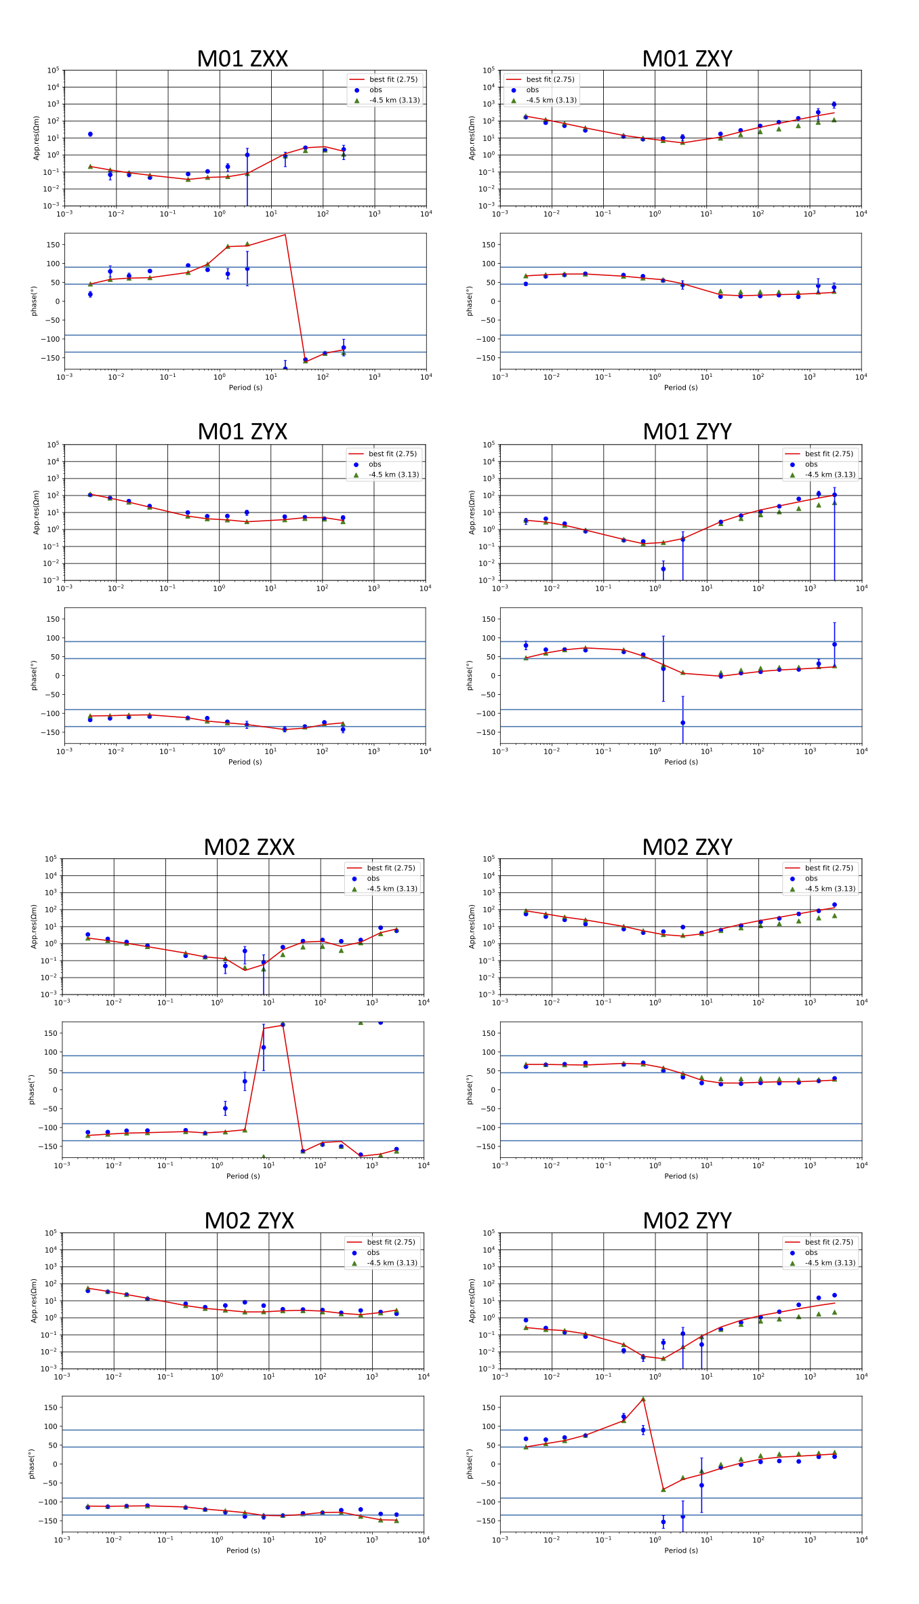
S6 (b). The response curves of the full impedance components at site M01, M02 and M03 when the lower limit of C2 was varied to -4.5 km. Each symbol in the figures represents the model response when D_{max} is varied. The values in parentheses are the RMS misfit values for the model.
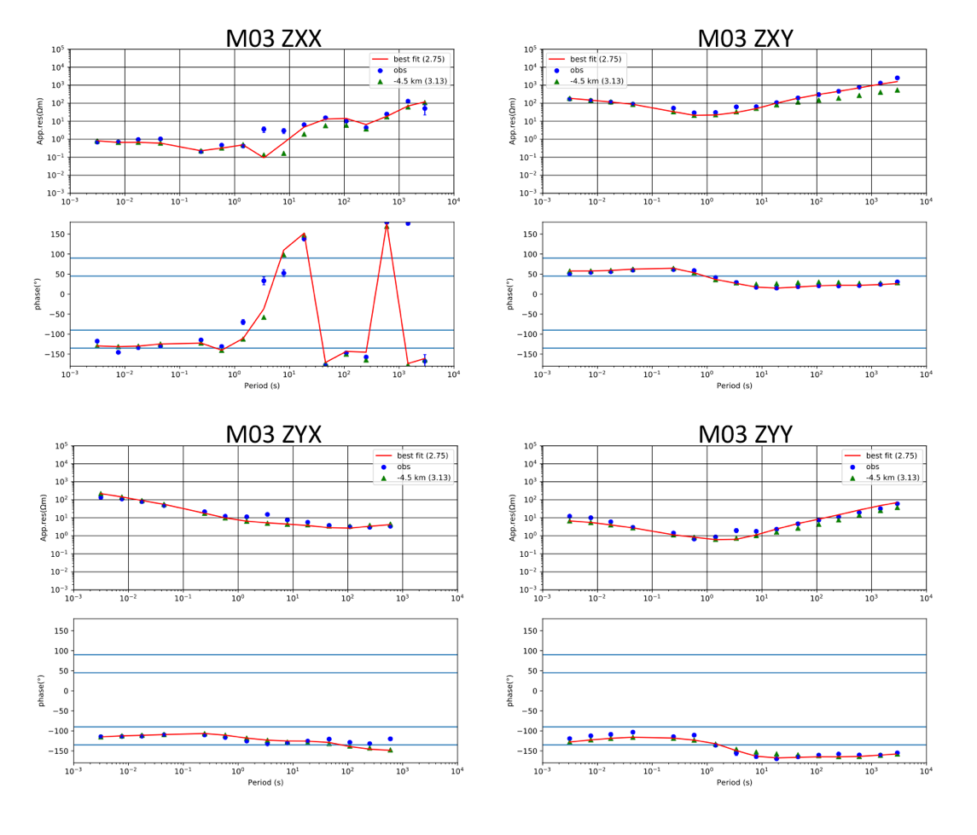
S6 (b). (continued).

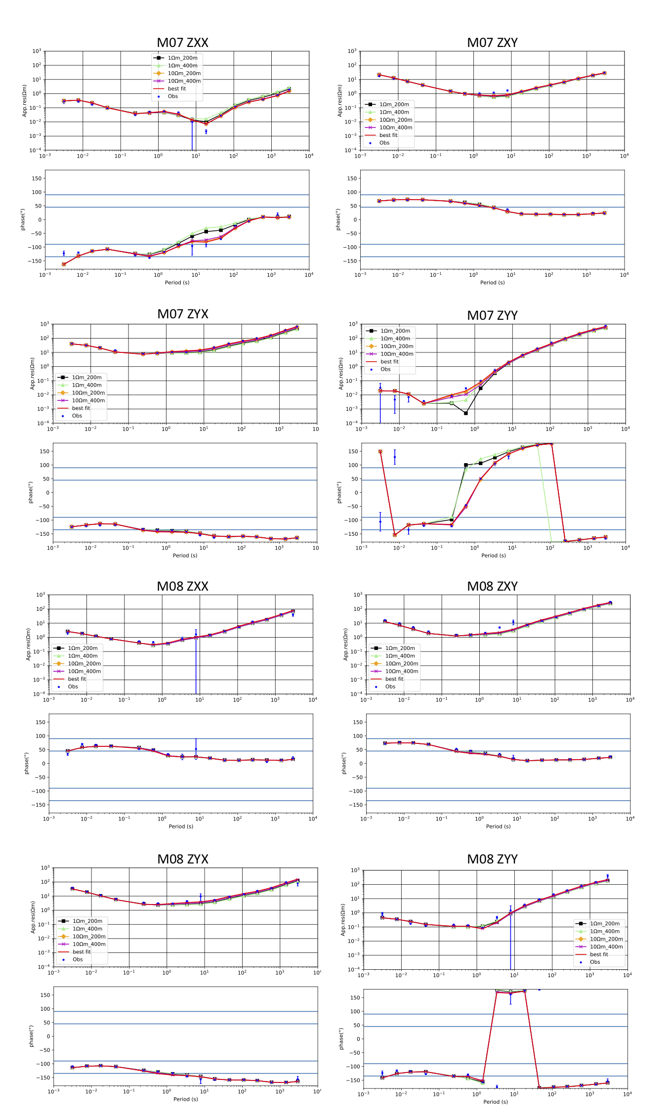
S6 (c). The response curves of the full impedance components at site M07, M08 and 180A when the bulk resistivity value and the thickness of Ca were varied.
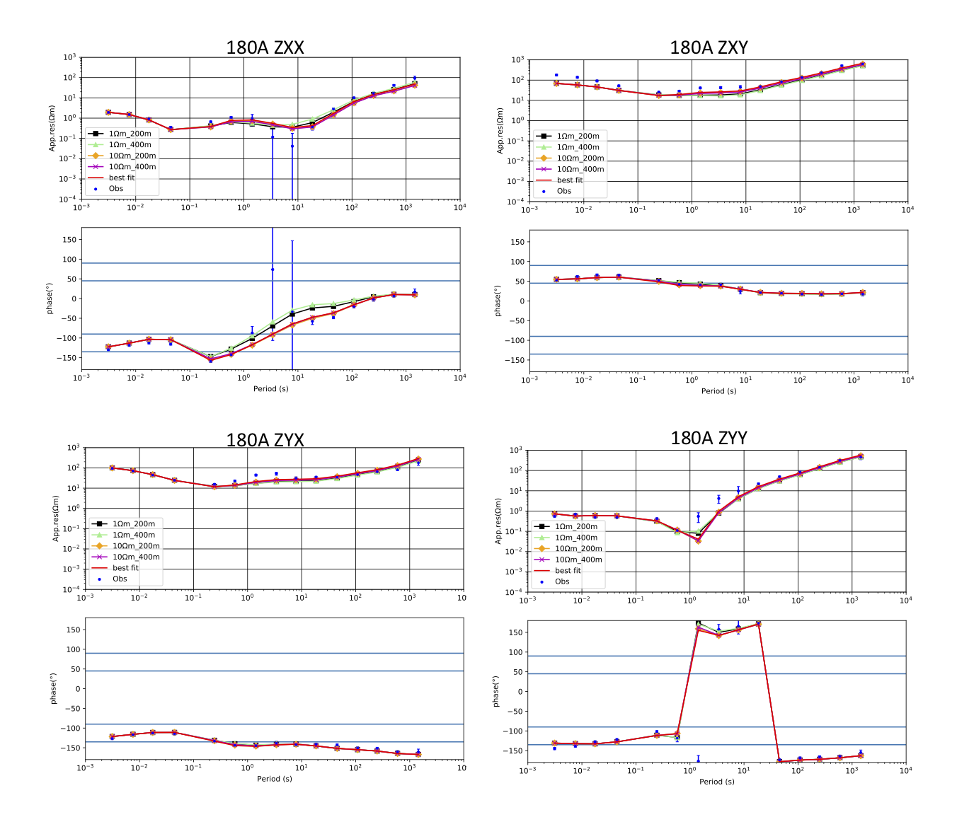
S6 (c). (continued).

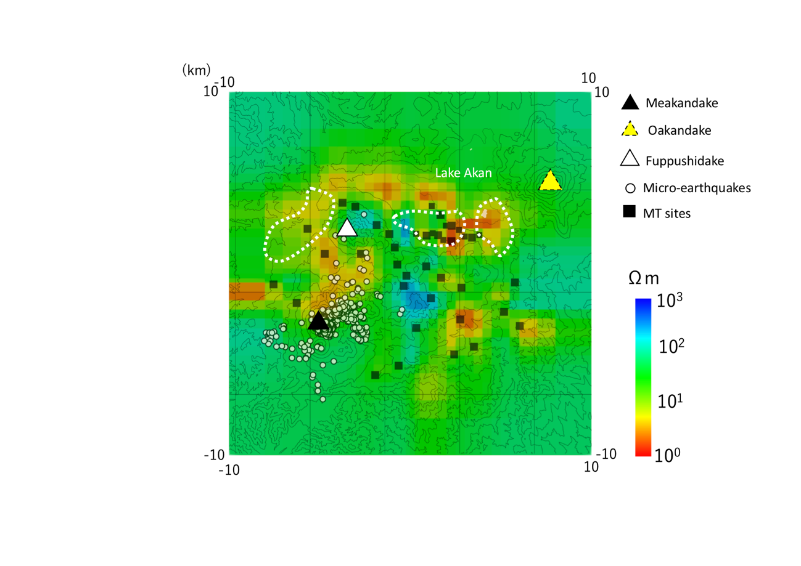
S7. The best-fit resistivity model sliced at 0 km BSL. The low resistivity anomalies appeared in the lakeside south shore of Lake Akan and the region around of Mt. Fuppushidake. The white dashed line indicates three low gravity anomalies (Hasegawa et al., 2009).

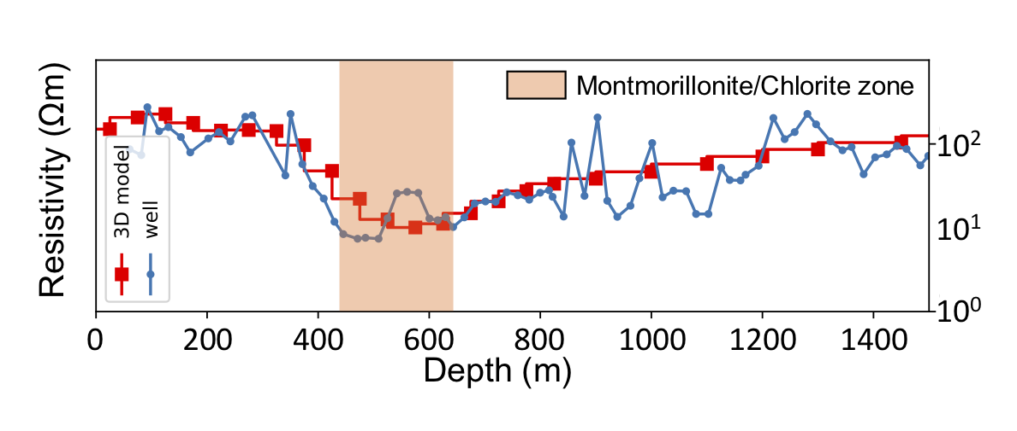
S8. Comparison between our MT model and the electrical well logging by NEDO (1992) at the drilling site shown as a cross symbol in Fig. 1. The montmorillonite/chlorite zone reported in NEDO (1992) is hatched.

