Supporting information
Crustal structure beneath earthquake swarm in the Noto peninsula, Japan

Junichi Nakajima

Department of Earth and Planetary Science,
School of Science, Tokyo Institute of Technology, Japan
E-mail: nakajima@geo.titech.ac.jp

Supporting information includes Figures S1 to S7.
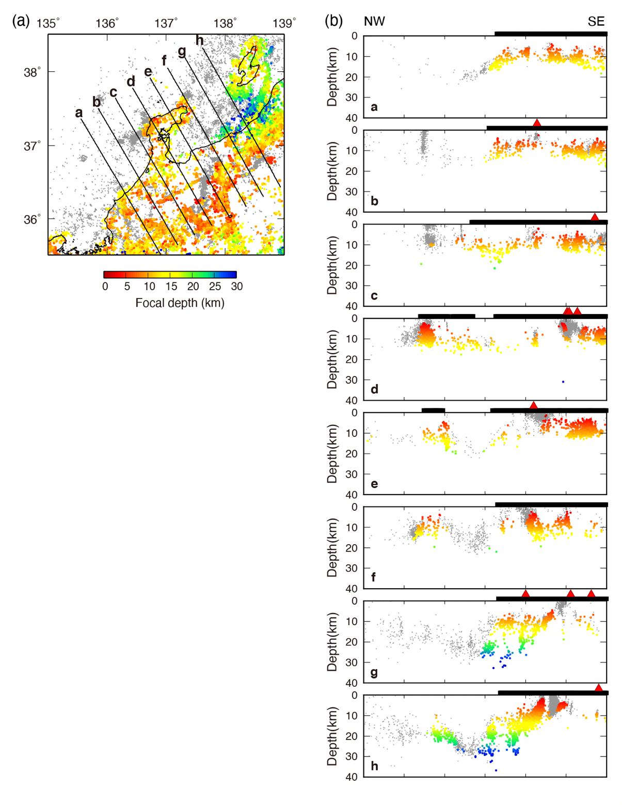
Figure S1. (a) Map showing distribution of the JMA hypocenters (M≥1) (gray dots) that occurred at depths of 0–60 km from January 2003 to March 2022. Colored dots denote earthquakes that satisfied the condition H_{dep} > D_{min} (see text for details), which are used in the tomographic inversions. (b) Vertical cross sections of hypocenters along eight profiles (a–h) in (a) that occurred within 10 km from each profile. Black bars and red triangles on the surface represent the land areas and active volcanoes, respectively.
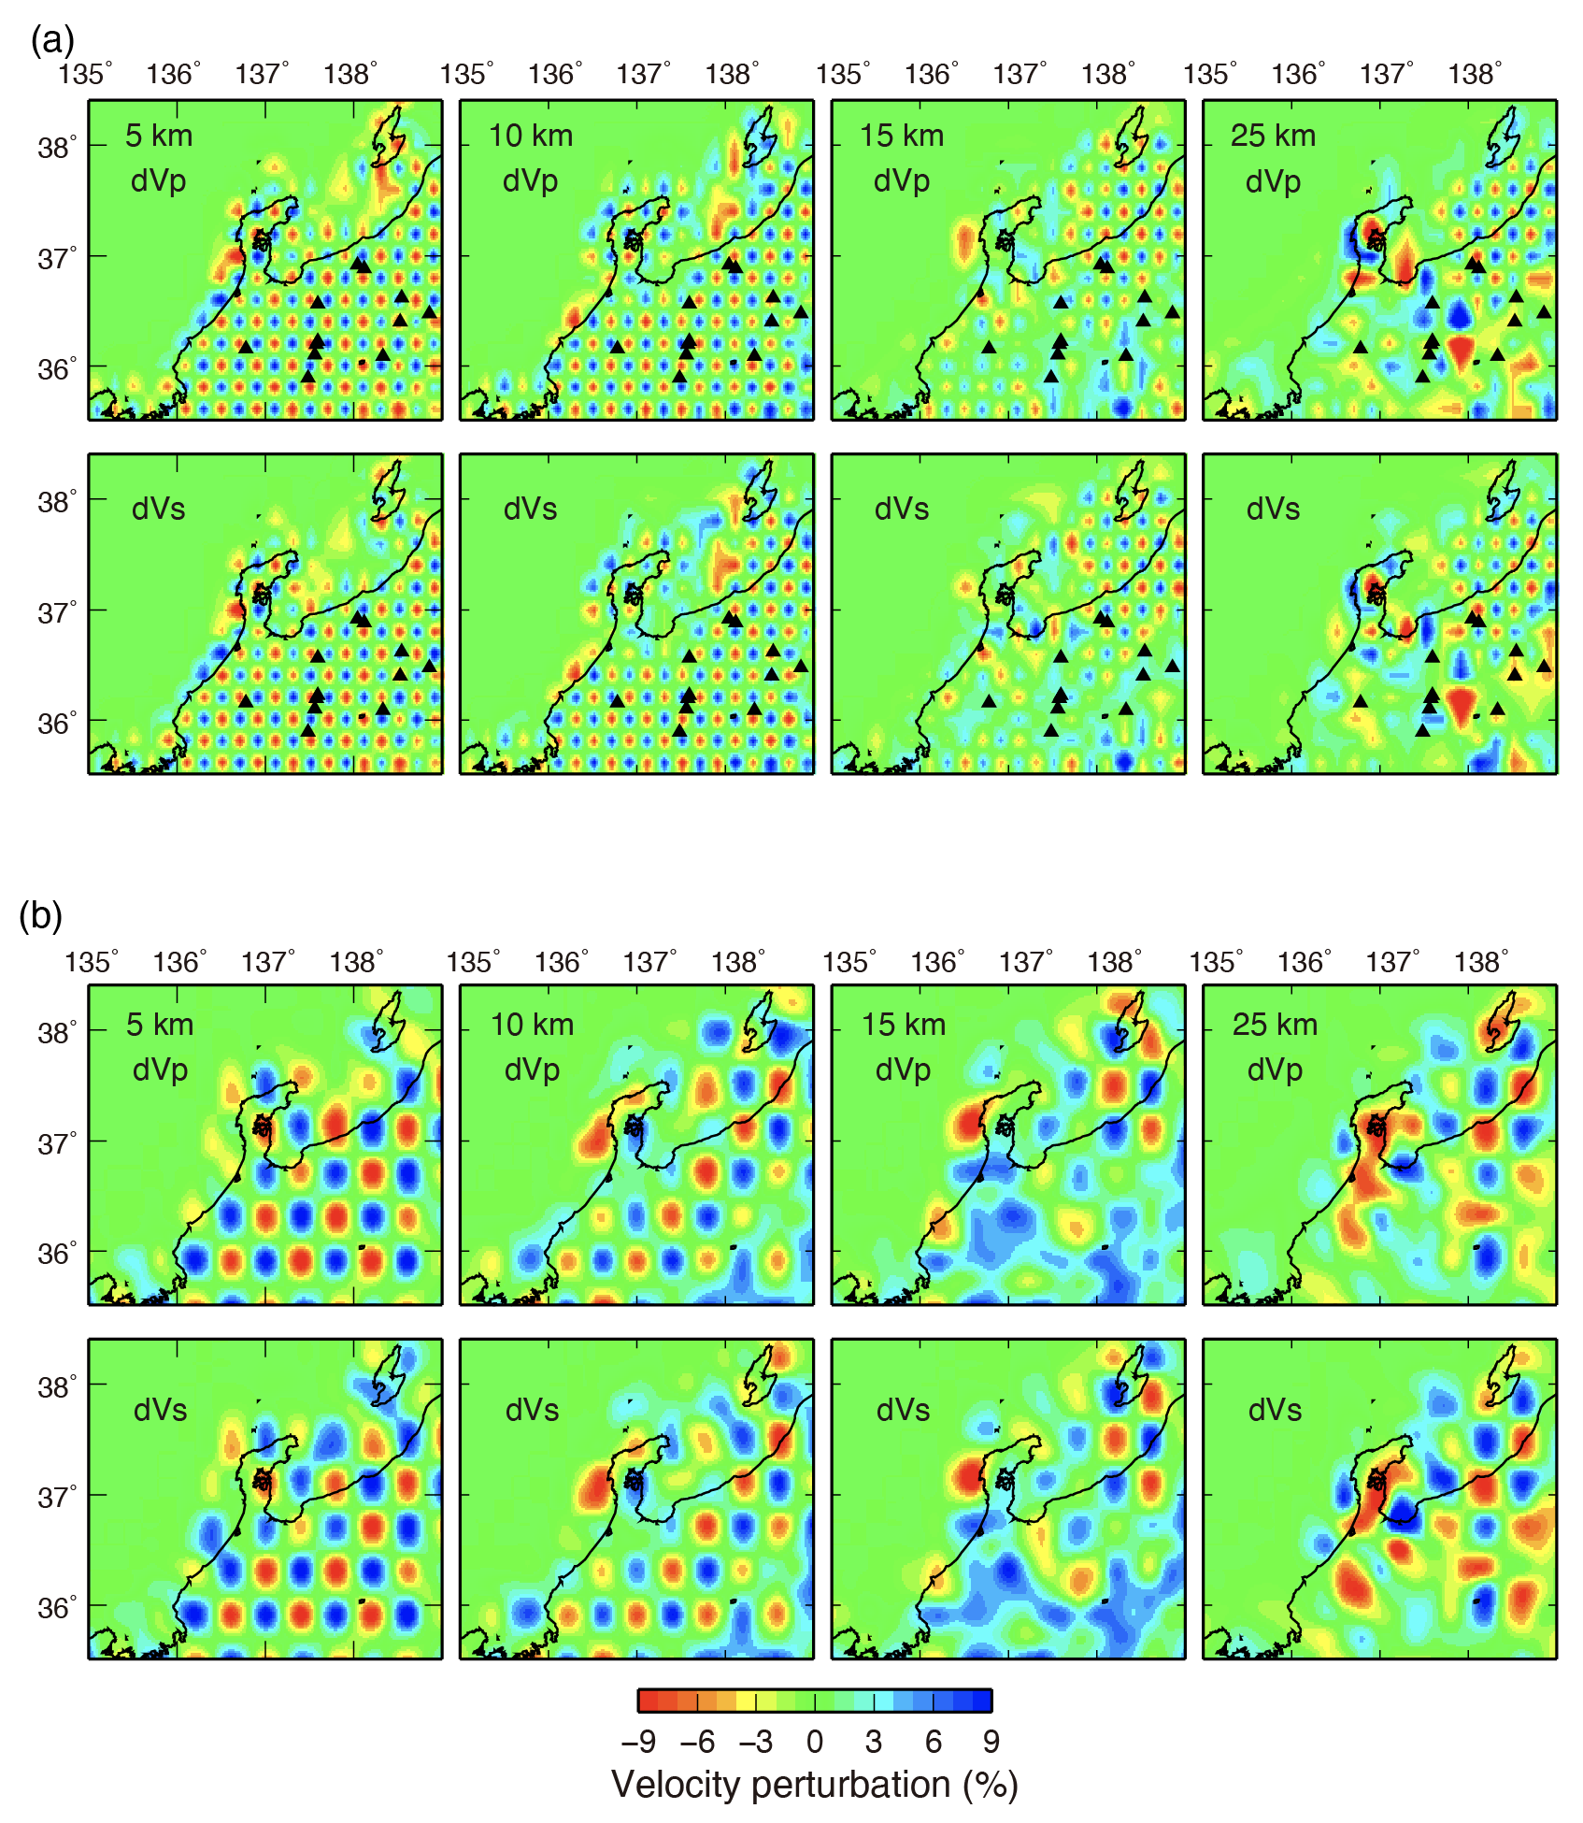
Figure S2. Results of checkerboard resolution tests of P and S waves at depths of 5, 10, 15, and 25 km. (a) Results of velocity anomalies that assigned to alternate grid nodes. (b) Results of velocity anomalies that assigned to every two grid nodes.

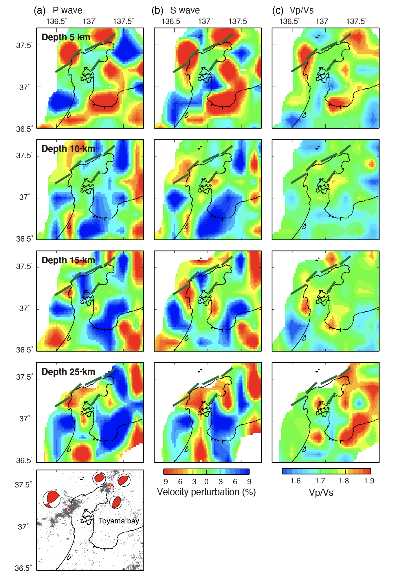
Figure S3. (a) P-wave and (b) S-wave velocity perturbations and (c) Vp/Vs ratios at depths of 5, 10, 15, and 25 km. Velocity perturbations are the deviations from the average velocity at each depth. Regions with the deviated weight sum of greater than 1,000 are shown. Location of major active faults and segments are shown by green lines (see Hiramatsu, 2022). Distribution of hypocenters (gray dots) and the F-net focal mechanisms for the 2007 M6.9 Noto-Hanto earthquake and three M≥5 earthquakes in the Noto earthquake swarm are shown in the inset.

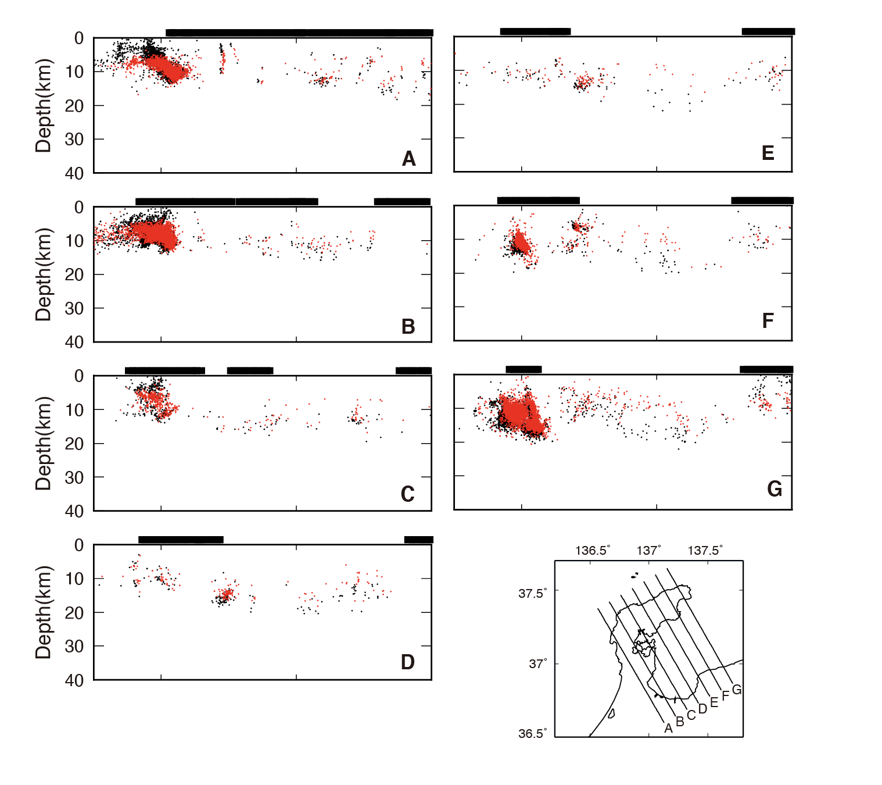

Figure S4. Vertical cross sections of JMA original (black) and relocated (red) hypocenters (M≥1) with the 3D velocity model along seven profiles shown in the inset map.

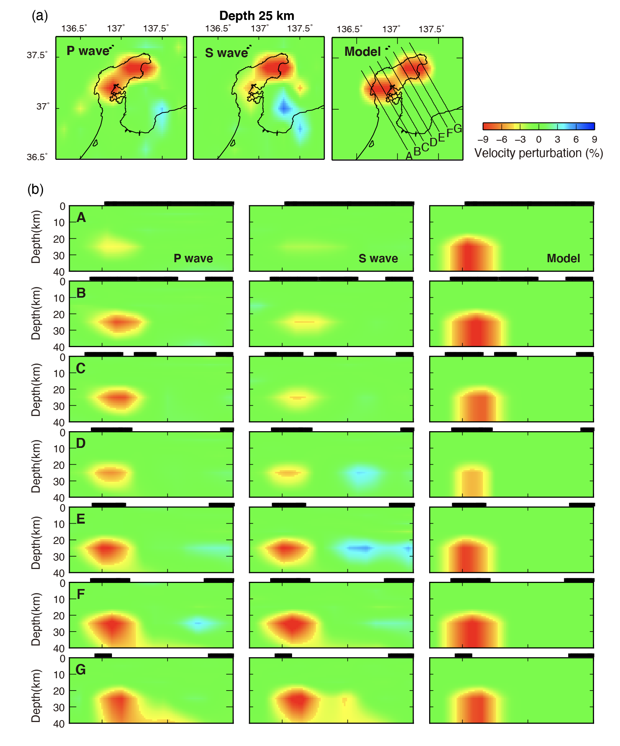
Figure S5. Results of sensitivity test of P and S waves (a) at a depth of 25 km and (b) along seven profiles. The model panels show the distribution of a velocity anomaly that assigned to the synthetic model (see text for details).

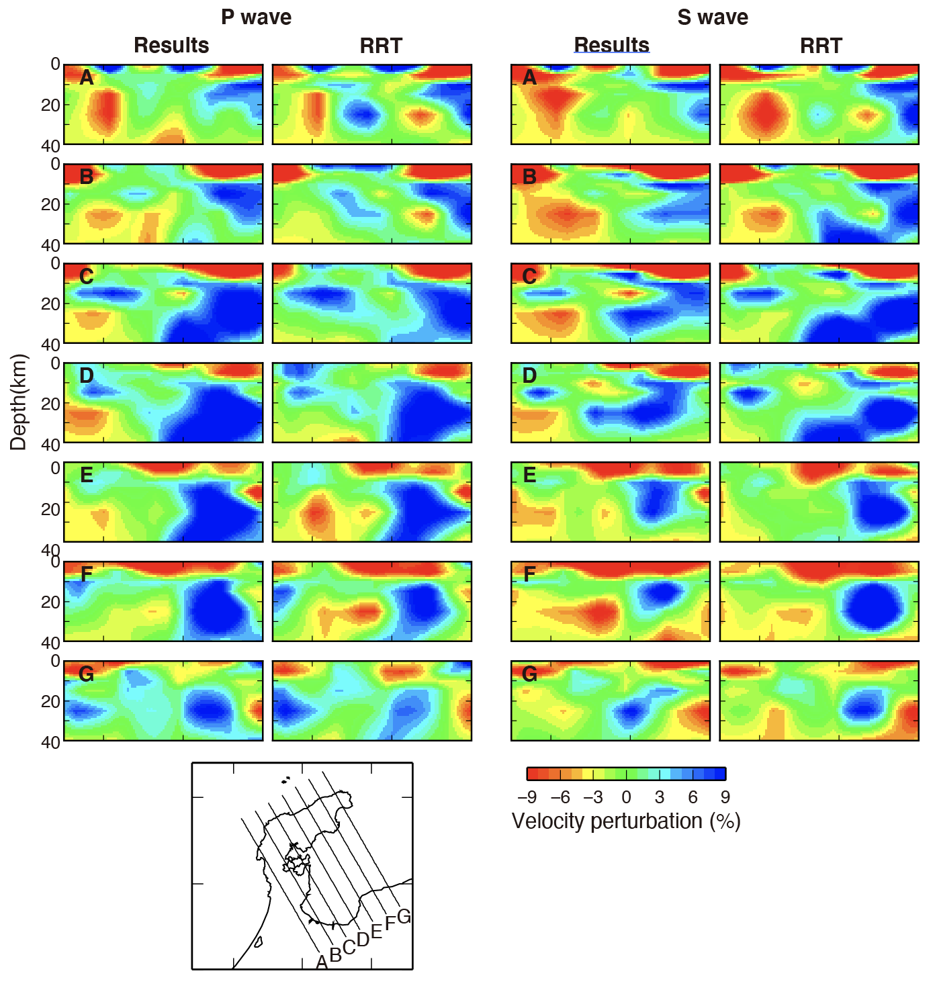
Figure S6. Results of the real inversion and restoring resolution test of P (left) and S (right) waves along seven profiles shown in the inset map.

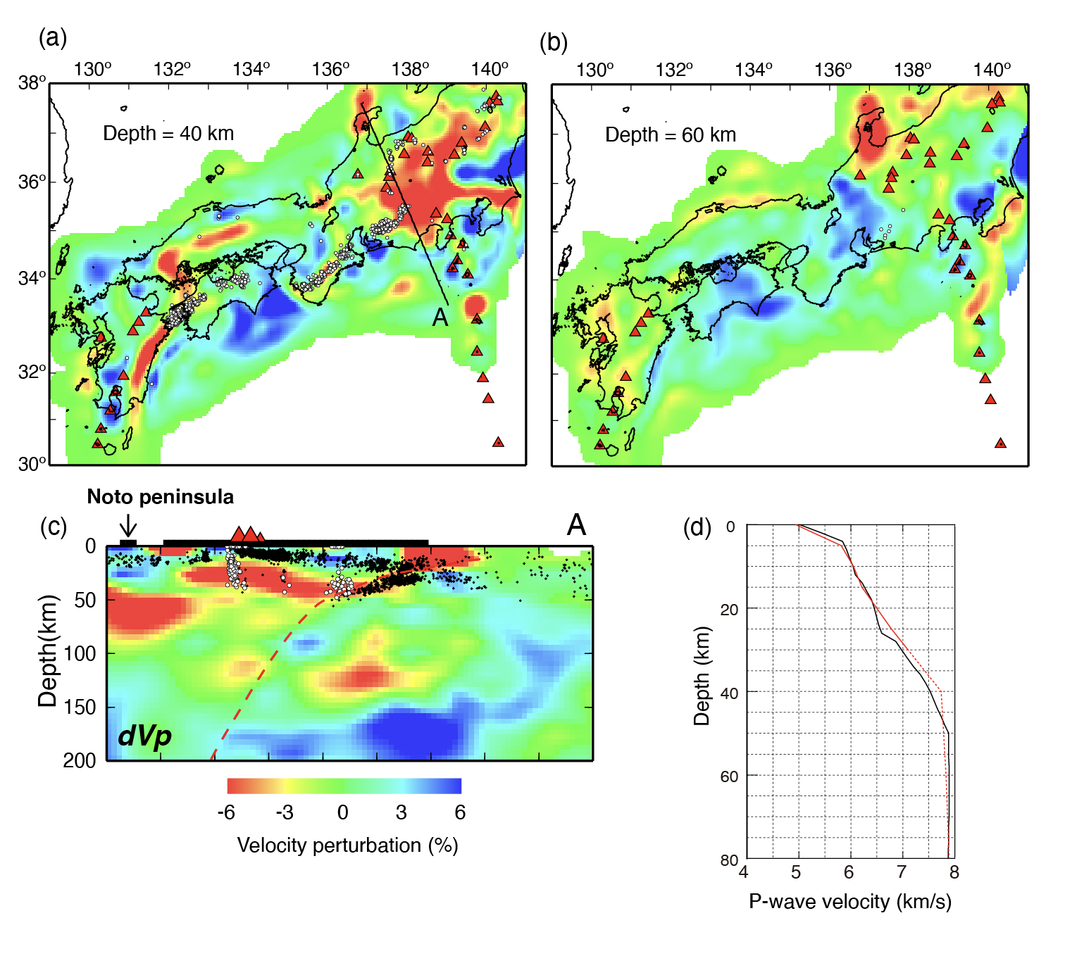
Figure S7. Examples of regional tomographic study (modified from Nakajima and Hasegawa, 2007a). Distribution of P-wave velocity at a depth of (a) 40 and (b) 60 km. (c) A vertical cross section of P-wave velocity structure along profile A in (a). The location of the Noto peninsula is indicated by an arrow. (d) The average P-wave velocities after the tomographic inversions derived from this study (red line) and from Nakajima and Hasegawa (2007a) (black line). P-wave velocity perturbations shown in each figure are the deviation from this average velocity. It is noted that this study cannot resolve seismic velocities at depths of ≥30 km (red dashed line).

