Additional file
Middle Miocene Alkaline Magmatism in Amami-Oshima Island, central Ryukyu Arc: Implications for Paleoreconstruction of Shikoku Basin

Ginta Motohashi^{1,2, 3}, Osamu Ishizuka², Hirokuni Oda², Takashi Sano⁴, Shun Sekimoto⁵ Kohtaro Ujiie⁶

¹ Graduate school of Life and Environmental Sciences, University of Tsukuba, Tsukuba, Japan.
² Geological Survey of Japan, National Institute of Advanced Industrial Science and Technology, Tsukuba, Japan.
³ INPEX Corporation, Akasaka, Japan.
⁴ Department of Geology and Paleontology, National Museum of Nature and Science, Tsukuba, Japan.
⁵ Institute for Integrated Radiation and Nuclear Science, Kyoto University, Osaka, Japan.
⁶ Faculty of Life and Environmental Sciences, University of Tsukuba, Tsukuba, Japan.

Corresponding author: Ginta Motohashi (motohashi.ginta.md@alumni.tsukuba.ac.jp)

Additional file Text
Texts S1–S3
Additional file Figure
Figures S1–S9
Additional file Table
Tables S1–S5

a

Text S1 Methods
Text S1-1. ⁴⁰Ar-³⁹Ar dating analyses
⁴⁰Ar/³⁹Ar dating was conducted on plagioclase in basaltic dike samples at the Geological Survey of Japan (GSJ Lab.), AIST. Details of the procedures have been reported by Ishizuka et al. (2018). Basaltic dike samples (160–175 g) were disaggregated using a high-voltage electric pulse fragmentation device (SELFRAG Lab) and sieved to 150–350 μm at the NMNS. Ten grams of the samples were treated in 6N HCl for 30 min at 95 °C while stirring to remove any alteration products (clays and carbonates) present in interstitial spaces. After this treatment, 20–25 mg of fresh plagioclase was handpicked under a microscope. Sample irradiation was performed at the Kyoto University Reactor (KUR) for 10 h at the hydro-irradiation port under 1 MW operation, where the thermal and fast neutron fluxes were 1.6 × 10¹³ and 7.8 × 10¹² n/ cm² s, respectively. Sanidine separated from the Fish Canyon Tuff (FC3) was used for flux monitoring and assigned an age of 27.5 Ma (Lanphere and Baadsgaard, 2001).
A CO₂ laser heating system (NEWWAVE MIR10-30) was used for sample heating. Argon isotopes were measured in the peak-jumping mode on an IsotopX NGX noble gas mass spectrometer fitted with a Hamamatsu Photonics R4146 secondary electron multiplier. Correction for interfering isotopes was achieved by analyzing CaF₂ and KFeSiO₄ glasses irradiated with the samples. The blank of the system including the mass spectrometer and the extraction line was 2.9 × 10⁻¹⁴ ml STP for ³⁶Ar, 1.4 × 10⁻¹³ ml STP for ³⁷Ar, 1.0 × 10⁻¹⁴ ml STP for ³⁸Ar, 1.2 × 10⁻¹⁴ ml STP for ³⁹Ar, and 1.9 × 10⁻¹² ml STP for ⁴⁰Ar. A blank analysis was performed for every 2 or 3 step analyses. All errors for the ⁴⁰Ar/³⁹Ar results are reported at one standard deviation. Errors in ages include analytical uncertainties for Ar isotope analysis, correction for interfering isotopes, and J value estimation. An error of 0.5% was assigned to the J-values as a pooled estimate.
Plateau ages were calculated as weighted means of the ages of plateau-forming steps, where each age was weighted by the inverse of its variance. Age plateaus were determined according to the definition of Fleck et al. (1977). Inverse isochrons were calculated using York's least-squares fit, which accommodates errors in both the ratios and correlations of errors (York, 1968).

Text S1-2. Major and trace element analyses
The major and trace elements of ten unweathered samples from Naon were determined using a Rigaku ZSX Primus II X–ray fluorescence spectrometer (XRF) at the Tsukuba Research Department of Geology and Paleontology, National Museum of Nature and Science (NMNS), Japan. Selected chips of bulk rock samples were desalinated with hot running water at 50 ℃ for one week to remove any trace of sea water, and then washed ultrasonically, twice in ethanol, and twice in ultrapure water at 45 ℃ for 10 min. The cleaned chips were dried in an oven at 110 ℃ for 12 h and then broken into 0.5 cm grains in an iron mortar. Fresh grains were handpicked and crushed in an iron mortar to millimeter-sized grains. The crushed grains were ground using a multibead shocker (Yasui Kikai, Osaka, Japan) to obtain a powder sample.
For trace element analyses, 4.0 g of the powder was pressed into a pellet using a 15-ton hydraulic press. Loss on ignition (LOI) values were determined prior to major element analyses by weighting 0.4–1 g of powder before and after heating to 1025 ℃ for 4 h in an electric maffle furnace. After LOI determination, the sample powder was mixed with a flux of lithium tetraborate (sample: flux = 1:10 in weight) and fused at 1100 ℃ to obtain the glass beads. The abundance of major elements was determined using glass beads.
Details of the sample preparation, analytical methods, and analytical accuracy and precision of XRF analyses have been described by Sano et al. (2020). The analytical precision was estimated from repeated analyses of well–established reference standards (JB–1). The accuracy of the calibration lines for the XRF analyses in Sano et al. (2020) was used for analytical errors because their values were higher than the standard deviations of repeated analyses. The major element contents were normalized on a volatile-free basis before plotting and interpretations.
Trace element analyses were also conducted at NMNS, using a quadrupole Agilent 7700 inductively coupled plasma source mass spectrometer (ICP–MS), following the procedure documented by Sano et al. (2021). The sample powder was digested using an acid mixture comprising HF–HClO₄–HNO₃, and finally dissolved in 2% HNO3 plus 0.1% HF spiked with ¹¹⁵ In and ²⁰⁹ Bi. These elements were added to standardize the signal for the ICP–MS measurements. The analytical precision was estimated from repeated analyses of well–established reference standards (JB–1a).

Text S1-3. Paleomagnetic measurements
The natural remanent magnetization of the specimens was measured using a spinner magnetometer (ASPIN; Natsuhara Giken in GSJ-Lab., AIST). Specimens from each block were subjected to stepwise thermal demagnetization experiments (ThD) at room temperature, 25 °C, up to 600 ℃ using a thermal demagnetizer (TDS-1; Natsuhara Giken in GSJ-Lab., AIST). The experiments were conducted over 24 (25 ℃ intervals) or 30 (25 ℃ intervals for 25–500 ℃, and 10 ℃ intervals for 500–600 ℃) steps. The remanent magnetization was measured using a superconducting rock magnetometer (SRM, model 760; 2G Enterprises in GSJ-Lab., AIST).

Text S1-4. Paleomagnetic analyses
The results of stepwise ThD were plotted on orthogonal vector plots (Zijderveld diagrams; Zijderveld, 1967) and equal-area projections using the Palomagnetism.org software (Koymans et al., 2016, 2020). For a specimen with a stable linear component on the orthogonal vector plot, the direction of the component was determined by fitting a linear regression line using a principal component analysis (PCA; Kirschvink, 1980). For a specimen with vector endpoints of a component forming an arc on the equal area projection, the pole of the component was determined by fitting a great circle using PCA (Kirschvink, 1980). For the PCA, each line or great circle was fitted using more than three vector endpoints; then, linear or great circle fittings with a maximum angular deviation (MAD) of <10° were considered reliable. To maximize the success rate and reliability of paleomagnetic directions while minimizing the contamination of secondary magnetizations, the mean ChRM of each hand sample was determined by the combined analyses of remagnetization circles (McFadden and McElhinny, 1988) using the fitted lines and great circles of multiple specimens. Fitting of lines or great circles using PCA and combined analyses of remagnetization circles were conducted using Palomagnetism.org.
The ChRM direction of each hand sample for Dike1 and Dike2 was determined using the following steps: 1) If two or more specimens with stepwise ThD results were available from one hand sample, the specimen with a fitting line of MAD <10° was selected for further analysis. Other specimens from the corresponding hand sample were fitted with either a line or a great circle, and the average direction of the hand sample was determined by remagnetization circle analyses (McFadden and McElhinny, 1988). Only average directions with a 95% confidence limit (α₉₅) of <15° were selected for this study. 2) If only one specimen was available from one hand sample with stepwise ThD results showing a reliable linear component, a linear fitting direction with a MAD of <10° was taken as representative of each hand sample. 3) The mean direction and related statistical parameters of each hand sample were calculated from the selected ChRM directions using Paleomagntetism.org. 4) Finally, the mean directions and related statistical parameters of each dike were calculated from those of hand samples using Mageplot.com (Hatakeyama, 2018). The virtual geomagnetic pole (VGP) positions were calculated from the ChRM directions of the dikes using the plotting script of Igor Pro TM after Oda (1995).

Text S1-5. Rock magnetic measurements
The low-temperature phase transitions of the magnetic minerals were examined using a magnetic property measurement system (MPMS, Quantum Design Inc.) at the Nano-Processing Facility, AIST-NPF. The sequences of the measurement cycles are as follows:
1. Zero-field (ZF) cycling curve: imparting saturation isothermal remanent magnetization (SIRM) by a magnetic field of 5 T at room temperature (300 K), then measuring a remanence at every 25 ℃ during cooling from 300 to 10 K and warming back to 300 K in zero field.
2. Zero-field cooling (ZFC) curve: cooling from 300 to 10 K in zero field and then imparting SIRM in a field of 5 T at 10 K. This is followed by measuring a remanence at every 25 ℃ in zero field during warming from 10 to 300 K.
3. Field cooling (FC) curve: cooling from 300 to 10 K in a magnetic field of 5 T followed by continuous measurement for remanence at 25 ℃ intervals in zero field during warming from 10 to 300 K.
Stepwise thermal demagnetization experiments of the three-axis isothermal remanent magnetization (IRM) were performed on two samples from each dike (Lowrie, 1990). IRM was imparted at 2.5 T in the X-axis using a pulse magnetizer (Model 660; 2G Enterprises) at GSJ-Lab., AIST. A secondary IRM was put at 0.4 T in the Y-axis, which was followed by 0.12 T acquisition of the third IRM in the Z-axis. This procedure allowed the samples to acquire magnetization for hard (0.4–2.5 T), medium (0.12–0.4 T), and soft (0–0.12 T) coercivity components in the X-, Y-, and Z- axes, respectively. Stepwise ThD of the IRM was performed from room temperature up to 600 °C at intervals of 25 °C using a thermal demagnetizer in GSJ-Lab., AIST. The IRM at the temperature steps was measured using the SRM in GSJ-Lab., AIST. During stepwise ThD, the thermal alteration of minerals was monitored by measuring the weight and low-field magnetic susceptibility of the specimens using an electronic balance and a magnetic susceptibility meter (KLY-4 Kappabridge; AGICO) in the GSJ-Lab., AIST, respectively.
Isothermal remanent magnetization (IRM) acquisition experiments, starting from the initial state with negligible remanence to 2 T at room temperature, were conducted using a vibrating sample magnetometer (Lake Shore Cryotronics Inc. model 8604 VSM) at GSJ Lab., AIST. First-order reversal curve (FORC) measurements were performed using an alternating gradient magnetometer (Lake Shore Cryotronics, Inc. PMC MicroMag 2900 AGM) at GSJ Lab., AIST. The results of IRM and FORC were evaluated using MaxUnmix (Maxbauer et al., 2016), and FORCinel software (Harrison and Feinberg, 2008) working on Igor Pro TM.

Text S2. Rock magnetism
Text S2-1. Results of rock magnetic measurement
Figure S6 shows the results of the low-temperature magnetic measurements of basaltic Dike1 and Dike2. Magnetization during warming and cooling in ZF cycling, and warming after ZFC and FC showed inflection points of magnetization at ~115 K and ~113 K for Na-D1-7-2a and Na-D2-2-3b, respectively (Figure S6). The ZFC remanence was greater than the FC remanence.

The unmixing results of the IRM acquisition curves (Na-D1-6-1a and Na-D2-2-3b) revealed that the coercivity spectrum can be described by three low coercivity components (B_{h}: ~10, 20–30, 40–60 mT) and a high coercivity component (B_{h} ~400–450 mT) (Figure S7). The FORC diagrams of samples (Na-D1-6-1a and Na-D2-2-3b) show evidence of single-domain (SD)-like, pseudo-single-domain (PSD)-like, and multi-domain (MD)-like magnetic moments with high coercivity components (Figure S8).

The stepwise ThD of the three-axis IRM experiments showed that the soft coercivity component (0–0.12 T) had an inflection point at 250℃ and a drop to zero at 550–575℃ following a continual decrease (Figure S9). The medium coercivity component (0.12–0.4 T) gradually decreased during heating up to 600 ℃. The hard coercivity component (0.4–1.2 T) was almost negligible but showed a slight decrease at temperatures between 400–425 ℃ (Figure S9). The magnetic susceptibility gradually decreased at temperatures between 300–575 ℃ and dropped at ~575 ℃. The weight of the sample gradually decreased at temperatures between 25–250 ℃ and decreased significantly at temperatures between 550–575 ℃.

Text S2-2. Magnetic minerals
The Verwey transition temperatures of the basaltic dikes were ~115 K (Figure S6), which is slightly lower than that of stoichiometric magnetite (~125 K). This fact suggests the presence of impurities, such as titanomagnetite, and/or non-stoichiometry with low-temperature oxidation to maghemite (Jackson and Moskowitz, 2021). Based on Figure 1 of Jackson and Moskowitz (2021), a Verwey temperature of ~115 K can be obtained by ~0.7% titanium substitution or ~0.2% of non-stoichiometry. Decomposition of the IRM acquisition data of representative samples revealed similar four-component model fits (Figure S7). The unmixing of IRM acquisition curves into coercivity components and FORC diagrams suggests that there is an SD magnetic mineral with a peak coercivity B_{h} of ~20–30 mT (Figures S7 and S8), which could be the origin of the stable magnetization for the basaltic dikes investigated. Considering the existence of Verwey transitions and their transition temperatures, stable magnetization was carried out mainly by SD magnetite with a small fraction of Ti substitution and/or non-stoichiometry.

ThD of three-axis IRM revealed that the soft coercivity component gradually decreased from 250 °C to 525 °C (Figure 9). Component D (unblocking temperatures of 450–600 ℃) of stepwise ThD for natural remanent magnetization (NRM) corresponded to the soft coercivity component with higher unblocking temperatures (>450 ℃). The soft coercivity component was completely demagnetized at 550–575 ℃ (Figure 9), slightly lower than the Curie temperature of pure magnetite (~580 °C; e.g. Lattard et al., 2006). The removal of magnetization by heating at 550–575 ℃ suggests the unblocking of magnetizations carried by SD grains of nearly pure magnetite, which is consistent with the Verwey transition temperatures. Considering these factors, the stable ChRM obtained at 450–575℃ is considered the primary magnetization at the time of the basaltic dike intrusions, which is carried by magnetite with a small fraction of Ti substitution and/or non-stoichiometry. The decreases in volume susceptibility at 550–600 ℃ may possibly be due to the decomposition of magnetic minerals. A reduction in the sample weight was observed in the same temperature range, which suggests the decomposition of sulfides and/or dehydration of oxyhydroxides.

Text S3. Probability of basaltic intrusion occurring during either the polarity transitions or geomagnetic excursions

The approximate probability that the paleomagnetic recording occurred during the period of polarity transitions or geomagnetic excursions can be estimated as follows. There were eight polarity reversals in the last 2800 kyrs (e.g. Channell et al., 2020), and the duration of the Matuyama-Brunhes boundary is 5–7 kyr (Channell, 2017). Assuming that the durations of the other polarity transitions and those for the Miocene are comparable to that of the Matuyama-Brunhes boundary, the possibility that the basaltic intrusion event occurred during the polarity transition is 1.4-2.0%. However, the duration of geomagnetic excursion is estimated to be <3 kyr, and there were 23 excursions during the last 2800 kyrs (Channell et al., 2020). This corresponds to the 69 kyr of the excursional period of 2800 kyrs, which is approximately 3% of the total period.

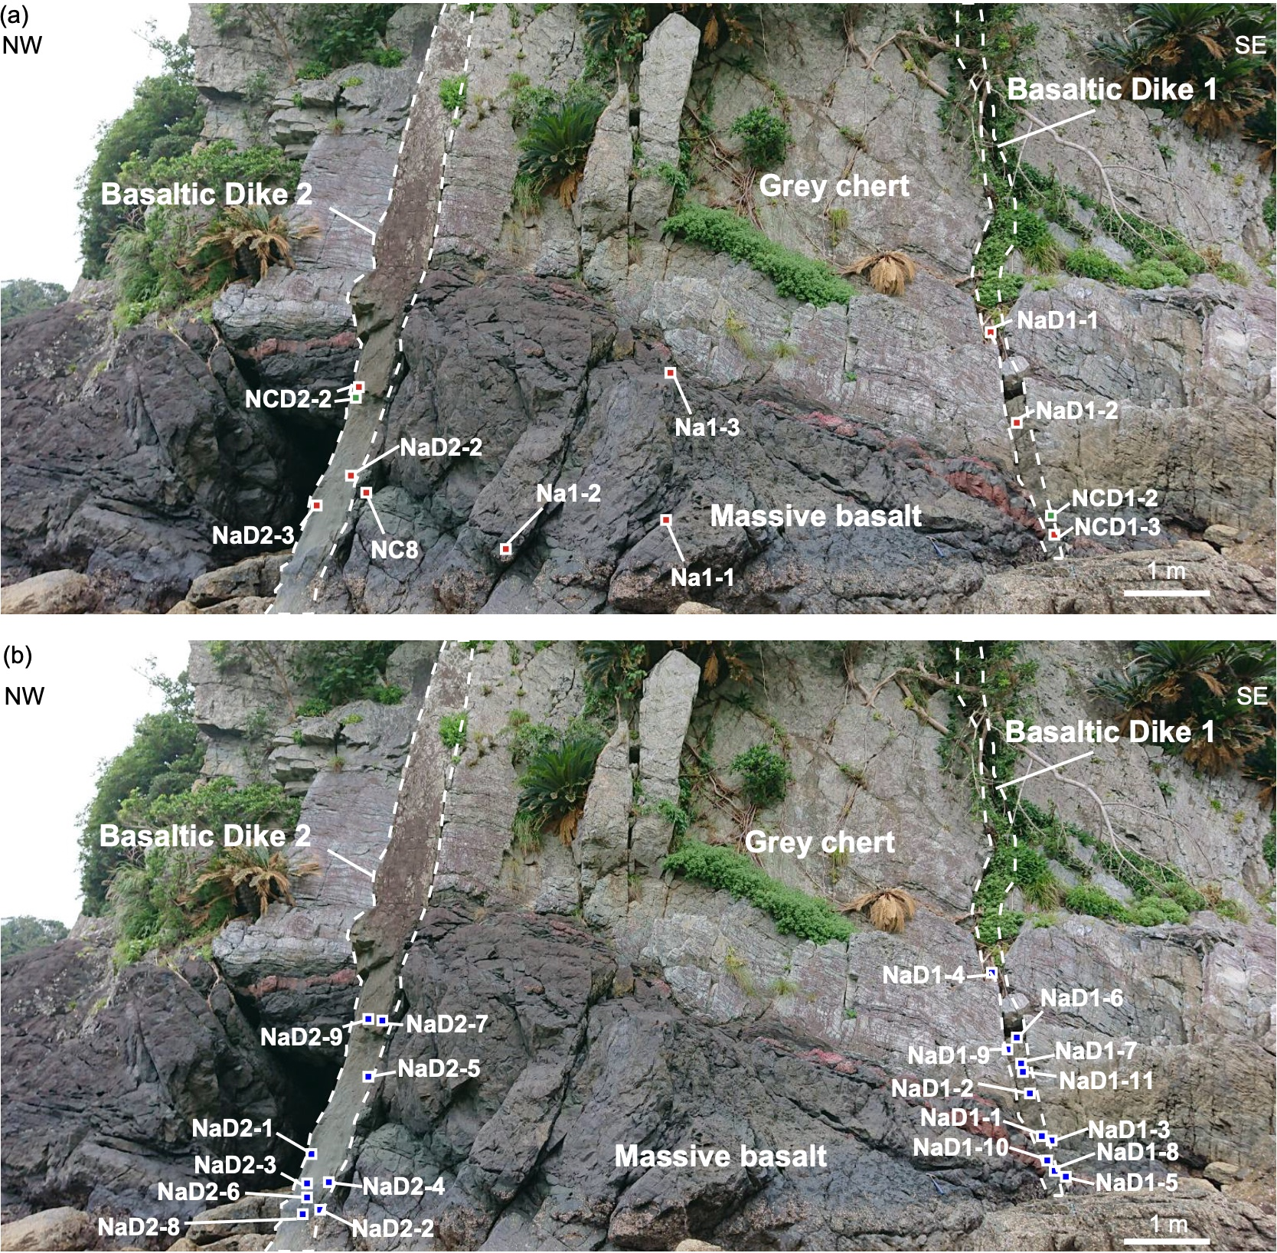
Figure S1. Location of the samples.
(a) Red and green rectangles indicate samples for geochemical and geochronological analyses, respectively. (b) Blue rectangles indicate paleomagnetic samples.

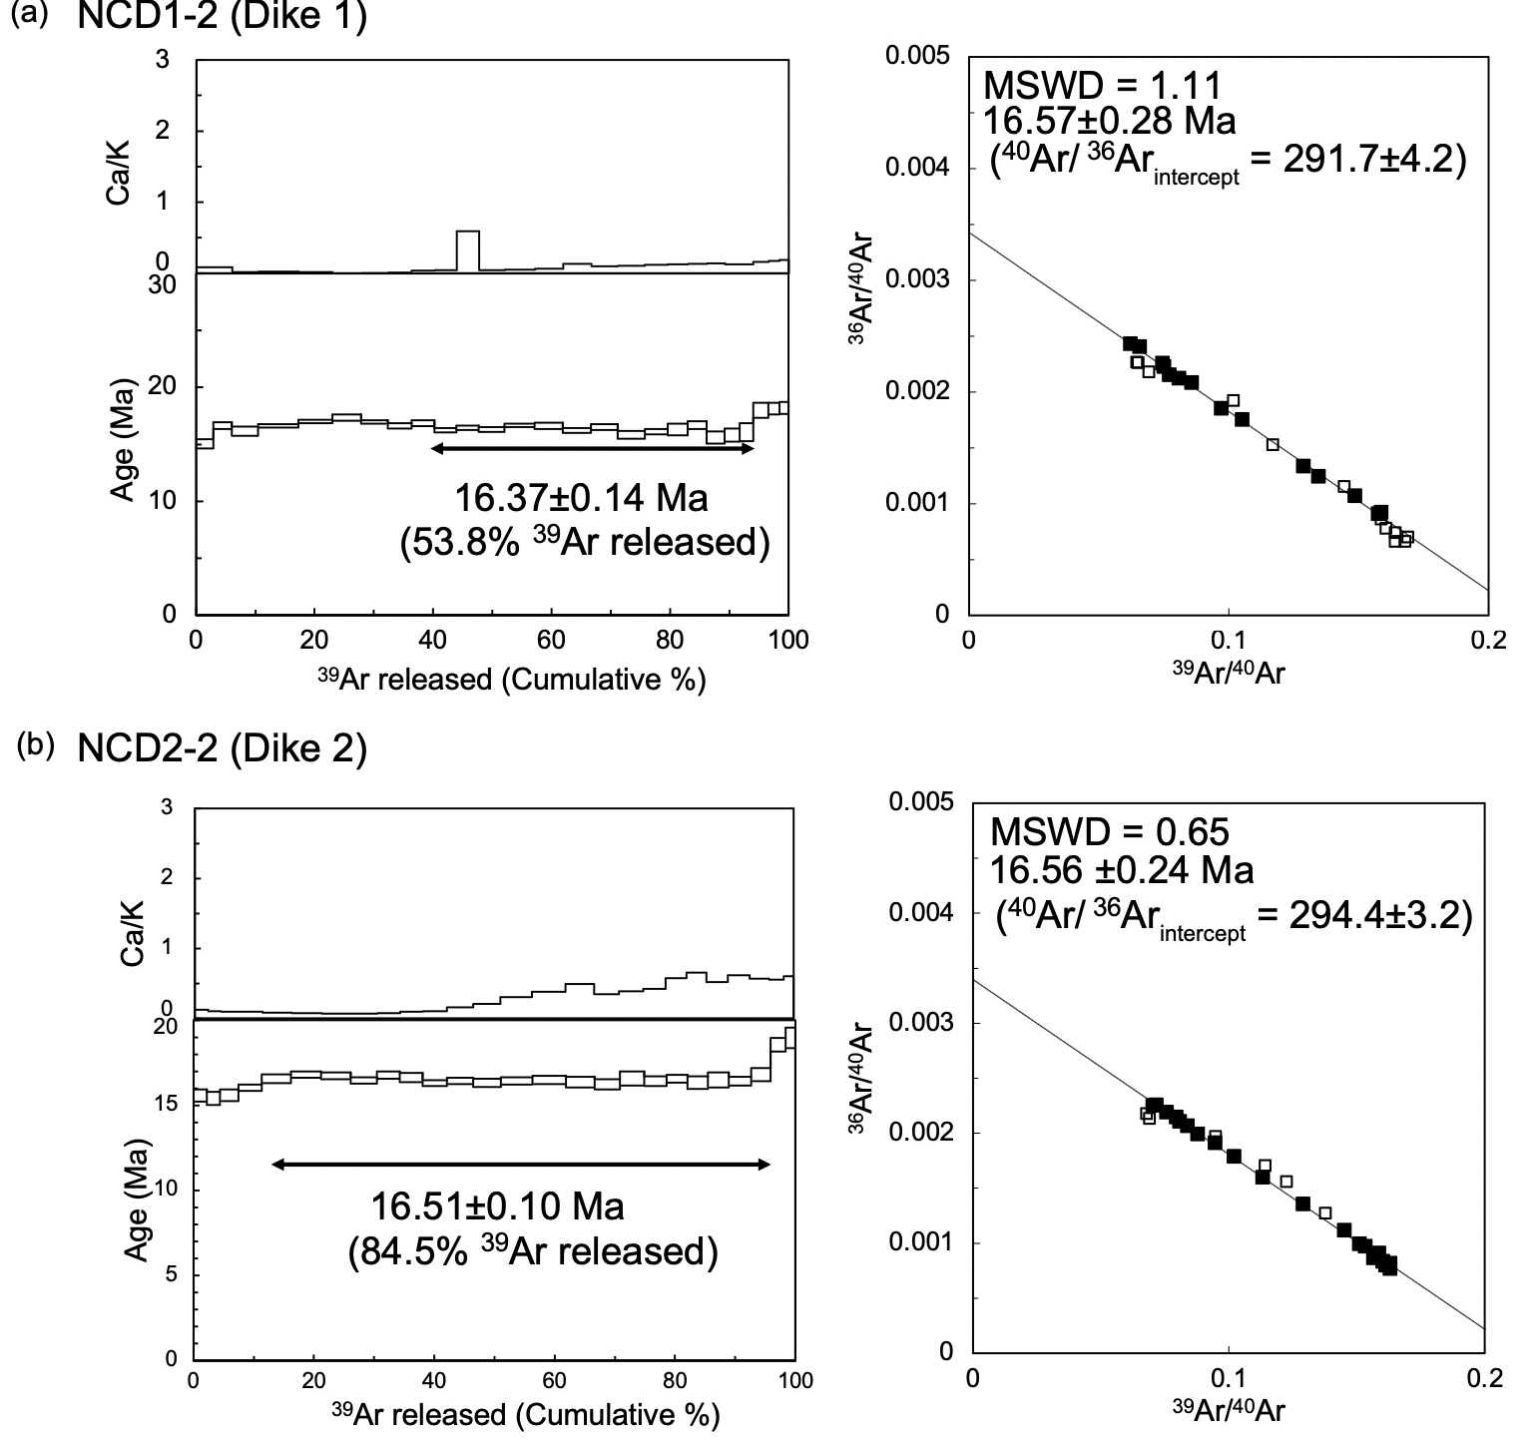
Figure S2. Results of ⁴⁰Ar/³⁹Ar dating analyses.
Age spectra with a Ca/K plot (left) and inverse isochron plot for groundmass samples from (a) NCD1-2 and (b) NCD2-2.

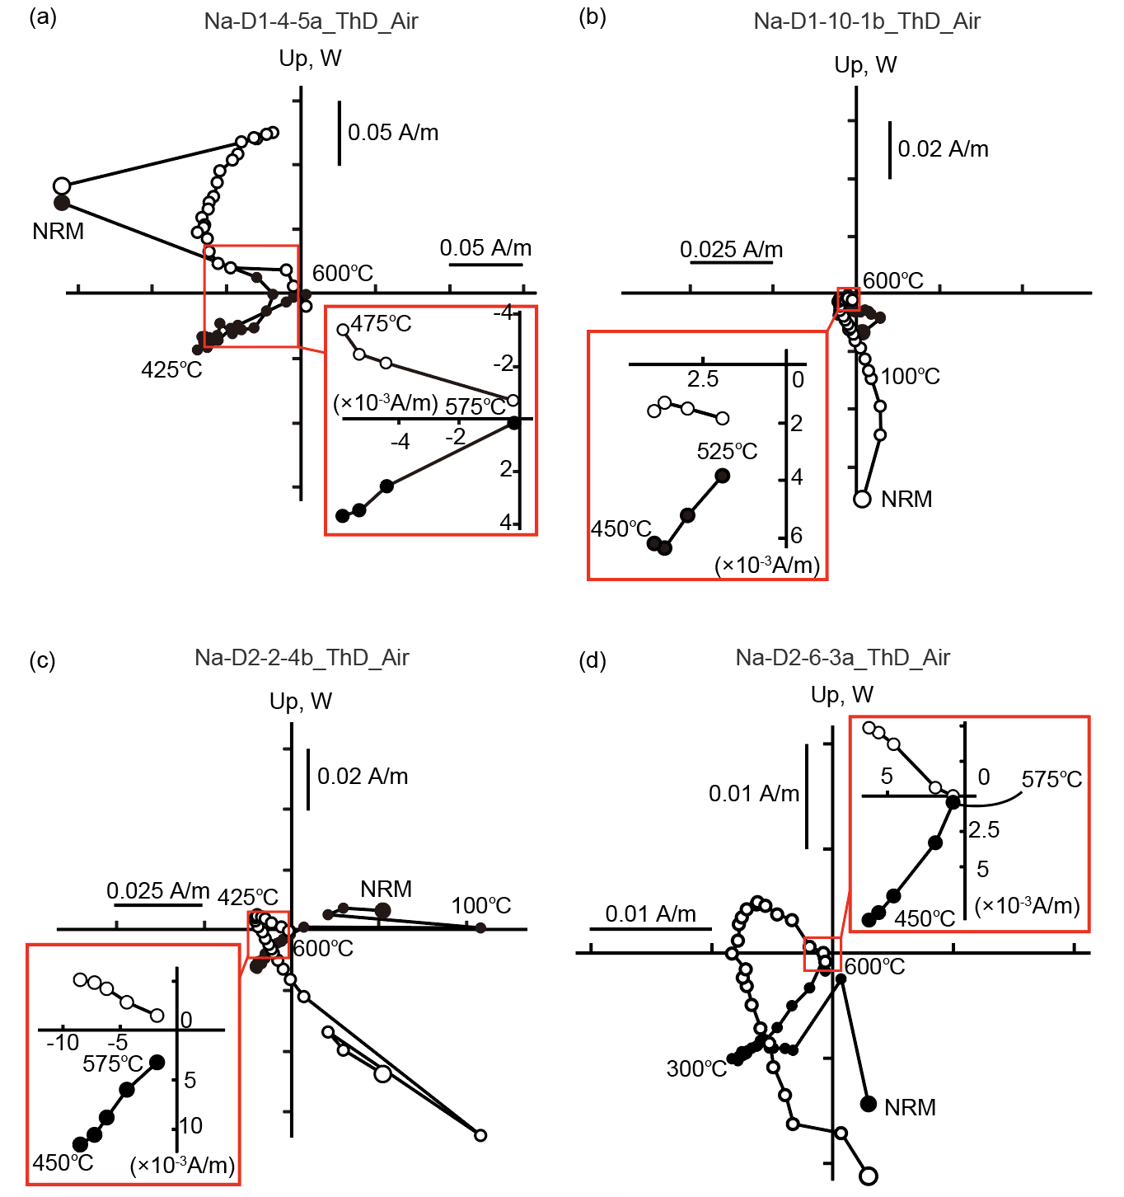
Figure S3. Representative Zijderveld diagrams obtained by stepwise thermal demagnetization experiments in air.
(a) Na-D1-4-5a, (b) Na-D1-10-1b, (c) Na-D2-2-4b, and (d) Na-D2-6-3a. Insets for each subfigure comprise a close-up of each diagram showing characteristic remanent magnetization with the linear trend identified at temperatures above 450 °C. Typically, the intensities of magnetizations are about 0.01 A/m at 450 °C, which is reduced to <0.002 A/m at 575 °C in case of successful ThD. Note that white and black circles are vertical and horizontal projections, respectively.

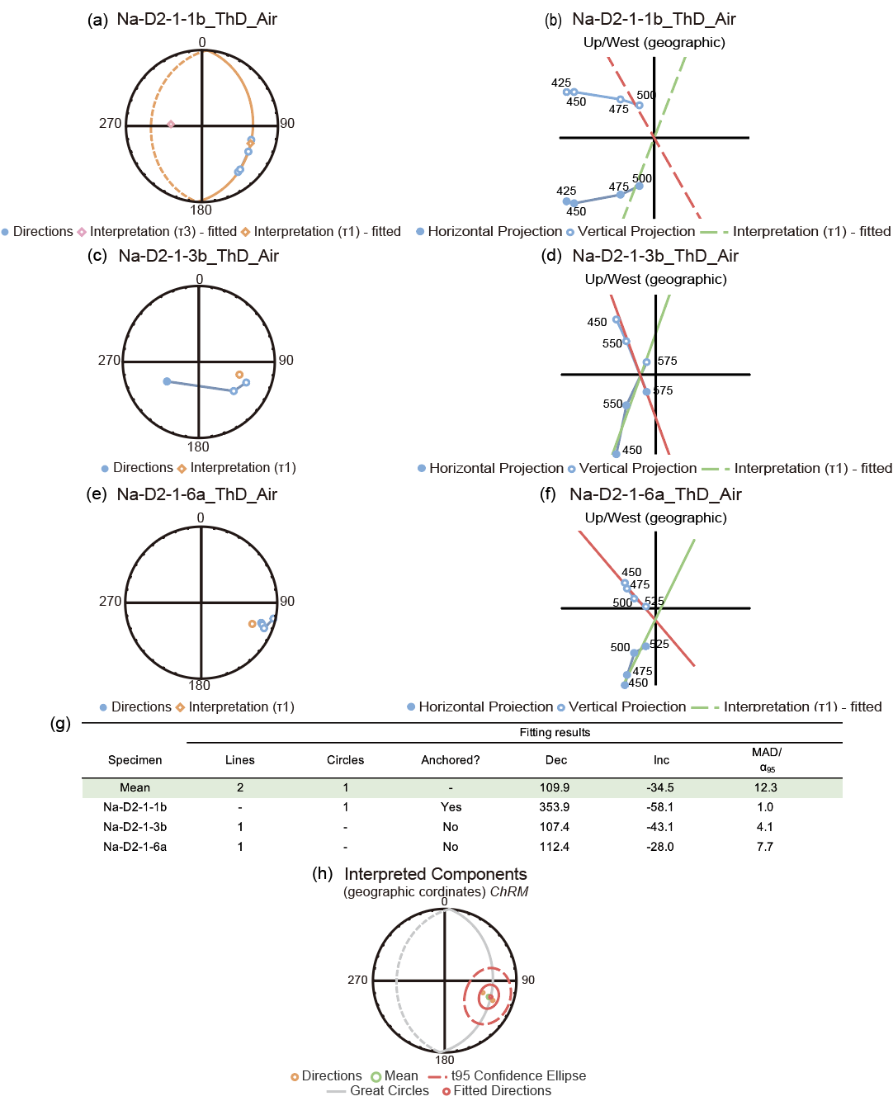
Figure S4. Representative paleomagnetic results of combined analyses for three specimens from hand sample Na-D2-1.
Paleomagnetic data were fitted with either a great circle (a-b) or a line (c-f), depending on the linearity of the demagnetization data. (a, c, e) Equal-area projections, marked by where white and black circles comprise projections onto the upper and lower hemispheres, respectively. (b, d, f) Zijderveld plots, where the white and black circles represent the vertical and horizontal projections, respectively. (g) Table summarizing the mean direction of the hand sample and fitting results of the specimens. (h) Equal-area projection of the mean direction obtained by combined analyses of remagnetization circles (McFadden and McElhinny, 1988) and directions of line fitting and a fitted great circle. The solid red circle represents the 95% confidence limit for the mean direction.

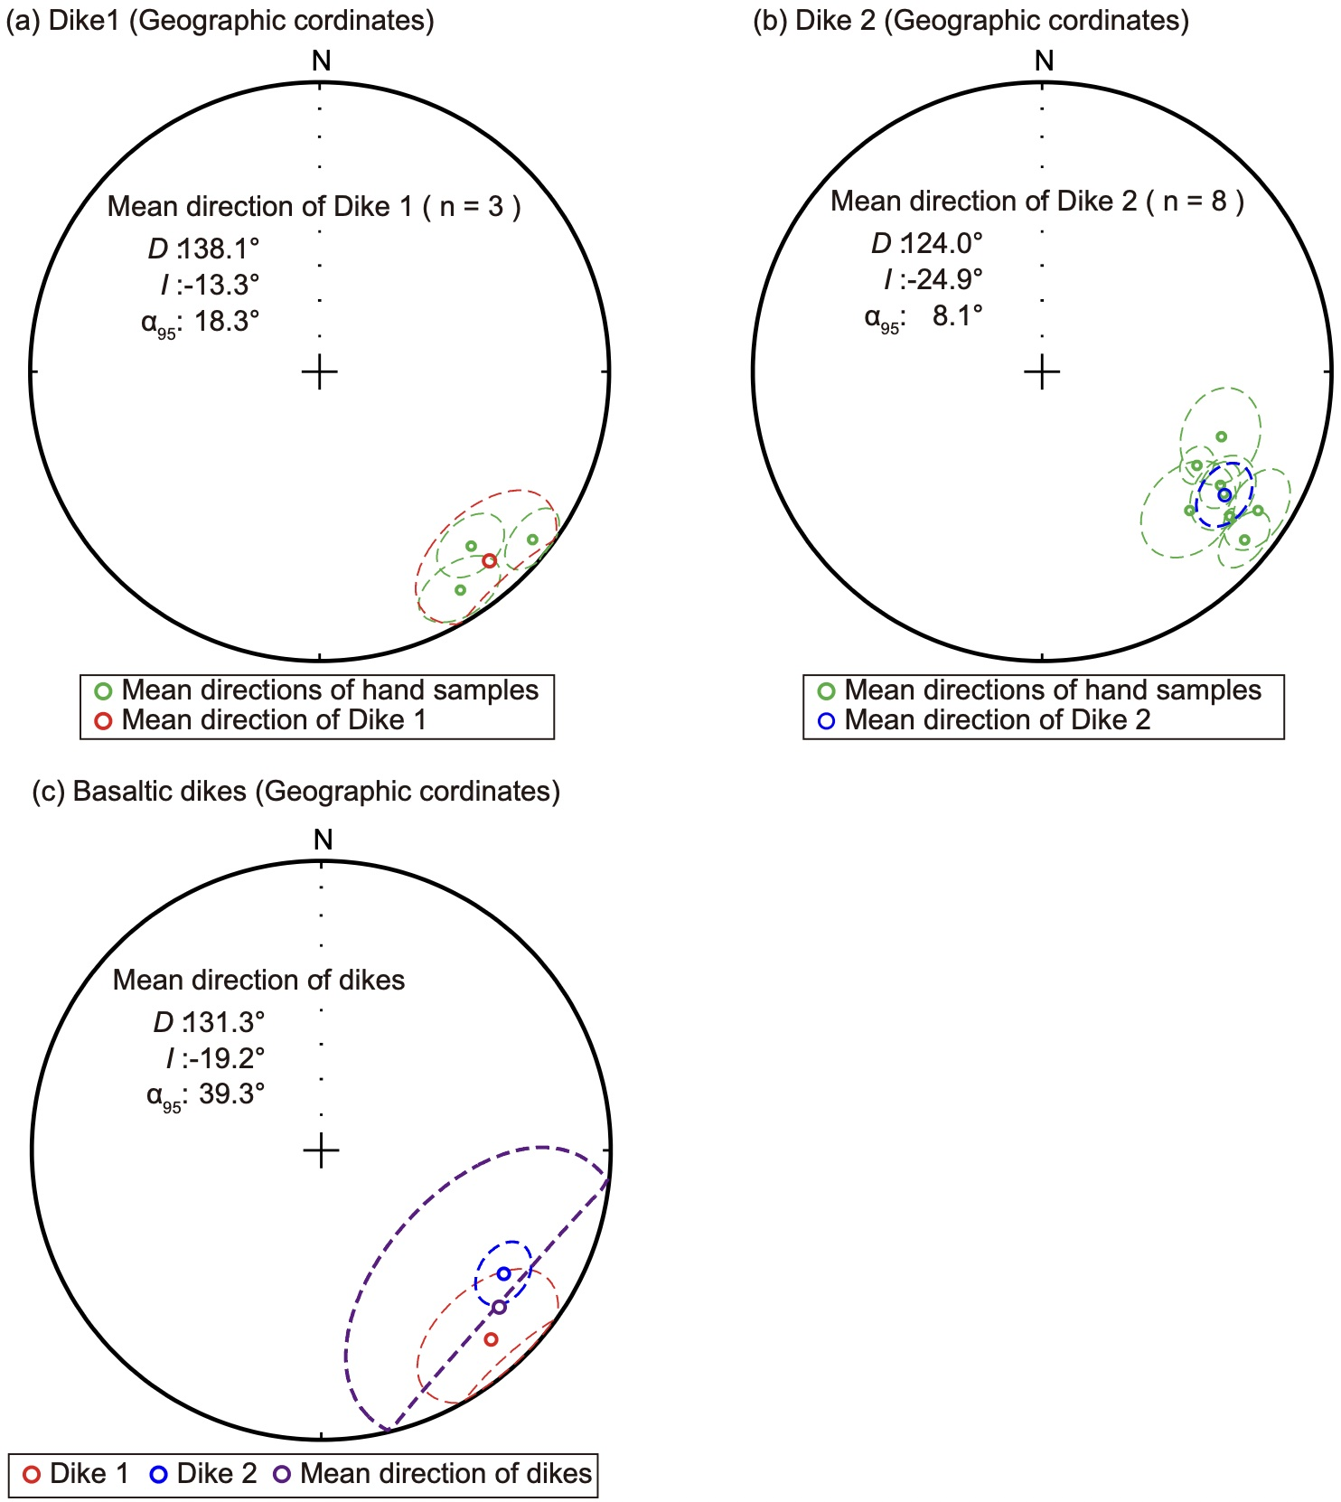
Figure S5. Paleomagnetic directions for basaltic dikes at Naon.
Equal-area projections of paleomagnetic directions for specimens from (a) basaltic Dike1, and (b) basaltic Dike2. (c) Equal-area projection of the mean directions and means of the two dikes. Open symbols represent projections onto the upper hemisphere. The dashed line indicates the 95% confidence limits.

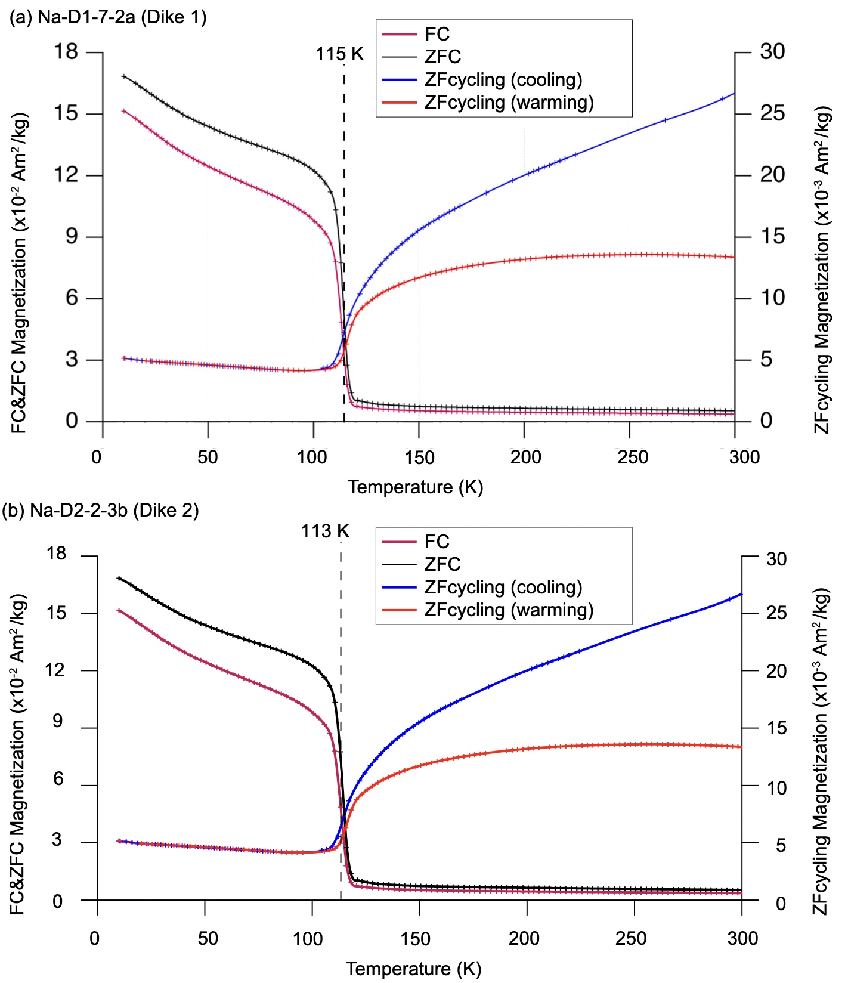
Figure S6. Low-temperature property of a chip sample with MPMS.
Magnetization was monitored during the warming and cooling of zero-field (ZF) cycling and the warming of zero-field cooling (ZFC) and field cooling (FC). The interpolation of the measured data using a smoothing spline is shown. The curve after differentiation (black broken line) clearly shows inflection points at ~115 K and 113 K.

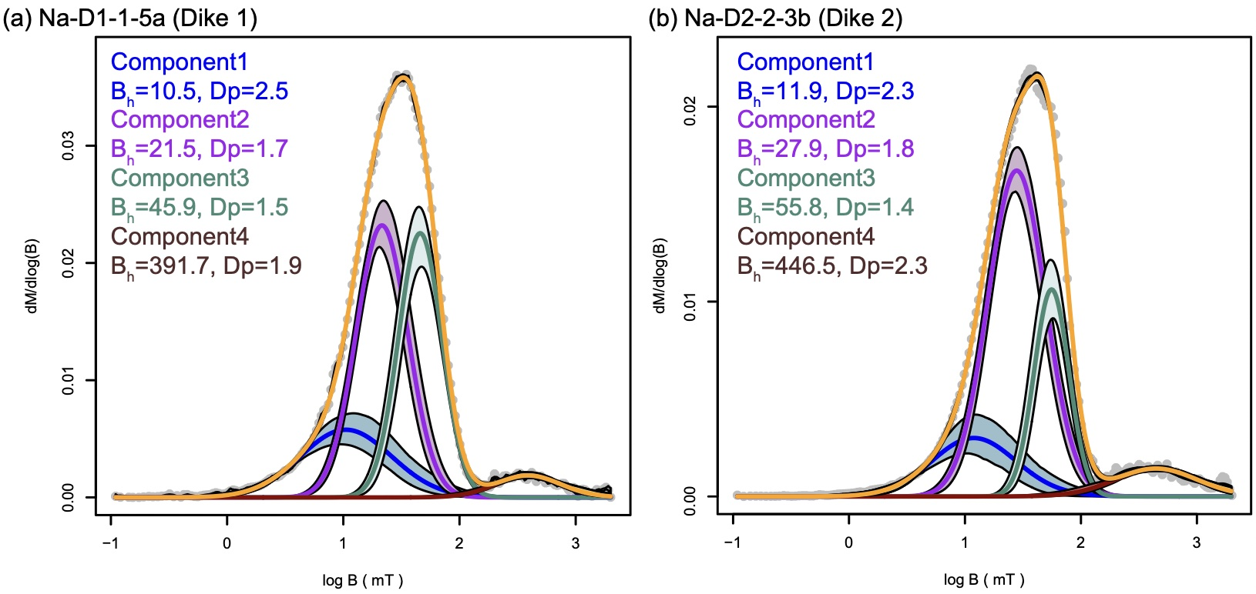
Figure S7. Results of unmixing IRM measurement.
Coercivity distribution from IRM acquisition with shaded areas representing the 95% confidence interval. The yellow line is the interpolation of the measured data (grey solid circles) by a smoothing spline. (a) Na-D1-1-5a and (b) Na-D2-2-3b. B_{h}: mean coercivity; DP: Diperison parameter.
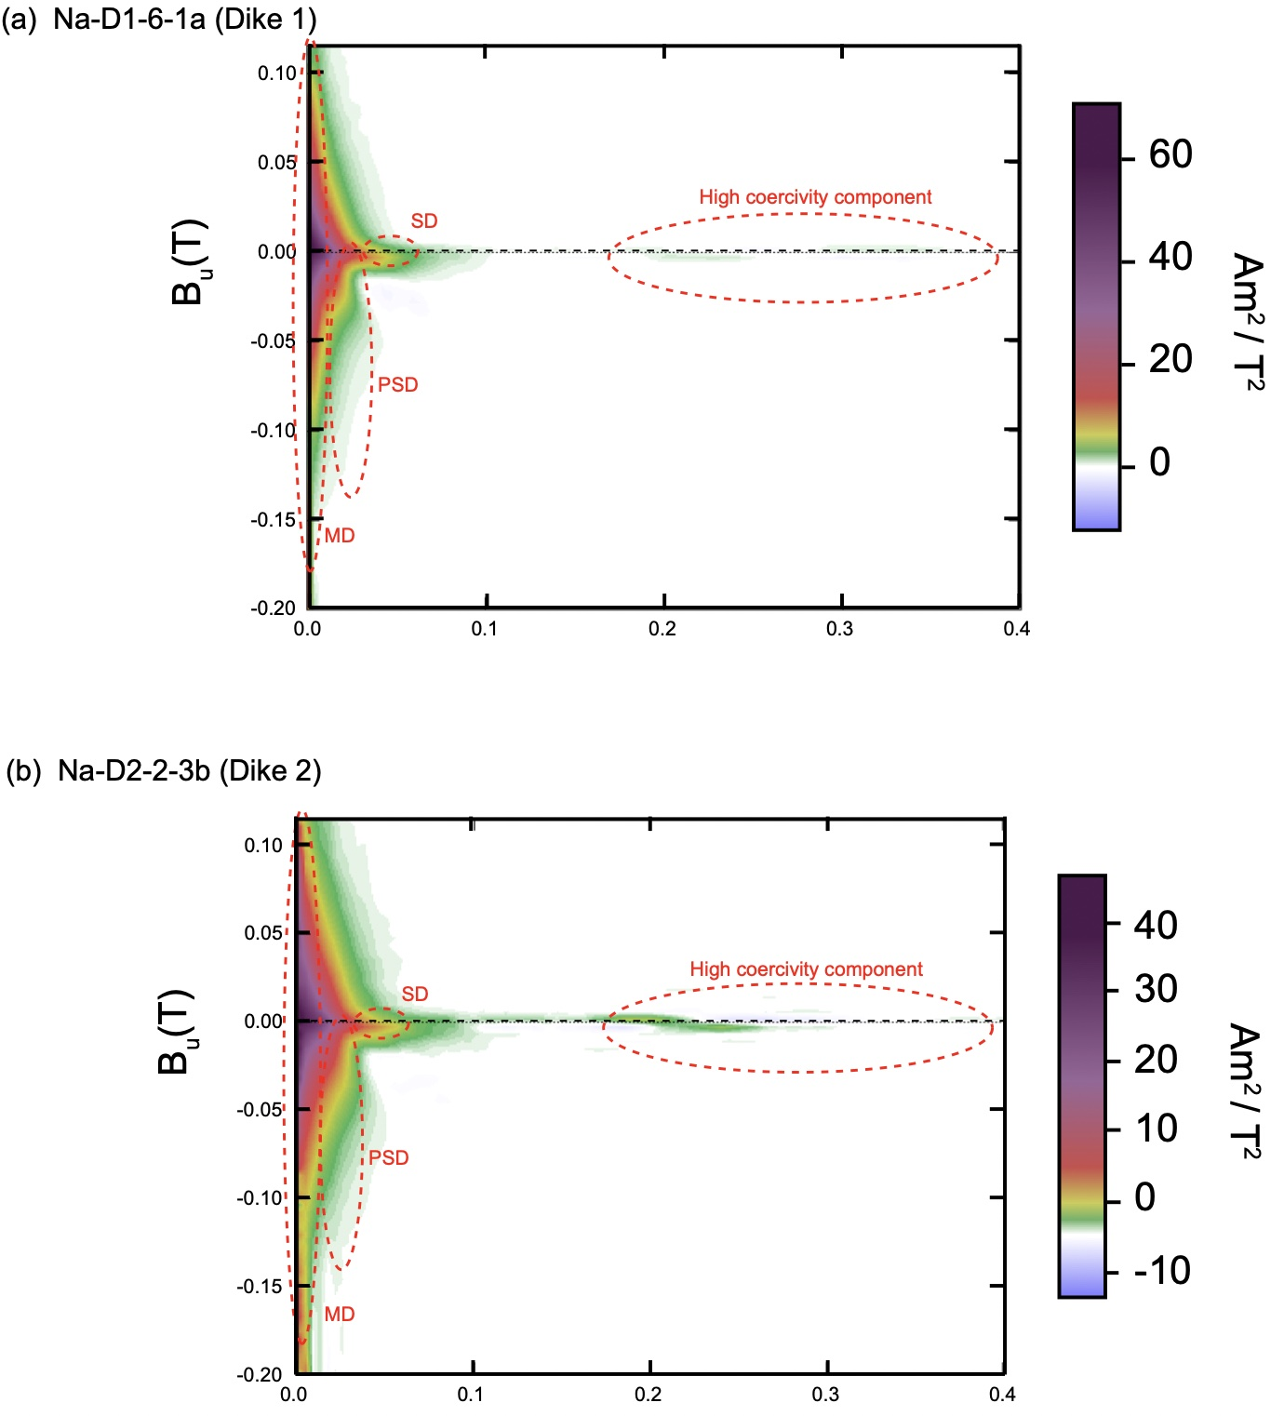
Figure S8. Results of FORC measurement.
The FORC diagram indicates the presence of four components with different grain sizes. SD: single domain; PSD: pseudo-single domain; MD: multi-domain. (a) Na-D1-6-1a and (b) Na-D2-2-3b.

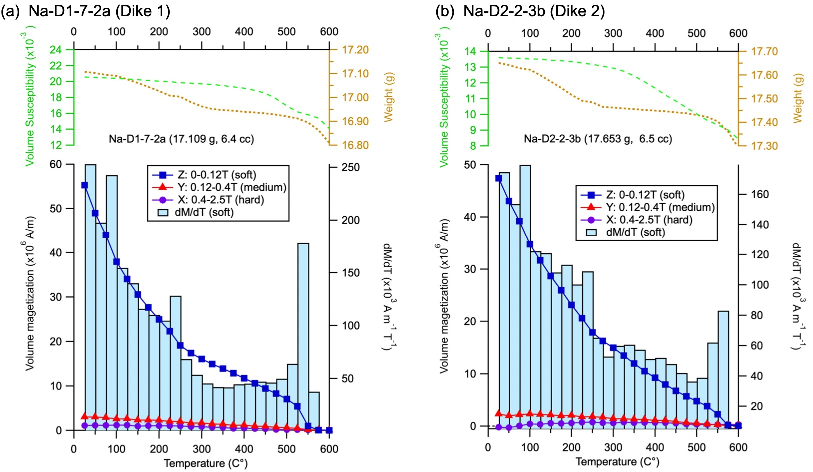
Figure S9. Results of three-axis IRM ThD.
Magnetization was plotted versus temperature for stepwise thermal demagnetization of three-axis IRM experiments based on Lowrie (1990). Blue rectangles, red triangles and purple circles are soft (0–0.12 T), medium (0.12–0.4 T) and hard (0.4–2.5 T) coercivity components, respectively.
Table S1. Results of stepwise-heating analyses of volcanic rocks in Amami-Oshima Island
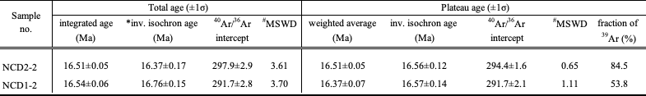
* inv. isochron age: inverse isochron age.
# MSWD: mean square of weighted deviates ((SUMS/(n-2)) ^0.5) in York (1968).
Integrated ages were calculated using sum of the total gas released.
l_{b}=4.962x10-10y-1, l_{e}=0.581x10-10y-1, ⁴⁰K/K=0.01167% (Steiger & Jager 1977). Atmospheric ⁴⁰Ar/³⁶Ar = 295.5.

Table S2. XRF major and trace element compositions of basaltic rocks in Amami-Oshima Island
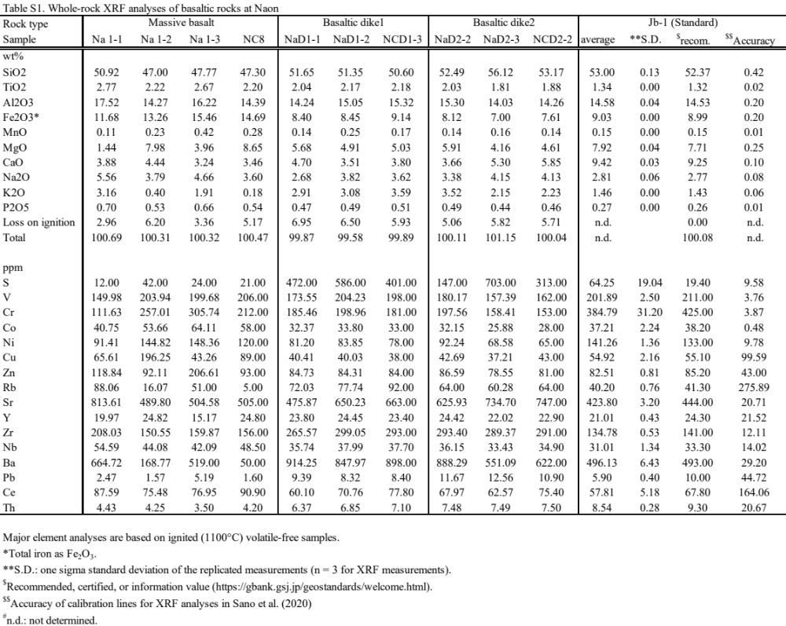
Major element analyses are based on ignited (1100°C) volatile-free samples. *Total iron as Fe₂O₃.
**S.D.: one sigma standard deviation of the replicated measurements (n = 3 for XRF measurements).
$Recommended, certified, or information value (https://gbank.gsj.jp/geostandards/welcome.html).
$$Accuracy of calibration lines for XRF analyses in Sano et al. (2020).
n.d.: not determined.

Table S3. ICP-MS trace element compositions of basaltic rocks in Amami-Oshima Island
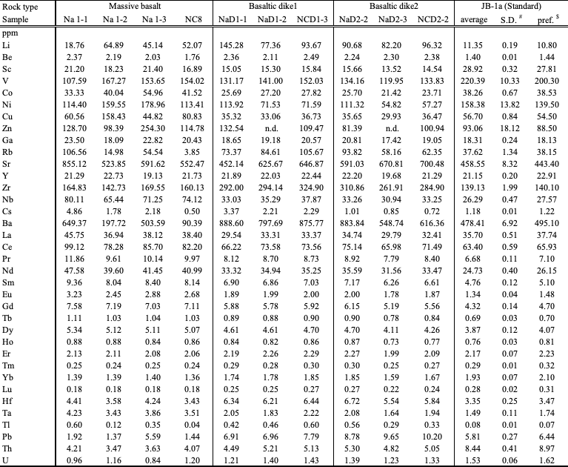
*S.D.: One sigma standard deviation of the replicated measurements (n=3 for JB-1a with the exception of n=2 for Zn ).
$ Georem preferred value (http://georem.mpch-mainz.gwdg.de/).
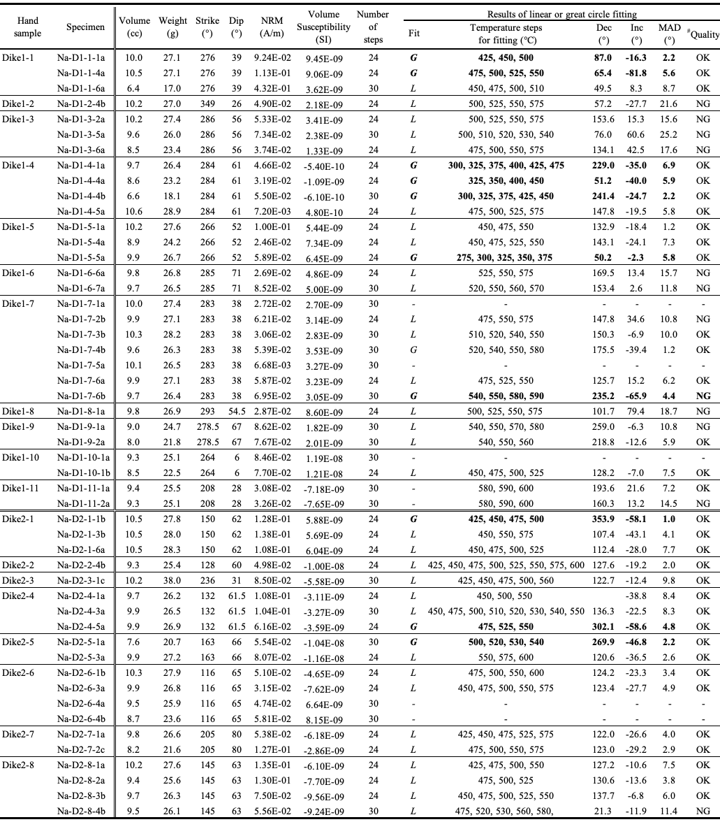
Table S4. Physical properties, orientations, and results of linear or great circle fittings for paleomagnetic specimens subjected to stepwise ThD experiments
All experimental results were obtained by thermal demagnetization experiments in air. NRM: natural remanent magnetization. Dec: declination. Inc: inclination. MAD: maximum angular deviations.
Number of steps: number of experimental steps (24 or 30). Fit: fitting (L: line fitting; G: great circle fitting anchored to the original points; -: no fitting). # Quality: selection criteria for OK = (MAD < 10°).

Table S5. Results of combined analyses of remagnetization circles
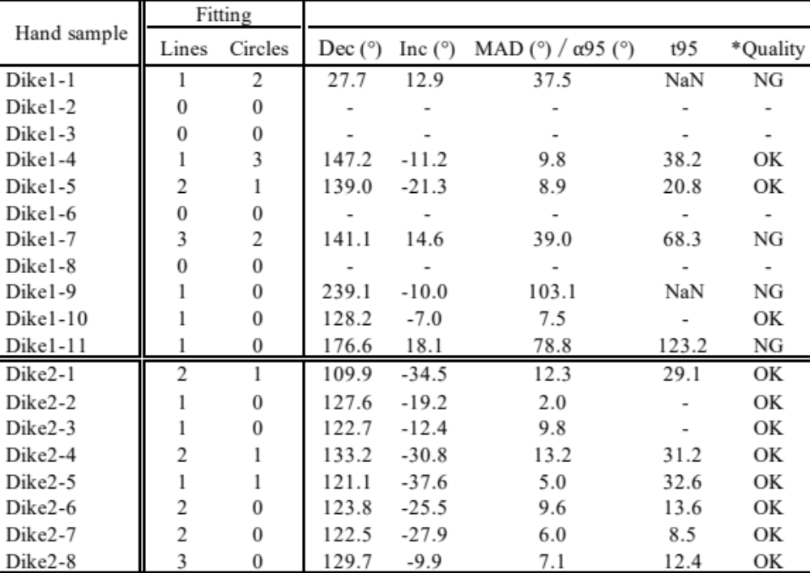
Dec: declination. Inc: inclination. MAD: maximum angular deviations. α₉₅: 95% confidence limit.
*Quality: selection criteria for OK = (MAD < 10° for one data, ⍺95 < 15° for more than two data).

Additional references
Channell JET, Singer BS, Jicha BR (2020) Timing of Quaternary geomagnetic reversals and excursions in volcanic and sedimentary archives. Quat Sci Rev 228:106114. https://doi.org/10.1016/j.quascirev.2019.106114
Channell JET, Vázquez Riveiros N, Gottschalk J, Waelbroeck C, Skinner LC (2017) Age and duration of Laschamp and Iceland Basin geomagnetic excursions in the South Atlantic Ocean. Quat Sci Rev 167(3):1–13. https://doi.org/10.1016/j.quascirev.2017.04.020
Fleck RJ, Sutter JF, Elliot DH (1977) Interpretation of discordant 40Ar/ 39Ar age-spectra of mesozoic tholeiites from antarctica. Geochim Cosmochim Acta 41(1):15–32. https://doi.org/10.1016/0016-7037(77)90184-3
Hatakeyama T (2018) Online plotting applications for paleomagnetic and rock magnetic data. Earth, Planets, Space 70(1):1–8. https://doi.org/10.1186/s40623-018-0906-5
Harrison RJ, Feinberg JM (2008) FORCinel: An improved algorithm for calculating first-order reversal curve distributions using locally weighted regression smoothing. Geochem Geophys Geosystems 9(5):Q05016. https://doi.org/10.1029/2008GC001987
Ishizuka O, Hickey-Vargas R, Arculus RJ, Yogodzinski GM, Savov IP, Kusano Y, McCarthy A, Brandl PA, Sudo M (2018) Age of Izu-Bonin-Mariana arc basement. Earth Planet Sci Lett 481:80–90. https://doi.org/10.1016/j.epsl.2017.10.023
Jackson MJ, Moskowitz B (2021) On the distribution of Verwey transition temperatures in natural magnetites. Geophys J Int 224(2):1314–1325. https://doi.org/10.1093/gji/ggaa516
Lanphere MA, Baadsgaard H (2001) Precise K-Ar, Ar-40/Ar-39, Rb-Sr and U/Pb mineral ages from the 27.5 Ma Fish Canyon Tuff reference standard. Chem Geol 175(3-4):653–671. https://doi.org/10.1016/S0009-2541(00)00291-6
Lattard D, Engelmann R, Kontny A, Sauerzapf U (2006) Curie temperatures of synthetic titanomagnetites in the Fe-Ti-O system: Effects of composition, crystal chemistry, and thermomagnetic methods. J Geophys Res 111(B12):B12S28. https://doi.org/10.1029/2006JB004591
Oda H (1995) Detailed records of Brunhes/Matuyama geomagnetic polarity reversal. Dissertation, Kyoto University. http://hdl.handle.net/2433/59300
Steiger RH, Jäger E (1977) Subcommission on geochronology: Convention on the use of decay constants in geo- and cosmochronology. Earth Planet Sci Lett 36(3):359–362. https://doi.org/10.1016/0012-821X(77)90060-7
Verwey EJW (1939) Electronic Conduction of Magnetite (Fe 3 O 4 ) and its Transition Point at Low Temperatures. Nature 144(3642):327–328. https://doi.org/10.1038/144327b0
York D (1968) Least squares fitting of a straight line with correlated errors. Earth Planet Sci Lett 5:320–324. https://doi.org/10.1016/S0012-821X(68)80059-7

