<Additional file>
Estimation of source parameters using a non-Gaussian probability density function in a Bayesian framework
Nana Yoshimitsu, Takuto Maeda, Tomonari Sei

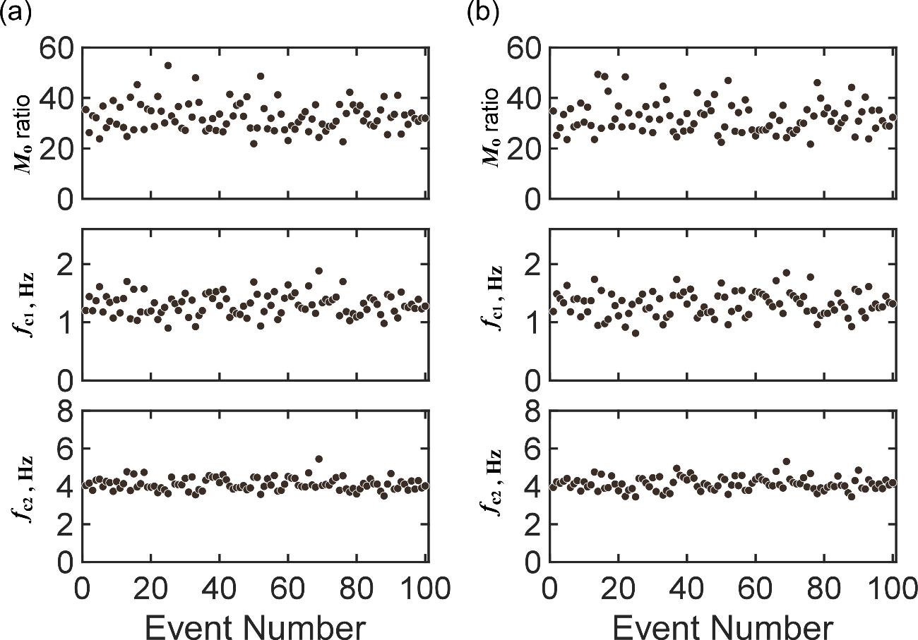
Figure S1. Estimates of seismic parameters calculate from synthetic spectral ratios, assuming (a) an F-distribution and (b) a normal distribution. Top panels indicate the result of seismic moment, middle panels indicate the result of $f_{c1}$, and the bottom panels indicate the result of $f_{c2}$

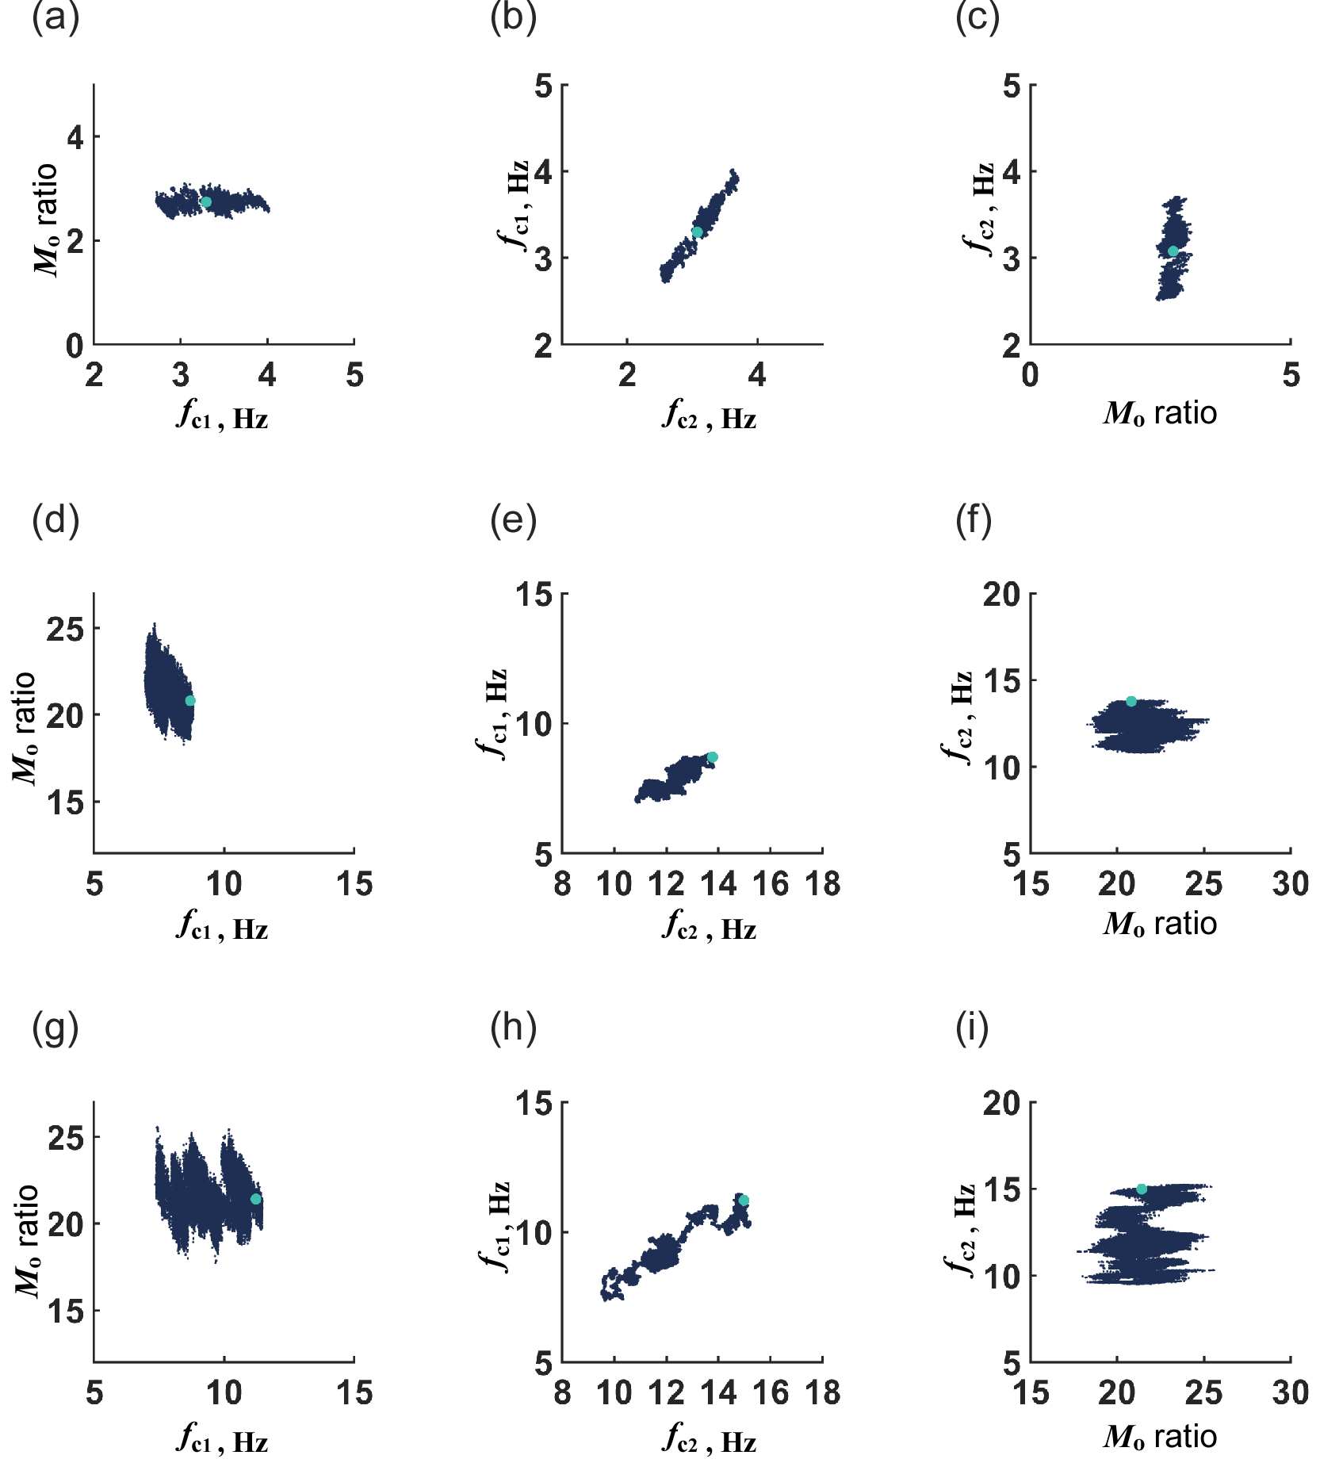
Figure S2. Sampling distribution of project onto a 2D plane with irregular spectral shape. (a), (b), and (c) represent the sampling distributions obtained from the event in Fig. 8(a). (d), (e), and (f) are obtained from the event in Fig. 8(b). (g), (h), and (i) are obtained from the event in Fig. 8(c). (a), (d), and (g) indicate the relationships between moment ratio and $f_{c1}$. (b), (e), and (h) indicate the relationships between $f_{c1}$ and $f_{c2}$. (c), (f), and (i) indicate the relationship between moment ratio and $f_{c2}$.

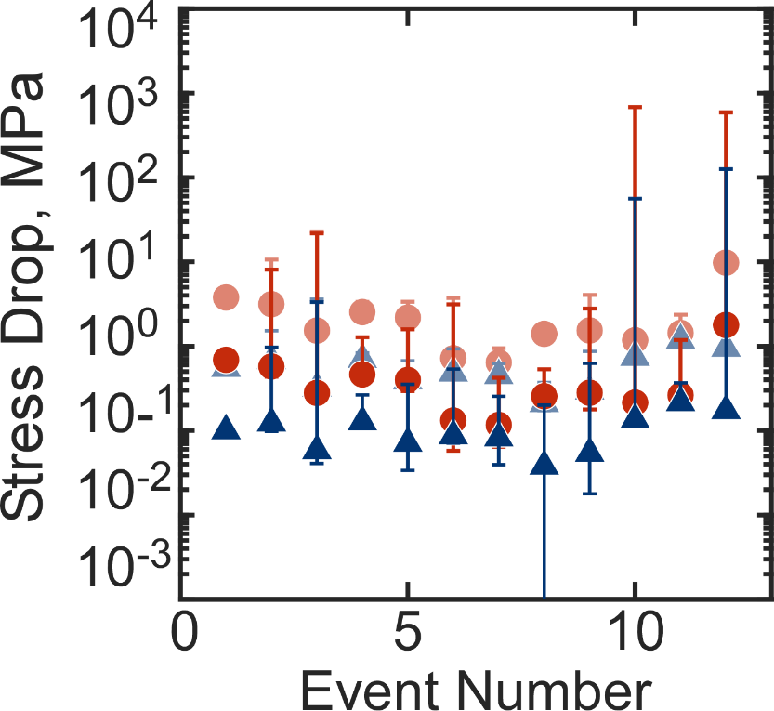
Figure S3. Stress drops within an earthquake cluster after event selection. Red circles indicate the results obtained from large earthquakes, and blue triangles indicate results obtained from smaller earthquakes. Dark color obtained from the source model proposed by Brune (1970) and light color obtained from the source model proposed by Madariaga (1976).

