Additional file for
Measurement of ferric iron in Chang’e-5 impact glass beads
Lixin Gu¹, Yangting Lin^{1,2*}, Yongjin Chen^{3*}, Yuchen Xu⁴, Xu Tang¹, Sen Hu^{1,2}, Ho-kwang Mao³, Jinhua Li^{1,2*}
¹Key Laboratory of Earth and Planetary Physics, Institute of Geology and Geophysics, Chinese Academy of Sciences, Beijing, 100029, China.
²College of Earth and Planetary Sciences, University of Chinese Academy of Sciences, Beijing 100049, China
³Center for High Pressure Science and Technology Advanced Research, Beijing 100094, China
⁴State Key Laboratory of Space Weather, National Space Science Center, Chinese Academy of Sciences, Beijing, 100190, China

Contents of this file

Additional file Text
Figures S1: Background subtraction method for Fe L-edge EELS.
Figures S2: STEM-EDS mapping of foil 2 (sample #084).
Figures S3: Repeated measurements of Fe L-edge EELS at different regions of sample #090.
Figures S4: Comparative experiment for sample #090 conducted at the same location with dwell times of 0.02 s and 0.1 s, respectively.

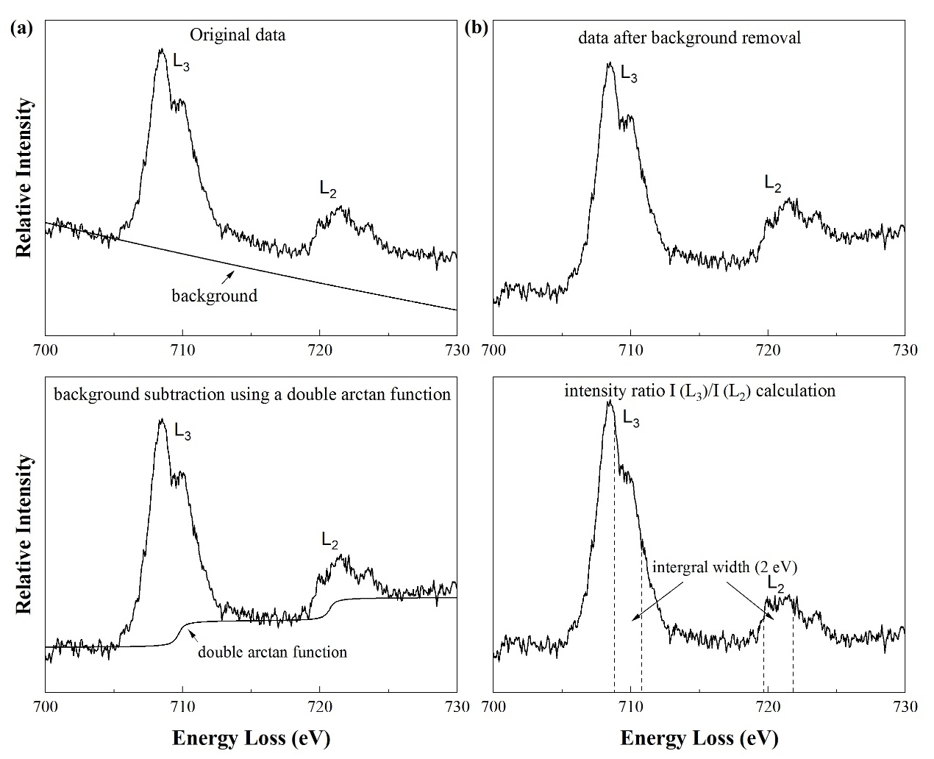
Figures S1. Background subtraction method for Fe L-edge EELS. (a) Original EELS and background using a standard power law fit. (b) The EELS after initial background removal. (c) Background subtraction using a double arctan function. (d) Intensity I(L₃)/I(L₂) ratio calculation method. The integral intensity I(L3) and I(L2) is from two windows 2 eV wide centered around on the maximum of the L₃Fe³⁺ peak (~709.7 eV) and at the L₂ edge for Fe²⁺ (~720.7 eV). The intensity ratio I (L₃)/I (L₂) was converted to Fe³⁺/ΣFe using the universal calibration calculated by van Aken & Liebscher (2002).
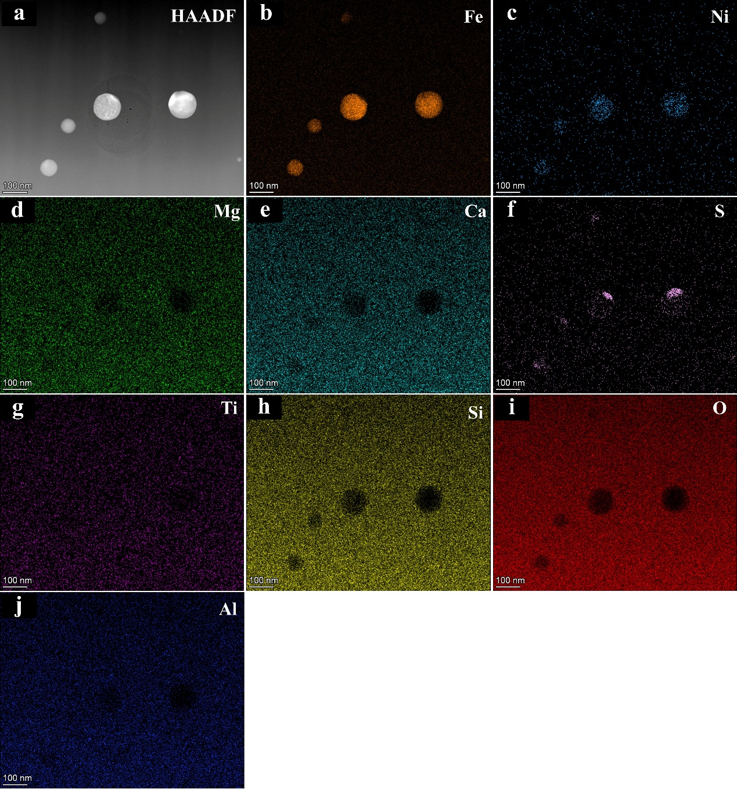
Figures S2: STEM-EDS mapping of foil 2 (sample #084). The nanoparticles are mainly composed of Fe-Ni metal and iron sulfide.

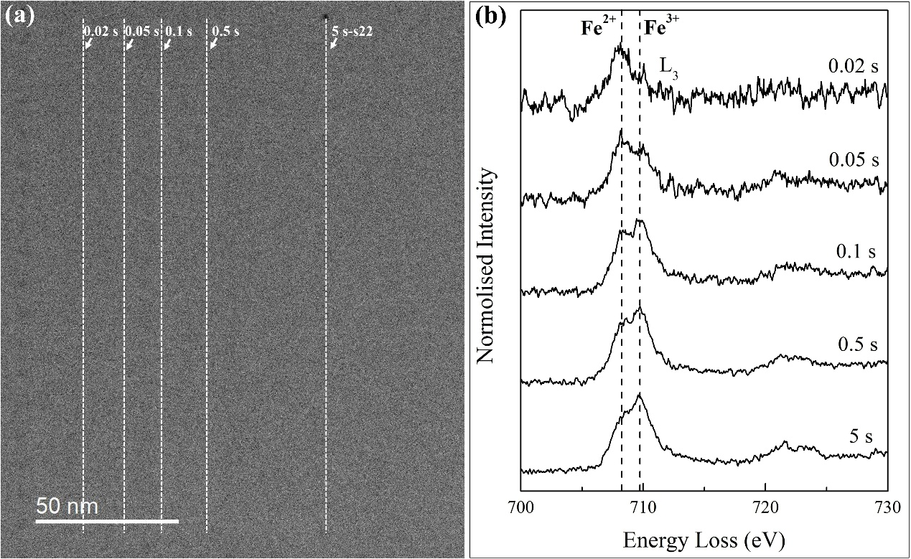
Figures S3. Repeated measurements of Fe L-edge EELS at different region (sample #090). This EELS measurement was conducted two months after that shown in figure 3, and had a slightly worse signal-to-noise ratio. (a) HAADF image of measured area. (b) Despite a slightly worse signal-to-noise ratio, Fe L-edge EELS with different dwell times show that the peak intensity around 710 eV increases rapidly with increase of dwell time, indicating the change of iron valence state.

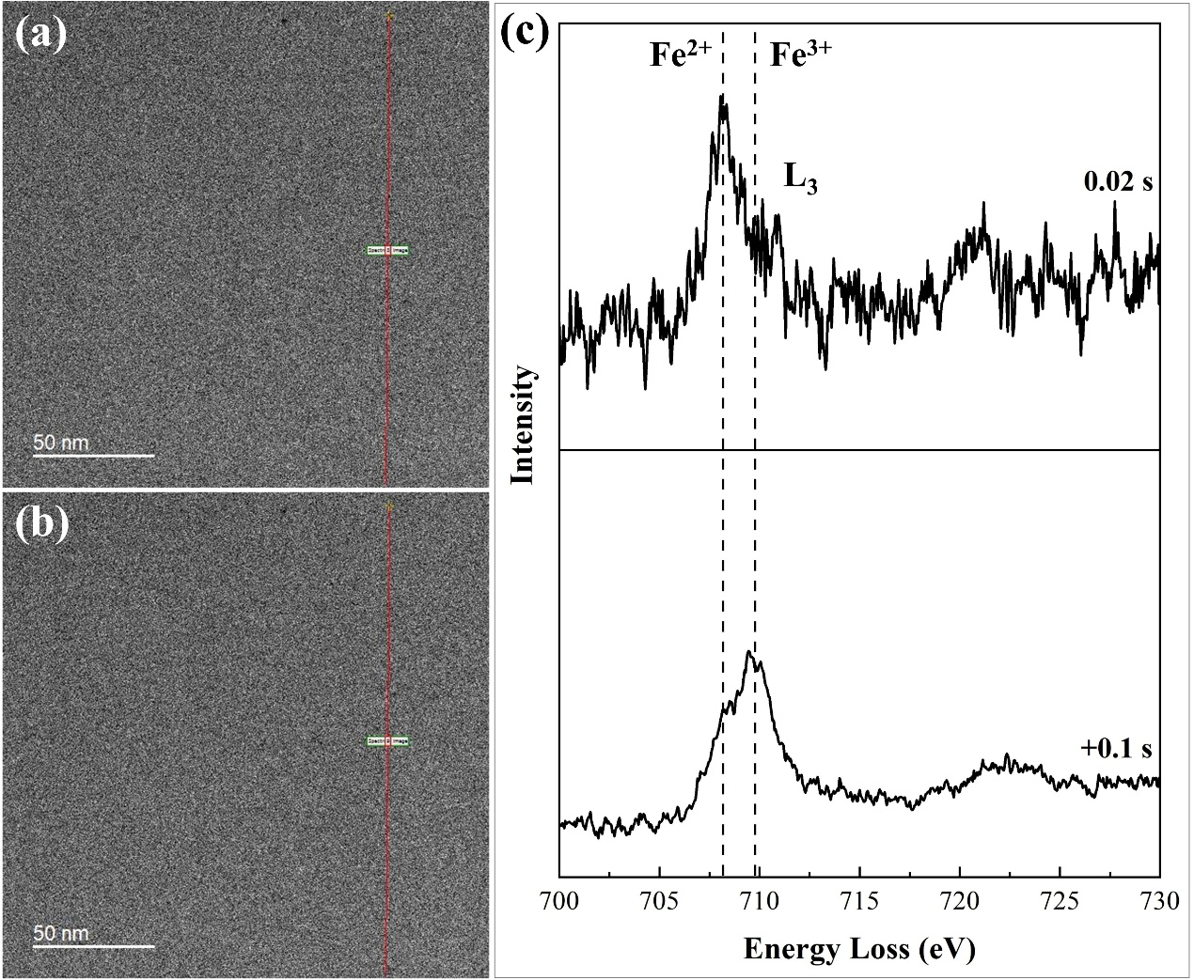
Figures S4. Comparative experiment for sample #090 conducted at the same location with 0.02 s and 0.1 s, respectively.

References
van Aken, P. A., & Liebscher, B. (2002), Quantification of ferrous/ferric ratios in minerals: new evaluation schemes of Fe L 23 electron energy-loss near-edge spectra, Physics and Chemistry of Minerals, 29, 188-200.

