Appendix A: Reactivation of the fumarole field – sulfur deposits and effect on vegetation

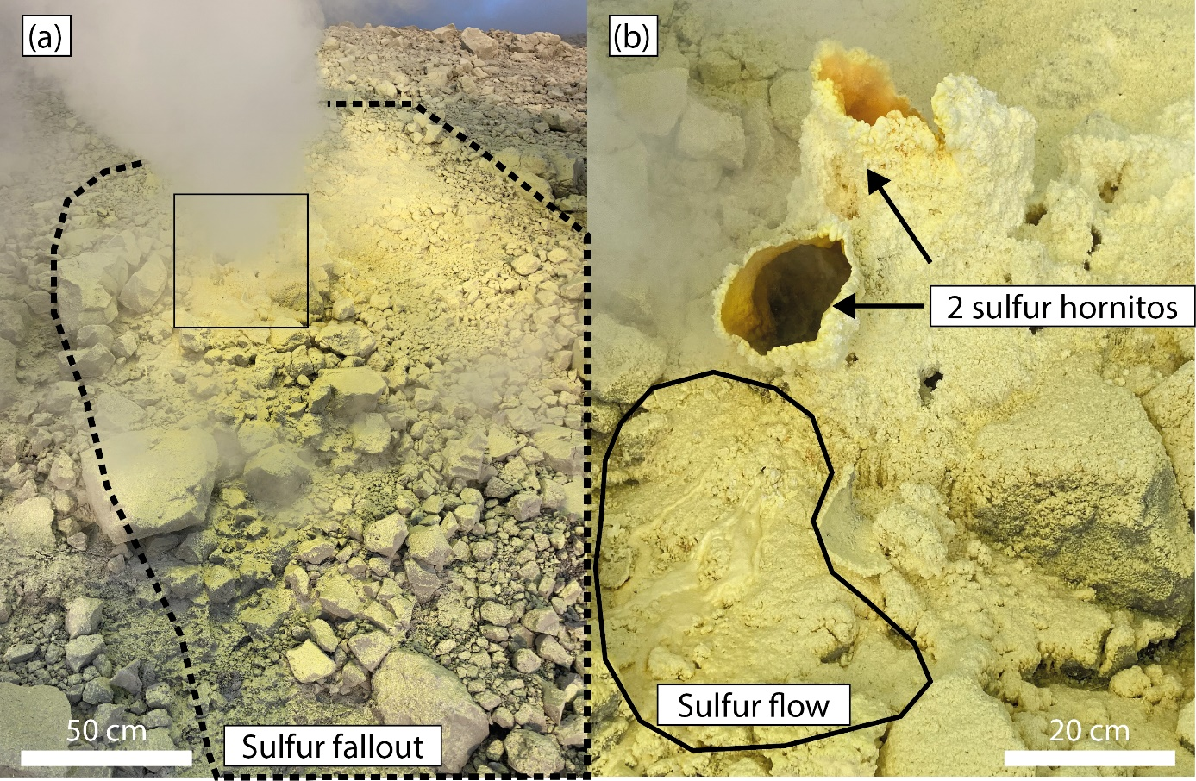Figure A1: (a) Close pictures inside the Fossa fumarole field on 01/12/2022 of sulfur hornitos and associated sulfur fallout (a) and flows (a, b); (b) is the enlargement of the black square showing the details that in (a) are hidden by fume.
The stressed and dead vegetation (Figure A2) on the north rim (around the Forgia Vecchia crater, Figure 1b) and on the south rim is also consistent with increased soil heating and diffusive CO₂ degassing.
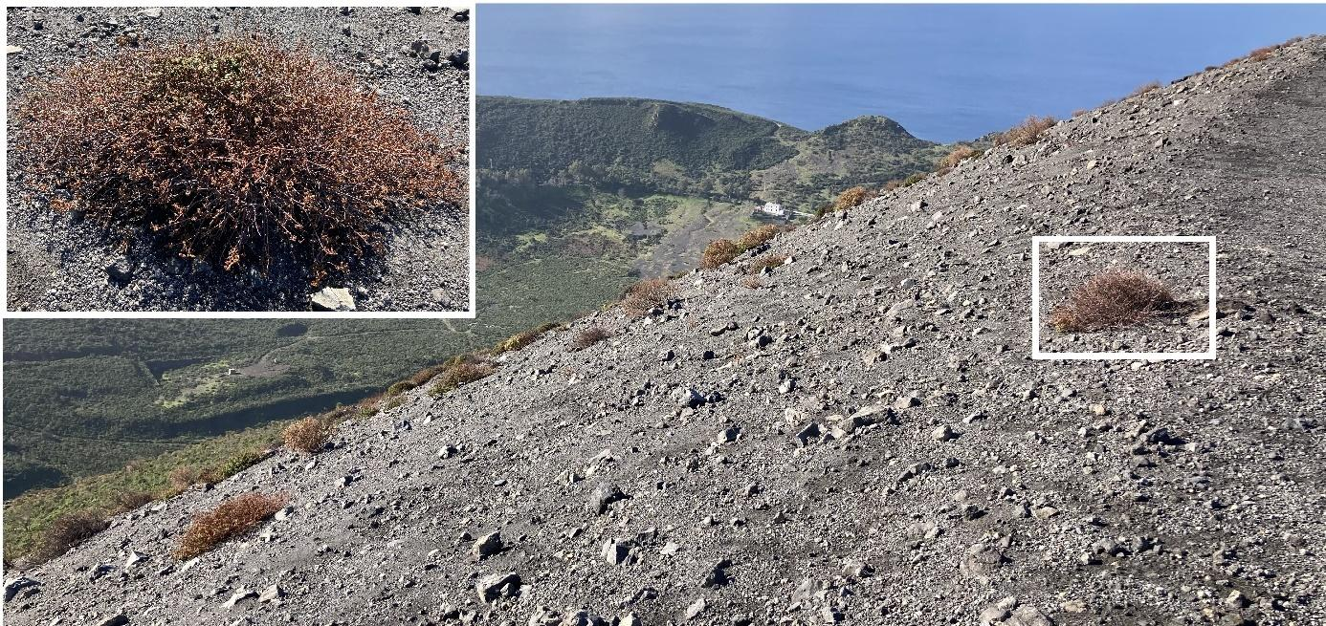
Figure A2: Stressed vegetation on the south rim of La Fossa crater in January 2021. White rectangle is magnified top left.

Appendix B: List of punctual field measurements and instruments
 | 2020 |  |  |  | 2021 |  |  |  |  |  | 2022
 | January |  | October |  | March |  | June |  | September |  | January
 | T₁₅ | CO₂ | T₁₅ | CO₂ | T₁₅ | CO₂ | T₁₅ | CO₂ | T₁₅ | CO₂ | T₁₅ | CO₂
Profile 1 | ✔ |  | ✔ |  | ✔ | ✔ | ✔ | ✔ | ✔ | ✔ | ✔ | ✔
Profile 2 |  |  |  |  |  |  | ✔ | ✔ | ✔ | ✔
Profile 3 |  |  |  |  |  |  | ✔ | ✔ | ✔ | ✔
Profile 4 |  |  |  |  |  |  | ✔ | ✔ | ✔ | ✔
Grid 1 |  |  |  |  | ✔ |  | ✔ | ✔ | ✔ | ✔ | ✔ | ✔
FA Grid |  |  |  |  | ✔ |  | ✔
 | Day | Night | Day | Night | Day | Night | Day | Night | Day | Night | Day | Night
IR cam | ✔ | ✔ | ✔ | ✔ | ✔ |  | ✔ | ✔ | ✔ | ✔ | ✔
Figure A1: T₁₅, CO₂ measurements and thermal images acquired during our field works in 2020-2022. IR cam = infrared camera.

Ground-based thermal measurements
We used four different thermal instruments and five measurement strategies to define the various thermal surfaces, their relation to each other and their spatial distribution and temporal evolution. This involved different scales of measurements, which ranged from synoptic images of the whole area to detailed point-based measurements in-situ at representative zones. The point-based measurements could be extrapolated across each image and also provided ground-truth for the thermal imagery.
Three types of instruments were used to carry out the point-based measurements. K-type thermocouples were selected for the purpose of collecting punctual temperature measurements with a high accuracy. They were OMEGA’s TJ1-CASS-M15U-600 and Ebro electronic thermocouples with a diameter of 1.5 mm and length of 600 mm, stainless steel sheath material and ungrounded junction because of the corrosive environment. The datalogger (DL) used had a 1.2 s response time. Dataloggers were also permanently installed in preferred areas of the crater (4-channel HOBO U12-008, weatherproof rugged enclosure, data storage of 43,000 measurements, and user detectable sampling rates 1 second to 18 hours). The permanently installed DL was connected to three TMC1-HD soil temperature sensors (operational range – 40 °C to 100 °C, accuracy of ± 0.25 °C). The HOBO datalogger recorded measurements until the memory capacity was exhausted, which took around 90 days, using 3 channels and a 5-minute sampling rate. The data were downloaded manually and processed through the HOBOware Pro software before being exported to ASCII files.
In addition, two thermal infrared (IR) thermometers were used for close distance measurements. The first one was a Fluke 568 Contact & Infrared Temp Gun, operating from – 40 °C to 800 °C (± 1.0 °C or 1.0 % of reading accuracy, whichever is greater). It has an 8-14 µm spectral response, 500 ms response time, with a distance-to-spot ratio of 50:1 and adjustable emissivity. When the Fluke 568 ceased functioning, it was replaced by another handheld gun-type thermometer: Extech OS-VIR50 operating from -50 °C to 2200 °C (± 2.0 °C or 1.0 % of reading accuracy) and 150 ms response time. The infrared thermometer allows surface and vent measurements without environment disruption and with additional safety for the user. When used standing, the surface temperature measurement is made at a 0.5-1 m distance which equals to a measurement area diameter of 10-20 mm. It is possible to hold the trigger to generate maximum, minimum and mean temperature of a measurement series. Ground surface temperature were also collected using TIR thermometer. The brightness temperature measurements were corrected for surface emissivity, considering the crater surfaces are variable. We will consider three types of surfaces here: (1) altered and reduced trachytic-rhyolitic material, light grey in color, (2) oxidized non-altered trachytic-rhyolitic material, reddish-brown in color, which both are deposits from the last eruptions, and lastly (3) sulfur deposits. New sample spectral analyses (carried out using samples collected in May 2019) are consistent with the values of Harris & Maciejewski (2000) and are respectively (1) 0.94445, (2) 0.9217, (3) 0.8858. Across the distance between the instrument and the target (around 1 m), the fumaroles emit vapor which contaminates the signal. To assess this effect, we compared thermocouple and TIR thermometer measurements, which resulted in a typical uncertainty of ±1.0 °C in windless conditions, increasing up to ±2.5 °C in the presence of wind or cloud shadow.
For a synoptic view, we used a tripod-mounted thermal infrared (TIR: 7.5-13 microns) camera, this been a FLIR SC660. This camera operates between – 40 °C to + 1500 °C in three ranges with a ± 1.0 °C or 1.0% of reading accuracy. It has a 24°x18° field of view (FOV) with a spatial resolution of 0.65 mrad. The selected sampling rates ranged from 10 seconds to 1 minute and the 640 x 480 JPEG files were processed through the FLIR ResearchIR software. For each satellite overpass, acquisition started 15 minutes before and ended 15 minutes after the overpass, with a sampling rate of 1 image per minute. The sampling rate was increased to one image every 10 seconds two minutes either side of the scheduled overpass time. We selected for further processing the images with the most fume-free surface. Three images were necessary to cover the entire fumarole field.
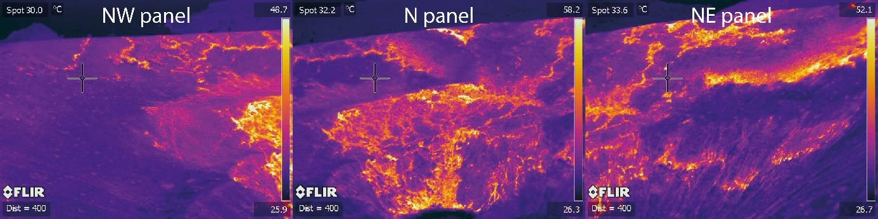
Figure 2: The three thermal image panels used to reconstruct the panorama of the entire fumarole field and surrounding heated ground areas on the northern sector of the crater.

Satellite-based thermal measurements
Two types of satellite infrared data were used. Firstly, the Advanced Spaceborne Thermal Emission and Reflection Radiometer (ASTER) aboard the spacecraft Terra is a partnership between NASA, Japan's Ministry of Economy, Trade and Industry (METI), the National Institute of Advanced Industrial Science and Technology (AIST) in Japan, and Japan Space Systems (J-spacesystems) (USGS, 2022b). Terra’s altitude is 705 km so that its ground track repeat cycle is 16 days (NASA Jet Propulsion Laboratory, 2022). Its orbit is sun-synchronous, which means that at a particular latitude, it overpasses at the same time each day either during day (around 10 AM GMT) or night time (around 9 PM GMT). It offers high-resolution (15 to 90 m per pixel) images of the Earth in 14 different wavelength bands, ranging from visible to thermal infrared light, especially five TIR bands between 8 and 12 µm spectral range (TERRA, 2022). In particular, it provides Level-2 products such as the Surface Kinetic Temperature (AST_08). AST_08 products are generated using the five TIR bands and deliver surface temperatures at 90 m spatial resolution for the land areas only. These temperatures are calculated by applying Planck's Law using the emissivity values from the Temperature/Emissivity Separation (TES) algorithm, which uses atmospherically corrected ASTER surface radiance TIR data (USGS, 2022a). All ASTER products are freely available through Nasa’s Earthdata Search platform (https://search.earthdata.nasa.gov/search) a few days after their collection.
Moreover, the Visible Infrared Imaging Radiometer Suite (VIIRS) sensor, on board Suomi National Polar-orbiting Partnership (Suomi NPP) and National Oceanic and Atmospheric Administration-20 (NOAA-20), was employed for the thermal monitoring of Vulcano. With a swath width of 3060 km in a near-circular, sun-synchronous, near-polar orbit, at 840 km mean altitude, VIIRS provides data every 12h, or less depending on the latitude, in 22 spectral bands from 412 nm to 12 µm of which: 5 (I-bands) at 375 m at Nadir, 16 (M-bands) at 750 m at Nadir and one day/night panchromatic band at 750 m spatial resolution throughout the scan respectively (Wolfe et al., 2013). Among these bands, the higher spatial resolution middle infrared band, I04 (centered at 3.74 μm) and the thermal infrared band I05 (centered at 11.45 μm) at 375 m are particularly useful for the monitoring of subtle thermal anomalies observable in closed conduit volcanos (Coppola et al., 2022). VIIRS archive imagery can be searched and downloaded via the NOAA CLASS Data web interface (https://www.avl.class.noaa.gov/) or automatically downloaded by using the wget utility via the Lance Near Real Time system, generally available within three-to-five hours from the satellite observation.

Gas Measurements
Soil CO₂ flux was measured using the accumulation chamber method (Chiodini et al., 1998). The field campaign of June 2021 was carried out using a West Systems composed of an A-type accumulation chamber (diameter 200 mm, height 100 mm) connected to a temperature-stabilized LI-COR LI-820 infrared sensor (0 – 20 000 ppm CO₂). The sensor has a detection limit of 1.5 ppm on CO₂ content and a 3 % accuracy on the reading. Subsequent field campaigns were made by combining a West Systems C-type accumulation chamber (diameter 300 mm, height 100 mm) and a PP Systems EGM-5 (Environmental Gas Monitoring) infrared gas analyzer device, with temperature and pressure compensation. The EGM-5 device has a CO₂ range up to 50 000 ppm (5 %) and an accuracy of <1 % over the calibrated range.

Appendix C: FA_grid

The location of FA_grid is shown on Figure 1C. In this area we measured an extensive increase in T₁₅, to values close to boiling point. The FA grid showed the alignment of hot temperatures along the break-in slope at the top of the inner crater.
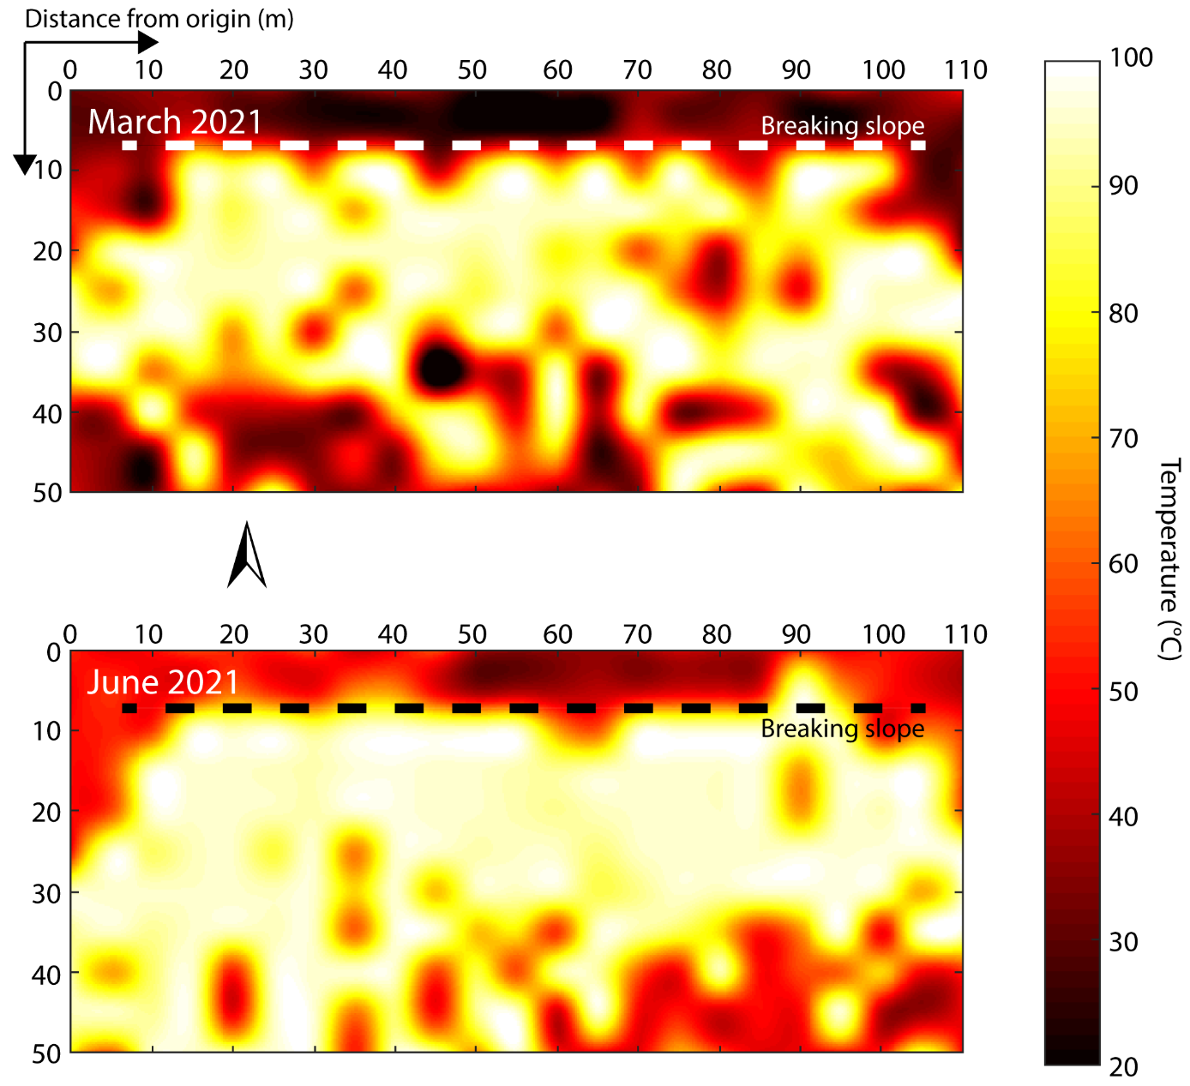
Figure C: T₁₅ for FA grid (see Figure 1C for location).

Appendix D: Fossa surface temperature frequency distributions from AST08
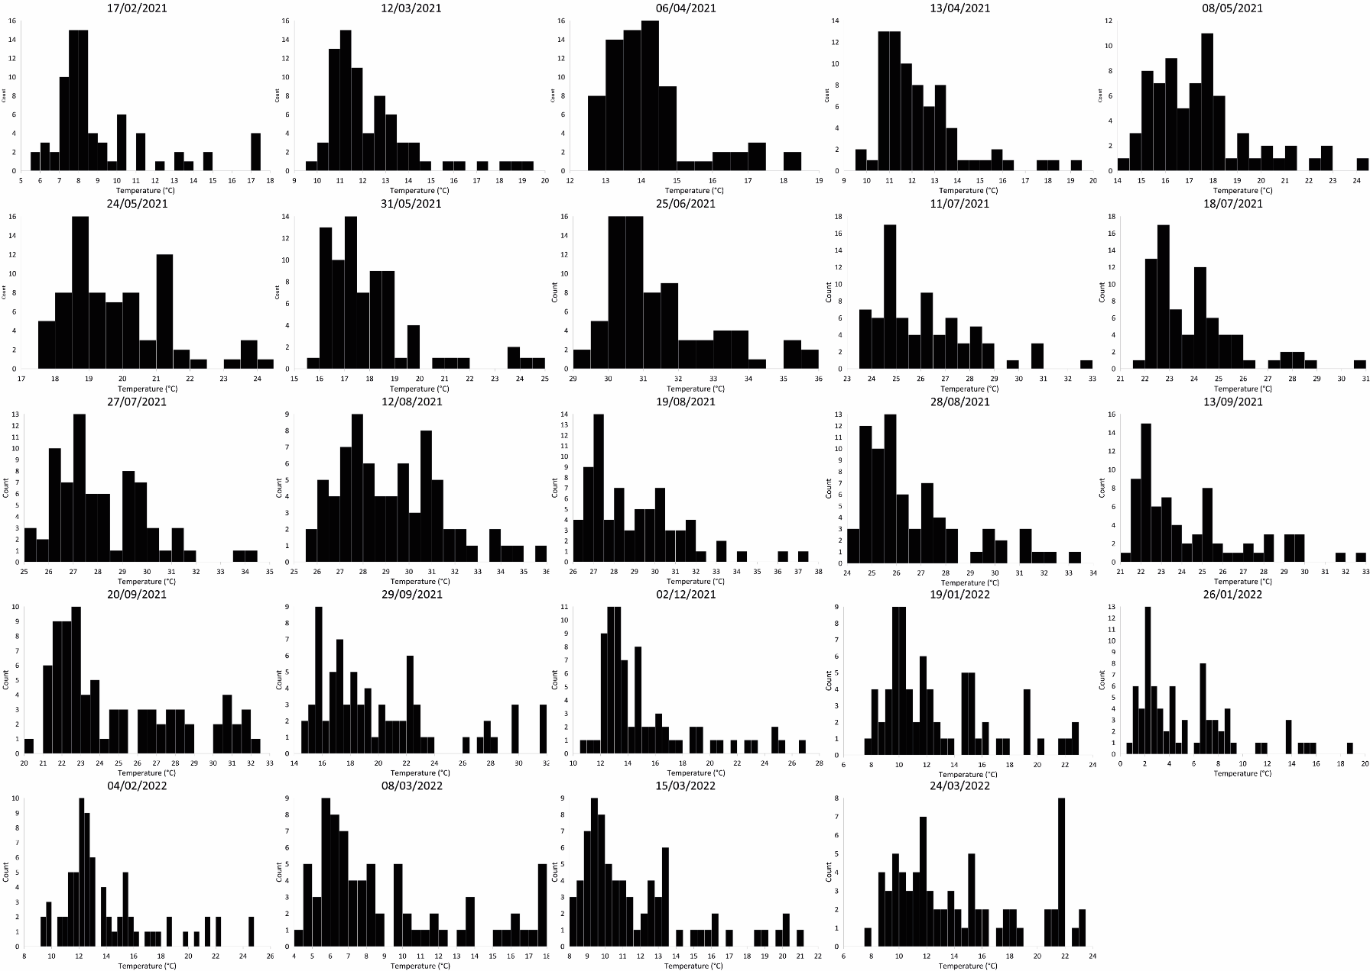
Figure C1: Surface temperature frequency distributions of La Fossa ROI obtained from ASTER

Appendix E: Fossa anomalous pixel detected from temperature distribution
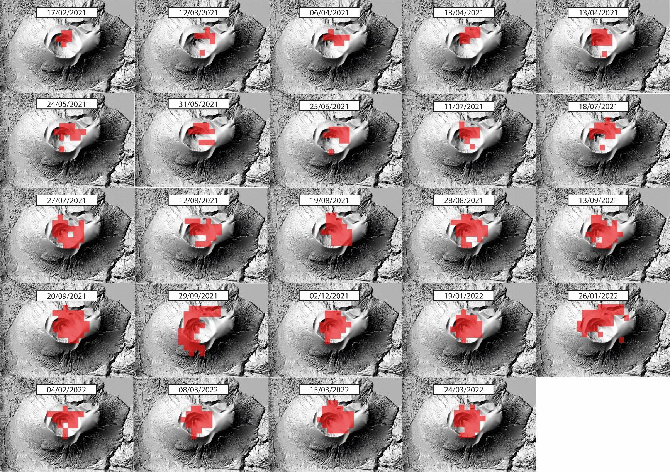
Figure D1: Fossa thermal anomalous pixel obtained using the surface temperature frequency distribution from ASTER

Appendix F: T₁₅ of the Profile1 between 2015 and 2021

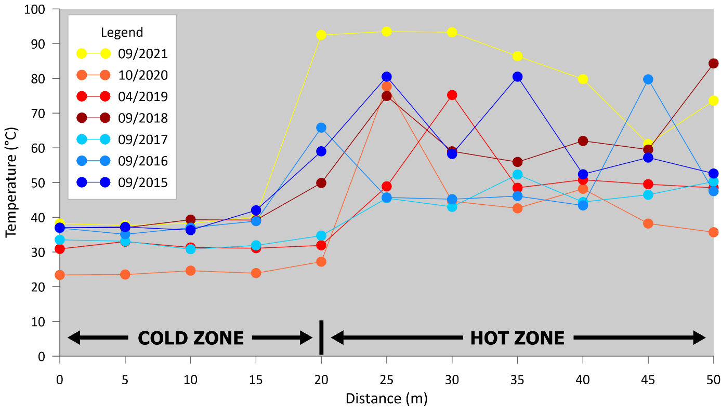
Figure A1: Temperature at 15 cm depth on a 50 m-long profile west of the fumarole field (2015-2021) (see Figure 1C for location)
Profile1 has been subjected to measures annually since 2015. The location of each point is strictly fixed only since 2019, which explains the little variation of the transition zone position around the 20 m mark. (Figure A1). Until June 2021, the transition was marked by an increase in T₁₅ by 3 to 10 °C. The hot zone had temperatures up to 20 °C higher than the cold zone, and occasionally hot spots up to 80 °C. These hotspots were highly localized, but spatially and temporarily variable. In September 2021, the hotspot expanded to include the entire hot segment of the line. At the same time the hot-cold transition moved 5 m into the cold zone.

Appendix G: Minimum and maximum and index temperatures from the fumarole surveys, by areas

Temperature data of the fumarole field vents show a general decline following the 1990s crisis to lowest levels recorded in March 2021 (Figure G1). Thereafter there is an increase in the mean temperature which, 14 months recovered to levels higher than in 1994. The trend is the same in terms of number of fumaroles. The exception to these generalities is a peak in the mean temperature in 2018; a peak which is not apparent in the maximum temperature and number of fumaroles. This appears to be a spurious result from averaging the lowest number of fumaroles ever recorded (Figure 8).
Figure G1: Average and maximum temperature of the Fossa fumarole vents. The lines on the plots are interrupted when the gap between two surveys is higher than one year.

Additional material: Minimum and maximum (Figure G2, G3) and index temperatures (Figure G4) from the fumarole surveys, by areas
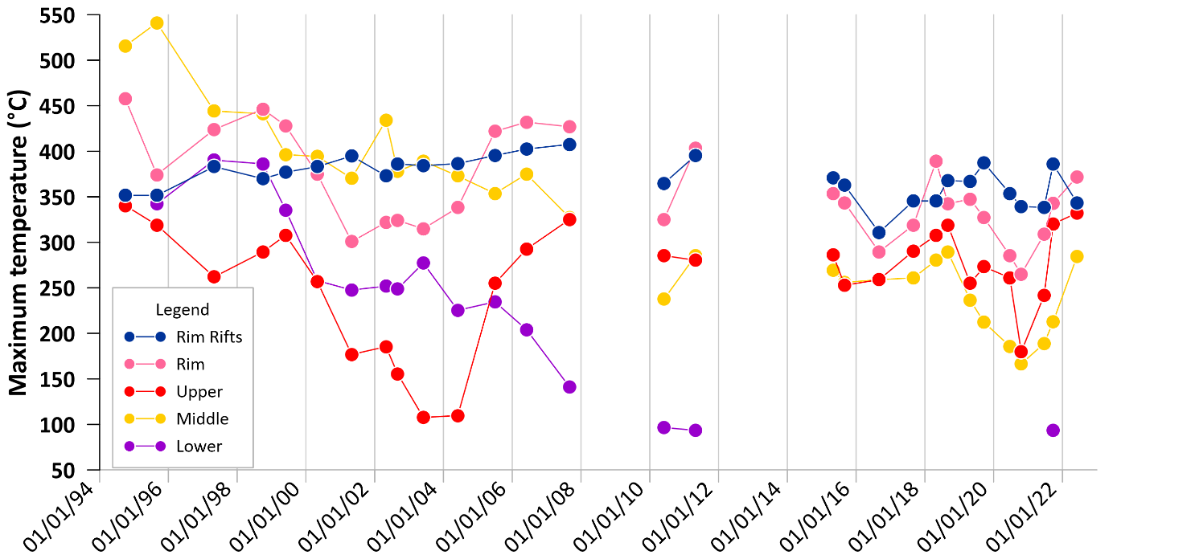
Figure G2: Fumarole survey maximum temperature evolution by zones

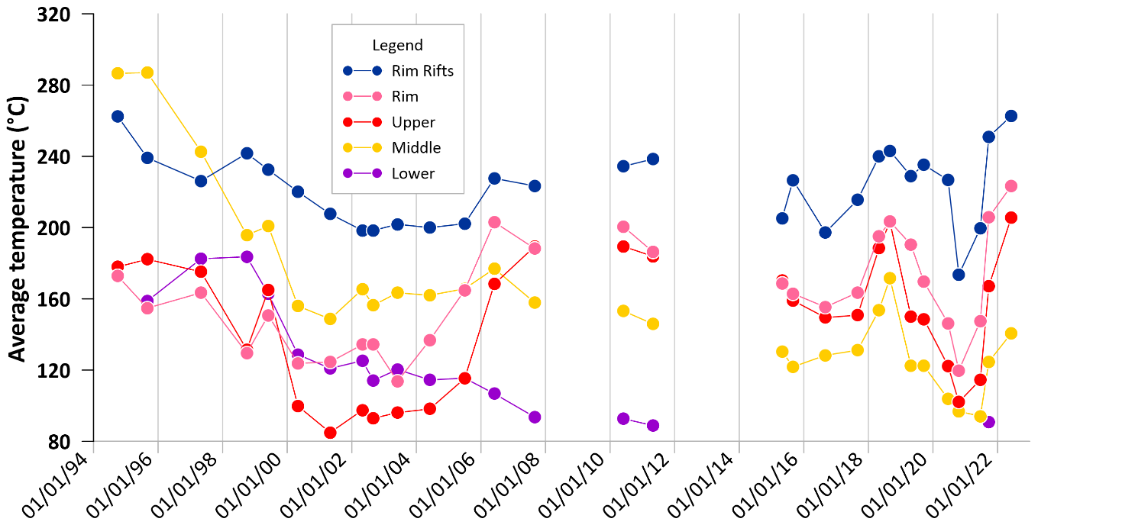
Figure G3: Fumarole survey average temperature evolution by zones

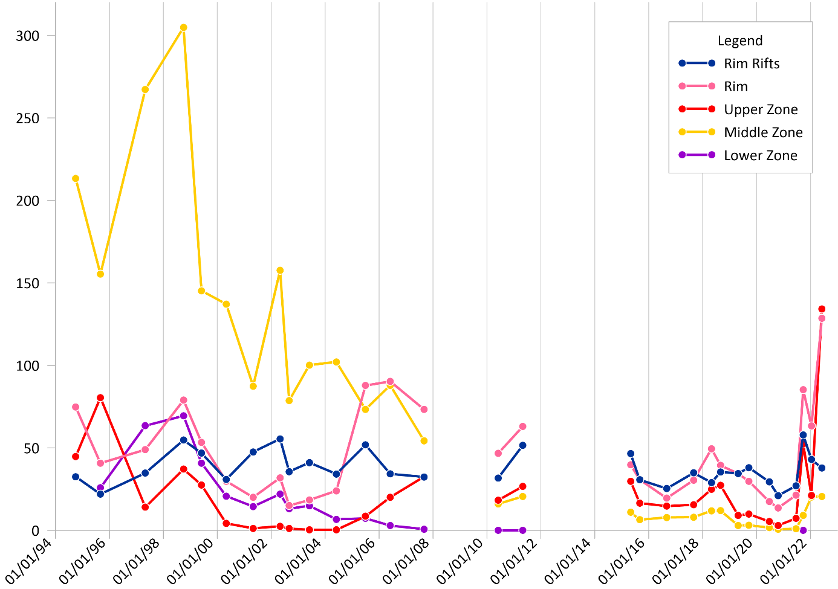
Figure G4: Fumarole survey FTI evolution by zones

Appendix H: Average and maximum temperatures and bimodality from the satellite survey

The maximum and mean temperatures within the thermal anomaly show a behavior linked to the exogenous seasonal cycles. The mean temperature also is especially sensitive to rainfall events (for example during the July 2021 storm).
All temperature distributions were skewed to high temperatures (Appendix D), but from June 2021 to January 2022 high temperature tails became more robust and a secondary temperature peak appeared (Figure 3). We applied Sarle’s bimodality coefficient (BC) (Tarbă et al., 2022) to assess the emergence of bimodality (Tarbă et al., 2022):
$$BC=\frac{Skewness^{2}+1}{Kurtosis+3\frac{(n-1)²}{(n-2)(n-3)}}$$
where $n$ is the sample size, here the number of pixels in La Fossa’s ROI. The coefficient ranges from zero to one, with one being the value for a perfectly bimodal distribution. An empirical threshold places the lower limit for bimodality at 0.55 (Tarbă et al., 2022).
This coefficient however presents two problems. First, BC values for July 27 and August 12 are falsely unimodal, because the two modes (background and anomaly) are too close together (Appendix B). Second, the heavily skewed distributions between February and June 2021, results in high BC values even though the distributions are unimodal (Pfister et al., 2013). Increase in BC after September however, does result from a higher number of hot pixels within the anomaly from this point onwards. The BC test is thus only effective after mid-August, when it picks out the onset of the crisis and bimodality. 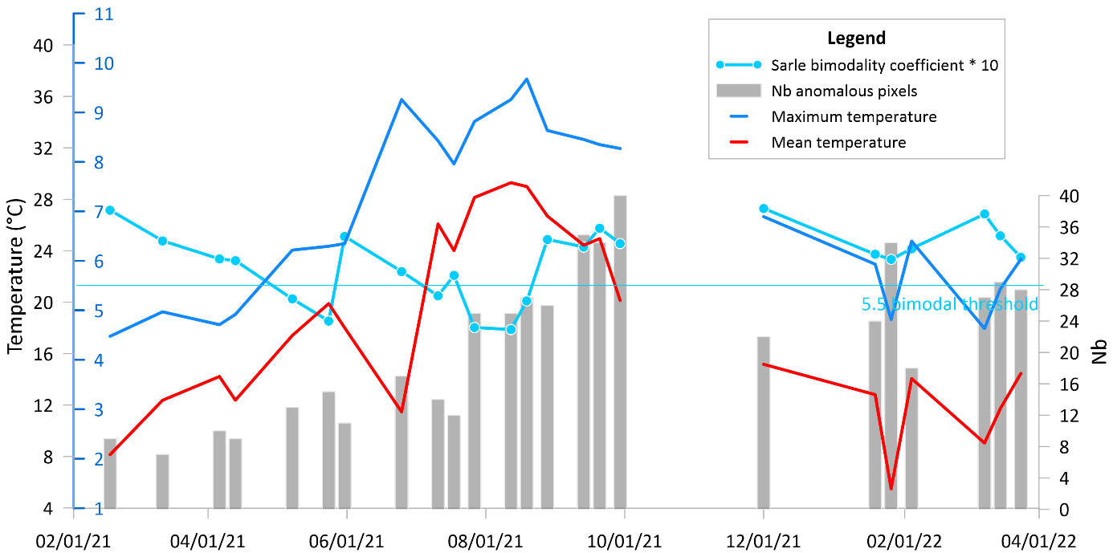
Figure H1: Number, mean and maximum temperatures of anomalous pixels and Sarle’s bimodality coefficient
There was no correlation between the temporal variation of mean or maximum pixel temperatures and the number of anomalous pixels (Figure H1). However, there was plainly an increase in the size and magnitude of the anomaly (Appendix D,E). We thus developed a method to highlight the thermal anomaly and extract any temporal trends
The first step isolates the thermal anomaly by using the ambient control to define ΔT_{max}:
$${∆T}_{max}{= Tmax}_{crater}-{Tmax}_{control}$$
where ${Tmax}_{crater}$ is the maximum temperature from the anomaly in the Fossa ROI, and ${Tmax}_{control}$ is the maximum temperature of the ambient control ROI on Vulcanello (Figure 1B). However, due to the high variability of ${Tmax}_{control}$ this failed to pick out any trends.

Figure 15: ASTER-derived thermal indices. Three scenes (09/29/21, 01/26/22 and 03/14/22) were still selected even though the cloud cover was partially covering the crater (colored star mark). The July 2021 storm events are marked by a blue triangle. The STI and NB_{p} baselines are respectively placed at 40 and 10 pixels.

Appendix I: HTF temperatures between 2021–2023

Figure I1: The temperature trends recorded in the HTFs on the northern slope of La Fossa

