Additional Materials for

Geomagnetic relative paleointensity and direction during the last 40,000 years obtained from a sediment core in the Nankai Trough

Ryoya Goto^{1, 2}, Toshitsugu Yamazaki¹, Natsumi Okutsu^{1, 3}, and Juichiro Ashi¹
[1] Atmosphere and Ocean Research Institute, The University of Tokyo, Kashiwa, Japan
[2] Ministry of Education, Culture, Sports, Science and Technology Japan
[3] Institute for Marine-Earth Exploration and Engineering, Japan Agency for Marine-Earth Science and Technology

Corresponding author: Toshitsugu Yamazaki (yamazaki@aori.u-tokyo.ac.jp)

Additional Figures
Figure S1
Figure S2

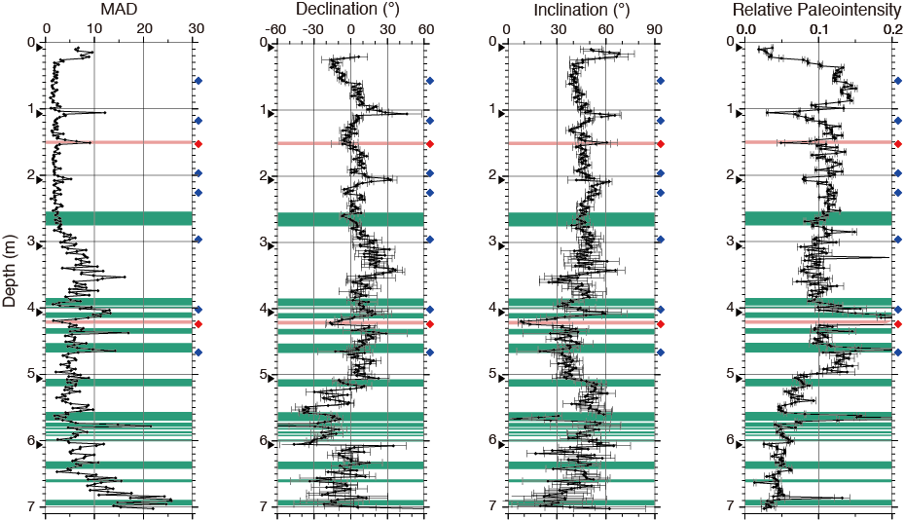

Fig. S1. Maximum angular deviation (MAD), declination, inclination, and relative paleointensity (from left to right) obtained from Core PC04 in the depth scale before excluding tephra (red) and turbidite layers (green). Blue and red diamonds along the depth axis indicate age-control points based on ¹⁴C dating and volcanic ashes, respectively. Black triangles show the locations of core-section boundaries. Error bars in declination and inclination are based on MAD values, and those in relative paleointensity are from the uncertainties of the best-fitting slopes in NRM-ARM demagnetization diagrams (Kono and Tanaka 1984).

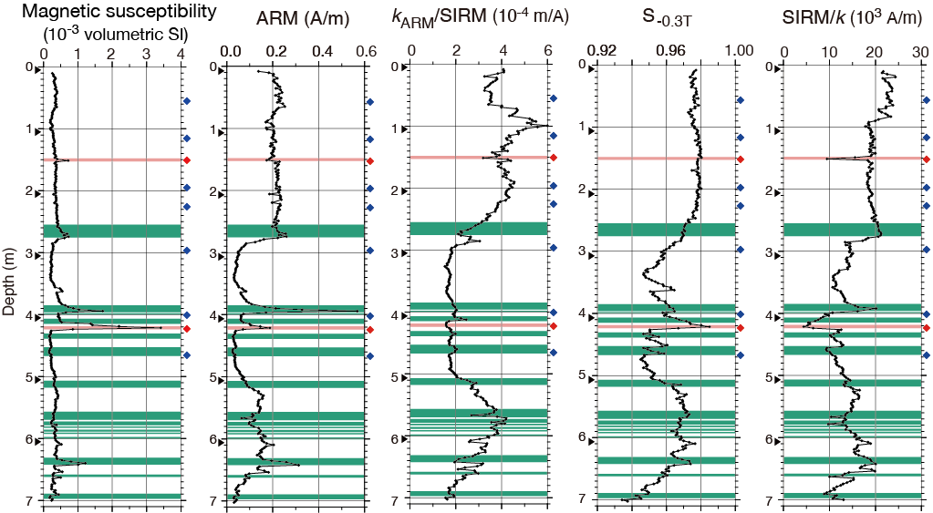

Fig. S2. Bulk magnetic properties of Core PC04 in the depth scale before excluding tephra (red) and turbidite (green) layers. Magnetic susceptibility (k), anhysteretic remanent magnetization (ARM), the ratio of ARM susceptibility (k_{ARM}) to saturation iso-thermal remanent magnetization (SIRM), S ratio (S_{-0.3T}), and the ratio of SIRM to k (from left to right). Blue and red diamonds along the depth axis indicate age-control points based on ¹⁴C dating and volcanic ashes, respectively. Black triangles show the locations of core-section boundaries.

