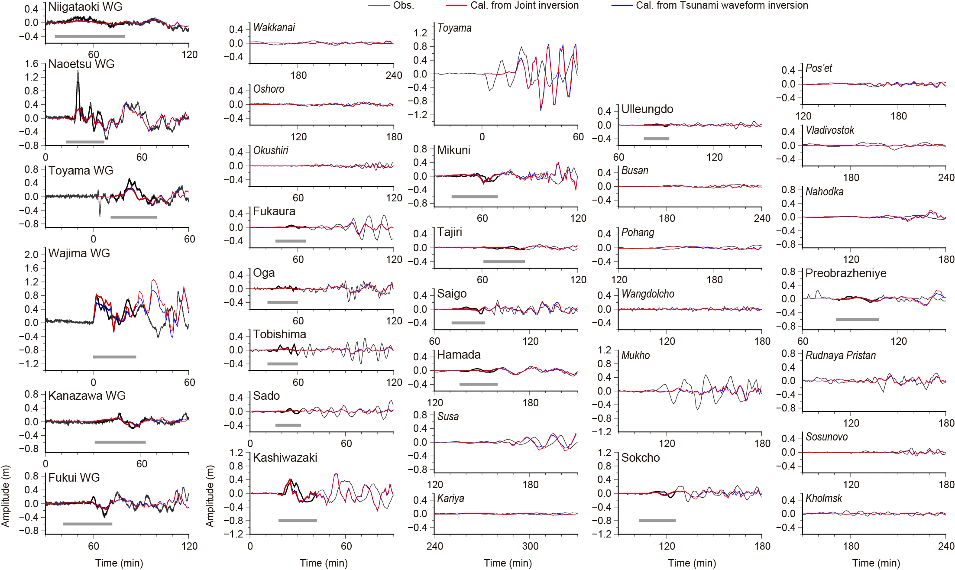
Fig. S1 Comparison of the observed and calculated tsunami waveforms from the joint inversion of tsunami waveform and GNSS data for the JSPJ fault models. The thick black and gray lines are the observed waveforms used and not used in the inversion, respectively. The red lines show the synthetic tsunami waveforms from the joint inversion, with the thick parts used in the inversion. The blue lines show the computed waveforms from the inversion using only tsunami waveform data. Synthetic waveforms from the joint inversion and the tsunami waveform inversion are indistinguishable except at Wajima WG station. The gray bars below the waveforms indicate the time windows used in the inversions.

Table S1 Fault parameters of the MLIT models and the inversion results.
#_Seg.# | Lat. (deg) | Lon. (deg) | Length (km) | Width (km) | Depth (km) | Strike (deg) | Dip (deg) | Rake (deg) | Slip (m)
 |  |  |  |  |  |  |  |  | Joint | Tsunami | GNSS
F42_1* | 38.009533 | 137.893863 | 37.7 | 17.7 | 2.5 | 201 | 45 | 78 | 0.39 | 0.41 | 0.00
F42_2* | 37.698281 | 137.743602 | 18.1 | 17.7 | 2.5 | 241 | 45 | 112 | 0.00 | 0.00 | 0.00
F43_2 | 37.51792 | 137.17528 | 45.9 | 19.7 | 1.1 | 55 | 45 | 105 | 3.46 | 3.41 | 5.83
F43_1 | 37.327401 | 136.681138 | 48.3 | 19.7 | 1.1 | 64 | 45 | 113 | 2.12 | 1.96 | 2.58
#_Seg.#: Subfault and segment number. Lat., Lon., and Depth: Location and the top depth of the eastmost corners (with *), and the westmost corners for the others. Rigidity of 34.3 GPa is assumed. |  |  |  |  |  |  |  | Mo (Nm) | 1.85 × 10²⁰ | 1.79 × 10²⁰ | 2.65 × 10²⁰
 |  |  |  |  |  |  |  | Mw | 7.4 | 7.4 | 7.5

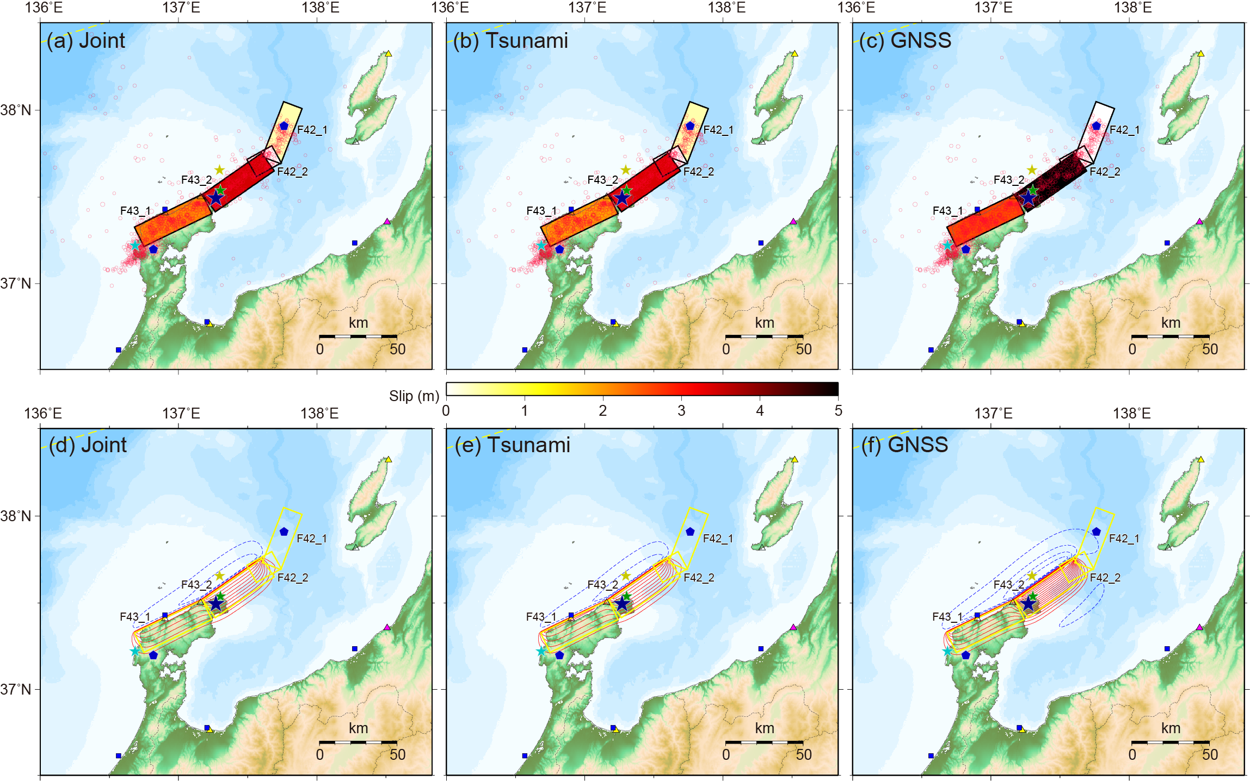
Fig. S2 Same as Fig. 4, but for a case adopting the MLIT fault models.

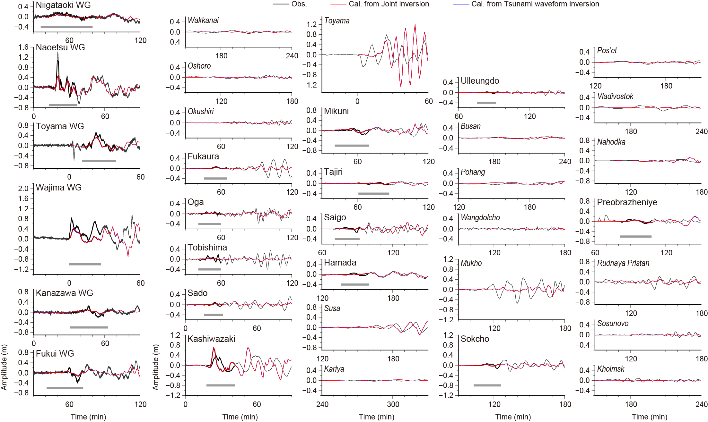
Fig. S3 Same as Fig. S1, but for a case adopting the MLIT fault models.

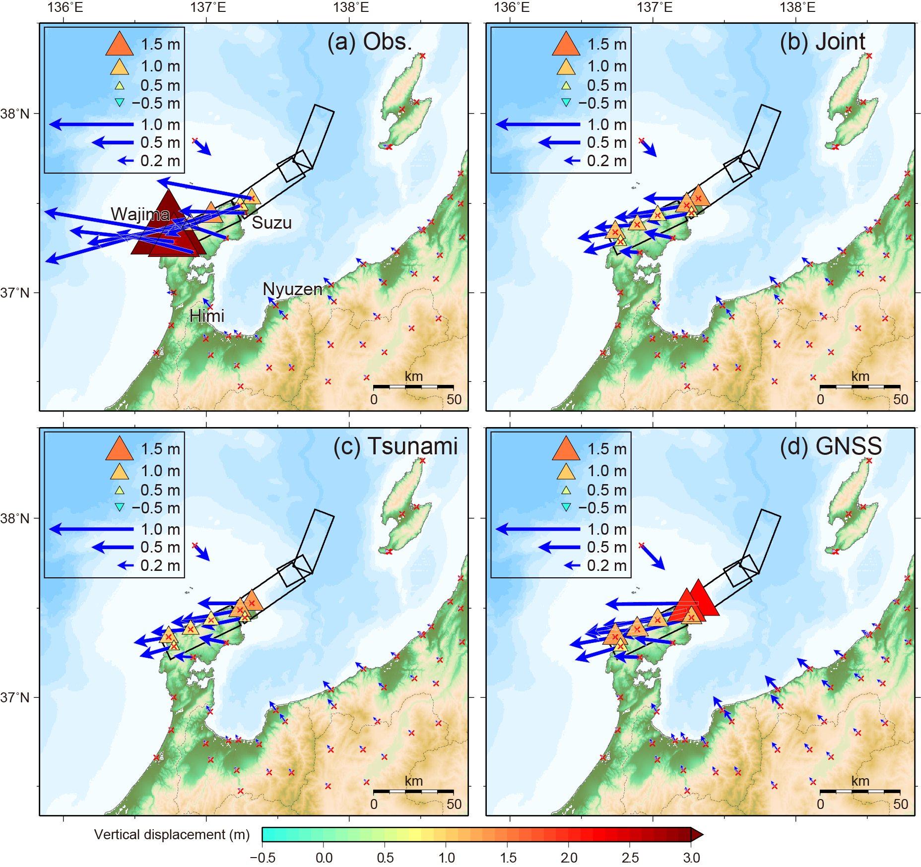
Fig. S4 Same as Fig. 3, but for a case adopting the MLIT fault models.

