Additional file 1:
Data Assimilation for Fault Slip Monitoring and Short-Term Prediction of Spatio-temporal Evolution of Slow Slip Events: Application to the 2010 Long-Term Slow Slip Event in the Bungo Channel, Japan

Masayuki Kano, Yusuke Tanaka, Daisuke Sato, Takeshi Iinuma, and Takane Hori

This additional file contains Figs. S1–S2 and Table S1.

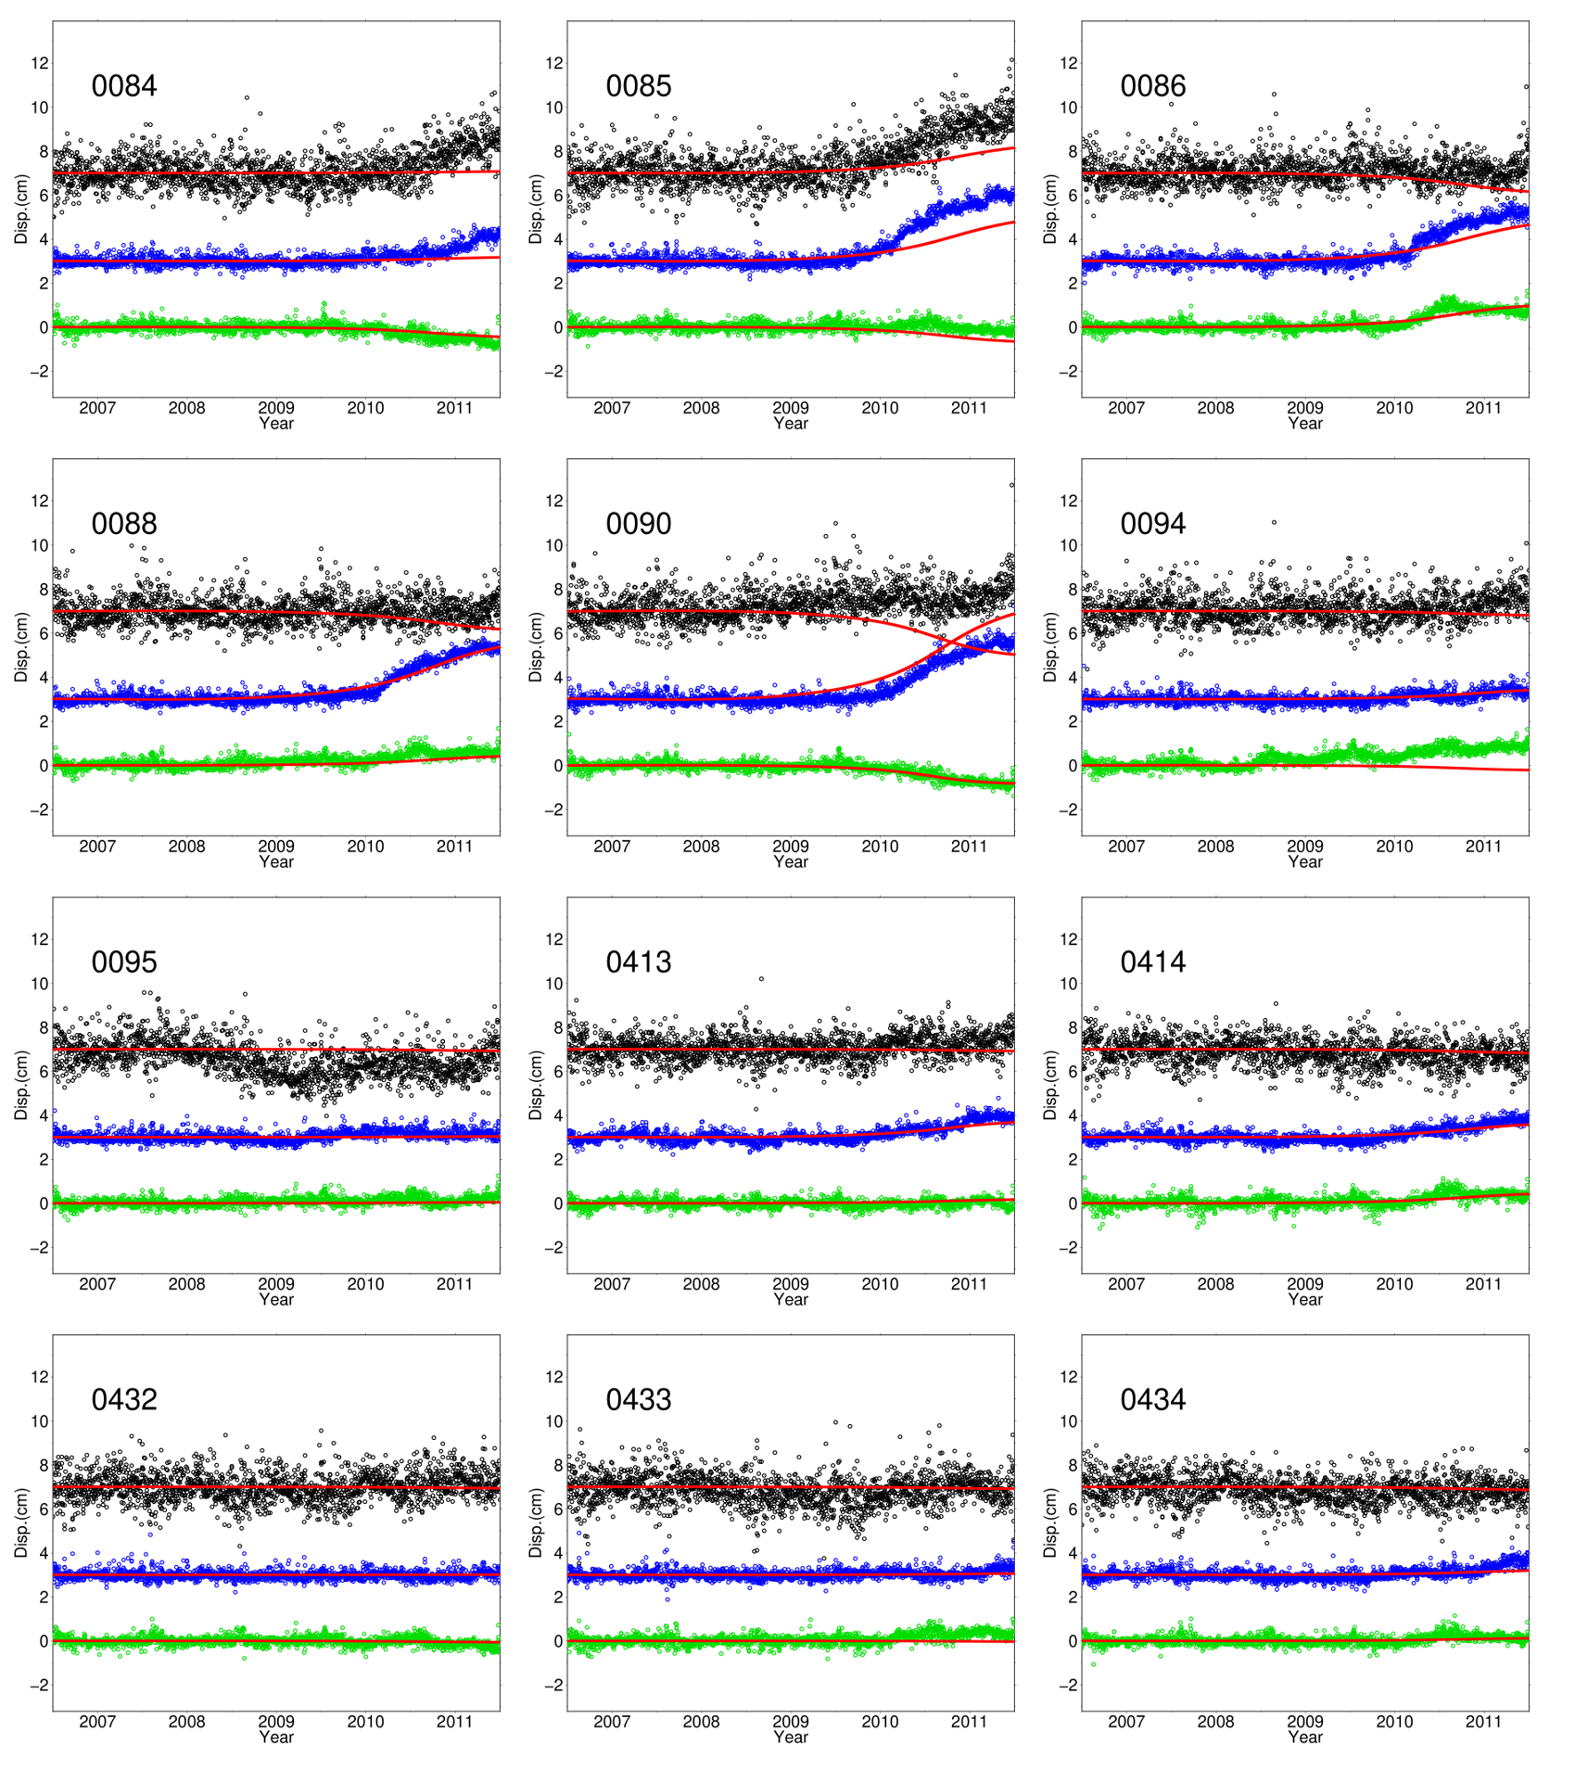
Figure S1: The locations of GNSS stations (green triangles) and the time series at all stations. The displacements in trench-parallel (X), trench-perpendicular (Y), and vertical (Z) components are represented by green, blue, and black dots, respectively. The red lines depict the calculated time series, derived from the set of frictional parameter showing the largest posterior PDF value in the case of DA period of 3.0 yrs. Refer to Table S1 for locations of the stations.

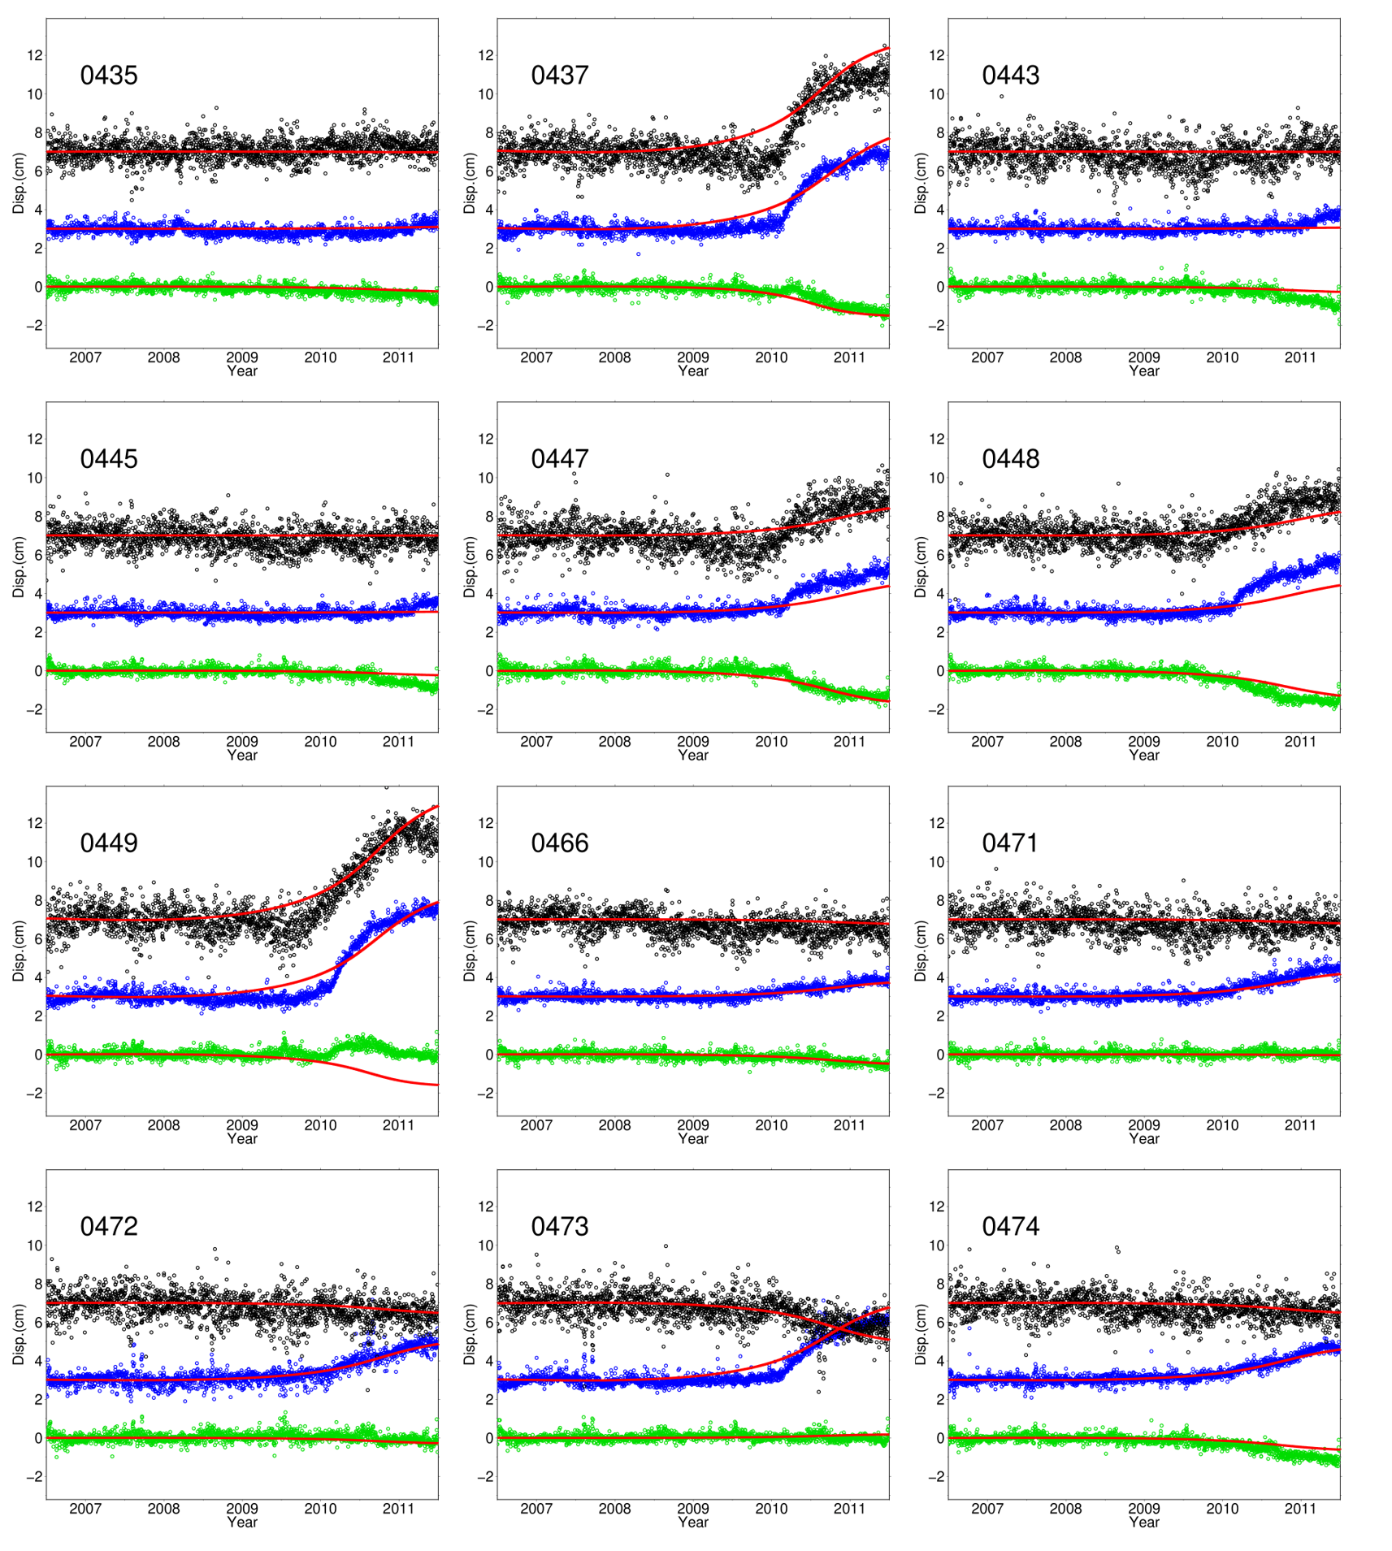
Figure S1 (continued)

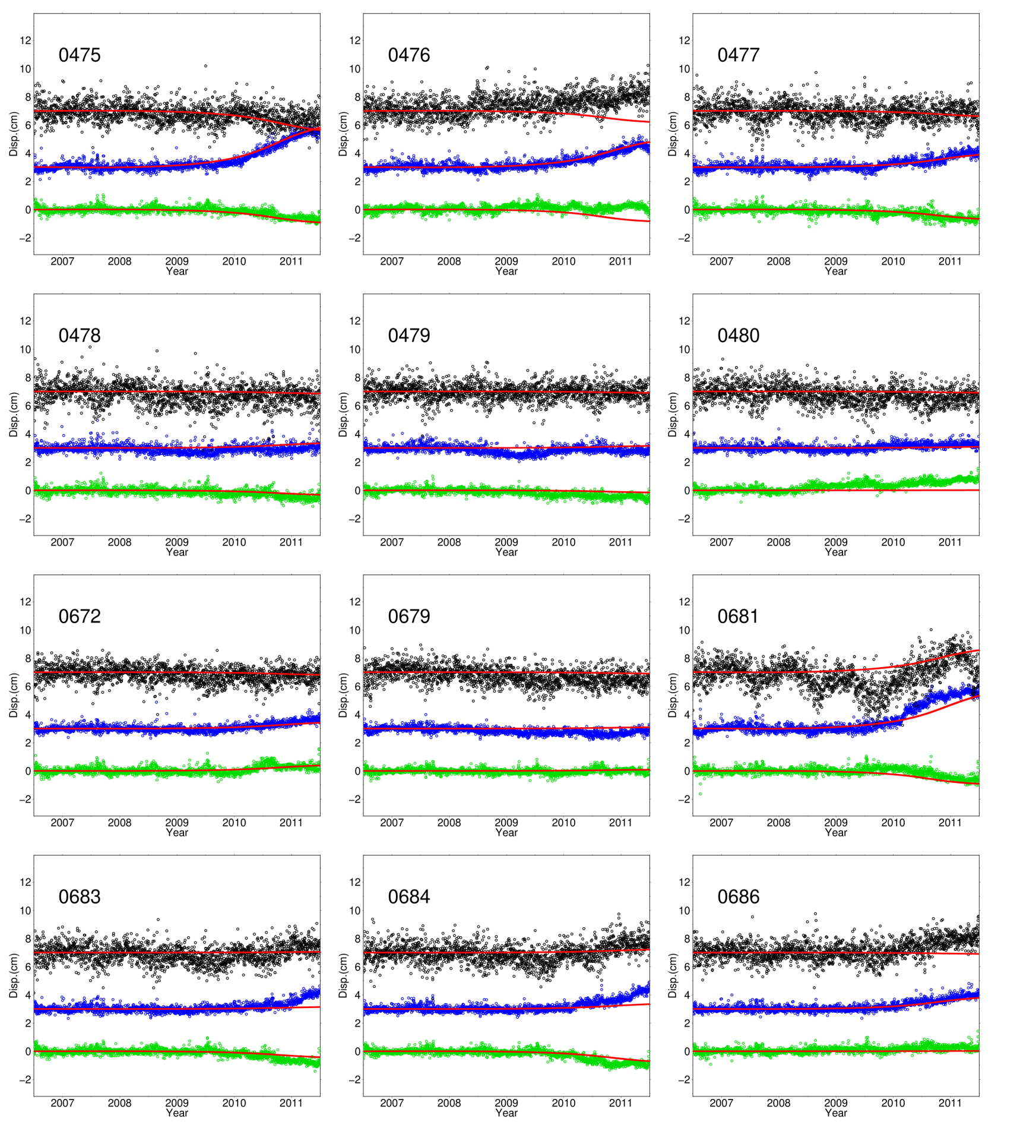
Figure S1 (continued)

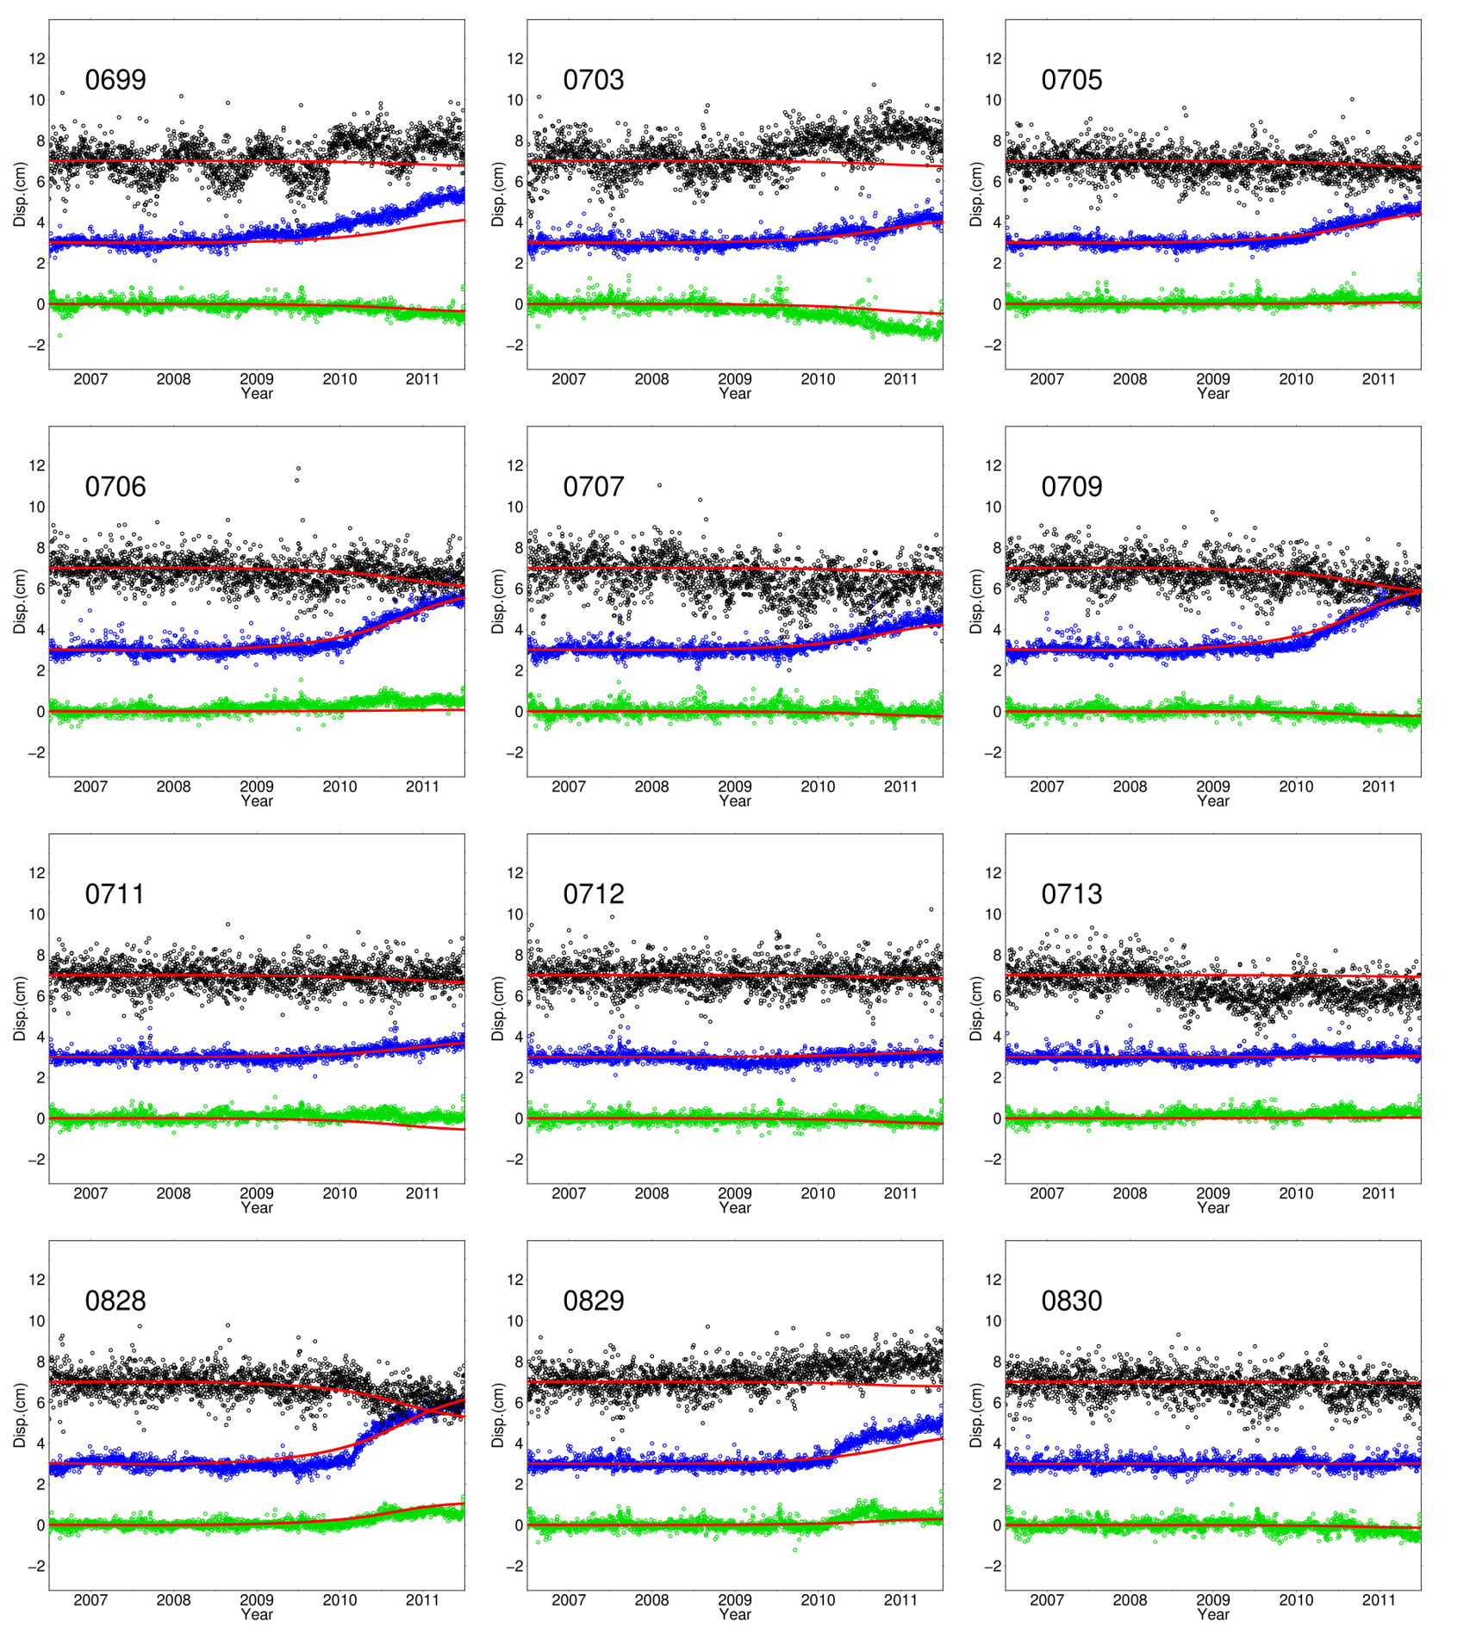
Figure S1 (continued)

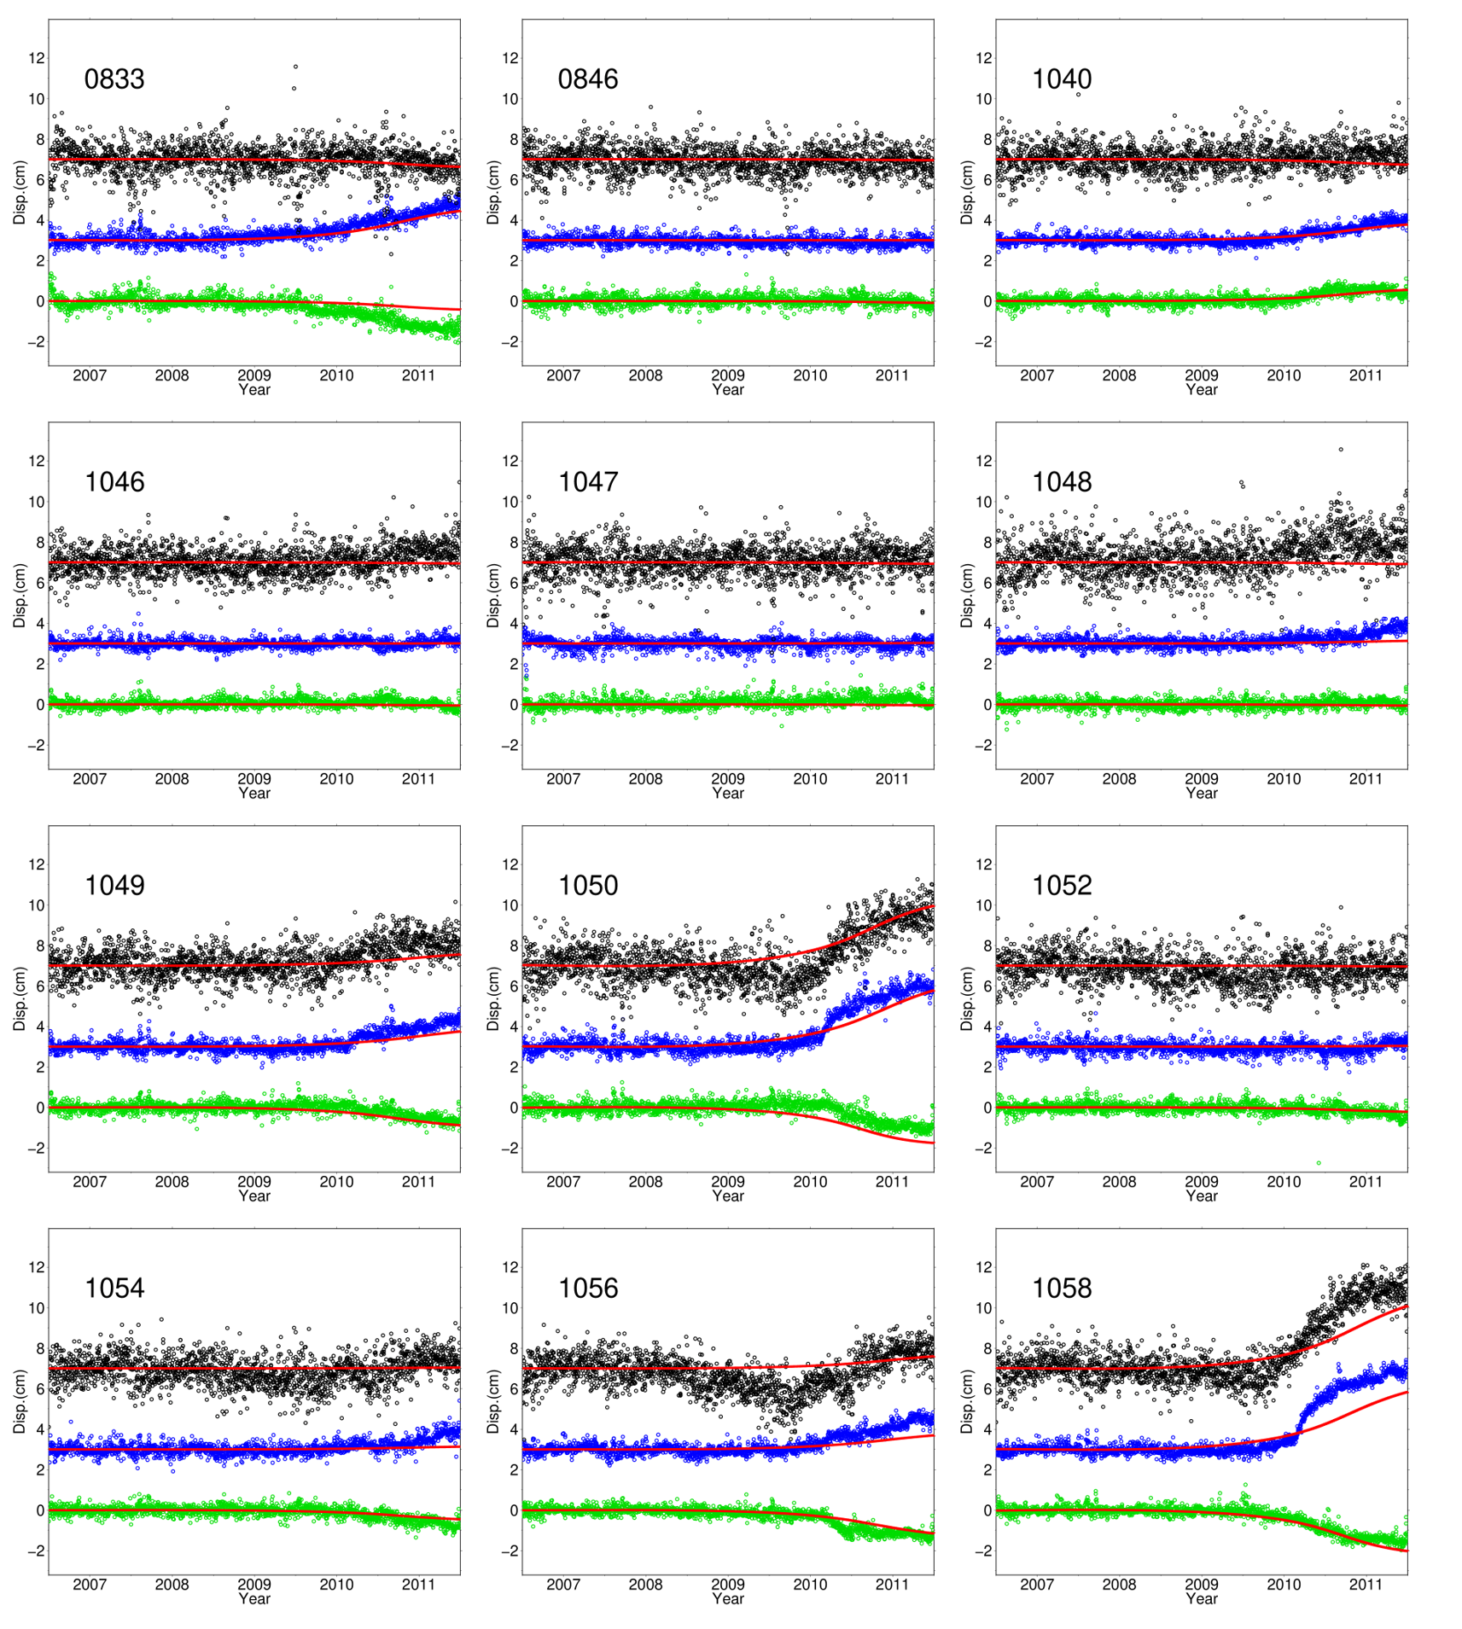
Figure S1 (continued)

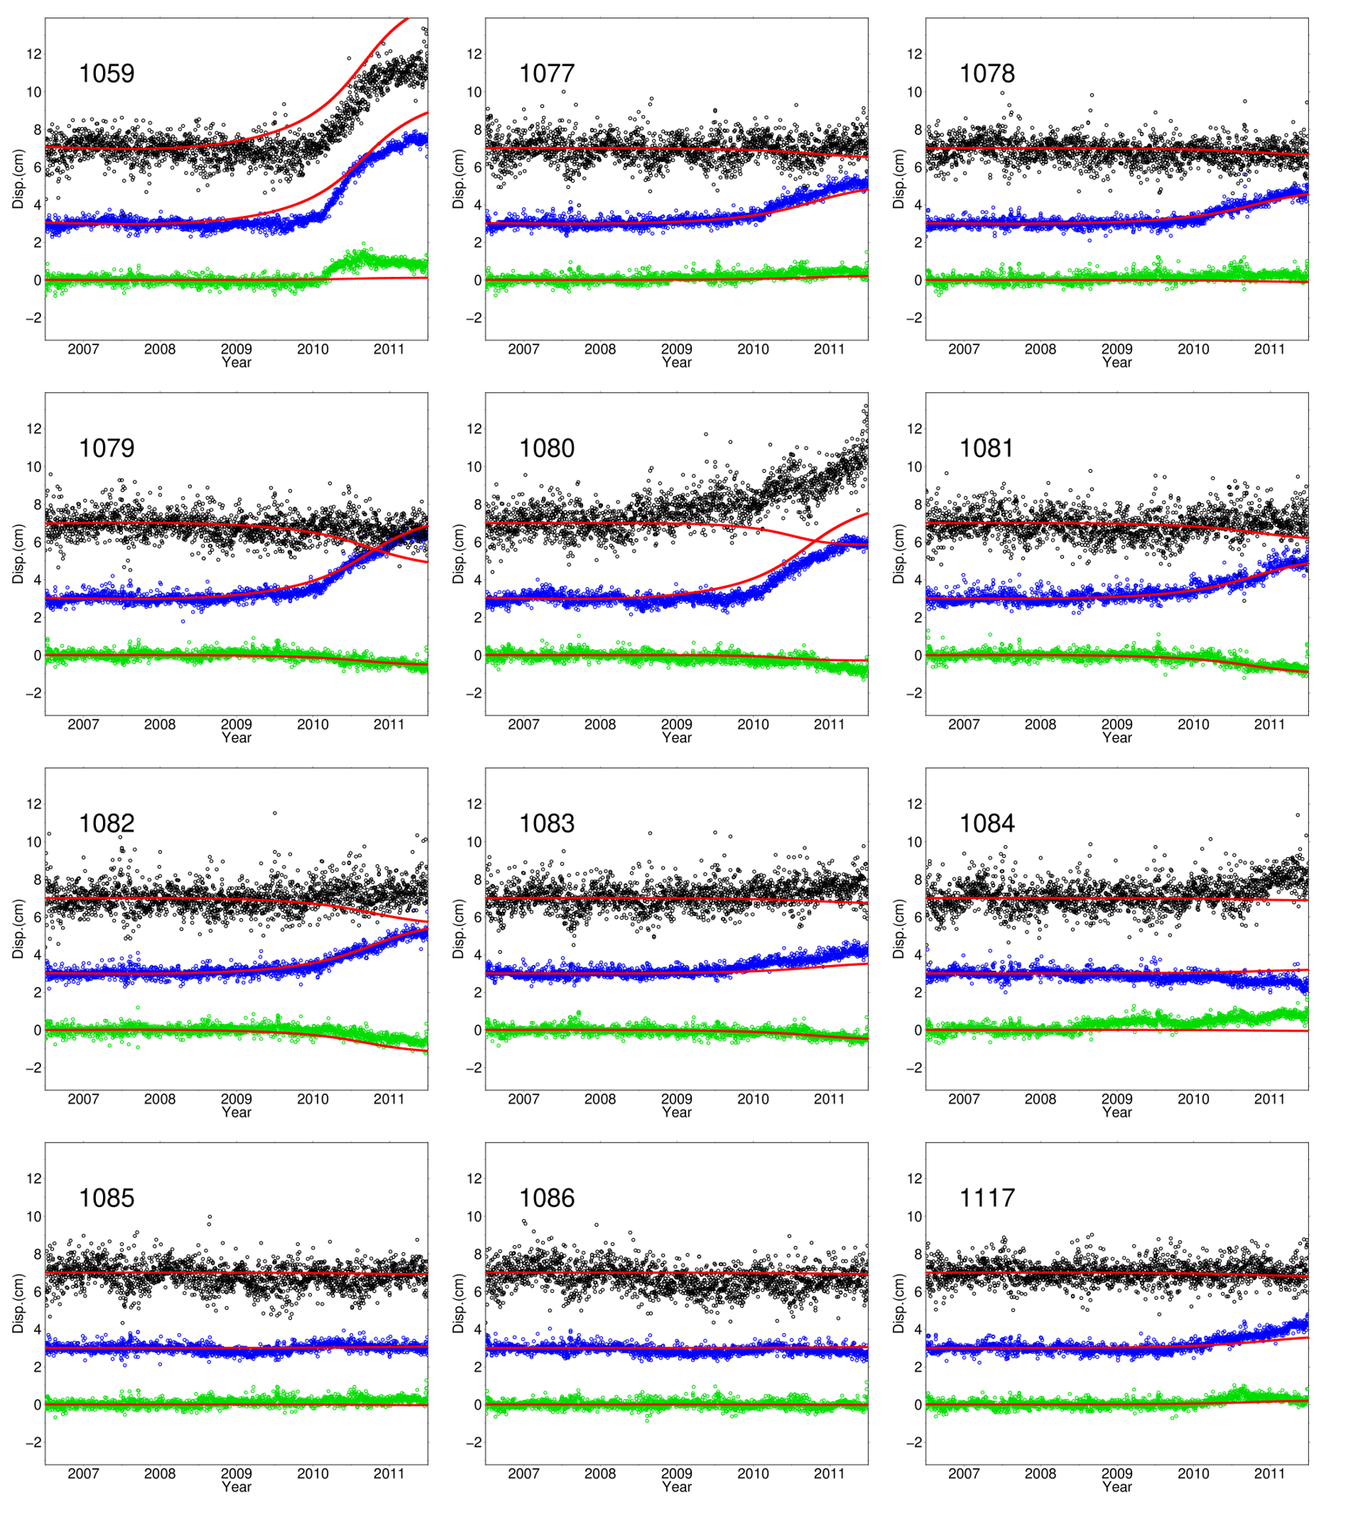
Figure S1 (continued)

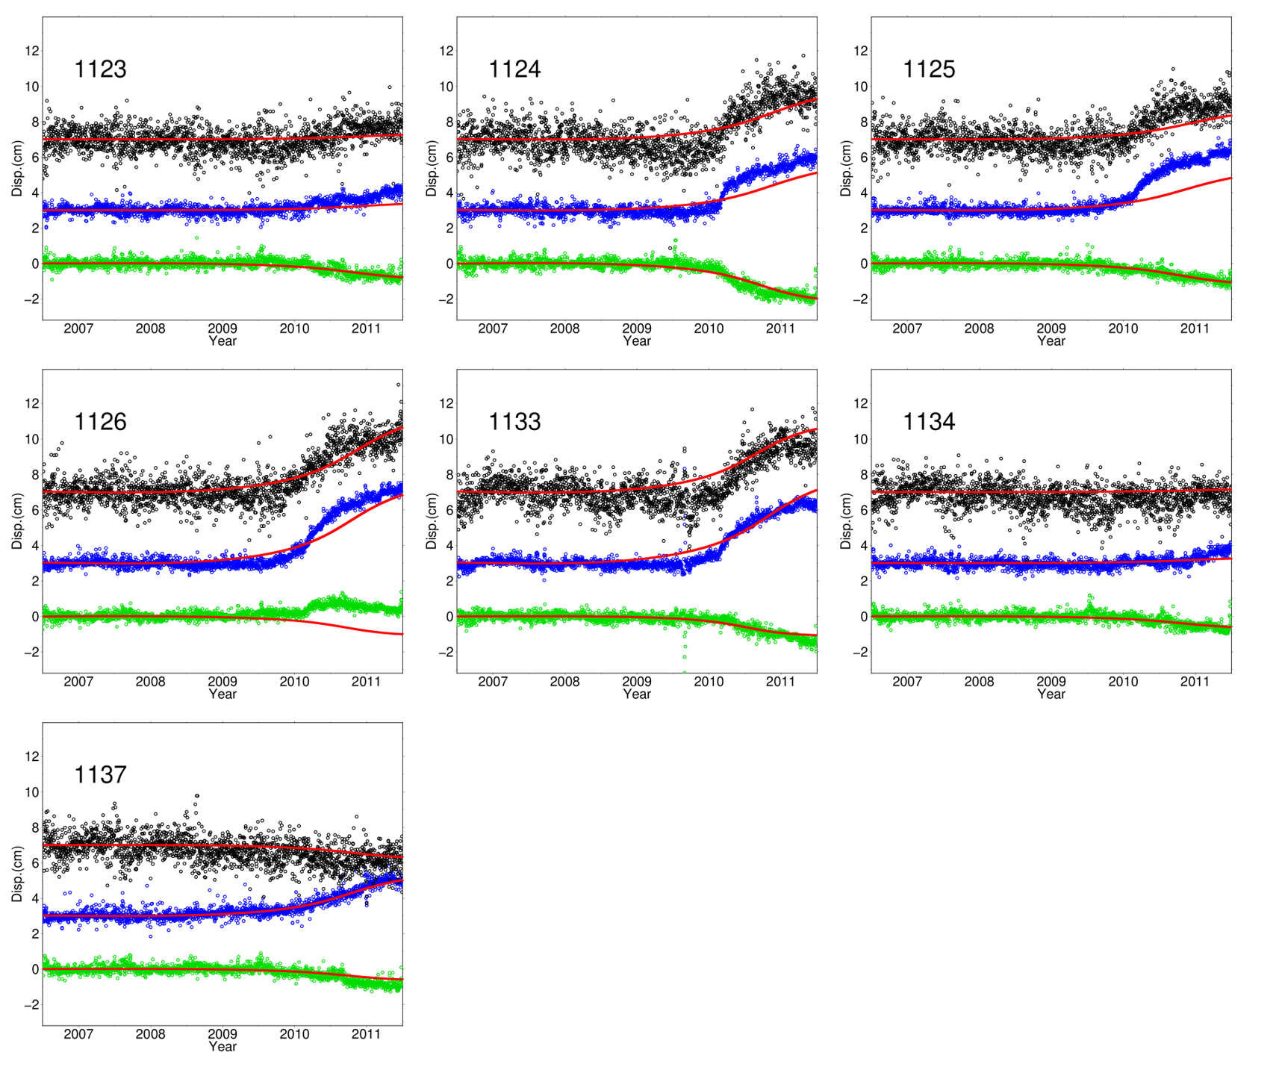
Figure S1 (continued)

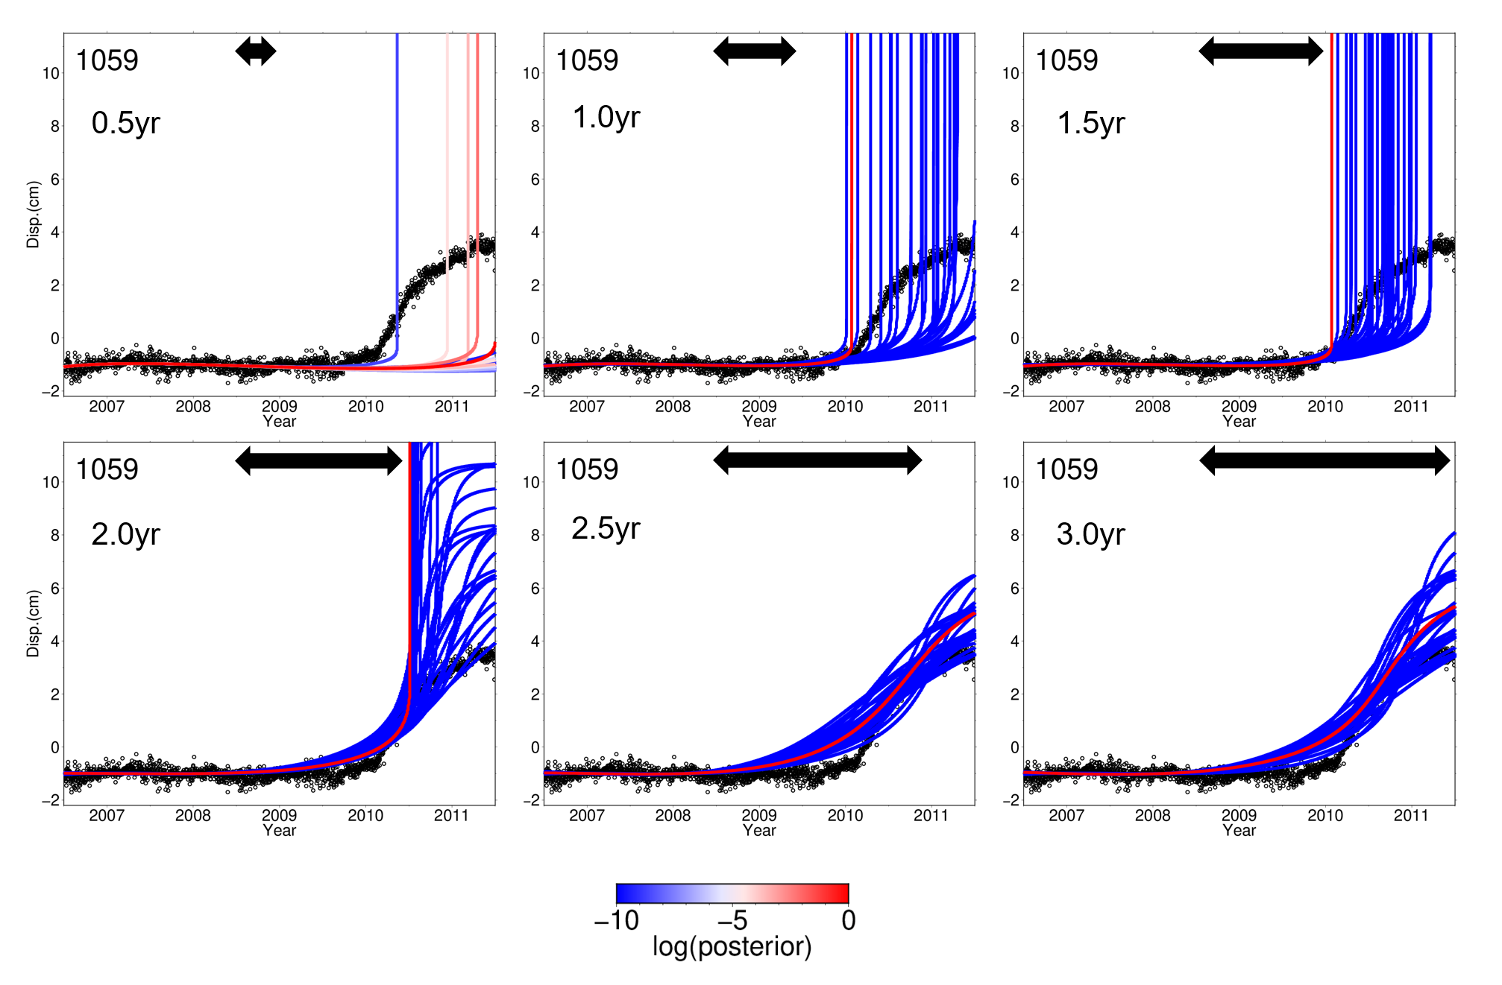
Figure S2: Same as Figure 4a, but only the time series with the 30 largest posterior values are shown among all the time series. Note that the color scales are different from Fig. 4a and the posterior values are adjusted by adding constants so that the largest posterior values become zero because only the difference of the posterior values is important in the MCMC computation.

Table S1. List of locations of GNSS stations.
*Stations whose observations in horizontal components are assimilated.
**Stations that are not used in DA and whose time series are not shown in Figure S1.
Site | Longitude  (East) | Latitude (North) |  | Site | Longitude  (East) | Latitude  (North)
0084 | 133.24179 | 33.27290 |  | 0706 | 131.58843 | 33.34985
0085 | 132.96641 | 32.75574 |  | 0707* | 131.12114 | 33.27027
0086 | 132.28118 | 33.46901 |  | 0709 | 131.57948 | 33.22843
0088 | 131.69137 | 33.46155 |  | 0711 | 131.53068 | 32.55705
0090 | 131.87638 | 32.92459 |  | 0712 | 131.33402 | 32.38440
0094 | 131.63233 | 32.44544 |  | 0713 | 131.48602 | 32.06911
0095 | 131.46968 | 32.02176 |  | 0828 | 132.04609 | 33.36797
0413 | 131.28604 | 33.97771 |  | 0829 | 132.47535 | 33.38437
0414 | 132.10444 | 33.97507 |  | 0830 | 133.36264 | 33.70428
0432 | 133.20131 | 33.92120 |  | 0833 | 131.20680 | 33.12784
0433 | 132.91164 | 33.79650 |  | 0846 | 133.46180 | 33.81836
0434 | 132.68397 | 33.72260 |  | 1040 | 132.11996 | 33.84592
0435 | 132.93788 | 33.56922 |  | 1046 | 133.35070 | 33.97417
0436** | 132.69341 | 33.44676 |  | 1047 | 133.04740 | 33.88409
0437 | 132.56182 | 32.96390 |  | 1048 | 132.79853 | 33.64273
0443 | 133.28091 | 33.46840 |  | 1049 | 132.74369 | 33.30506
0445 | 133.40298 | 33.40770 |  | 1050 | 132.63364 | 33.09609
0447 | 132.79269 | 33.17164 |  | 1052 | 133.15449 | 33.60702
0448 | 132.99923 | 32.99123 |  | 1054 | 133.08954 | 33.41666
0449 | 132.70373 | 32.84061 |  | 1056 | 132.97213 | 33.19314
0466 | 131.09930 | 32.74065 |  | 1058 | 132.83146 | 32.96107
0470** | 131.56417 | 33.67119 |  | 1059 | 132.55544 | 32.73861
0471 | 131.16893 | 33.49623 |  | 1077 | 131.52115 | 33.51433
0472 | 131.34728 | 33.25404 |  | 1078 | 131.29168 | 33.38375
0473 | 131.79807 | 33.23944 |  | 1079 | 131.74841 | 33.09620
0474 | 131.28609 | 33.00903 |  | 1080 | 132.03905 | 32.93636
0475 | 131.58784 | 32.98686 |  | 1081 | 131.44153 | 32.89890
0476 | 131.75684 | 32.70402 |  | 1082 | 131.62923 | 32.85222
0477 | 131.32762 | 32.68483 |  | 1083 | 131.36470 | 32.52793
0478 | 131.14887 | 32.45664 |  | 1084 | 131.58303 | 32.31623
0479 | 131.18523 | 32.24586 |  | 1085 | 131.34749 | 32.11189
0480 | 131.51585 | 32.17043 |  | 1086 | 131.25446 | 32.00180
0672 | 132.35834 | 33.90993 |  | 1117 | 132.56470 | 33.51035
0679 | 132.78174 | 33.95947 |  | 1118 | 132.36039 | 33.20218
0680** | 132.48726 | 33.61159 |  | 1119 | 133.43171 | 33.54573
0681* | 132.54376 | 33.17759 |  | 1123 | 132.97402 | 33.31213
0683 | 133.22847 | 33.32691 |  | 1124 | 132.82208 | 33.06012
0684 | 133.12864 | 33.21543 |  | 1125 | 132.98217 | 32.86948
0686 | 131.01653 | 33.69740 |  | 1126 | 132.81066 | 32.76210
0699* | 131.06290 | 33.12196 |  | 1132** | 133.04323 | 33.54583
0703 | 131.09343 | 32.95065 |  | 1133 | 132.48877 | 33.03946
0704** | 131.13215 | 32.84500 |  | 1134 | 132.92265 | 33.39103
0705 | 131.35664 | 33.53712 |  | 1137 | 131.38403 | 33.07884

