Supplements Information
Figure S1 show the Earthquake map and data distribution of the subset region from the testing dataset. The latitude range is from 35°N to 40°N and longitude range is from 139°E to 144°E. There are 399 earthquakes from inland, with $M_{JMA}$ ranging from 3.0 to 6.3, and depths and epicenter distances are less than 151km and 100km. For the offshore, 588 earthquakes with $M_{JMA}$ from 3.0 to 7.4, the depth ranges from 0 to 90 km, and the epicenter distance is less than 200 km.
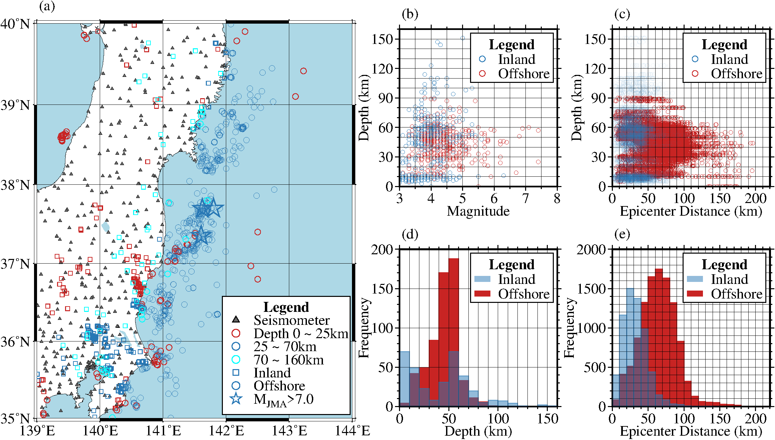
Figure S1. Earthquake map and data distribution of the subset-region. The subfigure a indicates the distribution of the seismometers and earthquake epicenters. Different colors indicate the earthquake depth range and different shapes indicate different geographical regions. Subfigure b indicates the distribution between depths and magnitudes. Subfigure c indicates the distribution between the depths and epicenter distances. The subfigures d to e indicate the frequency distribution of depths and epicenter distances. The different colors indicate different geographical regions.

